BDP-Homework-4
Submitted-By:
Anuj Bansal (2018201096)

Part-1 : Working with Twitter Apis

1. Collect 3,200 most recent tweets from the BJP's official Twitter handle.

a) Most Liked Tweet:

ID : 1110886268408233984
Full Text :
Congress led UPA Surgical Strike : Don't do it Air Strike: Don't do it A-SAT Missile: Don't do it Modi Sarkar Surgical Strike: Go For It Air Strike: Go For It A-SAT Missile: Go For It Modi Hai To Mumkin Hai. #MissionShakti
Likes: 43519
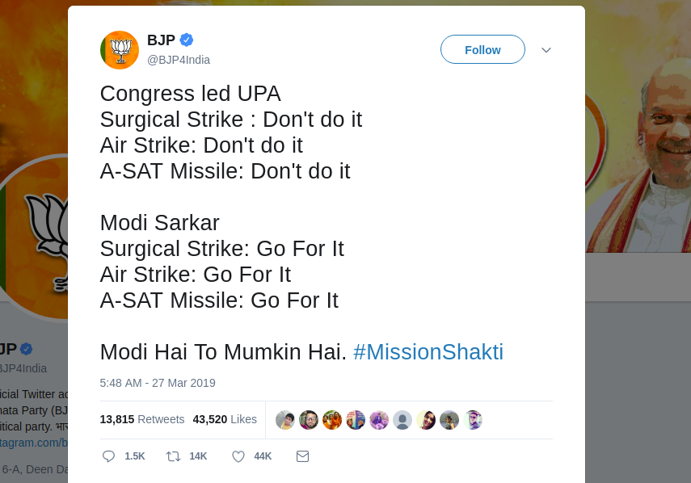
URL: https://twitter.com/statuses/1110886268408233984

b) Tweets Most Retweeted:

ID : 1101524057353342981
Full Text :
Welcome Home Wing Commander Abhinandan!
The nation is proud of your exemplary courage.
Our armed forces are an inspiration for 130 crore Indians.
Vande Mataram!
Retweets: 66206
URL: https://twitter.com/statuses/1101524057353342981
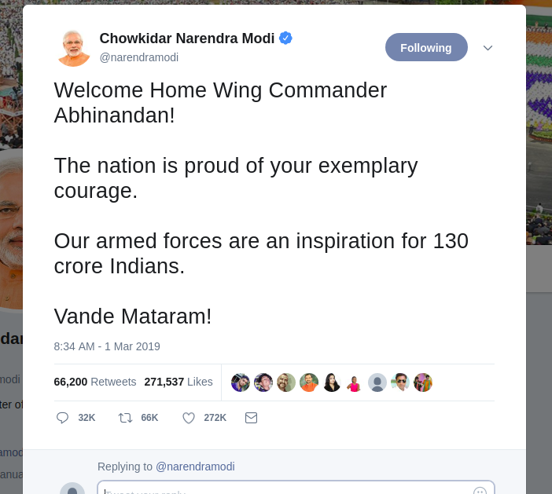

c) Top 5 most popular tweets:
To retrive most popular tweets we used the maximization solution , giving more weightage to “Retweet ” count compared to that of “Likes” count.
Popularity = 2x(retweet_count) + likes_count

1. ID : 1101524057353342981

Full Text :
Welcome Home Wing Commander Abhinandan!
The nation is proud of your exemplary courage.
Our armed forces are an inspiration for 130 crore Indians.
Vande Mataram!
Likes: 0
Retweets: 66206
URL: https://twitter.com/statuses/1101524057353342981

2. ID : 1106767552351559680

Full Text :
Your Chowkidar is standing firm & serving the nation.
But, I am not alone.
Everyone who is fighting corruption, dirt, social evils is a Chowkidar.
Everyone working hard for the progress of India is a Chowkidar.
Today, every Indian is saying-#MainBhiChowkidar
Likes: 0
Retweets: 56313
URL: https://twitter.com/statuses/1106767552351559680

3. ID : 1114495595421376512

Full Text :
आज तक ने प्रधानमंत्री श्री नरेन्द्र मोदी के भाषण पर दिखाई गलत खबर। आखिर क्यों?
Likes: 37936
Retweets: 18176
URL: https://twitter.com/statuses/1114495595421376512

4. ID : 1110886268408233984

Full Text :
Congress led UPA Surgical Strike : Don't do it Air Strike: Don't do it A-SAT Missile: Don't do it Modi Sarkar Surgical Strike: Go For It Air Strike: Go For It A-SAT Missile: Go For It Modi Hai To Mumkin Hai. #MissionShakti
Likes: 43519
Retweets: 13814
URL: https://twitter.com/statuses/1110886268408233984

5. ID : 1110802295527079936

Full Text :
#MissionShakti is special for 2 reasons:
(1) India is only the 4th country to acquire such a specialised & modern capability.
(2) Entire effort is indigenous.
India stands tall as a space power!
It will make India stronger, even more secure and will further peace and harmony.
Likes: 0
Retweets: 35344
URL: https://twitter.com/statuses/1110802295527079936

d) Top 5 most used hashtags by the BJP's official handle:
Hashtag | Frequency
BJPSankalpPatr2019 | 139
IsBaarNaMoPhirSe | 134
IsBaarPhirModi | 123
IndiaWithNaMo | 112
DeshKeLiyeModi | 102

2. Collect 3,200 most recent tweets from the Indian National Congress' official Twitter handle.

a) Most Liked Tweet:

b) Word cloud of the top 1000 most popular tweets.
Words occurs most frequently
Congress President,President, Rahul Gandhi, India, Public, People, NoMo, BJP, Modi, Govt, Parliament, Congress Party.
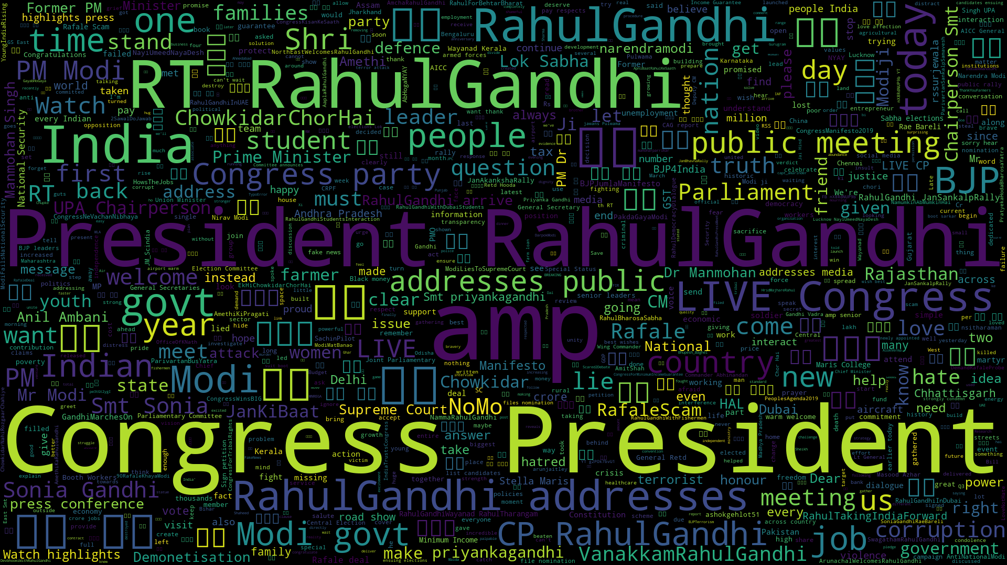

c) Top 5 most used hashtags by the INC's official handle.
Hashtag | Frequency
NammaRahulGandhi | 56
RafaleScam | 50
TelanganasProgressWithCongress | 45
YoungIndiaRising | 45
VanakkamRahulGandhi | 41

Part-2 : Working with Instagram data using instaloader to scrape posts

1. Collect 500 most recent posts from the Indian National Congress' official Instagram handle.

a) Most Liked Post and Post with most comments:

Most Liked Post
Post ID: Bs-IxK3FTIx
Post URL: https://www.instagram.com/p/Bs-IxK3FTIx
Caption: Congratulations to Priyanka Gandhi Vadra on becoming the #AICC General Secretary of #UP East. We’re fired up and ready to go! #PriyankaGandhi #PGV #Politics #IndianPolitics #Congress #Democracy #WomenLeaders
Post Likes: 47568
Post Comments: 831
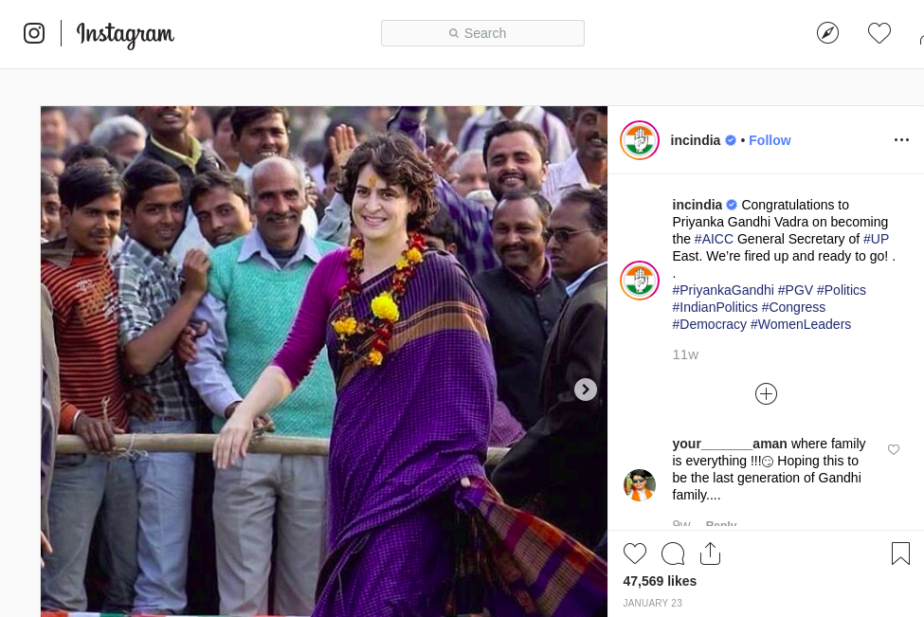

Most Commented Post:
Post ID: BtoT5MoFAL3
Post URL: https://www.instagram.com/p/BtoT5MoFAL3
Caption: The most talked about video on social media!
Post Comments: 3907
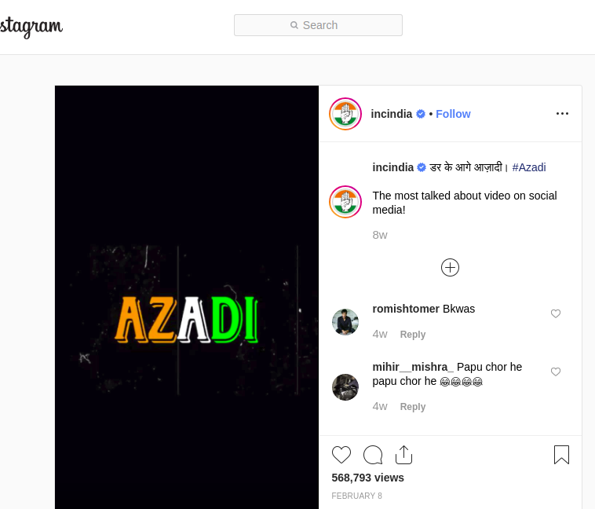
Post Likes: 19040

b) 5 most popular posts

To retrive most popular instagram posts we used the maximization solution , giving more weightage to “Likes” count compared to that of “Comments” count.
Popularity = 2(likes_count) + comments_count

1.
Post ID: Bs-IxK3FTIx
Post URL: https://www.instagram.com/p/Bs-IxK3FTIx
Caption:
Congratulations to Priyanka Gandhi Vadra on becoming the #AICC General Secretary of #UP East. We’re fired up and ready to go! . . #PriyankaGandhi #PGV #Politics #IndianPolitics #Congress #Democracy #WomenLeaders
Post Comments: 831
Post Likes: 47568

2.
Post ID: BrmutwOF63Y
Post URL: https://www.instagram.com/p/BrmutwOF63Y
Caption: The grace and charm of #SoniaGandhi captured through the lens of #RajivGandhi! . . #TBT #ThrowbackThursday
Post Comments: 777
Post Likes: 46398

3.
Post ID: Bvgd6WZlmsz
Post URL: https://www.instagram.com/p/Bvgd6WZlmsz
Caption: Congress President @rahulgandhi welcomes Smt. @urmilamatondkarofficial to the Congress Party. . . #Congratulations #IndianNationalCongress
Post Comments: 599
Post Likes: 41730

4.
Post ID: BrQDi4VFI2-
Post URL: https://www.instagram.com/p/BrQDi4VFI2-
Caption: जनता की पुकार है, अब हमारी सरकार है, प्रचंड जीत का यह शंखनाद है #CongressWinsBIG #Elections #Polls2018 #Victory #Congress #RahulGandhi #Rajasthan #MadhyaPradesh #Chhattisgarh
Post Comments: 1339
Post Likes: 40947

5.
Post ID: Bt6QHouleGN
Post URL: https://www.instagram.com/p/Bt6QHouleGN
Caption: Congress President @rahulgandhi pays his respects to the fallen soldiers in the terrorist attack in #Pulwama. #CRPFJawans
Post Comments: 489
Post Likes: 36889

c) Top 5 most used hashtags by the INC's official handle.
Hashtag | Frequency
Congress | 78
India | 41
NoMo | 30
RahulGandhi | 24
BJP | 23

2. Collect 1,000 most recent posts from the BJP's official Instagram handle.

a) Posts consist of videos?
Out of 1000 posts of BJP's official handle, 364 posts consisting of videos
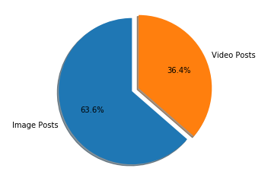

b) Word cloud of the top 200 most popular posts' descriptions..
Words occurs most frequently
PM, NarendraModi, Prime Minister, India, Temple, New Delhi, Election, Gujarat, National President, People, MAinBhiChowkidar

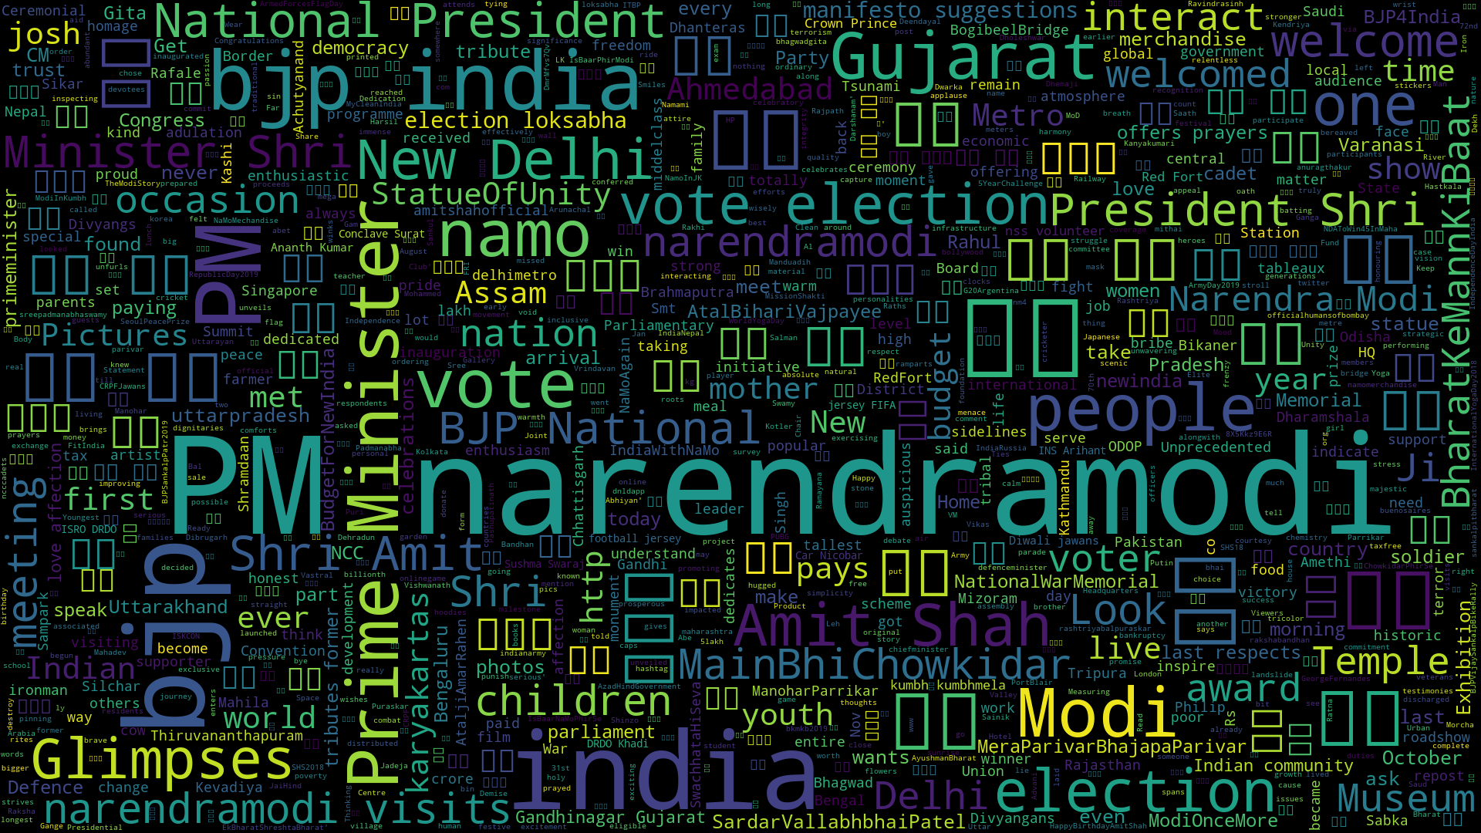

c) Top 5 most used hashtags by the BJP's official handle.

Hashtag | Frequency
BJP | 96
India | 68
Election | 39
Vote | 34
Bharatkemannkibaat | 16

