A

Minor Project Synopsis on
AI powered software design tool

Submitted to

RAJIV GANDHI PROUDYOGIKI VISHWAVIDYALAYA, BHOPAL (M.P)
In Partial fulfillment for the award of degree of

BACHELOR OF TECHNOLOGY

IN

Computer Science Engineering

By

Anaiza Hashmi, 0818CS231029

Ankit Prajapati, 0818CS231033

Anuj Patel, 0818CS231040

Minisha Solanki , 0818IT231048

Under the Guidance of

Pankaj Wadhwani

Trainer


INDORE INSTITUTE OF SCIENCE & TECHNOLOGY, INDORE

PITHAMPUR ROAD, OPPOSITE IIM, RAU, INDORE 453331, MP.

Approved by AICTE, New Delhi, affiliated to RGPV, Bhopal, Recognized by UGC under Section 2(f)

Jul-Dec-2025

DECLARATION

We hereby declare that the work, which is being presented in this dissertation entitled “AI powered software design tool” in partial fulfillment of the requirements for the award of the degree of Bachelor of Technology in Computer Science Engineering, is an authentic record of work carried out by us.
The matter embodied in this report has not been submitted by us for the award of any other degree.

Anaiza Hashmi  0818CS231029 | Ankit Prajapati  0818CS231033
Anuj Patel  0818CS231040 | Minisha Solanki 0818IT231048

Department of Computer Science Engineering
CERTIFICATE
This is to certify that the project entitled “……………………………………………………………………………………...………………………….” submitted to RGPV, Bhopal (M.P.) in the Department of………………………………………………………..by Mr./Ms………………………Enrollment number.……………………… Mr./Ms………………………Enrollment number.……………………… Mr./Ms………………………Enrollment number.……………………… Mr./Ms……………………..Enrollment number.………………………. in partial fulfillment of the requirement for the award of the degree of Bachelor of Technology in ………………………... during the academic year …………

PROJECT GUIDE HEAD OF THE DEPARTMENT

PRINCIPAL

ABSTRACT
Modern software development is often slowed by the "documentation gap" , the transition from ambiguous requirements to structured technical artifacts. This project introduces an AI-powered engineering assistant that automates the generation of verified software engineering (SE) artifacts from natural language input. Following standardized SE phases, the system generates Software Requirements Specifications (SRS), use cases, and acceptance criteria. It further automates architectural blueprints, including UML diagrams, Entity-Relationship Diagrams (ERDs) mapped to database schemas, and OpenAPI skeletons.
The core innovation lies in the integration of automatic traceability and a human-in-the-loop review workflow, ensuring that all scaffolds remain standard-compliant. Rather than replacing the engineer, this "Copilot for Modeling" eliminates repetitive manual documentation, reducing the transition from concept to technical baseline from days to minutes. The result is an accelerated development lifecycle that prioritizes design integrity and engineering focus.

i

ACKNOWLEDGEMENT
We take this opportunity to express our heartfelt gratitude to everyone who has supported us throughout the journey of completing our minor project.
First and foremost, we would like to thank the Head of the Department, Richa Gupta, for their encouragement, guidance, and providing us with all the necessary facilities to carry out this project.
We extend our sincere gratitude to our Project Coordinator, Megha Birthare, for their continuous support, timely advice, and valuable feedback. We are deeply indebted to our Project Guide, Pankaj Wadhwani, for their expert guidance, valuable suggestions, and support throughout this project.
Thank you all for making this project a meaningful and enriching experience.
Anaiza Hashmi  0818CS231029 | Ankit Prajapati  0818CS231033
Anuj Patel  0818CS231040 | Minisha Solanki 0818IT231048

ii

LIST OF TABLES

S.NO | NAME OF THE TABLE | PAGE. NO
 | Use Times New Roman with 12 font

NOTE 1: ( if no tables in your project work than remove this page )

iii

LIST OF FIGURES
S.NO | NAME OF THE FIGURE | PAGE. NO
 | Ex- Fig 1.- Flow chart of waterfall model
 | Use Times New Roman with 12 font

iv

LIST OF ABBREVATIONS
S.NO | ABBREVATION | DESCRIPTION | PAGE. NO
 |  | Use Times New Roman with 12 font

NOTE 1: ( IF NO ABBREVATIONS THAN REMOVE THIS PAGE )
NOTE 2: EX-
A List of Common Technology Abbreviations
ERP Software – Enterprise Resource Planning Software.
API–Application Program Interface.
CRM – Customer Relationship Management.

v

INDEX
CHAPTER PAGE
Abstract | i
Acknowledgement | ii
List of Tables | iii
List of Figures | iv
List of Abbreviations | v
Table of Contents | vi
1. Introduction | 1
1.1 Background | 2
1.2 Problem Statement | 3
1.3 Purpose/Objective
1.4 Solution Approach
1.5 Scope of the Project
1.6 Existing System & Limitations
2. Methodology
2.1 Proposed Methodology
2.2 Process Model Adopted
2.3 Planning and Scheduling
3. Requirements and Analysis
3.1 Problem Definition
3.2 Feasibility Study
3.2.1 Technical Feasibility
3.2.2 Economic Feasibility
3.2.3 Operational Feasibility
3.3 Functional Requirements
3.4 Non-Functional Requirements
3.5 Technical Requirements
3.5.1 Hardware Requirements
3.5.2 Software Requirements
3.5.3 Network Requirements
3.6 Software Design
4. Technology Stack
4.1 Front-End Technology
4.2 Back-End Technology
4.3 Database
4.4 APIs and Other Tools
5. Conclusion, Limitations and Future Work
5.1 Conclusion
5.2 Limitations/Constraints
5.3 Future Work
References

vi
CHAPTER 1
INTRODUCTION
1.1 Background
In modern software development, the pressure for rapid delivery often creates a "documentation gap," where rigorous design is sacrificed for speed. While formal modeling such as Software Requirements Specifications (SRS) and UML diagrams is essential for long-term stability, it is frequently bypassed because manual creation is slow and labor-intensive. This omission leads to architectural drift, where the final codebase eventually loses alignment with the original project goals, making maintenance difficult and costly.
The primary bottleneck in this lifecycle is the translation of ambiguous natural language requirements into structured technical scaffolds. Converting a stakeholder’s vision into precise assets like ERDs or OpenAPI skeletons requires significant cognitive effort and creates a time-intensive bridge between the "idea" and "execution" phases. Without automated traceability, it becomes nearly impossible to ensure that every technical component accurately reflects a specific business need, often resulting in unverified system architectures.
While current AI tools excel at generating code syntax, they often overlook the critical modeling and architectural layers. This project introduces an AI-powered engineering assistant that automates the generation of verified, standard-compliant SE artifacts directly from natural language. By providing a "Copilot for Modeling" that includes a human-in-the-loop review process, the system reduces the transition from concept to technical baseline from days to minutes. This ensures that design integrity remains a priority without slowing down the development lifecycle.
1.2 Problem Statement
In software development, preparing essential documentation and design artifacts such as SRS documents, UML and ER diagrams, database schemas, and feasibility study reports is a time-consuming and error-prone process that is mostly done manually using multiple
disconnected tools. This leads to inconsistencies between requirements and design, delays in early SDLC phases, and increased effort, especially for students, startups, and small teams. There is a lack of a unified system that can automatically convert natural language project descriptions into complete and structured software engineering artifacts. Hence, an intelligent platform is required to automate the generation of standardized documentation and diagrams from plain-text requirements, improving accuracy, consistency, and efficiency in the software design and documentation process.
1.3 Purpose/Objective
The goal of this project is to build a smart assistant that handles the heavy lifting of project planning so that developers can spend more time solving real problems and less time wrestling with paperwork. By bridging the gap between a simple project idea and a fully structured technical blueprint, we aim to make high-quality software design accessible to everyone from students to startup teams without the usual headache of manual documentation.
To achieve this, the project focuses on the following key objectives:
- Automate the "Blueprint" Phase: Build a system that instantly turns plain-text descriptions into professional documents, including requirements (SRS), visual maps (UML), and database designs (ERDs).
- Keep the Human in Control: Create a "Human-in-the-Loop" workflow where the AI does the initial drafting, but the engineer provides the final check, ensuring the designs are accurate and reliable.
- Ensure Everything Connects: Develop a traceability feature that links every technical detail back to the original idea, making sure no part of the project gets lost or misinterpreted as the build progresses.
- Simplify the Toolset: Provide a single, unified platform that replaces the need to jump between multiple, disconnected design tools, saving time and reducing confusion.
- Maintain Industry Standards: Ensure that every generated file whether it's an API skeleton or a database schema follows professional engineering standards right out of the box.

1.4 Solution Approach
Our solution approach centers on a unified, three-stage workflow that transforms conversational project ideas into rigorous technical blueprints. First, the system uses a specialized language model to act as an automated analyst, extracting core requirements and logic from the user’s natural language input. This data is then funneled into a generation engine that simultaneously produces a suite of standardized artifacts—including SRS documents, UML diagrams, and API skeletons—ensuring that every design piece stays perfectly in sync. Finally, the platform incorporates a "human-in-the-loop" review layer, where the engineer can verify and refine the AI’s work. This ensures that the final output isn't just a generic guess, but a traceable, professional-grade foundation that allows the developer to move from a blank page to a verified technical baseline in minutes.
1.5 Scope of the Project
The scope of this project is to create a focused, web-based workspace that bridges the gap between initial project ideas and the first line of code. It specifically targets the "analysis and design" phase of the software lifecycle, automating the creation of essential blueprints like SRS documents, UML diagrams (Class, Use Case, and Sequence), and Database Schemas. While the system handles the heavy lifting of formatting and structuring, it remains a "Human-in-the-Loop" tool—meaning it provides the scaffolds for an engineer to review and refine rather than attempting to build the final software autonomously. The project is designed to support individual developers, students, and small teams by providing a unified environment that replaces the need for multiple, disconnected design tools.

Key Features of the Platform
To make the transition from concept to technical baseline seamless, the platform includes the following features:
- Natural Language to Artifacts: Simply describe your project in plain English. The AI acts as a virtual business analyst, extracting features and logic to automatically draft your documentation and diagrams.
- Automated Modeling Suite: Instantly generate industry-standard diagrams, including UML Class and Sequence diagrams and Entity-Relationship Diagrams (ERDs), without needing to learn complex modeling syntax.
- One-Click Documentation: Generate a full Software Requirements Specification (SRS) that includes functional requirements, user roles, and system constraints, all formatted to professional standards.
- Database & API Scaffolding: Beyond just pictures, the tool produces "developer-ready" outputs like SQL database schemas and OpenAPI (Swagger) skeletons to jumpstart your implementation.
- The "Human Checkpoint": An interactive editor allows you to review, edit, and approve every AI-generated artifact. This ensures the final output is 100% accurate and reflects your specific vision.
- Automatic Traceability: The platform keeps everything connected. You can click on a database table or an API endpoint and see exactly which project requirement it was built to solve.
- Export & Integration: Download your designs in various formats (PDF, PNG, JSON, or SQL) to share with your team or import directly into your development environment.

1.6 Existing System & Limitations
In the existing software development environment, requirement analysis, documentation, and system design are mostly performed using manual or semi-automated tools. Software Requirement Specification (SRS) documents and feasibility reports are typically created using word processors such as Microsoft Word or Google Docs, while design artifacts like UML and ER diagrams are developed using separate tools such as Draw.io, Lucidchart, StarUML, and MySQL Workbench.

Although these tools are useful, they operate independently and require significant manual effort. Users must interpret project requirements themselves and convert them into technical documents and diagrams, which increases the chances of inconsistency and human error. Any change in requirements requires repeated manual updates across multiple tools, making the process inefficient and time-consuming.

Recent AI-based tools such as ChatGPT and GitHub Copilot mainly focus on code generation and programming assistance. These tools do not provide structured support for software engineering documentation, system modeling, or requirement traceability. As a result, the critical design and analysis phase of the Software Development Life Cycle (SDLC) remains largely manual.

Limitations of Existing Systems

● Heavy reliance on manual documentation and diagram creation.
● No automatic conversion of natural language requirements into structured artifacts.
● Lack of consistency between requirements, design, and database models.
● Absence of traceability between requirements and design components.
● Steep learning curve for modeling tools, especially for beginners.
● Limited affordability and suitability for students and small teams.
● AI tools focus on code rather than complete software design workflows

Due to these limitations, there is a need for an integrated AI-powered system that can automatically generate standardized software design documents and diagrams from natural language input, improving efficiency, accuracy, and consistency in the early stages of software development.

CHAPTER 2

METHODOLOGY

2.1 Proposed Methodology
The proposed methodology focuses on converting natural language project descriptions into complete and structured software design artifacts using AI-driven automation. The system follows these key steps:
- Accepts project requirements or ideas in plain natural language.
- Uses NLP and Large Language Models (LLMs) to analyze and understand the input.
- Extracts functional and non-functional requirements.
- Automatically generates:
  - SRS documents
  - UML diagrams (Use Case, Class, Sequence, Activity)
  - ER diagrams
  - Database schemas and SQL scripts
  - Feasibility study reports (Technical, Operational, Economic)
- Suggests an appropriate SDLC model such as Waterfall, Agile, or Spiral.
- Allows users to review, edit, collaborate, and export generated artifacts.
This methodology ensures consistency, reduces errors, and significantly saves time in the software design phase.

2.2 Process Model Adopted
The project adopts an Agile-based iterative process model, as it allows flexibility, continuous improvement, and user feedback at each stage. The process includes:
- Requirement Input – User provides project details in natural language.
- Analysis Phase – AI analyzes and structures the input requirements.
- Design Generation – Automated creation of documents and diagrams.
- User Review & Feedback – Users review, modify, and validate outputs.
- Iteration – Improvements are made based on feedback.
- Final Export & Deployment – Artifacts are exported and finalized.
This model supports incremental enhancements, making the system adaptable to evolving requirements.

2.3 Planning and Scheduling
Project planning and scheduling were carried out in a structured manner to ensure timely completion. The development was divided into phases:
- Phase 1: Requirement Analysis & Literature Survey
Understanding the problem, studying existing tools, and finalizing objectives.
- Phase 2: System Design
Designing system architecture, workflow, UI wireframes, and data flow.
- Phase 3: Technology Selection
Finalizing frontend, backend, database, AI models, and cloud platform.
- Phase 4: Implementation
Developing frontend UI, backend logic, AI integration, and diagram generation.
- Phase 5: Testing & Validation
Functional testing, performance testing, and usability evaluation.
- Phase 6: Documentation & Deployment
Preparing project report, user manual, and final presentation.
A milestone-based schedule was followed to track progress, manage risks, and ensure quality deliverables within the academic timeline.

CHAPTER 3

REQUIREMENTS AND ANALYSIS

3.1 Problem Definition
In traditional software development, creating documentation and design artifacts such as SRS documents, UML diagrams, ER diagrams, and database schemas is a manual and time-consuming process. Developers and students rely on multiple disconnected tools like Word, Draw.io, Lucidchart, and MySQL Workbench. This results in inconsistencies, increased errors, repetitive effort, and delayed project initiation. There is a lack of an integrated, intelligent system that can automatically convert natural language requirements into structured software design documents and diagrams. Hence, a need exists for an AI-powered solution that automates and streamlines the software design process.

3.2 Feasibility Study
The feasibility study evaluates whether the proposed system is practical, cost-effective, and operationally viable.

3.2.1 Technical Feasibility
The system is technically feasible as it uses proven and widely available technologies. Large Language Models (LLMs) are capable of understanding natural language and generating structured outputs. Diagram generation tools such as PlantUML, Mermaid.js, and Graphviz support automated diagram creation. Cloud platforms like AWS, GCP, or Azure provide scalability and reliability. The required technical resources and expertise are readily available.

3.2.2 Economic Feasibility
The project is economically feasible as it follows a SaaS model with low development and maintenance costs. Open-source tools and cloud-based infrastructure reduce initial investment. The freemium and premium pricing model makes the system affordable for students while generating revenue from startups and organizations. Automation significantly reduces documentation effort, saving time and labor costs.

3.2.3 Operational Feasibility
The system is easy to operate and does not require specialized technical skills. Users only need to provide project details in natural language. The intuitive web interface with drag-and-drop features ensures quick adoption. Minimal training is required, making the system suitable for students, developers, and non-technical users.

3.3 Functional Requirements
The system shall:
- Accept project ideas or requirements in natural language.
- Generate Software Requirement Specification (SRS) documents.
- Create UML diagrams (Use Case, Class, Sequence, Activity).
- Generate ER diagrams and database schemas.
- Produce feasibility study reports.
- Suggest suitable SDLC models.
- Support real-time collaboration among team members.
- Maintain version control of documents.
- Allow export of outputs in DOCX, PDF, PNG, and SQL formats.
- Provide user authentication and role-based access.

3.4 Non-Functional Requirements
The system shall:
- Ensure high reliability with minimum downtime.
- Provide fast response time (5–10 seconds for medium complexity inputs).
- Maintain data security through encryption and access control.
- Support scalability for multiple concurrent users.
- Offer a user-friendly and responsive interface.
- Ensure data consistency and accuracy.
- Be extensible for future integrations with IDEs and project management tools.

3.5 Technical Requirements

3.5.1 Hardware Requirements

- Processor: Intel i5 or higher
- RAM: Minimum 8 GB
- Storage: 256 GB SSD or higher
- Internet-enabled device (Laptop/Desktop)

3.5.2 Software Requirements

- Operating System: Windows / Linux / macOS
- Frontend: HTML, CSS, JavaScript, React
- Backend: Node.js / Python (Flask or Django)
- Database: MySQL / PostgreSQL / MongoDB
- AI Models: GPT, Gemini, Claude (via API)
- Diagram Tools: PlantUML, Mermaid.js, Graphviz
- Browser: Chrome, Firefox, or Edge
3.5.3 Network Requirements
- Stable internet connection
- Minimum bandwidth: 5 Mbps
- Secure HTTPS protocol for data transmission
- Cloud connectivity for AI processing and storage

3.6 Software Design

The software design follows a modular architecture consisting of frontend, backend, AI processing layer, and database. The frontend handles user input and visualization. The backend manages business logic, authentication, and API communication. The AI layer processes natural language input and generates structured outputs. The database stores user data, project details, and version history. This layered design ensures scalability, maintainability, and security.

3.6.1 Flowchart
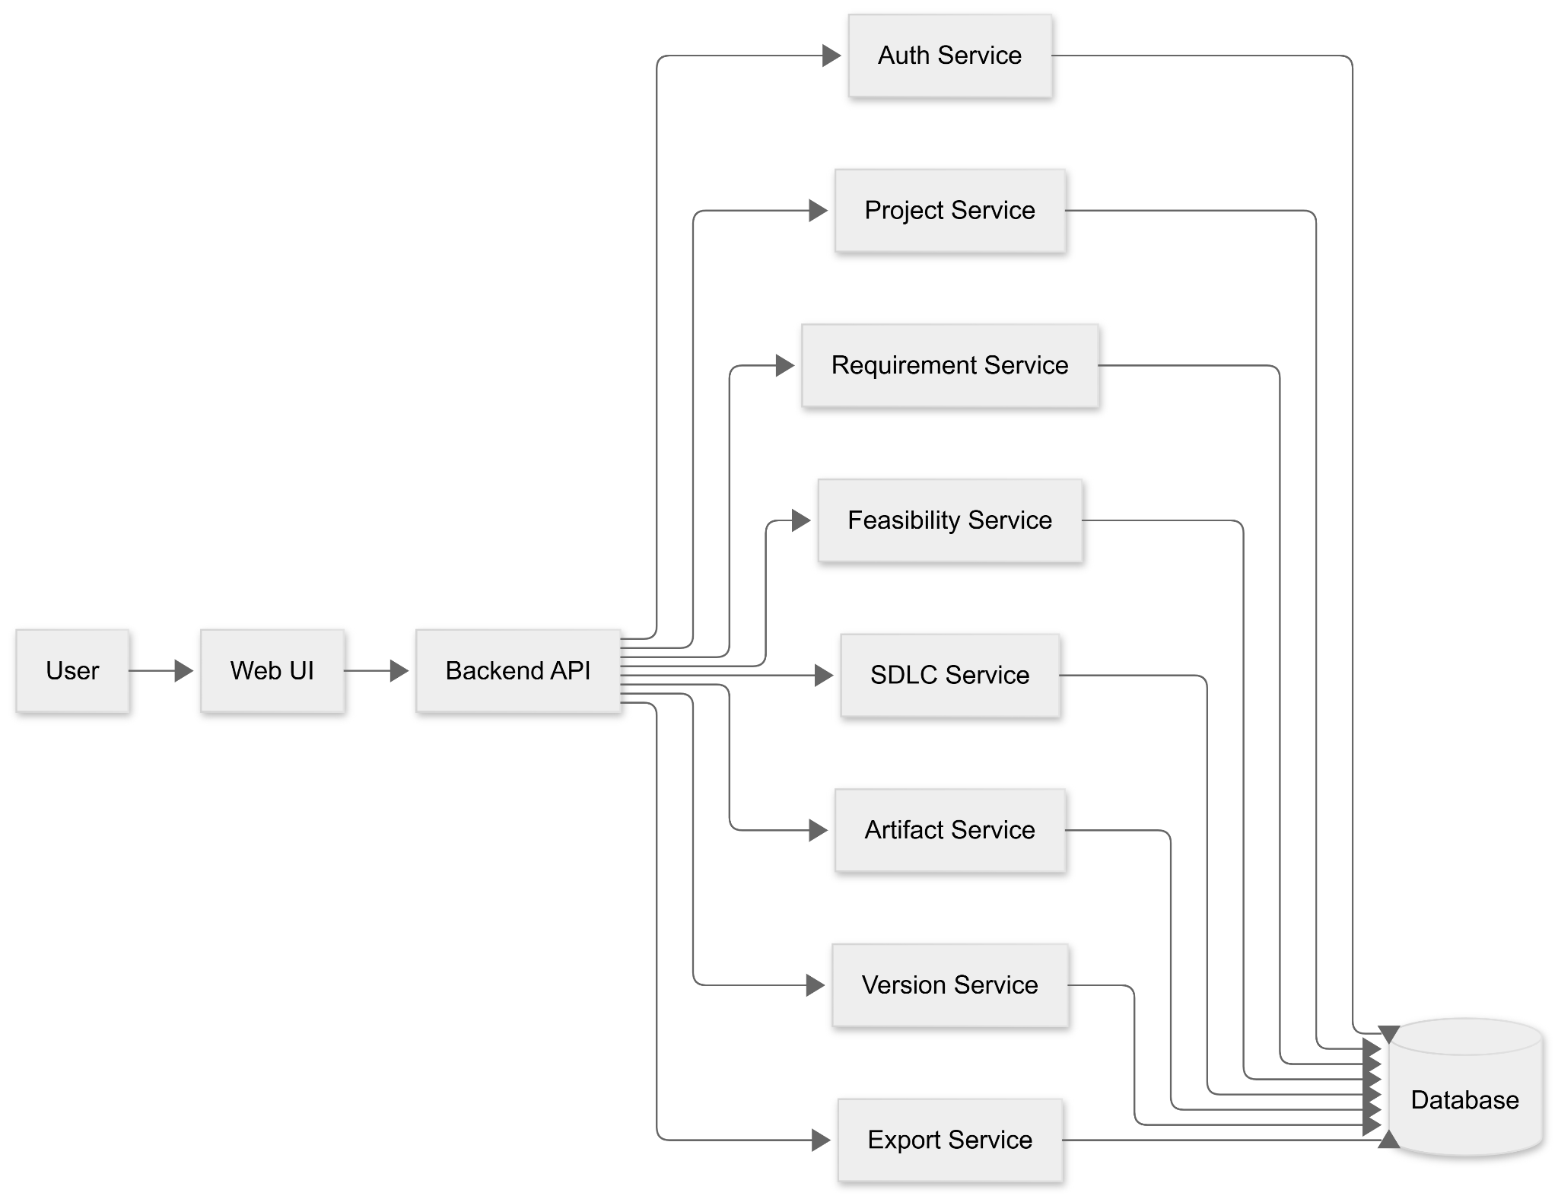
1.1 Flowchart Diagram

3.6.2 ER diagram
This document explains the Entity Relationship (ER) diagram of a Project Management and Software Documentation System.
The system is designed to manage users, projects, requirements, feasibility analysis, SDLC models, and project artifacts such as documents and diagrams in a structured manner.

1. User
The User entity represents individuals who interact with the system, such as administrators, developers, and analysts.
Key Points:
- A user can create and own projects
- A user can be a member of multiple projects
- Each user has login credentials, role, and account creation details

2. Project
The Project entity is the core of the system and represents a software project under development.
Key Points:
- Each project is owned by a user
- A project can have multiple members
- Projects include requirements, feasibility reports, and artifacts
- Each project follows a selected SDLC model
- Project status can be active or archived

3. Project Member
The Project Member entity manages the relationship between users and projects.
Key Points:
- Allows multiple users to work on the same project
- Stores access level or role of the user in the project
- Records the date when a user joins the project

4. Requirement
The Requirement entity defines what the project is expected to achieve.
Key Points:
- Each requirement belongs to one project
- Requirements have priorities such as high, medium, or low
- Requirements are used for feasibility analysis and documentation

5. Feasibility Report
The Feasibility Report evaluates whether a project is practically viable.

Key Points:
- Includes technical, economic, and operational feasibility scores
- Stores the final decision regarding project feasibility
- Each feasibility report is linked to a project

6. SDLC Model
The SDLC Model entity defines the software development methodology used in a project.

Key Points:
- Examples include Waterfall and Agile
- Describes the approach followed during development

7. Project SDLC
The Project SDLC entity connects a project with its chosen SDLC model.
Key Points:
- Shows which SDLC model is applied to a project
- Stores a confidence score indicating the suitability of the selected model

8. Artifact
The Artifact entity represents outputs generated during the project lifecycle.
Key Points:
- Artifacts can be documents or diagrams
- Artifacts are created by users
- Each artifact is associated with a project

9. Document and Diagram
Document and Diagram are specialized forms of artifacts.
Key Points:
- Documents include files such as PDF and DOCX
- Diagrams include ER, UML, and flow diagrams
- Specialization avoids duplication and improves system structure

10. Version
The Version entity tracks changes made to artifacts.
Key Points:
- Maintains version history of artifacts
- Stores change summaries
- Helps in tracking updates and rollback

11. Export
The Export entity manages how artifacts are shared externally.

Key Points:
- Supports formats such as PDF, DOCX, PNG, and SQL
- Stores export format and export timestamp

Conclusion
This ER diagram design closely follows real-world software project workflows.
It ensures proper role management, structured documentation, version control, and systematic development using suitable SDLC models.
The design is scalable, organized, and easy to extend for future requirements.

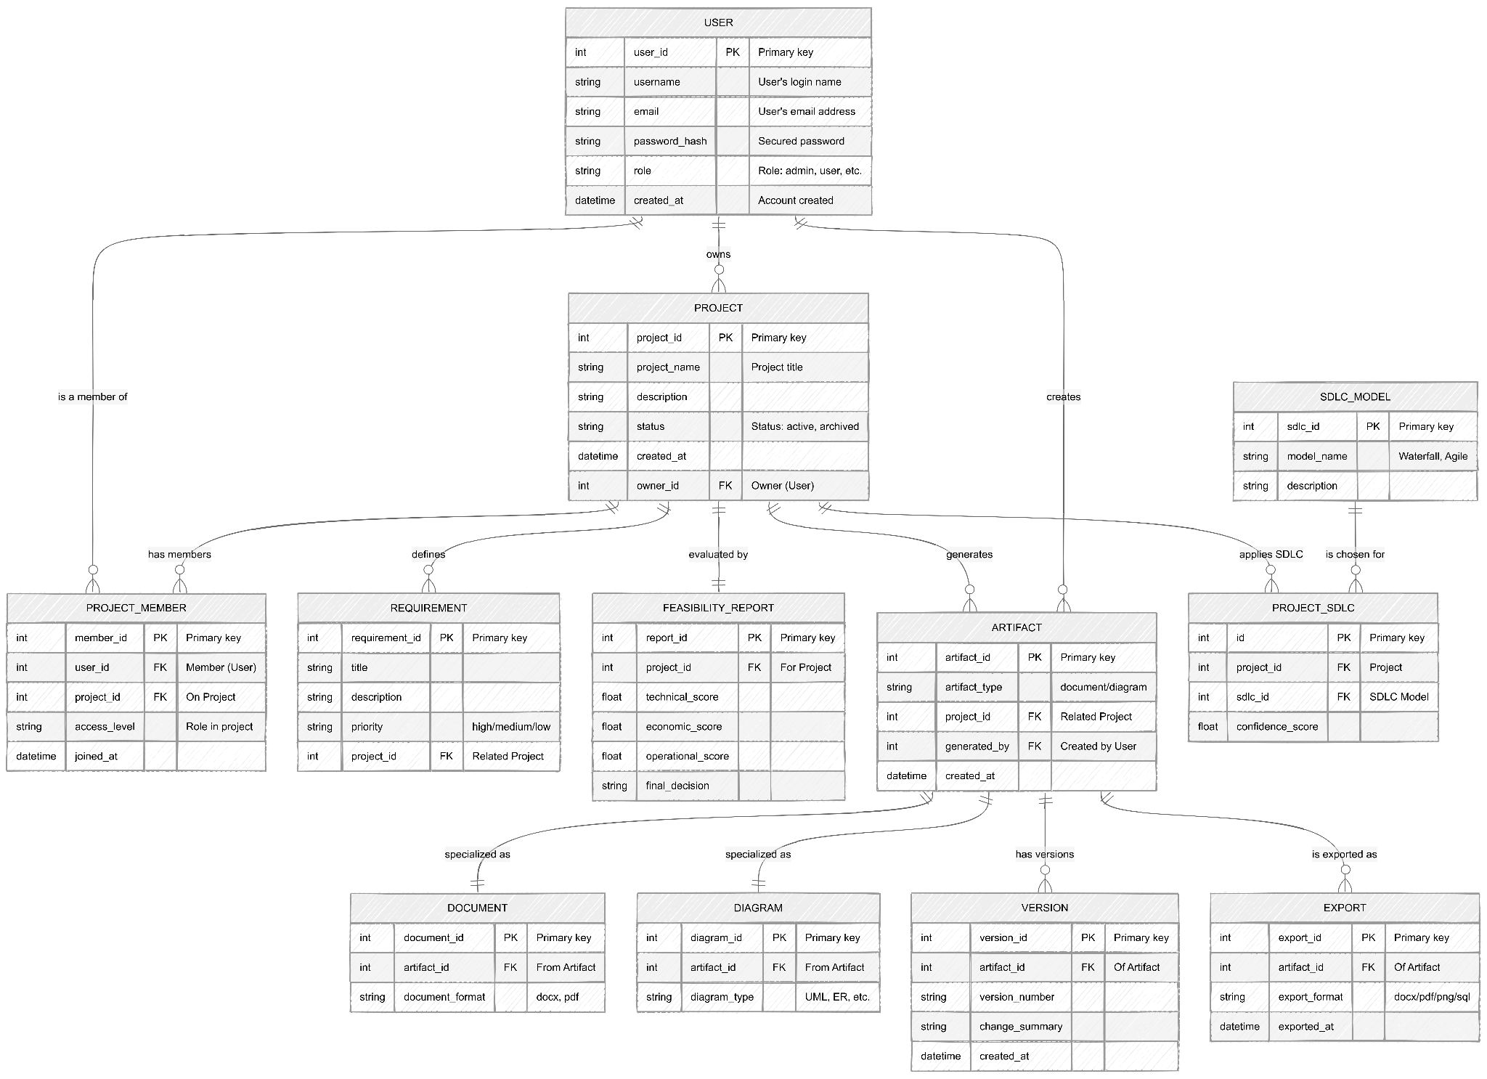

1.2 ER Diagram

CHAPTER 4

Technology Stack

4.1 Front-End Technology

- HTML5, CSS3, JavaScript – Structure and styling
- React.js – Component-based UI development
- Tailwind CSS / Bootstrap – Responsive design
- Drag-and-drop UI libraries – Diagram editing and interaction

4.2 Back-End Technology
- Node.js / Python (FastAPI / Flask) – Server-side logic
- RESTful APIs – Communication between frontend and backend
- Authentication Services – User login and role management
- Cloud Hosting – AWS / GCP / Azure

4.3 Database
- PostgreSQL – Structured data storage
- MongoDB – Document-based storage for generated artifacts
- Redis (optional) – Caching and session management

4.4 APIs and Other Tools
- AI APIs: OpenAI GPT-4, Gemini, Claude
- Diagram Tools: PlantUML, Mermaid.js, Graphviz
- Export Tools: DOCX, PDF, PNG generators
- Version Control: Git, GitHub
- Collaboration Tools: WebSockets / Real-time sync APIs

Chapter 5

5.1 Conclusion
The AI Powered Software Design Tool successfully automates the generation of software design documents and diagrams from natural language input. The system reduces manual effort, improves accuracy, and accelerates the early stages of software development. It provides an efficient and user-friendly solution for students, startups, and organizations.

5.2 Limitations / Constraints
- Quality of output depends on clarity of user input
- Limited customization for complex enterprise projects
- Requires continuous internet connectivity
- Advanced AI models may increase operational cost

5.3 Future Work
- Integration with IDEs like VS Code and IntelliJ
- Support for more diagram types and programming languages
- Advanced AI-based requirement validation
- Integration with project management tools like Jira and Trello
- Offline mode support and enhanced customization

Chapter 6

References
- IEEE Software Engineering Standards
- UML Documentation – Object Management Group
- OpenAI, Gemini, and Claude AI Documentation
- PlantUML and Mermaid.js Official Documentation

