**Database name- football_tournaments**

**OUTPUT:-**

**Table of players**

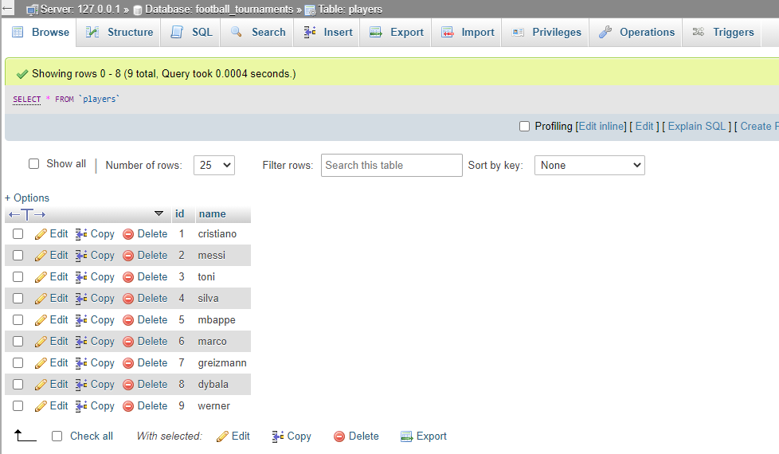

**Table of countries**

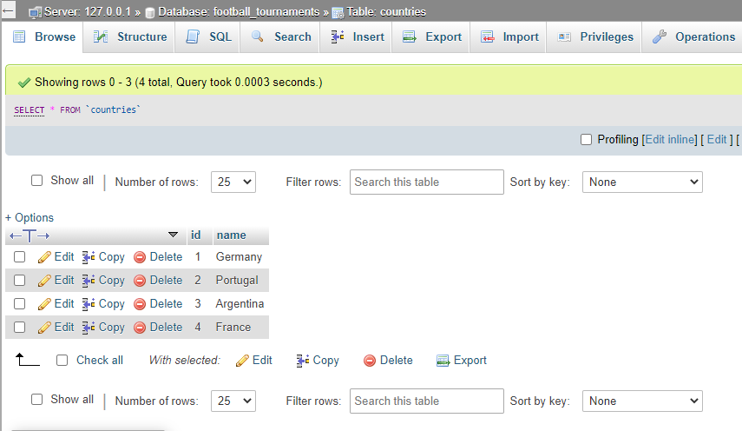

**Table of goals**

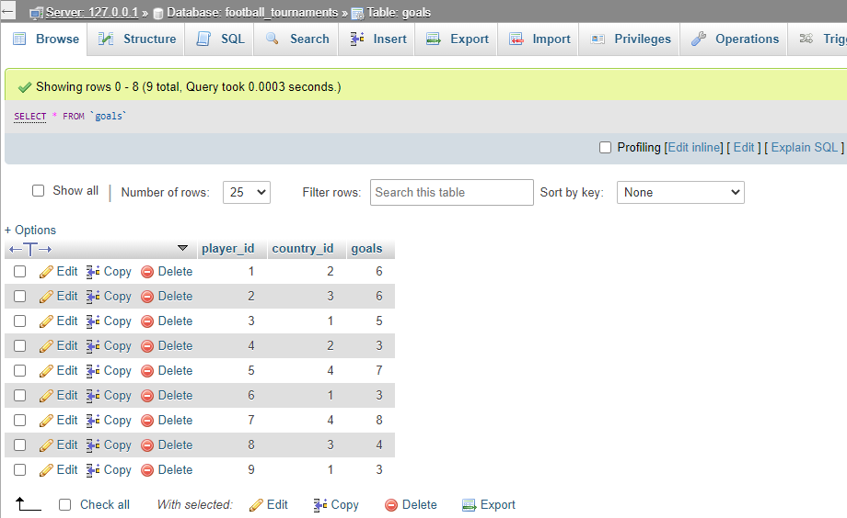

**Final OutPut:-**

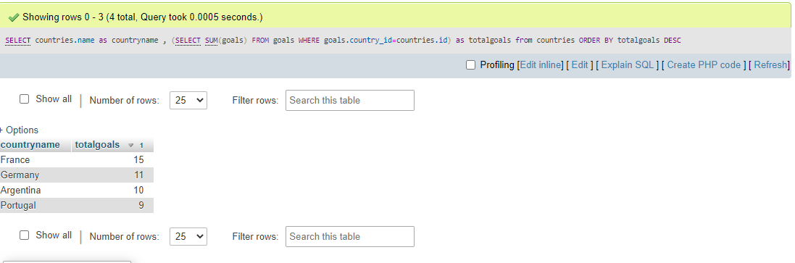

**Query:**

SELECT countries.name as countryname , (SELECT SUM(goals) FROM goals WHERE goals.country_id=countries.id) as totalgoals from countries ORDER BY totalgoals DESC