ITE5315 Assignment 2

**Submission Deadline:** Friday Nov 3, 2023, @ 11:59pm

**Assessment Weight:** 5% of your final course Grade

**Objective**: To explore more on Express Form and Template Engines

**Description:** Using the concepts of week3~6 , we are going to develop a new Node/Express app program using template engines. We are going to design a simple app and using handlebars and then will try to utilize Assignment2 in this new app by redesigning it using handlebars template, expression, and helpers.

***Note: You need to use the new dataset (modified version of ASN1)!***

**Complete the following steps and take screenshot of the outcome of each step: Step1:** Create new Node/Express app as follow:

* Create new folder named “Asn2-yourname”.
* Change directory to “Asn2-yourname”:
* Open terminal and run npm init
* In the terminal run: npm install express --save
* In the terminal run: npm install express-handlebars --save
* Make sure to have the following project structure:

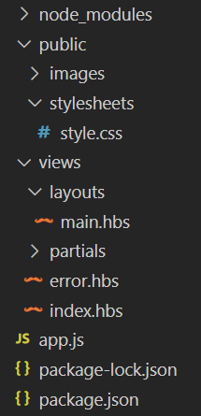

Create a “public” which contains all

images and stylesheets

Create “views” folder which includes all Handlebars templates. Make sure to add two folders “ partials” and “layouts” inside “views”. Also add “index.hbs” and error.hbs” files.

In the “views/layouts”, create a new file: “main.hbs”

Create “app.js” in the project root.

Make sure to have proper project settings

and dependencies in “package.json”

*Note: It's important to distinguish that we've separated our* ***views*** *folder into three classifications for* ***layouts****,* ***partials****, and* ***pages****, where* ***pages*** *occupy the* ***root /views*** *directory. It's important to keep this distinction as our structure affects how we serve up these templates.*

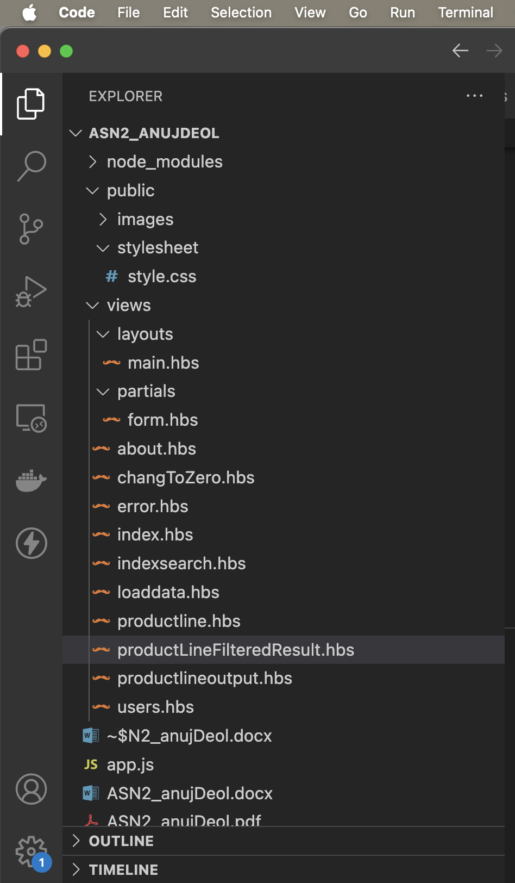

**Step2:** Using the attach file (codenippet.txt), copy/paste the related code to “style.css”, “main.hbs”, “index.hbs”, “error.hbs” and “app.js”.

**Step 3**: Run the application and test it using the following routes:

* http://localhost:3000/
* http://localhost:3000/users
* http://localhost:3000/notExist

**Step 4**: Base on your observation, answer the following questions:

1. What is the role of “main.hbs”? How does it being used/called in the app?

main.hbs typically represents the main layout or template for rendering HTML pages. It serves as a common structure for various web pages in your application, defining the shared structure, header, footer, and potentially other elements that should appear consistently across multiple pages.

defaultLayout: 'main', // Specifiend that 'main' as the default layout, therefore if any .hbs file renders the main.hbs layout will be applied as an common layout

1. What is the role of “index.hbs” and “error.hbs”? How do these files being used/called in the app?

Error.hbs: This handlebar used to show the error on the webpage if we try to apply a wrong route the specific message will showup.

index.hbs: In this assignment, I have used this index.hbs file for root route to show the buttons of every route present in this app.js file

1. In “app.js”, what is the role of the following line? What happen if you commend it out?

app.use(express.static(path.join( dirname, 'public')));

The app.use(express.static(path.join(__dirname, 'public'))) middleware in app.js application serves a specific purpose: It is used to serve static files, such as images, stylesheets, JavaScript files, and other assets, to client browsers. These static files are typically located in a directory called "public," and this middleware enables your application to make them available to users when they access your website.

1. Try to add proper comments to each line/block in app.js

**Step 5**: Modify the layout of the page and add “header”, “content” and “footer” as follow.

* Add your name/std_id to the header
* Add your email address to the footer
* The other dynamic contents/messages should be displayed in the “content” area.
* Use your creativity to add proper css style/format. Add

*(hint: you need to redesign main.hbs and style.css*)

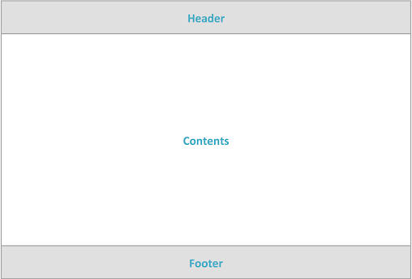

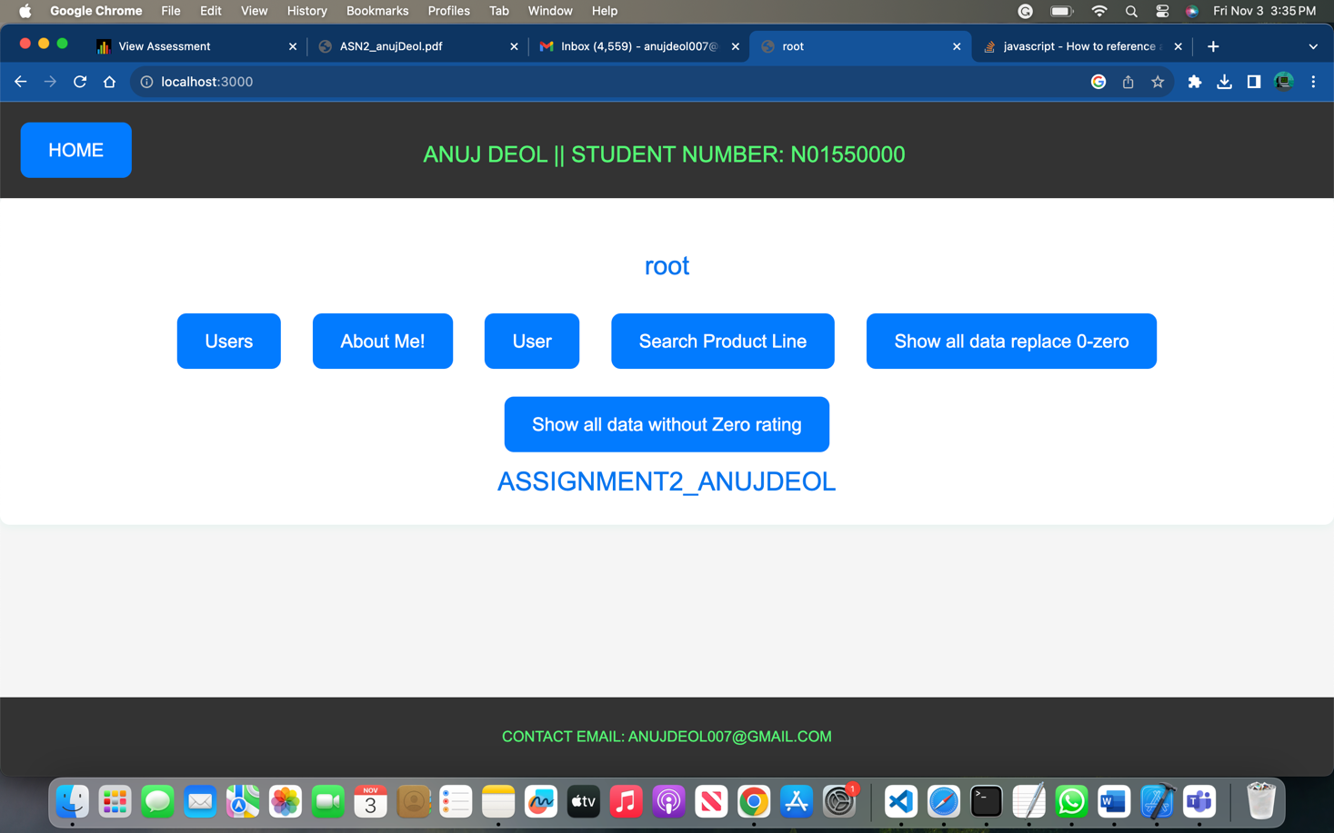

**Step 6**: Add the Assignment1 code into this template. So the assignment1 form and output should be displayed in the content area of the layout.

* For each of the route in assignment 1 (like /allData, /alldata/invoiceID/{index}, /search/ produceLine/, /search/invoiceID/), you need to create a related “page” in “/views” folder. So, when the “app.get” of the related route is called, you gonna use the proper “res.render(‘page’, {data})”. (*hint: use similar ideas like index.hbs*) Moreover, you also should redesign the way that you generate output in Assingment2 by displaying the output using Handlebars *expression/helpers*.

INDEX SEARCH:

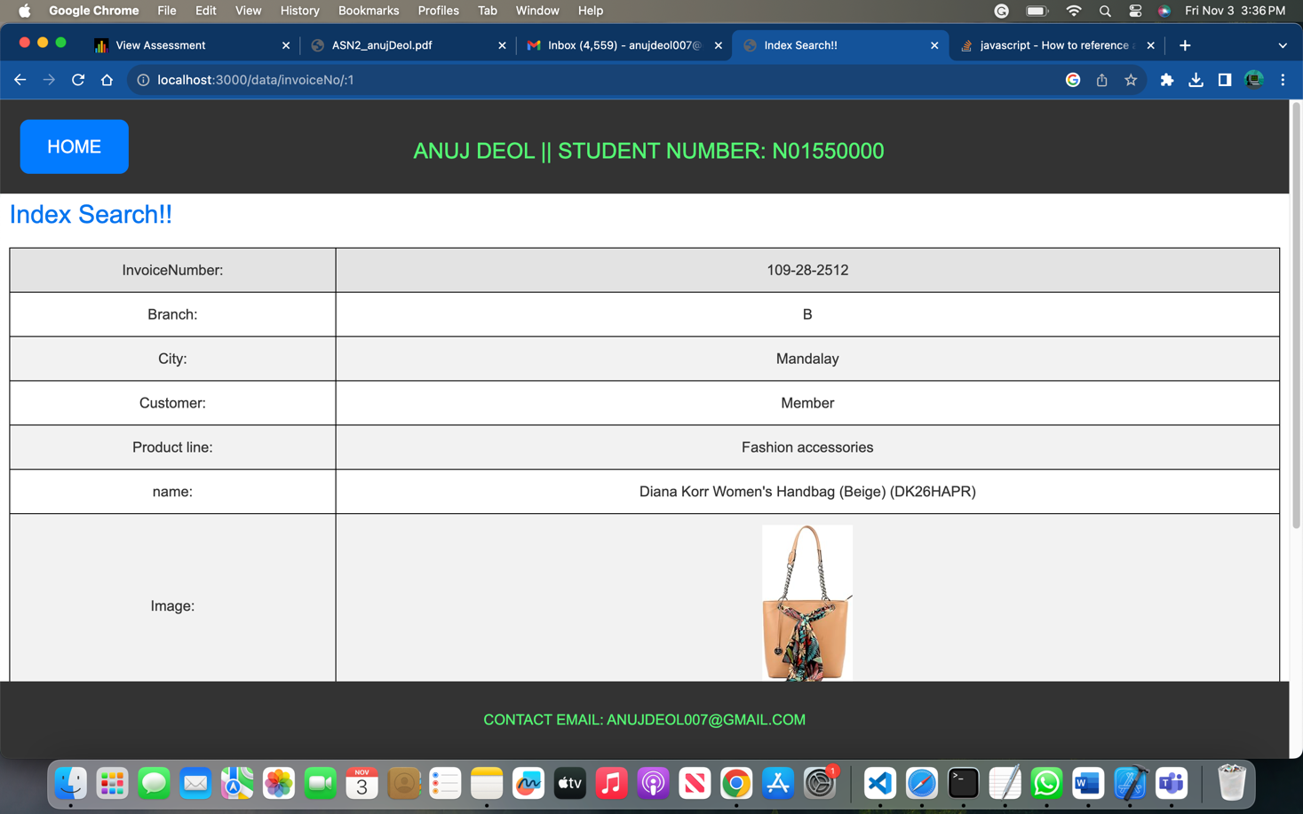

Productline search :

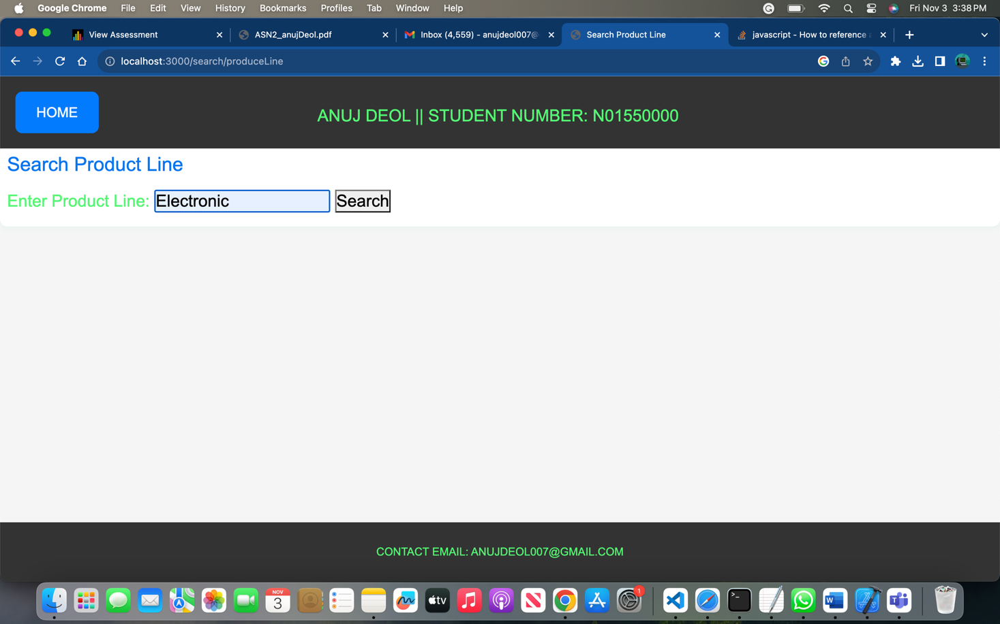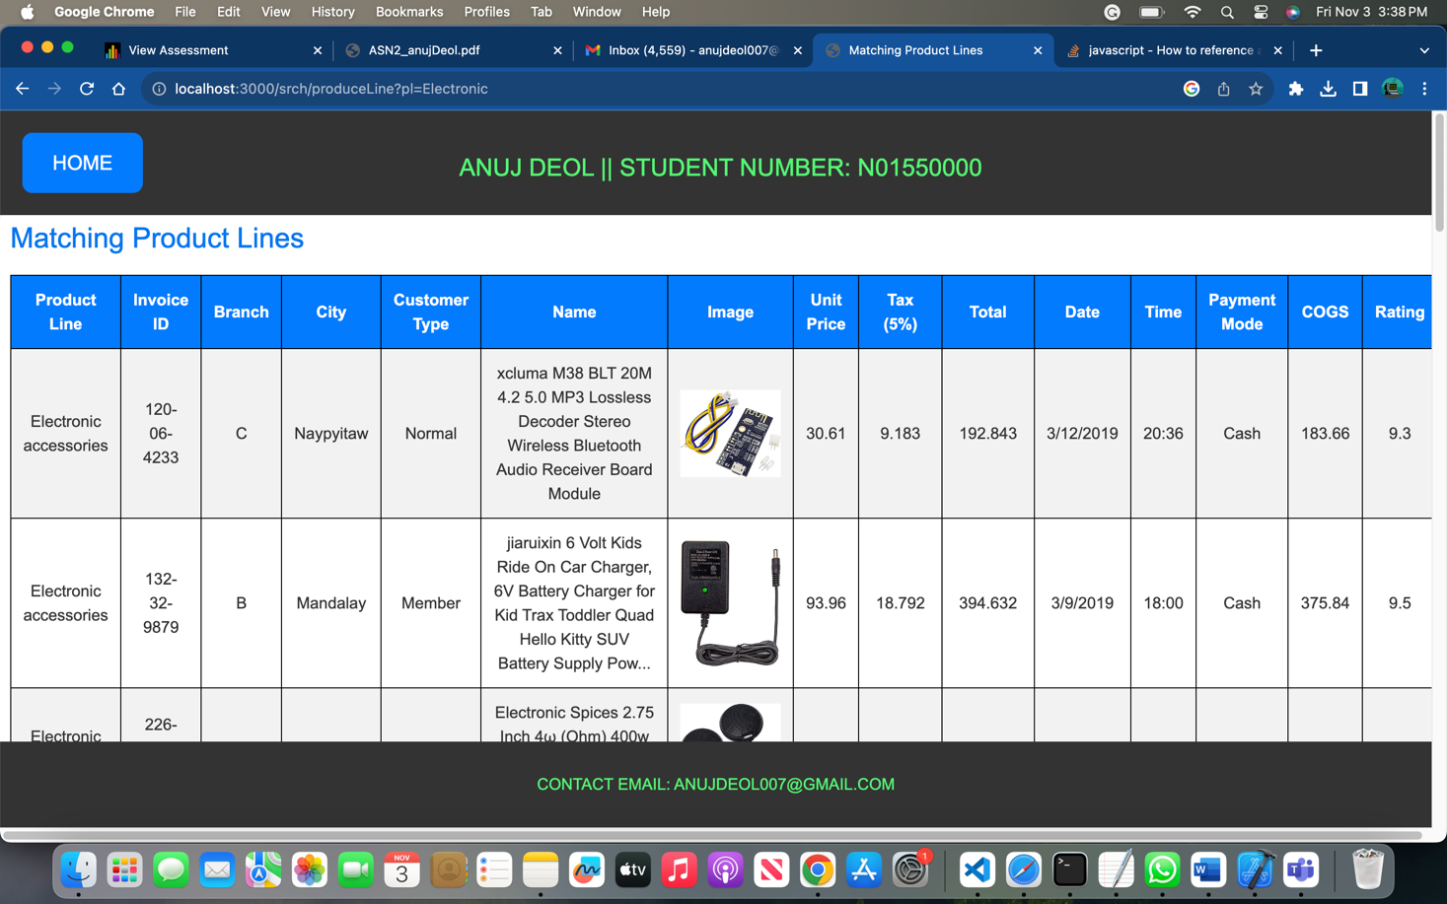

**Step 7**: Design a new route “/viewData” to display all Sales info in html table output using handlebars helpers/expression.

**Step 8**: Modify Step 7 (change the endpoint/view name) by removing those invoices which their

“rating” is zero (*hint: use “#if” helper* ☺)

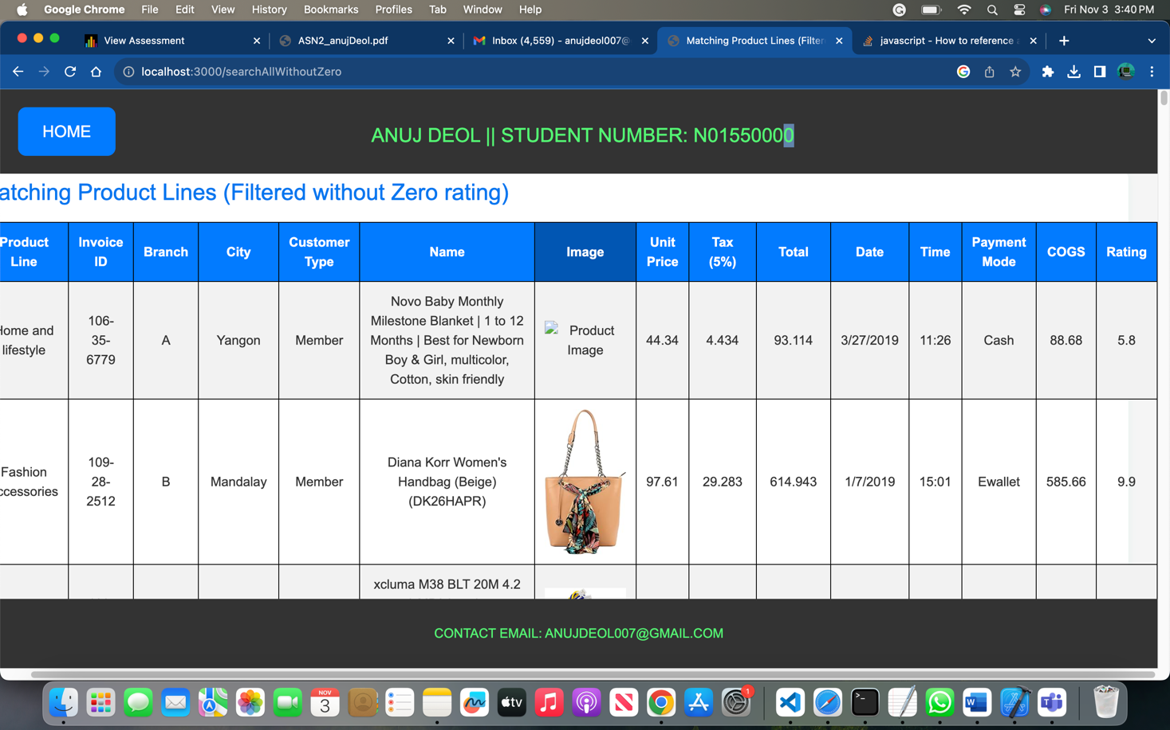

**Step 9**: Design a custom helper for changing the records with “rating” “0” to “zero”. Apply this

on Step7&8 in order to display all records but highlight those rows that their “rating” is “0”!

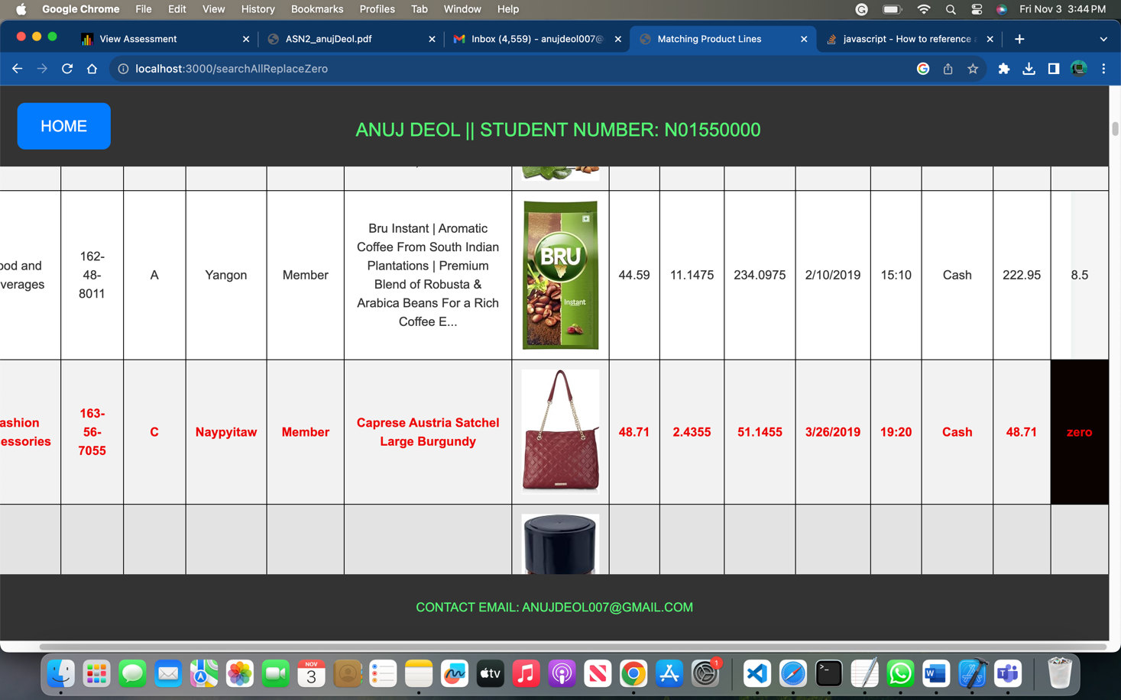

**Step 10**: Any idea how to do any of the followings:

* 1. You want to change table row color for those records which “rating” is “0”. Any way that

you can implement it using Template Engine?

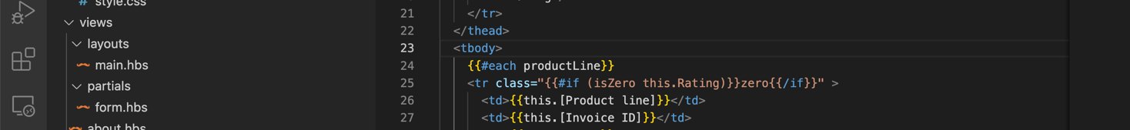

I have used the helper function to isZero to highlight the entire row which has rating “zero” at line number 25.

* 1. In this app, do you find any use cause for utilizing “Partial” Templates? Explain your answer

I've used partial template for Productline search form:

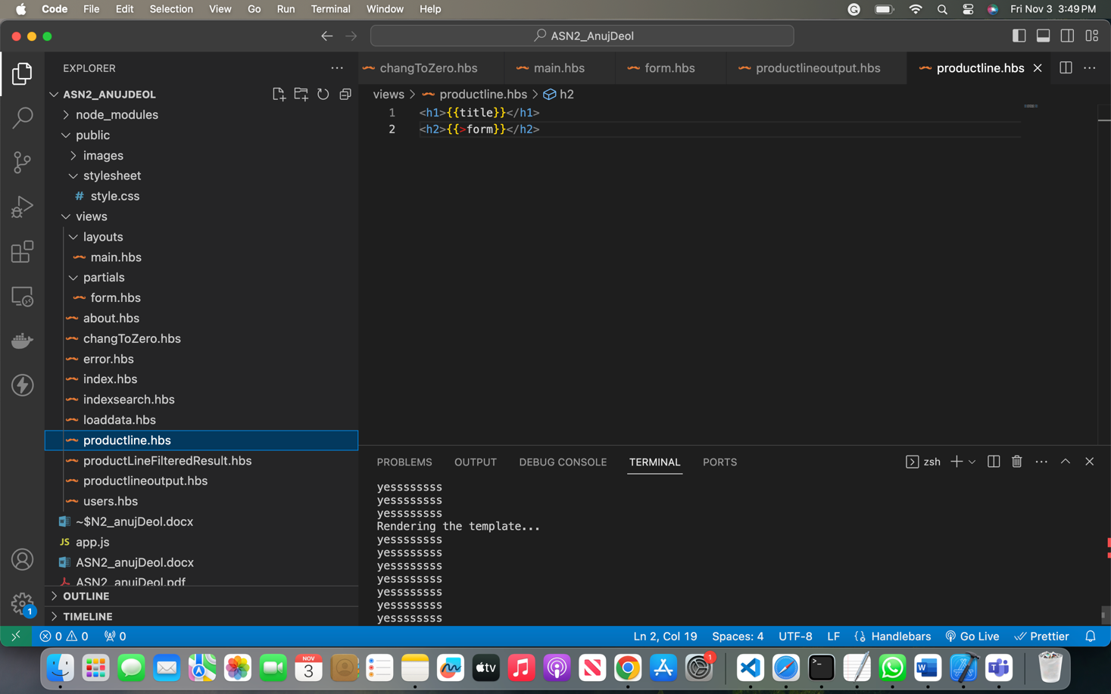

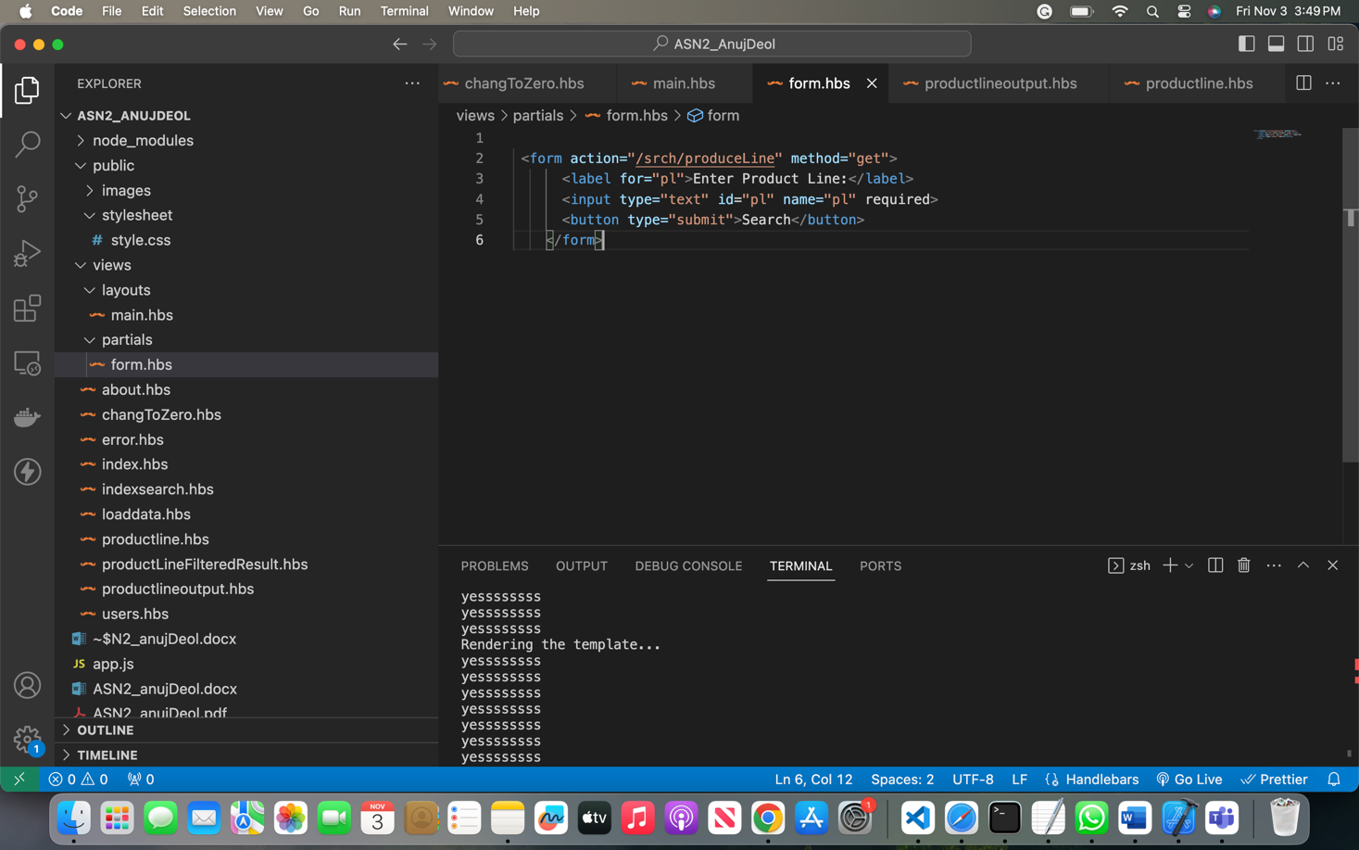

* Bonus: implement your idea of A and B!

**Step 11**: Deploy the app to Vercel.

# Assignment Submission:

* Add the following declaration at the top of .js files

/******************************************************************************

***

* + ITE5315 – Assignment 2
  + I declare that this assignment is my own work in accordance with Humber Academic Policy.
  + No part of this assignment has been copied manually or electronically from any other source
  + (including web sites) or distributed to other students.
  + ​
  + Name: Student ID: Date:
  + ​
  + ​

******************************************************************************

**/

* Compress (.zip) the files in your Visual Studio working directory (this is the folder that you opened in Visual Studio to create your client side code).

# Important Note:

* Submitted assignments must run locally, ie: start up errors causing the assignment/app to fail on startup will result in a **grade** **of** **zero** **(0)** for the assignment.
* **LATE** **SUBMISSIONS** **for** **assignments**. There is a deduction of 10% for Late assignment submissions, and after three days it will grade of zero (0).
* Assignments should be submitted along with a video-recording which contains a detailed walkthrough of solution. Without recording, the assignment can get the maximum of 1/3 of the total.
* In case you are running out of time, you can submit your project on time and submit the video-recording within 24 hours
* ​