DMS - Installation Manual & User Guide

Overview
The GEM Data Management System is a metadata catalogue: dataset is records in a Django admin, and the public searches them on a React map portal. It runs as five Docker containers started by one docker compose file.
Service | Container | Host port | Role
PostgreSQL 15 + PostGIS 3.4 | dms-database | 5433 | Stores records and lookups in the new_dms database
Elasticsearch 8.13 | dms-elasticsearch | 9200 | Search index; records are pushed here on every save
pygeoapi | dms-pygeoapi | 5000 | OGC API – Records endpoint over the Elasticsearch indexes
Frontend (React + nginx) | dms-frontend | 9005 | Public search portal served at /dms/
Backend (Django 6 + gunicorn) | dms-backend | 9006 | Admin portal (/dms/admin/) and REST API (/dms/api/)
Records flow one way: an admin saves a record in Django, a signal pushes it to Elasticsearch, and both the portal and pygeoapi read from there. Editing an Elasticsearch index in the admin also regenerates pygeoapi's config, so its collections always mirror the active indexes.
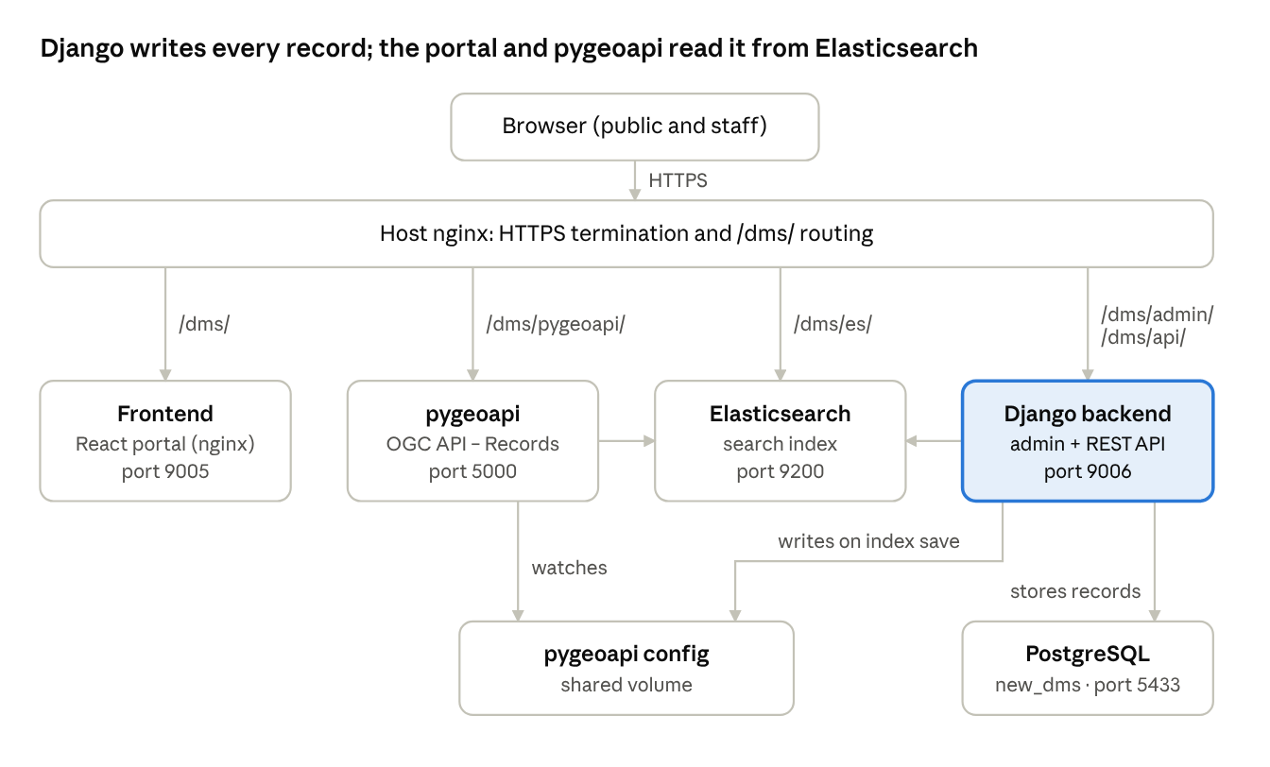
DMS architecture · 5 containers behind the host proxy
The arrows between the middle boxes are data pushes: Django sends each saved record to Elasticsearch, and pygeoapi serves those same indexes as OGC collections.

Prerequisites
Item | Requirement
Memory | 4 GB minimum; Elasticsearch alone is pinned to a 1 GB heap
Disk | Room for the Postgres and Elasticsearch volumes plus backend/media/ (uploaded acquisition reports)
Software | Docker Engine with the Compose plugin, Git, curl
Ports free on the host | 5000, 5433, 9005, 9006, 9200, 9300
The production compose file expects an external Docker volume named dms-main_postgres_data. Create it once before the first start (step 3 below).

Installation and deployment
A fresh production install takes nine steps; all commands run from the repository root on the server. Containers start in a fixed order (database → Elasticsearch → pygeoapi → frontend → backend), each waiting for the previous one's health check.

1. Clone the repository
git clone https://github.com/anujdivesh/medin-dms dms
cd dms
git checkout main

2. Create the environment files
Two files hold: .env in the repository root (read by Compose) and backend/.env (read by Django). Section 4 lists every variable.
cat > .env <<'EOF'
POSTGRES_USER=dms_user
POSTGRES_PASSWORD=<strong-password>
POSTGRES_DB=dms
ELASTIC_PASSWORD=<elastic-password>
VITE_ES_USERNAME=<read-only-es-user>
VITE_ES_PASSWORD=<read-only-es-password>
EOF
nano backend/.env # fill in from the Configuration section

3. Prepare the database volume and pygeoapi config
docker volume create dms-main_postgres_data
cp pygeoapi/pygeoapi-generate-config/pygeoapi-config.yml.docker \
pygeoapi/pygeoapi-generate-config/pygeoapi-config.yml

4. Build and start the stack
docker compose up -d --build
docker compose ps # all five should reach "healthy"
The backend container runs migrate and collectstatic on every start, then serves with gunicorn (3 workers).

5. Load the data
On a brand-new volume, Postgres creates the new_dms database and loads the bundled seed (new_dms_seed_2026-08-12.sql) on first start, so no action is needed. To load your own backup instead, follow a-e below. This replaces everything currently in database.
a. Make sure new_dms exists. The init scripts only run on an empty volume. On an existing volume, create the database once (an "already exists" error means you can skip this):
docker exec -it dms-database psql -U dms_user -d dms -c "CREATE DATABASE new_dms OWNER dms_user;"
b. Stop the backend so nothing writes during the restore:
docker stop dms-backend
c. Copy your backup into the database container:
docker cp /path/to/your_backup.dump dms-database:/tmp/restore.dump
d. Restore it. The command depends on how the backup was made. Run head -c 5 your_backup if unsure: custom-format files start with PGDMP.
Backup file | Made with | Restore with
.dump / .backup (custom format) | pg_dump -Fc | pg_restore
.sql (plain text) | pg_dump with no -F | psql
Custom format (also used by the repo's database/new_dms_prod.dump):
docker exec -it dms-database pg_restore -U dms_user -d new_dms \
--clean --if-exists --no-owner --role=dms_user /tmp/restore.dump
Plain SQL: it does not drop existing tables, so empty the database first, then load the file:
docker exec -it dms-database psql -U dms_user -d dms \
-c "DROP DATABASE IF EXISTS new_dms;" -c "CREATE DATABASE new_dms OWNER dms_user;"
docker exec -it dms-database psql -U dms_user -d new_dms -f /tmp/restore.sql
e. Start the backend and rebuild search:
docker start dms-backend # applies any migrations newer than the backup
docker exec -it dms-backend python manage.py push_to_elasticsearch
Search indexes are not part of the database backup, so step e is what makes the portal show the restored records. Uploaded files are not in it either: if the backup came from another server, copy that server's backend/media/ folder across as well.

6. Create the first admin user
docker exec -it dms-backend python manage.py createsuperuser

7. Build the search indexes
docker exec -it dms-backend python manage.py push_to_elasticsearch --create-index
docker exec -it dms-backend python manage.py sync_pygeoapi_config --no-restart
docker restart dms-pygeoapi
Add --dry-run to the first command to preview documents without sending them.

8. Configure the host reverse proxy
The containers expect the public site under /dms/. A sample host nginx block (adjust to your server's existing config):
# --- DMS starts here ---

# Upstreams
set $frontend_upstream "127.0.0.1:9005";
set $es_upstream "127.0.0.1:9200";

# Backend API proxy - MUST come before general /dms/ location
location ^~ /dms/api/ {
proxy_pass http://127.0.0.1:9006/api/;
proxy_http_version 1.1;
proxy_set_header Host $host;
proxy_set_header X-Real-IP $remote_addr;
proxy_set_header X-Forwarded-For $proxy_add_x_forwarded_for;
proxy_set_header X-Forwarded-Proto https;
proxy_set_header X-Forwarded-Host $host;
proxy_set_header X-Forwarded-Port $server_port;
proxy_buffering off;
proxy_redirect off; # Prevent Nginx from rewriting redirects
}

# Django admin - MUST come before general /dms/ location
location ^~ /dms/admin/ {
proxy_pass http://127.0.0.1:9006/admin/;
proxy_http_version 1.1;
proxy_set_header Host $host;
proxy_set_header X-Real-IP $remote_addr;
proxy_set_header X-Forwarded-For $proxy_add_x_forwarded_for;
proxy_set_header X-Forwarded-Proto https;
proxy_set_header X-Forwarded-Host $host;
proxy_set_header X-Forwarded-Port $server_port;
proxy_buffering off;
proxy_redirect off;
}

# Django static files (admin CSS/JS) - MUST come before general /dms/ location
location ^~ /dms/static/ {
proxy_pass http://127.0.0.1:9006/static/;
proxy_http_version 1.1;
proxy_set_header Host $host;
proxy_set_header X-Real-IP $remote_addr;
proxy_set_header X-Forwarded-For $proxy_add_x_forwarded_for;
proxy_set_header X-Forwarded-Proto https;
proxy_buffering off;
}

# Django media (uploads) - MUST come before general /dms/ location
location ^~ /dms/media/ {
proxy_pass http://127.0.0.1:9006;
proxy_http_version 1.1;
proxy_set_header Host $host;
proxy_set_header X-Real-IP $remote_addr;
proxy_set_header X-Forwarded-For $proxy_add_x_forwarded_for;
proxy_set_header X-Forwarded-Proto https;
proxy_buffering off;
}

# Direct Elasticsearch passthrough - MUST come before general /dms/ location
location ^~ /dms/es/ {
proxy_pass http://127.0.0.1:9200/;
proxy_http_version 1.1;
proxy_set_header Host $host;
proxy_set_header X-Real-IP $remote_addr;
proxy_set_header X-Forwarded-For $proxy_add_x_forwarded_for;
proxy_set_header X-Forwarded-Proto $scheme;
proxy_set_header Authorization $http_authorization;

# Nginx-level CORS handling
if ($request_method = 'OPTIONS') {
add_header 'Access-Control-Allow-Origin' '*';
add_header 'Access-Control-Allow-Methods' 'GET, POST, OPTIONS, PUT, DELETE';
add_header 'Access-Control-Allow-Headers' 'DNT,User-Agent,X-Requested-With,If-Modified-Since,Cache-Control,Content-Type,Range,Authorization';
add_header 'Access-Control-Max-Age' 1728000;
add_header 'Content-Type' 'text/plain; charset=utf-8';
add_header 'Content-Length' 0;
return 204;
}
add_header 'Access-Control-Allow-Origin' '*';

proxy_set_header Origin "";
proxy_buffering off;
rewrite ^/dms/es/(.*)$ /$1 break;
}

# PyGeoAPI proxy - MUST come before general /dms/ location
location ^~ /dms/pygeoapi/ {
proxy_pass http://127.0.0.1:5000/;
proxy_http_version 1.1;
proxy_set_header Host $host;
proxy_set_header X-Real-IP $remote_addr;
proxy_set_header X-Forwarded-For $proxy_add_x_forwarded_for;
proxy_set_header X-Forwarded-Proto https;
proxy_set_header X-Forwarded-Host $host;
proxy_set_header X-Forwarded-Port $server_port;
proxy_buffering off;
proxy_redirect off;
}

# Forward all other DMS traffic to frontend container
location ^~ /dms/ {
proxy_pass http://127.0.0.1:9005;
proxy_http_version 1.1;
proxy_set_header Host $host;
proxy_set_header X-Real-IP $remote_addr;
proxy_set_header X-Forwarded-For $proxy_add_x_forwarded_for;
proxy_set_header X-Forwarded-Proto $scheme;
proxy_set_header X-Forwarded-Host $host;
proxy_set_header X-Forwarded-Port $server_port;
proxy_buffering off;
}

# DMS landing image
location = /dms/dms_landing.jpg {
proxy_pass http://127.0.0.1:9006/dms/dms_landing.jpg;
}

# --- DMS ends here ---

9. Verify
curl -f http://localhost:9006/api/health/
curl -u elastic:$ELASTIC_PASSWORD http://localhost:9200/_cat/indices?v
curl -f http://localhost:5000/collections
Then open https://<host>/dms/ for the portal and https://<host>/dms/admin/ for the admin.

Updating an existing deployment
git pull
docker compose up -d --build
Migrations run automatically. Rebuild the frontend image whenever VITE_* values change: they are baked in at build time.

Configuration
Secrets live in two untracked files; everything else is set in docker-compose.yml, which overrides backend/.env where both define a variable.

Root .env (Compose)
Variable | Used by | Purpose
POSTGRES_USER / POSTGRES_PASSWORD | database, backend | Postgres login (default dms_user / dms_password; change it)
POSTGRES_DB | database | Bootstrap database dms; the backend uses new_dms
ELASTIC_PASSWORD | elasticsearch, backend | Password for the elastic superuser
VITE_ES_USERNAME / VITE_ES_PASSWORD | frontend build | Elasticsearch credentials the portal searches with; use a read-only user, since they ship in the browser bundle

backend/.env (Django)
Variable | Purpose
DJANGO_SECRET_KEY | Long random string; required in production
DJANGO_DEBUG | False in production (Compose already sets this)
DJANGO_ALLOWED_HOSTS | Comma-separated host names the backend answers on
DB_NAME, DB_USER, DB_PASSWORD, DB_HOST, DB_PORT | Django database; Compose sets new_dms on host database:5432
ELASTICSEARCH_URL, ELASTICSEARCH_USERNAME, ELASTICSEARCH_PASSWORD | Where records are pushed
CORS_ALLOWED_ORIGINS | Origins allowed to call the API, e.g. https://oceandata.spc.int
FRONTEND_URL, BACKEND_URL | Public URLs used in links

Set in docker-compose.yml
Variable | Value in production | Purpose
DJANGO_FORCE_SCRIPT_NAME | /dms | Admin and API live under /dms/
DJANGO_STATIC_URL / DJANGO_MEDIA_URL | /dms/static/, /dms/media/ | Asset URLs behind the proxy
PYGEOAPI_DIR | /pygeoapi | Where the backend writes the regenerated pygeoapi config (shared volume)
PYGEOAPI_AUTO_RESTART | False | pygeoapi reloads itself when its config file changes
CORS_ORIGINS, http.cors.allow-origin | https://oceandata.spc.int | Browser origin allowed by pygeoapi and Elasticsearch
VITE_BASE_PATH (build arg) | /dms/ | URL prefix of the portal

Moving to a new domain
To move DMS to a new domain, change every oceandata.spc.int / opmthredds.gem.spc.int entry in docker-compose.yml, the CORS and host values in backend/.env, and the pygeoapi server URL in pygeoapi-config.yml.docker, then rebuild.

Persistent data
What | Where
Postgres data | Docker volume dms-main_postgres_data (external)
Elasticsearch data | Docker volume elasticsearch_data
Uploaded files | backend/media/ bind mount
pygeoapi config | pygeoapi/pygeoapi-generate-config/ bind mount, shared with the backend

User guide
The public uses the portal at /dms/ to find and request datasets; staff/meta data entry use the admin at /dms/admin/ to create and maintain them. Anything saved in the admin is published.

Public portal: finding data
The home page has two tabs: Search and Stats.
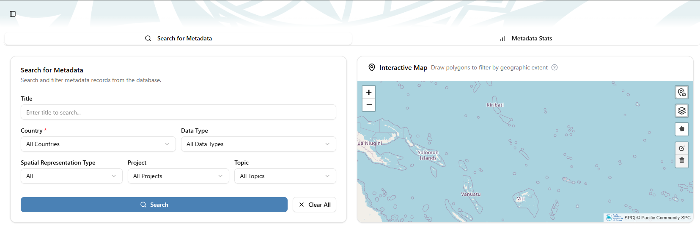
- Open Search and set any filters: title text, Country, Data Type, Spatial Representation Type, Project, Topic and Publisher. Selecting a country also zooms the map to it.
- Optionally click Draw a polygon on the map to limit results to an area.
- Click Search. Clear All resets every filter and the drawn area.
- Use Sort by (Default, Date added newest/oldest, Title A–Z/Z–A) and Per page (25, 50, 100) above the results. Click a page number, or the ellipsis to jump to a page.
- On a result card, View Details opens the full record in pygeoapi in a new tab.
The Stats tab charts data completeness, top countries, topic distribution and records over time, with a paged table of all records.
Other controls in the sidebar footer: the light/dark mode toggle, Start guided tour for a walkthrough of the page, and Login for staff. Press Ctrl + / (Cmd + / on Mac) to open quick search by title.

Admin portal: managing records
Sign in at /dms/admin/ (or click Login in the portal) with an account created by createsuperuser or by another admin under Users.

Add or edit a metadata record
- Go to Metadata records → Add.
- Pick a Template; its extra fields appear below the core fields.
- Fill the core metadata: title, abstract, metadata type, country, publisher, topic, keywords, contacts, access constraints and the boundary (draw it on the map or enter coordinates).
- Attach the acquisition report file if there is one.
- Click Save. The record is pushed to Elasticsearch at once and appears in the portal on the next search.
Deleting a record also removes it from the search index. The list view filters by metadata type, template, access constraints, country and topic, and searches title and abstract.

Maintain lookup lists
Contacts, Countries, Coordinate reference systems, Publishers, Topics, Keywords, Projects, Spatial representation types, Data types and Metadata types each have their own admin page. Editing a lookup re-indexes every record that uses it.

Define templates
Under Metadata templates, a template holds a name, version and a list of field definitions. Each field becomes an input on records that use the template. Mark old templates inactive rather than deleting them.

Control what is published to search
Under Elasticsearch indexes, each metadata type maps to one index and one pygeoapi collection. The inline field list is a whitelist: only the listed core fields leave the database. Saving an index regenerates pygeoapi's config and pygeoapi reloads on its own. To rebuild an index after changing its fields, select it in the list and run the action Resync selected indexes to Elasticsearch.

Manually starting the dev stack
Start each service in its own terminal from the repository root, in the order below. Elasticsearch and the frontend run from a Windows terminal; pygeoapi and Django run inside WSL.

1. Elasticsearch · Windows terminal
cd elasticsearch\
docker-compose -f docker-compose-local.yml up

2. pygeoapi · WSL
wsl -d Ubuntu
cd pygeoapi/
source .venv/bin/activate
python main.py

3. Frontend (React) · Windows terminal
cd frontend\
npm install
npm run dev

4. Backend (Django) · WSL
wsl -d Ubuntu
cd backend/
source .venv/bin/activate
python manage.py runserver 0.0.0.0:8000

