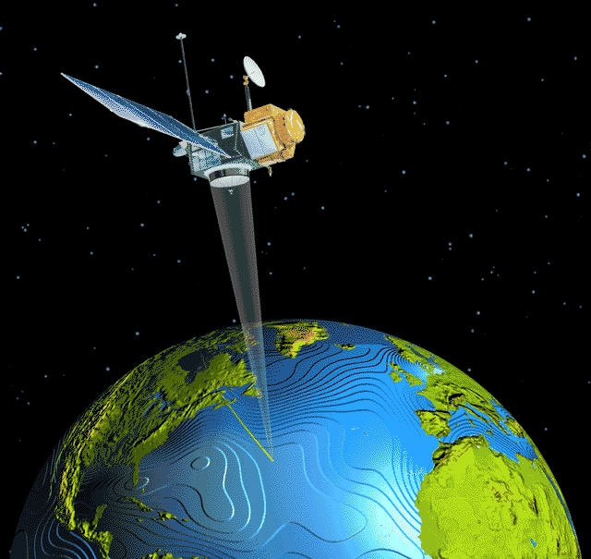COSPPac Ocean Portal

About: Near Real-Time Sea Level Anomaly

*In Brief*

*Daily and monthly near real-time sea level anomaly data is available from the ocean portal sourced from* ***satellite altimetry*** *that can be viewed as* ***maps*** *showing spatial differences in sea level. The anomaly shown is with respect to a 20-year average (1993 to 2012).*

Introduction

There are various satellite missions orbiting the earth that measure the ocean surface height via radar. There are presently four satellite missions that contribute to the near real-time sea level anomaly dataset (HY-2A, Saral/AltiKa, Cryosat-2, Jason-2). The satellites orbit the earth along different paths (see Figure 1), and are merged together on a daily basis to produce a complete gridded sea level anomaly map of the globe.

Altimetry measurements need to be corrected for short-term sea level signals that cannot be properly resolved due to the temporal and spatial resolution of the orbital tracks. Short-term signals that cause data inconsistency include waves, tides (ocean, earth, polar and loading effects), and effects from atmospheric pressure.

Following data corrections, the final sea level dataset is comprised of sea level signals that sustain for periods longer than approximately 20-days, including:

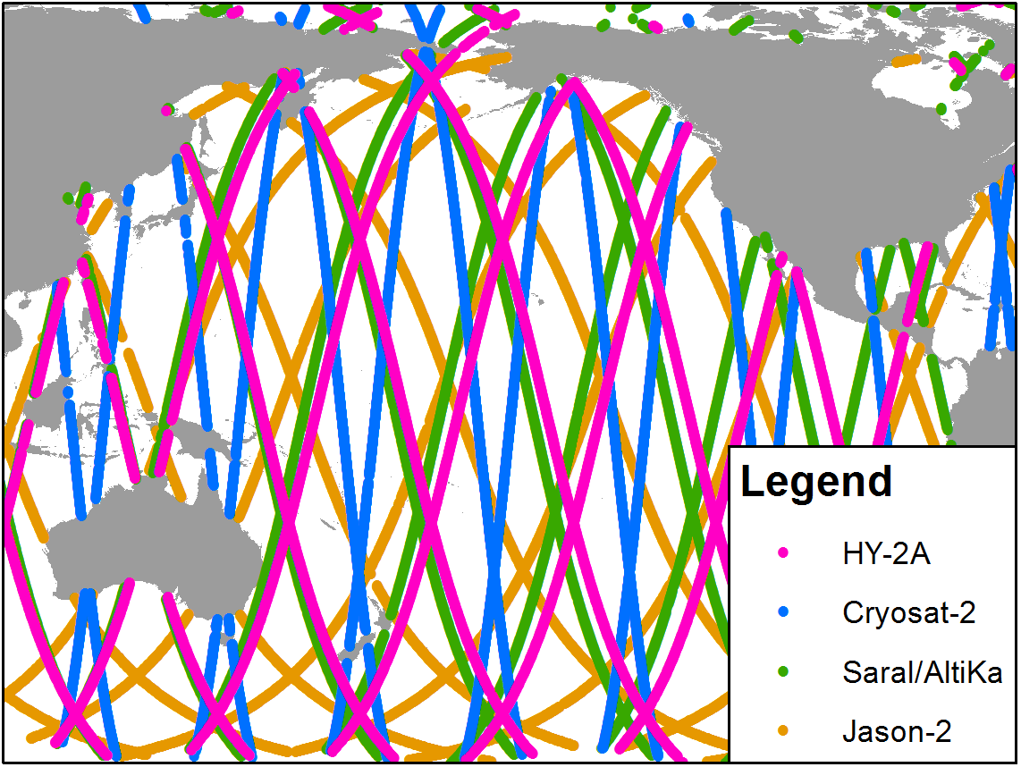**Water mass variations:** Increases and decreases in the volume of water in the ocean. Increases can be from rain over the ocean, run-off from the rivers, and glaciers melting. Decreases can occur from less runoff due to construction of new artificial reservoirs, evaporation, increased precipitation over land and the development of glaciers.

**Density variations:** Salinity and temperature determine the density or buoyancy of sea water. Generally in the open ocean, warmer water with a lower salinity (less salty) is less dense and has a higher sea surface height than denser cooler water with a higher salinity.

**Ocean circulation changes:** The movement of surface water in the ocean can change the sea level.

Figure 1. Satellite coverage for the near real-time sea level

dataset over a three day period

Using the Portal

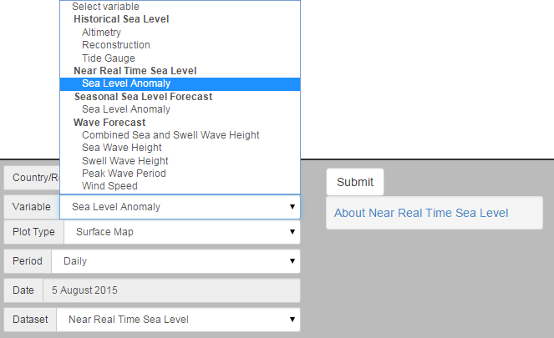

(2) A date (Year and Month) must be selected.

(3) Click the ‘Submit’ button to produce your map.

(1) Use the Variable menu to select ‘Sea Level Anomaly’ under the ‘Near Real Time Sea Level.

Figure 2. Producing a sea level map

Description of Parameters

*Near Real-Time Sea Level Anomaly (SLA):*

The sea level anomaly is available daily, with monthly averages generated from the daily data. The data shows sea level anomaly, which is how the sea level is different from the long-term average. The map shows locations of both higher and lower water levels, indicated by positive and negative numbers. Units for SLA are in millimetres with a resolution of 0.25 degrees. The seasonal SLA forecasts are created by comparing the model predictions of sea level in the coming months to the long-term averages, using the 20-year reference period from 1993-2012.

Examples of Applications

* **Management of Extreme Sea Level Events:** Stakeholders can use forecasts of extreme sea level to make decisions aimed at the protection of communities and infrastructure (Miles et al. 2013).
* **Monitoring ENSO Impacts:** Sea level varies during El Niño Southern Oscillation events, resulting in significantly high or low levels for many months. This was the cause of much coral die-off in Samoa during the 1997-1998 El Niño event, when sea level dropped in the western Pacific by up to 30 cm, exposing shallow reefs. Samoans refer to this sea level event as “taimasa” - shown in Figure 3 (Widlansky et al. 2014).

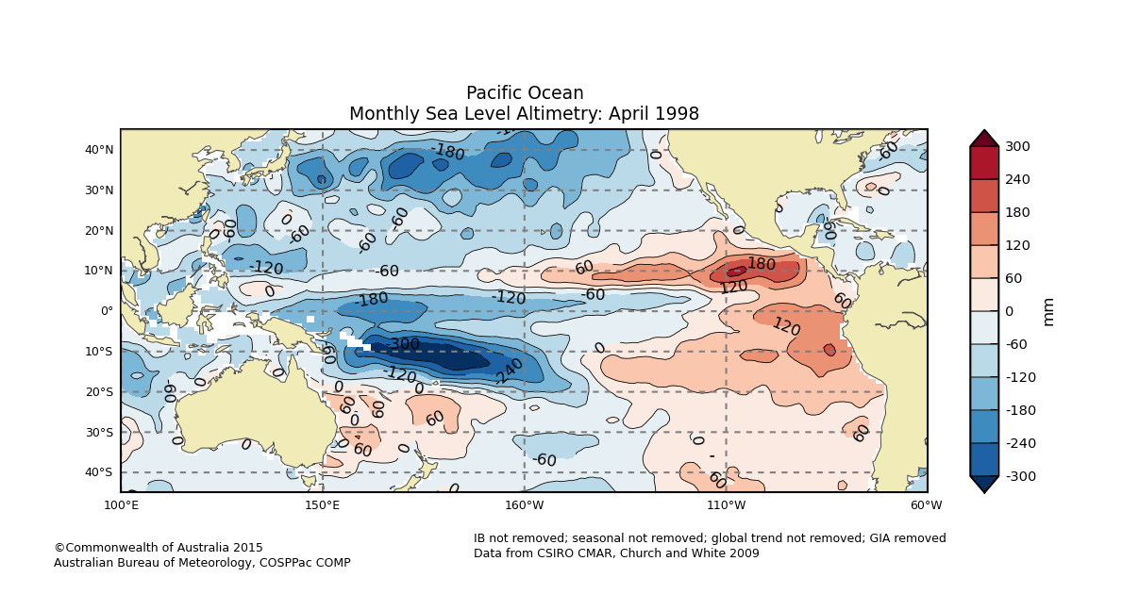

Figure 3. Altimetry data showing ‘taimasa’ which is the low sea level event occurring during certain El Niño events (dark blue region).

* **IPO Monitoring[1]:** The Inter-decadal Pacific Oscillation (IPO) characterises decade-to-decade changes in ENSO cycles, thereby having an effect on sea level. The oscillation can stay in a positive or negative phase for years to decades, and jump to the opposite phase relatively quickly causing a step jump in mean sea level (Stephens and Bell, 2012).



Figure 4. Movement of the IPO over the decades (PCCSP, 2011)

Data Source

The altimeter products are produced by Ssalto/Duacs (Data Unification and Altimeter Combination System) in collaboration with the LEGOS (Laboratoire d'Etudes en Geophysique et Océanographie Spatiales) and CTOH (Center for Topographic studies of the Ocean and Hydrosphere), distributed by AVISO (Archiving, Validation and Interpretation of Satellite Oceanographic data), with support from Cnes (Centre national d'études spatiale) The system’s primary objective is to provide operational applications with directly usable high quality data from all missions available (Cnes 2015).

Links

AVISO Website, data location, product descriptions, applications:

<http://www.aviso.altimetry.fr/>

Laboratoire d'Etudes en Geophysique et Océanographie Spatiales:

<http://www.legos.obs-mip.fr/>

Centre for Topographic Studies of the Ocean and Hydrosphere:

<http://ctoh.legos.obs-mip.fr/>

Centre National d’Etudes Spatiales:

<https://cnes.fr/fr>

Disclaimer

The Bureau advises that the information in this service comprises general statements based on scientific research. The Bureau does not warrant, guarantee or make any representations regarding the currency, correctness, accuracy, completeness, reliability, or any other aspect regarding characteristics or use of the information shown on this web portal. The user accepts sole responsibility and risk associated with the use and results of Bureau material in this service, irrespective of the purpose to which such use or results are applied. To the extent permitted by law, the Bureau (including each of its employees) excludes all liability to any person for any consequences, including but not limited to losses, damages, costs, expenses and any other compensation, whether in an action, contract, negligence or tort, arising out of or in connection with the use or performance of Bureau material in this service and any information or material contained in it.

The information shown in this web portal is covered by the Bureau of Meteorology’s Copyright Notice – see <http://www.bom.gov.au/other/copyright.shtml?ref=ftr>.

References

Cnes 2015, *SSALTO/DUACS User Handbook: (M)SLA and (M)ADT Near-Real Time and Delayed Time Products*,.

Miles, E, Spillman, C, McIntosh, P, Church, J, Charles, A & de Wit, R 2013, ‘Seasonal sea-level predictions for the Western Pacific’, in *20th International Congress on Modelling and Simulation*, pp. 2855–2861.

Widlansky, MJ, Timmermann, A, Mcgregor, S, Stuecker, MF & Cai, W 2014, ‘An Interhemispheric tropical sea level seesaw due to el niño taimasa’, *Journal of Climate*, vol. 27, pp. 1070–1081.

Contact

For more information, please email [cosppac_comp_unit@bom.gov.au](mailto:cosppac_comp_unit@bom.gov.au).

1. The IPO is similar to the Pacific Decadal Oscillation (PDO) in terms of sea temperature changes, but affects ocean waters south of 20° N Latitude, which the PDO does not.