COSPPac Ocean Portal

About: BRAN (Bluelink ReANalysis)

*In Brief*

***Ocean temperature****,* ***salinity****, and* ***currents*** *are available as* ***monthly****,* ***3-monthly****,* ***6-monthly****,* ***12-monthly*** *averages from* ***January******1993*** *to* ***July 2012****. The dataset is accessed within the* ***‘Ocean Monitoring’*** *application.*

*Data resolution is 0.1 degrees in the west tropical Pacific and 0.9 degrees in central-east tropical Pacific. There are 30 vertical depth levels composed of 5-metre intervals down to a depth of 20 metres, and coarser layers at greater depths. SST is taken from the top vertical layer which is centred on 2.5 metres.*

*The data source is the Bluelink ReANalysis (BRAN) version 3.5, an eddy-resolving ocean reanalysis which interpolates field observations through a data assimilation system, and interpolates the observations to provide estimates of variables where they have not been observed* (Oke et al. 2013)*.*

Introduction

Even on a seemingly calm day, the ocean is always on the move, from the surface to the depths below. Currents are defined as bodies of water that move in mainly horizontal directions (but also in vertical directions). Currents are driven by wind blowing across the ocean surface, differences in density related to salinity and temperature, and astronomical tides. Currents are steered by the rotation of the Earth, the locations of land masses, and the shape of the ocean floor.

Ocean currents play a crucial role in:

* The transport of heat, by moving warm tropical water towards the poles;
* Transport of salt, nutrients and other chemicals, including pollutants and contaminants;
* Regulating the weather and climate; and,
* Sustaining marine ecosystems that are home to countless plants and animals that rely on the ocean for life.

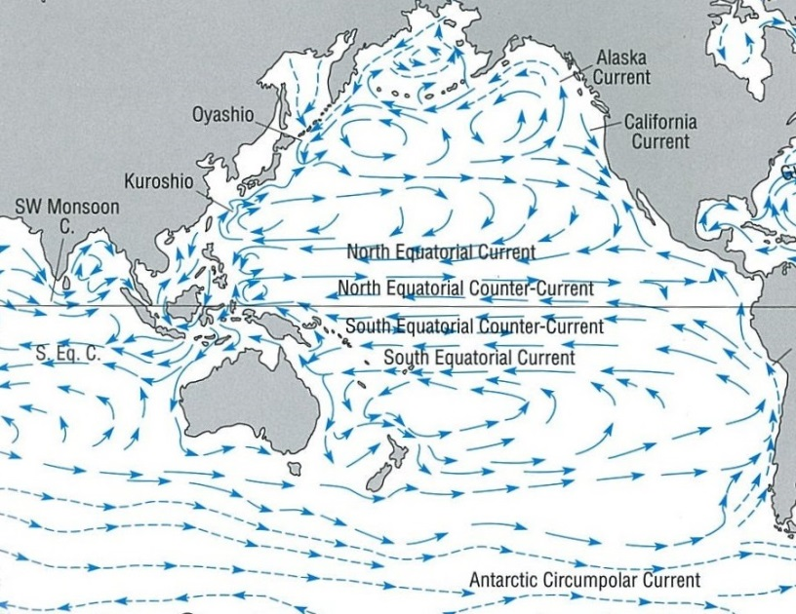At a basin scale, basin-wide rotating circulations, referred to as gyres, are driven by large-scale atmospheric surface winds. The patterns of circulation are determined by the speed and direction of atmospheric winds, and the shapes of the ocean basins (Figure 1). It has been reported that garbage and debris accumulates in the centre of these gyres (Moore 2003).

Subpolar Gyre

North Pacific Gyre

South Pacific Gyre

Figure 1. The gyres of the Pacific Ocean. Picture source: Colling (2007)

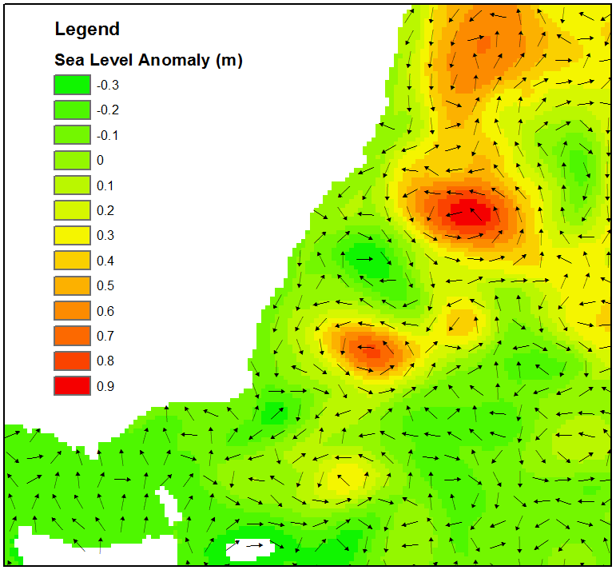On a smaller scale, circulations known as ‘eddies’ are swirling movements that can be between 10 km to 200 km in diameter. They are relatively short-lived and are created in regions of strong ocean currents, e.g. boundaries of ocean basins and the Southern Ocean (Figure 2).

Currents have a major impact on the weather and climate, the biological characteristics of the ocean and on human activities that take place in the marine environment.

Figure 2. Anti-cyclonic (clockwise) eddies can be observed forming around higher sea level anomalies off the east coast of Australia (source: OceanMaps model)

Salinity and temperature determine the density or buoyancy of sea water; both attributes vary at different locations and depths over time. Generally at scales of 100 - 1000 km in the open ocean, warmer water with a lower salinity (less salty) is less dense and has a higher sea surface height than denser cooler water with a higher salinity. The difference in sea surface height between two areas creates a current, as water tends to flow from the higher sea surface towards the lower sea surface.

Salinity varies from various factors that can either increase or reduce its concentration. Fresh water input at the sea surface from rain and river inflow reduces salinity. In contrast, salinity is increased by evaporation and by the formation of sea ice. High surface evaporation in the sub-tropics creates higher salinity near the sea surface.

The main source of ocean warming is solar irradiance (energy from the sun), which varies depending on solar cycles, cloud cover and stratospheric aerosols. Heat is also exchanged with the atmosphere via thermal radiation, evaporation and through contact with the air. Under the ocean surface, the temperature decreases with increasing ocean depth; deep waters are cold and dense. The ‘thermocline’ is where the temperature change occurs over a shorter vertical distance than it does in the layers above or below, and is located typically near the 20°C isotherm in the tropical Pacific Ocean. Near the equator, the thermocline is usually located at about 150 metres depth in the western Pacific, sloping up to about 50 metres in the eastern Pacific.

Thermocline at the 20°C contour

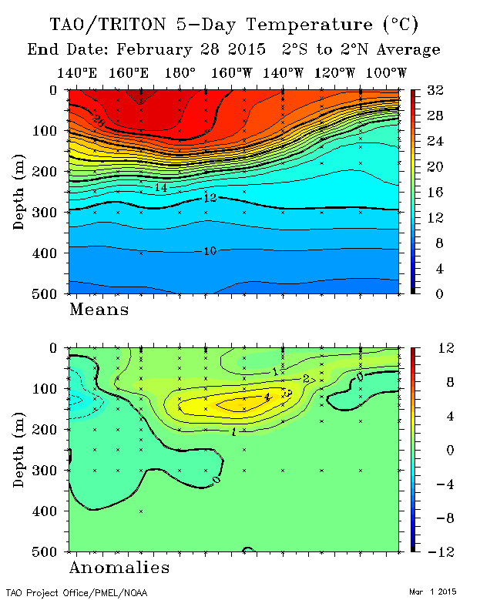

Figure 3. Sub-surface ocean temperature along with equator for 28th February 2015. The thermocline is observed as the area where the isotherm lines are bunched together (typically around the 20°C isotherm).

Using the Portal

(2) Select the “Mean Temperature”, “Salinity”, or “Current Speed & Direction” using the ‘Variable’ drop down box.

(1) For a regional view of a Pacific Nation’s Exclusive Economic Zone, select the country’s name from this drop down box.

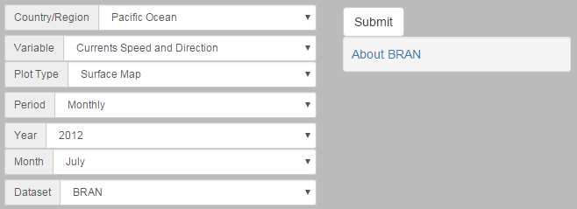

(3) Select “monthly”, or 3, 6, 12 monthly averaging periods.

(4) Select date for the centre of the averaging period.

(5) Select “BRAN” as the data source before finally clicking the “Submit” button.

Figure 4. Creating SST/Salinity/Current maps

(2) Click on the map with the mouse cursor to pick your location. The corresponding latitude/longitude will automatically appear in the boxes below.

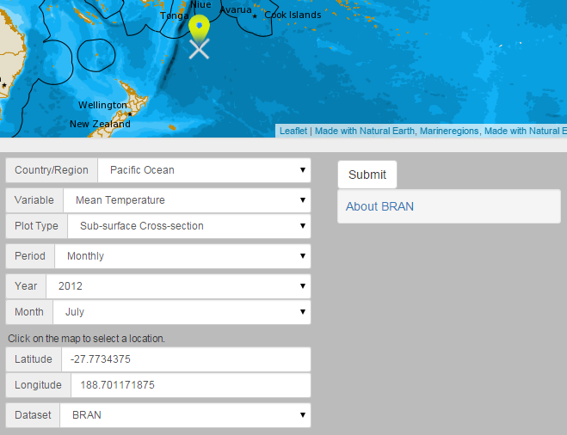

(3) Select monthly averaging time period.

(4) The “BRAN” dataset will automatically be selected for sub-surface plots.

(1) If “Sub-surface Cross-section” is selected as the plot type, additional latitude and longitude information is required.

Figure 5. Creating sub-surface cross section plots

Description of Parameters

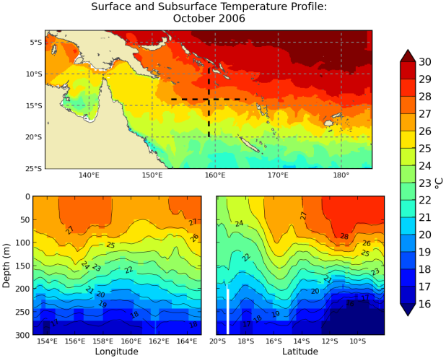*Mean Temperature (Surface Map):*

Temperature expressed in degrees Celsius (°C) for surface maps.

*Mean Temperature (Sub-surface):*

Temperature is expressed in degrees Celsius (°C) along two cross-sections: along a longitude and along a latitude, approximately 1,300 kilometres long from the surface to a depth of 300 metres. The cross-sections are indicated by black dashed lines on the map, centred on where the cursor was clicked.

*Salinity:*

The unit of measurement for salinity is called the Practical Salinity Unit (PSU) and is a measure based on seawater conductivity. One PSU is equal to approximately one gram of salt per one kilogram of water (e.g. 1 PSU=1 g/kg).

*Temp & Currents:*

Surface currents are indicated by a vector arrow that is scaled based on current speed in metres per second (m/s). Vectors are plotted over a background colour representing SST.

**Data Resolution**

All maps show data contours processed from a resolution of 0.1º x 0.1° between longitudes 90° East to 180° East and 75° South to 16° North latitude. The resolution is 0.9° x 0.1° across the Indian Ocean and East Pacific Ocean. In terms of vertical depth, there are 30 vertical levels (5 m intervals down to 20 m, then scales from 6 m to 10 m intervals down to 200 m, *and 10 to 40 metres down to 300 metres*). All parameters are available as monthly, 3-monthly, 6-monthly, and yearly averages, from January 1993 to July 2012.

**Limitations**

Caution is advised when interpreting data for coastal regions. Tides, tidal currents, and storm surges are all important processes in coastal regions but they are not currently represented in BRAN3.5. In addition, caution is advised when interpreting data in regions with low grid resolution such as the eastern Pacific Ocean as the resolution is too coarse to resolve eddies and other small scale ocean processes.

Examples of Applications

* **Fisheries:** Migration of pelagic fish species, such as tuna, can be linked to variations in sea surface temperature, salinity, and ocean currents. Comparing historical fish stock records to past environmental conditions can be used to identify correlations, which can then be related to the existing and future conditions. Tuna hatching and larval survival are also linked to environmental conditions incorporating SST and salinity (Kim et al. 2015).
* **Tracking Pollutant/Pest Sources:** Possible source locations of particles that are subject to drifting through the ocean (i.e. pollutants, marine pests) can be estimated by looking at historical average ocean currents. For example, the crown of thorns starfish, which is a particularly invasive pest in the southwest Pacific that can decimate a coral reef, spawns larvae that typically spend between two to four weeks drifting in ocean currents. This movement is how the starfish infests a new reef location.
* **Hydrological Cycles:** Signatures of rainfall can be observed in ocean salinity, showing both short and long term trends. Short term (months) rainfall events can be observed as shown in Figure 6. In terms of long-term trends, the western tropical Pacific Ocean has become significantly less salty over recent decades. Conversely, regions to the east have generally become saltier. These changes suggest that the hydrological cycle has intensified (Australian Bureau of Meteorology and CSIRO 2011).

|  |  |  |  |
| --- | --- | --- | --- |
| (a) | http://tuscany/portal/raster/BRN00001_salt_200902_fiji.png | (b) | http://tuscany/portal/raster/BRN00001_salt_201002_fiji.png |

Figure 6. Salinity surrounding Fiji following: (a) higher than average rainfall; (b) lower than average rainfall.

* **Analysis of Past Events: T**he Pacific is characterised by climate variability on a wide range of time scales. The El Niño Southern Oscillation, the Pacific Decadal Oscillation, and the Interdecadel Pacific Oscillation all have ocean related components that can be observed within the BRAN dataset.

Data Sources

The Bluelink Re-ANalysis (BRAN) 3.5 is a high-resolution ocean reanalysis for a 19-year period from 1993-2012 (Oke et al. 2013; Chiswell & Rickard 2014). This product was developed by the Bluelink Project, which is a partnership between the Bureau of Meteorology, CSIRO and the Royal Australian Navy to deliver ocean forecasts for the Australian region. The ocean reanalysis was constructed by combining observational data with a high-resolution ocean model to establish an eddy-resolving best estimate of the ocean state. Observations of the ocean temperature, salinity and sea-level were assimilated from satellites and in-situ ocean monitoring instruments such as ARGO profiling floats, tide gauges, XBTs and the TOGA TAO moored array (see Oke et al. 2013 for more information).

Links

BRAN:

<http://www.cmar.csiro.au/staff/oke/BRAN.htm>

Disclaimer

The Bureau advises that the information in this service comprises general statements based on scientific research. The Bureau does not warrant, guarantee or make any representations regarding the currency, correctness, accuracy, completeness, reliability, or any other aspect regarding characteristics or use of the information shown on this web portal. The user accepts sole responsibility and risk associated with the use and results of Bureau material in this service, irrespective of the purpose to which such use or results are applied. To the extent permitted by law, the Bureau (including each of its employees) excludes all liability to any person for any consequences, including but not limited to losses, damages, costs, expenses and any other compensation, whether in an action, contract, negligence or tort, arising out of or in connection with the use or performance of Bureau material in this service and any information or material contained in it.

The information shown in this web portal is covered by the Bureau of Meteorology’s Copyright Notice – see <http://www.bom.gov.au/other/copyright.shtml?ref=ftr>.

References

Australian Bureau of Meteorology and CSIRO 2011, *Climate Change in the Pacific: Scientific Assessment and New Research. Volume 1: Regional Overview*,.

Chiswell, SM & Rickard, GJ 2014, ‘Evaluation of Bluelink hindcast BRAN 3.5 at surface and 1000 m’, *Ocean Modelling*, vol. 83, pp. 63–81.

Colling, A 2007, *Ocean Circulation* 2nd edn A Colling (ed), Butterworth-Heinemann, Oxford.

Kim, Y-S, Delgado, DI, Cano, IA & Sawada, Y 2015, ‘Effect of temperature and salinity on hatching and larval survival of yellowfin tuna Thunnus albacares’, *Fisheries Science*, pp. 1–7.

Moore, C 2003, ‘Trashed: across the Pacific Ocean, plastics, plastics, everywhere’, *Natural History*, vol. 112, pp. 17–55.

Oke, PR, Sakov, P, Cahill, ML, Dunn, JR, Fiedler, R, Griffin, DA, Mansbridge, J V., Ridgway, KR & Schiller, A 2013, ‘Towards a dynamically balanced eddy-resolving ocean reanalysis: BRAN3’, *Ocean Modelling*, vol. 67, pp. 52–70.

You should also acknowledge our Bluelink partners, the Australian Navy and the CSIRO (Wealth from Oceans, National Research Flagships) when using the BRAN product.

Contact

For more information, please email [cosppac_comp_unit@bom.gov.au](mailto:cosppac_comp_unit@bom.gov.au)