COSPPac Ocean Portal

About: High Resolution Temperature with Front Detection

*In Brief*

*Daily high resolution* ***sea surface temperature*** *(SST) is available in near-real time (2-days lag) inclusive of Exclusive Economic Zones for 14 Pacific Island Countries at a resolution of approximately 1km.*

*The locations of* ***ocean fronts*** *are also provided daily, and are derived from the high resolution SST data. Analogous to atmospheric fronts, ocean fronts mark large changes in SST over short distances, and are useful indicators of high biological activity.*

Introduction

The temperature of the ocean varies at different locations and different depths. The main source of ocean warming is energy from the sun, which varies depending on solar cycles, cloud cover and stratospheric aerosols. The turbidity (clarity) of the water can also affect the depth to which sunlight penetrates, and ocean mixing (driven by winds and waves) can warm layers of the ocean below the surface. The highest sea surface temperatures in the Pacific exist in the middle of the ‘Warm Pool’, typically located close to the equator in the west of the Pacific Basin.

Ocean temperature has implications for climate, rainfall, cyclone development, ocean currents, coral bleaching and fish habitat. Data sources for ocean temperature are derived from satellite measurements, *in situ* observations (e.g. ships, buoys) and numerical modelling.

**Ocean Fronts**

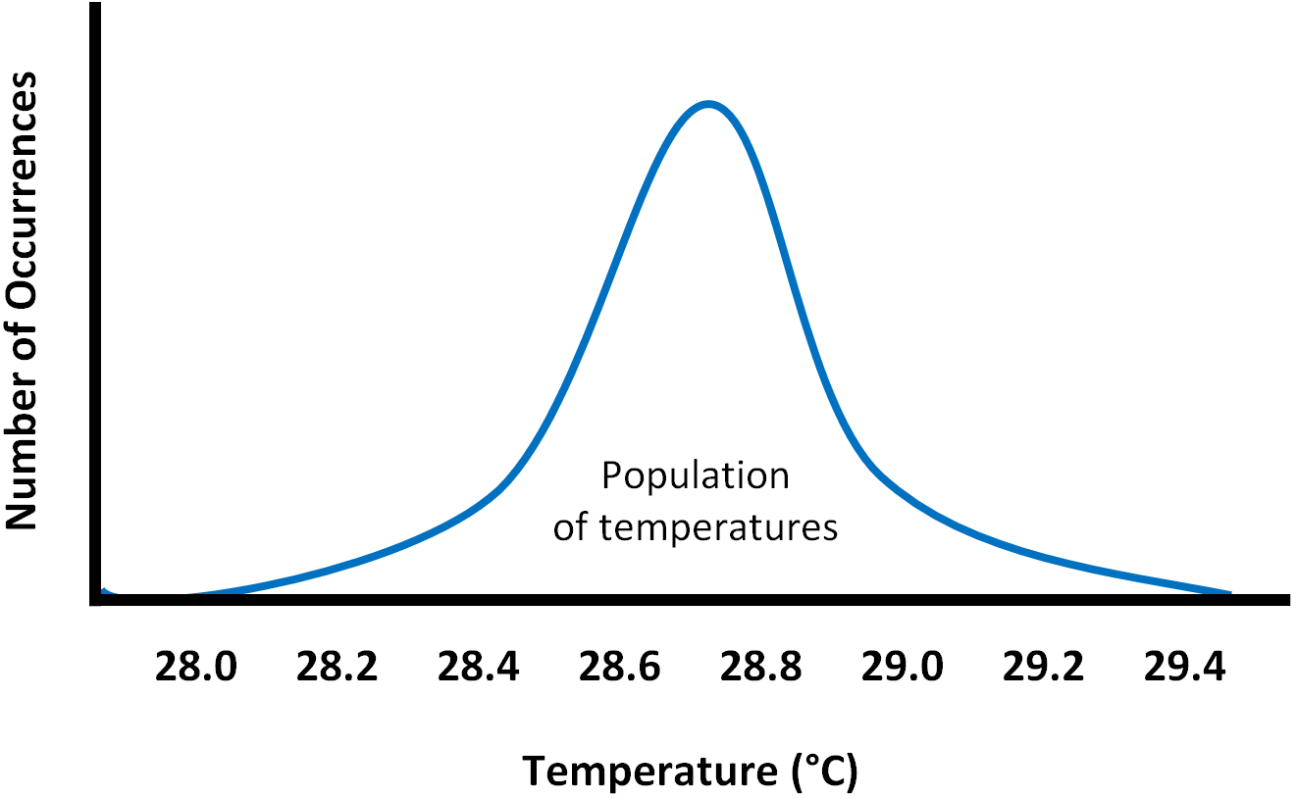Ocean fronts can be associated with upwellings, bringing deep water nutrients to the sea surface. These regions become hot spots of biological activity that produce good fishing conditions. Knowledge of front locations can aid fishermen who rely on subsistence and economic benefits, and promote fishing outside highly stressed fringing coral reef ecosystems.

Front lines are located at regions where sea surface temperature changes rapidly over a relatively short distance. These regions are identified by looking at the distribution of temperatures in a section of ocean.

When no front is present, the occurrence of temperatures is represented by a singular bell curve, known as a normal distribution as shown in the figure on the right.

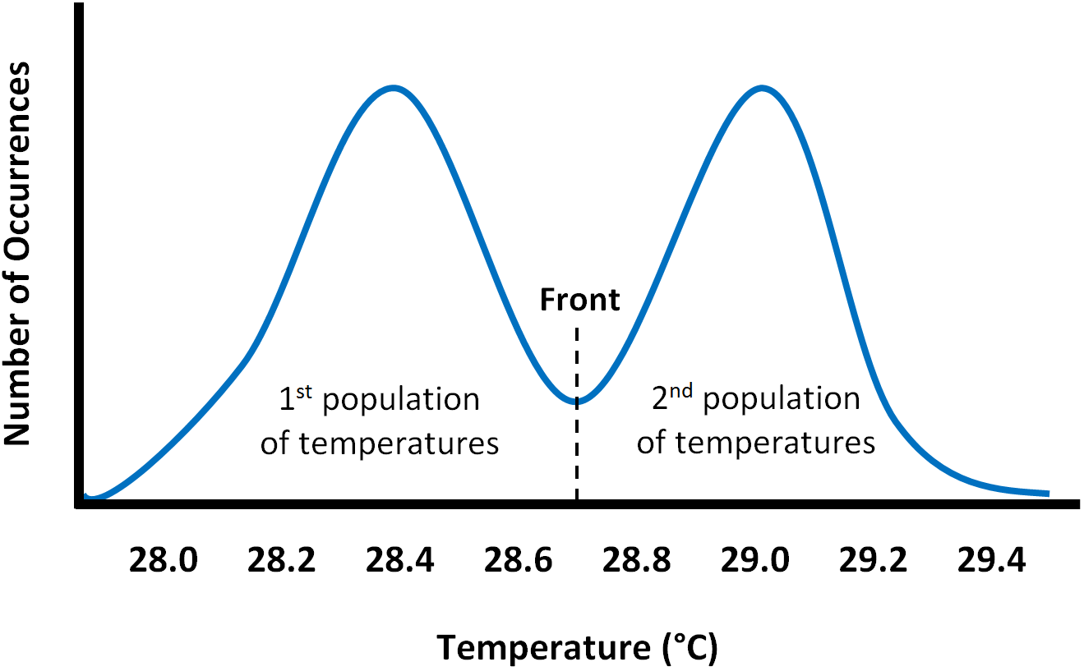If two distinct distributions of sea surface temperatures can be identified, this indicates a front exists in this particular section of ocean. The two peaks represent a warmer body of water and a cooler body of water. The mid-point between the two bodies of warmer and cooler water is the location of the front line. This method for front identification is based on an algorithm developed by Cayula & Cornillon (1995).

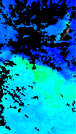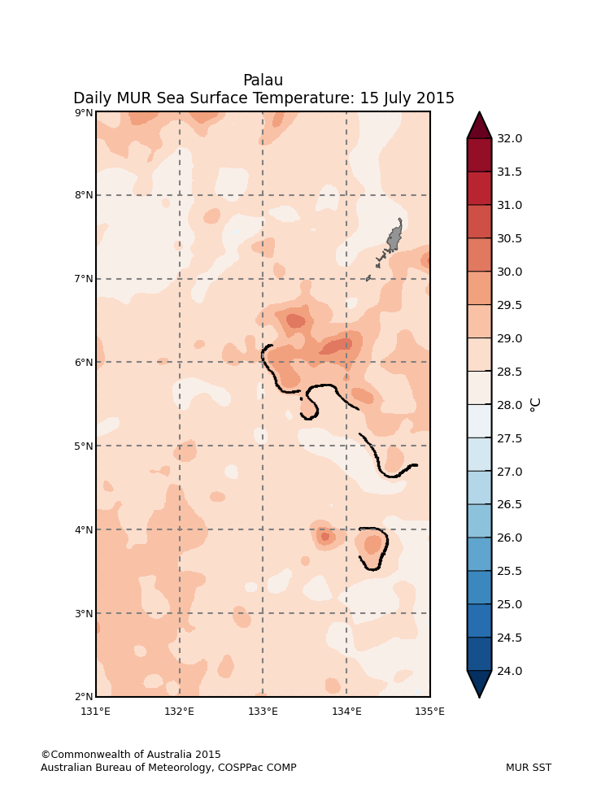

Once the location of the front is identified, it can be drawn over the map of SST to indicate the division between warmer and cooler water.

Locations of ocean fronts can be confirmed by observing the corresponding high levels of chlorophyll-a, also in the fisheries application of the ocean portal. Daily coverage of chlorophyll can be quite poor due to cloud cover, hence the need to identify fronts using SST maps as the primary method.

**Ocean front line with corresponding chlorophyll front**

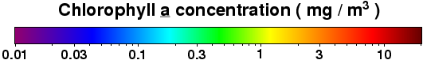

Using the Portal

(1) For a regional view of a Pacific Nation’s EEZ, select the country’s name from this drop down box. When ‘Pacific’ is selected, a lower resolution SST dataset is used and fronts are not displayed.

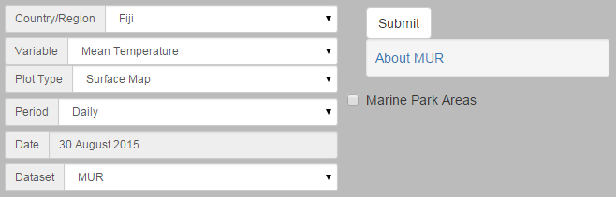

(3) Click the ‘Submit’ button to create map.

(2) Select ‘Mean Temperature’ from the ‘Variable’ drop down menu.

Figure 1. Creating high resolution SST maps with front detection.

Description of Parameters

*Mean Temperature (Surface Map):*

High resolution sea surface temperature is available in near-real time at a resolution of approximately 1km (0.01 degrees). Fronts that have been identified in the sea surface temperature are delineated by a black line on the map. When ‘Pacific’ is selected, a lower resolution SST dataset (Reynolds) is used and fronts are not displayed.

Examples of Applications

* **Fisheries:** Different species of fish are sometimes known to be found at certain temperature ranges. Near real time SST maps can help inform where good fishing locations might be. Conversely, there may be particular environmental conditions to reduce by-catch (unwanted fish/sea animals).

Table 1. Ranges of sea surface temperature that different species of tuna a present in the Pacific (Sund, Blackburn & Williams 1981).

|  |  |  |  |
| --- | --- | --- | --- |
| **Common name** | **Species** | **All occurrences (°C)** | **Abundant occurrences (°C)** |
| Skipjack | Katsuwonus pelamis | 17–30 | 20–29 |
| Yellowfin | Thunnus albacares | 18–31 | 20–30 |
| Bigeye | T. obesus | 11–29 | 13–27 |
| Albacore | T. alalunga | 13–25 | 15–21 |
| Southern | bluefin T. maccoyii | 10.5–21 | 17–20 |

*The typical ‘rule of thumb’ is to fish on the warm side of a front.*

* **Aquaculture / Marine Park Site Selection:** Aquaculture sites thrive when the food supply is consistently abundant. Many filter feeders (i.e. oysters, mussels, clams, scallops) rely on plankton being readily available in the surrounding environment as they have limited to no abilities to forage. Identifying fertile grounds where regular and consistent fronts occur can aid in selecting a suitable site. Similar characteristics can be used to identify candidates for managed marine areas where ecological and biological marine species development can be stimulated and protected.

Data Sources

NASA JPL’s Multi-Scale Ultra-High Resolution (MUR) Sea Surface Temperature dataset is comprised of satellite data merged from a microwave radiometer sensor on WindSat, along with infra-red radiometer on board Aqua MODIS, and an Advanced Very High Resolution Radiometer (AVHRR) on NOAA-18, NOAA-19, METOP-A, and METOP-B. The microwave sensors have typically coarser 25-km resolution than the infra-red sensors which can resolve down to a 1-km scale. However, the IR-based measurements are prone to data voids due to cloud contamination, which does not affect microwave sensors nearly as much. To deal with the data voids which can be both persistent in time and recurrent over particular geographical regions, a motion-compensated analysis technique is employed to reduce temporal smearing of small-scale coherent patterns. Also, to merge satellite measurements with drastically different spatial resolution and coverage, NASA employs a wavelet-based, multi-resolution analysis technique (Chin, Milliff & Large 1998) to ensure consistency of their analysis with the self-similar (power-law) characteristics observed empirically over a wide range of wavenumber spectrum.

Links

MUR SST Home Page

<http://mur.jpl.nasa.gov/>

Disclaimer

The Bureau advises that the information in this service comprises general statements based on scientific research. The Bureau does not warrant, guarantee or make any representations regarding the currency, correctness, accuracy, completeness, reliability, or any other aspect regarding characteristics or use of the information shown on this web portal. The user accepts sole responsibility and risk associated with the use and results of Bureau material in this service, irrespective of the purpose to which such use or results are applied. To the extent permitted by law, the Bureau (including each of its employees) excludes all liability to any person for any consequences, including but not limited to losses, damages, costs, expenses and any other compensation, whether in an action, contract, negligence or tort, arising out of or in connection with the use or performance of Bureau material in this service and any information or material contained in it.

The information shown in this web portal is covered by the Bureau of Meteorology’s Copyright Notice – see <http://www.bom.gov.au/other/copyright.shtml?ref=ftr>.

References

Cayula, J-F & Cornillon, P 1995, ‘Multi-Image Edge Detection for SST Images’, *Journal of Atmospheric and Oceanic Technology*, vol. 12, pp. 821–829.

Chin, T, Milliff, R & Large, W 1998, ‘Basin-scale, high-wavenumber sea surface wind fields from a multiresolution analysis of scatterometer data’, *Journal of Atmospheric and Oceanic Technology*, vol. 15, pp. 741–763.

Sund, PN, Blackburn, M & Williams, F 1981, ‘TUNAS AND THEIR ENVIRONMENT IN THE PACIFIC OCSAN: A REVIEW’, *Oceanography Marine Biology: An Annual Review*, vol. 19, pp. 443–512.

Contact

For more information, please email [cosppac_comp_unit@bom.gov.au](mailto:cosppac_comp_unit@bom.gov.au)