COSPPac Ocean Portal

About: Seasonal Sea Surface Temperature Forecast

*In Brief*

***Seasonal Sea Surface Temperature Forecasts*** *are issued monthly, out to nine months ahead. Temperature forecasts in degrees Celsius are available in the “Fisheries” application (along with the location of the* ***convergence zone****). Anomalies are available in the “Coral Reefs” application.*

*Seasonal forecasts differ from short term forecasts in that instead of predicting individual events they show the average sea surface temperature signals over monthly periods.*

Introduction

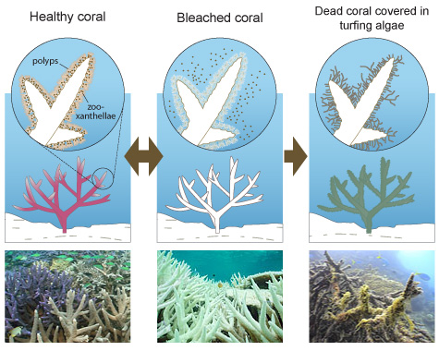The temperature of the ocean varies at different locations, with seasonal sea surface temperature (SST) patterns often persisting for many months. In the Pacific Ocean, variability of SST is primarily linked with seasonal cycles (i.e. summer/winter) and the El Niño Southern Oscillation (ENSO). ENSO events have been associated with droughts, floods, changes in cyclone frequency and location, and occurrence of vector-borne diseases transmitted via mosquitos (such as malaria).

SST fluctuations can also have an effect on the coral reef marine ecosystems of the tropical Pacific. Coral bleaching is largely a result a sustained period of above average water temperatures. Degraded coral reefs present many potential social and economic problems for Pacific partners, including long-term loss of tourism, degradation of fisheries and reduction in coastal protection (Miles et al., 2014).

Seasonal sea surface temperatures forecasts for upcoming months are currently being produced using the Australian Bureau of Meteorology’s ocean-atmosphere forecast model, POAMA[1]. Forecast models, like POAMA, have been shown to produce skilful forecasts of SST in the equatorial Pacific up to several months ahead (e.g. six months) (Barnston et al., 2012; Griesser and Spillman, 2012).

**The Convergence Zone**

For the scale of the Pacific basin, relative abundance of Skipjack tuna is well correlated with the movement of the convergence zone (Lehodey et al., 1997) where large predators like tuna gather due to the presence of plankton and micronekton. The convergence zone is a well-defined salinity front that surrounds the western Pacific warm pool. The 29°C isotherm around the western Pacific warm pool forms a good proxy for the convergence zone, and can therefore be used to track the gravity centre of Skipjack tuna fishing activity in the east/west direction during ENSO phases.

Skill of Forecast

The accuracy or ‘skill’ of POAMA was assessed by correlating the model’s SST anomalies with observed SST anomalies for the period 1982 to 2010, derived from the POAMA ensemble Ocean Data Assimilation System (Yin et al., 2011). A lead time of 0 corresponds to the month following model initialisation, and a lead time of 1 is the next month after that, and so on.

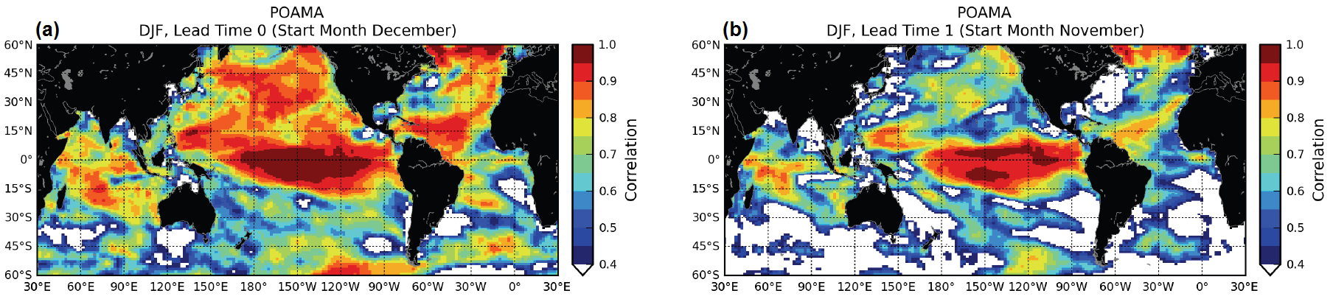

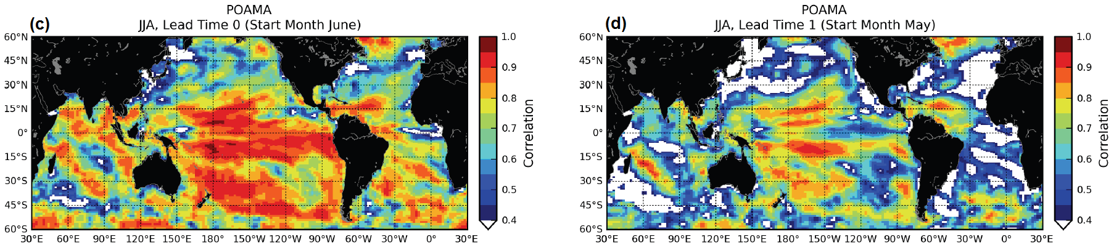

Figure 1. Skill of POAMA SST for Austral Summer (a, b) and Austral Winter (c, d) for different lead times (Griesser and Spillman, 2012)

The model’s skill is highest over the central and eastern equatorial Pacific Ocean for the initialisation period of December-January-February, and decreases at a lead time of 1. For the period June-July-August, the highest model skill occurs over the tropical and south Pacific (Griesser and Spillman, 2012).

Using the Portal

(2) Select the “Sea Surface Temperature Anomaly” option in the Coral Reefs Application or “Sea Surface Temperature” option in the Fisheries Application using the ‘Variable’ drop down box.

(1) For a regional view of a Pacific Nation’s EEZ, select the country’s name from this drop down box.

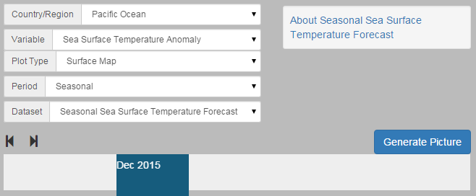

(4) Click the ‘Generate Picture’ button to create a map that you can download to insert into documents, presentations, etc.

(3) The slider at the bottom lets you select the monthly period for the forecast information. The month represents the middle of the three-monthly seasonal forecast.

Description of Parameters

*Sea Surface Temperature (SST):*

Temperature is shown in degrees Celsius and forecast out to nine months ahead. Dataset is located in the “Fisheries” application. The convergence zone (represented by the 29ºC contour) is shown over the SST map along with the position for where the convergence zone is typically located for a given month.

*Sea Surface Temperature Anomaly (SSTA):*

A seasonal SSTA forecast anomaly shows how the temperature is different from the long-term average. The map shows locations of both higher and lower temperatures, indicated by positive and negative numbers. Units are in degrees Celsius and forecast out to nine months ahead. The seasonal SST forecasts are created by comparing the model predictions of SST in the coming months with the long-term averages using the recent 29-year period from 1982-2010. The dataset is located in the “Coral Reefs” application.

Examples of Applications

* **Fisheries:** Stakeholders in the fisheries sector can compare the forecast position of the convergence zone with its typical location for any given month to aid in decision making regarding upcoming tuna stocks. This is of particular interest for countries in the far west or east of the south west Pacific that experience drift of the convergence zone in and out of their exclusive economic zones during ENSO events.



Figure 2. Typical location of the convergence zone throughout the year

* **ENSO:** SST is one of the key indicators of the El Niño Southern Oscillation. Long-lead seasonal SST forecasts provide us with possible scenarios for the evolution of ENSO within the indicator regions shown in Figure 3.

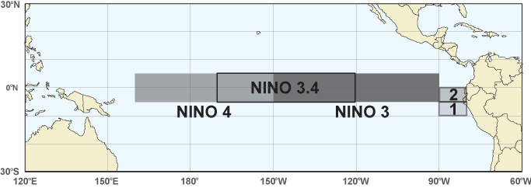

Figure 3. The NINO boxes are the areas of interest when observing anomalous SST as indicators of ENSO events.

* **Climate:** Processes in the atmosphere and ocean are connected. Ocean temperature influences rainfall patterns around the world.Rainfall amounts can be anticipated by monitoring patches of warmer and cooler anomalies. Warmer SSTs in the tropics are often associated with increased rainfall.
* **Cyclones:** The formation of tropical cyclones requires SSTs higher than 26.5 degrees Celsius, although major storms require higher temperatures (Webster et al., 2006). Monitoring warm patches of ocean gives insight into the potential for cyclone formation, and the possible start or finish of the cyclone season.
* **Coral Bleaching:** Along with the Coral Bleaching Forecasts that are based on the NCEP CFSv2 model, POAMA provides another source of information that can be used to confirm the likelihood of bleaching events by monitoring high SST anomalies.

Data Source

POAMA stands for Predictive Ocean Atmosphere Model for Australia. POAMA is the Bureau of Meteorology's dynamical (physics based) climate model used for multi-week to seasonal, through to inter-annual climate outlooks. It is a state of the art long-range forecast system using ocean, atmosphere, ice and land data observations to initiate outlooks up to eight months ahead. POAMA was developed jointly by the Bureau of Meteorology and CSIRO Marine and Atmospheric Research.

POAMA forecasts are run every week, and consist of 33 scenarios for the coming eight months. The variability of the results among the 33 runs gives an indication of the uncertainty in the future evolution of the climate system. When many individual forecasts are considered together they are said to comprise an ensemble in which the spread in the variables they forecast can be used to gauge the likelihood of future patterns, such as ENSO (Wang et al., 2004).

Links

Original PACCSAP webpage for Seasonal Sea Surface Temperature with skill analysis

<http://poama.bom.gov.au/experimental/pasap/sst.shtml>

Help Page for Seasonal Prediction of Extreme Ocean Temperatures/Coral Bleaching

<http://poama.bom.gov.au/experimental/pasap/pacific/help-seasonal-extremes.shtml>

Disclaimer

The Bureau advises that the information in this service comprises general statements based on scientific research. The Bureau does not warrant, guarantee or make any representations regarding the currency, correctness, accuracy, completeness, reliability, or any other aspect regarding characteristics or use of the information shown on this web portal. The user accepts sole responsibility and risk associated with the use and results of Bureau material in this service, irrespective of the purpose to which such use or results are applied. To the extent permitted by law, the Bureau (including each of its employees) excludes all liability to any person for any consequences, including but not limited to losses, damages, costs, expenses and any other compensation, whether in an action, contract, negligence or tort, arising out of or in connection with the use or performance of Bureau material in this service and any information or material contained in it.

The information shown in this web portal is covered by the Bureau of Meteorology’s Copyright Notice – see <http://www.bom.gov.au/other/copyright.shtml?ref=ftr>.

References

Barnston, A.G., Tippett, M.K., Heureux, M.L., Li, S., Dewitt, D.G., 2012. Skill of real-time seasonal ENSO model predictions during 2002-11: Is our capability increasing? Bull. Am. Meteorol. Soc. 93, 631–651. doi:10.1175/BAMS-D-11-00111.1

Griesser, A., Spillman, C.M., 2012. SST forecast skill of the new intra-seasonal configuration of POAMA-2. CAWCR Res. Lett. 10–16.

Lehodey, P., Bertignac, M., Hampton, J., Lewis, A., Picaut, J., 1997. El Niño Southern Oscillation and tuna in the western Pacific. Nature 389, 715–718. doi:10.1038/39575

Miles, E.R., Griesser, A., Charles, A., Spillman, C.M., 2014. The Pacific-Australia Climate Change Science and Adaptation Planning Program’s Seasonal Prediction Websites. CAWCR Tech. Rep. 72, 20.

Wang, G., Alves, O., Zhong, A., Smith, N., Schiller, A., Meyers, G., Tseitkin, F., Godfrey, S., 2004. POAMA: An Australian ocean-atmosphere model for climate prediction, in: Bulletin of the American Meteorological Society. pp. 4559–4563. doi:J13.18

Webster, P., Gulledge, J., Curry, J., 2006. Expanding tropical warm pool: Increased tropical cyclone season length and storm duration, in: American Geophyscial Union, Fall Meeting. pp. 709–719.

Yin, Y., Alves, O., Oke, P.R., 2011. An Ensemble Ocean Data Assimilation System for Seasonal Prediction. Mon. Weather Rev. doi:10.1175/2010MWR3419.1

Contact

For more information, please email [cosppac_comp_unit@bom.gov.au](mailto:cosppac_comp_unit@bom.gov.au).

1. POAMA: Predictive Ocean Atmosphere Model for Australia