COSPPac Ocean Portal

About: Seasonal Sea Level Anomaly Forecasts

*In Brief*

***Seasonal Sea Level Anomaly Forecasts*** *(averaged over a three-month period) are available up to nine months ahead.*

*Seasonal forecasts differ from a short term forecast in that, instead of predicting individual events, they show the average sea level anomalies (values above long-term average) over a period of three months.*

Introduction

It’s possible for significantly low or high sea level to persist for several seasons. In the Pacific, these long-lived anomalies are usually a result of La Niña or El Niño events. When high seasonal sea levels occur at the same time as extreme sea level events from spring tides and/or storm surges, the already serious situation can become even more problematic. The impacts of extreme sea levels include: the loss of amenities; the inhibition of primary production processes; loss of property; loss of cultural resources and values; loss of tourism, recreation and transportation functionality; and increased risk of loss of life (Miles et al., 2014).

Seasonal sea level anomaly forecasts for upcoming months are currently being produced using the Australian Bureau of Meteorology’s ocean-atmosphere forecast model, POAMA[1]. At any point in the ocean, POAMA calculates the surface height (sea level) due to the combined effects of temperature, salinity and wind on the water column.

Sea level variations from POAMA are primarily used to monitor seasonal cycles and the impacts from the El Niño Southern Oscillation. It does not account for atmospheric pressure, astronomical tides, surface waves, mesoscale eddies, land water storage, self-attraction and loading, tectonic uplift, inter-decadal Pacific Oscillation, sea level rise, glacial isotactic adjustment.

Skill of Forecast

The accuracy of the seasonal forecast is dependent on location and how far into the future the forecast is targeting - known as the lead-time. The area of highest skill for the austral summer season (December–January–February) is the eastern Pacific, where the model shows a high degree of skill in capturing the ENSO signal (Figure 1). For the austral winter season (June–July–August) there is again high model skill in the Pacific, particularly in the eastern region. These diagrams indicate that the Dec-Feb season is more predictable than the June-Aug season.

|  |  |
| --- | --- |
| **Target: December-January-February (Austral Summer)** | **Target: June-July-August (Austral Winter)** |
|  |  |
|  | |
| Figure 1. Skill of POAMA Sea Level Forecast for Austral Summer (a, b, c) and Austral Winter (d, e, f) Correlations of seasonal forecasts for SLA for target season DJF [Dec-Jan-Feb] from 1981 to 2010 for 0, 3 and 6 months lead-times. Significant correlations are shaded, > 0.361 is significant at the 95 % confidence level (Miles et al., 2014). | |

Using the Portal

(1) For a regional view of a Pacific Nation’s EEZ, select the country’s name from this drop down box.

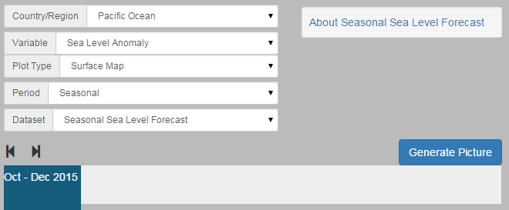

(2) Select the “Sea Level Anomaly” option using the ‘Variable’ drop down box.

(4) Click the ‘Generate Picture’ button to create a map that you can download to insert into documents, presentations, etc.

(3) The slider at the bottom lets you select the 3-monthly seasonal period for the forecast information.

Description of Parameters

*Sea Level Anomaly (SLA):*

A seasonal SLA forecast shows how the sea level is different from the long-term average. The map shows locations of both higher and lower water levels, indicated by positive and negative numbers. Units for SLA are in millimetres. The seasonal SLA forecasts are created by comparing the model predictions of sea level in the coming months to the long-term averages, using the recent 30-year average from 1981-2010.

The three-monthly period spans from the start of the first month to the end of the final month. For example, a February-March-April forecast is the average of the daily sea level anomalies from 1 February up-to and including 30 April.

Examples of Applications

* **Management of Extreme Sea Level Events:** Stakeholders can use forecasts of extreme sea level to make decisions aimed at the protection of communities and infrastructure (Miles et al., 2013).
* **Monitoring ENSO Impacts:** Sea level varies during El Niño Southern Oscillation events, resulting in significantly high or low levels for many months. This was the cause of much coral die-off in Samoa during the 1997-1998 El Niño event, when sea level dropped in the western Pacific by up to 30 cm, exposing shallow reefs. Samoans refer to this sea level event as “taimasa” - shown in Figure 2 (Widlansky et al., 2014).

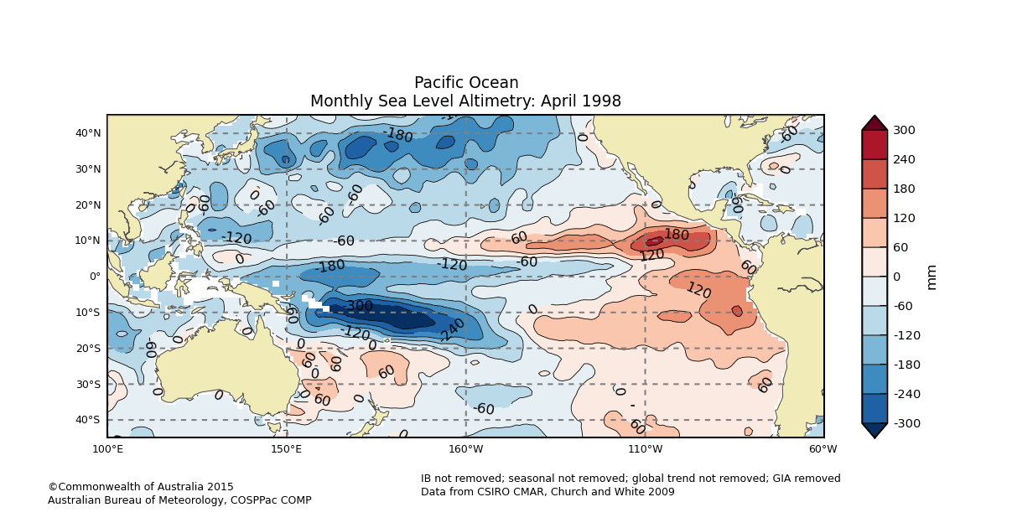

Figure 2. Altimetry data showing ‘taimasa’ which is the low sea level event occurring during certain El Niño events (dark blue region).

Data Source

The forecasts are generated using the Australian Bureau of Meteorology's Predictive Ocean-Atmosphere Model for Australia (POAMA). This is a global ocean-atmosphere coupled ensemble seasonal forecast system developed jointly by the Australian Bureau of Meteorology (BoM) and the CSIRO Division of Marine and Atmospheric Research (CMAR).

POAMA calculates sea surface height (SSH) using a rigid-lid approximation that conserves volume. The SSH is calculated by determining any changes to the height of the grid cell's surface generated by the perpendicular forcing from water being shifted into neighbouring grid columns due to horizontal temperature, salinity and wind gradients. This means that POAMA captures sea level contributions due to dynamic height, barotropic circulation, advection and dissipation processes.

POAMA seasonal sea level anomaly (SLA) forecasts are derived using an ensemble of 33 SSH forecasts by removing the corresponding model climatology, in order to correct for any model bias. The climatologies are computed relative to the start month and lead-time of each model configuration. The ensemble members are then averaged to create the multi-model ensemble mean forecasts (Wang et al., 2004).

Links

Pacific-Australia Climate Change Science Adaptation Planning Program (PACCSAP) webpage for Seasonal Sea Level Anomalies with skill analysis:

<http://poama.bom.gov.au/experimental/pasap/sla.shtml>

About Seasonal Prediction of Sea Level Anomalies in the Western Pacific:

<http://poama.bom.gov.au/experimental/pasap/pacific/about-sea-level-outlooks.shtml>

Help Page for Seasonal Prediction of Sea Level Anomalies in the Western Pacific:

<http://poama.bom.gov.au/experimental/pasap/pacific/help-sea-level-outlooks.shtml>

Disclaimer

The Bureau advises that the information in this service comprises general statements based on scientific research. The Bureau does not warrant, guarantee or make any representations regarding the currency, correctness, accuracy, completeness, reliability, or any other aspect regarding characteristics or use of the information shown on this web portal. The user accepts sole responsibility and risk associated with the use and results of Bureau material in this service, irrespective of the purpose to which such use or results are applied. To the extent permitted by law, the Bureau (including each of its employees) excludes all liability to any person for any consequences, including but not limited to losses, damages, costs, expenses and any other compensation, whether in an action, contract, negligence or tort, arising out of or in connection with the use or performance of Bureau material in this service and any information or material contained in it.

The information shown in this web portal is covered by the Bureau of Meteorology’s Copyright Notice – see <http://www.bom.gov.au/other/copyright.shtml?ref=ftr>.

References

Miles, E., Spillman, C., McIntosh, P., Church, J., Charles, A., de Wit, R., 2013. Seasonal sea-level predictions for the Western Pacific, in: 20th International Congress on Modelling and Simulation. pp. 2855–2861.

Miles, E.R., Spillman, C.M., Church, J.A., McIntosh, P.C., 2014. Seasonal prediction of global sea level anomalies using an ocean–atmosphere dynamical model. Clim Dyn 43, 2131–2145.

Wang, G., Alves, O., Zhong, A., Smith, N., Schiller, A., Meyers, G., Tseitkin, F., Godfrey, S., 2004. POAMA: An Australian ocean-atmosphere model for climate prediction, in: Bulletin of the American Meteorological Society. pp. 4559–4563. doi:J13.18

Widlansky, M.J., Timmermann, A., Mcgregor, S., Stuecker, M.F., Cai, W., 2014. An Interhemispheric tropical sea level seesaw due to el niño taimasa. J. Clim. 27, 1070–1081. doi:10.1175/JCLI-D-13-00276.1

Contact

For more information, please email [cosppac_comp_unit@bom.gov.au](mailto:cosppac_comp_unit@bom.gov.au).

1. POAMA: Predictive Ocean Atmosphere Model for Australia