COSPPac Ocean Portal

About: Chlorophyll-a

*In Brief*

*Recent* ***daily chlorophyll-a*** *maps are available as part of “Coral Reef” and “Fisheries” applications. Data is available for the past seven days but can be quite sparse due to cloud coverage. If data is missing for a particular day it is recommended to check the days before or after instead.*

***Monthly chlorophyll-a*** *maps are accessible in the “Ocean Monitoring” application, and offer a near-complete coverage. They become available at the beginning of the month. Data dates back to 2002.*

*Chlorophyll is commonly used as a proxy for the biomass of phytoplankton, which has applications in fisheries and coral reef management. Chlorophyll-a is the principal photosynthetic pigment.*

Introduction

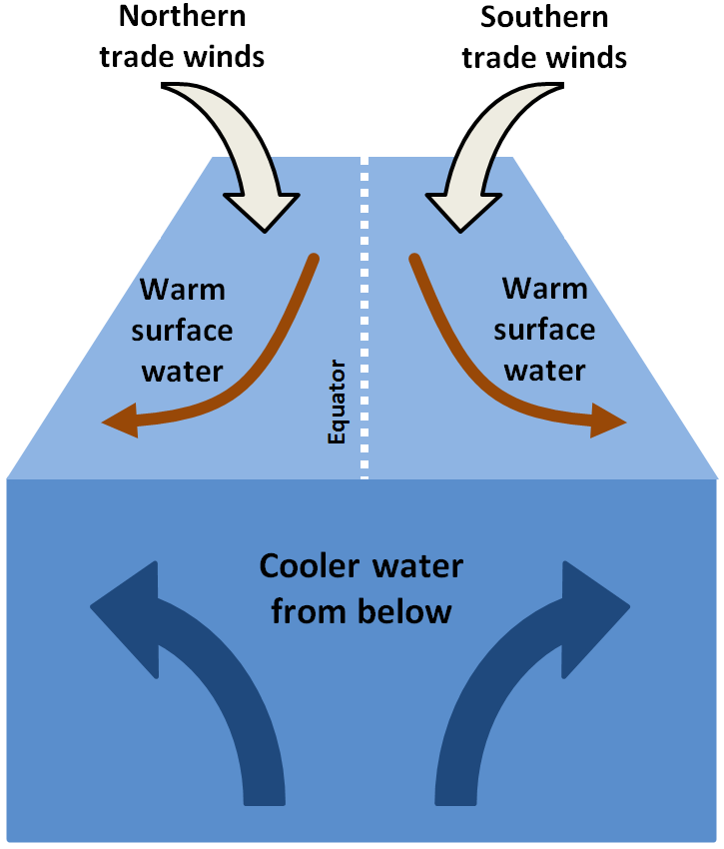At the base of the ocean food chain are plant-like single-cell organisms known as phytoplankton. Similar to plants on land, phytoplankton photosynthesise using light from the sun, combined with water and carbon dioxide, to produce the energy they need to grow and survive. At the core of photosynthesis is the green pigment chlorophyll. High concentrations of phytoplankton in a water body results in high concentrations of chlorophyll, which makes the water take on a greenish colour. The greenness a water body is visible from space. This, in turn, allows the measurement of the concentration of chlorophyll from remote sensors on-board earth observing satellites and is how the daily chlorophyll products are derived.

The highest chlorophyll concentrations are found in coastal waters or in places where ocean currents bring cold water to the surface (known as upwelling), such as around the equator and along some coastlines. Upwellings carry nutrients from the deeper ocean where they have accumulated over time.

A band of chlorophyll-rich water circles the globe at the Equator, with the highest equatorial concentrations in the Atlantic Ocean and the open waters of the Pacific Ocean. This zone of enhanced phytoplankton growth comes from the frequent upwelling of cooler, deeper water as a result of the dominant easterly trade winds blowing across the ocean surface.

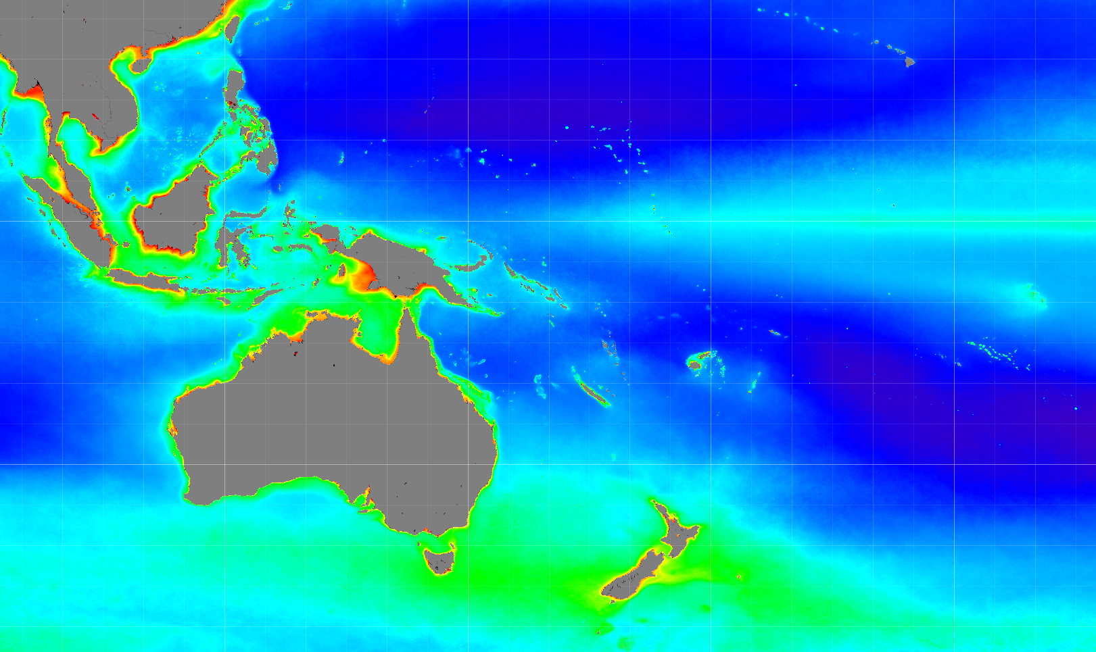

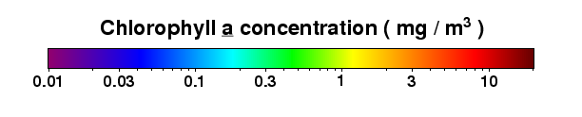

Figure 1. Average sea-surface chlorophyll for entire Aqua MODIS mission (4th July 2002 to 28 February 2015). Persistent higher chlorophyll concentrations can be observed along the Equator, and surrounding Pacific Island coastlines and reefs.

Using the Portal

1. Click the ‘Submit’ button to produce your map.
2. For a regional view of a Pacific Nation’s EEZ, select the country’s name from this drop down box.

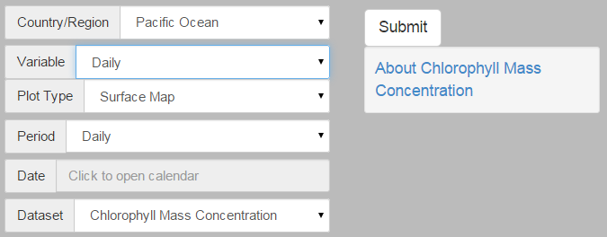

1. Use the Variable menu to select either Chlorophyll ‘Daily’ in the ‘Fisheries’ or ‘Coral Reefs’ applications, or Chlorophyll ‘monthly’ in the ‘Ocean Monitoring’ application.
2. Select either the date for the ‘daily’ data, or the month for the ‘monthly data.

Figure 2. Producing a chlorophyll-a map

Description of Parameters

*Chlorophyll-a:*

Daily maps of chlorophyll-a are available in the “Fisheries” and “Coral Reefs” applications of the Ocean Portal. Units are in milligrams of chlorophyll per cubic metre, and are representative of surface waters only.

Land areas are shown as dark grey. Places where the satellite could not collect data because of sea ice, polar darkness, sensor failure, or clouds are shown as black. Data is available for the past seven days but has significant gaps. If data is missing for a particular day at the location of interest it is recommended to check the days before or after instead to form an estimate of what the chlorophyll-a levels might have been on that day.

Monthly maps are available in the “Ocean Monitoring” application. These maps are formed by combining daily maps over the month, thereby creating an almost complete coverage.

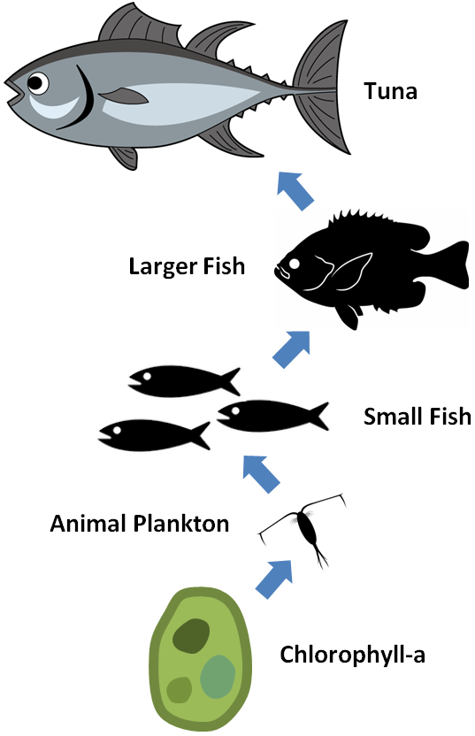HO

Examples of Applications

* **Fisheries:** Most fish in the sea depend either directly or indirectly on the presence of zooplankton (animal plankton), which in turn depends on the presence of phytoplankton (represented by the chlorophyll) for its growth. Fishermen targeting smaller pelagic (open sea) fish may be interested in the chlorophyll concentration in the ocean, because smaller fish are closer to phytoplankton on the food chain. But for large predators, such as tuna, there can be a very large time-lag and great distance between their appearance and that of phytoplankton. Therefore, longline fishermen targeting tuna are often more interested in sea surface temperature and ocean currents (Beverly and Choi, 2011).
* **Monitoring Ocean Health:** These measurements give scientists valuable insights into the health of the ocean environment, and help scientists study the ocean carbon cycle.
* **Fish Disease:** Reef fish diseases, such as ciguatera, can cause both gastrointestinal and neurological effects in humans who consume infected fish. Management of reef fish diseases is primarily achieved through limiting nutrient run-off. Monitoring phytoplankton blooms, which can occur in regions of high nutrient outflow near the coast, using remote sensed chlorophyll can help provide information about environmental conditions such as run off, which can provide an indication of potential hazardous conditions.
* **Crown of Thorns Starfish:** The Crown of Thorns starfish (COTS), Acanthaster planci, is a coral eating pest that can consume up to 13 square metres of reef per year. When an outbreak occurs, a coral reef can be completely wiped out. Coral bleaching, cyclone damage, and COTS are the three biggest threats to coral reefs in the Pacific. COTS outbreaks are highly dependent on the large-scale success of reproduction and larvae development following a spawning event (Lucas, 1982). Feeding on phytoplankton, starfish larvae develop into coral consuming adults over approximately 4-6 months. There have been many correlations of COTS outbreaks with high chlorophyll concentrations, such as the starfish occurrence of January-February of 2009 in Vanuatu (Houk and Raubani, 2010). Chlorophyll fronts in Hawaii (Bograd et al., 2004) and at Palau (Heron et al., 2006) have also been linked to COTS outbreaks (Houk et al., 2007). Chlorophyll, as a proxy for phytoplankton abundance, can be used to monitor potentially fertile areas where COTS spawning is likely to be more successful.
* **Site Selection:** Aquaculture sites thrive when the food supply is consistently abundant. Many filter feeders (i.e. oysters, mussels, clams, scallops) rely on plankton being readily available in the surrounding environment as they have limited to no abilities to forage. Identifying fertile grounds where regular and consistent fronts occur can aid in selecting a suitable site. Similar characteristics can be used to identify candidates for managed marine areas where ecological and biological marine species development can be stimulated and protected.
* **Harmful Algal Blooms:** Harmful algal species are usually naturally occurring algae that reach high enough concentrations and become a hazardous towards fish, animals, or public health. Remote sensing of harmful algal blooms has been shown to be useful for large-scale applications (Wei et al., 2008).

Data Source

The observations come from the Moderate Resolution Imaging Spectroradiometer [(MODIS)](http://modis.gsfc.nasa.gov/) on NASA’s Aqua polar-orbiting satellite. Aqua orbits the Earth every 98.8 minutes and is synchronised with the Sun, meaning that it crosses the equator around local noon on its northward-bound leg. It views the entire Earth every one to two days.

Links

NASA’s OceanColor WEB

<http://oceancolor.gsfc.nasa.gov/cgi/l3>

NASA Earth Observations

<http://neo.sci.gsfc.nasa.gov/view.php?datasetId=MY1DMM_CHLORA>

Disclaimer

The Bureau advises that the information in this service comprises general statements based on scientific research. The Bureau does not warrant, guarantee or make any representations regarding the currency, correctness, accuracy, completeness, reliability, or any other aspect regarding characteristics or use of the information shown on this web portal. The user accepts sole responsibility and risk associated with the use and results of Bureau material in this service, irrespective of the purpose to which such use or results are applied. To the extent permitted by law, the Bureau (including each of its employees) excludes all liability to any person for any consequences, including but not limited to losses, damages, costs, expenses and any other compensation, whether in an action, contract, negligence or tort, arising out of or in connection with the use or performance of Bureau material in this service and any information or material contained in it.

The information shown in this web portal is covered by the Bureau of Meteorology’s Copyright Notice – see <http://www.bom.gov.au/other/copyright.shtml?ref=ftr>.

References

Beverly, S., Choi, Y., 2011. A Beginner’s Guide to Using Remote Sensing for Offshore Tuna Fishing.

Bograd, S.J., Foley, D.G., Schwing, F.B., Wilson, C., Laurs, R.M., Polovina, J.J., Howell, E.A., Brainard, R.E., 2004. On the seasonal and interannual migrations of the transition zone chlorophyll front. Geophys. Res. Lett. 31. doi:10.1029/2004GL020637

Heron, S.F., Metzger, E.J., Skirving, W.J., 2006. Seasonal variations of the ocean surface circulation in the vicinity of Palau. J. Oceanogr. 62, 413–426. doi:10.1007/s10872-006-0065-3

Houk, P., Bograd, S., Woesik, R., 2007. The transition zone chlorophyll front can trigger Acanthaster planci outbreaks in the Pacific Ocean: Historical confirmation. J. Oceanogr. 63, 149–154. doi:10.1007/s10872-007-0013-x

Houk, P., Raubani, J., 2010. Acanthaster planci Outbreaks in Vanuatu Coincide with Ocean Productivity, Furthering Trends throughout the Pacific Ocean. J. Oceanogr. 66, 435–438.

Lucas, J.S., 1982. Quantitative studies of feeding and nutrition during larval development of the coral reef asteroid Acanthaster planci (L.). J. Exp. Mar. Bio. Ecol. doi:10.1016/0022-0981(82)90043-0

Wei, G., Tang, D., Wang, S., 2008. Distribution of chlorophyll and harmful algal blooms (HABs): A review on space based studies in the coastal environments of Chinese marginal seas. Adv. Sp. Res. 41, 12–19. doi:10.1016/j.asr.2007.01.037

Contact

For more information, please email [cosppac_comp_unit@bom.gov.au](mailto:cosppac_comp_unit@bom.gov.au).