COSPPac Ocean Portal

About: Coral Bleaching

*In Brief*

***Coral bleaching alerts*** *are available in both* ***near real-time,*** *and* ***forecast*** *out to* ***4 weeks****,* ***8 weeks****, and* ***12 weeks*** *from NOAA Coral Reef Watch. The near real-time alerts are derived from satellite remote sensing of sea surface temperature (SST) and the forecast is based on the Climate Forecast System (CFS) computer model.*

Introduction

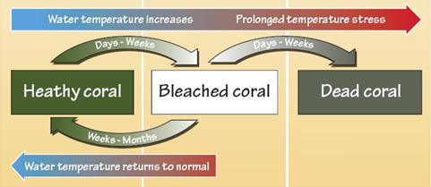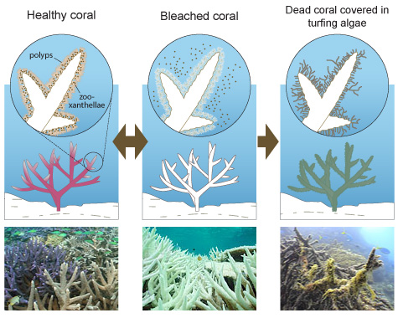Coral bleaching refers to the process whereby corals expel their symbiotic algae (zooxanthellae), leaving the white skeleton visible through the transparent coral tissue. Bleaching is a common stress response of corals, caused on broad scales by elevated sea temperatures. During periods of unusually high sea temperatures, corals can bleach and may eventually die if the heat stress is intense and sustained over several weeks. Aside from temperature, bleaching can also be caused by other stresses such as freshwater inflows, nutrient pollution and intense light.

Different species of coral have different responses and vulnerability to thermal stresses. For example, branching corals are more likely to experience bleaching at lower thermal stress levels than massive corals that are more resilient (Marshall and Baird, 2000).

Figure 1. Coral bleaching process caused by elevated SST.

Source: Great Barrier Reef Marine Park Authority

The coral bleaching datasets in the ocean portal provide bleaching alerts that summarise the location, coverage, and potential risk level of the current coral bleaching thermal stress conditions. A set of thermal stress gauges reflect the highest observed bleaching alert level surrounding selected islands or countries, as seen in Figure 2.

|  |  |  |
| --- | --- | --- |
| **Alert Level** | **Effect** | O:\5. COSPPac COMP Unit\Oceans\Pilot Projects\Coral Bleaching\Updated_Arrows3.png |
| No Data | No alert data available |
| No Stress | No thermal stress |
| Bleaching Watch | Low-level thermal stress |
| Bleaching Warning | Coral bleaching possible |
| Bleaching Alert Level 1 | Coral bleaching likely |
| Bleaching Alert Level 2 | Coral mortality likely |

Figure 2. Bleaching alert level colours and the possible resulting effect, with an example alert dial.

Using the Portal

1. For a regional view of a Pacific Nation’s EEZ, select the country’s name from this drop down box.

*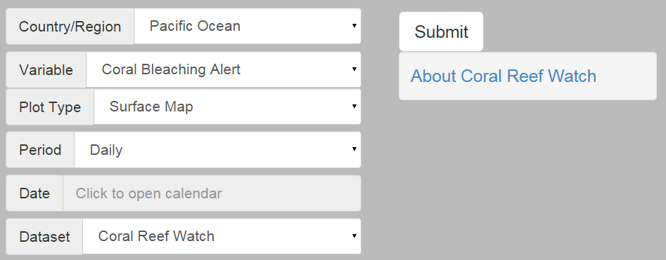*

1. Click the ‘submit’ button to produce your map.
2. If “Coral Bleaching Alert” is selected, the next step is to select the date of interest from the pop-up calendar.

Description of Parameters

*Bleaching Alert:*

Defined in the table below, the bleaching alert levels are based on current values of the coral bleaching HotSpot and Degree Heating Weeks (DHW) products. HotSpot is defined as the positive difference between the satellite-observed SST and the climatologically averaged temperature for the warmest month at that pixel. Degree Heating Weeks is the accumulated thermal stress, and is calculated as the sum of all values of HotSpot ≥ 1ºC during the past 12-week period at that pixel. In the Bleaching Alert Area product every pixel has an alert level defined and is color-coded (see Table 1). The alert reflects the maximum thermal stress experienced in the prior seven days. The data are at 0.05 degree (5 km) resolution, updated daily.

|  |  |  |
| --- | --- | --- |
| Table 1. Coral bleaching thermal stress levels based on the [NOAA Coral Reef Watch 5-km Coral Bleaching HotSpots and DHW products](http://coralreefwatch.noaa.gov/satellite/bleaching5km/index.php). | | |
| **Alert Level** | **Level Definition** | **Effect** |
| No Stress | HotSpot ≤ 0.0 | No thermal stress |
| Bleaching Watch | Watch 0.0 < HotSpot < 1.0 | Low-level thermal stress |
| Bleaching Warning | 1.0 ≤ HotSpot and 0.0 < DHW < 4.0 | Coral bleaching possible |
| Bleaching Alert Level 1 | 1.0 ≤ HotSpot and 4.0 ≤ DHW < 8.0 | Coral bleaching likely |
| Bleaching Alert Level 2 | 1.0 ≤ HotSpot and 8.0 ≤ DHW | Coral mortality likely |

A status level of "Bleaching Watch" means that there is low-level thermal stress present at that location but not of sufficient magnitude to accumulate stress for corals, should they exist in that location. Previous thermal stress exposure may still have adverse impacts on the corals, although recovery may be underway. If SST at a location exceeds the bleaching threshold (maximum monthly mean climatology + 1ºC, = HotSpot of 1°C) then a bleaching warning is issued. Alert Level 1 indicates that DHW has reached 4ºC-weeks and coral bleaching is likely to occur for some coral species. Alert Level 2 indicates DHW has reached 8ºC-weeks and both widespread bleaching and significant coral mortality are likely. The bleaching intensities given are representative of ecosystem impacts for most coral reef communities. Coral species more susceptible to thermal stress may experience bleaching during a Bleaching Warning, while resistant species may only bleach during Alert Level 2. A worked example of the bleaching alert calculation for one pixel location is show in Table 2.

|  |  |  |  |  |  |  |  |  |  |  |  |  |  |  |  |  |  |  |  |  |  |  |
| --- | --- | --- | --- | --- | --- | --- | --- | --- | --- | --- | --- | --- | --- | --- | --- | --- | --- | --- | --- | --- | --- | --- |
|  | Table 2. Worked calculation over 22 weeks for the bleaching alert level, shown as colours. | | | | | | | | | | | | | | | | | | | | | |
|  | **Week Number** | | | | | | | | | | | | | | | | | | | | | |
|  | **1** | **2** | **3** | **4** | **5** | **6** | **7** | **8** | **9** | **10** | **11** | **12** | **13** | **14** | **15** | **16** | **17** | **18** | **19** | **20** | **21** | **22** |
| **Observed SST** | 26 | 26 | 26 | 27 | 27 | 28 | 28 | 29 | 29 | 30 | 30 | 31 | 30 | 31 | 30 | 31 | 32 | 32 | 31 | 30 | 29 | 28 |
| **Average SST for**  **warmest month** | 29.1 | 29.1 | 29.1 | 29.1 | 29.1 | 29.1 | 29.1 | 29.1 | 29.1 | 29.1 | 29.1 | 29.1 | 29.1 | 29.1 | 29.1 | 29.1 | 29.1 | 29.1 | 29.1 | 29.1 | 29.1 | 29.1 |
| **Difference between obs & warmest month SST** | -3.1 | -3.1 | -3.1 | -2.1 | -2.1 | -1.1 | -1.1 | -0.1 | -0.1 | 0.9 | 0.9 | 1.9 | 0.9 | 1.9 | 0.9 | 1.9 | 2.9 | 2.9 | 1.9 | 0.9 | -0.1 | -1.1 |
| **HotSpot** | **0** | **0** | **0** | **0** | **0** | **0** | **0** | **0** | **0** | **0.9** | **0.9** | **1.9** | **0.9** | **1.9** | **0.9** | **1.9** | **2.9** | **2.9** | **1.9** | **0.9** | **0** | **0** |
| **Degree Heating Weeks** | **-** | **-** | **-** | **-** | **-** | **-** | **-** | **-** | **-** | **-** | **-** | **-** | **1.9** | **1.9** | **3.8** | **3.8** | **5.7** | **8.6** | **11.5** | **13.4** | **13.4** | **13.4** |

*Bleaching Outlooks:*

The seasonal coral bleaching thermal stress outlook product has a 0.5°x0.5° spatial resolution and is based on sea surface temperature (SST) forecasts generated by an operational, dynamical, fully coupled ocean-land-atmosphere seasonal climate forecast model. The output is probabilistic, showing 60% chance of the thermal stress occurring. Alert forecasts are presented for 4 weeks, 8 weeks, and 12 weeks in the future.

In a normal year, the outlook forecasts no potential for bleaching. When the forecast SST exceeds bleaching thresholds over a long enough period to cause bleaching, the Outlook maps display the bleaching potential. Actual conditions may vary due to model uncertainty, subsequent changes in the broad-scale climate, extreme localized variability, or weather patterns.

Examples of Applications

**Bleaching Response & Management**

When combined with the implementation of a management plan, advanced knowledge of potential bleaching events can reduce the severity of the bleaching event and aid in recovery. Following a bleaching event, coral recovery can be inhibited by opportunistic algae growth. Limiting fishing in the region can increase fish populations, which in turn maximises the consumption of plant growth and limits their impact on the corals. Corals are also impacted by poor water quality. Therefore, land management practices which reduce chemical and sediment runoff can also help coral recover in the event of bleaching.

The bleaching alerts serve as an early warning system. Once a potential bleaching event is detected, a management plan should be implemented to reduce the impacts of the bleaching. An example of a management plan based on basic resources is listed below (Marshall and Schuttenberg, 2006).

* Early Warning System
  + Identify potential bleaching event
  + Monitor the coral reef sites
* Impact Assessment
  + Assess severity of the bleaching
  + Identify coral types affected
  + Report bleaching event to ReefBase

(see Links section for online form; offline form is in Appendix A)

* Management Interventions
  + Protect herbivore populations through fishing regulations
  + Protect water quality by limiting harmful land-use practice
* Communication
  + Talk to local community and media about bleaching event
  + Brief senior decision makers
  + Meet with other key stakeholders

Data Source

The [Bleaching Alert Area data](http://coralreefwatch.noaa.gov/satellite/bleaching5km/index.php) are part of the NOAA [Coral Reef Watch](http://coralreefwatch.noaa.gov/satellite/index.php) suite of products. The alerts are derived from SST measurements sourced from the NESDIS daily global 5-km geostationary-polar-orbiting (geo-polar) blended night-time-only SST analysis (Liu et al, 2014).

The [weekly 0.5-degree thermal stress outlooks](http://coralreefwatch.noaa.gov/satellite/bleachingoutlook_cfs/outlook_cfs.php) are derived from the NOAA/National Weather Service/National Centers for Environmental Prediction's (NCEP) Climate Forecast System (CFS). A detailed description of the CFS-based Seasonal Bleaching Outlook product is given in Eakin et al. (2012).

Links

NOAA Coral Reef Watch Home web page:

<http://coralreefwatch.noaa.gov/satellite/index.php>

ReefBase Bleaching Report

<http://www.reefbase.org/contribute/bleachingreport.aspx>

A Reef Manager’s Guide to Coral Bleaching

<http://www.gbrmpa.gov.au/__data/assets/pdf_file/0013/4450/Gbrmpa-ReefManagersGuidetoCoralBleaching.pdf>

Disclaimer

The Bureau advises that the information in this service comprises general statements based on scientific research. The Bureau does not warrant, guarantee or make any representations regarding the currency, correctness, accuracy, completeness, reliability, or any other aspect regarding characteristics or use of the information shown on this web portal. The user accepts sole responsibility and risk associated with the use and results of Bureau material in this service, irrespective of the purpose to which such use or results are applied. To the extent permitted by law, the Bureau (including each of its employees) excludes all liability to any person for any consequences, including but not limited to losses, damages, costs, expenses and any other compensation, whether in an action, contract, negligence or tort, arising out of or in connection with the use or performance of Bureau material in this service and any information or material contained in it.

References

Eakin, C.M., G. Liu, M. Chen, A. Kumar (2012). Ghost of bleaching future: Seasonal Outlooks from NOAA's Operational Climate Forecast System. Proceedings of the 12th International Coral Reef Symposium, Cairns, Australia, 9-13 July 2012. ---  **[Free download](http://www.icrs2012.com/proceedings/manuscripts/ICRS2012_10A_1.pdf" \t "_blank)** from the conference website.

Liu, G, Heron SF, Eakin CM, Muller-Karger FE, Vega-Rodriguez M, Guild LS, De La Cour JL, Geiger EF, Skirving WJ, Burgess TFR, Strong AE, Harris A, Maturi E, Ignatov A, Sapper J, Li J, Lynds S (2014) Reef-scale Thermal Stress Monitoring of Coral Ecosystems: New 5-km Global Products from NOAA Coral Reef Watch. *Remote Sensing* 6(11): 11579-11606, doi:10.3390/rs61111579.   
      ---  **[Free download](http://www.mdpi.com/2072-4292/6/11/11579" \t "_blank)**.

Marshall, P.A., Baird, A.H. (2000). Bleaching of corals on the Great Barrier Reef: differential susceptibilities among taxa. Coral Reefs 19: 155-163.

Marshall, P. and Schuttenberg, H., 2006. A Reef Manager’s Guide to Coral Bleaching. Great Barrier Reef Marine Park Authority, Townsville. (see links section for free download)

Contact

For more information, please email cosppac\_comp\_unit@bom.gov.au

Coral bleaching, which occurs predominantly during periods of hot, calm weather, is a major threat to coral reef health and survival. Bleached corals appear white or extremely pale compared to their natural brownish color. If you have made any observations of coral bleaching, please provide details of your observation below, or submit an online report at <http://www.reefbase.org/contribute/bleachingreport.aspx>. Your contribution will be made available on the ReefBase web site for managers and researchers interested in managing the impacts of bleaching on coral reefs.

|  |  |  |  |  |  |
| --- | --- | --- | --- | --- | --- |
| Name |  | | | Contact/Email |  |
| Organization (if applicable) |  | | | | |
| Country/Territory/State |  | | | | |
| Reef or Site Name |  | | | Latitude and Longitude (if known) |  |
| Date of observation | | | | | |
| Did you observe coral bleaching (pale or white colonies) on the reef during your visit?  No Yes – If yes, please complete the rest of the form. If no, please send the form with  only the site details above filled in. | | | | | |
| Approximate area surveyed (m2) | |  | Type of survey conducted (line transect, belt transect, quadrat, etc.) | |  |
| Number of surveyors | |  | Skill level of surveyor(s): (beginner, intermediate, advanced, expert) | |  |
| Water temperature | |  | Location in reef zone  (slope/reef flat/ etc.) | |  |
| Type of Coral dominating the reef (List top 5 species or common names) | |  | | | |
| Depth bleaching was observed | |  | Date bleaching started (if known) | |  |
| Percentage of live coral cover on reef | |  | Percentage of live coral that is bleached | |  |
| Type of live Coral bleached (List top 5 species or common names) | |  | | | |
| Percentage of dead coral on reef | |  | | | |
| Type of dead Coral (List top 5 species or common names) | |  | | | |
| Other observations | |  | | | |

Please e-mail, mail, or fax this report to:

ReefBase Project Leader • The WorldFish Center

Jalan Batu Maung, Batu Maung • 11960 Bayan Lepas • Penang, Malaysia

Telephone: (604) 626-1606 • Fax: (604) 626-5530 • Email: [reefbase@cgiar.org](mailto:reefbase@cgiar.org)