COSPPac Ocean Portal

About: Forecast Ocean Currents

*In Brief*

***Surface Ocean Currents*** *forecast information is available showing a* ***short term forecast****. Currents are viewed as a* ***speed*** *with a* ***direction****. The colour represents the speed and the direction is displayed as an arrow.*

*The currents provided are driven by wind and density changes due to temperature and salinity. The model represents offshore currents in the open ocean; it does not account for local effects in the coastal zone.*

Introduction

Even on a seemingly calm day, the ocean is always on the move, from the surface to the depths below. Currents move water in mainly horizontal directions (but also in vertical directions) and are driven by wind blowing across the ocean surface, differences in density related to salinity and temperature, and astronomical tides. Currents are steered by the rotation of the Earth as well as the locations of land masses and the shape of the ocean floor.

Ocean currents play a crucial role in:

* The transportation energy via heat and salt;
* Transport of nutrients and other chemicals, some of these may be pollutants and contaminants;
* Regulating the weather and climate; and,
* Sustaining marine ecosystems that are home to countless plants and animals that rely on the ocean for life.

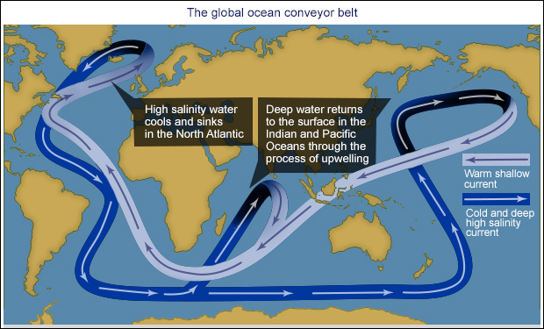Salinity and temperature determine the density or buoyancy of sea water. Generally at scales of 100 - 1000 km in the open ocean, warmer water with a lower salinity (less salty) is less dense and has a higher sea surface height than denser cooler water with a higher salinity. The difference in sea surface height between two areas creates a current, as water flows from the higher sea surface towards the lower sea surface.

On a global scale, changes in ocean density drive the transport of warm water poleward on the surface, to be replaced by the upwelling of cold, deep water originating from the polar regions. This transport of water drives the global thermohaline circulation (i.e. the circulation of heat and salt) within the ocean. This has been called the Global Conveyor Belt, and a particle of water can take up to 1,000 years to complete the journey.

Figure 1. The general directions of the Global Conveyor belt

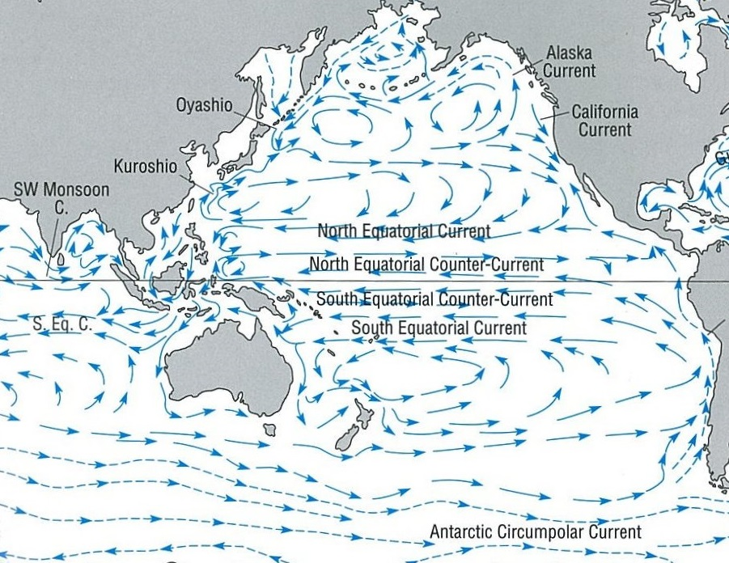At a basin scale, basin-wide circulations referred to as gyres are driven by large-scale atmospheric surface winds. The patterns of circulation are determined by the speed and direction of atmospheric winds, and the shapes of the ocean basins (Figure 2). It has been reported that garbage and debris accumulates within the gyres (Moore, 2003).

South Pacific Gyre

North Pacific Gyre

Subpolar Gyre

Figure 2. The gyres of the Pacific Ocean. Picture source: Colling (2007).

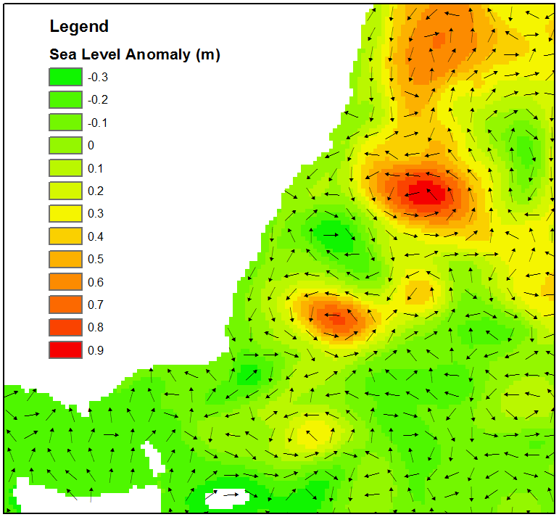On a smaller scale, circulations known as ‘eddies’ are swirling movements that can be between 10 km to 200 km in diameter. They are relatively short-lived and are created when water spins away from a surface ocean current (Figure 3).

The water movement associated with tides induces relatively small tidal currents in the open oceans, but these currents can be substantially magnified by shallow water at coastal locations.

Currents have a major impact on human activities that take place in the marine environment, weather and climate, and the biological characteristics of the ocean.

Figure 3. Anti-cyclonic (clockwise) eddies can be observed forming around higher sea level anomalies off the east coast of Australia (source: OceanMaps model)

Using the Portal

(1) For a regional view of a Pacific Nation’s EEZ, select the country’s name from this drop down box.

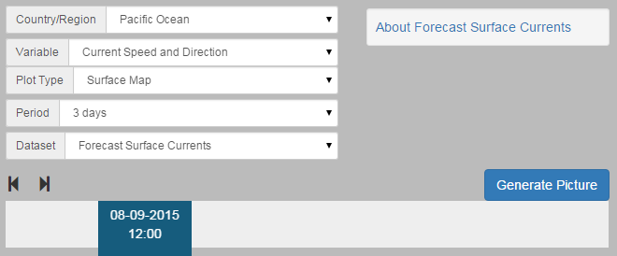

(4) Click the ‘Generate Picture’ button to create a map that you can download to insert into documents, presentations, etc.

(2) Select the ‘Current Speed’ parameter using the ‘Variable’ drop down box.

(3) The slider at the bottom lets you select the date and time for the forecast information.

Description of Parameters

*Current Speed with Direction:*

The colours show the strength of the current speed in metres per second, while the arrows show the direction of the current. The currents shown in the Portal are indicative of the ocean surface offshore; they do not account for local effects in the coastal zone. The resolution of the dataset is 0.08°

Examples of Applications

* **Shipping:** Opposing currents can cause delays in shipping activities and increased fuel costs, which also leads to increased CO2 emissions. Forecast ocean currents can be incorporated into route planning for offshore shipping activities in the Pacific, including inter-island ferry services.
* **Search & Rescue:** Ocean current forecasts can be used to track probable paths of people lost at sea and drifting survivor craft to improve search and rescue efforts, and to assist in estimating search areas.
* **Oil Spill Management:** Floating on the ocean surface, oil spills are spread by winds and currents.Forecast knowledge of possible oil slick movement can help inform an effective spill response, in theory leading to a reduction in potential clean-up costs and environmental impacts.

Data Source

The HYCOM Consortium provides near real-time global ocean prediction system based on the Hybrid Coordinate ocean Model (HYCOM) (Chassignet et al., 2007) and the Navy Coupled Ocean Data Assimilation (NCODA) (Lunde and Coelho, 2009). Surface forcing is from the NAVy Global Environmental Model (NAVGEM) version 1.2 The HYCOM models 3-dimensional temperature, salinity, and current structure with the ability to depict mesoscale features (fronts and eddies). Model resolution is 0.08 degrees.

Links

HYCOM + NCODA Global 1/12° Analysis

<https://hycom.org/dataserver/glb-analysis>

Disclaimer

The Bureau advises that the information in this service comprises general statements based on scientific research. The Bureau does not warrant, guarantee or make any representations regarding the currency, correctness, accuracy, completeness, reliability, or any other aspect regarding characteristics or use of the information shown on this web portal. The user accepts sole responsibility and risk associated with the use and results of Bureau material in this service, irrespective of the purpose to which such use or results are applied. To the extent permitted by law, the Bureau (including each of its employees) excludes all liability to any person for any consequences, including but not limited to losses, damages, costs, expenses and any other compensation, whether in an action, contract, negligence or tort, arising out of or in connection with the use or performance of Bureau material in this service and any information or material contained in it.

The information shown in this web portal is covered by the Bureau of Meteorology’s Copyright Notice – see <http://www.bom.gov.au/other/copyright.shtml?ref=ftr>.

References

Chassignet, E.P., Hurlburt, H.E., Smedstad, O.M., Halliwell, G.R., Hogan, P.J., Wallcraft, A.J., Baraille, R., Bleck, R., 2007. The HYCOM (HYbrid Coordinate Ocean Model) data assimilative system. J. Mar. Syst. 65, 60–83. doi:10.1016/j.jmarsys.2005.09.016

Colling, A., 2007. Ocean Circulation, 2nd ed. Butterworth-Heinemann, Oxford.

Lunde, B.N., Coelho, E.F., 2009. Implementations of the Navy Coupled Ocean Data Assimilation system at the Naval Oceanographic Office. Ocean. 2009, MTS/IEEE Biloxi - Mar. Technol. Our Futur. Glob. Local Challenges.

Moore, C., 2003. Trashed: across the Pacific Ocean, plastics, plastics, everywhere. Nat. Hist. 112, 17–55.

Contact

For more information, please email [cosppac_comp_unit@bom.gov.au](mailto:cosppac_comp_unit@bom.gov.au).