COSPPac Ocean Portal

About: Historical Sea level Data

*In Brief*

*The historical sea level data available from the ocean portal consists of* ***satellite altimetry****,* ***reconstructed****, and* ***tide gauge*** *observation data.*

***Satellite altimetry*** *and* ***reconstructed*** *data can be viewed as* ***maps*** *showing spatial differences in sea level as a monthly average. Time series data can also be extracted and viewed as a* ***chart*** *by indicating a point on the portal map.*

***Tide gauge*** *observational data is available from the locations of the tide gauges around the southwest Pacific that are part of the Pacific Sea Level Monitoring (PSLM) Project.*

Introduction

There are many factors that influence the sea level at a particular location, and these factors span several time scales. Short-term sea level fluctuations are caused by waves created from local of distant winds. Medium-term time scale influences include long waves, tsunamis, tides and storm surges. Long time scale sea level variations include seasonal cycles driven primarily by temperature, El Niño Southern Oscillation (ENSO), inter-decadal Pacific Oscillation (IPO), sea level rise due to climate change, and the glacial isotactic adjustment (GIA).

|  |  |  |
| --- | --- | --- |
| Table 1. Contributing factors to sea level, see Stephens and Bell (2012) for more details | | |
| **Category** | **Phenomenon** | **Period** |
| **Short Waves** | Wind Waves | 1 – 8 sec |
| Swell | 8 – 25 sec |
| **Long Waves** | Infra-gravity Waves | 25 – 120 sec |
| Tsunami | 5 min – 1 hr |
| Seiche | 20 min – 4 hr |
| Astronomical Tides | 3 – 25 hr |
| Storm Surge (winds) | 12 hr – 5 days |
| Storm Surge (Atmospheric Pressure) | 12 hr – 5 days |
| **Climate Cycles and Trends** | Seasonal Cycles | 1 yr |
| El Niño Southern Oscillation | 2 – 5 yr |
| Inter-decadal Pacific Oscillation | 20 – 30 yr |
| Sea level rise | > 50 yr |
| Glacial Isostatic Adjustment | > 1,000 yr |

The sea level data in the Ocean Portal are available in monthly periods. This is achieved through averaging techniques that ultimately remove influences from short and long waves due to their smaller time scales ranging from seconds to days (this includes tides). The data show effects due to longer term climate cycles and changes.

Sea level observations can be recorded by either remote sensing methods, i.e. satellites for the altimetry data, or *in situ* gauges that are physically taking measurements at a specific location.

Using the Portal

(1) Use the Variable menu to select one of ‘Altimetry’, ‘Reconstruction’ or ‘Tide Gauge’.

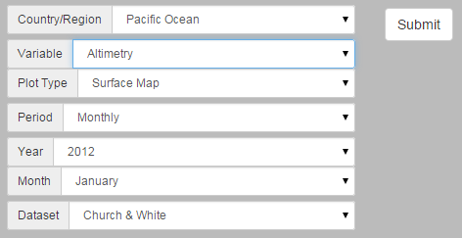

(4) Click the ‘Submit’ button to produce your map.

(3) If ‘Surface Map’ is selected as the Plot Type, a date (Year and Month) must be selected.

(2) For Altimetry or Reconstruction, the Plot Type menu can then be used to select either a ‘Surface Map’ or ‘Timeseries’.

Figure 1. Producing a sea level map

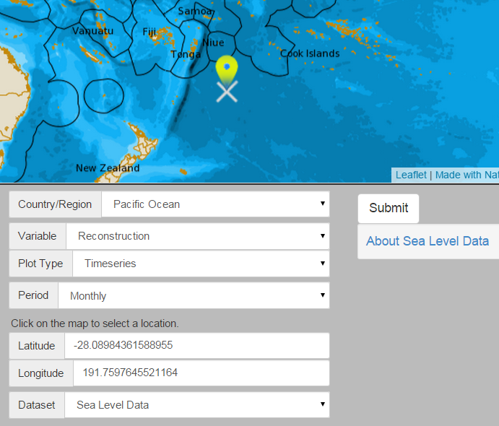

(2) This can be achieved by moving the mouse cursor to the position of interest on the map and clicking the ‘Submit’ button.

(1) Alternatively, if ‘Timeseries’ was selected in step 2 from Figure 1, then a location must be selected on the map.

Figure 2. Producing a time series from altimetry or reconstruction datasets

(1) If ‘Tidal Gauge’ was chosen from the Variable menu in step 1 from Figure 1, then the tidal gauges will be displayed as yellow markers on the map.

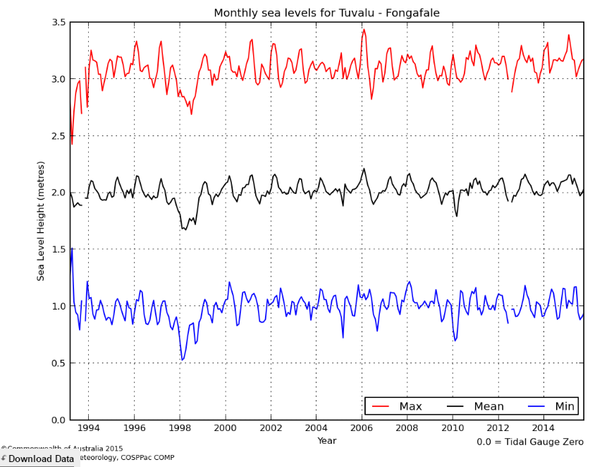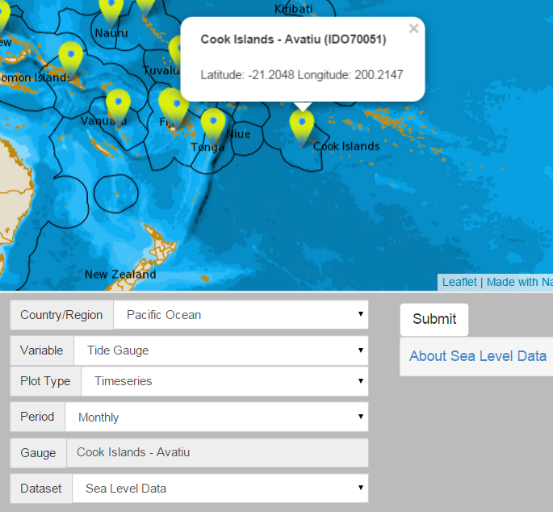

(3) Monthly data can be downloaded as a text file by clicking the ‘Download Data’ button that appears on the bottom left of the time-series plot.

(2) Click the tide gauge of interest before clicking Submit.

Figure 3. Producing a time series from tide gauge data

Description of Parameters

*Altimetry:*

Dating from 1993, satellite altimeter data provide a global perspective of sea level, enabling the tide gauge data to be placed in context. Three satellites have been used: TOPEX/Poseidon, Jason-1 and OSTM/Jason-2. They each reference a different height datum – see *Church and White 2011* (below) for more information. Data is available as a monthly mean anomaly (in millimetres) spanning the period January 1993 to August 2014, which will be periodically updated.

*Reconstruction:*

Using relationships between a historical global tide gauge network and satellite altimetry in the recent record, Church et al. (2004) have developed a technique to reconstruct the spatial data back in time prior to the satellite era. Data are available as a monthly mean anomaly (in mm), spanning the period from January 1950 to December 2012, which will be periodically updated. Both the altimetry and reconstruction gridded datasets have a 1° (latitude) by 1° (longitude) resolution over the region from 60°E to 210°E, and from 15°N to 65°S.

*Tide Gauge:*

The tide gauges in the Ocean Portal form part of the Australian Baseline Sea Level Monitoring Project (ABSLMP) and the Pacific Sea Level and Monitoring (PSLM) Project. The tide gauge data available in the portal are monthly means, along with monthly maximum and monthly minimum measurements in metres. The length of the data series for tide gauges varies from site to site, although most of the south Pacific tide gauges were installed between 1992 and 1994. Data are currently updated monthly.

Note: Tide gauges track the height of the sea relative to a local reference point, while the altimetry and reconstruction data refer to the Geodetic Datum GSFC00.1.

Each dataset has a different combination of observable phenomena depending on the processing techniques applied when they were created.

|  |  |  |  |
| --- | --- | --- | --- |
| Table 2. Phenomena that can contribute to sea level in each dataset | | | |
| **Phenomenon** | **Tide Gauges** | **Altimetry** | **Reconstruction** |
| Atmospheric Pressure | ✓ | ✓ | ✗ |
| Seasonal Cycles | ✓ | ✓ | ✗ |
| El Niño Southern Oscillation | ✓ | ✓ | ✓ |
| Inter-decadal Pacific Oscillation | ✓ | ✓ | ✓ |
| Sea level rise | ✓ | ✓ | ✓ |
| Glacial Isostatic Adjustment | ✓ | ✗ | ✗ |

Examples of Applications

* **Monitoring ENSO Impacts:** Sea level varies in similar patterns to sea surface temperature during El Niño Southern Oscillation events, resulting in significantly high or low levels for many months. This was the cause of much coral die-off in Samoa during the 1997-1998 El Niño event. Samoans refer to this sea level event as “taimasa”.

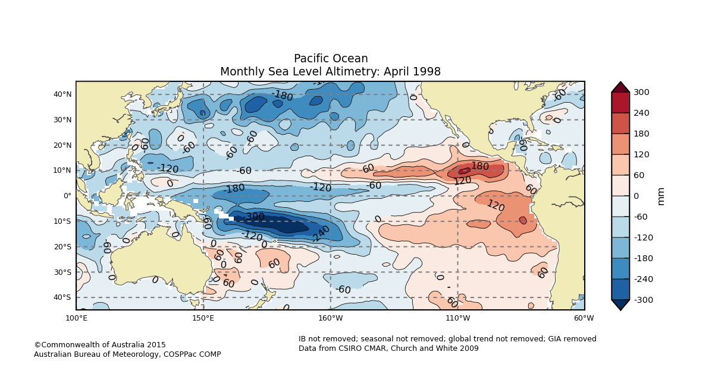

Figure 4. The dark blue area is ‘taimasa’, the low sea level event occurring during certain El Niño events

* **Sea Level Rise:** There is a strong interest in sea level rise amongst low lying nations that are susceptible to inundation and coastal erosion. The reconstruction data covers a large enough time period to capture sea level rise due to climate change.
* **Links between Weather and Sea Level:** Tide gauge data show the minimum and maximum recorded monthly sea level measurements, which are largely attributable to residual from weather-related drivers. Residual refers to effects from storm surge including wind setup and setdown (water being pushed towards or away from the coast due to wind), and effects from atmospheric pressure. Typically a decrease of 1 millibar (hPa) in atmospheric pressure leads to a 1cm rise in sea level.
* **IPO Studies[1]:** The Inter-decadal Pacific Oscillation (IPO) characterises decade-to-decade changes in ENSO cycles, thereby having an effect on sea level. The oscillation can stay in a positive or negative phase for years to decades, and jump to the opposite phase relatively quickly causing a step jump in mean sea level (Stephens and Bell, 2012).



Figure 5. Movement of the IPO over the decades (PCCSP, 2011)

Data Source

The tide gauge data can be found on the [Australian Baseline Sea Level Monitoring Project (ABSLMP)](http://www.bom.gov.au/oceanography/projects/abslmp/abslmp.shtml) website, with additional statistical and project informant found at the [Pacific Sea Level Monitoring](http://www.bom.gov.au/pacific/projects/pslm/index.shtml) website (see ‘Links’ section).

The altimetry and reconstruction gridded datasets are sourced from CSIRO. We recommend you read the information at <http://www.cmar.csiro.au/sealevel/sl_data_cmar.html> to understand how the datasets have been compiled.

Links

Australian Baseline Sea Level Monitoring Project:

<http://www.bom.gov.au/oceanography/projects/abslmp/abslmp.shtml>

Pacific Sea Level Monitoring (PSLM) Project:

<http://www.bom.gov.au/pacific/projects/pslm/>

Pacific Island Country Tide Calendars:

<http://www.bom.gov.au/australia/tides/#!/offshore>

Sea Level Altimetry and Reconstruction Data Downloads

<http://www.cmar.csiro.au/sealevel/sl_data_cmar.html>

Disclaimer

The Bureau advises that the information in this service comprises general statements based on scientific research. The Bureau does not warrant, guarantee or make any representations regarding the currency, correctness, accuracy, completeness, reliability, or any other aspect regarding characteristics or use of the information shown on this web portal. The user accepts sole responsibility and risk associated with the use and results of Bureau material in this service, irrespective of the purpose to which such use or results are applied. To the extent permitted by law, the Bureau (including each of its employees) excludes all liability to any person for any consequences, including but not limited to losses, damages, costs, expenses and any other compensation, whether in an action, contract, negligence or tort, arising out of or in connection with the use or performance of Bureau material in this service and any information or material contained in it.

The information shown in this web portal is covered by the Bureau of Meteorology’s Copyright Notice – see <http://www.bom.gov.au/other/copyright.shtml?ref=ftr>.

When publishing tide gauge data from this site you should acknowledge the National Tidal Unit, the Australian Bureau of Meteorology Australian Baseline Sea Level Monitoring Project (ABSLMP), the South Pacific Sea Level and Climate Monitoring Project (SPSLCMP), and CAWCR. Publishing of the reconstructed data requires acknowledgement of Church et al.

References

Church, J. A., White, N. J., Coleman, R., Lambeck, K. and J. X. Mitrovica, 2004: Estimates of the Regional Distribution of Sea Level Rise over the 1950-2000 Period. Journal of Climate, 17, 2609-2625.

Church, J., and N. White, 2011: Sea-Level Rise from the Late 19th to the Early 21st Century, Surveys in Geophysics, 1-18. <http://link.springer.com/article/10.1007%2Fs10712-011-9119-1>

PCCSP, 2012. Climate Change in the Pacifis: Scientific Assessment and New Research. Volume 1: Regional Overview. Australian Aid.

Stephens, S. and Bell, R., 2012. Toolbox 2.2.2: Causes of sea level variability. NIWA, 15p. <http://www.niwa.co.nz/sites/niwa.co.nz/files/tool_2.2.2_causes_of_sea_level_variability.pdf>

Contact

For more information, please email [cosppac_comp_unit@bom.gov.au](mailto:cosppac_comp_unit@bom.gov.au).

1. The IPO is similar to the Pacific Decadal Oscillation (PDO) in terms of sea temperature changes, but affects ocean waters south of 20° N Latitude, which the PDO does not.