COSPPac Ocean Portal

About: Historical Wave Climate

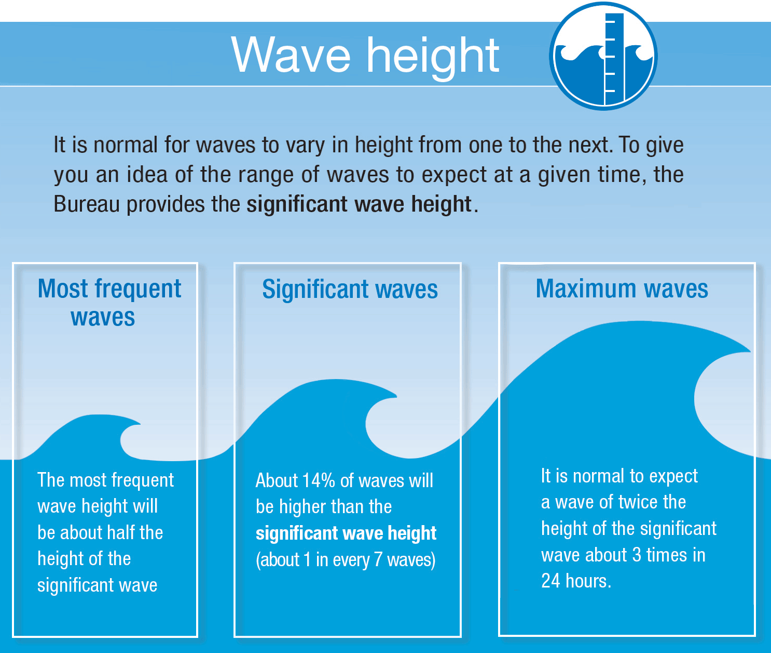

*In Brief*

*Wave information for the period 1979 to 2015 is available as surface maps in hourly intervals. Parameters available are* ***significant******wave height****,* ***mean******wave direction****, and* ***mean wave period.***

*Wave climatology is also presented statistically as histograms and wave roses for the period 1979 to 2009.*

*The data does not account for local effects in the coastal zone. However, when there are large offshore waves travelling towards a coastal region, the waves experienced along the coast will generally be larger than normal as well.*

Introduction

Waves are formed by wind blowing over the surface of water. Wave height is dependent on wind speed, fetch length, and duration the wind blows over the fetch. 'Fetch' is the distance the wind blows over water with similar speed and direction. Higher wind speeds blowing for long periods over longer stretches of water result in the highest waves.

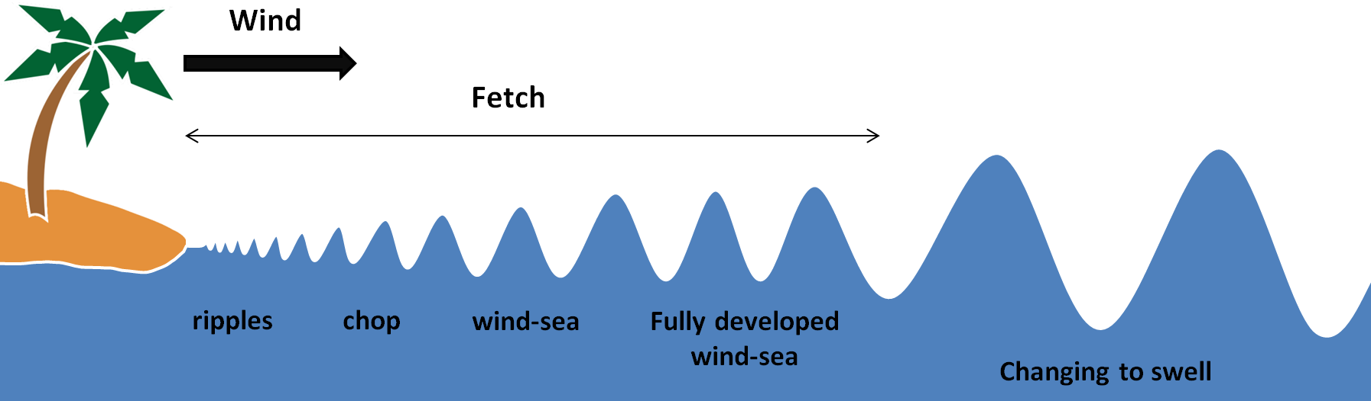

The ocean surface is often observed as having an uneven and chaotic nature. What we are observing is the combination of many waves of different size, shape and speed travelling in different directions. The waves may have been produced by local winds, referred to as wind-sea (or wind waves), or could have been created hundreds or thousands of kilometres away from distant storms, referred to as swell.

As waves travel over these large distances, smaller waves are absorbed by larger ones, faster waves overtake slower waves, all gradually growing and arranging themselves into the regular ‘sets’ familiar to people along the coast. The result of these interactions is that it is normal to experience a wide range of wave heights and periods when on the water.

(2) Select the wave parameter using the ‘Variable’ drop down box.

Using the Portal

(3) Select ‘Surface Map’ to view a certain moment in time from the wave hindcast.

(1) For a regional view of a Pacific Nation’s EEZ, select the country’s name from this drop down box.

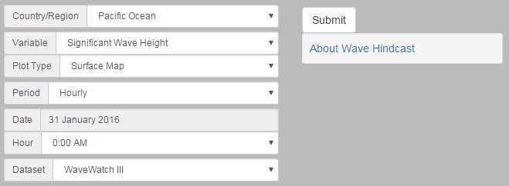

(4) Select the date and time before clicking the ‘Submit’ button.

Figure 1. Viewing a surface map

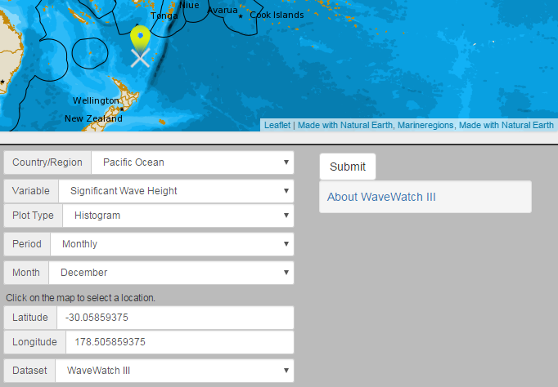

(3) Select the month of interest, and then click the ‘Submit’ button.

(1) Change ‘Plot Type’ to ‘Histogram’ to view statistical information for ‘Significant Wave Height’ and ‘Mean Wave Period’. If ‘Mean Wave Period’ is selected, a wave rose will be generated.

(2) Select a location by clicking anywhere on the map. A yellow marker will appear. Alternatively, manually enter the latitude and longitude by typing in the numbers in the text boxes below.

Figure 2. Viewing a statistical histogram or wave rose

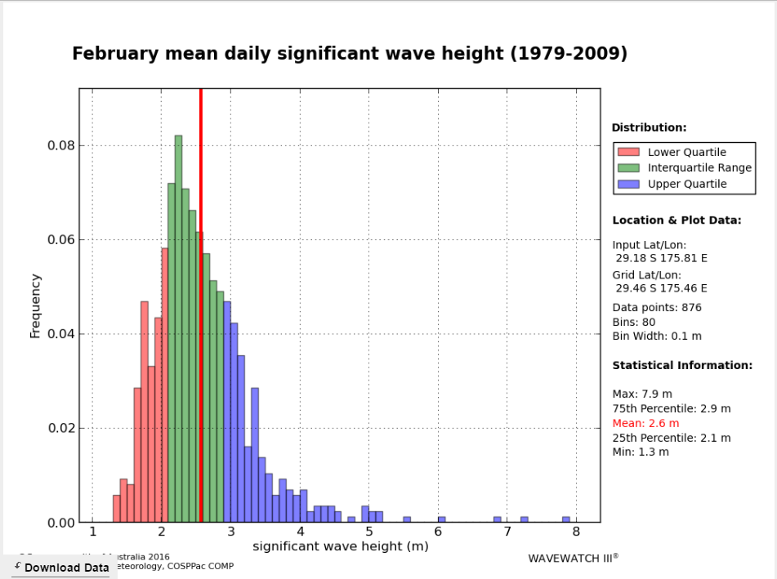

(4) Daily data can be downloaded as a text file by clicking the ‘Download Data’ button that appears on the bottom left of the histogram or wave rose.

Description of Parameters

The modelled wave climatology is only applicable in offshore depths of 25-metres or more. Waves in the coastal zone may have undergone shoaling, reflection, refraction, diffraction, and will ultimately be different from the wave.

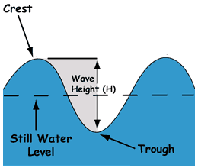*Significant Wave Height:*

This refers to the average height of the highest one-third of all waves, which corresponds to what mariners typically observe on open waters.

*Note on all wave heights:* Wave height is measured in metres, from the wave trough to the wave crest. Some waves will be higher and some lower than the significant wave height. **The probable maximum wave height can be up to twice the significant wave height, which can be expected to occur for about 3 waves in a 24 hour period.**

*Mean Wave Period:*

The wave period is a measurement of the time difference (in seconds) between two successive wave crests of the waves with the largest amount of energy. The ‘mean wave period’ refers to the average wave period of all waves for a given location. Generally, higher wave period indicates a more powerful wave.

*Mean Wave Direction:*

The ‘mean wave direction’ is the average wave direction of all of the waves at a given location, given as a compass bearing in degrees. The arrow shows the direction towards which the waves are moving.

Examples of Applications

* 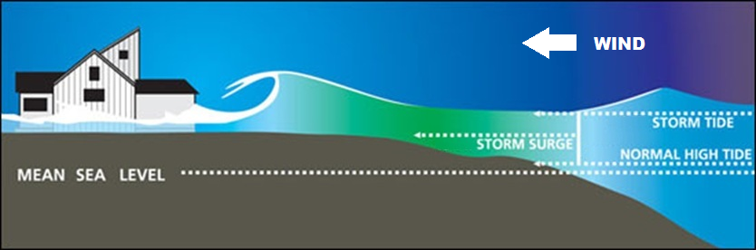**Inundation Events:** Flooding of coastal areas can occur in certain low lying regions when spring tides coincide with large wave events created by storms, either nearby or distant. Estimates of the frequency and severity of extreme waves can inform planning decisions such as appropriate zoning for residential buildings. Historical surface maps for inundation events can be used to determine wave height thresholds for possible coastal inundation.
* **Shipping/Boating:** Wave climatology information can be valuable to determine safe and efficient shipping routes. Previous situations that were hazardous can be diagnosed - historical surface maps can show the sources of waves responsible for causing the hazard.
* **Other Ocean Activities:** Construction works, naval architecture, equipment maintenance, and any other development occurring near the ocean require knowledge of the typical wave climate that a region is likely to experience.

Reading Histograms and Wave Roses

|  |  |
| --- | --- |
| Significant wave height data are presented in a histogram of 10 cm ranges (bins). The histogram is coloured by quartile: red for the first quartile, blue for the fourth quartile, and green for the inter-quartile range (quartiles two and three). Additionally, a red vertical line is used to display the mean of the significant wave heights over all days for the particular month.  The information panel on the right displays important statistical information. Firstly, the latitude and the longitude of the nearest data point to the selected point are displayed, followed by the number of bins, the width of the bins and the total number of data points (days). Below this, the maximum and minimum mean daily significant wave heights are displayed along with the mean daily significant wave height. | http://tunceli/portal/raster/WAV00001_-029.458_+175.458_Hs_02.png |
| Mean wave period data are presented in a similar way to wave height data, with bins of width 0.1 or 0.2 seconds depending upon the spread of the data at the selected location. As for significant wave height, the histogram of wave period data shows quartiles: lower quartile in red; upper quartile in blue; and the inter-quartile range in green. The mean daily value is shown by a vertical red line. | http://tunceli/portal/raster/WAV00001_-022.458_+175.458_Tm_02.png |
| Mean wave direction is presented in a special kind of histogram known as a wind rose, which is useful for visually displaying angular data. The compass points on the wind rose indicate the direction towards which the waves are travelling. Note this oceanographic convention for wave direction is the opposite of the meteorological convention for wind direction. The lengths of the ‘petals’, or bins, of the rose indicate the proportion of waves travelling in one of the eight standard compass directions. Having a width of 45 degrees, these bins are centred on each of these compass directions  The mean of all wave directions is indicated by the red line. The information panel on the right displays statistical information, including the latitude and longitude of the nearest data point to the selected point, the numbers of points (days) and bins, and the bin width. Finally, the mean of the peak wave directions (from north) is shown in red (corresponding to the red line), and percentages of peak wave directions occurring in each of the eight compass directions. | http://tunceli/portal/raster/WAV00001_-022.458_+175.458_Dm_02.png |

Data Source

WAVEWATCH III® is a wind-wave model originally developed by the National Oceanic and Atmospheric Administration. The wave hindcast dataset is a product of the PACCSAP waves project, a joint venture between CSIRO and the Bureau of Meteorology who generated the data for the period 1979 – 2009 (Durrant et al. 2014). Periodic updates are being completed by COSPPac.

The surface maps are generated from hourly data that has a global resolution of 0.4°. Climatology information for histogram and wave roses is extracted from six-hourly time-steps with a resolution of 1° globally between 80°S and 80°N (that has been derived from the hourly data).

Links

PACCSAP Wave Hindcast Dataset:

<http://opendap.bom.gov.au:8080/thredds/catalogs/paccsap-catalog.html>

Disclaimer

The Bureau advises that the information in this service comprises general statements based on scientific research. The Bureau does not warrant, guarantee or make any representations regarding the currency, correctness, accuracy, completeness, reliability, or any other aspect regarding characteristics or use of the information shown on this web portal. The user accepts sole responsibility and risk associated with the use and results of Bureau material in this service, irrespective of the purpose to which such use or results are applied. To the extent permitted by law, the Bureau (including each of its employees) excludes all liability to any person for any consequences, including but not limited to losses, damages, costs, expenses and any other compensation, whether in an action, contract, negligence or tort, arising out of or in connection with the use or performance of Bureau material in this service and any information or material contained in it.

References

Durrant, T, Greenslade, D, Hemar, M & Trenham, C 2014, *CAWCR Technical Report No. 070: A Global Hindcast focussed on the Central and South Pacific*, Melbourne.

Contact

For more information, please email [cosppac_comp_unit@bom.gov.au](mailto:cosppac_comp_unit@bom.gov.au)