COSPPac Ocean Portal

About: Wave and Wind Forecasts

*In Brief*

*Wave and wind forecast information is available with a lead time of* ***seven days****. Parameters available are* ***wave height (wind-sea and swell)****,* ***wave direction****,* ***wave period****, and* ***wind speed with direction****.*

*The wave forecast should be used as an indicator of large wave events that may be travelling towards a particular region. The model may not account for local effects in the coastal zone. However, when there are large offshore waves travelling towards a coastal region, the waves experienced along the coast will generally be larger than normal as well.*

*It is recommended that the wave forecast be accessed repeatedly in the days leading up to the time when wave information is critical, as there are likely to be at least subtle changes in the forecast.*

Introduction

The ocean surface is often observed as having an uneven and chaotic nature. What we are observing is the combination of many waves of different size and speed travelling in different directions. The waves may have been produced by local winds, referred to as wind-sea, or could have been created many kilometres away from distant storms, referred to as swell.

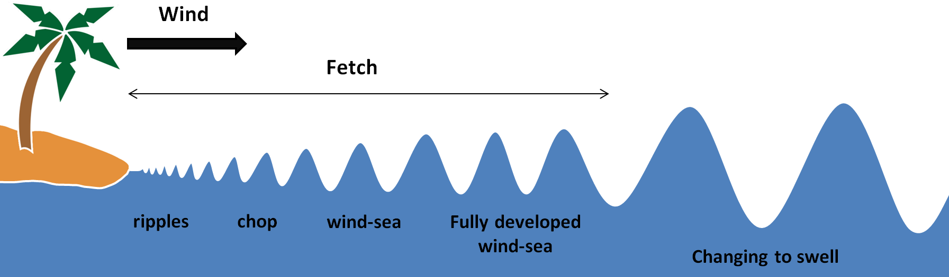

The wave parameters available in the Ocean Portal as part of the wave forecast, describe the attributes of the most significant wind-sea and swell waves, as well as a description of the wave height when wind-sea and swell are combined. The table below shows what the resulting significant wave height can be when wind-sea and swell are combined.

|  |  |  |  |  |  |  |  |  |  |  |
| --- | --- | --- | --- | --- | --- | --- | --- | --- | --- | --- |
|  |  | **Swell Wave Height (metres)** | | | | | | | | |
|  |  | **0** | **0.5** | **1** | **1.5** | **2** | **2.5** | **3** | **4** | **5** |
| **Wind Wave Height**  **(metres)** | **0.5** | 0.5 | 0.7 | 1.1 | 1.6 | 2.1 | 2.6 | 3 | 4 | 5 |
| **1** | 1 | 1.2 | 1.4 | 1.8 | 2.2 | 2.7 | 3.2 | 4.1 | 5.1 |
| **1.5** | 1.5 | 1.6 | 1.8 | 2.1 | 2.5 | 2.9 | 3.4 | 4.3 | 5.2 |
| **2** | 2 | 2.1 | 2.2 | 2.5 | 2.8 | 3.2 | 3.6 | 4.5 | 5.4 |
| **2.5** | 2.5 | 2.6 | 2.7 | 2.9 | 3.2 | 3.5 | 3.9 | 4.7 | 5.6 |
| **3** | 3 | 3 | 3.2 | 3.4 | 3.6 | 3.9 | 4.2 | 5 | 5.8 |
| **4** | 4 | 4 | 4.1 | 4.3 | 4.5 | 4.7 | 5 | 5.7 | 6.4 |

Generally, wave forecasting becomes less precise when the model predicts further into the future, but there is always a margin of error at any forecast time period. The modelled waves are only applicable in offshore depths of 25-metres or more. Waves in the coastal zone may have undergone shoaling, reflection, refraction, diffraction, and will ultimately be different from the wave forecast.

Using the Portal

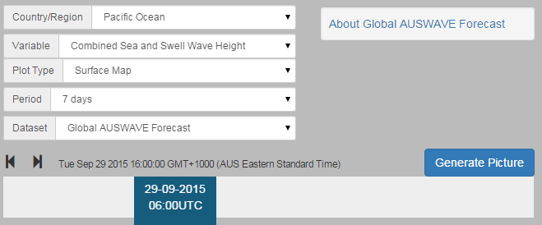

(2) Select the wave or wind parameter using the ‘Variable’ drop down box.

(1) For a regional view of a Pacific Nation’s EEZ, select the country’s name from this drop down box.

(4) Click the ‘Generate Picture’ button to create a map that you can download and insert into documents, presentations, etc.

(3) The slider at the bottom lets you select the date and time for the forecast information.

Description of Parameters

*Wind-sea Wave Height:*

Wind-sea waves (also called ‘sea’ or ‘wind’ waves) waves are generated by the local prevailing wind and vary in size according to the length of time a particular wind has been blowing, the fetch (distance the wind has blown over the sea) and the water depth.

*Swell Wave Height:*

Swell waves are the regular longer period waves generated by distant weather systems. There may be several sets of swell waves travelling in different directions, causing a confused sea state.

*Combined Wind-sea and Swell Wave Height*

Combined wind-sea and swell is also known as total wave height. Combined sea and swell describes the combined height of the sea and the swell that mariners observe on open waters.

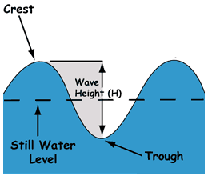*Note on all wave heights:* Wave height is measured in metres, from the wave trough to the wave crest. All wave heights are calculated as the 'significant wave height' which represents the average height of the highest one-third of the waves. Some waves will be higher and some lower than the significant wave height. **The probable maximum wave height can be up to twice the significant wave height, which can be expected to occur for about 3 waves in a 24 hour period.**

*Wave Period:*

‘Peak wave period’ is a measurement of the time difference (in seconds) between two successive wave crests of the waves with the largest amount of energy. Generally, higher wave period indicates are more powerful wave.

*Wave Direction:*

The average wave direction of all of the waves in the spectrum, given as a compass bearing in degrees, and the arrow shows the direction the waves are moving towards.

*Wind Speed and Direction:*

These wind parameters describe the characteristics of wind averaged over a 10-minute period at 10 metres above the sea surface. Wind speed is given in the units of knots, and the arrow direction is a compass bearing that shows the direction the wind is moving towards.

The wind forecasts does not show gusts, which are increases in wind speed lasting for just a few seconds. The speeds are typically 30 to 40 per cent higher than the average wind speed, but stronger gusts are likely in the vicinity of showers, thunderstorms and frontal systems.

Examples of Applications

* **Shipping/Boating:** Critical shipping and ferry activities between islands can be postponed during high wave events that are predicted by the wave forecasts. Additionally, operators of smaller boats may be more interested in the local wind forecast, as many experienced boaters have traditional knowledge regarding what wind conditions can create smaller choppy waves that impact smaller vessels.
* **Tourism/Recreation:** There are many activities that rely on wind and waves for maximum enjoyment and safety of the participants. Some examples of these are surfing, windsurfing, kitesurfing, fishing, scuba diving, snorkelling, boating, and any other recreational activities occurring in (or near) the ocean.
* 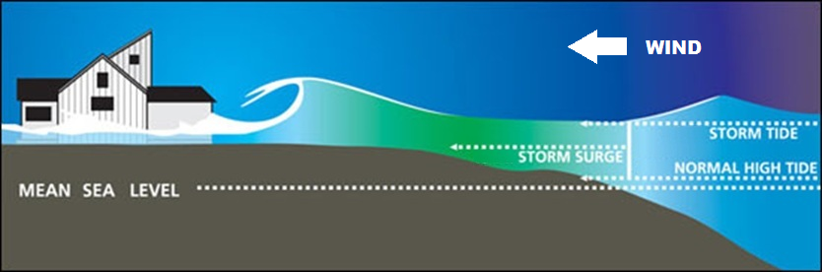**Inundation:** Flooding of coastal areas can occur in certain low lying regions when spring tides coincide with large wave events created by storms many kilometres away. This can become even more problematic when there is a strong onshore wind pushing more water towards the coastline. Wave forecasts can show when there’s the potential for a large wave event to affect a region coinciding with a spring tide and onshore winds. Tidal information can be accessed from: <http://www.bom.gov.au/oceanography/projects/spslcmp/tidecalendars.shtml>
* **Other Ocean Activities:** Construction works, equipment maintenance, or any other development occurring near the ocean may need to have knowledge of possible unmanageable wind and wave conditions.

Data Source

The Bureau of Meteorology operates a global wave forecast model called AUSWAVE that runs twice a day. It is based on version 3.14 of WAVEWATCH III. Operational runs are performed using surface wind data from the Australian Community Climate and Earth-System Simulator (ACCESS). Model spatial resolution is 0.4 degrees globally. Additional details of the model can be found in [NMOC Operations Bulletin Number 92](http://www.bom.gov.au/australia/charts/bulletins/apob92.pdf) (Bureau of Meteorology, 2012).

Links

AUSWAVE description: <http://www.bom.gov.au/nwp/doc/auswave/data.shtml>

Disclaimer

The Bureau advises that the information in this service comprises general statements based on scientific research. The Bureau does not warrant, guarantee or make any representations regarding the currency, correctness, accuracy, completeness, reliability, or any other aspect regarding characteristics or use of the information shown on this web portal. The user accepts sole responsibility and risk associated with the use and results of Bureau material in this service, irrespective of the purpose to which such use or results are applied. To the extent permitted by law, the Bureau (including each of its employees) excludes all liability to any person for any consequences, including but not limited to losses, damages, costs, expenses and any other compensation, whether in an action, contract, negligence or tort, arising out of or in connection with the use or performance of Bureau material in this service and any information or material contained in it.

References

Bureau of Meteorology, 2012. Operational Upgrade to the AUSWAVE Global Wave Model (AUSWAVE-G). NMOC Operations Bulletin Number 92, 10p.

Contact

For more information, please email [cosppac_comp_unit@bom.gov.au](mailto:cosppac_comp_unit@bom.gov.au)