1. Title
Free VPN Server on AWS using OpenVPN Access Server

2. Aim
To deploy a VPN Server on Amazon Web Services (AWS) using OpenVPN Access Server, configure it to route client internet traffic through the AWS server, connect a client device, verify the VPN connection, and safely terminate all AWS resources after completing the practical.
The practical uses the OpenVPN Access Server Marketplace AMI and an EC2 instance.

3. Objectives
- To create a zero-spend budget alert in AWS.
- To select an AWS region for deploying the VPN server.
- To create an EC2 key pair for secure server access.
- To launch an OpenVPN Access Server EC2 instance from AWS Marketplace.
- To configure the required network and security-group rules.
- To connect to the EC2 instance.
- To perform the OpenVPN initial configuration.
- To access the OpenVPN Administration UI.
- To configure VPN networking and routing.
- To create a VPN user.
- To connect a computer/mobile device to the VPN.
- To verify that internet traffic is routed through the AWS VPN server.
- To terminate and clean up AWS resources after the practical.

4. AWS Services Used
AWS Service | Purpose
Amazon EC2 | Hosts the OpenVPN Access Server
AWS Marketplace | Provides the OpenVPN Access Server AMI
Amazon VPC | Provides the virtual network for the EC2 instance
Security Groups | Controls inbound and outbound network traffic
Elastic IP | Optional fixed public IP address
Amazon EBS | Provides storage for the EC2 instance
AWS Billing / Budgets | Creates a zero-spend budget alert
EC2 Key Pair | Provides secure SSH authentication

The practical specifically uses an EC2 instance launched from the OpenVPN Access Server Marketplace AMI, with the required VPN and management ports configured.

5. Prerequisites

Hardware / Software
- Computer or laptop
- Internet connection
- Modern web browser
- AWS account
- AWS Management Console access
- AWS CLI / PowerShell if SSH is required
- OpenVPN Connect application for the client device

AWS Requirements
- AWS account with EC2 access
- Permission to launch EC2 instances
- Access to AWS Marketplace
- A valid email address for budget notifications

Key Pair
An EC2 key pair is required for secure access to the server. In this practical, the key pair used was:
2203-vpn-KP
The private .pem file should be stored securely because AWS does not allow the private key to be downloaded again after creation.

6. Architecture Diagram
The architecture of the implemented VPN system is shown below.
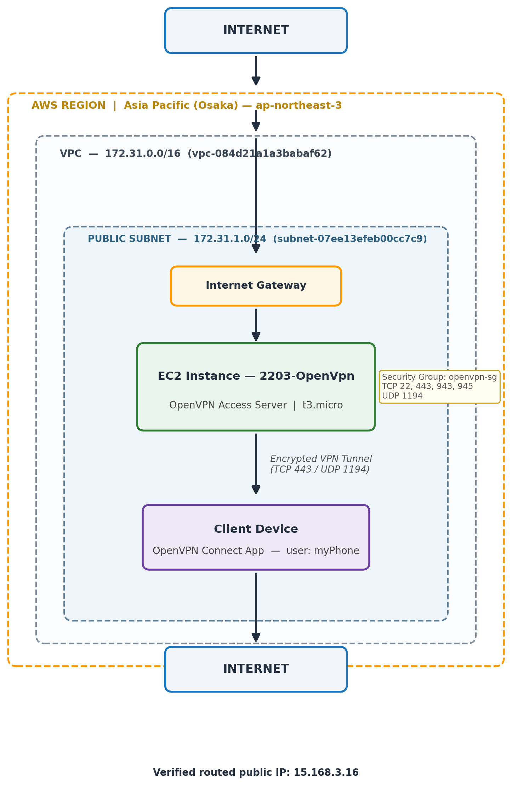

Main Traffic Flow
Client Device
↓ OpenVPN Connect App
↓ Encrypted VPN Tunnel
↓ AWS EC2 OpenVPN Server
↓ AWS Internet Gateway
↓ Internet
The practical requires client internet traffic to be routed through the VPN server.

7. Step-by-Step Implementation
Step 1 — Create a Zero-Spend Budget
Procedure
- Open AWS Management Console.
- Open Billing and Cost Management.
- Select Budgets.
- Click Create budget.
- Select Use a template (simplified).
- Select Zero spend budget.
- Enter the budget name: vpn-zero-spend
- Enter your email address.
- Click Create budget.
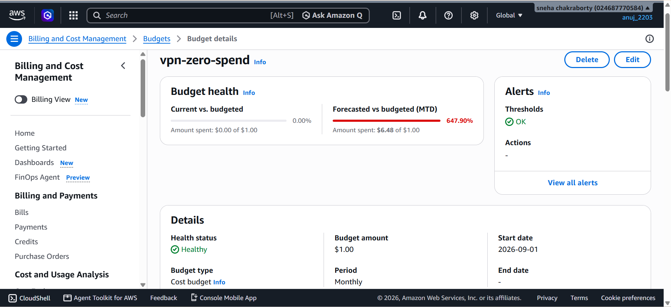
The practical begins with a zero-spend budget to monitor AWS usage.

Step 2 — Select AWS Region
For this implementation, the selected region was:
Asia Pacific (Osaka) — ap-northeast-3
Procedure
- Open AWS Console.
- Click the Region selector in the top-right corner.
- Select: Asia Pacific (Osaka) — ap-northeast-3
- Continue all remaining AWS operations in this region.
The source practical permits Mumbai or another region, depending on the desired VPN public IP location.
Step 3 — Create EC2 Key Pair
Procedure
- Go to: EC2 → Network & Security → Key Pairs
- Click: Create key pair
Setting | Value
Name | 2203-vpn-KP
Key pair type | RSA
Private key format | .pem

Click Create key pair. The .pem file is downloaded to the computer.

Step 4 — Launch OpenVPN EC2 Instance
4.1 Open EC2 Launch Instance
Go to: EC2 → Instances → Launch instances
Enter Name: 2203-OpenVpn
4.2 Select OpenVPN Marketplace AMI
Under Application and OS Images, search: OpenVPN Access Server
Select: OpenVPN Access Server by OpenVPN Inc.
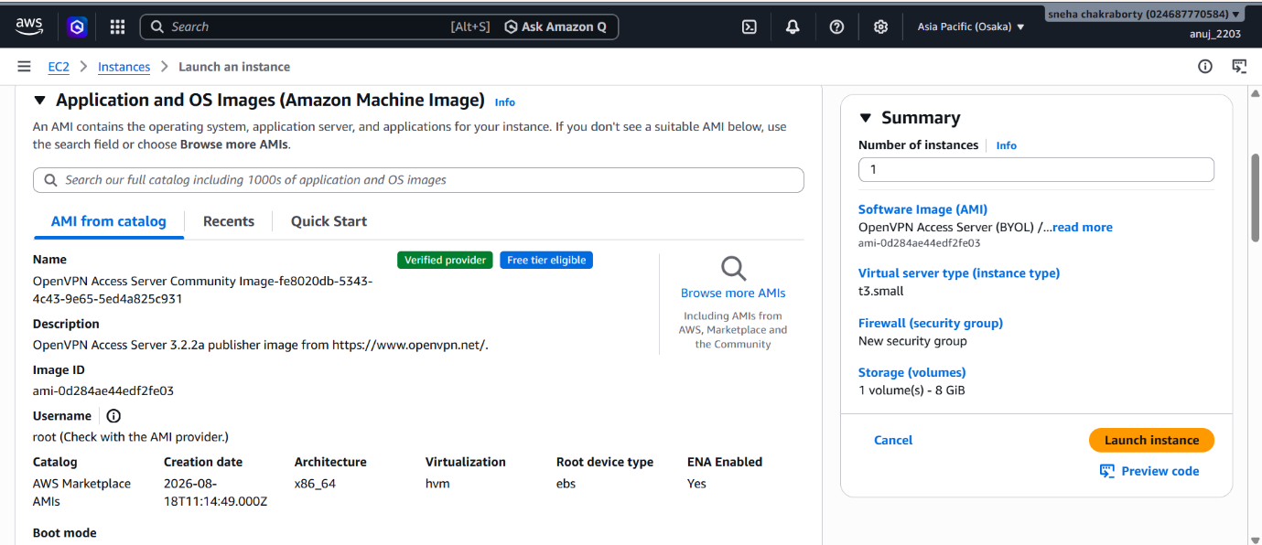
The Marketplace listing used for this practical was the OpenVPN Access Server BYOL/self-hosted VPN offering.
Step 5 — Configure EC2 Instance
Instance Type
t3.micro
Key Pair
2203-vpn-KP
Network
- VPC: vpc-084d21a1a3babaf62 (CIDR 172.31.0.0/16)
- Subnet: subnet-07ee13efeb00cc7c9 (CIDR 172.31.1.0/24)
- Public IPv4: Enabled
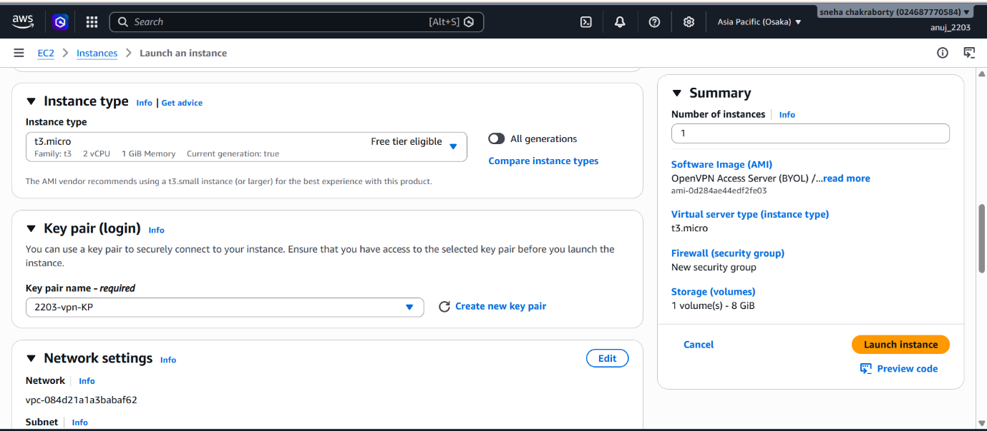

Step 6 — Configure Security Group
The security group used was:
openvpn-sg
Required inbound ports
Protocol | Port | Purpose
TCP | 22 | SSH
TCP | 443 | VPN / HTTPS
TCP | 943 | OpenVPN Admin/User Portal
TCP | 945 | Cluster communication
UDP | 1194 | OpenVPN UDP

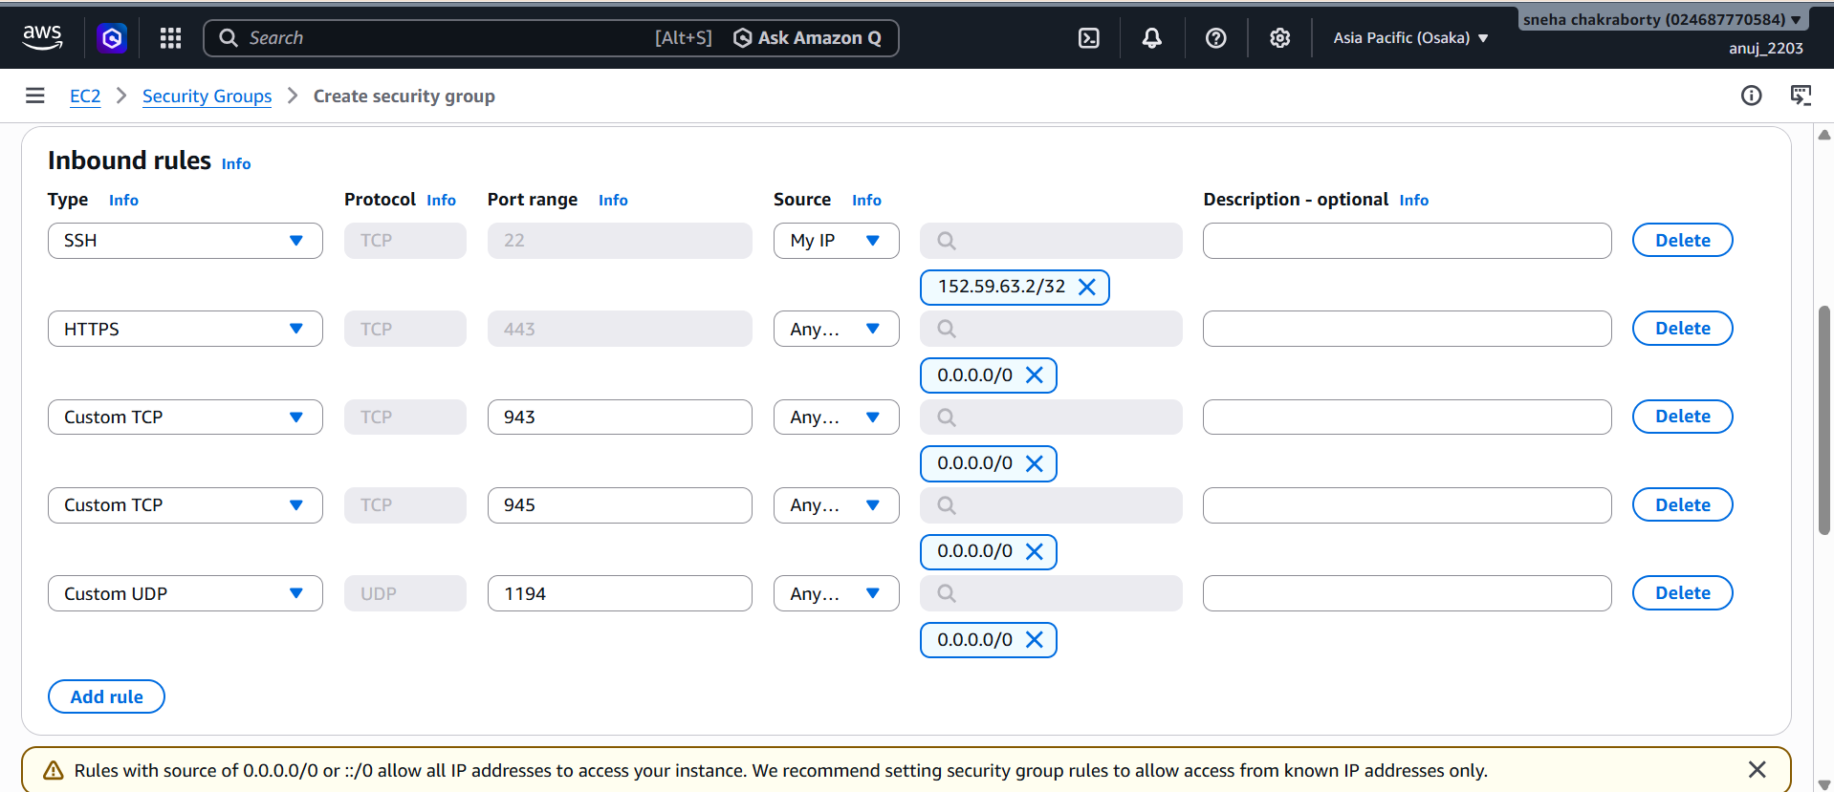
The practical specifies these inbound ports for the OpenVPN server.

Step 7 — Launch the Instance
Review the configuration and click: Launch instance
After launching
- Open the EC2 instance.
- Wait until the state becomes: Running
- Wait until: Status checks: 2/2 checks passed
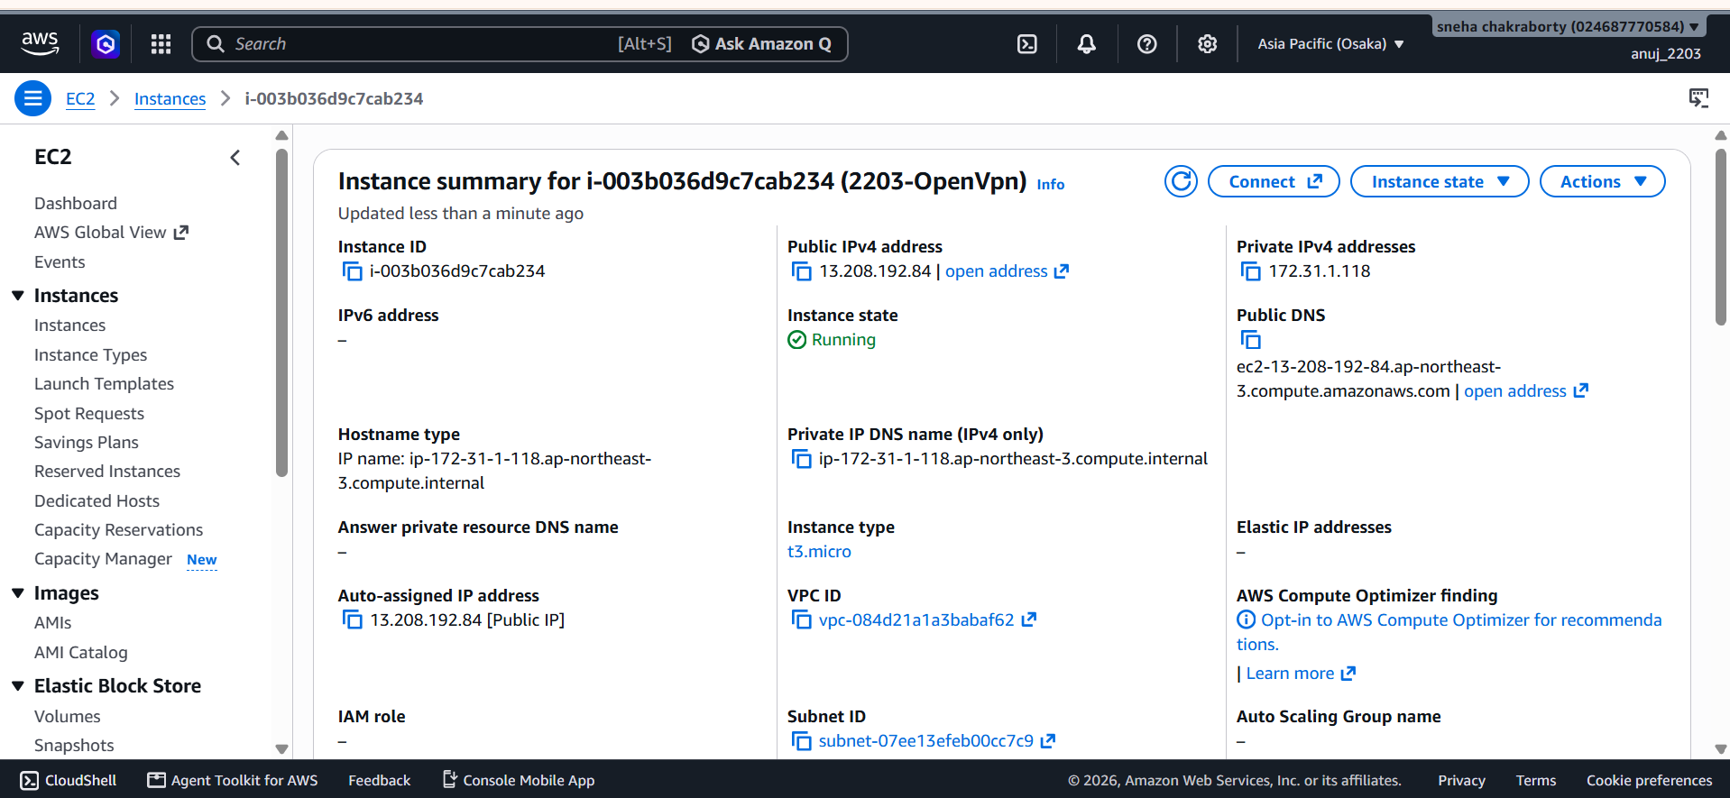
Step 8 — Connect to the EC2 Instance
EC2 Instance Connect was attempted, but normal SSH was used when necessary.
Windows PowerShell command
ssh -i "C:\Users\Admin\Downloads\2203-vpn-KP.pem" openvpnas@<PUBLIC-IP>
. 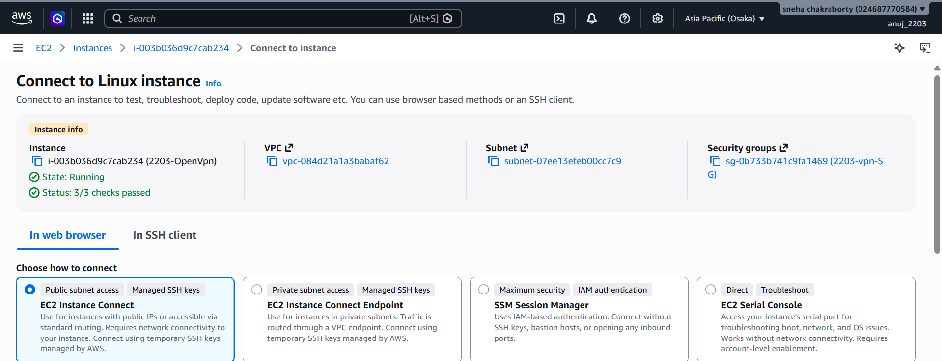
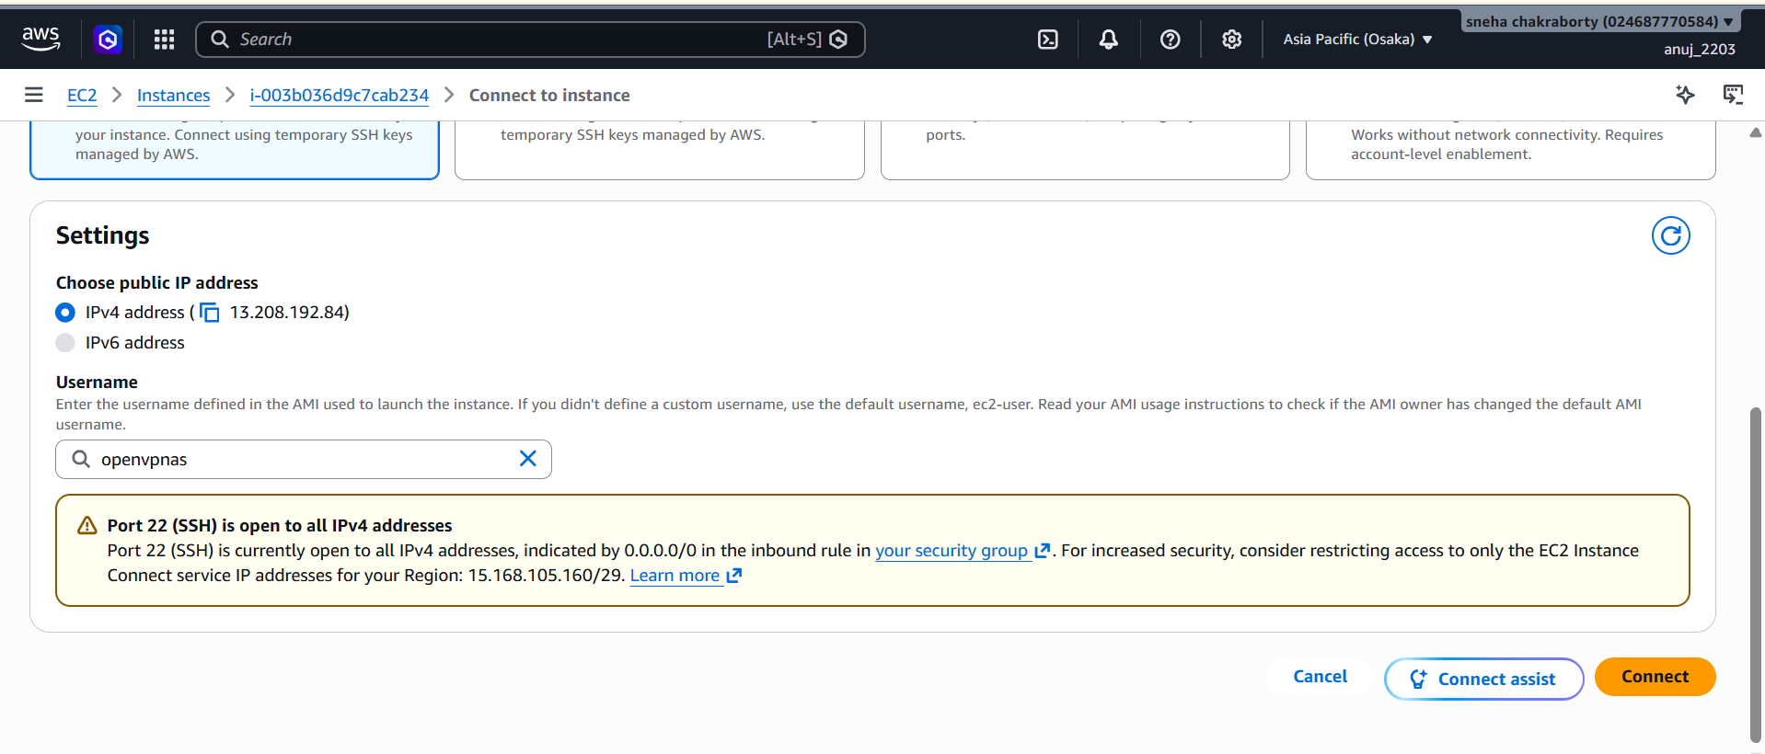

Step 9 — Run OpenVPN Initial Setup
The OpenVPN setup wizard starts during the initial configuration.
Setting | Configuration
License agreement | Yes
Primary Access Server node | Yes
Network interface | Default
Admin UI port | 943
OpenVPN TCP | 443
Client internet traffic | Yes
Client DNS through VPN | Yes
Private subnet access | Yes
Login user | openvpn
Activation key | Blank / demo configuration
Let's Encrypt | Skipped
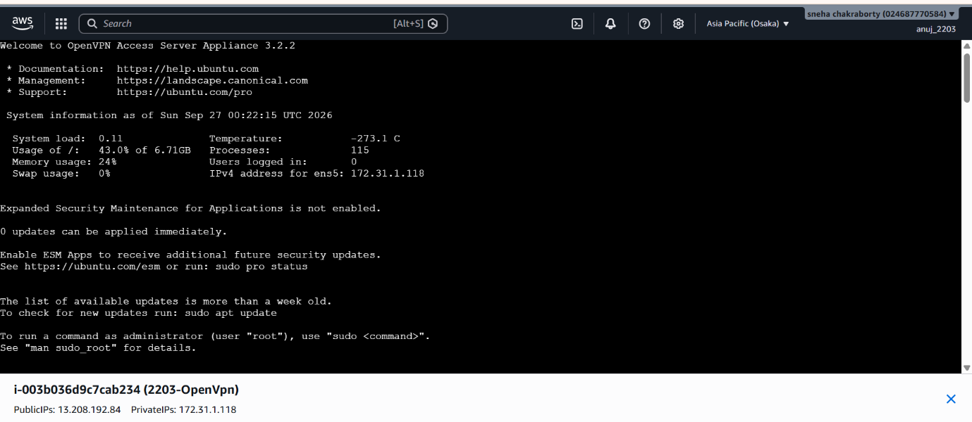
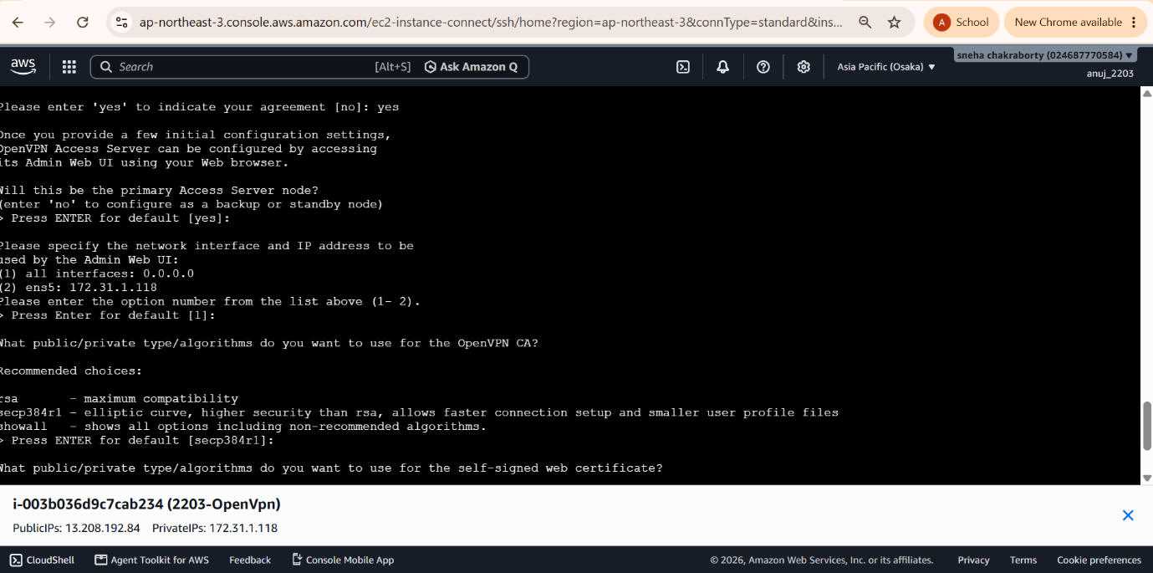
If necessary, the setup command is:
sudo ovpn-init --ec2
To set the OpenVPN administrator password:
sudo passwd openvpn

Step 10 — Open OpenVPN Admin UI
https://<PUBLIC-IP>:943/admin
Example format:
https://15.168.3.16:943/admin
Because the server initially uses a self-signed certificate, the browser may display a certificate warning. Proceed to the website.
Login
- Username: openvpn
- Password: <configured password>
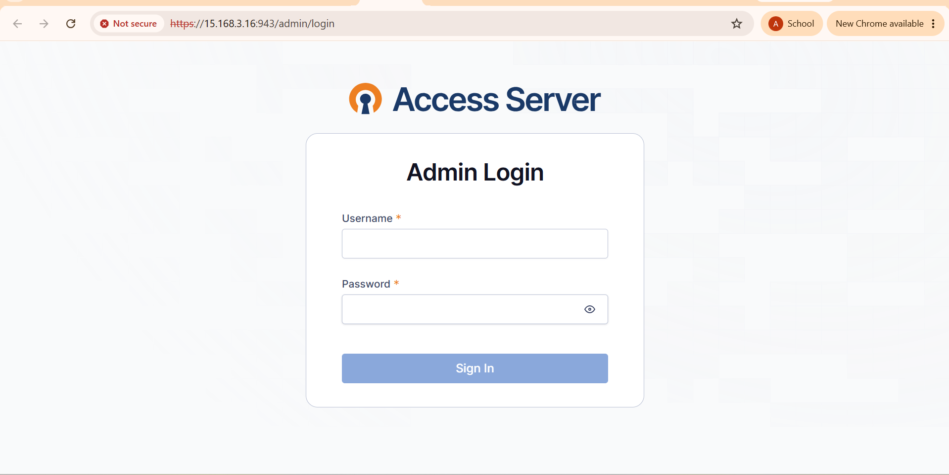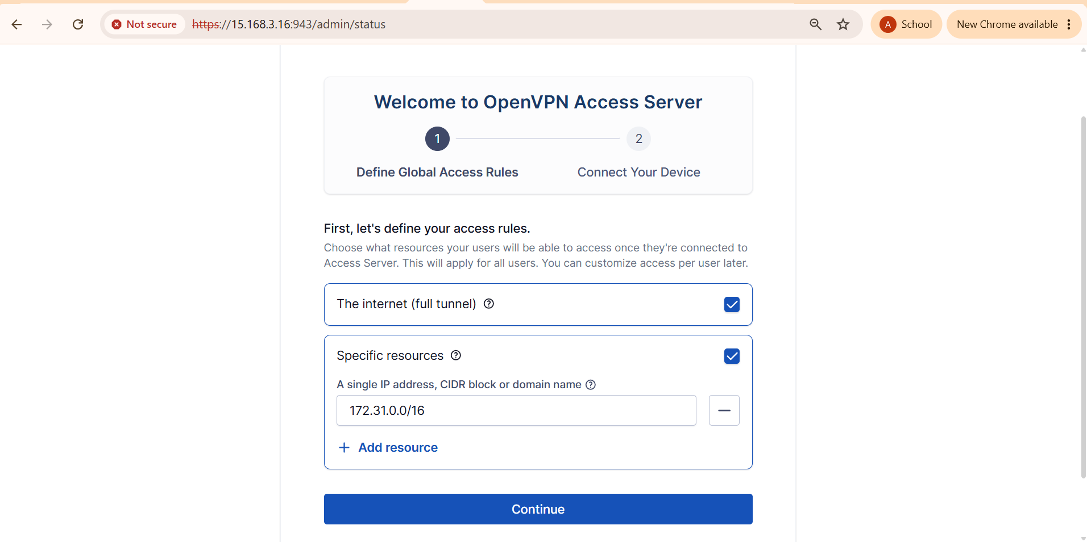
The source practical specifies accessing the Admin UI on port 943.

Step 11 — Configure Network Settings
Go to: Configuration → Network Settings (or, depending on the OpenVPN version: Access Server Settings → Network)
Make sure the hostname/IP uses the public IP, not the private 172.31.x.x address.
Configure
- Protocol: TCP and UDP
- TCP Port: 443
- UDP Port: 1194
Click: Save Settings
Step 12 — Configure VPN Routing
Go to: Configuration → VPN Settings
Configure
- Should client Internet traffic be routed through the VPN? → YES
- Use specific DNS servers: YES
- Primary DNS: 1.1.1.1
- Secondary DNS: 8.8.8.8
Click: Save Settings, then click: Update Running Server
This step is important because the saved configuration must be applied to the running OpenVPN server.
Step 13 — Create VPN User
Go to: User Management → User Permissions (or in newer versions: Users → Create User)
Create
Username: myPhone
- Enable: Allow Auto-login
- Set a password.
Then: Save settings, then click Update Running Server.
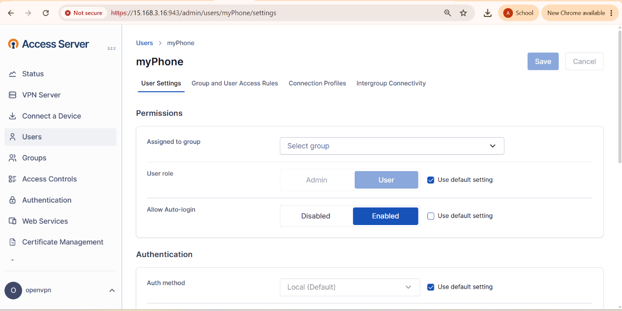
Step 14 — Connect the Client Device
Open:
https://<PUBLIC-IP>:943 (do not add /admin)
Login using
- Username: myPhone
- Password: <myPhone password>
- Download the OpenVPN profile.
- Install OpenVPN Connect.
- Import the downloaded .ovpn profile.
- Add the profile.
- Turn the VPN connection ON.
- Allow VPN permissions.

Step 15 — Verify VPN Connection

Before connecting the VPN, check the public IP:
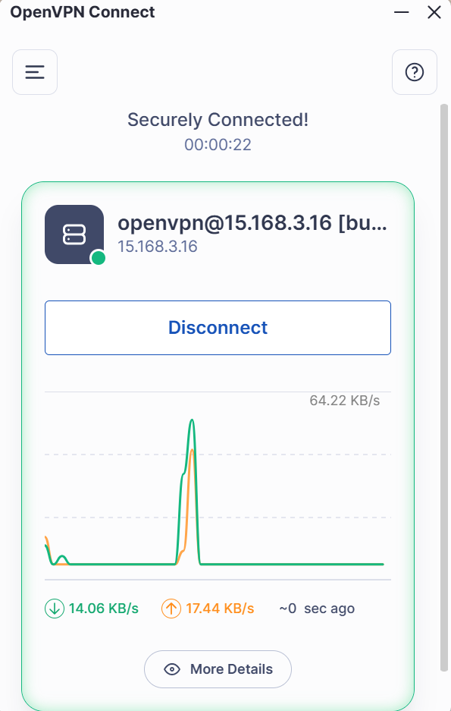
Openvpn id
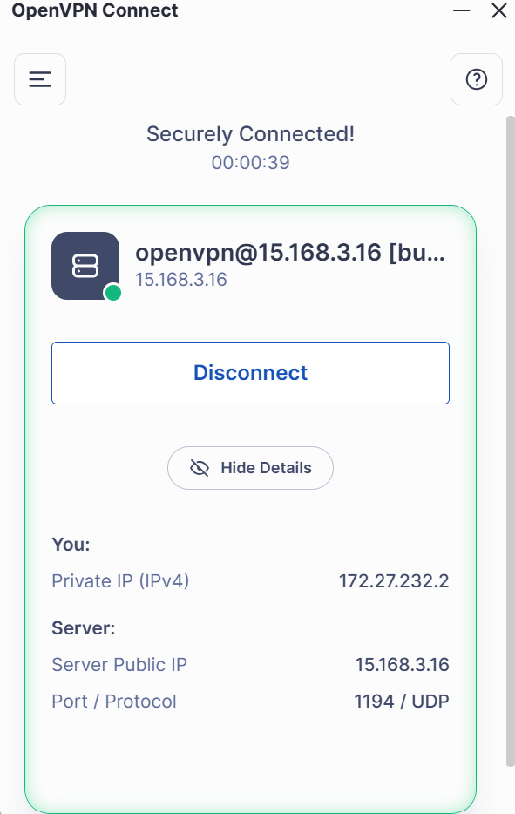
Openvpn id

curl https://checkip.amazonaws.com
After connecting to OpenVPN, run the same command again. The implemented practical produced:
15.168.3.16
while connected through the VPN. Therefore, the client traffic was being routed through the AWS OpenVPN server.
Verification Table
Test | Expected Result
VPN OFF | Home/ISP public IP
VPN ON | AWS/OpenVPN public IP
OpenVPN connection | Connected
Internet access | Working
Traffic routing | Through AWS VPN

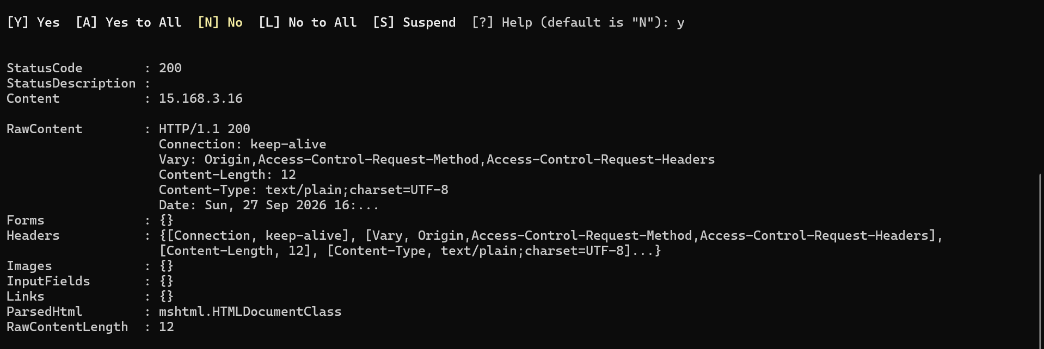

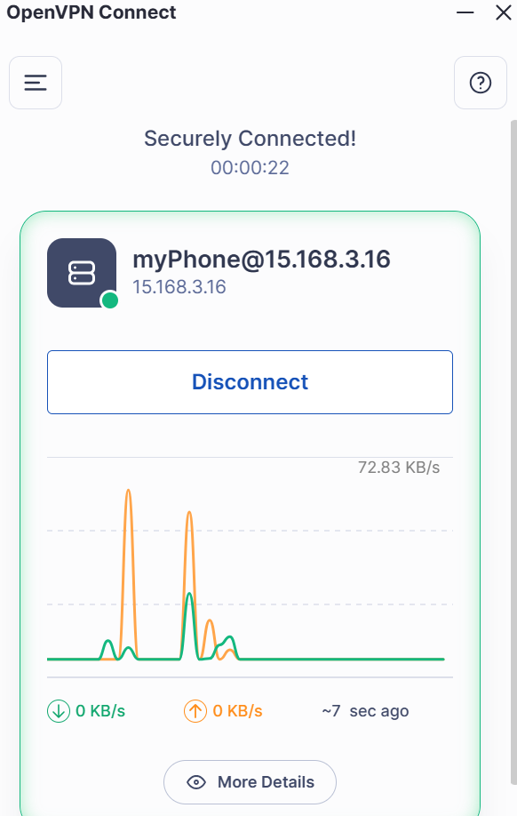

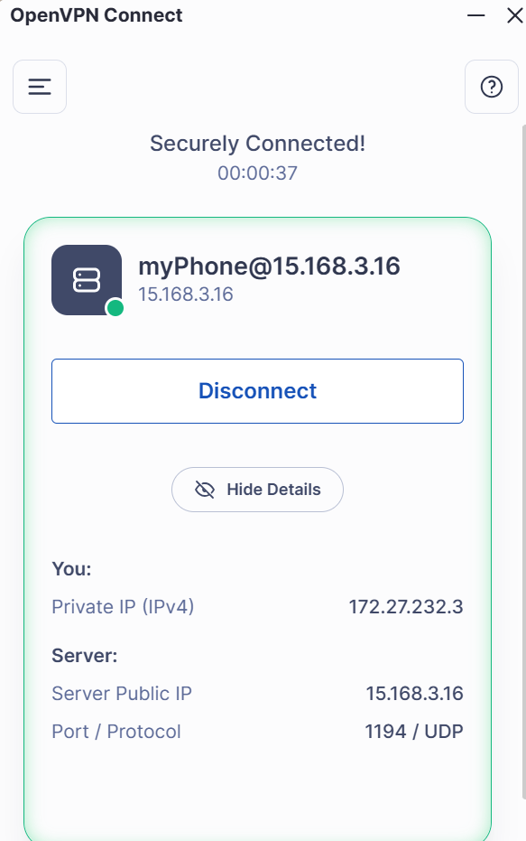
8. Optional Elastic IP Configuration
An Elastic IP can be associated with the EC2 instance if a fixed public IP is required.
- Open EC2 → Elastic IPs.
- Click Allocate Elastic IP address.
- Select the IP.
- Choose Actions → Associate Elastic IP address.
- Select the EC2 instance.
- Associate the address.
- Update the OpenVPN hostname.
- Save and update the running server.
- Re-import the VPN profile.
This was an optional part of the practical and was not used in the completed implementation.
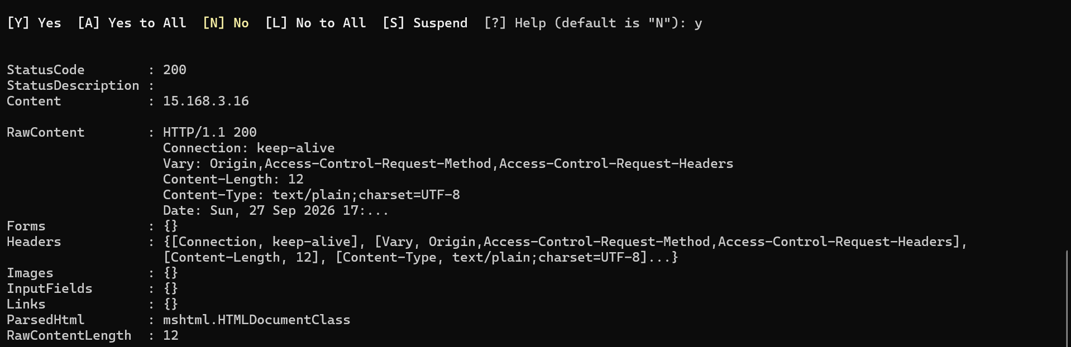

11. Verification / Testing

Test 1 — EC2 Server
Expected / Observed: Instance State: Running · Status Checks: 2/2
Result: PASS

Test 2 — OpenVPN Admin UI
Expected / Observed: https://<public-ip>:943/admin — admin login successful
Result: PASS

Test 3 — VPN User
Expected / Observed: User "myPhone" created
Result: PASS

Test 4 — OpenVPN Client
Expected / Observed: Profile imported and VPN connection established
Result: PASS

Test 5 — Public IP Verification
Expected / Observed: Public IP changed to 15.168.3.16 while VPN connected
Result: PASS
This confirms that internet traffic was routed through the AWS OpenVPN server.

12. Teardown / Resource Deletion
After testing, AWS resources were removed to prevent unnecessary resource usage. Recommended teardown order:
- VPN Client Profile
- EC2 Instance
- Elastic IP (if used)
- Security Group
- Key Pair
- Marketplace Subscription
- Unused EBS Volumes
Completed cleanup
- VPN profile removed
- EC2 OpenVPN instance terminated
- No Elastic IP was created
- openvpn-sg deleted
- 2203-vpn-KP key pair deleted
The remaining check is the EC2 → EBS → Volumes page to ensure there is no Available volume left from the terminated instance.

13. Result
The OpenVPN Access Server was successfully deployed on an AWS EC2 instance. The server was configured with the required VPN networking, a VPN user named myPhone was created, and the OpenVPN Connect client successfully established a VPN connection.
The public IP verification showed the AWS/OpenVPN public IP:
15.168.3.16
when the VPN was connected. Therefore, the practical successfully demonstrated:
Client Device → OpenVPN VPN Tunnel → AWS EC2 OpenVPN Server → Internet

14. Conclusion
The practical successfully demonstrated the deployment and configuration of a VPN server using OpenVPN Access Server on AWS EC2. The EC2 instance hosted the OpenVPN server, security-group rules allowed the required VPN and management traffic, and the VPN configuration routed client internet traffic through AWS.
The successful change in public IP after connecting OpenVPN verified that the client was using the AWS VPN server for internet traffic. Finally, the AWS resources were terminated/deleted as part of the teardown process to minimize unnecessary AWS resource usage.

15. Final Practical Summary
Item | Implementation
Practical | Free VPN Server on AWS
VPN Software | OpenVPN Access Server
Cloud Platform | AWS
Region | Asia Pacific (Osaka)
Region Code | ap-northeast-3
EC2 Instance | 2203-OpenVpn
Instance Type | t3.micro
VPC | vpc-084d21a1a3babaf62
Subnet | subnet-07ee13efeb00cc7c9
Security Group | openvpn-sg
Key Pair | 2203-vpn-KP
VPN User | myPhone
Admin User | openvpn
Admin Port | 943
VPN TCP Port | 443
VPN UDP Port | 1194
VPN Verification IP | 15.168.3.16
Client | OpenVPN Connect
Verification | Public IP changed to AWS VPN IP
Final State | AWS resources cleaned up

