Title
Create a custom AMI from an EC2 instance and deploy the custom AMI on another EC2 instance.

Aim
To create a custom Amazon Machine Image (AMI) from an existing EC2 instance and use that custom AMI to launch a new EC2 instance with the same base configuration.

Objectives
- Understand the purpose of a custom AMI.
- Configure an EC2 instance before creating the image.
- Create a custom AMI from the configured instance.
- Monitor the AMI creation process.
- Launch a new EC2 instance using the custom AMI.
- Verify that the new instance uses the custom image configuration.

AWS Services Used
- Amazon EC2
- Amazon Machine Image (AMI)
- Amazon EBS
- Amazon VPC
- Security Group
- AWS Management Console

Prerequisites
- Active AWS account.
- Existing EC2 instance or permission to create one.
- Access to Amazon EC2.
- Basic understanding of AMI and EC2.
- Required permissions to create and launch AMIs/instances.

Architecture Diagram
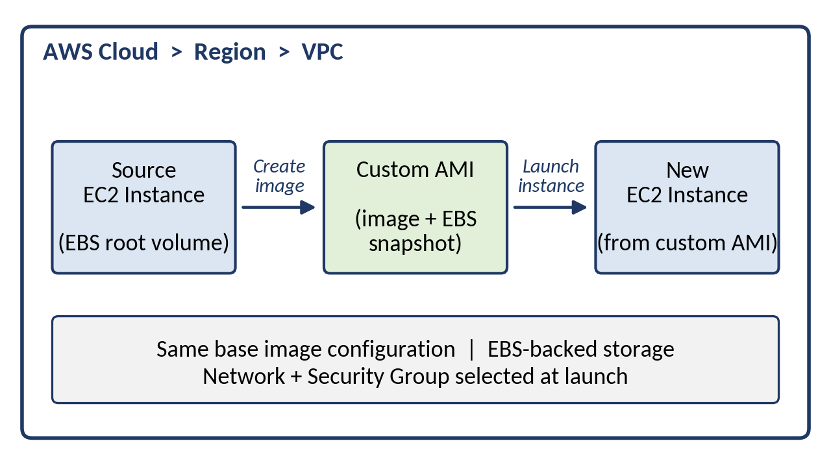
Figure 4.1: Architecture of Practical 4

Step-by-Step Implementation
- Sign in to the AWS Management Console.
- Open Amazon EC2.
- Select the required AWS Region.
- Launch or select an existing EC2 source instance.
- Configure the source instance as required for the custom image.
- Select the source instance.
- Choose Actions → Image and templates → Create image.
- Enter a suitable Image name and description.
- Review the EBS volume settings.
- Click Create image.
- Open AMIs from the EC2 navigation panel.
- Wait until the custom AMI status becomes Available.
- Select the custom AMI.
- Click Launch instance from AMI.
- Choose the required instance type and network settings.
- Configure or select a suitable security group.
- Review the settings and launch the new instance.
- Open the Instances page.
- Select the new instance and verify its AMI ID and configuration.
- Compare the new instance with the source instance and record the observations.

Screenshot for Every Major Step
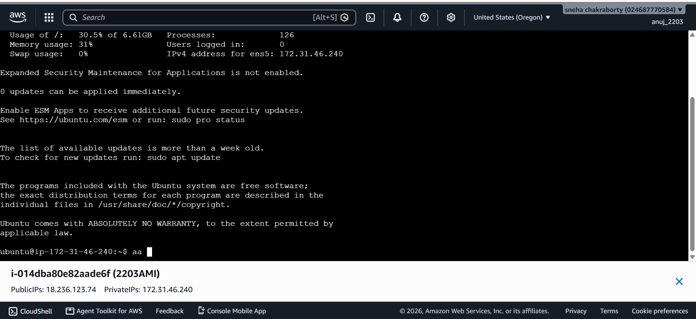
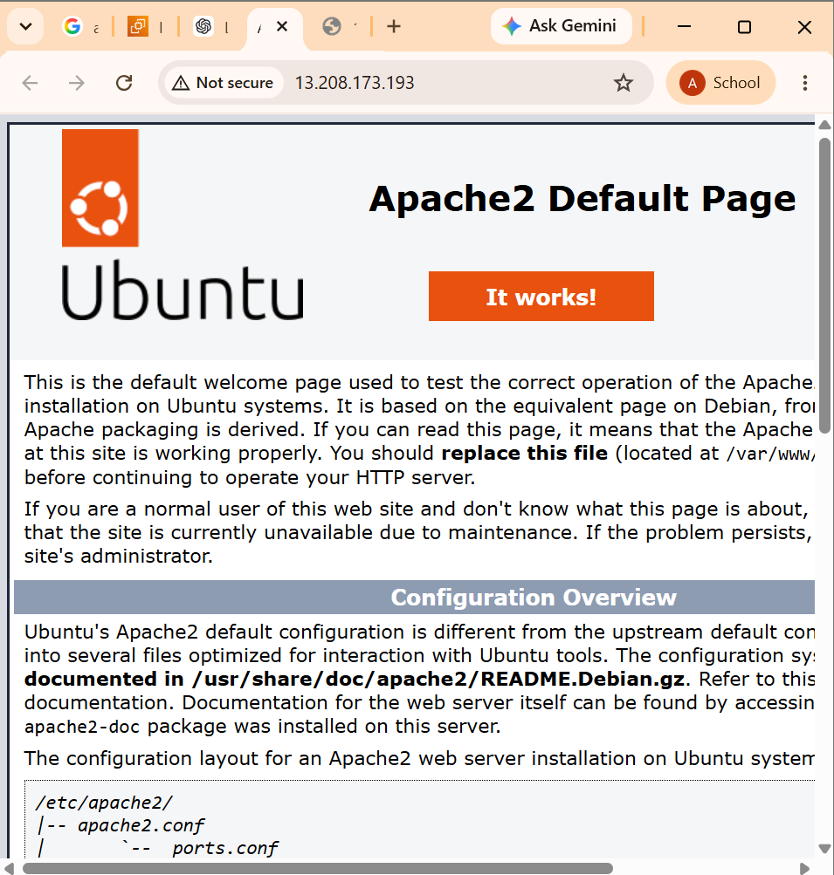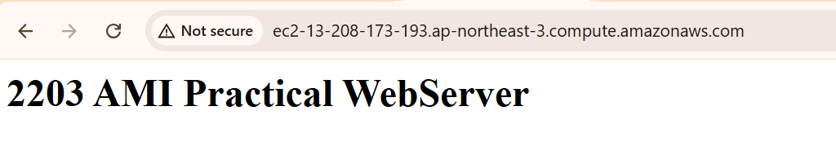
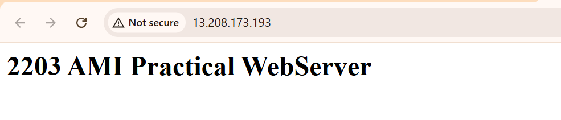

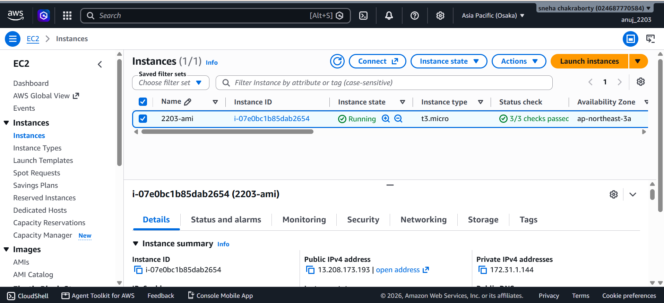

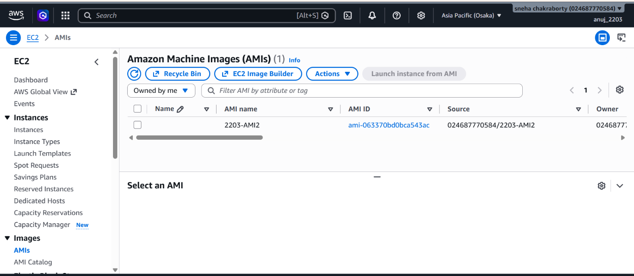

Verification / Testing
- Verify that the custom AMI is created successfully.
- Verify that the AMI state changes to Available.
- Verify the AMI ID and name.
- Launch a new EC2 instance using the custom AMI.
- Verify that the new instance references the custom AMI.
- Verify the instance type, network, security group, and storage configuration.
- Compare the source and deployed instances to confirm successful deployment.

Comparison of the source instance and the newly deployed instance (fill in from your console):

Note: the new instance should show the custom AMI ID, while the source instance shows the original AMI ID it was launched from.

Result / Conclusion
A custom AMI was successfully created from an EC2 instance and used to deploy a new EC2 instance. The practical demonstrated how a configured EC2 environment can be captured as an AMI and reused for consistent instance deployment.

