Title
Configure an ALB in AWS, attach it to more then two EC2 instances, and observe how AWS handles the incoming traffic load.

Aim
The aim of this practical is to design and deploy a highly available, fault-tolerant web application on AWS. I used an Application Load Balancer (ALB) to spread incoming HTTP traffic across multiple EC2 instances placed in different Availability Zones inside a VPC, so that the application keeps running smoothly even if one server (or an entire zone) becomes unavailable.

Objectives
- Set up a VPC with public subnets spread across multiple Availability Zones, along with security groups to control who can talk to what.
- Launch Ubuntu EC2 instances in different subnets and use a startup script to automatically install and run Apache so each one serves a simple web page on boot.
- Configure security group rules so only the necessary traffic – SSH and HTTP – is allowed between clients, the load balancer, and the web servers.
- Create a target group with HTTP health checks so AWS can automatically monitor whether each server is actually up and responding.
- Set up an internet-facing Application Load Balancer with an HTTP listener that spans multiple Availability Zones.
- Test everything by hitting the ALB's DNS name repeatedly and confirming that traffic really is being spread across the different servers.

AWS Services Used
Service | What I Used It For | Details
Amazon EC2 | Backend web servers | Ubuntu (AMI ami-0086ee55a149bd32), t3.micro
Application Load Balancer | Distributes incoming HTTP traffic | Internet-facing, HTTP listener on port 80, spans 3 AZs
Target Group | Health checks + routing to EC2s | 2203-TG – HTTP:80, health check path “/”
Security Groups | Firewall rules for the ALB and EC2s | 2203-ALB-SG and 2203_anuj_SG (sg-08f9739e936f30cff)
EC2 Key Pair | SSH login to the instances | 2203_anuj_KP (RSA)

Prerequisites
- An AWS account with IAM permissions to manage EC2, Elastic Load Balancing, VPC, and Security Groups.
- A VPC (vpc-084d21a1a3babaf62) with at least two public subnets in different Availability Zones, in the Asia Pacific (Osaka) region (ap-northeast-3).
- An existing RSA key pair, 2203_anuj_KP, already imported in that region.
- A web browser and a terminal, to test the final ALB endpoint once everything is set up.

Architecture Diagram
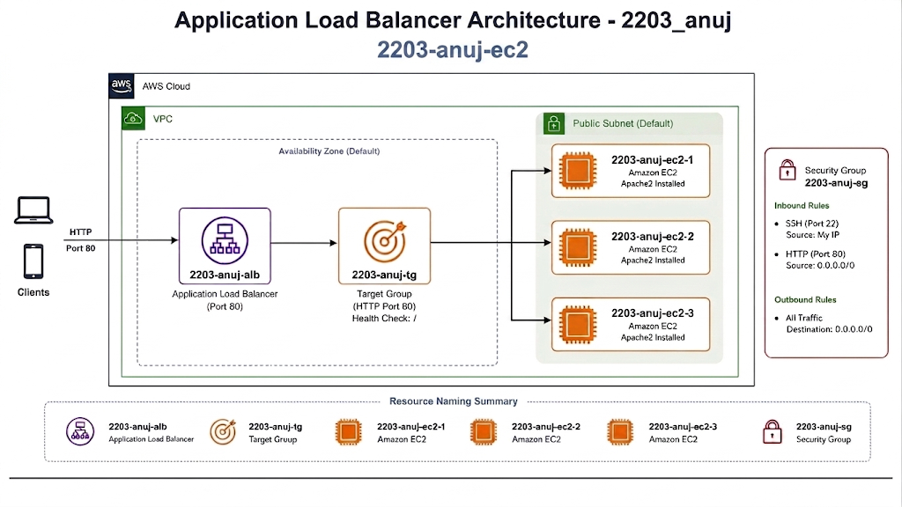
Application Load Balancer architecture for this practical, showing the ALB, target group, EC2 web servers, and the two security groups involved.
Here's how it all fits together: client traffic from the internet first hits 2203-ALB at its DNS name, 2203-alb-731494956.ap-northeast-3.elb.amazonaws.com, on port 80. The ALB is spread across three Availability Zones in ap-northeast-3 (3a, 3b, and 3c), each with its own public subnet. Two separate security groups control what traffic is allowed where: 2203-ALB-SG lets public HTTP traffic reach the load balancer, and 2203_anuj_SG (sg-08f9739e936f30cff) only allows the ALB itself to reach the EC2 web servers on port 80. Each server runs Apache and returns a page showing its own private IP (like 172.31.20.64 or 172.31.18.239), which is exactly how I could tell which server had answered a given request while testing.

Step-by-Step Implementation

Create key pair

1)open AWS console->Ec2->In Ec2 select key pair->create key pair

2)name 2203_anuj_KP.

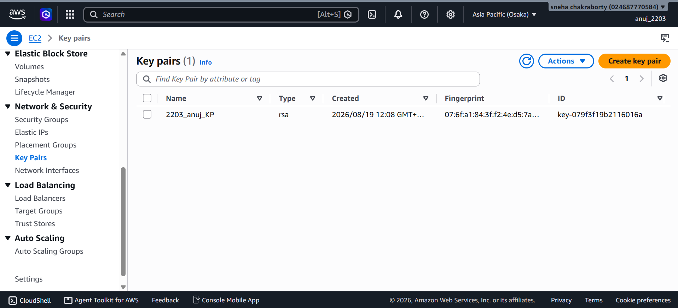
create key pair(2203_anuj_KP)

Step 1: Launch EC2 Web Server 1
1) Open AWS Console → EC2 → Launch instance.
2) Name: 2203-WebServer-1.
3) Select Ubuntu AMI ami-0086ee55a149bd32.
4) Choose instance type: t3.micro.
5) Select key pair: 2203_anuj_KP.
6) Select VPC vpc-084d21a1a3babaf62.
7) Select subnet subnet-0e466f0d0663dbdda (ap-northeast-3a).
8) Enable Auto-assign public IP.
9) Add the Apache User Data script.
10) Click Launch instance.
#!/bin/bash
sudo apt update -y
sudo apt install apache2 -y
sudo systemctl start apache2
sudo systemctl enable apache2
echo "<h1>This is system: $(hostname -i)</h1>" > /var/www/html/index.html
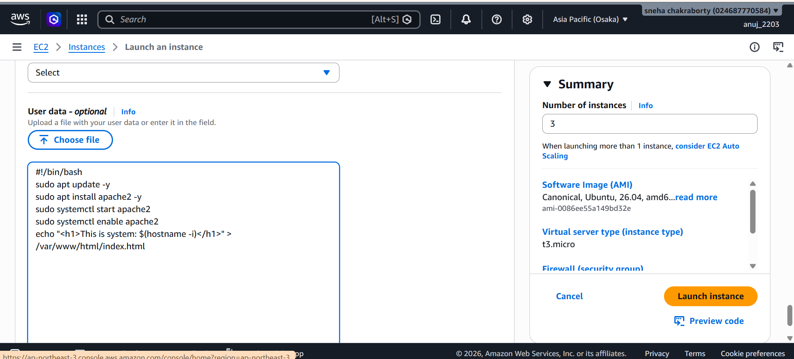
Fig 1: Launch EC2 Web Server 1

Step 2: Launch EC2 Web Server 2
- Open EC2 → Launch instance.
2) Name: 2203-WebServer-2.
3) Use Ubuntu AMI ami-0086ee55a149bd32.
4) Choose t3.micro.
5) Select key pair: 2203_anuj_KP.
6) Select subnet subnet-08745bfe61e6891c4 (ap-northeast-3b).
7) Add the same Apache User Data script.
8) Click Launch instance.

#!/bin/bash
sudo apt update -y
sudo apt install apache2 -y
sudo systemctl start apache2
sudo systemctl enable apache2
echo "<h1>This is system: $(hostname -i)</h1>" > /var/www/html/index.html
Fig 2: Launch EC2 Web Server 2

Step 3: Configure EC2 Security Group
1) Open EC2 → Security Groups → Create security group.
2) Name: 2203_anuj_SG.
3) Select VPC vpc-084d21a1a3babaf62.
4) Allow SSH (TCP 22) from 0.0.0.0/0.
5) Allow HTTP (TCP 80) from 0.0.0.0/0.
6) Keep the default outbound rule.
7) Click Create security group.
8) Attach the group to both web servers.
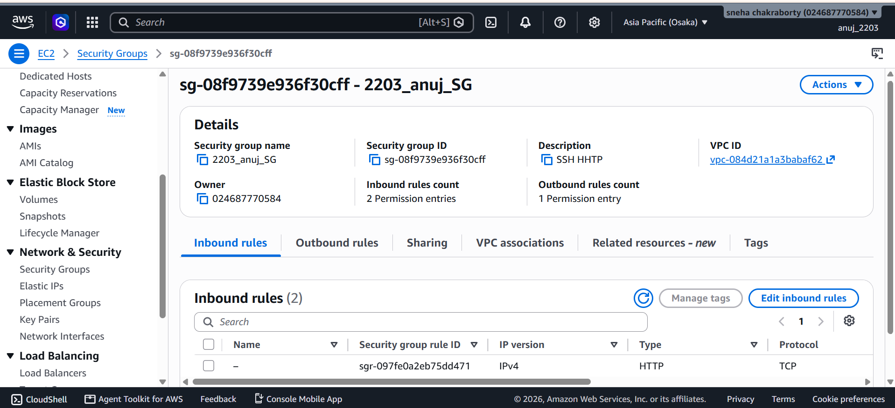
Fig 3: Configure EC2 Security Group

Step 4: Create ALB Security Group
1) Open Security Groups → Create security group.
2) Name: 2203-ALB-SG.
3) Select VPC vpc-084d21a1a3babaf62.
4) Allow HTTP (port 80) from 0.0.0.0/0.
5) Allow outbound TCP 80 to EC2 security group sg-08f9739e936f30cff.
6) Click Create security group.

Step 5: Create Target Group
1) Open Load Balancing → Target Groups → Create target group.
2) Target type: Instances.
3) Name: 2203-TG.
4) Protocol: HTTP; Port: 80.
5) Select VPC vpc-084d21a1a3babaf62.
6) Health check path: /.
7) Set interval: 30 seconds.
8) Set timeout: 5 seconds.
9) Set healthy/unhealthy threshold: 2.
10) Click Next and create the target group.
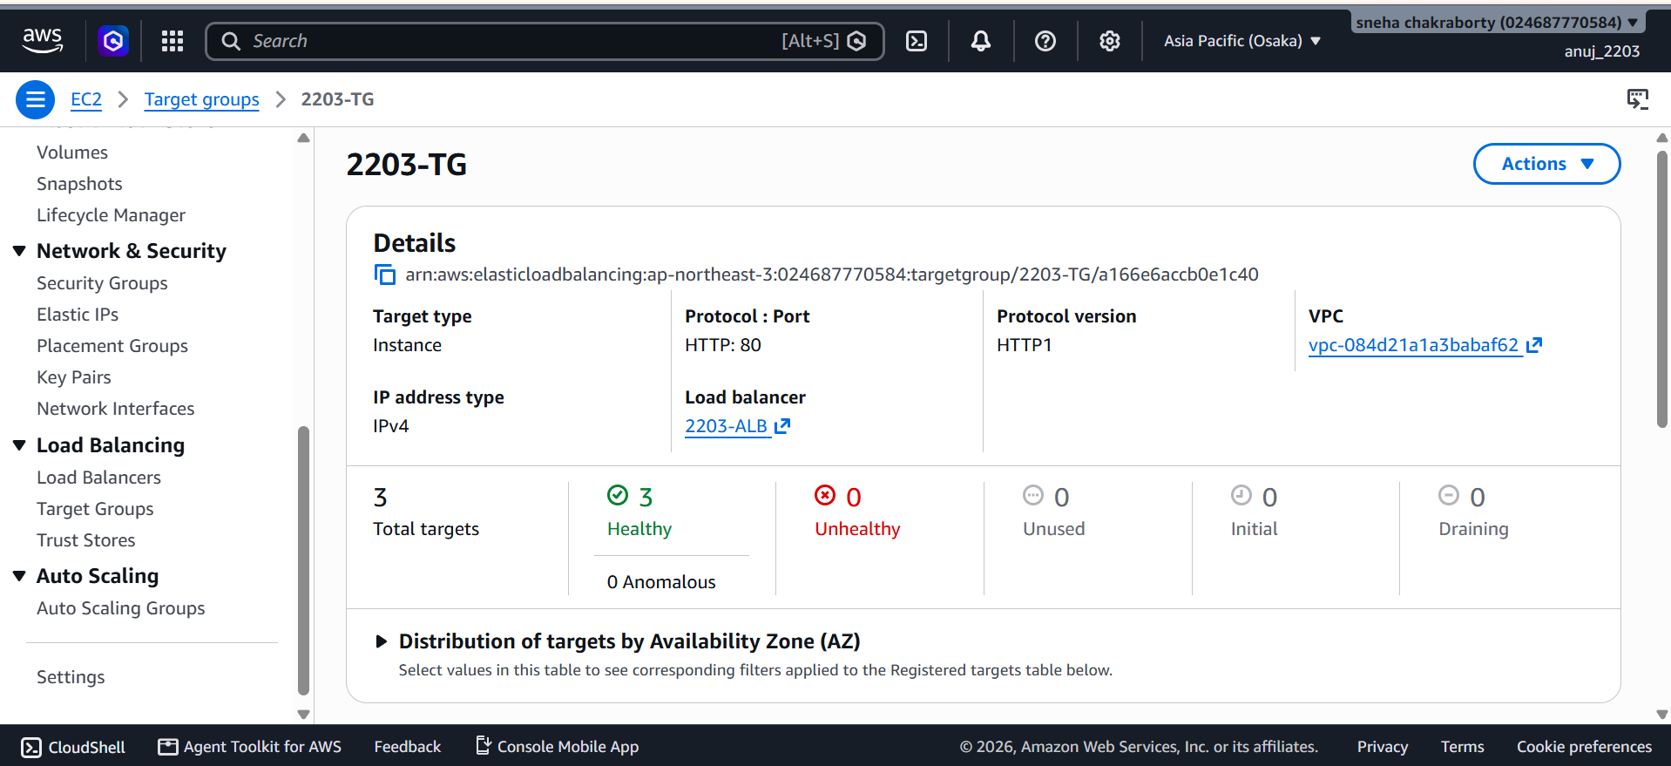
Fig 4: Create Target Group

Step 6: Register EC2 Instances with Target Group
1) Open the Register targets screen.
2) Select both web servers.
3) Set port 80 for both instances.
4) Click Include as pending.
5) Confirm the pending targets.
6) Click Create target group.

Step 7: Verify Target Health
1) Open target group 2203-TG.
2) Open the Targets tab.
3) Wait for the health status to change from Initial to Healthy.
4) Confirm the targets are healthy.
Fig 5: Verify Target Health

Step 8: Create Application Load Balancer
1) Open Load Balancers → Create load balancer.
2) Select Application Load Balancer.
3) Name: 2203-ALB.
4) Scheme: Internet-facing.
5) IP address type: IPv4.
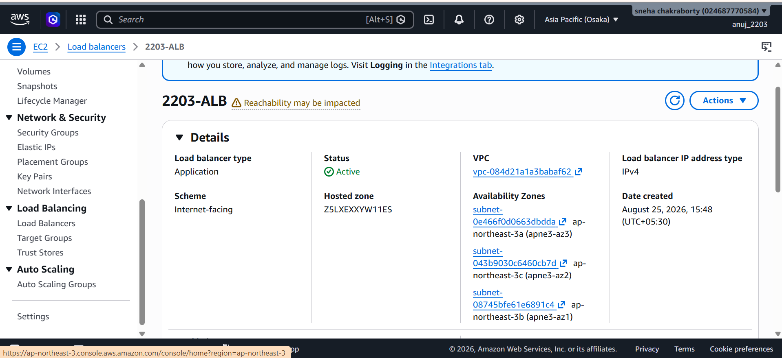
Fig 6: Create Application Load Balancer

Step 9: Configure Security Group
1) Remove the default security group.
2) Select 2203-ALB-SG.
3) Confirm the ALB security group.

Step 10: Configure HTTP Listener
1) Open Listeners and routing.
2) Add HTTP listener on port 80.
3) Set action: Forward to target groups.
4) Select 2203-TG.
5) Set traffic weight to 100%.
6) Click Create load balancer.

Step 11: Verify ALB Status
1) Open 2203-ALB.
2) Check the Status field.
3) Wait for Provisioning to change to Active.
4) Refresh the page if required.
Fig 12: Verify ALB Status

Step 12: Copy ALB DNS Name
1) Open the ALB details.
2) Find the DNS name.
3) Copy: 2203-alb-731494956.ap-northeast-3.elb.amazonaws.com.
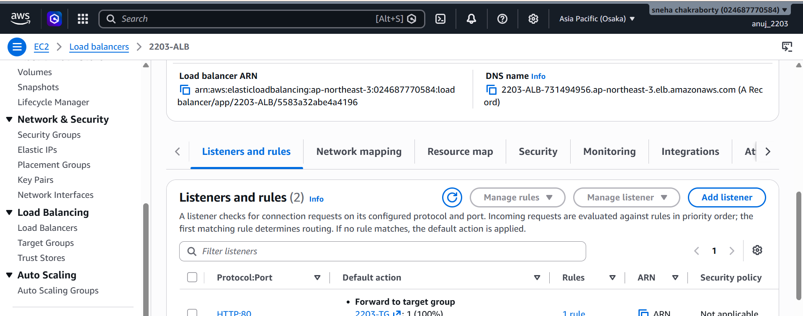
Fig 13: Copy ALB DNS Name

Step 13: Test Application Using ALB DNS
1) Open Chrome.
2) Enter the ALB DNS address.
3) Open the HTTP page.
4) Check the server IP shown on the page.
5) Confirm HTTP 200 response.
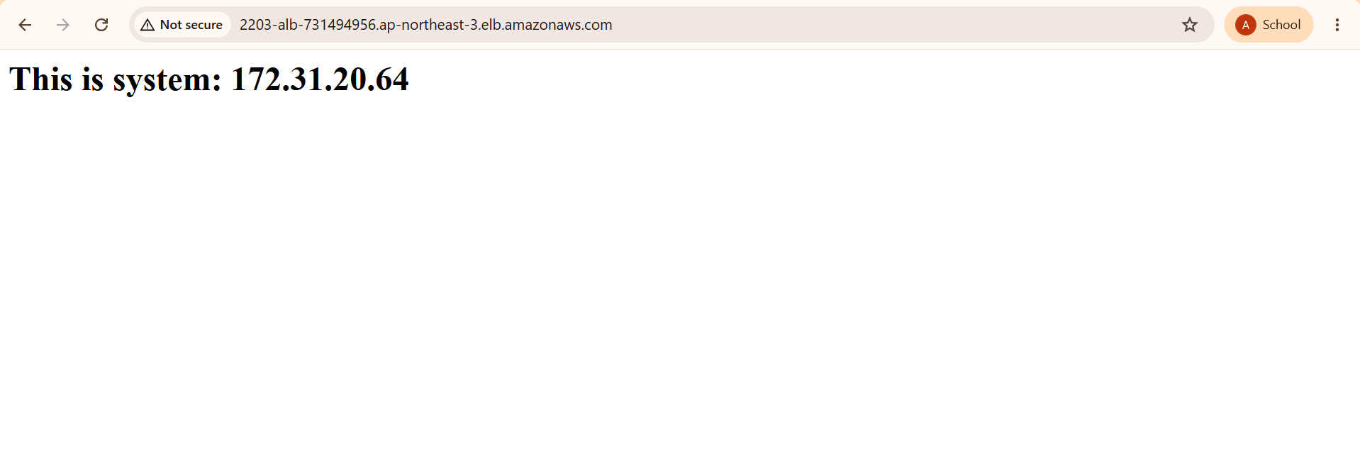
Fig 14: Test Application Using ALB DNS

Step 14: Verify Load Balancing
1) Refresh the ALB page using Shift + F5.
2) Repeat the refresh several times.
3) Check the server IP after each refresh.
4) Confirm responses switch between Web-Server-1 and Web-Server-2.
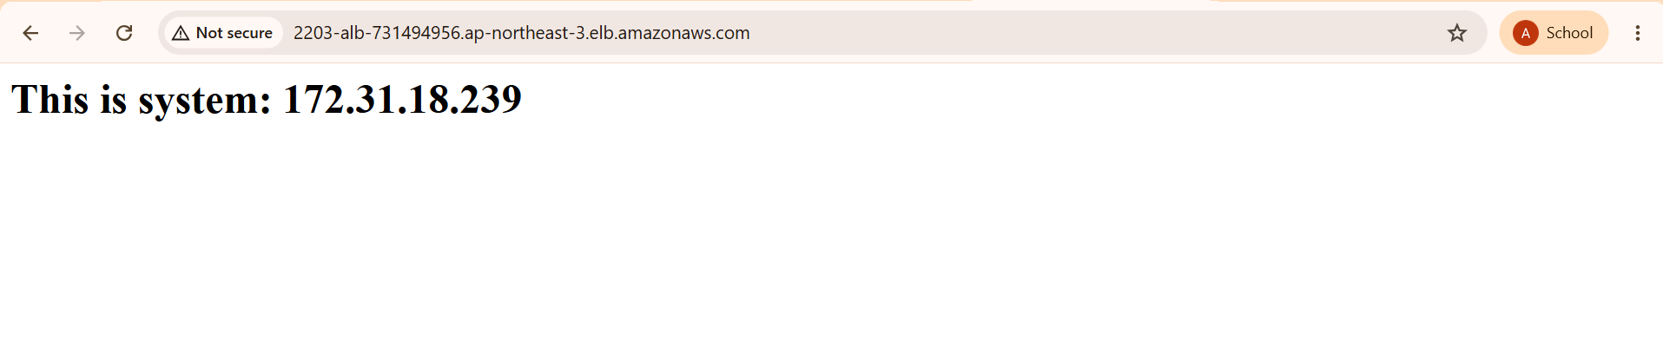
Fig 15: Verify Load Balancing
Evidence | What It Shows | Where to Find It
Key pair validation | Confirms the 2203_anuj_KP key pair exists and its details | See screenshot below
EC2 security group rules | Inbound/outbound rules for 2203_anuj_SG | See Step 3 screenshot above
User data / bootstrap script | Apache install script running on instance launch | See Step 1 screenshot above
Target group health | 3 of 3 targets healthy in 2203-TG | See Step 7 screenshot above
ALB active status | 2203-ALB showing State: Active | See Step 12 screenshot above
Listener configuration | HTTP:80 listener forwarding to 2203-TG | See Step 11 screenshot above
End-to-end test 1 | Browser output: 172.31.20.64 | See Step 14 screenshot above
End-to-end test 2 | Browser output: 172.31.18.239 | See Step 15 screenshot above
What I Tested | How I Tested It | Result
DNS resolution | Looked up the ALB's DNS name | Resolves correctly to the ALB
Request routing | Sent an HTTP GET to the ALB on port 80 | Forwarded successfully to 2203-TG
Load balancing | Refreshed the browser several times (Shift+F5) | Response alternated between the two server IPs
Target health | Checked the Targets tab in 2203-TG | All 3 targets showed Healthy
Security boundaries | Tried accessing on allowed vs. blocked ports | Only port 80 traffic passed through as expected
Test | Expected Behaviour | What Actually Happened | Status
Server startup | User data script installs Apache and writes index.html with the host IP | Apache started correctly; index.html rendered the private IP | PASS
Target health | Target group marks instances healthy after passing checks on / | All 3 targets showed Healthy | PASS
ALB provisioning | ALB moves from Provisioning to Active with a DNS name assigned | State changed to Active with DNS 2203-alb-731494956... | PASS
Application access | ALB DNS returns HTTP 200 from a backend server | Page showed “This is system: 172.31.20.64” | PASS
Load balancing | Refreshing rotates traffic to a different target | Page updated to “This is system: 172.31.18.239” | PASS

Result / Conclusion
By the end of this practical, I had a working Application Load Balancer (2203-ALB) successfully distributing HTTP traffic across two EC2 web servers running in different Availability Zones. The target group reported all targets as healthy, and repeated testing through the ALB's DNS name confirmed that requests really were being spread across both servers rather than always hitting the same one. This practical gave me a much clearer, hands-on understanding of how load balancing, health checks, and security groups work together in AWS to keep an application available even if individual servers or zones run into problems.

