Title
Setting Up AWS Free Tier Account and Accessing the AWS Management Console
Aim
The aim of this practical is to set up and access an AWS Free Tier account and explore the AWS Management Console. It includes accessing the IAM service and creating IAM users for controlled access to AWS services.

Objectives
- To set up an AWS Free Tier account.
- To access the AWS Management Console.
- To understand the basic AWS Management Console interface.
- To access the Identity and Access Management (IAM) service.
- To create IAM users within the AWS account.
- To verify the created IAM users through the AWS Management Console.
- To understand the basic concept of controlled access to AWS resources.

AWS Services / Features Used
AWS Service / Feature | Use in Practical
AWS Management Console | Web-based interface used to access and manage AWS services
AWS Account | Provides access to AWS cloud services
AWS Free Tier | Provides eligible limited usage of selected AWS services
IAM | Manages identities and access to AWS resources
IAM Users | Provides individual identities for controlled AWS access

Prerequisites
- Computer or laptop
- Internet connection
- Web browser
- AWS account
- Valid AWS account credentials
- Access to the AWS Management Console

Theory
Amazon Web Services (AWS)
Amazon Web Services (AWS) is a cloud computing platform that provides on-demand cloud services such as computing, storage, networking, databases, security, and monitoring. Users can provision resources through the AWS Management Console, command-line tools, APIs, and other interfaces.

AWS Free Tier
AWS Free Tier offers eligible customers limited usage of selected AWS services without standard charges, subject to usage limits. It is useful for learning, experimentation, and application development.

AWS Management Console
The AWS Management Console is a web-based interface for accessing and managing AWS services and resources, including EC2, S3, IAM, VPC, CloudWatch, CloudTrail, and RDS.

Root User
The root user is the identity created when the AWS account is made, having full access to all AWS account resources. Root credentials must be secured and not used routinely.

Identity and Access Management (IAM)
IAM controls access to AWS resources via users, groups, roles, and permission policies. It allows assigning differentiated permissions to meet security and operational needs.

Step-by-Step Implementation

Step 1: Access AWS Management Console
- Open a web browser.
- Navigate to the official AWS website and select Sign in to the AWS Management Console.
- Choose the appropriate sign-in method.
- Enter the AWS root-user credentials.
- Complete two-factor authentication if enabled.

- Upon successful sign-in, the AWS Management Console home page appears.
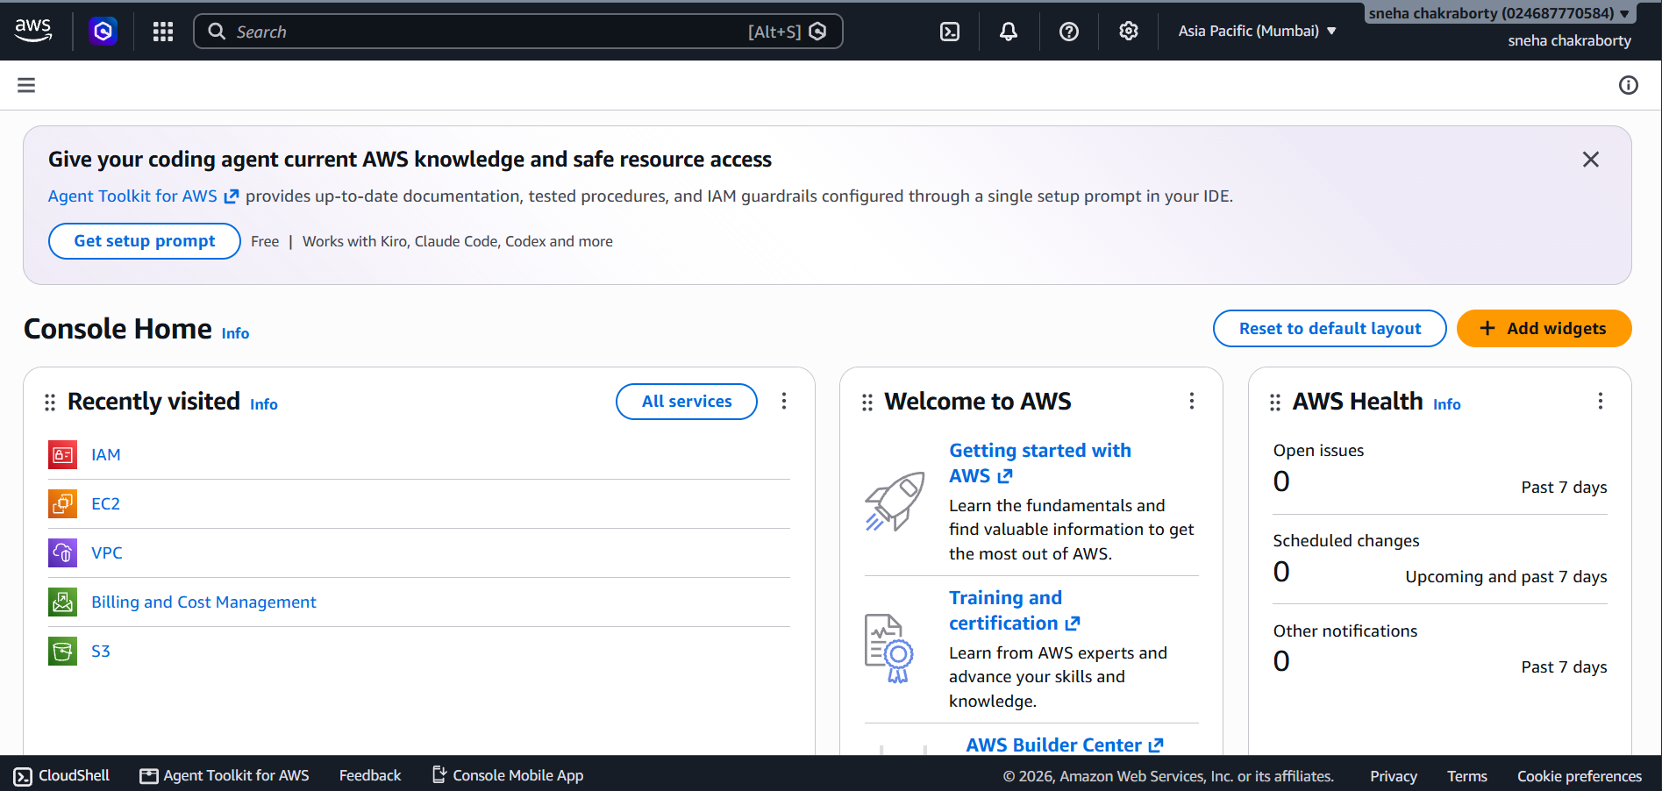
- Verify your AWS account name and selected AWS Region.
Fig 1: AWS Management Console Home Page
The figure shows the AWS Management Console home page after login, featuring the service search bar, selected AWS Region, and dashboard.

Step 2: Explore AWS Management Console
- Observe the services navigation pane and search bar.
- Use the search bar to find services like EC2, S3, IAM, VPC, and CloudWatch.
- Verify that you can access multiple AWS cloud services from the console.

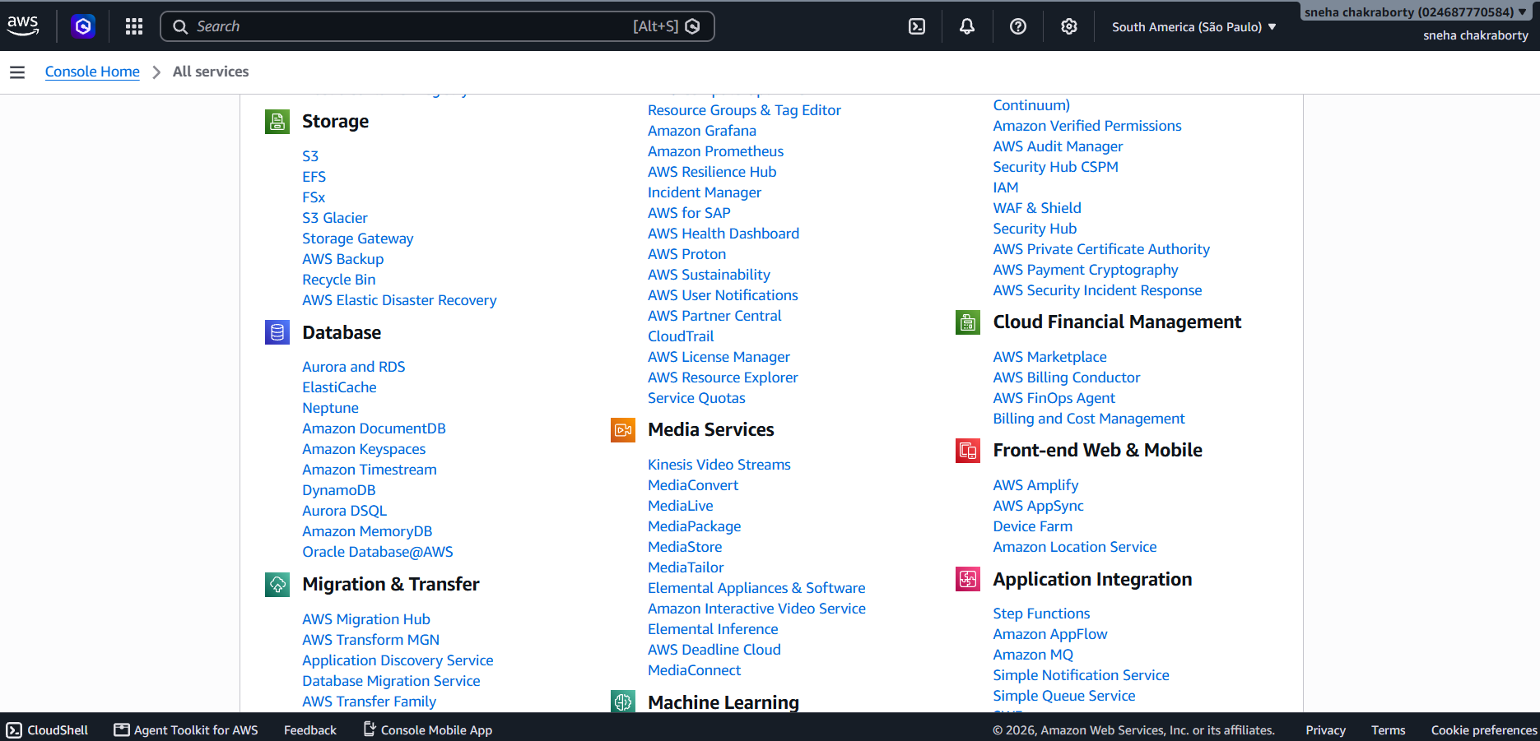
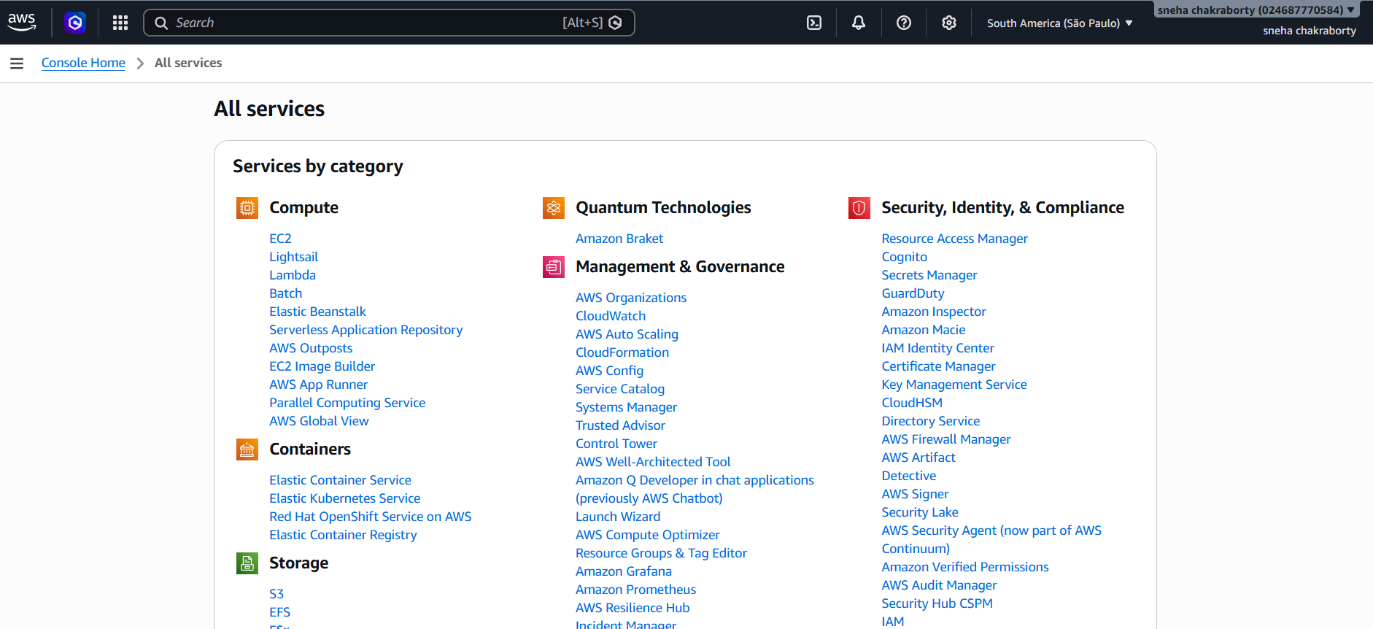
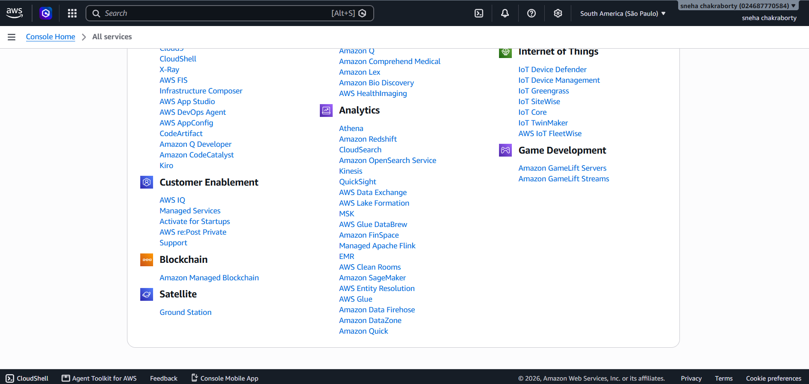
Fig 2: AWS Services Available Through the Management Console
The figure shows the list of AWS services available on the console main page.

Step 3: Open IAM Service
- In the AWS Management Console, search for IAM.
- Select Identity and Access Management (IAM) from the search results.
- The IAM Dashboard will be displayed.
- Review options for managing users, groups, roles, and policies.

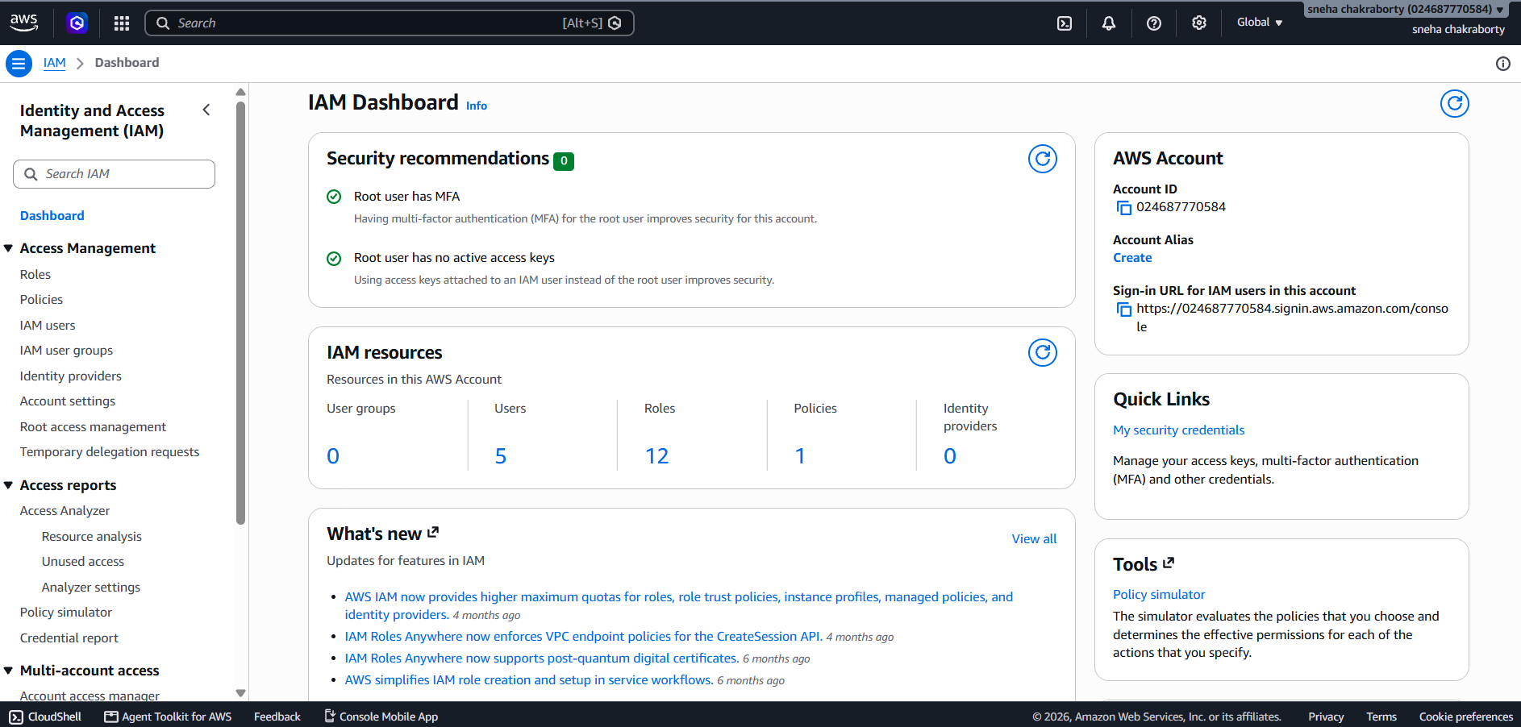
Fig 3: IAM Dashboard
The figure shows options available on the IAM Dashboard for identity and permission management.

Step 4: Open IAM Users
- In the IAM dashboard, click on Users in the left-hand panel.
- The IAM Users page will list existing IAM identities.
- Click Create user to add a new IAM user.
- Enter a username for the new IAM user.
- Configure permissions such as programmatic access or console access.
- Complete the user creation process.

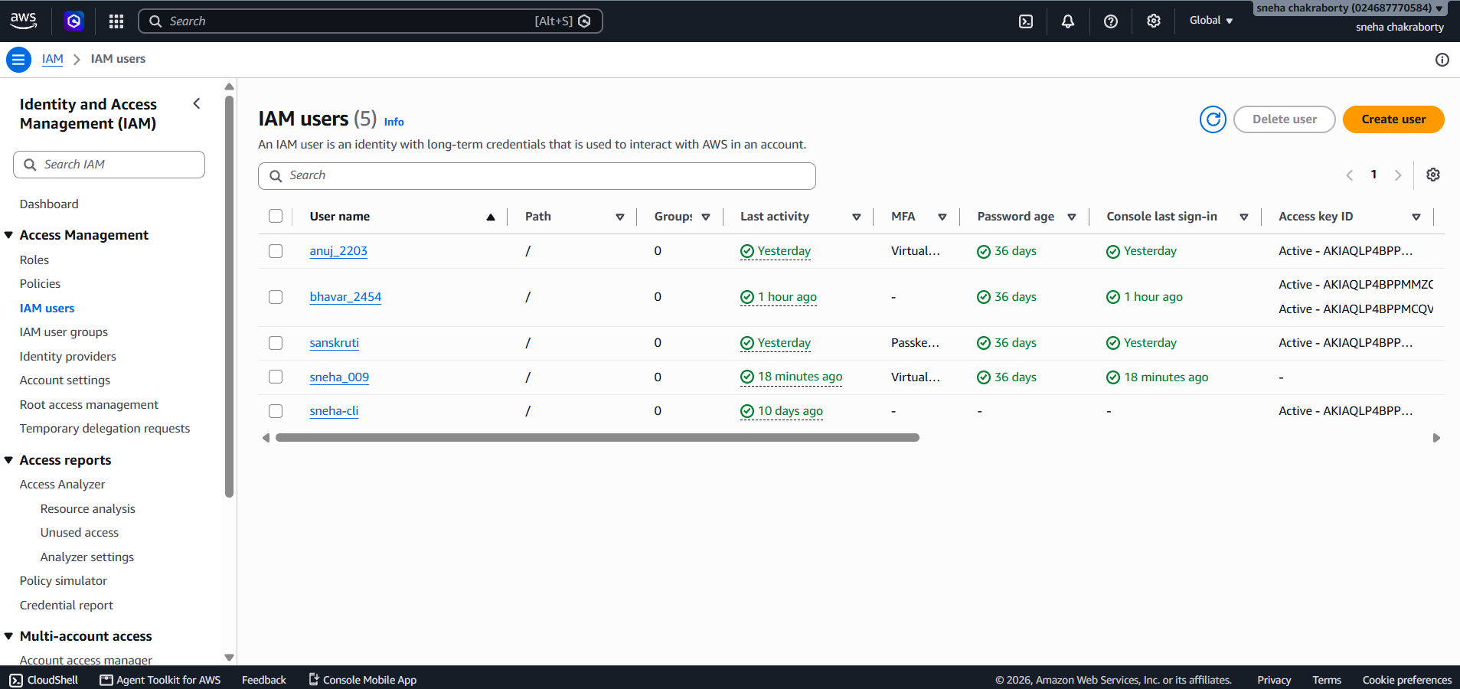

Fig 4: IAM Users Page
The figure shows the page where IAM users can be created and listed.

Step 5: Create IAM Users
- Create the first IAM user with an appropriate username and access permissions.
- Repeat the above steps to create four IAM users in total.
- After creation, return to IAM → Users list.
- Verify that all four users are displayed.

Step 6: View IAM User Details
- Select any created IAM user from the list.
- Open the user details page.
- Observe user information including permissions, groups, security credentials, and access keys.
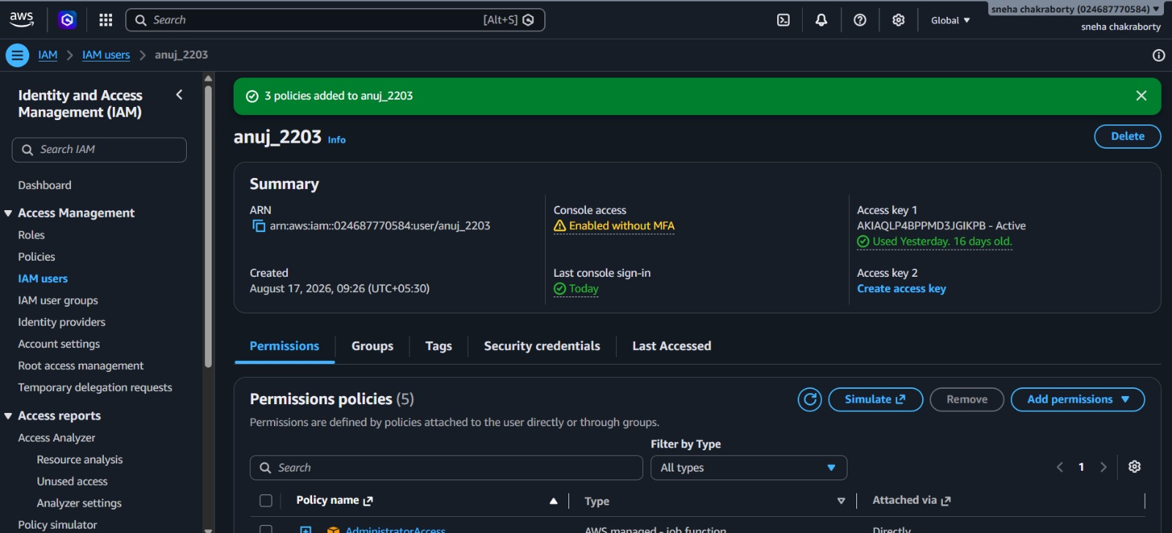
Fig 6: IAM User Details
The figure shows detailed settings and information for a selected IAM user.

Step 7: Verify AWS Free Tier / Account Usage
- Return to the AWS Management Console home page.
- Open Billing → Free Tier section.
- Review usage statistics to monitor your Free Tier limits.
- Use this to keep track of resource consumption during practicals.

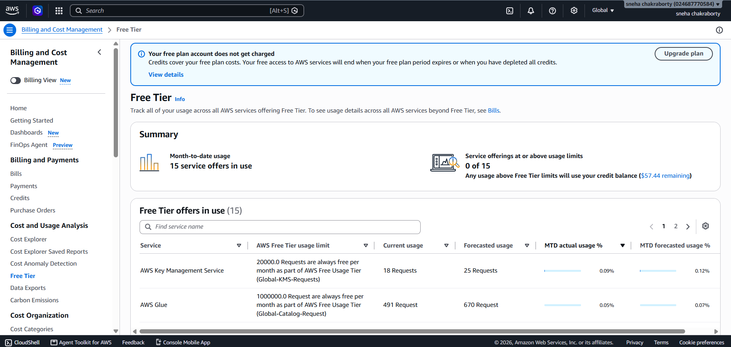

Fig 7: AWS Free Tier Usage / Billing Dashboard
The figure shows billing and Free Tier usage details, useful for monitoring resource consumption.

AWS Account and Access Structure

AWS ACCOUNT
│
ROOT USER
│
IAM
│
__________________________
│ │ │ │
User 1 User 2 User 3 User 4

Observations
Sr. No. | Observation | Status
1 | AWS Free Tier account accessed | Successful
2 | AWS Management Console accessed | Successful
3 | Root user access verified | Successful
4 | IAM service accessed | Successful
5 | IAM Users section opened | Successful
6 | IAM User 1 created | Successful
7 | IAM User 2 created | Successful
8 | IAM User 3 created | Successful
9 | IAM User 4 created | Successful
10 | Four IAM users verified in Users list | Successful

Verification / Testing
What I Tested | How I Tested It | Result
AWS Console access | Logged in using root account | Successful
Management Console | Opened console home page | Successful
IAM access | Accessed IAM service | Successful
IAM Users | Created and listed IAM users | Successful
User details | Viewed individual IAM user info | Successful
Free Tier monitoring | Viewed billing and usage | Successful

Evidence / Screenshot Summary
Evidence | What It Shows | Figure
AWS Console | Access to Management Console | Fig 1
AWS Services | AWS service list in console | Fig 2
IAM Dashboard | IAM management interface | Fig 3
IAM Users | User creation and listing | Fig 4
Four IAM Users | Verification of created IAM users | Fig 5
IAM User Details | Detailed user configuration | Fig 6
Free Tier Dashboard | Monitoring Free Tier usage | Fig 7

Expected Output
- AWS Management Console opens after authentication.
- IAM service accessible from console.
- IAM Users section displays created users.
- Four IAM users are visible in the list.
- Individual IAM user details accessible.
- Free Tier and billing data viewable for usage monitoring.

Test Results
Test | Expected Behaviour | Status
AWS account login | Console homepage opens successfully | PASS
Console access | AWS services accessible | PASS
IAM access | IAM dashboard opens | PASS
User creation | IAM users created successfully | PASS
User verification | Four users appear in list | PASS
User details | Individual details accessible | PASS
Free Tier monitoring | Usage information displayed | PASS

Advantages
- Centralized access to diverse AWS cloud services.
- User-friendly web interface in the Management Console.
- IAM enables creation of users with role-based access.
- Reduces risk by limiting use of root credentials.
- Facilitates secure resource access and delegation.
- AWS Free Tier ideal for learning and experimentation within limits.
- Usage monitoring tools prevent unexpected charges.
Precautions
- Protect root user credentials and avoid sharing.
- Assign only necessary permissions to IAM users.
- Never share passwords or access keys in reports or screenshots.
- Monitor usage regularly to avoid exceeding Free Tier limits.
- Terminate unused resources promptly.
- Always verify Free Tier applicability before resource setup.

Result
The AWS Free Tier account was accessed successfully using the AWS Management Console. The AWS root user was authenticated, and the IAM service was opened. Four IAM users were created and verified in the AWS account. The practical enhanced understanding of AWS Management Console, root user, IAM users, and controlled access principles.
Conclusion
This practical demonstrated the process of setting up an AWS Free Tier account and accessing the AWS Management Console. Exploring the IAM service and creating IAM users provided insight into AWS identity and access control. The exercise reinforced core concepts of cloud account security and management through hands-on experience with AWS.

