Title
Create an On-Demand EC2 instance and observe its various instance states and parameters.

Aim
To create an On-Demand Amazon EC2 instance, launch it successfully, and observe the different instance states and configuration parameters through the AWS Management Console.

Objectives
- Understand the purpose of Amazon EC2.
- Launch an On-Demand EC2 instance.
- Select an Amazon Machine Image (AMI) and instance type.
- Observe instance ID, state, type, IP address, Availability Zone, and other parameters.
- Start, stop, reboot, and terminate the instance.
- Record the changes in the EC2 instance state.

AWS Services Used
- Amazon EC2
- Amazon Machine Image (AMI)
- Amazon VPC
- Security Group
- AWS Management Console

Prerequisites
- Active AWS account.
- Internet connection.
- Access to AWS Management Console.
- Basic knowledge of cloud computing and virtual machines.

Architecture Diagram
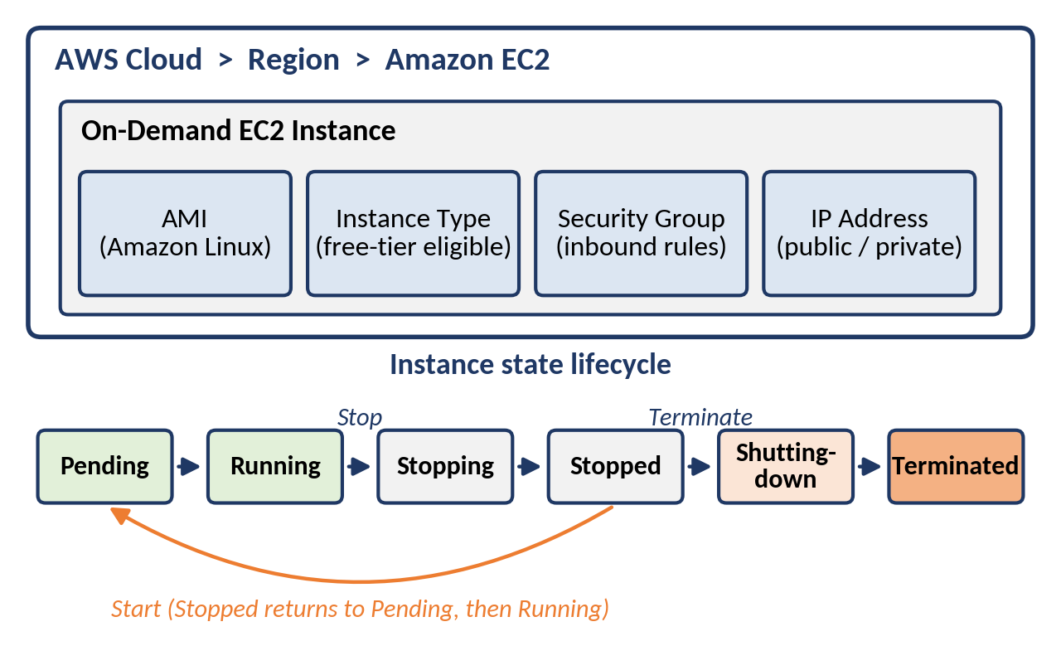
Figure 3.1: Architecture of Practical 3

Step-by-Step Implementation
- Sign in to the AWS Management Console.
- Open the Amazon EC2 service.
- Select the required AWS Region.Click Launch Instance.

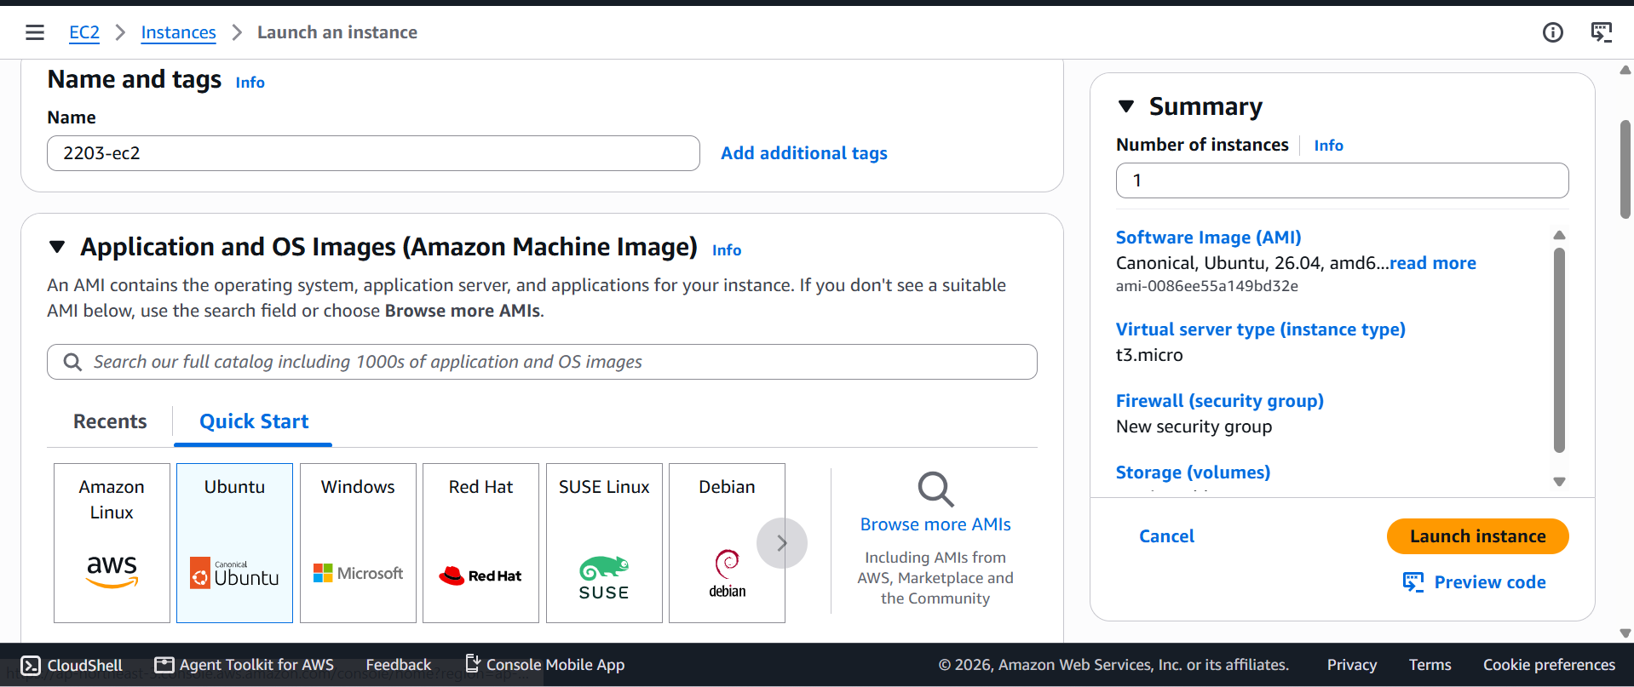
- Enter a suitable instance name.
- Select an Amazon Machine Image such as ubuntu.

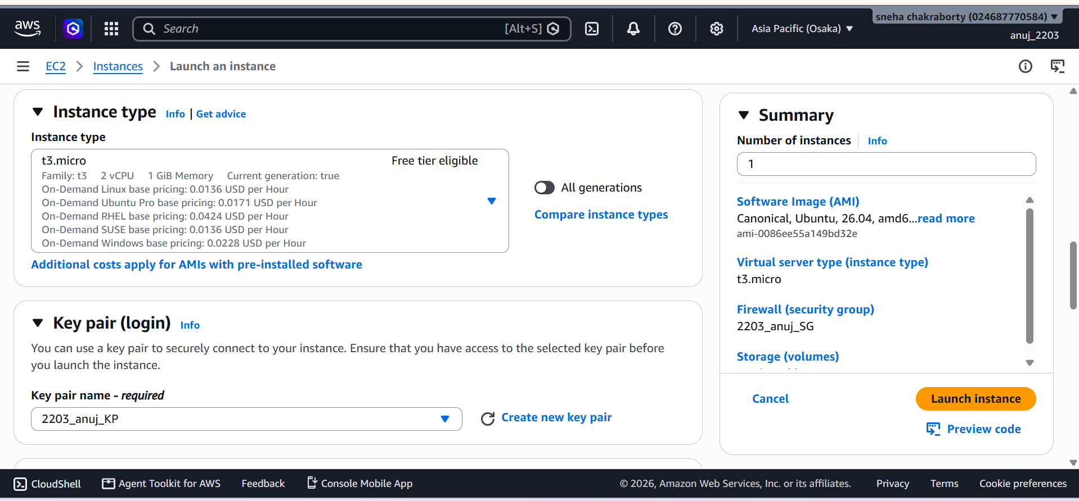
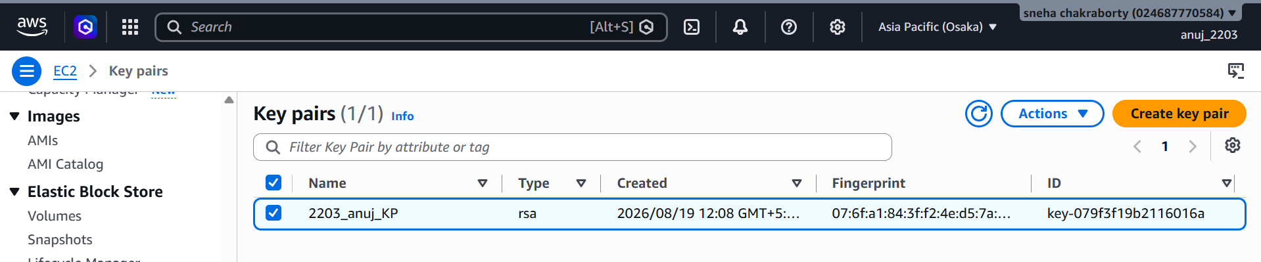
- Select an eligible On-Demand instance type.

- Create or select a key pair if required.

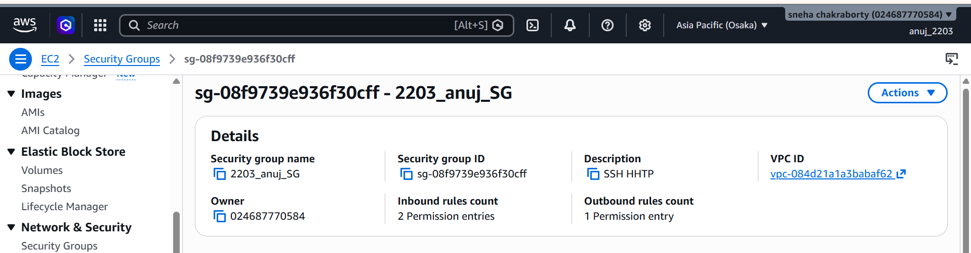

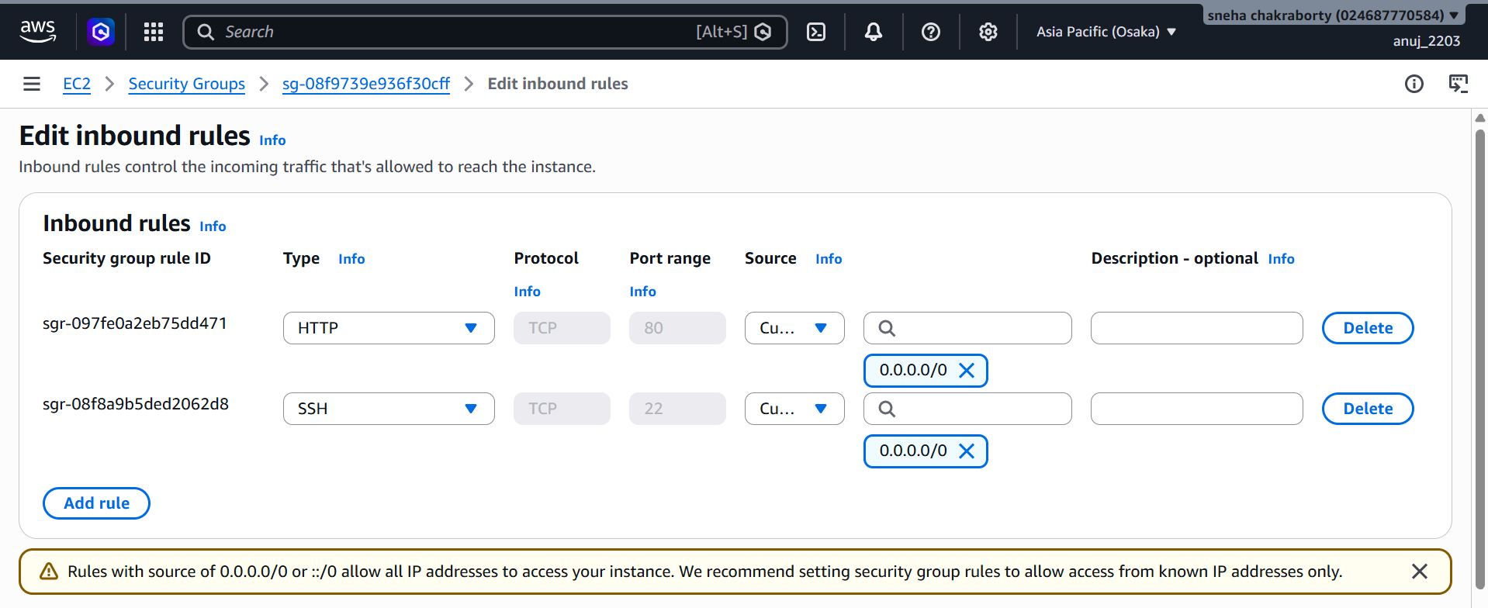

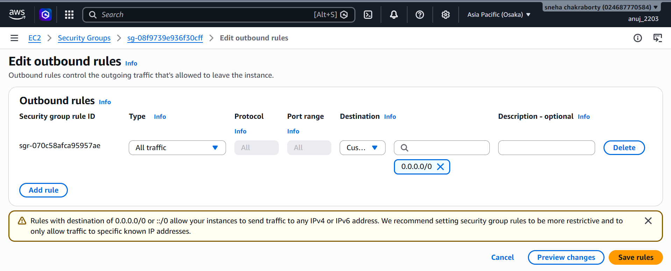
- Configure network settings and security group.
Set storage according to the practical requirement.
Review the configuration.
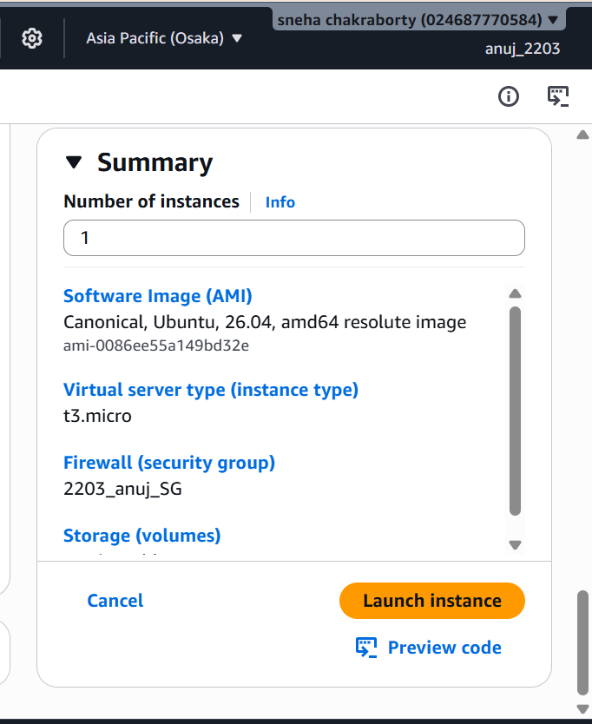
- Click Launch Instance.

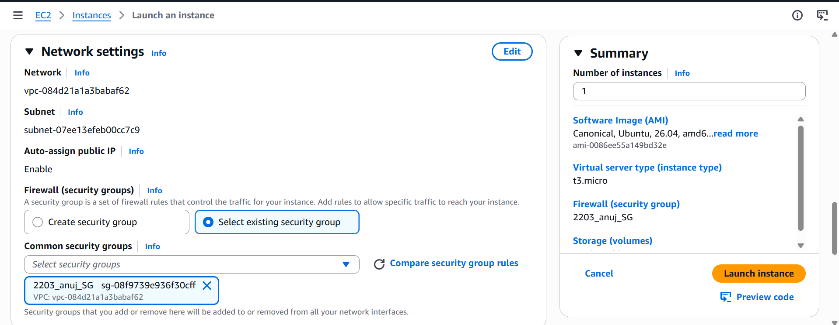
Observe Instance ID, Instance State, Instance Type, Public IPv4 address, Private IPv4 address, Availability Zone, AMI ID, and Security Group.
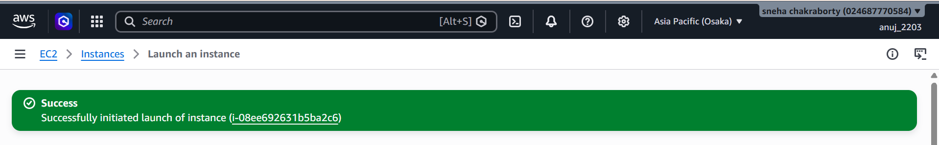
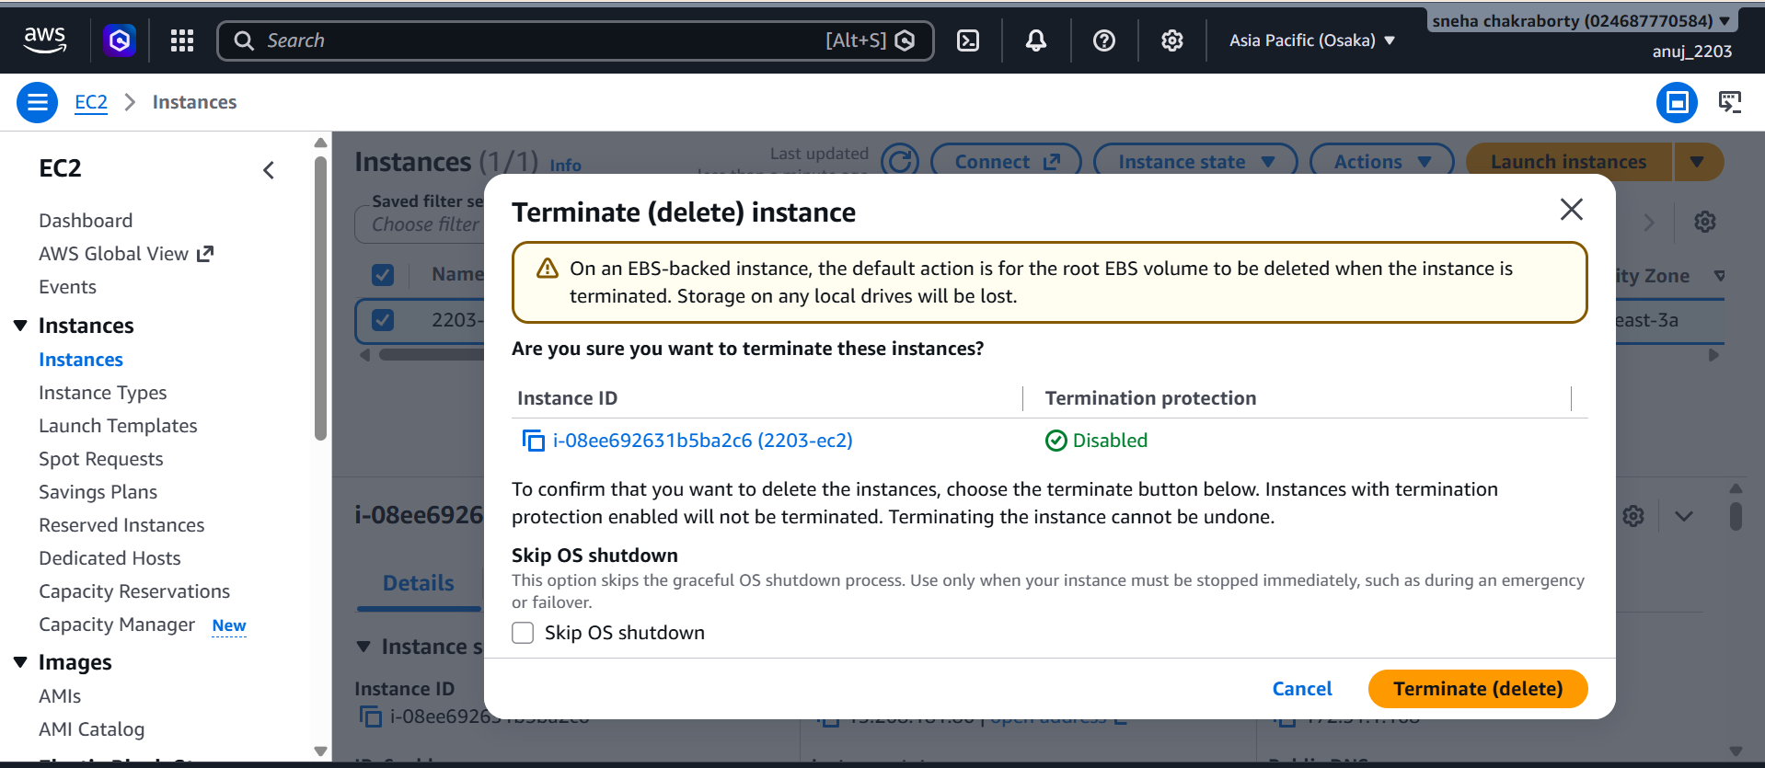

Terminate the instance after completing the observation.

Verification / Testing
- Verify that the EC2 instance is created successfully.
- Verify the Instance ID and Instance Type.
- Verify the selected AMI and Availability Zone.
- Verify the security group and IP address parameters.
- Verify the Running state.
- Stop the instance and verify the Stopped state.
- Start the instance and verify the Running state.
- Reboot the instance and verify that it returns to the Running state.
- Terminate the instance and verify the Terminated state.

State transitions observed during the practical:
Action | Instance State Observed
Launch instance | Pending → Running
Terminate instance | Shutting-down → Terminated

Instance parameters recorded
Parameter | Observed Value
Instance ID | i-08ee92631b5ba2c6(2203-ec2)
Instance state | Running
Instance type | t3.micro
AMI ID | ami-08f9739e936f30cff
Security group | sg-08f9739e936f30cff-2203_anuj_SG

Note: the public IPv4 address of an instance without an Elastic IP usually changes after a stop and start, but stays the same after a reboot.

Result / Conclusion
An On-Demand EC2 instance was successfully created and its important configuration parameters and instance-state transitions were observed. The practical demonstrated the basic lifecycle of an Amazon EC2 instance from launch to termination.

