Title
Create IAM Users and Assign Granular Access Using AWS Policies to Manage Service-Level Access
Aim
To create IAM users in an AWS account and assign controlled, service-level access using AWS IAM policies, thereby demonstrating how permissions can be managed for different users according to their required AWS services.
Objectives
- To understand AWS Identity and Access Management (IAM).
- To inspect and manage IAM users.
- To understand AWS managed policies and permissions.
- To assign service-level permissions to IAM users.
- To configure access to services such as Amazon S3 and Amazon EC2.
- To review and verify policies attached to individual IAM users.
- To understand the importance of controlled access and least-privilege permissions.

AWS Services / Features Used
Service / Feature | Purpose
AWS Management Console | Web-based interface used to manage AWS resources.
AWS IAM | Manages identities, authentication and authorization.
IAM Users | Individual identities within the AWS account.
IAM Policies | Define allowed or denied AWS actions.
Amazon S3 | Object storage service whose access can be controlled using IAM policies.
Amazon EC2 | Compute service whose access can be controlled using IAM policies.
Prerequisites
- AWS account with access to the AWS Management Console.
- Root-user or suitable administrative IAM permissions.
- Internet connection and web browser.
- Previously created IAM users.
- Basic understanding of AWS services and IAM policies.

Theory
- AWS Identity and Access Management (IAM) is a web service that helps securely control access to AWS resources. IAM enables administrators to create identities and define what actions those identities are allowed to perform.
- An IAM user represents an identity within an AWS account. Permissions can be provided by attaching policies directly to users or through groups.
- An IAM policy is a permissions document that specifies which actions are allowed or denied on AWS resources. AWS managed policies can be used when the required permissions are already defined by AWS.
- Granular or service-level access means assigning permissions according to the services required by a user. For example, an S3-related policy can provide access to Amazon S3, while an EC2-related policy can provide access to Amazon EC2.
- The practical also demonstrate broader policies such as PowerUserAccess and AdministratorAccess. These policies provide broader permissions than a strict least-privilege configuration and should therefore be used only when appropriate.

Architecture / Access Structure
 |  | AWS ACCOUNT
 |  | IAM SERVICE
anuj_2203 | bhavar_2454 | sanskruti | sneha_009 | sneha-cli
S3 / EC2 | S3 / EC2 | S3 / EC2 | Administrator | IAM identity

Step-by-Step Implementation
Step 1: Open AWS Management Console
- Open a web browser and access the AWS Management Console.
- Sign in using the AWS root-user credentials.
- Complete MFA if enabled.
- Verify that the AWS Management Console opens successfully.
Step 2: Open IAM and IAM Users
- Use the AWS console search bar and search for IAM.
- Open Identity and Access Management (IAM).
- From the left navigation panel, select IAM users.
- Review the list of existing IAM users.
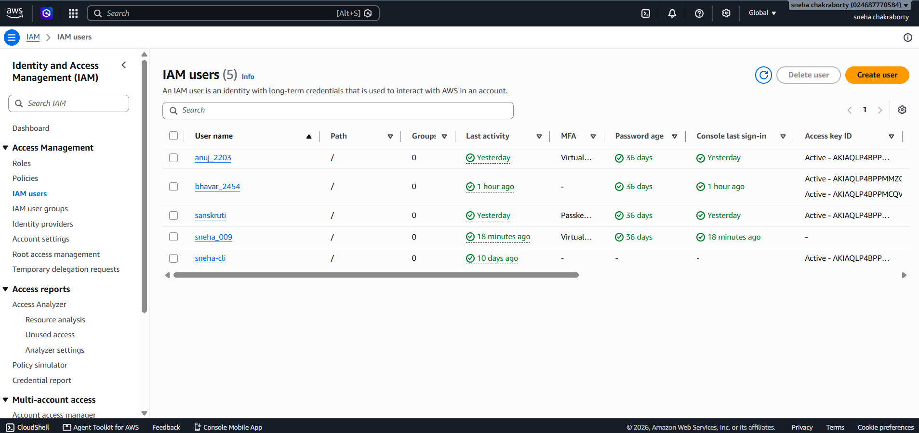
Fig 1: IAM Users List
The screenshot shows the AWS IAM Users page with the available identities in the account. The visible list includes anuj_2203, bhavar_2454, sanskruti, sneha_009 and sneha-cli, along with information such as last activity, MFA status, password age and console sign-in activity.

Step 3: Inspect the Permissions of an IAM User
- Select the IAM user sneha_009 from the Users list.
- Open the Permissions tab.
- Review the policies attached to the user.
- Observe whether each policy is attached directly or through a group.
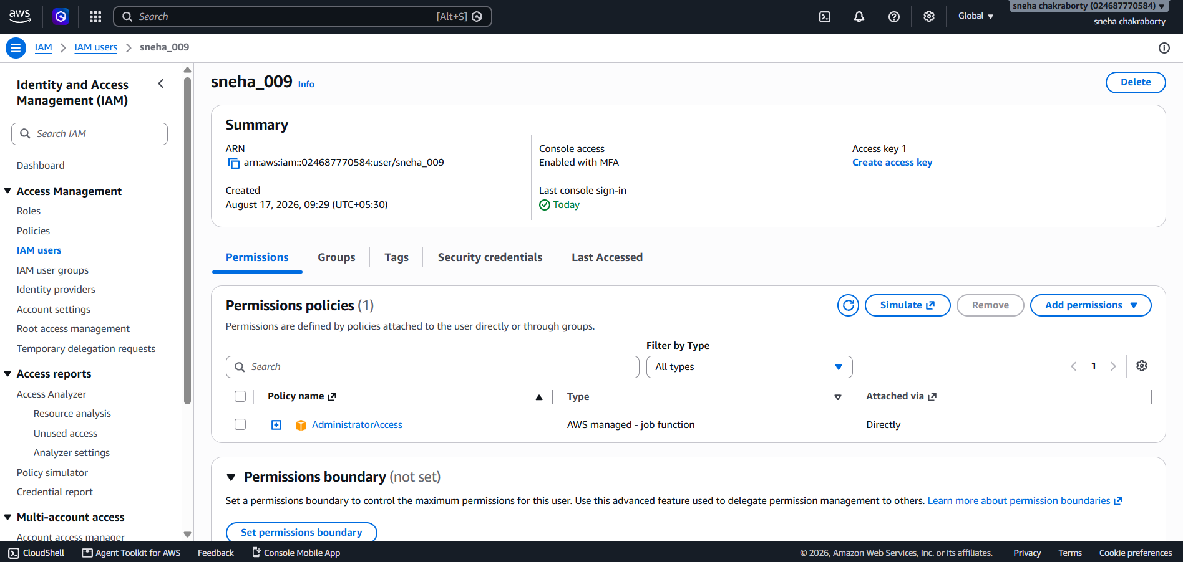
Fig 2: Permissions of IAM User sneha_009
The screenshot shows the IAM user details page for sneha_009. The Permissions tab displays AdministratorAccess as an AWS managed policy attached directly to the user. The summary also shows console access and recent sign-in information.

Step 4: Add Permissions to an IAM User
- Open the required IAM user.
- Click Add permissions.
- Choose the option to attach policies directly to the user.
- Search for the required AWS managed policies.
- Select the policies required for the user's service responsibilities.
- Continue to the Review page.

Step 5: Review Service Policies for anuj_2203
- Open IAM → Users → anuj_2203.
- Select Add permissions.
- Select the required AWS managed policies.
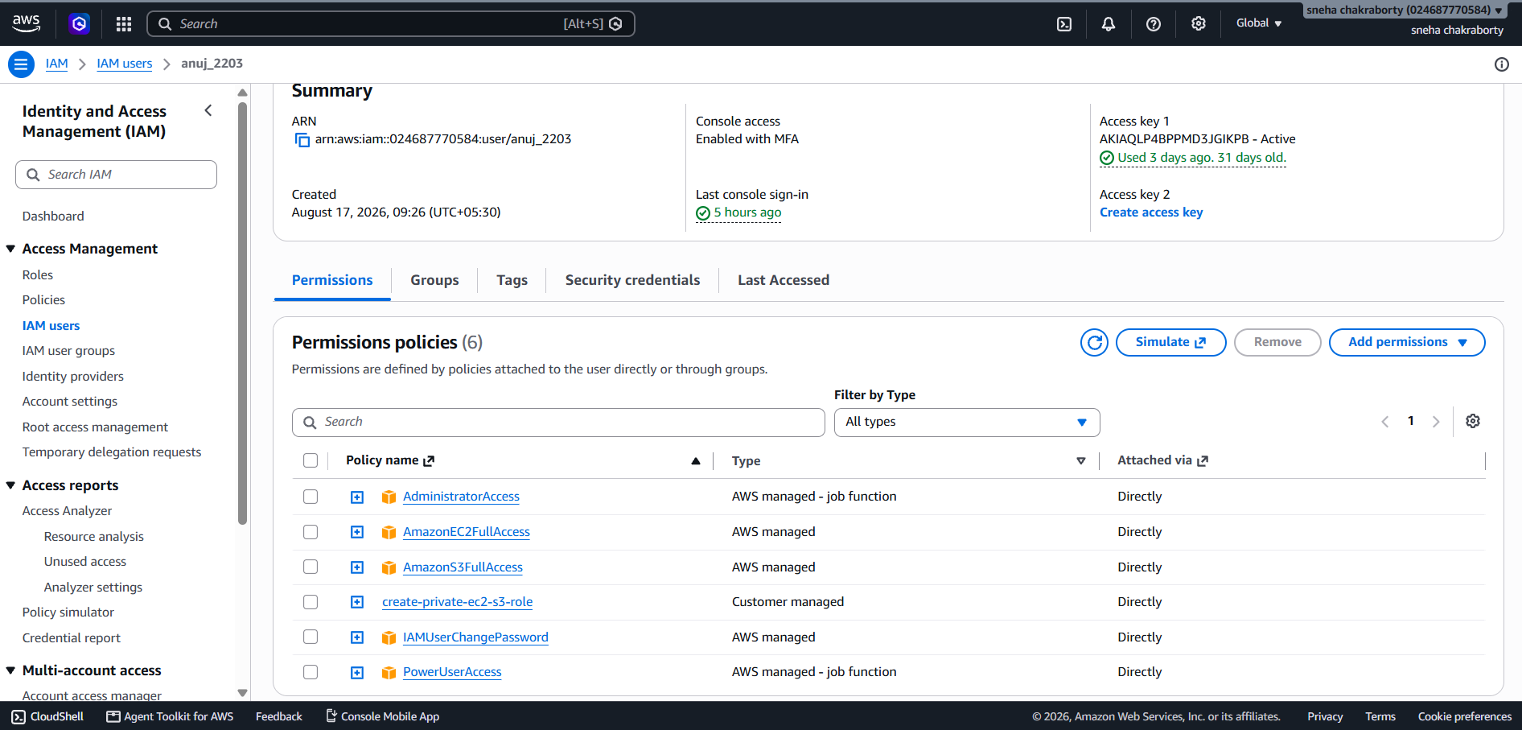
- Review the Permissions summary before applying the changes.
Fig 3: Permission Review for anuj_2203
The screenshot shows the Review page for anuj_2203. The Permissions Summary contains PowerUserAccess, AmazonS3FullAccess and AmazonEC2FullAccess. This screen allows the administrator to verify the selected policies before attaching them to the user.

Step 6: Verify the Attached Policies for anuj_2203
- Complete the permission assignment.
- Return to the anuj_2203 user details page.
- Open the Permissions tab.
- Verify the policies listed under Permissions policies.

Step 7: Review Service Policies for bhavar_2454
- Open IAM → Users → bhavar_2454.
- Select Add permissions.
- Select the required policies.
- Review the Permissions summary before applying the changes.

Step 8: Review Service Policies for sanskruti
- Open IAM → Users → sanskruti.
- Select Add permissions.
- Select the required AWS managed policies.
- Review the Permissions summary.
Step 9: Verify the Final IAM Policy Configuration
Return to IAM → Users.
Open each relevant IAM user.
Select the Permissions tab.
Check the attached policies and their attachment method.
Confirm that the configured policies correspond to the intended AWS services.

Policy Assignment Summary

IAM User | Policy / Access | Attachment | Purpose
sneha_009 | AdministratorAccess | Directly | Broad administrative access
anuj_2203 | PowerUserAccess | Directly | Broad service-level access
anuj_2203 | AmazonS3FullAccess | Directly | Full S3 access
anuj_2203 | AmazonEC2FullAccess | Directly | Full EC2 access
anuj_2203 | IAMUserChangePassword | Directly | Password change capability
bhavar_2454 | PowerUserAccess | Directly | Broad service-level access
bhavar_2454 | AmazonS3FullAccess | Directly | Full S3 access
bhavar_2454 | AmazonEC2FullAccess | Directly | Full EC2 access
sanskruti | PowerUserAccess | Review screen | Broad service-level access
sanskruti | AmazonS3FullAccess | Review screen | Full S3 access
sanskruti | AmazonEC2FullAccess | Review screen | Full EC2 access

Verification / Testing
Test | Expected Behaviour | Status
IAM service access | IAM dashboard opens successfully | PASS
IAM users | Users are visible in IAM Users | PASS
User permissions | Permissions tab displays attached policies | PASS
S3 policy | AmazonS3FullAccess appears for selected users | PASS
EC2 policy | AmazonEC2FullAccess appears for selected users | PASS
Permission review | Selected policies appear in Review screen | PASS
Direct attachment | Final permissions show policies attached directly | PASS

Evidence / Screenshot Summary
Figure | Evidence | What It Demonstrates
Fig 1 | IAM Users list | IAM identities available in the account
Fig 2 | sneha_009 permissions | AdministratorAccess attached directly
Fig 3 | anuj_2203 review | S3, EC2 and PowerUser policies selected
Fig 4 | anuj_2203 final permissions | Policies attached directly
Fig 5 | bhavar_2454 review | S3, EC2 and PowerUser policies selected
Fig 6 | sanskruti review | S3, EC2 and PowerUser policies selected

Expected Output
- IAM Users page displays the created identities.
- Individual IAM user details can be opened.
- The Add permissions workflow allows policies to be selected.
- The Review page displays the policies selected for attachment.
- The Permissions tab displays policies attached to the user.
- Service-level access can be configured using AWS managed policies.

Observations
- IAM provides centralized identity and access management for AWS resources.
- Different IAM users can have different permission sets.
- Policies can be attached directly to individual users.
- AmazonS3FullAccess provides full access to Amazon S3.
- AmazonEC2FullAccess provides full access to Amazon EC2.
- PowerUserAccess provides broad access to AWS services with restrictions on certain IAM and account-management operations.
- AdministratorAccess is a broad administrative policy and is not equivalent to narrowly scoped service-level access.
- The IAM console provides a review screen before policies are attached.
- The Permissions tab can be used to verify the resulting policy configuration.

Advantages
- Centralized access management.
- Individual user identities and accountability.
- Service-level permission control.
- Flexible policy assignment.
- Easy verification of effective configuration.
- Reduced need to share root-user credentials.
- Supports implementation of least privilege when policies are appropriately scoped.

Precautions
- Protect the root-user credentials and avoid using the root user for routine tasks.
- Do not assign AdministratorAccess unnecessarily.
- Avoid unnecessarily broad policies when a service-specific policy is sufficient.
- Review policies before attaching them to a user.
- Enable MFA for IAM users where appropriate.
- Remove unused users, credentials and permissions.
- Monitor AWS resource usage and costs while performing practicals.

Result / Conclusion
- The practical was successfully performed using AWS IAM. Existing IAM users were accessed and AWS managed policies were reviewed and assigned through the IAM permission-management workflow. The practical demonstrated service-related access using Amazon S3 and Amazon EC2 policies and showed how the attached policies can be verified from the IAM Permissions tab.

- The practical also demonstrated that IAM allows different permission configurations for different users. Broad policies such as PowerUserAccess and AdministratorAccess provide wider permissions, whereas appropriately scoped service policies can be used when narrower access is required.

