**PROGRAM – 1**

**AIM :** WAP to remove comments and whitespaces and add line numbers . Take input from source file and write to new output file .

**PROGRAM :**

#include <bits/stdc++.h>

using namespace std ;

string removeSpaces(string input) {

input.erase(remove(input.begin() , input.end() , ' ') , input.end());

input.erase(remove(input.begin() , input.end() , '\t') , input.end());

return input;

}

int main() {

ifstream file1("test.cpp") ;

ofstream file2("test1.cpp") ;

bool remove = false , do_replace ;

if(file1 . is_open()) {

int i = 1 ;

string str ;

while(getline(file1 , str)) {

do_replace = true ;

if(str . find("//") != string::npos) {

size_t pos1 = 0 , pos2 = 0 ;

size_t pos = str . find("//" , pos1) ;

size_t posf = str . find("\"" , pos2) ;

size_t posl = str . find("\"" , posf + 1) ;

while(pos != string::npos) {

if(! (pos > posf && pos < posl)) {

size_t temp1 = str . find("\"" , posl + 1) ;

size_t temp2 = str . find("\"" , temp1 + 1) ;

if((pos < temp1 && pos < temp2) || temp1 == string::npos || temp2 == string::npos) {

str . replace(str . begin() + pos , str . end() , "") ;

break ;

} else {

pos1 = posl + 1 ;

pos2 = posl + 1 ;

}

} else {

pos1 = posl + 1 ;

pos2 = posl + 1 ;

}

pos = str . find("//" , pos1) ;

posf = str . find("\"" , pos2) ;

posl = str . find("\"" , posf + 1) ;

}

}

size_t npos1 = str . find("/*" , 0) ;

size_t npos2 = str . find("*/" , npos1 + 2) ;

if(npos1 != string::npos && npos2 != string::npos) {

do_replace = false ;

size_t pos1 = 0 , pos2 = 0 ;

size_t posf = str . find("\"" , pos2) ;

size_t posl = str . find("\"" , posf + 1) ;

while(npos1 != string::npos && npos2 != string::npos) {

if(! (npos1 > posf && npos1 < posl && npos2 > posf && npos2 < posl)) {

str . replace(str . begin() + npos1 , str . begin() + npos2 + 2 , "") ;

} else {

pos1 = posl + 1 ;

pos2 = posl + 1 ;

}

npos1 = str . find("/*" , pos1) ;

npos2 = str . find("*/" , npos1 + 2) ;

posf = str . find("\"" , pos2) ;

posl = str . find("\"" , posf + 1) ;

}

}

if(npos1 != string::npos && npos2 == string::npos && do_replace) {

remove = true ;

str . replace(str . begin() + npos1 , str . end() , "") ;

do_replace = false ;

}

if(npos1 == string::npos && npos2 != string::npos && do_replace) {

size_t pos = str . find("*/") ;

str . replace(str . begin() , str . begin() + npos2 + 2 , "") ;

remove = false ;

}

if(remove && do_replace) {

str . replace(str . begin() , str . end() , "") ;

}

string temp = removeSpaces(str) ;

if(temp != "")

file2 << i ++ << " : " << str << "\n";

}

file1 . close() ;

} else {

cout << "Unable to open file ..\n" ;

}

return 0 ;

}

**Input File :**

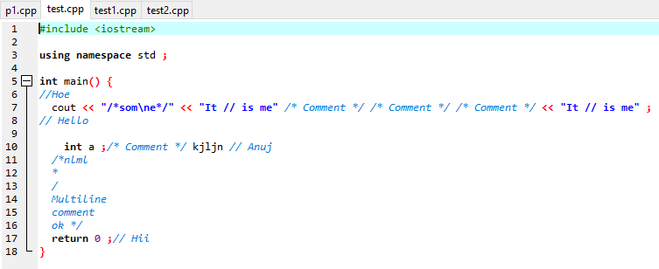

**Output File :**

