**PROGRAM – 4**

**AIM :** WAP to remove comments and whitespaces and add line numbers using LEX tools . Take input from source file .

**LEX PROGRAM :**

whitespace [ \t]

newline \n

%{

#include <bits/stdc++.h>

using namespace std ;

int line_no = 1 ;

bool do_remove = false ;

%}

%%

\"[^\"]*\" {

cout << yytext ;

}

\/\/.* ;

\/\* {

do_remove = true ;

}

\*\/ {

do_remove = false ;

}

{whitespace}{whitespace}+ ;

{newline}+ {

if(! do_remove)

cout << "\n\t" << ++line_no << "\t" ;

}

. {

if(! do_remove)

cout << yytext ;

}

%%

int yywrap() {

return 1 ;

}

int main() {

yyin = fopen("test.cpp" , "r") ;

cout << "\t" << line_no << "\t" ;

yylex() ;

cout << "\n" ;

fclose(yyin) ;

return 0 ;

}

**Input File :**

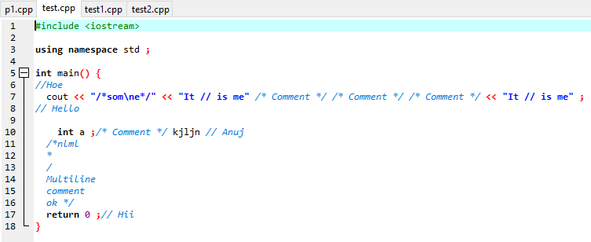

**Output :**

