**CS 273 Final Project**

**Team members: Anujin Munkhbat, Amon Ratna Sthapit**

**Project Name: Game of Life**

Final Summary

Answers to questions :

Graphs :

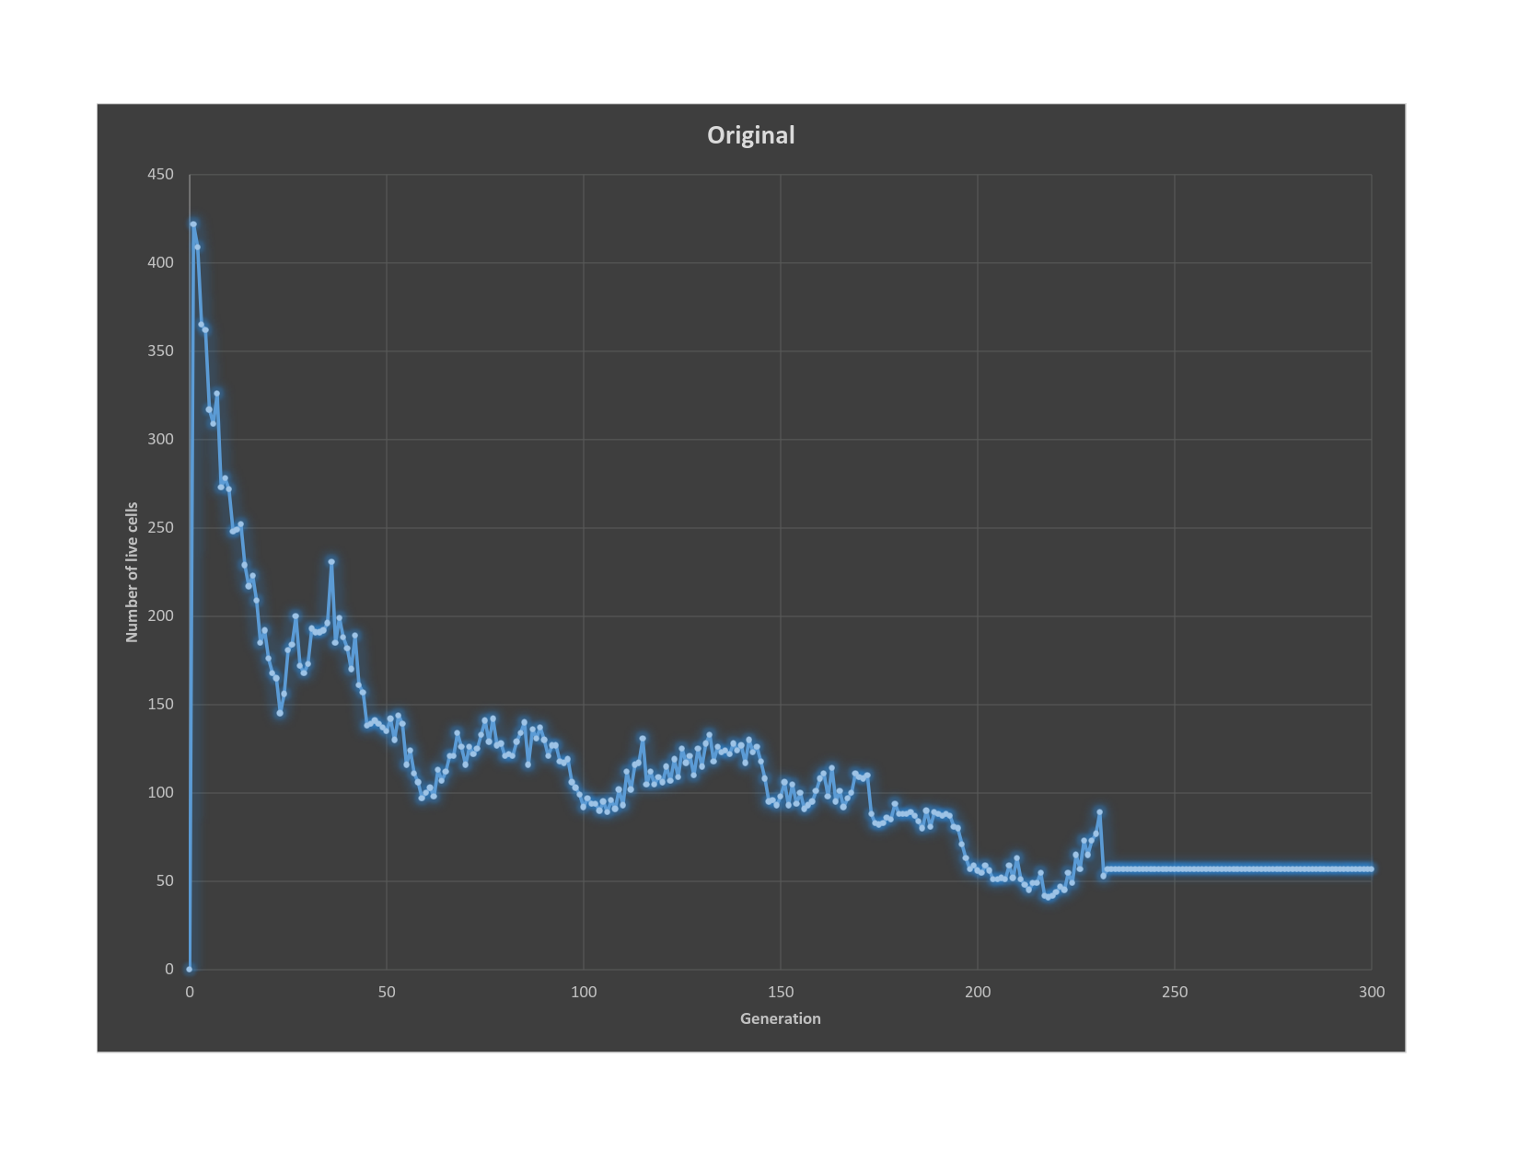

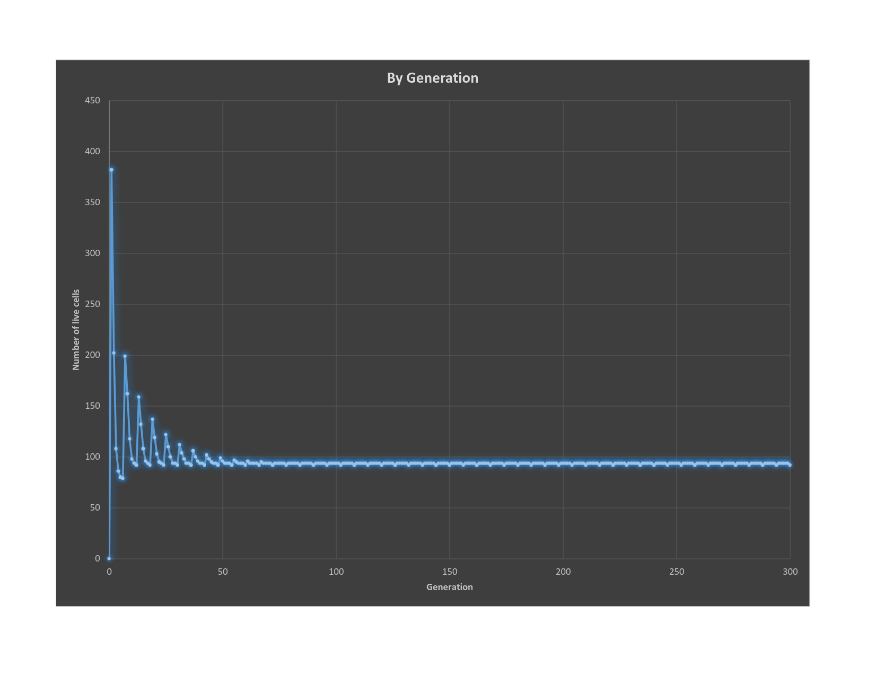

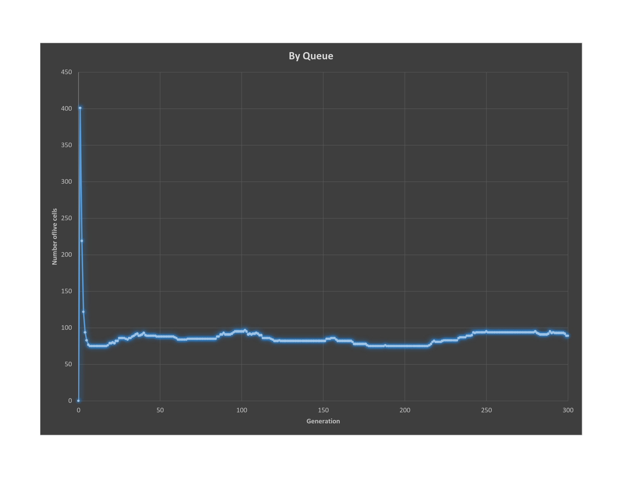

Changes from initial design in final implementation :

Lessons learned ? :