RideEase
A Ride-Hailing Web App with Real Road Routing
& AI-Powered Chat Translation
System Architecture, Cloud Deployment & Scalability Report

Academic Project Submission
Tech stack: Python · Flask · HTML/CSS/JavaScript · Leaflet.js · OSRM · Google Gemini API
September 2026

Table of Contents
1. Business Problem and Target Users 3
2. Technology Stack 3
3. Current System Architecture 5
4. Data Flow Between Major Components 7
5. Current Hosting and Deployment Approach 7
6. Proposed Cloud Deployment Architecture (AWS) 9
7. Scalability Analysis: 1 Million and 5 Million Users 11
8. Implementation Details 13
9. Known Limitations and Future Scope 14

1. Business Problem and Target Users
Commuters in Indian cities frequently rely on two-wheeler and auto-rickshaw ride-hailing for short, affordable trips. Two everyday frictions motivate this project. First, riders and drivers often do not share a common language, which slows down coordinating pickup points and directions in the moment. Second, riders want a clear, upfront sense of the road route and fare before committing to a trip, rather than a straight-line estimate that ignores real streets and turns. RideEase is an academic prototype that explores how a lightweight web application could address both problems: real road-based routing for trip planning and fare estimation, plus an AI-powered translation layer so rider and driver can chat comfortably in their own languages.
As an academic project, RideEase intentionally keeps its scope narrow: it proves out the two hardest user-facing problems — real routing and cross-language chat — end to end, while explicitly stubbing out production concerns like payments, accounts, and emergency response rather than leaving them half-built. This keeps the limitation explicit rather than silently broken, and sets up the cloud architecture and scaling discussion later in this report.

Target Users
- Riders — commuters booking short intra-city trips who want an accurate fare based on a real road route, and may prefer to communicate in a regional language.
- Drivers — represented in this prototype via a simulated engine (a vehicle marker moving along the route, preset Kannada reply phrases sent through the same translation pipeline).
- Evaluators / instructors — the immediate audience for this academic build, interested in seeing real routing, transparent pricing, and a practical use of a generative-AI API.

Business Requirements
- Accurate, upfront pricing — riders must see a fare based on real road distance before confirming a ride, not a straight-line estimate.
- Cross-language communication — riders and drivers who do not share a language must be able to coordinate pickup details without a translator.
- Trip transparency — the rider must be able to see the planned route, ETA, and driver/vehicle details once a ride is confirmed.
- A visible safety mechanism — an SOS control must be reachable from the active-ride screen, even if the calling/SMS integration is a later milestone.
- Low-cost demonstrability — the system must run end-to-end on free-tier or no-cost external services so it can be evaluated without incurring billing.
- A scaling path — the architecture must be able to grow from a single-instance demo to production traffic without a ground-up redesign.

2. Technology Stack
Layer | Technology | Purpose
Frontend | HTML / CSS / JavaScript | Structure, styling, interactivity
Frontend | Leaflet.js | Interactive map, markers, route polyline
Backend | Python 3 + Flask | Web server and REST API (app.py)
Backend | python-dotenv | Loads GEMINI_API_KEY from a local .env file
Backend | google-genai SDK | Calls the Gemini API for translation, server-side
External API | OSRM | Free road-routing engine, no API key required
External API | Google Gemini API | Language detection and translation

Leaflet and OSRM were chosen because both are free and need no API key, and OSRM returns real driving routes as GeoJSON rather than straight-line distances — a meaningful difference for a fare that is supposed to reflect the actual trip. Flask is lightweight enough to stand up a handful of JSON endpoints (fare estimate, translation, SOS stub) without the overhead of a full framework, which suited a small, single-developer academic build. Gemini's API was chosen for strong multilingual translation quality via a single prompt that both detects the source language and translates into the selected target language, avoiding the cost and complexity of a separate language-detection step. python-dotenv rounds out the stack by keeping the Gemini API key out of source control, loading it from a local .env file at process startup rather than hard-coding it anywhere in the codebase.

3. Current System Architecture
RideEase follows a simple two-tier architecture: a Flask backend serving a small JSON API, and a browser-based frontend handling all interaction, map rendering, and state. Two external services supply real-world data — OSRM for routing and Google's Gemini API for translation.
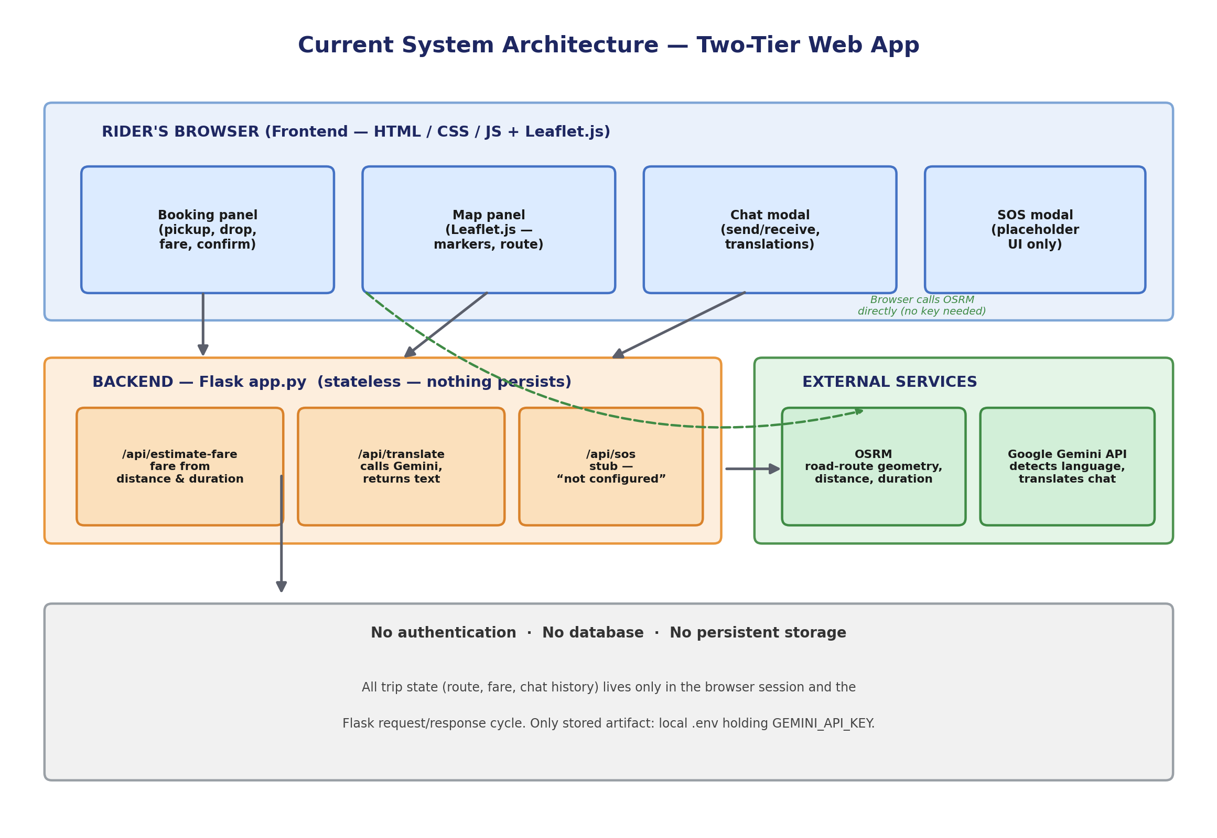
Figure 3.1 — Current system architecture: browser client, Flask backend, and the two external APIs it calls. No auth or persistent storage exists yet.
Layer | Component | Responsibility
Frontend | Booking panel | Collects pickup/drop, displays fare, confirms ride
Frontend | Map panel (Leaflet.js) | Renders map, markers, route line, vehicle position
Frontend | Chat modal | Sends/receives messages, displays translations
Backend | Flask app (app.py) | Serves pages, exposes REST endpoints
Backend | /api/estimate-fare, /api/translate, /api/sos | Fare calc, Gemini call, SOS stub
External | OSRM / Gemini API | Road-route geometry; language detection and translation

Frontend, Backend, and Authentication
The frontend is delivered as static assets (templates/index.html, static/style.css, static/script.js) rendered by Flask and executed entirely in the rider's browser. A single Leaflet map instance persists across both the booking and tracking views, avoiding the cost of re-initialising the map. The backend is a single Flask application exposing the three JSON routes described above; it is stateless between requests, so nothing is written to disk between one API call and the next. There is no authentication in the current build — a deliberate simplification for a single-session academic demo, so any visitor can start a simulated ride immediately with no login, signup, or identity check.

Database, Storage, and External Services
There is no database. All trip state — pickup/drop points, the computed route, fare, and chat history — lives only in browser memory and the transient Flask request/response cycle; nothing persists once the tab is closed or the server restarts. The only stored artifact is the local .env file holding the Gemini API key, excluded from version control. OSRM is called directly from the browser (no key needed, nothing sensitive to protect), while the Gemini API is called from the backend so the key stays private. Keeping fare logic on the backend also means it cannot be tampered with by editing client-side code, and SOS/payment are deliberately stubbed rather than half-built, so the gap is explicit rather than silently broken.

4. Data Flow Between Major Components
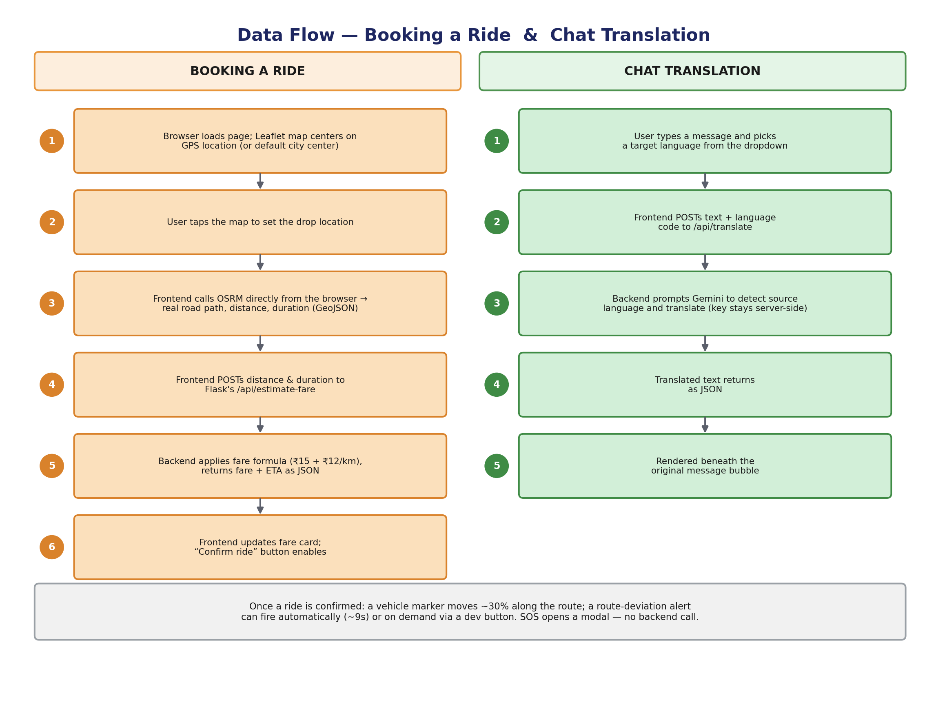
Figure 4.1 — Sequence of calls for booking a ride and for chat translation.

Booking a Ride
The browser centres the map on GPS (or a default city), the user taps a drop point, and the frontend calls OSRM directly for a real road route, distance, and duration. This is POSTed to /api/estimate-fare, which applies the fare formula (₹15 + ₹12/km) and returns fare and ETA; the frontend then enables "Confirm ride."

Chat Translation
The user types a message and picks a target language; the frontend POSTs text and language code to /api/translate; the backend prompts Gemini to detect the source language and translate (key stays server-side); the translated text renders beneath the original bubble.
Once confirmed, a vehicle marker moves ~30% along the route, and a route-deviation alert can fire automatically or on demand. SOS opens a modal without calling any backend route. Both flows originate from and return to the browser; the Flask backend acts purely as a calculation and translation-proxy layer, without persisting anything between requests — which is why refreshing the page or restarting the server clears an in-progress trip or chat entirely.

5. Current Hosting and Deployment Approach
- Runtime — a single Flask development-server process (python app.py).
- No worker pool or process manager (Gunicorn/uWSGI).
- Plain HTTP on localhost; no HTTPS, reverse proxy, or CDN.
- No scaling — assumes a small number of concurrent users.
- Secrets read from a local .env file at startup.
- No persistence — a restart or refresh clears all state.

This hosting approach is intentionally minimal and matches the project's scope as a functional concept demo rather than a production service. Section 6 proposes how this same set of components would evolve into a production-capable cloud deployment without changing the underlying product idea.

6. Proposed Cloud Deployment Architecture (AWS)
Moving RideEase to production keeps the same logical components but adds authentication, a real database, caching, autoscaling compute, and observability.
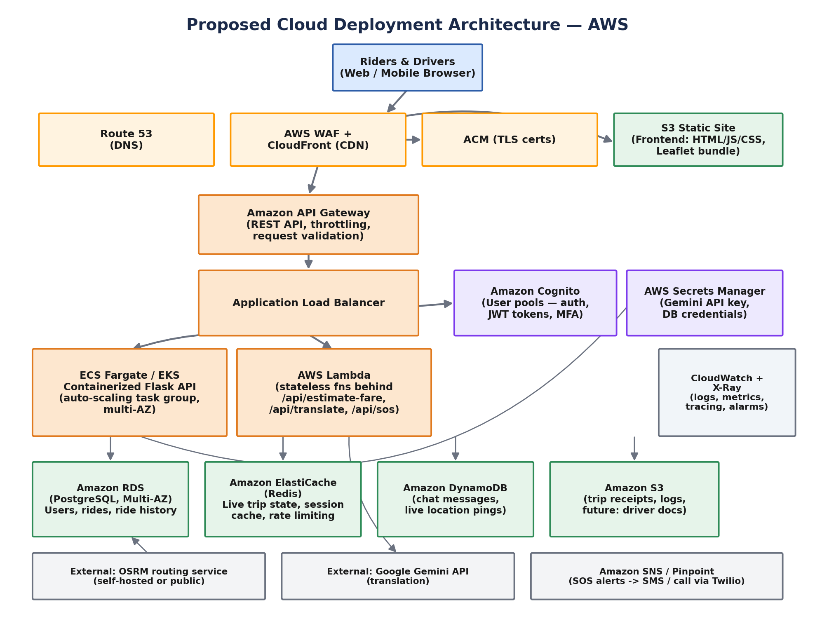
Figure 6.1 — Proposed AWS architecture.

Frontend and Backend Layers
Static frontend assets are built and uploaded to an Amazon S3 bucket configured for static website hosting, with CloudFront serving as the CDN in front of it — providing global edge caching, HTTPS termination via AWS Certificate Manager, and basic protection through AWS WAF. Route 53 handles DNS and can support multi-region routing as traffic grows. The Flask application itself is containerised with Docker and run on Amazon ECS with Fargate, removing the need to manage servers directly and enabling horizontal autoscaling across multiple Availability Zones. An Application Load Balancer distributes incoming requests and performs health checks, while Amazon API Gateway fronts the public REST surface with request throttling and validation. Lightweight, bursty operations behind the three API endpoints can additionally run as AWS Lambda functions, scaling independently of the main container fleet.

Authentication, Data, and External Services
Amazon Cognito provides sign-up/sign-in, issues JWT tokens, and supports multi-factor authentication — replacing the current build's complete lack of accounts. For data, Amazon RDS (PostgreSQL, Multi-AZ) stores relational data such as user profiles, ride records, and ride history; Amazon DynamoDB stores high-write, loosely structured data such as live chat messages and vehicle-position pings, which benefit from horizontal scaling without manual sharding; Amazon ElastiCache (Redis) caches frequent reads such as fare lookups and active trip state; and Amazon S3 stores durable objects such as trip receipts and logs. OSRM would run as a self-hosted instance behind an internal load balancer at scale rather than relying on the public endpoint, the Gemini API key would move into AWS Secrets Manager, and Amazon SNS/Pinpoint paired with Twilio would deliver the real SOS alerts described in the future scope.

Observability, Networking, and Security
Amazon CloudWatch collects logs, metrics, and alarms across all services, and AWS X-Ray provides distributed tracing. A dedicated VPC spans multiple Availability Zones, with public subnets holding only the load balancer and NAT gateways while private subnets hold the Fargate tasks, database, and cache — nothing stateful is directly internet-addressable. Security groups act as stateful firewalls scoped per tier, AWS WAF filters common web exploits, and VPC Endpoints keep AWS-internal traffic off the public internet. Encryption is applied both at rest (KMS-backed on RDS, DynamoDB, and S3) and in transit (TLS 1.2+ terminating at CloudFront/ALB), and automated RDS snapshots with Multi-AZ failover target a recovery point objective of a few minutes and a recovery time objective under an hour for a single-AZ failure.

Why AWS
AWS was chosen because ECS Fargate, API Gateway, and Lambda together cleanly cover RideEase's containerised-API-plus-bursty-function pattern; DynamoDB fits the highest-write, least-relational data (chat, GPS pings) well; and S3/CloudFront/Fargate pay-per-use pricing keeps a low-traffic build cheap while scaling to the 1M/5M figures in Section 7. Azure (App Service/AKS, Cosmos DB, Azure AD B2C) and GCP (Cloud Run, Firestore) are both viable alternatives; Firestore fits the chat/GPS write pattern slightly less well than DynamoDB at 5-million-user volumes.

Cloud Service Mapping Table
Business Need | AWS Service | Purpose
Static frontend hosting | S3 + CloudFront | Global edge caching and HTTPS
Backend API compute | ECS Fargate | Containerised Flask app, no server management
Request distribution | Application Load Balancer | Traffic distribution, health checks
Public API surface | API Gateway | Throttling, validation, stable contract
Event-driven functions | AWS Lambda | Bursty translation/SOS workloads
User authentication | Amazon Cognito | Sign-up/sign-in, JWT, MFA
Relational data | Amazon RDS (PostgreSQL) | User profiles, ride records/history
High-write chat/GPS data | Amazon DynamoDB | Chat messages, vehicle-position pings
Hot-path caching | ElastiCache (Redis) | Active trip state, fare lookups
Object storage | Amazon S3 | Receipts, logs, future driver documents
Secrets management | AWS Secrets Manager | Gemini API key, DB credentials
Monitoring | CloudWatch + X-Ray | Logs, metrics, alarms, tracing
Notifications (SOS) | SNS/Pinpoint + Twilio | Real emergency call/SMS delivery
DNS & routing | Route 53 | Domain routing, multi-region

7. Scalability Analysis: 1 Million and 5 Million Users
The proposed architecture is designed so that most components scale horizontally by adding capacity rather than requiring a redesign. The Flask backend today runs as a single process on a single machine — fine for a classroom demo, but it would slow down and eventually fail under any real concurrent load, since there is no database, no caching, and no redundancy anywhere in the stack. The table below walks through how each of twelve system layers evolves from the current demo to roughly one million users, and then to roughly five million users, covering application, database, storage, network, traffic management, caching, load balancing, security, monitoring, backup and recovery, third-party dependencies, and cost/DevOps practice.
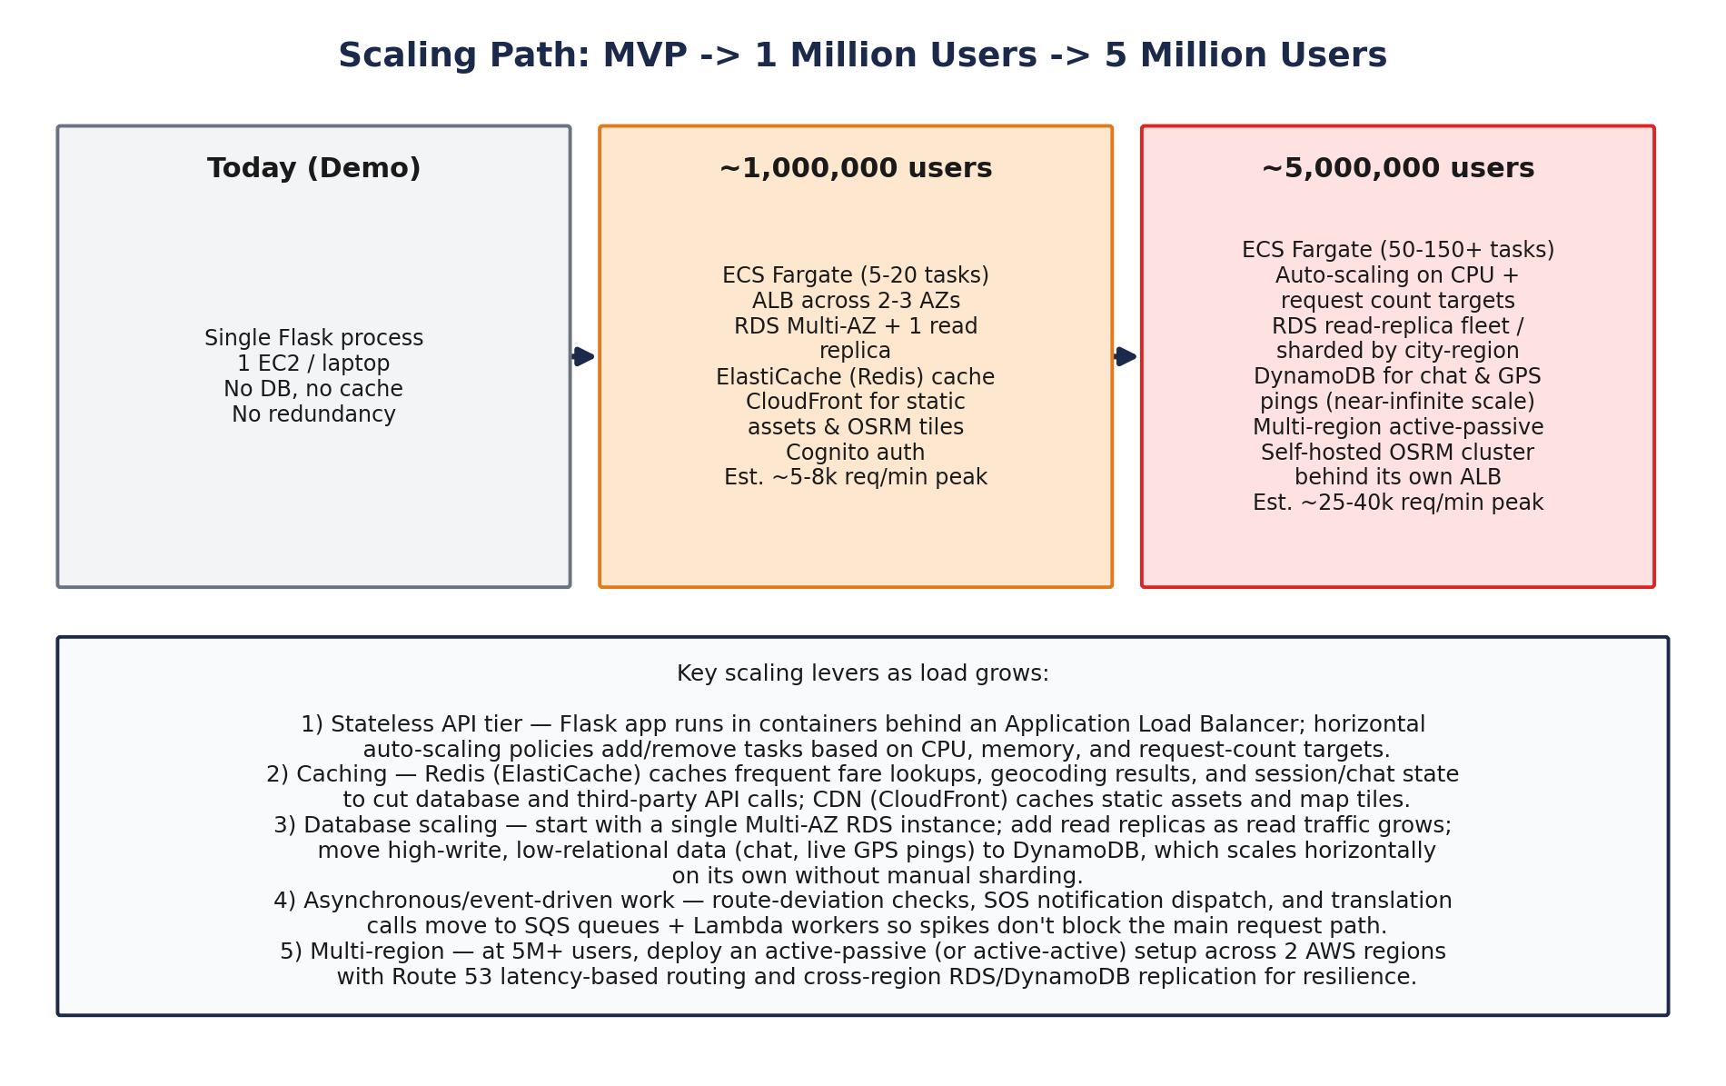
Figure 7.1 — Scaling path from demo to 1 million to 5 million users.
Layer | At ~1,000,000 Users | At ~5,000,000 Users
Application | Cloud host, multiple Flask copies behind a load balancer, Docker, autoscaling | Split into microservices (Booking, Routing, Chat, Fare); background workers via Celery+Redis; multi-region deployment
Database | Managed PostgreSQL/MySQL with read replicas, indexes, connection pooling | Partition/shard by region or user ID; NoSQL for chat/location; automatic failover
Storage | Cloud object storage (S3/GCS), decoupled from app servers | Multi-region replication, lifecycle rules to cold storage, CDN for static assets
Network | CDN, HTTPS/HTTP2, VPC for app/DB/cache | Multi-region servers, GeoDNS/global load balancing
Traffic mgmt. | API rate limiting, API gateway, spike queueing | Request prioritisation, circuit breakers, real-time auto-scaling
Caching | Redis for routes/fares, cached translations, CDN caching | Distributed Redis cluster, edge caching, invalidation rules
Load balancing | Nginx/ELB, health checks, round-robin | Multi-level balancing (region/server/service), selective sticky sessions
Security | Hashed/OTP auth + JWT, enforced HTTPS, secrets manager, input validation | WAF, DDoS protection, RBAC, audits, SOS fully built with Twilio
Monitoring | Dashboards (Grafana/Prometheus), alerting, business metrics | Distributed tracing, centralised logging (ELK), real-user monitoring
Backup/recovery | Automated daily backups, point-in-time recovery, tested restores | Multi-region backups, defined RPO/RTO, automatic regional failover
Third-party APIs | Move off free public OSRM; track Gemini quota with retry/backoff and fallbacks | Self-hosted regional OSRM cluster; backup translation provider; formal SLAs
Cost/DevOps | Auto-scaling right-sizing, CI/CD pipeline, billing alerts | Reserved+spot mix, blue-green/canary deploys, dedicated DevOps/SRE

RideEase also depends on two external services it does not control — OSRM for routing and Google's Gemini API for translation — and these can quietly become the biggest bottleneck even if RideEase's own servers are scaled perfectly. The public OSRM endpoint used today is meant for light testing, not production traffic, so moving to a dedicated or self-hosted routing service is treated as part of the 1-million-user milestone rather than an afterthought. Estimated peak load is roughly 5,000–8,000 requests per minute at 1 million users, and 25,000–40,000 requests per minute at 5 million users.
Stage | Rough total / month | Key drivers
Demo / low traffic | $40 – $70 | 1–2 small Fargate tasks; db.t3.micro; minimal CDN/storage
~1,000,000 users | $900 – $1,800 | 5–20 autoscaled tasks; Multi-AZ RDS + 1 read replica
~5,000,000 users | $6,000 – $13,000 | 50–150+ tasks at peak; sharding; multi-region; self-hosted OSRM

Because the API tier is stateless and the frontend is fully static/CDN-delivered, scaling at either milestone is a matter of adjusting autoscaling targets rather than re-architecting the app. The core product idea does not change — only the infrastructure underneath grows.

8. Implementation Details
rideease/
├── app.py # Flask backend
├── .env # API keys (GEMINI_API_KEY)
├── templates/
│ └── index.html # Main page
└── static/
├── style.css # Styling (ivory + maroon theme)
└── script.js # Map, routing, chat, and UI logic
- A single Leaflet map instance persists across booking and tracking views; pickup uses the Geolocation API, drop is set by clicking the map.
- Routes come from OSRM's public endpoint as GeoJSON — a real road route, not a straight line.
- Fare = ₹15 base + ₹12/km, using real OSRM distance.
- Gemini API translation uses one prompt to both detect language and translate; a "Simulate driver reply" button demonstrates two-way translation without a live second user.
- A timer auto-triggers a simulated route deviation ~9 seconds after confirmation; a manual dev button can also trigger it.
- SOS opens a modal explaining an emergency contact must be configured first — a scope decision, not an oversight.
- Payment is cash-only; UPI integration was scoped out since it requires a payment-gateway integration beyond this project's timeline.

Taken together, these pieces demonstrate the two hardest user-facing problems identified in Section 1 — real routing and cross-language communication — working end to end in a browser, backed by a server that is intentionally small enough to reason about in full. That smallness is also what makes the proposed AWS migration in Section 6 tractable: there are only three endpoints, one external routing call, and one external translation call to re-platform, rather than a sprawling legacy codebase.

9. Known Limitations and Future Scope
The limitations below are consequences of the scope decisions made in Section 1, not oversights discovered late — each maps directly to a corresponding item in the future-scope list and, where relevant, to a specific AWS service already named in Section 6.

Known Limitations
- Fare is a flat per-kilometre rate — no surge or traffic-based adjustment.
- SOS does not place a real call or send an SMS.
- No user authentication, accounts, or ride history.
- Driver replies in chat are simulated, not from a real second user.
- No database or persistent storage of any kind.
- No HTTPS, load balancing, or redundancy in the current hosting setup.

Future Scope
- Wire up SOS with a real emergency contact and Twilio/SNS-based calling/SMS.
- Add authentication (Cognito) and persist ride history in RDS.
- Replace the simulated vehicle marker with real-time driver GPS tracking via WebSockets, stored in DynamoDB.
- Add UPI/payment gateway integration.
- Introduce dynamic fare pricing informed by real-time demand and traffic.
- Move to a self-hosted, horizontally scaled OSRM cluster.
- Execute the proposed AWS cloud migration as usage grows toward the 1M/5M-user milestones.

— End of Report —

