SunExpress

First Name: rkd

Second Name: rkd1

Ssn no: 1234

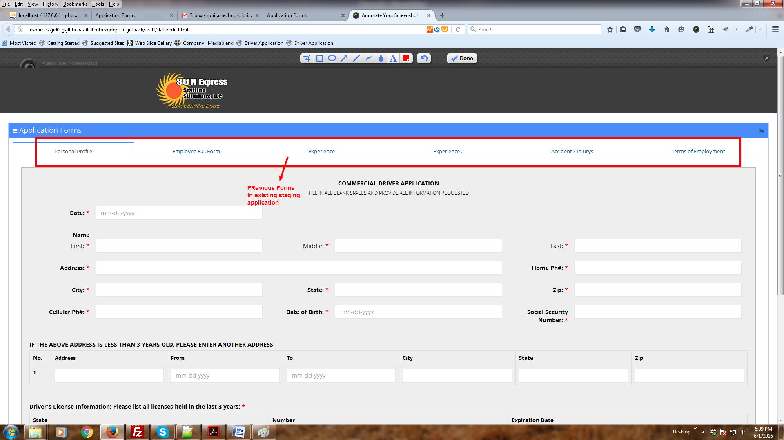

Here 6 steps for sunexpress and on each step there is a form in backend

We remove in existing system 4 forms ie

1. Employee E.C form
2. Experience 2
3. Accident/Injury
4. Terms of employment

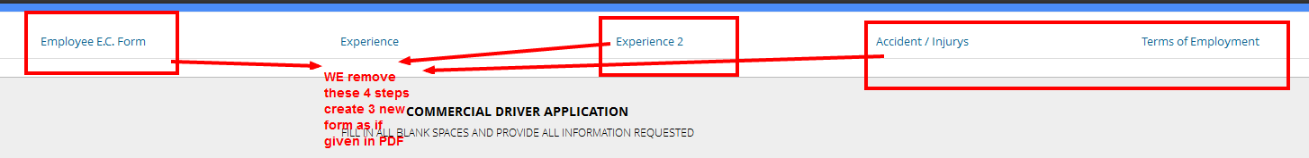

We Done with the first 2 steps in application with proper functionality. Which means proper inserting values in DB also with responsive design as well.

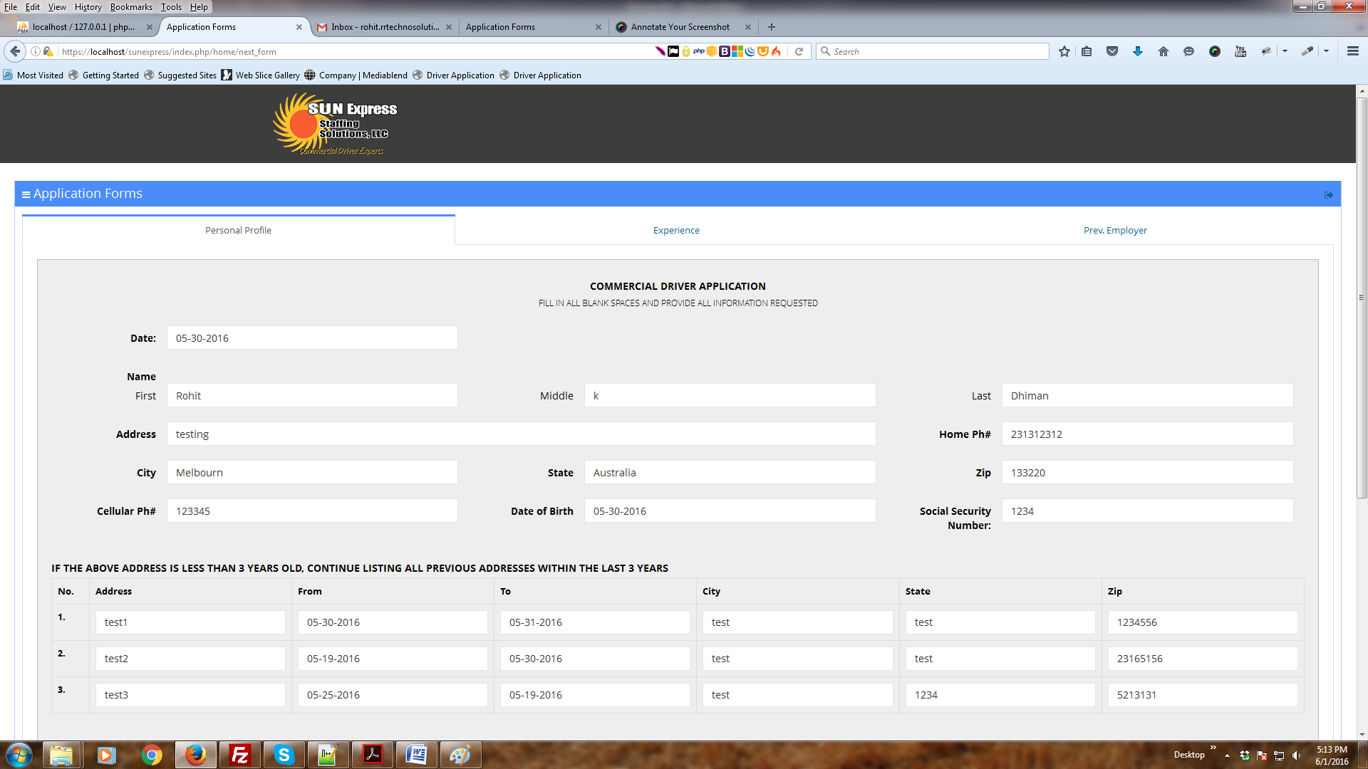

**Now I create step 3 Frontend part as if given in PDF till tomorrow eve we make all form frontend design with responsive**

