Guidewire Upgrade Readiness Assistant
Feature Guide — AI-Assisted Upgrade Readiness, Vendor Mocks, Contract Tests & Data Migration

The Guidewire Upgrade Readiness Assistant is a Next.js prototype delivery accelerator that helps programme managers, Guidewire architects, and test leads assess InsuranceSuite upgrade and cloud-migration risk before committing to a delivery plan. It pairs a deterministic rule engine with AI-generated steering recommendations produced by Claude (model claude-opus-4-8).
AI configuration: AI features are enabled by setting the ANTHROPIC_API_KEY environment variable. When it is not set, every screen falls back to deterministic summaries built from the rule engine, so the application is always demoable. The advisory and remediation screenshots in this document show that deterministic fallback; with a key configured, those sections are authored by Claude.

Overview
The application is organised into a landing page and three feature tools, reachable from the top navigation bar:
- Upgrade Readiness Scoring — score upgrade risk and generate an AI go/no-go advisory.
- Vendor Mocks & Contract Tests — simulate vendor endpoints and validate integration payloads.
- Data Migration Assist — validate source-to-target records and generate an AI remediation plan.
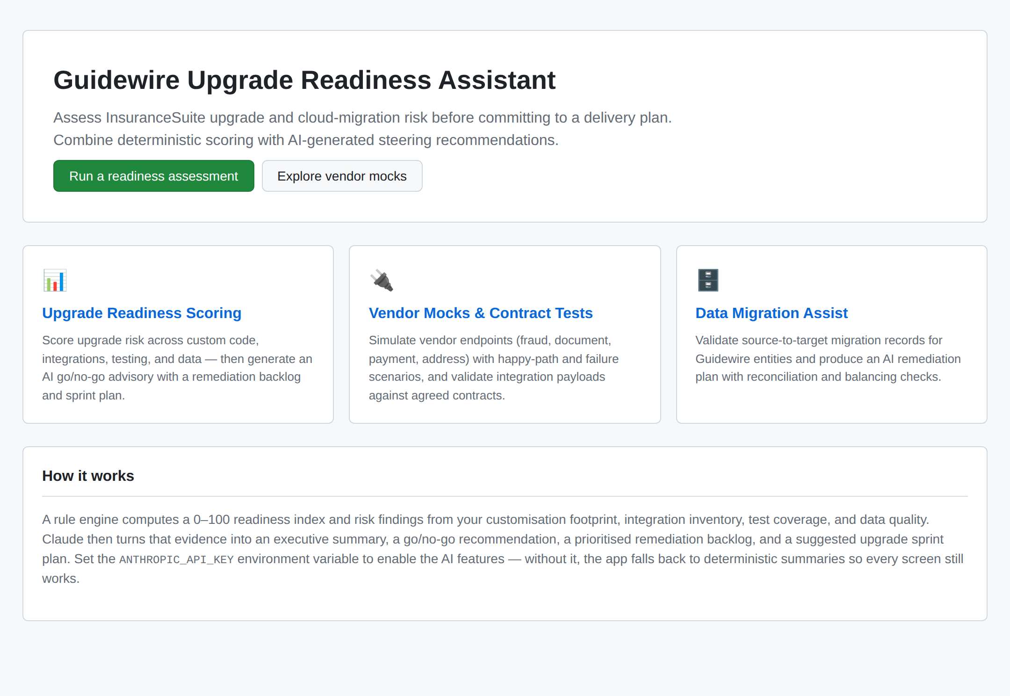
Figure: Landing page with feature navigation and a summary of how scoring and AI advisories work.

1. Upgrade Readiness Scoring
This tool captures the programme's upgrade profile — current and target versions, customisation footprint (Gosu classes, entities, typelists, PCF files), batch processes, test coverage, data quality, known blockers, and an integration inventory. All inputs are editable, and each integration can be toggled for whether it has a mock and a contract test.
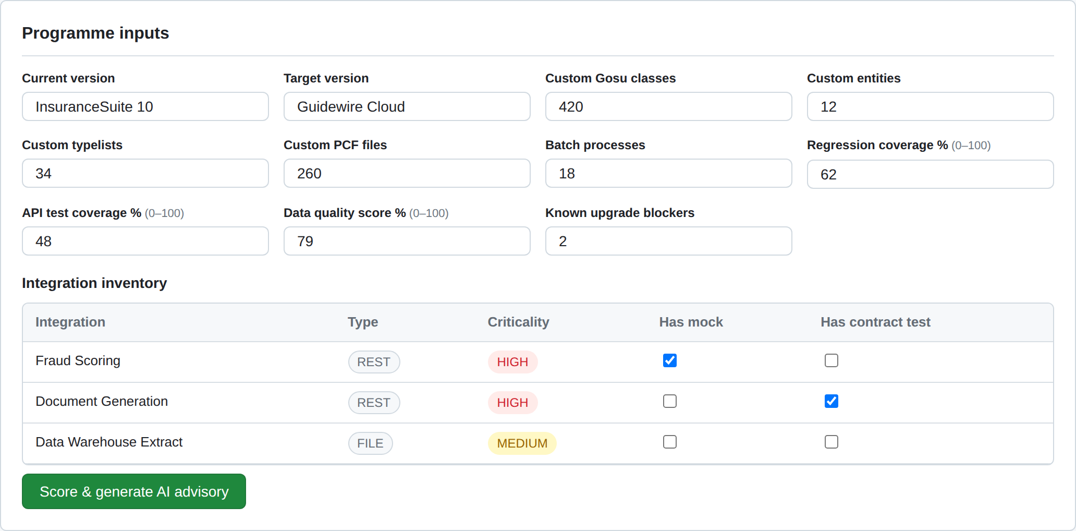
Figure: Editable programme inputs and integration inventory.
Submitting the form calls POST /api/ai/advisory, which runs the rule engine to produce a 0–100 readiness index and a risk level (LOW / MEDIUM / HIGH / CRITICAL), along with prioritised findings across customisation, integrations, testing, and data.
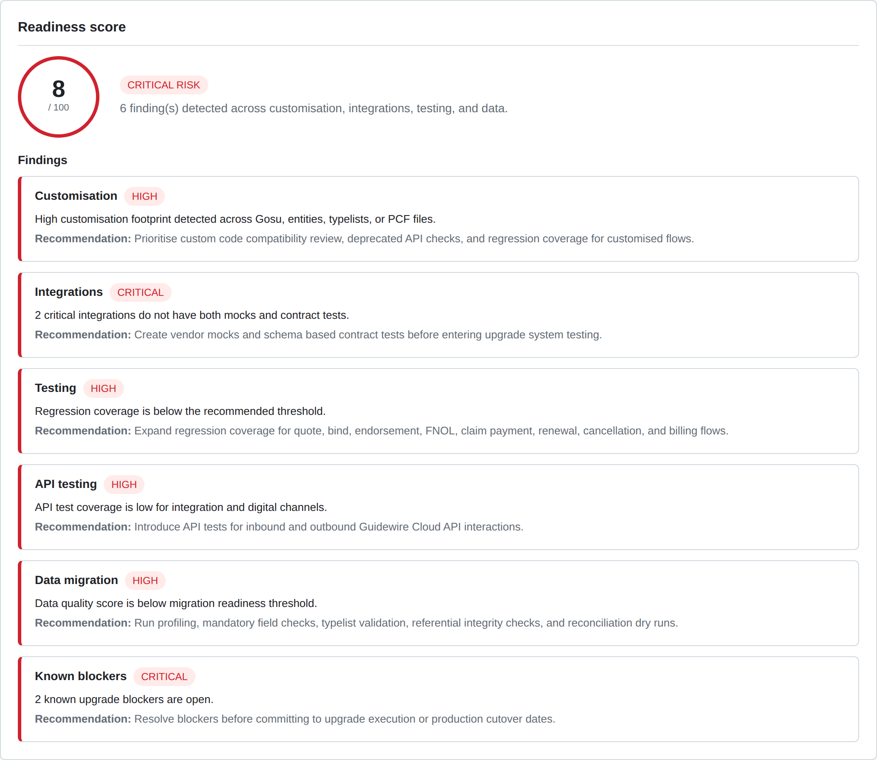
Figure: Computed readiness score, risk level, and rule-based findings.
Claude then turns that evidence into a steering advisory: an executive summary, a GO / CONDITIONAL GO / NO-GO recommendation with a confidence level, a key-risks table with business impact, a prioritised remediation backlog (P0–P3), and a suggested upgrade sprint plan. A badge indicates whether the advisory was generated by Claude or by the deterministic fallback.
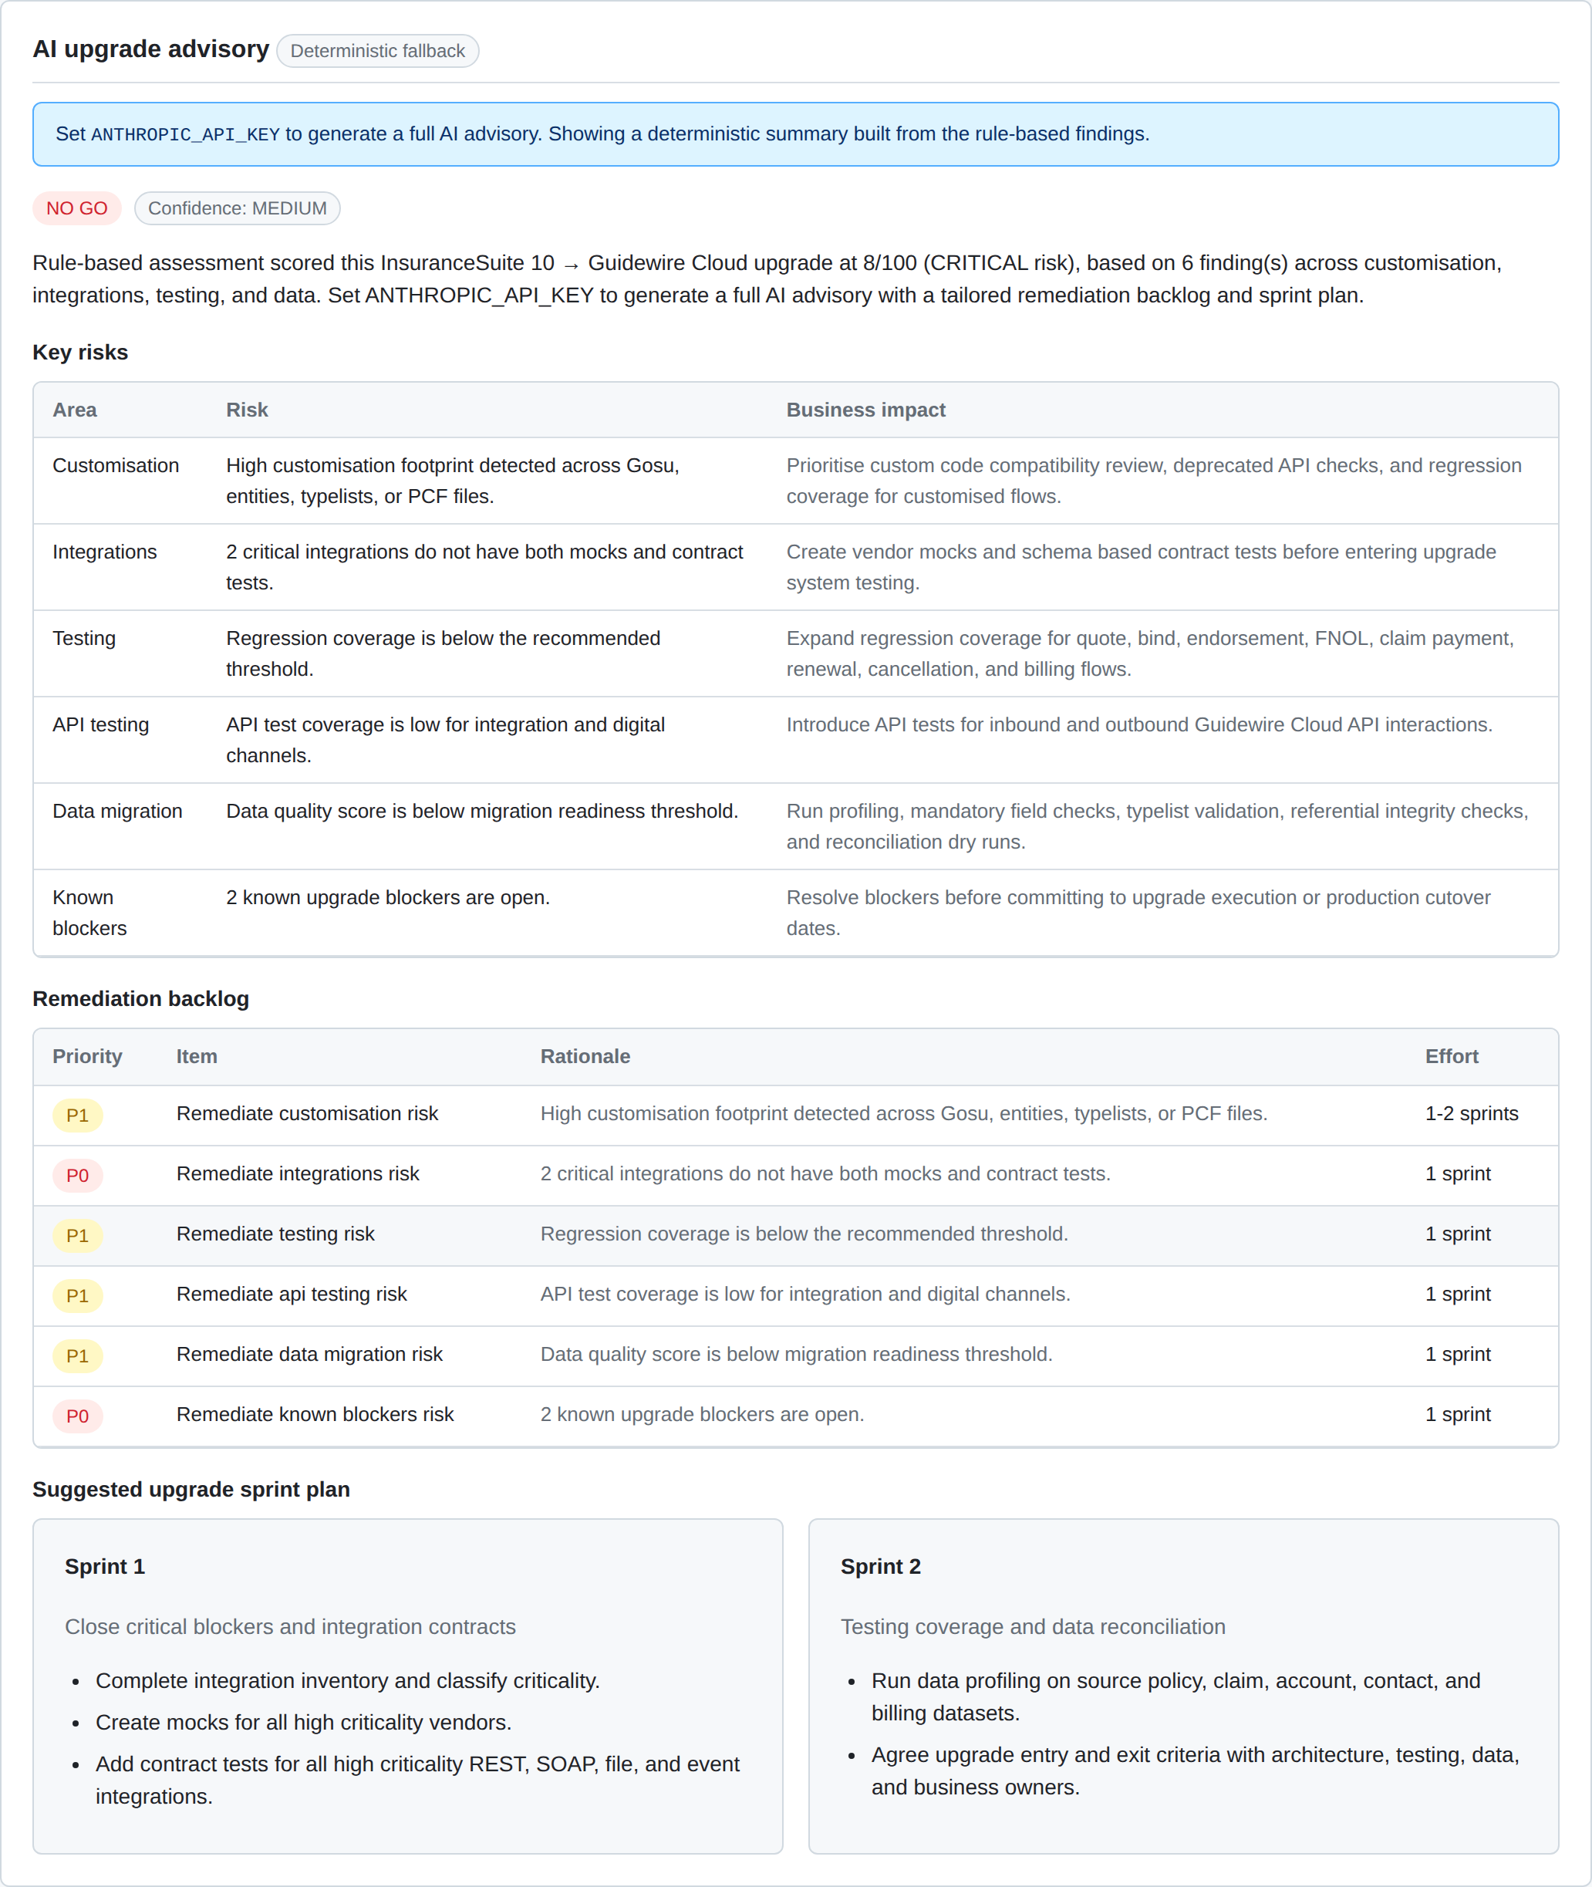
Figure: AI upgrade advisory: go/no-go, key risks, remediation backlog, and sprint plan (deterministic fallback shown).

2. Vendor Mocks & Contract Tests
This tool helps integration teams de-risk vendor dependencies during an upgrade. The vendor mock simulates Guidewire's external integrations — fraud scoring, document generation, payment, and address validation — and supports failure scenarios (happy path, 5-second timeout, 500 server error, and 401 unauthorised) so teams can rehearse error handling. The request body is fully editable and the live mock response (with its HTTP status) is displayed.
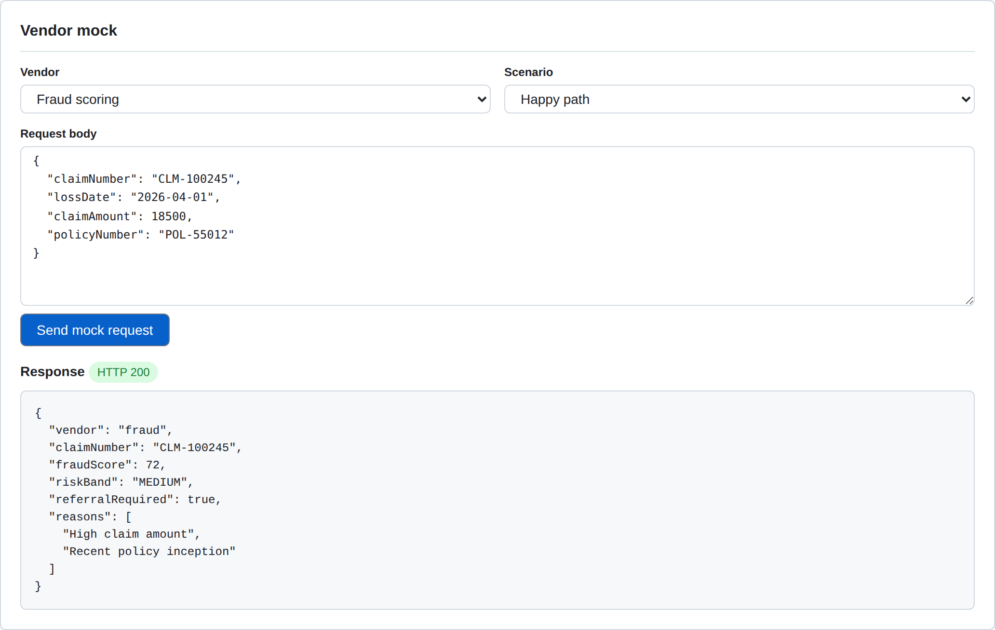
Figure: Vendor mock: editable request, selectable failure scenario, and the live mock response.
The contract test validates an outbound integration payload against an agreed JSON Schema contract (fraudRequest, paymentRequest, documentRequest) using AJV. Editing the payload to introduce a violation and re-running surfaces a PASS/FAIL result and a table of schema errors with their path and message — the same checks that gate integrations before upgrade system testing.
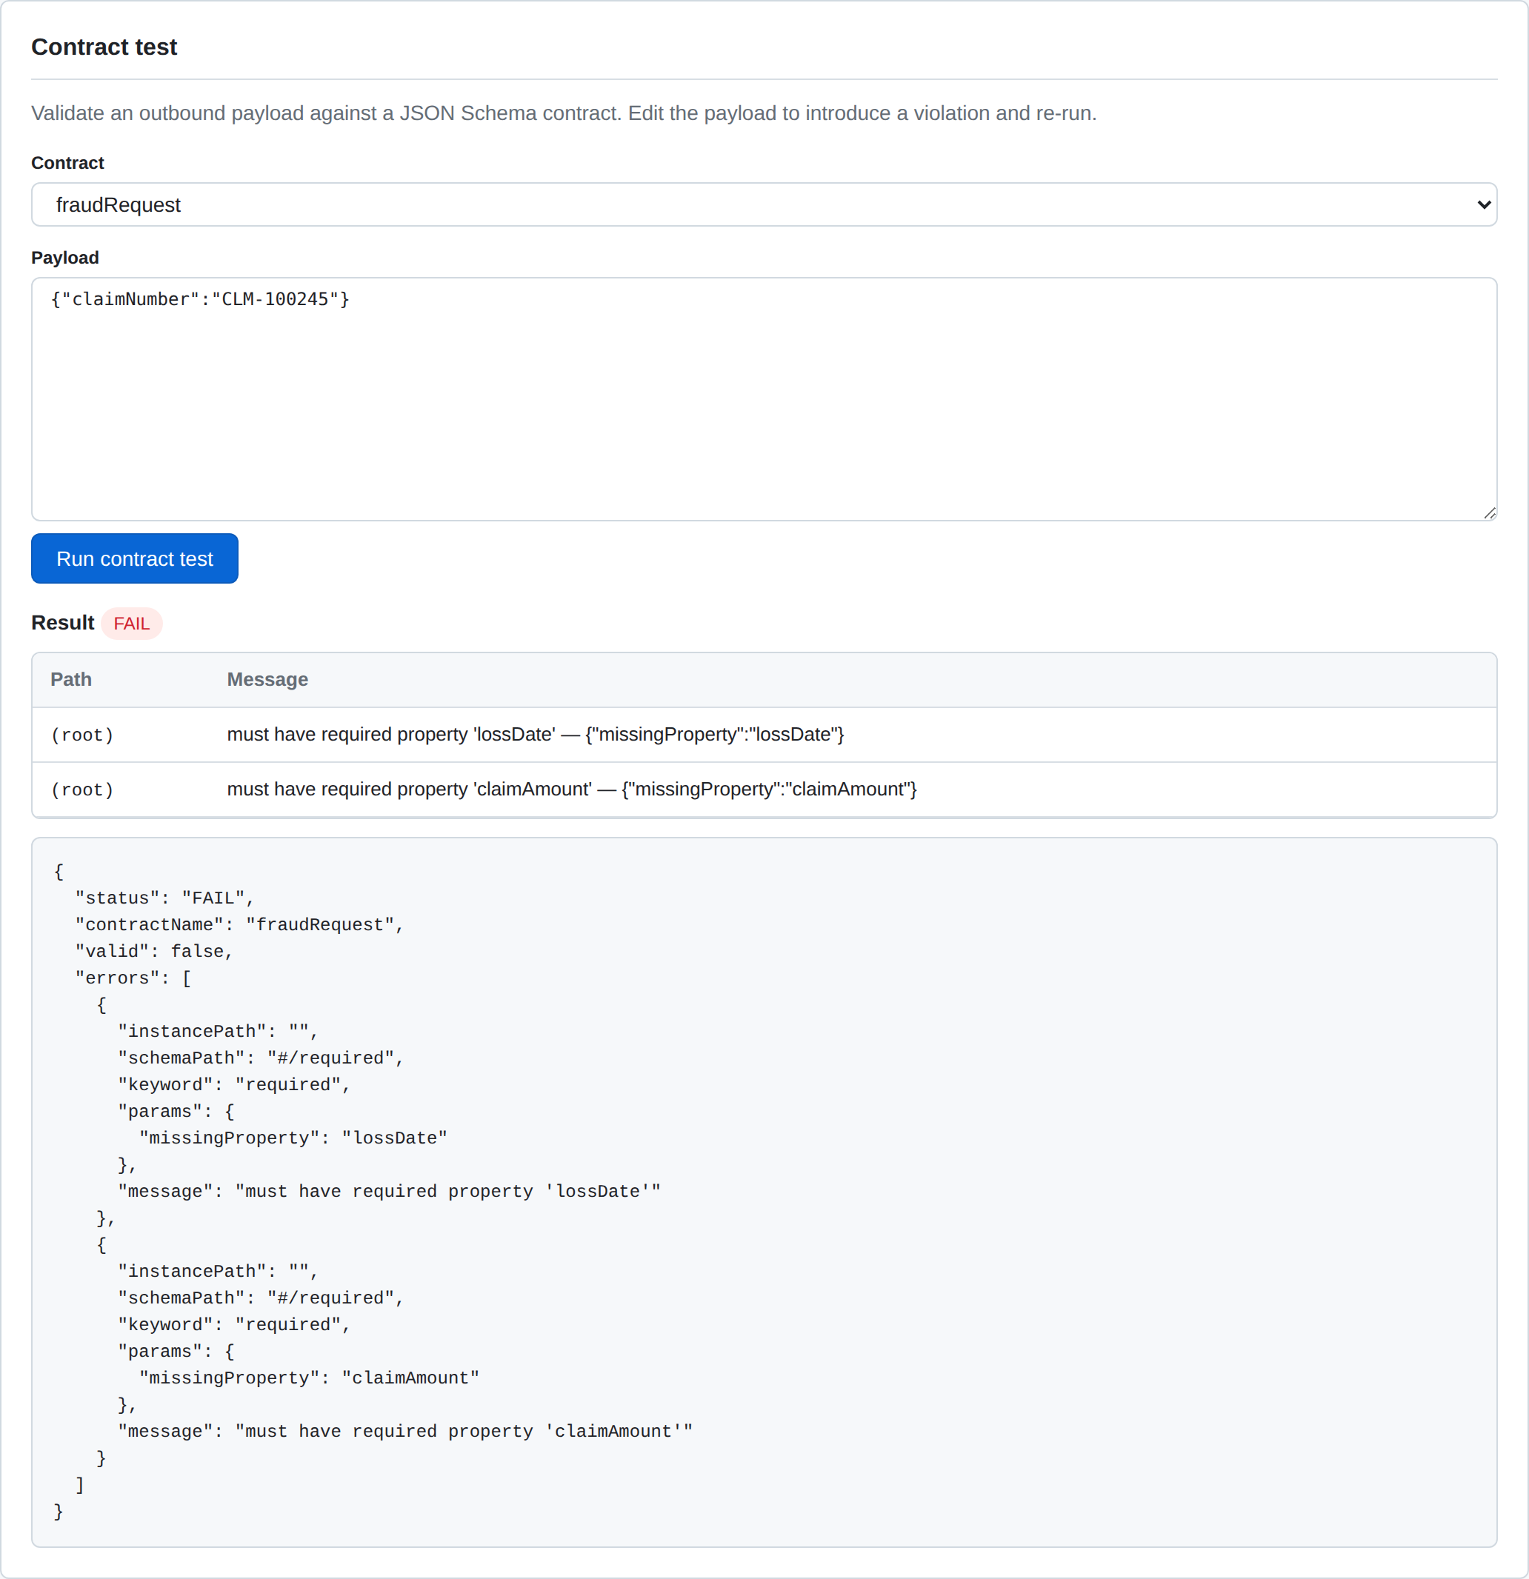
Figure: Contract test showing a FAIL result with the schema validation errors table.

3. Data Migration Assist
This tool validates candidate source-to-target migration records for Guidewire entities (Account, Policy, Claim, Exposure, Contact, BillingAccount). The records are provided as editable JSON so teams can test different data scenarios.
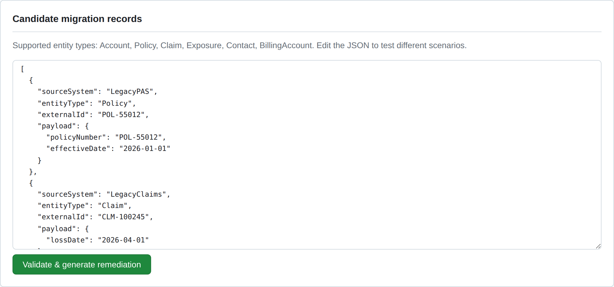
Figure: Editable candidate migration records.
Submitting calls POST /api/ai/migration-remediation. The rule engine first checks each record for missing identifiers, mandatory fields, and malformed values, returning a severity-rated issues table.
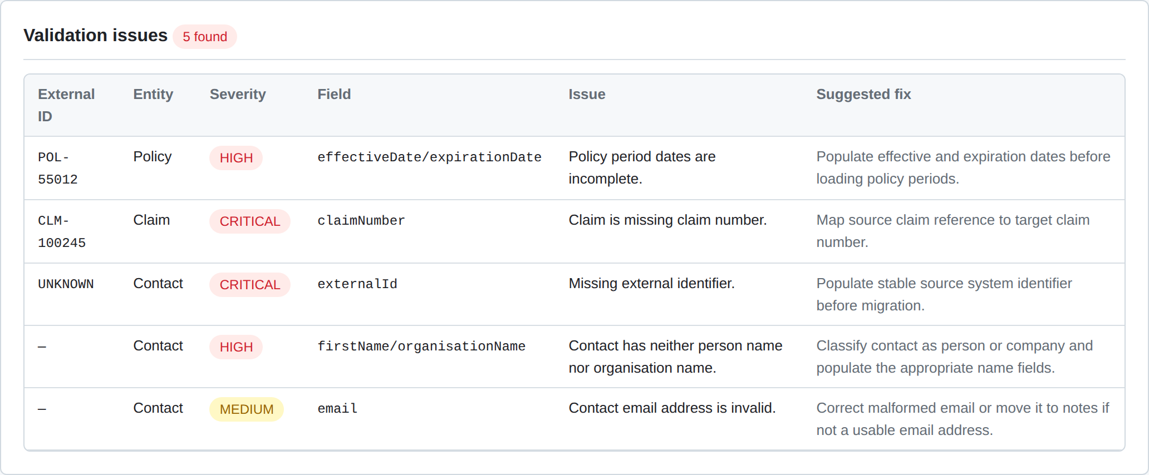
Figure: Rule-based validation issues with severity, field, and suggested fix.
Claude then produces a remediation plan: an overall data-readiness verdict (READY / NEEDS WORK / NOT READY), a prioritised list of fixes by entity, and reconciliation and balancing checks (record counts, control totals, typelist mapping, referential integrity, duplicate detection) to run before loading into Guidewire Cloud.
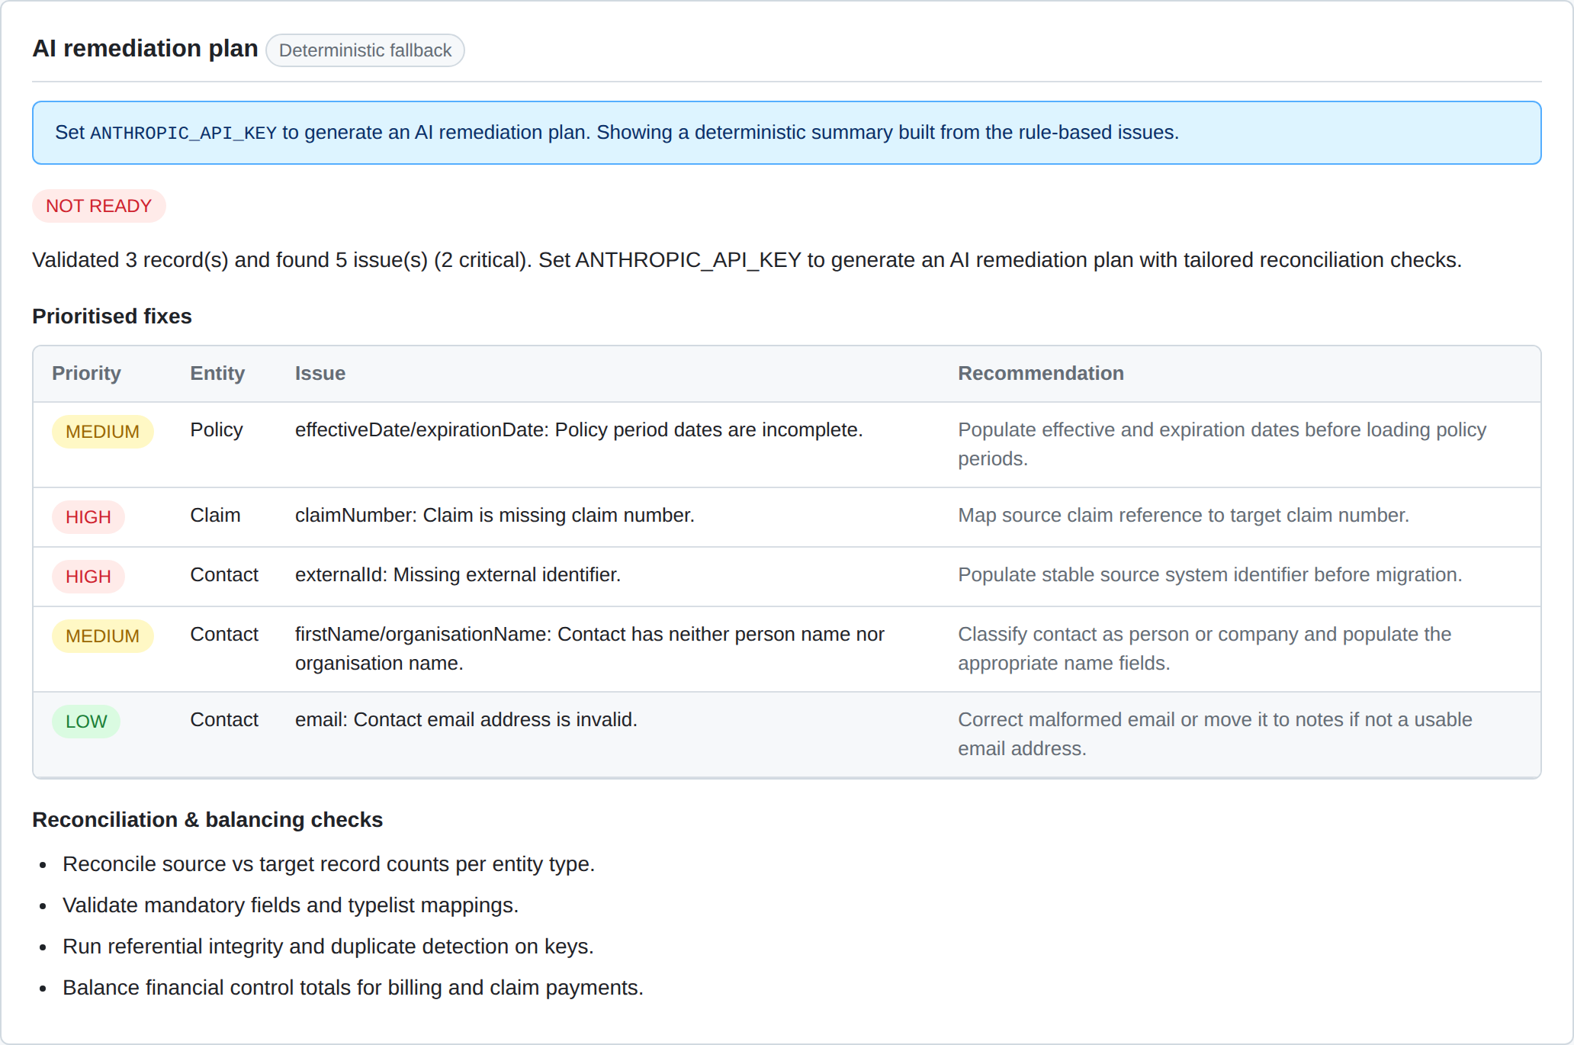
Figure: AI remediation plan: readiness verdict, prioritised fixes, and reconciliation checks (deterministic fallback shown).

Technical Summary
Architecture and key endpoints:
- Framework: Next.js 15 (App Router) with React 19 and TypeScript.
- Rule engine: lib/readiness.ts, lib/contracts.ts (AJV), lib/migration.ts, lib/mockVendors.ts.
- AI layer: lib/ai.ts using @anthropic-ai/sdk, model claude-opus-4-8 with adaptive thinking, with deterministic fallbacks.
- AI routes: POST /api/ai/advisory and POST /api/ai/migration-remediation.
- Deterministic routes: /api/readiness/score, /api/contracts/run, /api/migration/validate, /api/mocks/vendor/{vendor}.
- UI: GitHub Primer-inspired design system (globals.css) with a shared header/footer, cards, labels, and tables.

To enable the live AI features, set ANTHROPIC_API_KEY (see .env.example). Without it, the screens shown above render the deterministic fallback content.

