
PORTFOLIO CASE STUDY
Predictive Construction
Project Overrun Model
Early-warning classification and regression for cost overruns and schedule delays
Narciso M. Dickson · In Project LLC
Analytics lifecycle: Ask · Prepare · Process · Analyze · Share · Act
August 2026 · 2,362 projects · 40 predictors · 2019–2025
Synthetic-data disclosure All project records and model outcomes are fictional. Model performance is not an industry benchmark, and production use on real construction projects is not authorized by this portfolio project.
Contents
1. Executive Summary 2
2. Business Problem and Portfolio Progression 3
3. Analytical Lifecycle and Governance 3
4. Dataset, Feature Lineage, and Quality 4
5. Modeling Methodology 4
6. Classification Performance 5
7. Regression, Calibration, and Temporal Generalization 6
8. Feature Drivers and Project Risk Scoring 6
9. Dashboards and Portfolio Communication 8
10. Act Plan, Human Review, and Monitoring 9
11. Limitations, Responsible AI, and Conclusion 10
12. Sources and Deliverables 10

1. Executive Summary
This case study is the third project in a construction analytics portfolio. It combines the cost and schedule controls developed in Project 1 with the RFI and change-workflow indicators developed in Project 2 to predict future cost overruns and schedule delays from early and mid-project snapshots.
Dataset | Cost model | Schedule model | Test risk bands
2,362 clean projects  1,577 train  349 validation  436 test | Random Forest  ROC-AUC 0.899  PR-AUC 0.774 | Logistic Regression  ROC-AUC 0.756  PR-AUC 0.524 | 188 Red  138 Yellow  110 Green

Principal conclusions
- Cost-overrun classification generalized strongly to the future synthetic test period.
- Schedule-delay performance decreased from validation to test, creating a real model-monitoring concern rather than a result to hide.
- CPI and current cost variance were the strongest cost-overrun predictors.
- SPI, planned completion, procurement delay, and overdue workflow indicators were important schedule predictors.
- Predictions were converted into Red, Yellow, and Green review priorities, but every score requires human review.
- The Act phase defines a controlled-pilot path; it does not authorize production use.

2. Business Problem and Portfolio Progression

Primary business question
Which early and mid-project indicators best predict material construction cost overruns and schedule delays, and how can management prioritize intervention before the outcomes become unavoidable?

Portfolio progression
Project | Title | Contribution
Project 1 | Construction Project Controls Analytics | CPI, SPI, cost, schedule, contingency, EAC, and early-warning controls
Project 2 | Construction Change Order and RFI Analytics | RFI response, change approval, pending exposure, revision loops, and forecast lag
Project 3 | Predictive Construction Project Overrun Model | Time-validated probability and magnitude prediction with governance
Project 3 uses a new independent synthetic dataset. It references feature concepts from Projects 1 and 2 without mixing their folders, repositories, or records.

3. Analytical Lifecycle and Governance
Phase | CRISP-DM | DMAIC | Microsoft | PMI governance
Ask | Business Understanding | Define | Business Understanding | Initiating / Planning
Prepare | Data Understanding | Measure | Data Acquisition and Understanding | Planning
Process | Data Preparation | Measure / early Analyze | Data Acquisition and Understanding | Executing / Monitoring
Analyze | Modeling and Evaluation | Analyze | Modeling | Executing / Monitoring
Share | Evaluation | Analyze / improvement design | Customer Acceptance | Stakeholder engagement
Act | Deployment | Improve and Control | Deployment / Acceptance | Executing / Monitoring / Closing
The frameworks are conceptually aligned but are not treated as identical. The workflow is iterative, and quality or governance findings may require returning to earlier phases.

4. Dataset, Feature Lineage, and Quality
The deterministic generator created 2,400 intended projects with snapshots between approximately 35% and 60% planned completion. Raw tables intentionally contained duplicates, category variants, missing critical values, invalid numeric values, invalid dates, target inconsistencies, and orphan relationships.
Control | Result
Raw project rows | 2,412
Raw workflow rows | 2,417
Raw outcome rows | 2,416
Duplicate removals | 36
Quarantined records | 123
Clean model rows | 2,362
Cleaning actions | 199
SQLite integrity | ok
Foreign-key violations | 0

Feature families
- Project and contract attributes
- CPI, SPI, cost variance, schedule variance, contingency, and productivity
- Procurement, weather, and safety indicators
- RFI response, overdue rates, revisions, reopening, and RFI-to-change conversion
- Approved and pending change exposure, approval cycle, old pending rate, and forecast incorporation lag
- Workflow handoffs, revision loops, and snapshot workflow-risk score
Final outcomes, final CPI/SPI, actual end date, final EAC, and final status were excluded from predictor matrices.

5. Modeling Methodology
Element | Method
Time split | Train 2019–2023; Validation 2024; Test 2025
Cost classification | Final cost overrun ≥10%
Schedule classification | Final schedule delay ≥30 days
Cost regression | Final cost-overrun percentage
Schedule regression | Final schedule-delay days
Classification candidates | Logistic Regression and Random Forest
Regression candidates | Ridge Regression and Random Forest Regressor
Champion selection | Validation PR-AUC for classification; validation MAE for regression
Threshold selection | Maximum validation F1; test untouched
Explainability | Permutation importance on held-out test data
The model uses 40 predictors: 31 numeric and 9 categorical. Numeric fields are standardized for linear models, and categorical values are one-hot encoded with unknown-category handling.

6. Classification Performance
Target | Champion | ROC-AUC | PR-AUC | Precision | Recall | F1 | Brier
Cost overrun | Random Forest | 0.899 | 0.774 | 0.625 | 0.811 | 0.706 | 0.123
Schedule delay | Logistic Regression | 0.756 | 0.524 | 0.520 | 0.453 | 0.484 | 0.183
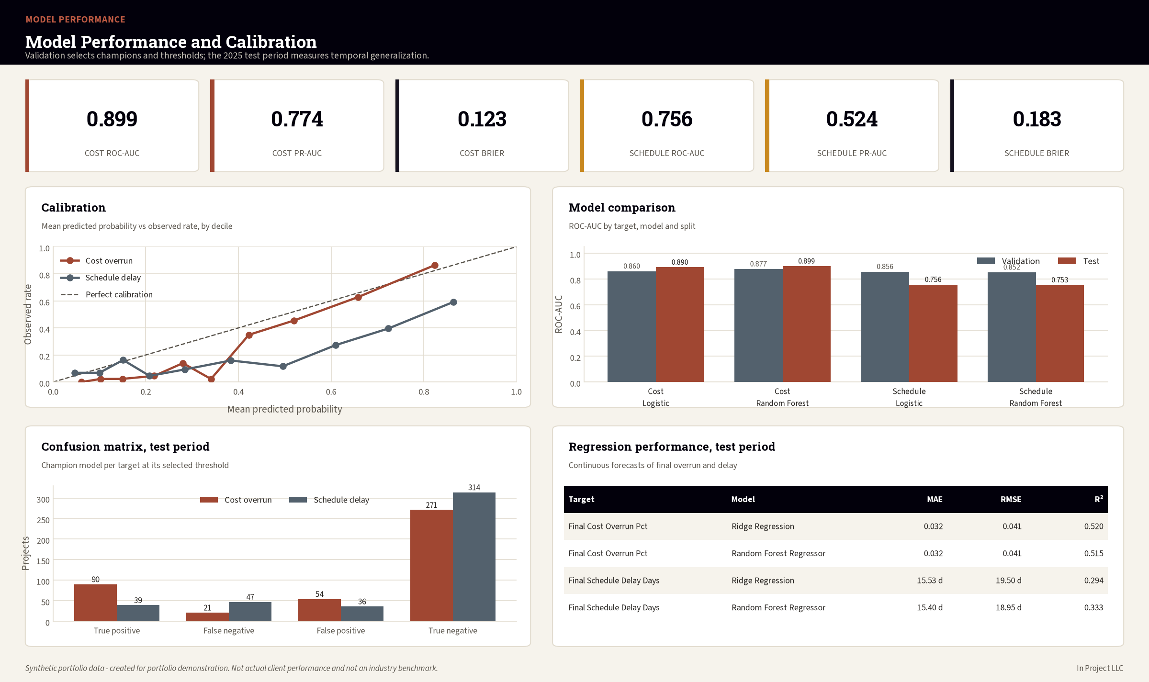
Figure 1. Model performance and calibration: champion selection on validation, temporal generalization measured on the 2025 test period.

7. Regression, Calibration, and Temporal Generalization
Target | Model | MAE | RMSE | R² | Interpretation
Final_Cost_Overrun_Pct | Ridge Regression | 0.032 | 0.041 | 0.520 | Cost-overrun percentage points
Final_Cost_Overrun_Pct | Random Forest Regressor | 0.032 | 0.041 | 0.515 | Cost-overrun percentage points
Final_Schedule_Delay_Days | Ridge Regression | 15.528 | 19.499 | 0.294 | Schedule-delay days
Final_Schedule_Delay_Days | Random Forest Regressor | 15.403 | 18.953 | 0.333 | Schedule-delay days

Temporal degradation
The schedule classifier achieved validation ROC-AUC 0.856 but test ROC-AUC 0.756. The reduction suggests temporal variation in the synthetic portfolio. The result is retained as an example of why model performance must be monitored after deployment.
The monitoring demonstration produced a schedule probability PSI of 0.105, above the proposed Yellow threshold of 0.10.

8. Feature Drivers and Project Risk Scoring
Rank | Cost feature | Importance | Schedule feature
1 | CPI_Snapshot | 0.0502 | SPI_Snapshot
2 | Cost_Variance_Pct_Snapshot | 0.0289 | Planned_Percent_Complete
3 | Approved_Change_Value_Pct_Budget | 0.0080 | Procurement_Delay_Days_to_Date
4 | Pending_Change_Exposure_Pct_Budget | 0.0030 | Overdue_RFI_Rate
5 | Labor_Productivity_Index | 0.0026 | Old_Pending_Change_Rate
6 | Contingency_Utilization_Pct | 0.0022 | Actual_Percent_Complete
7 | Procurement_Delay_Days_to_Date | 0.0020 | RFI_On_Time_Rate
8 | SPI_Snapshot | 0.0013 | Revision_Loop_Rate
9 | Snapshot_Data_Completeness_Pct | 0.0012 | Complexity_Level
10 | Complexity_Level | 0.0010 | Project_Type
Feature importance measures predictive contribution under permutation. It does not establish that changing a feature will cause a better outcome.
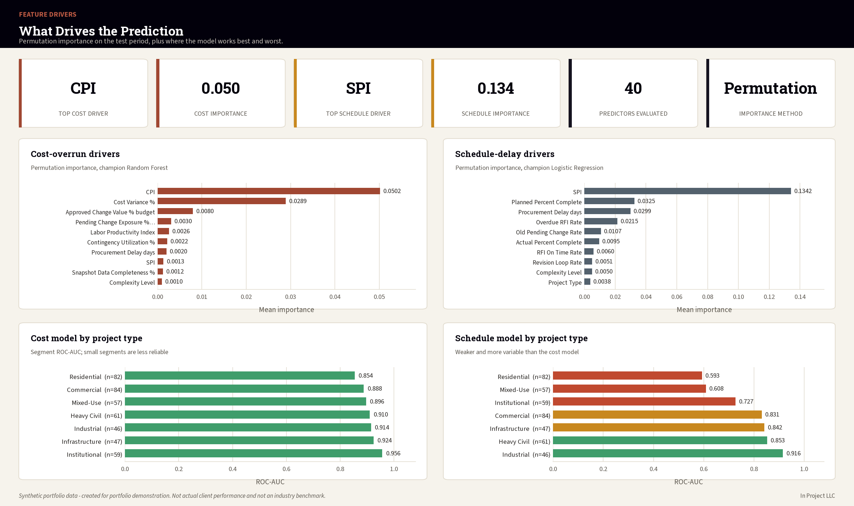
Figure 2. Permutation importance for both targets, with segment performance showing where each model is weakest.

Top predicted-risk projects
Project | Band | Overall | Cost | Schedule | Primary drivers
Gateway Bridge Program 1418 | Red | 99.8% | 94.0% | 97.4% | Slow change approval; Workflow risk score; Overdue RFI backlog
Granite Urban Village 1705 | Red | 99.8% | 89.1% | 97.7% | Overdue RFI backlog; Slow change approval; Workflow risk score
Horizon Neighborhood 34 | Red | 99.4% | 80.3% | 96.8% | Overdue RFI backlog; Workflow risk score; Slow RFI response
Redwood Logistics Center 1716 | Red | 99.2% | 91.6% | 90.9% | Overdue RFI backlog; Slow RFI response; Workflow risk score
Aspen Corporate Center 702 | Red | 99.1% | 91.8% | 89.2% | Overdue RFI backlog; Slow change approval; Slow RFI response
Northstar Highway Improvements 1925 | Red | 99.0% | 88.1% | 92.0% | Slow change approval; Workflow risk score; Slow RFI response
Pioneer Urban Village 1981 | Red | 98.8% | 94.1% | 80.4% | Overdue RFI backlog; Slow RFI response; Workflow risk score

9. Dashboards and Portfolio Communication
The Share phase produced executive, model-performance, project-risk, and feature-driver dashboards plus Power BI and Tableau build specifications.
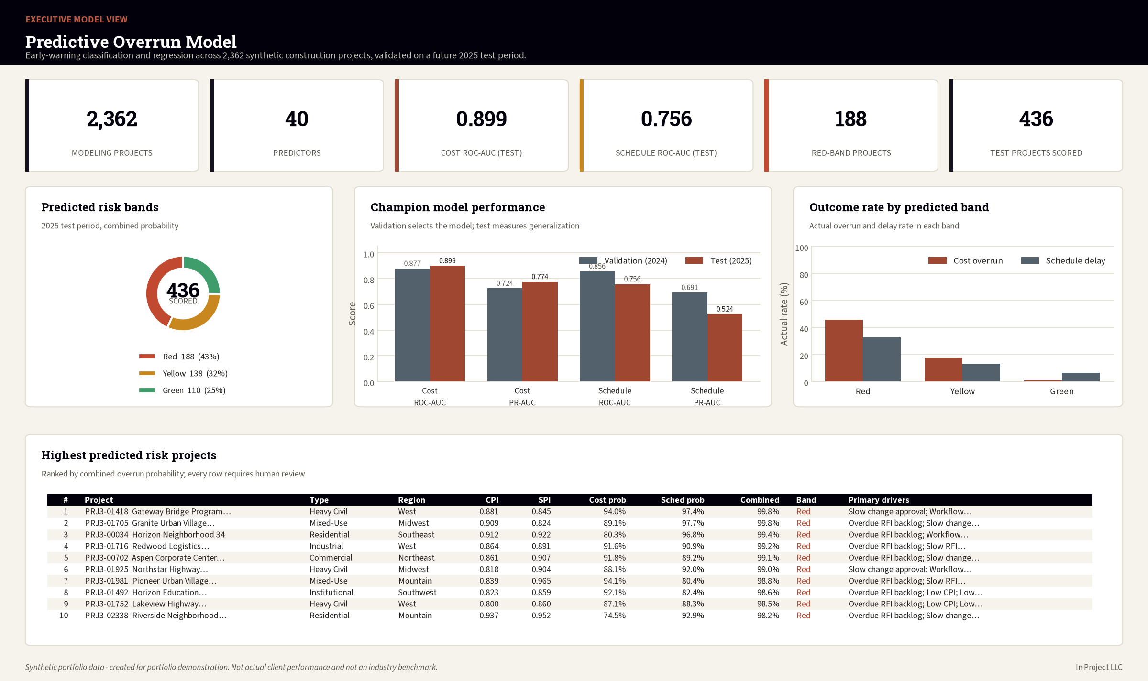
Figure 3. Executive model view: predicted risk bands, champion performance and the highest predicted-risk projects.
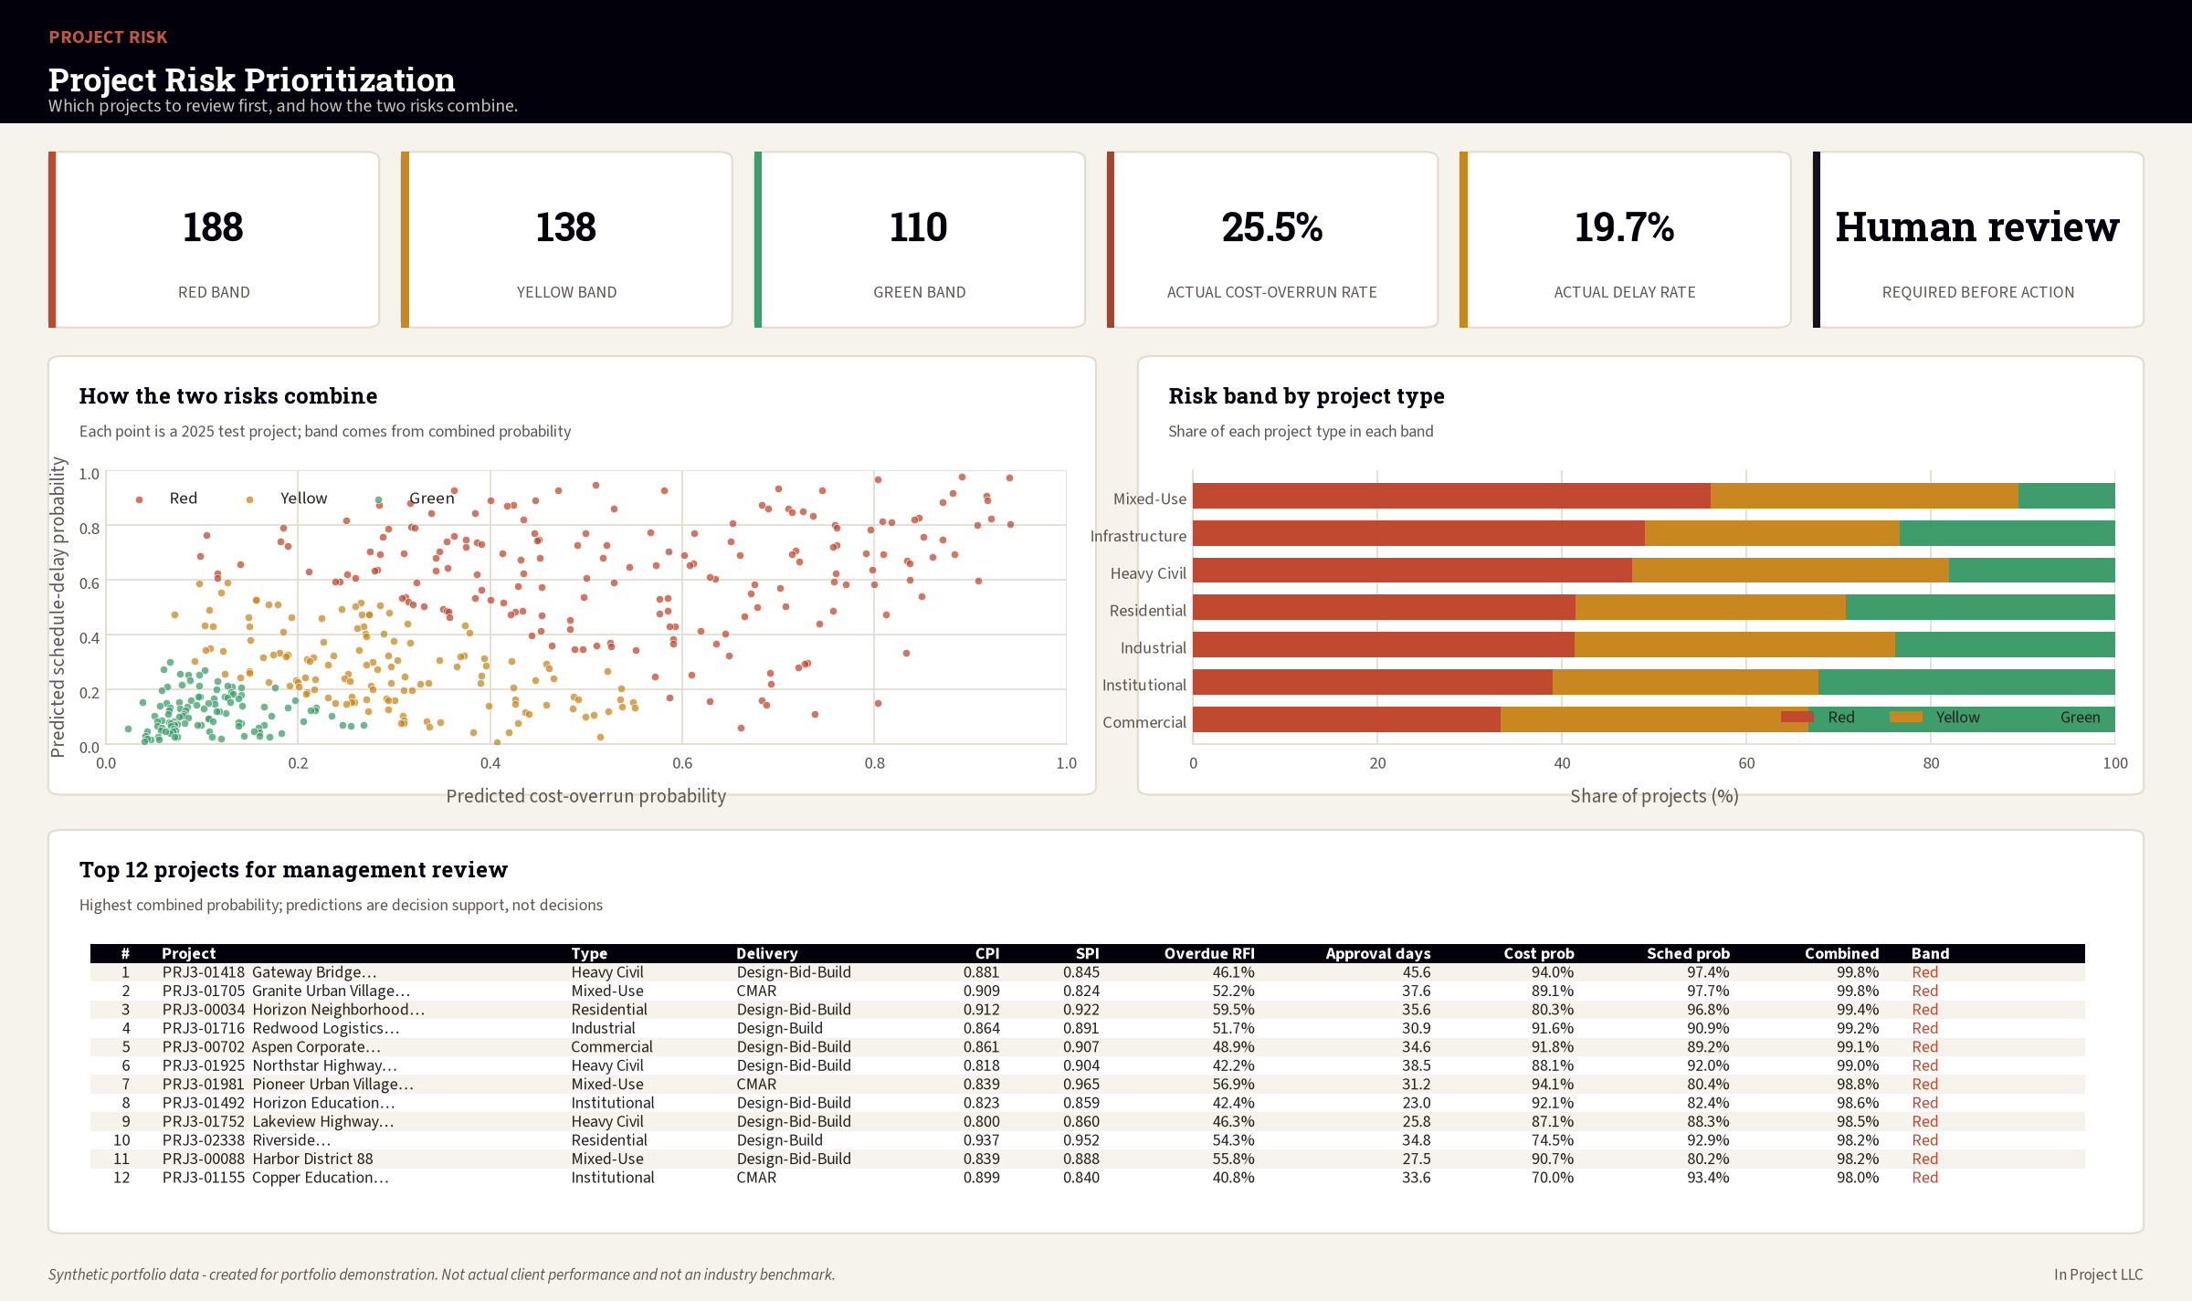
Figure 4. Project risk prioritization: how cost and schedule probability combine into a single review queue.
The communication design shows probability and risk band together, labels validation and test periods, and keeps synthetic-data, uncertainty, and human-review warnings visible.

10. Act Plan, Human Review, and Monitoring

Controlled-pilot roadmap
- Days 0–30: approve charter, prohibited uses, independent review, reproducibility, source mapping, and data-quality gates.
- Days 31–60: conduct a silent pilot, train reviewers, and review thresholds and monitoring.
- Days 61–90: conduct a limited visible pilot, record decisions and overrides, and make a formal go/no-go decision.

Human review
- Verify input data and snapshot context.
- Review cost, schedule, and overall probabilities.
- Review model and rule-based drivers.
- Consider current project context and known events.
- Accept, Override, Escalate, or Defer.
- Assign an action, owner, due date, and evidence.
- Record later outcomes for monitoring.

Proposed monitoring
Metric | Yellow | Red / stop
Cost ROC-AUC | Yellow <0.82 | Red <0.78
Schedule ROC-AUC | Yellow <0.75 | Red <0.70
Probability PSI | Yellow >0.10 | Red >0.20
Critical data quality | Any failure | Stop scoring
Segment AUC gap | Yellow >0.10 | Red >0.15
Override rate | Yellow >30% | Red >50%
Model age | Review at 12 months | Mandatory decision at 18 months

11. Limitations, Responsible AI, and Conclusion
- All data is synthetic and may not represent real project distributions.
- Performance is not an industry benchmark.
- Target thresholds are case-study definitions.
- Feature importance is predictive, not causal.
- The schedule model shows temporal degradation.
- Segment results have limited sample sizes.
- Real deployment requires approved data, independent validation, calibration, drift review, human oversight, access controls, and incident response.
- The model may not be used for contractual, legal, safety-critical, or personnel decisions.

Conclusion
Project 3 completes a three-project construction analytics portfolio progression from descriptive project controls, to diagnostic workflow analytics, to predictive early warning. The project demonstrates technical modeling and business governance together, including the discipline to retain unfavorable temporal results and restrict unvalidated production use.

12. Sources and Deliverables

Professional references
IBM CRISP-DM overview: https://www.ibm.com/docs/en/spss-modeler/18.6.0?topic=dm-crisp-help-overview
ASQ DMAIC: https://asq.org/quality-resources/dmaic
Microsoft Data Science Lifecycle: https://learn.microsoft.com/en-us/shows/dev-intro-to-data-science/what-is-the-data-science-lifecycle-2-of-28
PMI Process Groups: https://www.pmi.org/standards/process-groups

Primary project deliverables
- Analysis workbook and model-performance tables
- Saved classification and regression pipelines
- Feature manifest and model card
- Executive and operational dashboards
- Power BI and Tableau specifications
- Batch scoring and model-monitoring scripts
- Controlled-pilot Act plan, risk register, RACI, and override log
- Complete Ask–Prepare–Process–Analyze–Share–Act documentation
End of Report

