
Badami Store Data Analysis
Badami Store Data
Analysis

About the Dataset


- Type: Retail / E-commerce Dataset
Badami Store Data Analysis
- Nature: Structured (Tabular)
- Level: Customer Transaction Level
- Data Mix:
  - Numerical → Order ID, Customer ID, Age, Qty, Amount, Ship-postal-code
  - Categorical → Gender, Status, Channel, City, State

This dataset is used for customer purchasing analysis + business decision-making
Domain Background
In the retail industry, companies track every customer interaction:
- What customers buy
- What channel customer used to buy
- How much do they spend
- Which gender is purchasing more
Why This Data Is Important

This data helps businesses:

- Identify high-value customers
- Understand purchase patterns
- Optimize state-wise purchasing
- Improve marketing campaigns
- Increase customer lifetime value (CLV)

Business Problem: -

Badami store wants to create an annual sales report for 2022. So that, Badami can understand their customers and grow more sales in 2023.

Breaking Down the Problem
Sales and Order Performance Analysis

• How do sales and orders vary month-wise?
• Which month recorded the highest sales and orders?
Customer Purchase Behavior Analysis

• Who purchased more products — men or women?
• Which age group contributes the highest number of orders?

Order Status Analysis

• What are the different order statuses in 2022?
• Which order status has the highest percentage?

Regional Sales Performance Analysis

• Which are the top 5 states contributing to sales?
• Which regions generate the highest business revenue?

Sales Channel Performance Analysis

• Which channel contributes maximum sales?
• How do Amazon, AJIO, Flipkart, Meesho, and Myntra perform comparatively?

Product Category Performance Analysis

• Which product category generates maximum sales?
• Which categories perform better than others?

Data Dictionary

Order ID | Unique identification number assigned to each customer order
Cust ID | Unique ID used to identify individual customers
Gender | Represents the gender of the customer
Age | Shows the age of the customer
Date | Date on which the order was placed
Status | Displays the current order status of the order
Channel | Indicates the platform from which the order was placed
SKU | Unique code used to identify products
Category | Represents the type or category of the product
Size | Indicates the product size selected by the customer
Qty | Quantity of products ordered by the customer
Currency | Currency used for the transaction amount
Amount | Total sales amount generated from the order
ship-city | City where the order was delivered
ship-state | State where the order was delivered
ship-postal-code | Postal code of the delivery location

Data Cleaning Process: -

Data cleaning was performed in Excel to improve data quality.

The following steps were performed:

• Removed duplicate records
• Handled missing values
• Corrected formatting issues
• Standardized date formats
• Removed extra spaces using TRIM
• Corrected inconsistent category names
• Checked data types and accuracy
Data Processing & Analysis: -

After cleaning the data, pivot tables were created to summarize and analyze business performance based on sales trends, customer behaviour, order status, regional performance, sales channels, and product categories.

Analysis included:
• Month-wise sales and order analysis
• Identification of the month with the highest sales and orders
• Gender-wise customer purchase analysis
• Age group analysis based on number of orders
• Analysis of different order statuses in 2022
• Identification of the order status with the highest percentage
• Top 5 states contributing maximum sales
• Channel-wise sales analysis for Amazon, AJIO, Flipkart, Meesho, and Myntra
• Identification of the highest-performing sales channel
Dashboard Creation: -

An interactive Excel dashboard was created using:

• Pivot Charts
• Slicers
• KPI Cards
• Conditional Formatting
• Dynamic Filters

The dashboard allows users to analyze sales performance dynamically based on different categories and regions.

Below is dashboard image: -

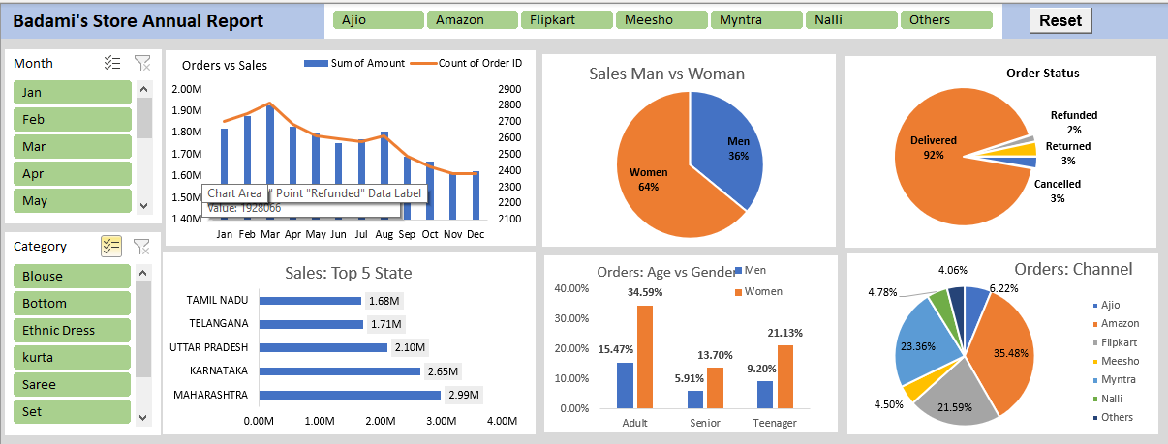

Key Insights: -

- Women are more likely to buy compared to men (-65%).
- Maharashtra, Karnataka and Uttar Pradesh are the top 3
- Adult age group (30-49 years) is max contributing (-50%).
- Amazon, Flipkart and Myntra channels are max contributing 80%.
Tools and Technologies used: -

Here are Tools & Technology used: -

• Microsoft Excel
• Pivot Tables
• Pivot Charts
• Slicers
• Data Cleaning Functions
• Dashboard Design
Conclusion: -

- This project successfully transformed raw retail data into meaningful business insights using Excel. The dashboard helps stakeholders monitor sales performance, identify trends, and make better business decisions through data-driven analysis.
- Target women customers of age group (30-49 years) living in Maharashtra, Karnataka and Uttar Pradesh by showing ads/offers/coupon available on Amazon, Flipkart and Myntra.

