All SQL commands can be found in the GitHub repo in assignment3/sql. Each Question has a file dedicated to it.

2,

DESCRIBE command responses:

1. users:  
    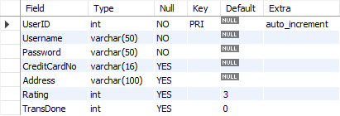
2. companyTransactions:   
   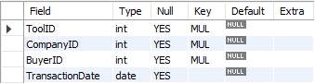
3. companies:  
   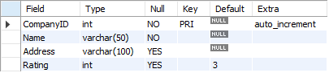
4. favouriteTools:   
   
5. tools:  
   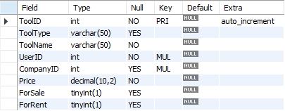
6. userTransactions:  
   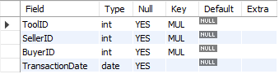
7. unavailableTools:  
   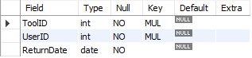

3,



4,



Users and tools both have 2000 tuples in them, and companies has 300 tuples in it.

a, We used a java program to generate 2000 insert statements. With our program we guaranteed that duplicates were not generated for keys.

b, We have checked and our insert statements only go through if there is a matching value. For example, when we add tools, we randomize an id between 1-2000 so it will match a userID.

5,



We tested the statements with no data to make sure the commands run successfully.

6, 

Again, tested to make sure the commands run.

7,

1. Query to create three views and the system response
2. Query involving each view with the systems response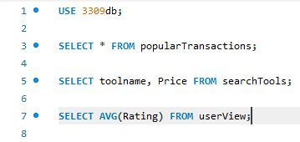
3. Query involving inserting in each view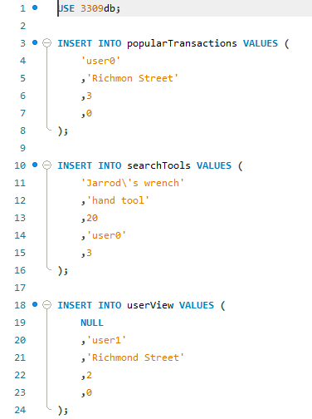  
   none of the views created can be updated as most of them were made involving joins without all the mandatory columns and one of them hides sensitive information such as password and credit card number which would be required to create a user tuple.

8,

No we did not run into this issue.