Project Interim Report on
File Compression Simulator (Using Core Java & OOP Concepts) RU-100-01-00012
Object oriented Programming with Java



RUNGTA INTERNATIONAL SKILLS UNIVERSITY
SESSION: 2025-26

Subject teacher name Submitted By :-
(Shivansh Mehta) Student name:- Anuj Kumar Singh Ref No :- 2025-02139
ERP ID :- RU-25-10250

Submitted To :

RUNGTA INTERNATIONAL SKILLS
UNIVERSITY ,CG
SCHOOL OF COMPUTER SCIENCE ENGINEERING

INDEX
S.NO | TITLE | PAGE NUMBER
1) | Abstract | 1
2) | Introduction and Objectives | 2
3) | Scope | 3
4) | System Requirements | 4
5) | Methodology | 5
6) | FlowChart | 6-7
7) | Class Diagram | 8-9
8) | Implementations | 10

INDEX
S.NO | TITLE | PAGE NUMBER
9) | Grantt chart | 11
10) | Conclusion | 12
11) | References | 13

Employee Payroll Management System
Object-Oriented Programming Project Report

━━━━━━━━━━━━━━━━━━━━━━━━━━━━━━

Programming Language: Java Subject: Object-Oriented Programming Academic Year: 2025–2026

━━━━━━━━━━━━━━━━━━━━━━━━━━━━━━

Abstract

The Employee Payroll Management System is a Java-based application developed using core Object-Oriented Programming (OOP) principles. It is designed to automate the management and calculation of employee salaries within an organization, replacing error-prone manual processes with a structured, reusable, and scalable software solution.

The system is needed because organizations employ people of different types — full-time and part- time — each requiring different salary computation logic. Manually handling these calculations is tedious and inconsistent. A software-based system built on OOP concepts provides a clean, extensible solution that mirrors real-world business logic.

The system defines a parent Employee class containing common attributes shared by all employees. It then creates two specialized subclasses — FullTimeEmployee and PartTimeEmployee — each overriding the salary calculation method with their own logic. This design demonstrates inheritance, polymorphism, constructor chaining using the super keyword, and method overriding in a practical, real-world context.

Introduction

Payroll management is a critical function in every organization. Ensuring accurate and fair salary computation for employees with different employment terms is a challenge when performed manually. Errors in payroll can lead to employee dissatisfaction, legal complications, and financial discrepancies. A software-based payroll system provides consistency, accuracy, and ease of management.

This project presents an Employee Payroll Management System implemented in Java using Object- Oriented Programming concepts. The system models different employee types through class hierarchies and automates salary computation based on employment type.

Objectives
- Manage employee records including name, employee ID, and salary details in a structured class hierarchy
- Compute salaries automatically based on employment type — full-time employees receive base salary plus bonus and allowances, while part-time employees are paid based on hours worked and hourly rate
- Reduce manual calculation errors by encapsulating salary logic inside dedicated class methods
- Apply and demonstrate core OOP concepts: inheritance, polymorphism, method overriding, and constructor chaining using the super keyword

Scope

The current version of the Employee Payroll Management System supports two types of employees: FullTimeEmployee and PartTimeEmployee. It is suitable for small organizations or academic demonstrations of OOP design. The system handles the creation of employee objects, computation of their salaries, and display of detailed payroll information.

The project can be extended in the future to include:
- Database integration using MySQL or SQLite for persistent storage of employee records
- Additional employee types such as Contractual, Intern, or Senior Management with their own salary structures
- Tax deduction and net salary computation modules including PF and ESI
- A graphical user interface (GUI) using JavaFX or Swing for improved usability
- Export of payroll reports to PDF or Excel format for official records

System Requirements

Hardware Requirements
- Processor: Intel Core i5 or equivalent (1 GHz or higher)
- RAM: Minimum 4 GB
- Storage: At least 500 MB free disk space
- Display: Any standard monitor with 1024×768 resolution or higher

Software Requirements
- Operating System: Windows 10 / macOS / Linux (Ubuntu 18.04 or higher)
- Programming Language: Java (JDK 8 or higher)
- IDE: VS Code, Eclipse, IntelliJ IDEA, or EditPlus
- Java Runtime Environment (JRE) for executing compiled programs

Methodology

The project follows a structured, step-by-step Object-Oriented design approach. The development process is divided into the following phases:

Step 1 — Define the Parent Employee Class
A parent abstract class Employee is created containing attributes common to all employees: name, id, and baseSalary. An abstract method calculateSalary() is declared inside this class, which must be implemented by every subclass. A displayDetails() method is also defined to print employee information.

Step 2 — Create Subclasses
Two subclasses are created that extend the Employee class:
- FullTimeEmployee — adds attributes bonus and allowances to model a salaried employee
- PartTimeEmployee — adds attributes hoursWorked and hourlyRate to model an hourly-wage employee

Step 3 — Implement Parameterized Constructors
Each subclass implements a parameterized constructor that accepts all required values and calls the parent constructor using the super() keyword to initialize the inherited attributes name, id, and baseSalary.

Step 4 — Override the Salary Calculation Method
Each subclass overrides the calculateSalary() method with its own logic:
- FullTimeEmployee: Total Salary = baseSalary + bonus + allowances
- PartTimeEmployee: Total Salary = hoursWorked × hourlyRate

Step 5 — Demonstrate Polymorphism
In the main method, Employee-type references are used to hold objects of both subclasses. When calculateSalary() is called on each reference, Java dynamically dispatches to the correct overridden method based on the actual object type. This demonstrates runtime polymorphism.

Step 6 — Display Results
Each employee's details — name, ID, type, and computed salary — are printed to the console using the overridden displayDetails() method. A final summary table shows all employees and the total payroll expenditure.

Flowchart

Main Program Flowchart
The following flowchart illustrates the execution flow of the Employee Payroll Management System from program start to salary display and termination.

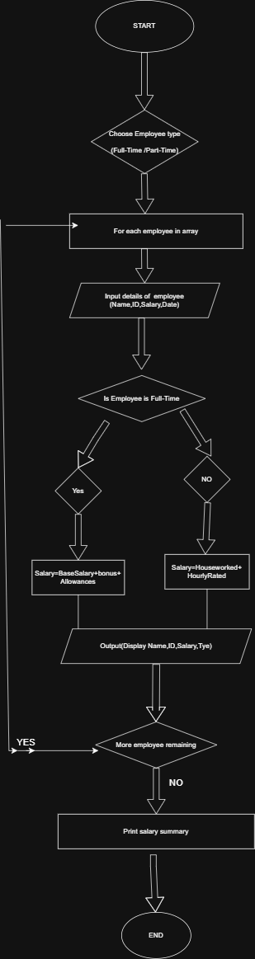

Class Diagram

The following class diagram represents the structure and relationships between the classes in the Employee Payroll Management System.

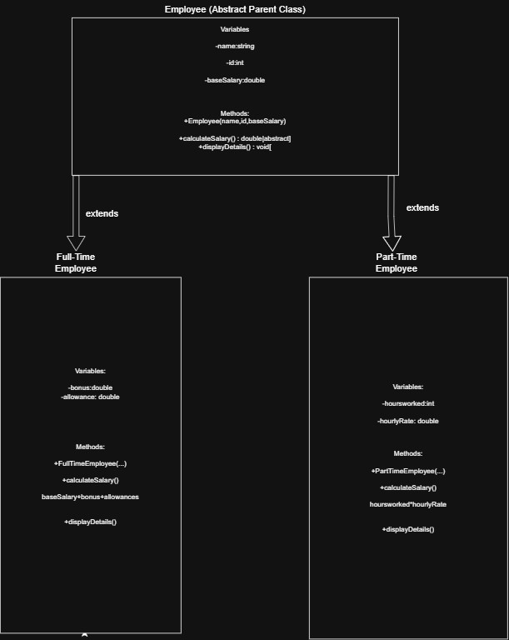

Implementation

The Employee Payroll Management System is implemented using four Java classes, each encapsulating specific responsibilities based on Object-Oriented Programming principles. The diagram below explains the logic of each class, the salary formulas used, and includes a sample terminal output showing the system in action.
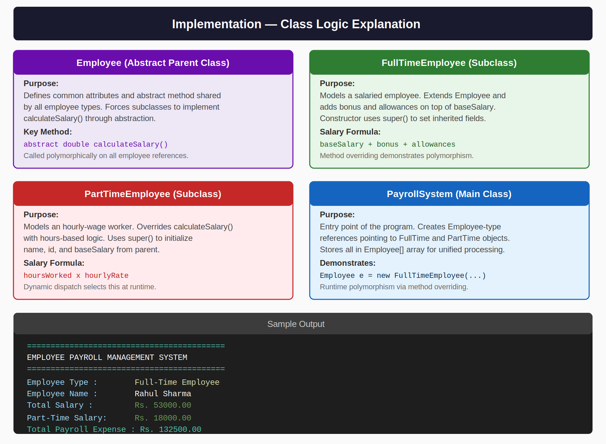

Gantt Chart

1. Planning and Structure: The Gantt chart breaks the project into phases and assigns each a timeline across 8 weeks, ensuring all milestones are tracked and completed on schedule.
2. Time Management: Each bar shows when a task starts and ends. Overlapping bars indicate parallel work. This helps avoid delays by distributing work evenly across the project timeline.
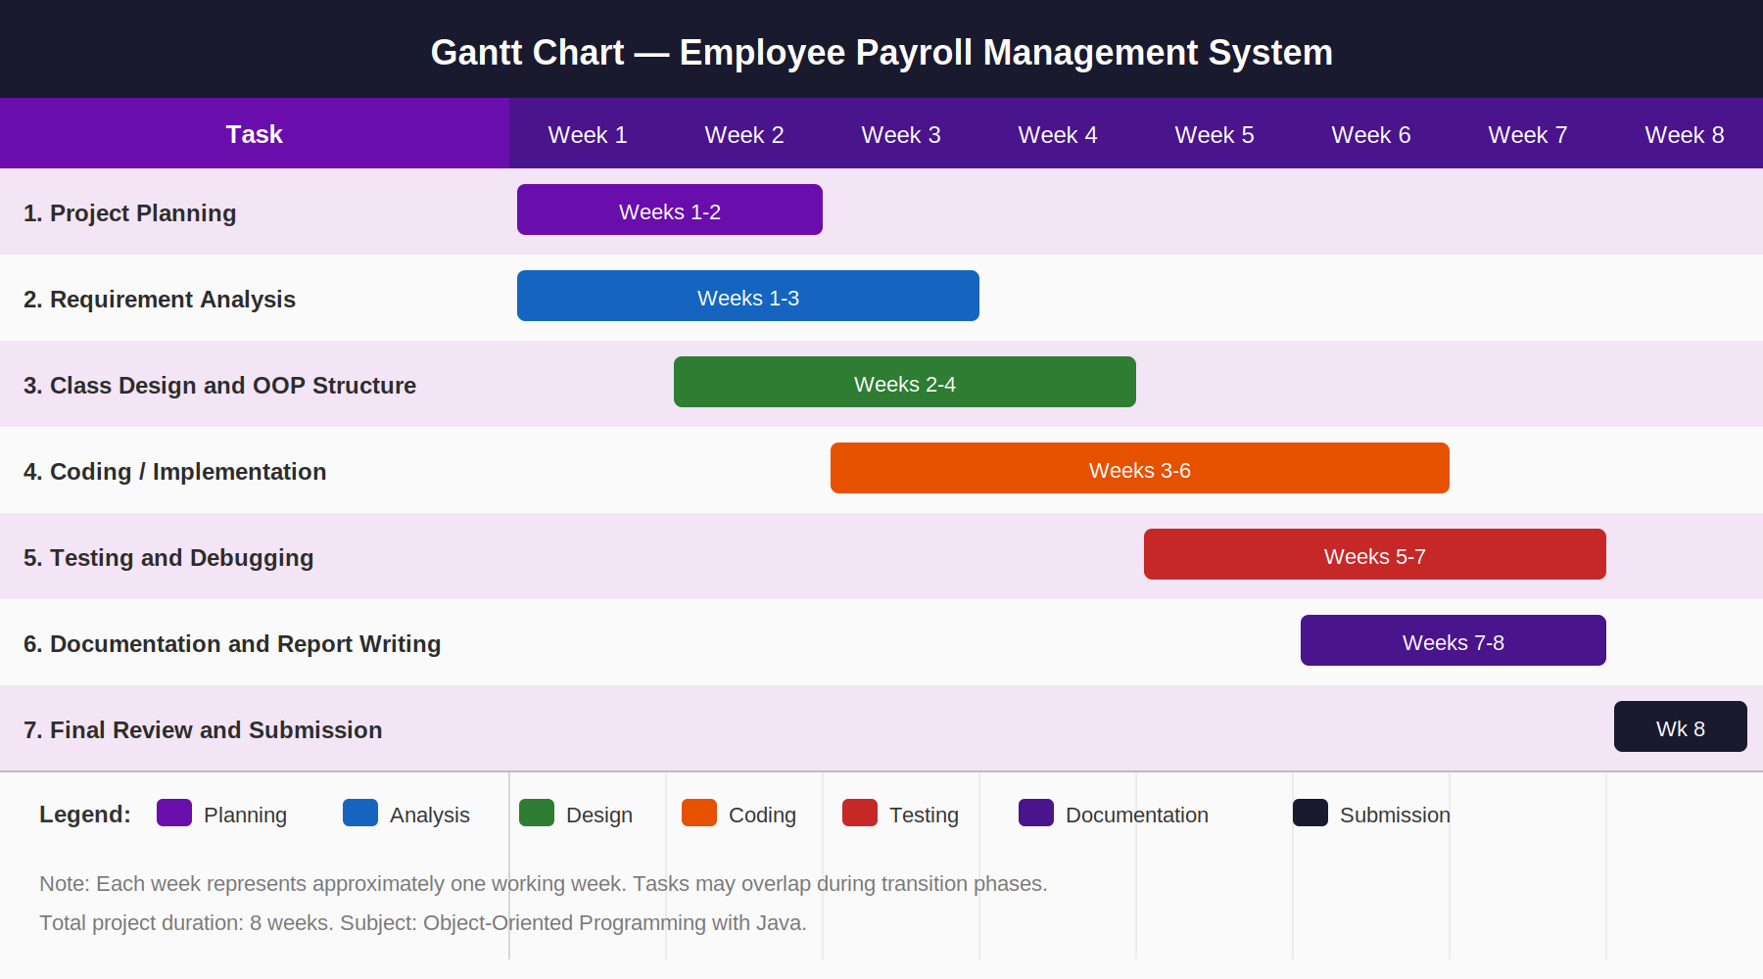
Conclusion

The Employee Payroll Management System successfully demonstrates the core principles of Object-Oriented Programming through a practical, real-world application. By designing a structured class hierarchy with a base Employee class and two specialized subclasses — FullTimeEmployee and PartTimeEmployee — the system achieves a clean separation of concerns while remaining flexible and extensible.
The use of inheritance eliminates code duplication by centralizing shared attributes (name, id, baseSalary) in the parent class, while method overriding allows each subclass to define its own salary calculation logic tailored to its employment type. Polymorphism further enhances the design by enabling a single Employee reference to invoke the correct calculateSalary() method at runtime through dynamic dispatch, without the caller needing to know the actual object type.
Constructor chaining via the super() keyword ensures proper and consistent initialization across the hierarchy, reinforcing best practices in object construction. The Main class ties everything together by acting as a driver that creates employee objects and demonstrates how the system behaves with different employee types.
Overall, this project reinforces that good OOP design leads to code that is modular, maintainable, and scalable
— new employee types such as ContractEmployee or InternEmployee can be added in the future simply by extending the Employee class, without modifying any existing code. This adherence to the Open/Closed Principle makes the system a strong foundation for a production-grade payroll application.

References

Books:
[1] H. Schildt, Java: The Complete Reference, 11th ed. New York: McGraw-Hill, 2018.
[2] E. Gamma, R. Helm, R. Johnson, and J. Vlissides, Design Patterns: Elements of Reusable Object-Oriented Software. Reading, MA: Addison-Wesley, 1994.
Websites:
[3] Oracle, "Java Documentation," Oracle. [Online]. Available: https://docs.oracle.com
[4] GeeksforGeeks, "Object-Oriented Programming in Java," GeeksforGeeks. [Online]. Available: https://www.geeksforgeeks.org/object-oriented-programming-oops-concept-in-java/
Journal Articles:
[5] A. Sharma and R. Gupta, "Machine Learning Techniques," International Journal of AI, vol. 5, no. 2, pp. 45-58, 2020.
Conference Papers:
[6] S. Kumar, "AI in Education," in Proc. IEEE Conf. on AI, 2021, pp. 120-125.

PROJECT CODE

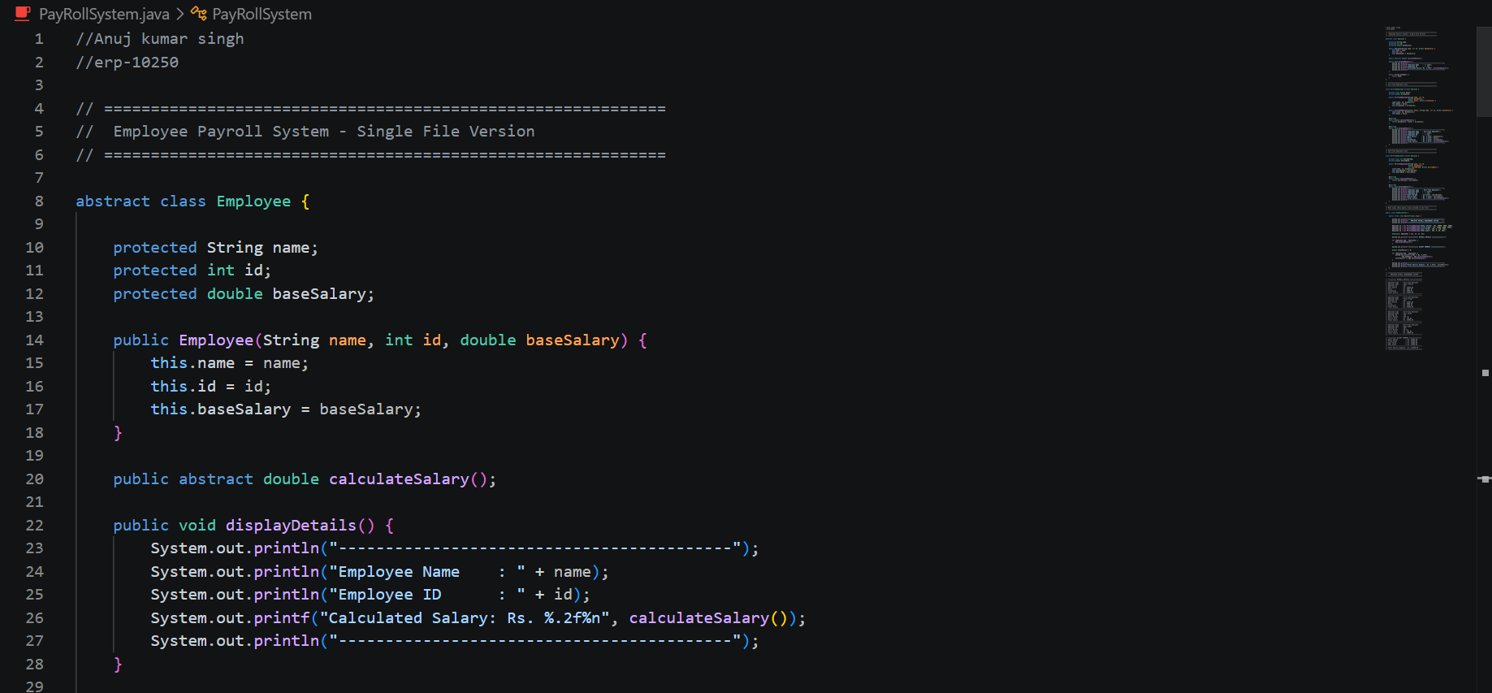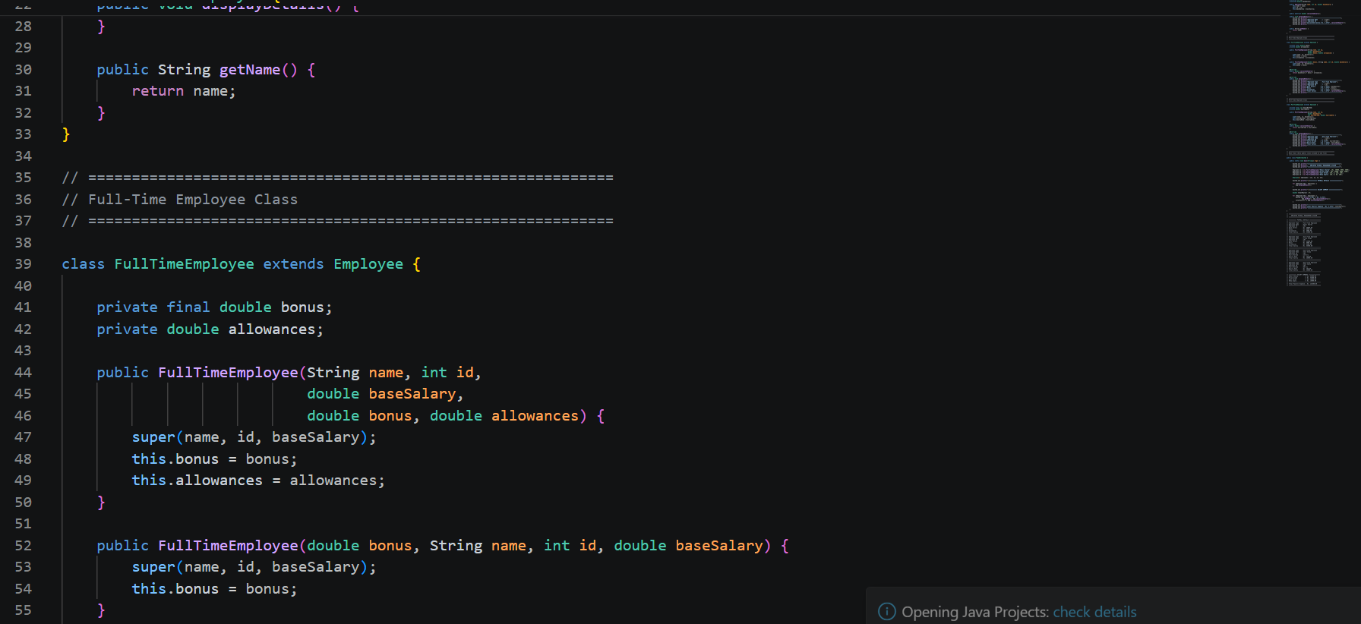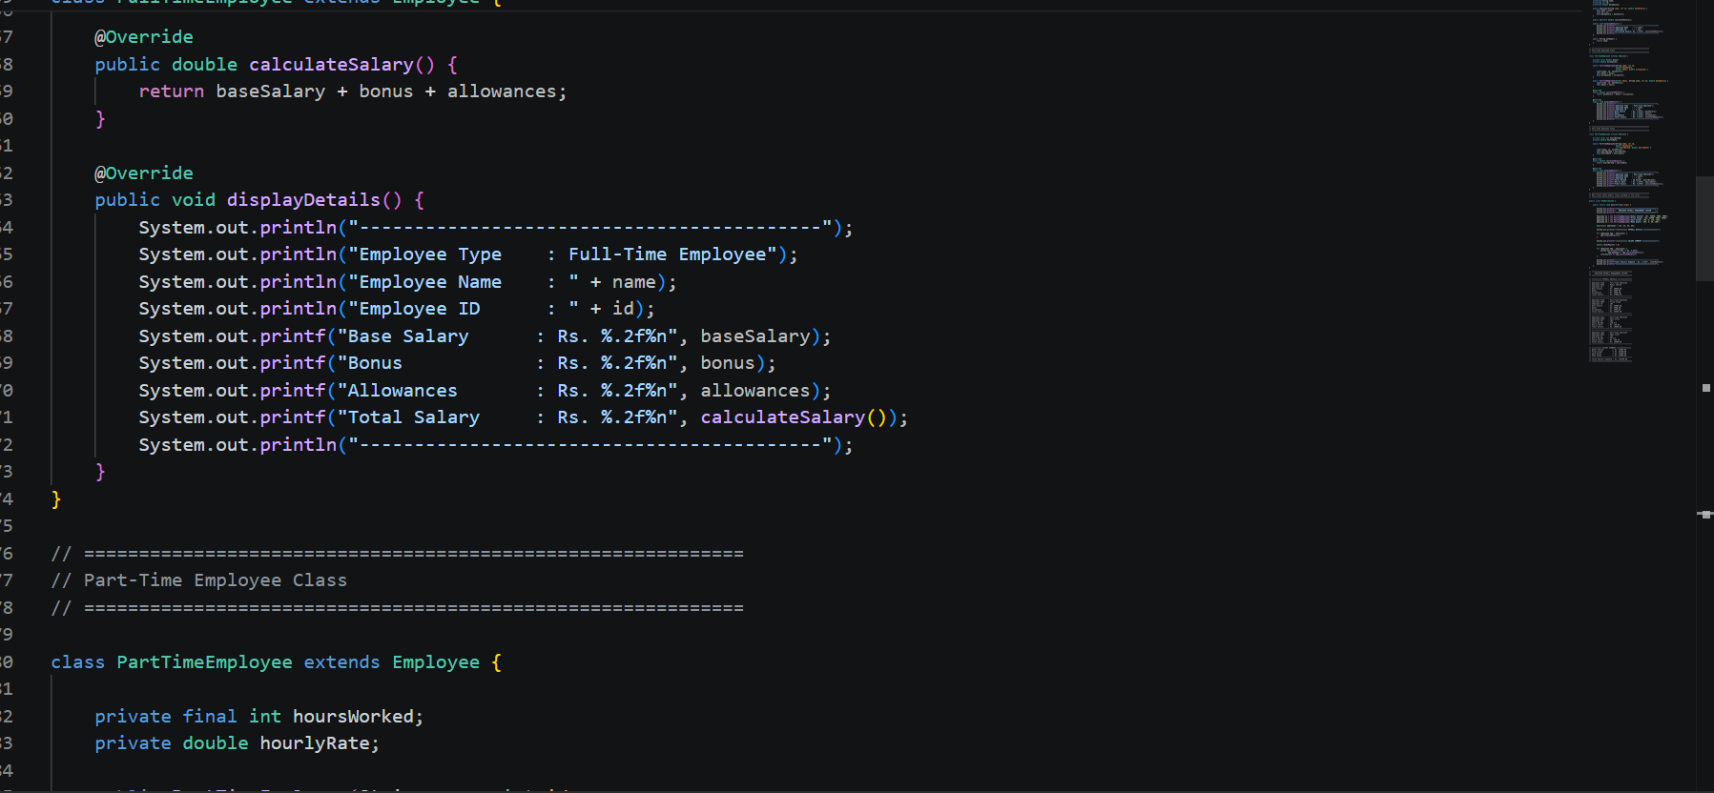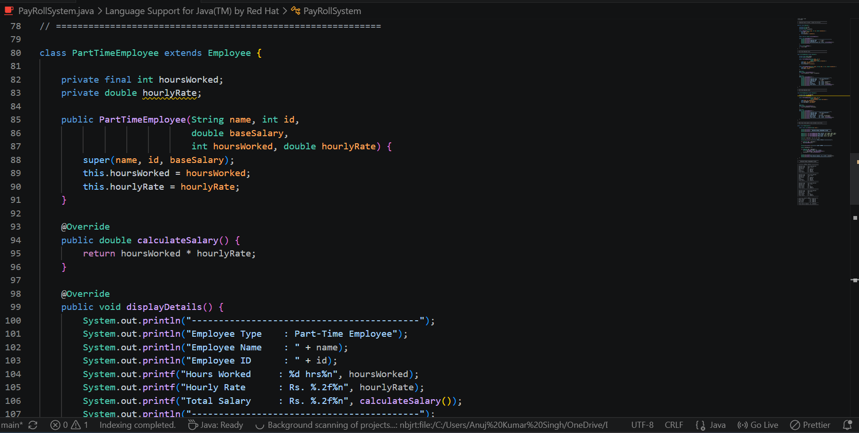
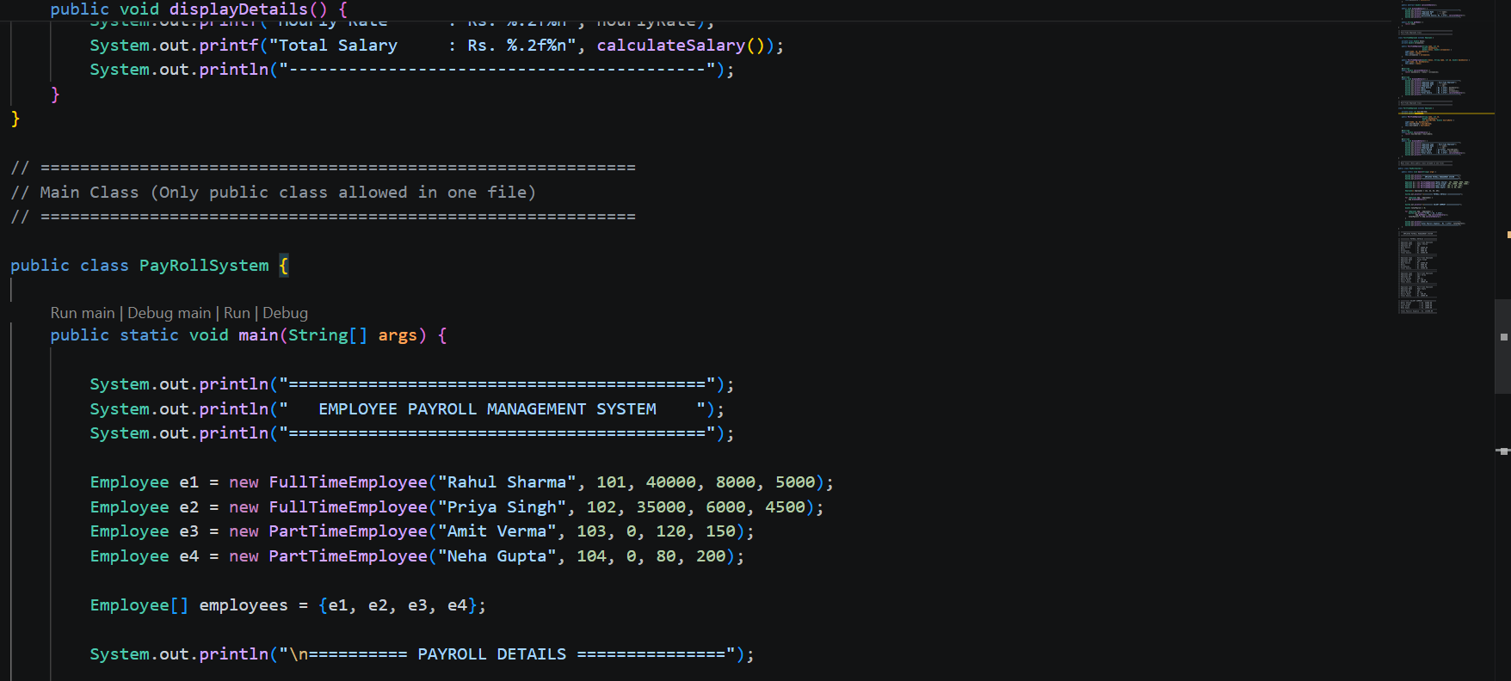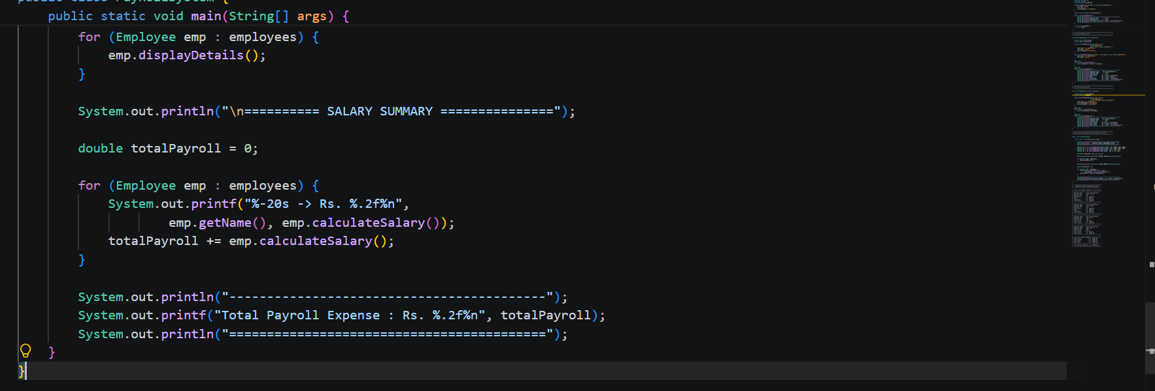

OUTPUT
