OrchestrAI: An Intelligent Multi-Agent AI Orchestration System

MINOR PROJECT REPORT
Submitted in partial fulfillment for the award of the degree of
BACHELOR OF TECHNOLOGY
Department of Computer Science and Engineering

Submitted to
INDIAN INSTITUTE OF INFORMATION TECHNOLOGY
BHOPAL (M.P.)

Submitted by
Anuj Mahore (24U020054 , Vth Semester)
Maanas Negi (24U020041 , Vth Semester)

Under the supervision of
Dr. Neeta Anna Eapen
Assistant Professor
CSE

November 2026

INDIAN INSTITUTE OF INFORMATION TECHNOLOGY
BHOPAL (M.P.)



CERTIFICATE

This is to certify that the work embodied in this report entitled “OrchestrAI” has been satisfactorily completed by Anuj Mahore (24U020054) and Maanas Negi (24U020041) . It is a bonafide piece of work, carried out under our guidance in the Department of Computer Science and Engineering, Indian Institute of Information Technology, Bhopal for the partial fulfillment of the Bachelor of Engineering during the academic year 2026

Date: 02-11-2026

Dr. Rahul Chaurasia
Department Coordinator
Department of CSE,
IIIT Bhopal (M.P.)
Dr. Neeta Anna Eapen
Assistant Professor
Department of CSE
IIIT Bhopal (M.P.)

 | INDIAN INSTITUTE OF  INFORMATION TECHNOLOGY  BHOPAL (M.P.)

DECLARATION

We hereby declare that the following major project synopsis entitled “OrchestrAI” presented in the is the partial fulfillment of the requirements for the award of the degree of Bachelor of Technology in Computer Science and Engineering. It is an authentic documentation of our original work carried out under the able guidance of Dr. Neeta Anna Eapen. The work has been carried out entirely at the Indian Institute of Information Technology, Bhopal. The project work presented has not been submitted in part or whole to award of any degree or professional diploma in any other institute or organization.

We, with this, declare that the facts mentioned above are true to the best of our knowledge. In case of any unlikely discrepancy that may occur, we will be the ones to take responsibility.

Anuj Mahore (24U020054)
Maanas Negi (24U020041)

ACKNOWLEDGEMENT

We, Anuj Mahore and Maanas Negi , would like to express our sincere gratitude to everyone who supported and guided us throughout the successful completion of our minor project titled "OrchestrAI".

First and foremost, we would like to extend our heartfelt thanks to our esteemed Director,
Dr. Ashutosh Kumar Singh , for providing us with the necessary resources and facilities for conducting our project. His encouragement and vision played a key role in helping us accomplish our goals.

We are deeply grateful to our Project Guide, Dr. Neeta Anna Eapen , for her constant guidance, invaluable suggestions, and expert advice throughout the project. Her knowledge and insights helped us enhance the quality of our work, and Her support kept us motivated during difficult times.

Our sincere thanks to the Department Coordinator, Dr. Rahul Chaurasia , for the valuable support and encouragement provided during completion of the project.

We would also like to express our gratitude to all the faculties of the Department of Computer Science and Engineering for their valuable guidance and support in clarifying doubts and providing us with the right direction throughout the smooth execution of our project.

A special thanks to our friends for their continuous support, valuable suggestions, and helping us during various stages of the project. Their insights and encouragement motivated us to keep working on the project with enthusiasm.

Last but certainly not the least, we would like to express our deepest gratitude to our parents and family members for their love, patience, and continuous moral support throughout the course of this project. Their understanding and encouragement were the driving force behind our efforts.

We are truly thankful to everyone who directly or indirectly contributed to the success of this project. Without their assistance and support, this project would not have been possible.

Anuj Mahore (24U020054)
Maanas Negi (24U020041)

AREA OF WORK

Our project called OrchestrAI is a multi agent artificial intelligence system that mainly focuses on different agents working for different tasks and supervisor agent that supervises the tasks that is like a manager that manages employees.
We are making different agents such as Chat Agent , Coding Agent , PDF agent , PPT Agent , Vision Agent , Search Agent. And we have a reviewer agent that checks the work completed by the different agent and gives the feedback to the supervisor agent.

The major technical areas that we are addressing:
- Multi-Agent Systems: We are designing specialized AI agents to handle different tasks of users.
- Supervisor Agent: We are making the supervisor agent using LangGraph to manage task routing.
- LLM Integration: We are integrating Groq and Google Gemini to support different AI functionalities.
- Reviewer Agent: We are developing the reviewer agent that checks the tasks completed by the AI agent and gives the feedback.

We are building the full stack website that uses modern AI technologies for the working professionals and the students that uses this application for their work. It demonstrates how different specialized agent that works under the centralized agent.After that the reviewer agent that improves the accuracy of the answer generated by the specialized agent.

TABLE OF CONTENT

S.no | Title | Page No.
 | Certificate
 | Declaration
 | Abstract | 8
1 | Introduction | 9
2 | Literature review | 12
3 | Problem Definition and Objectives | 16
4 | Methodology & Work Description | 19
5 | Proposed algorithm | 24
6 | Proposed flowchart/ DFD/ Block Diagram | 25
7 | Tools & Technology Used | 28
8 | Implementation & Coding | 29
9 | Result Analysis | 32
10 | Conclusion & Future Scope | 35
11 | References | 36

LIST OF FIGURES

Figure | Figure Title | Page No.
1 | Single-Agent AI Architecture | 10
2 | Problem Solving Approach of OrchestraAI | 16
3 | OrchestraAI Data Flow Diagram | 25
4 | OrchestraAI System Architecture and Module Interaction | 26
5 | Supervisior Routing and Reviewer Feedback Loop | 27
6 | Simplified Tool and Service Interaction | 31
7 | Review agent report for Chat agent | 32
8 | Review agent report for Coding agent | 33
9 | Output of Search Agent | 33
10 | Output of PDF Agent | 34

LIST OF TABLES

Table | Table Title | Page No.
1 | Summary of Related Work and Relevance to OrchestrAI | 15
2 | Problem to Solution Mapping | 17
3 | Routing Map of OrchestrAI | 21
4 | Tools and Technologies Used in OrchestrAI | 28

ABSTRACT

Generative artificial intelligence driven by LLMs is now widely wised for conversation ,programming assistance,information retrieval and content creation. Most deployed applications however route every kind of request to a single kind of request to a single generalpurpose model. Such a design makes it difficult to specialize behaviour for individual components independently.

This report presents OrchestraAI a multi agent AI orchestration platform in which several specialized agents cooperate under the control of a central supervisor agent.When a user submits a requests the supervisor agent interprets the task and routes it to the most suitable specialized agent : chat agent for general conversation, a coding agent for programming tasks, a search agent for information retrieval, a ppt agent for presentations, a pdf agent for documents, image Agent for image generation, and a vision agent for image understanding.The output of the selected agent is examined by the reviewer agent which acts as a checker before the result is returned through the supervisor agent to the user.

The platform is organized as a set of microservices that are containerized with docker and managed with docker compose with redis supports authenticated session storage, temporary conversion memory catching and per agent rate limiting. Communication between microservices is handled through https apis.

Authentication and billing services control user access and credit usage and generated pptx,pdf and png files are uploaded to supabase storage and delievered using temporary signed urls. The expected advantages of the design are modularity, task specific processing,scalability of individual services. This report describes the problem, the methodology, the algorithms, the architecture and the implementation of OrchestraAI and presents a qualitative comparision with single model designs.

Keywords: Large language models, Multi agent sysytems, Agent orcherstration, Langraph and Langchain, Supervisor agent, Reviewer agent.

INTRODUCTION

1. Artificial Intelligence and Generative AI
Artificial intelligence is a branch of computer science joined with making system that detect their environment and take action to take goal [1]. Over a past years researches in deep learning have moved artificial systems from small models to general uses models which can be used to many tasks. A major action was a transformer design which replaces repeatness with self attention and it is used to train very large sequencial models on large amount of text collections [2].
Generative artificial systems refer to models which produces fresh content such as text, source code, images or documents instead of only giving labels to inputs. Now a days many applications that is based on generative models which includes chatting helpers, coding helper, document making tools and image generations tools.

2. Large Language Models

Large language models are neural networks based on a transformer architecture and which is trained on huge amount of text. They can perform different tasks such as giving answers of our questions, writing files, and giving codes with only few instructions in the prompt.

Moreover llms also have some disadvantages and limiations. They may give answers that sound good but contain wrong information which is called hallucination. Their knowledge may not include current information and they cannot themselves access external tools or current data unless we provide the required tools by ourselves.

3. AI Agents, Agentic AI and Multi-Agent Systems
In old artificial systems an agent is a system that lie in the environment where it acts by itself to meet its design aims and a multiagent system is a group of such agents that interact with each other[7]. Modern llm based agents combine the language model with parts such as planning, memory and tool use so that the model can decide some actions instead of only generating text [8]. The term agentic ai is commonly used for systems that achieve goals through such as sequential decisions and actions.
A multi agent llm system uses several agents having their own roles, prompt, tools and model which synchronises to complete a task that would be hard to handle with one prompt [10]. With tht help of only one prompt we cannot do multiple tasks effectively. The ReAct approach gives reasoning steps with actions so that a model can use external sources while solving a task [11] and toolformer shows that language models can learn when needed and how to call external tools [12].

4. Need for Specialized Agents

When we give a prompt to a single agent then that single agent have to perform many tasks simultaneously for example suppose we give a prompt to a single agent that generate pdf and ppt simultaneously then that agent have to do both tasks and it can takes more times so there is need some agents that are masters on their work or we can say task for example instead of only single agent we can use pdf and ppt agent separately which can be coordinated by a manager and that manager in a simple way we called a supervisor that supervises the agents so that it can take lesser times so it saves our valuable time.

Therefore we needed some specialized agents and also a supervisor agent.

5. Challenges of Single-Agent Systems

Lesser specialization : the single agent are lesser specialized and they can do all works.

Late response : the single agent takes a lot of time and after that it gives the response.

Difficiult maintenance : the maintenance of a single agent systems are difficult to handle.

No Reviewer : the single agent systems has no reviewer and we do not know that the answer generated by the agent is correct or not.

Figure 1 shows the design of single agent systems
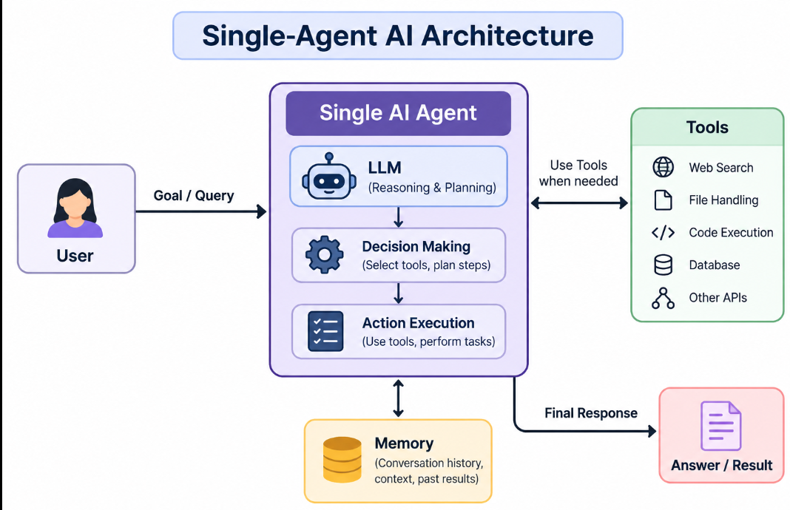
Figure 1 : Single-Agent AI Architecture

6. Agent Orchestration, Supervisors and Reviewers

Agent orchestration means allowing different agents and tools to work together to complete a single given task in our orchestra ai langraph manages the workflow of different agents and tools working together the supervisor agent recieves the request and then selects the agent that is built for that task.

Reviewer agent checks the output produced by the specialized agents and gives the feedback.

7. Motivation
Our aim of building this project orchestra ai is to build a efficient multi agent artificial system that has a supervisor to manages the task and reviewer that checks the output generated and gives feedback it will generate the output again if correction needed it will improve the accuracy of the outputs and would be better for the users such as students and working professionals.

GitHub Repository
https://github.com/anujmahore/Minor-Project

LITERATURE REVIEW

We surveys the research and documentation that forms the background of orchestra ai. It goes from single agents sysytems to multi agent systems tools ,frameworks and the histor of artificial agent systems.

1. Large Language Models and Generative AI
The transformer design given by vaswani et al. [2] is the basis of modern llms. By depending on self attention it allows parallel training and captures long range dependencies in text. Brown et al. [3] showed that scaling such a model to 175 billion parameters enables strong few shot behaviou meaning that a model can be directed to a new task through examples in its prompt alone. The gpt-4 technical report [4] describes a large multimodal model that accepts text and images and reports human level results on several professional benchmarks while also acknowledging limitations such as hallucination and limited reliability. Google gemini family [14] is another set of multimodal models trained jointly over text, images, audio and video, and is relevant to orchestrai because gemini is the model used for image and vision tasks.
Wei et al. [5] demonstrated that prompting a model to write out intermediate reasoning steps improves its performance on arithmetic commonsense and symbolic reasoning tasks. A comprehensive survey of hallucination by ji et al. [6] categorizes hallucinated content in natural language generation as either contradicting the source or not verifiable from it and reviews metrics and mitigation methods. This motivates the review and validation layer that orchestrai places after each specialized agent.

2. AI Agents and Autonomous Agents
Wooldridge and jennings [7] defined an intelligent agent through properties such as autonomy, social ability, reactivity and pro-activeness, and distinguished weak and strong notions of agency. These properties remain a useful vocabulary for llm based agents. Wang et al. [8] surveyed llm-based autonomous agents and proposed a general framework consisting of a profile module, a memory module, a planning module and an action module. Xi et al. [9] likewise present a conceptual framework of brain, perception and action for llm-based agents and discuss single-agent, multi-agent and human-agent scenarios.
Park et al. [15] built generative agents, in which llm-driven characters store experiences in memory, reflect on them and plan their behaviour in a simulated environment. Although their application domain differs from orchestrai, the work shows that memory, reflection and role-specific behaviour can be layered on top of a language model.

3. Tool-Using Agents
Because an llm alone cannot access current information or perform actions, much research focuses on tool use. React [11] interleaves reasoning traces with actions, allowing a model to query an external source and then update its plan from the observation. Toolformer [12] trains a model to decide which application programming interface (api) to call, when to call it and how to use the result. Hugginggpt [13] uses an llm as a controller that plans a task, selects expert models from a model hub for each sub-task, runs them and summarizes the results. This controller-and-experts structure is conceptually close to the supervisor agent and specialized agents of orchestrai, although orchestrai uses its own set of agents rather than a public model hub.

4. Multi-Agent LLM Systems and Agent Collaboration
Guo et al. [10] survey llm-based multi-agent systems and describe how agents are profiled, how they communicate, and how their capabilities grow over time, and they identify challenges such as coordination and scalability. Wu et al. [16] introduced autogen, a framework in which customizable conversable agents exchange messages to solve tasks, with support for human participation and tool use. Hong et al. [17] proposed metagpt, which encodes standard operating procedures from software engineering into the prompts of agents holding roles such as product manager, architect and engineer, so that intermediate artifacts are passed between roles in a structured way. These works demonstrate that role specialization and structured collaboration can make llm-based systems more organized than a single prompt. Orchestrai differs in being a user-facing service platform in which a supervisor routes each request to one task-specific agent, with a reviewer, rather than a team of agents that converse freely.

5. Retrieval and Search Agents
Retrieval augmented generation (rag), introduced by lewis et al. [18], combines a generative model with a non-parametric memory that is searched at generation time. The approach improves performance on knowledge-intensive tasks and allows knowledge to be updated without retraining the model. Search-capable agents in general follow the same principle of grounding generation in retrieved information, and react-style agents use search as one of their actions [11]. In orchestrai the search agent fills this role: it handles information-seeking requests and supplies relevant information for the answer.

6. Code Generation Agents
Chen et al. [19] evaluated codex, a gpt model fine-tuned on public code, on the humaneval benchmark of programming problems, showing that language models can synthesize working functions from docstrings, and that repeated sampling and testing improve the chance of a correct solution. Programming assistants today cover more than generation: explaining code, finding bugs, refactoring, translating between languages and writing documentation. Metagpt [17] also shows how code generation can be organized through role-based collaboration. In orchestrai, this variety of programming tasks is handled by a coding agent that first classifies the intent of the request and then applies a task-specific strategy.

7.Verification, Review and Self-Refinement
Several works study how model output can be checked and improved. Self-refine [20] has the same llm generate an output, produce feedback on it and then refine it, and reports improvements over single-pass generation across a range of tasks without additional training. Zheng et al. [21] examine the use of strong llms as judges of other model outputs, finding that such judges can reach agreement with human preferences comparable to agreement between humans, while noting biases such as position bias and verbosity bias. Together with the hallucination survey [6], these studies support the idea of a dedicated review step. The reviewer agent of orchestrai follows this principle by evaluating the output of a specialized agent and permitting re-processing before the result reaches the user. The extent of improvement obtained in orchestrai has not yet been measured.

8. Agent Orchestration Frameworks: LangChain and LangGraph
Langchain is an open-source framework that provides standard interfaces for chat models, prompt templates, tools, output parsers and retrieval components, so that applications can call different model providers through a common interface [22]. Langgraph is a library from the same ecosystem for building stateful, multi-actor applications as graphs: nodes are functions or agents, edges define transitions, conditional edges choose the next node from the current state, and cycles are allowed so that a workflow can loop back for revision. It also provides persistence and support for human-in-the-loop interaction [23]. These properties make langgraph suitable for a supervisor workflow with a review-and-retry loop, which is why it is used in orchestrai.

9. Microservices Based AI Architectures
Microservices are an architectural style in which an application is built as a set of small, independently deployable services that communicate through lightweight mechanisms. Dragoni et al. [24] review the origin of the style, its benefits, such as independent deployment and scaling, and its challenges, such as distributed-system complexity. Containers make it practical to package each service with its dependencies; merkel [25] describes docker as a way to obtain consistent development and deployment environments. Services commonly communicate through representational state transfer (rest) interfaces, an architectural style defined by fielding [26]. For ai applications, this style allows each agent to be developed, tested and scaled separately, and allows model-specific dependencies to be isolated from the rest of the platform.

10. Platform Technologies
Supabase is an open-source backend platform built on postgresql that offers authentication, database and object storage; its storage service organizes files in buckets and supports signed urls that grant time-limited access to private objects [27]. Redis is an in-memory data store used in orchestrai for authenticated session storage, temporary conversation memory caching and per-agent request rate limiting.[28]. Groq provides an api for fast llm inference [29], and openrouter provides a single api through which many models from different providers can be accessed [30]. These services form the infrastructure on which orchestrai is built.

11. Summary of Related Work and Research Gap
Table 1 summarizes the main works discussed above and their relevance to this project.

Table 1: Summary of Related Work and Relevance to OrchestrAI
Reference | Contribution | Relevance to OrchestrAI
Vaswani et al. [2] | Transformer architecture based on self-attention | Foundation of the LLMs used in the platform
Brown et al. [3] | Few-shot learning with very large language models | Prompt-based specialization of agents
Ji et al. [6] | Survey of hallucination in text generation | Motivation for the Reviewer Agent
Wang et al. [8]; Xi et al. [9] | Surveys and frameworks for LLM-based agents | Agent concepts such as planning, memory, and action
Yao et al. [11]; Schick et al. [12] | Reasoning with actions and learning to call tools | Tool-using specialized agents
Shen et al. [13] | LLM as a controller for selecting expert models | Similar controller–expert structure to the Supervisor Agent
Wu et al. [16]; Hong et al. [17] | Multi-agent conversation and role-based collaboration frameworks | Role specialization in multi-agent systems
Lewis et al. [18] | Retrieval-Augmented Generation (RAG) | Grounding and information retrieval in the Search Agent
Chen et al. [19] | Code generation using language models | Foundation for the Coding Agent
Madaan et al. [20]; Zheng et al. [21] | Iterative self-feedback and LLM-as-a-judge | Review and re-processing in the Reviewer Agent
LangChain [22]; LangGraph [23] | Frameworks for LLM applications and stateful agent graphs | Implementation of agents and Supervisor workflow
Dragoni et al. [24]; Merkel [25]; Fielding [26] | Microservices, containers, and REST architecture | Deployment and communication between OrchestrAI services

From this review, it can be observed that existing research establishes the capabilities of llms, the concept of tool-using and multi-agent LLM systems, and techniques for refinement and judging of outputs. Many of these works are research frameworks or evaluations of specific techniques. What is less commonly presented, particularly in student-scale projects, is an end-to-end application that combines supervisor routing, role-specialized agents backed by different LLM providers, a quality-control agent, generated file outputs, user authentication, credit-based billing and containerized microservice deployment in one platform.

PROBLEM DEFINITION AND OBJECTIVES

1. Problem Statement
In previous ai systems where they have a single agent that performs all the tasks through the same prompt when giving a complex task to a single ai system it have to perform all the different tasks by itself and simultaneously and also it is not verified by a separate reviewer before giving it to the user so the chances of getting the answer wrong is very high and also the maintainance of a single ai agent is difficult.
So we are building a multi agent ai system with a coordinator to manage the tasks and a reviewer to check the output and give the feedback it will be more efficient than a single ai system and also the maintainance would be easy comparable to single ai agent system.

2. How OrchestrAI Addresses the Problem
Figure 2 explains the basic structure of workflow of OrchestraAI .
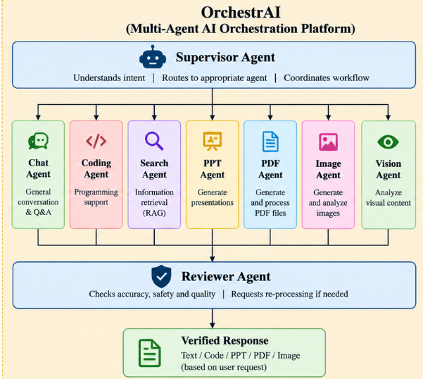
Figure 2 : Problem-Solving Approach of OrchestrAI

Table 2 maps each limitation of the single-model approach to the corresponding design decision in OrchestrAI.
Table 2: Problem to Solution Mapping
limitation of single general purpose system | orchestrai design element | expected benefit
no task specialization | seven specialized agents with dedicated prompts and tools | tasks specific behaviour and improved flexibility
lack of centralized decision making | supervisor agent for task understanding and routing | centralized and structured task execution
unverified output | reviewer agent for checking agent responses | quality control before returning the response
monolithic and difficult to modify architecture | modular architecture using microservices | agents can be modified or added independently
difficult to scale selectively | containerized services managed through docker compose | independent service deployment and scaling
model lock in | multiple llm providers, including groq, openrouter, and gemini | flexibility to select suitable models for different tasks
text only responses | ppt, pdf, and image generation agents with file storage | generation of downloadable documents and images
lack of access control and usage tracking | authentication and billing services | controlled access and credit-based usage

3. Objectives
the objectives of this project are:
- to develop a multiagent ai platform in which some agents cooperate to solve user requests
- to design a central supervisor agent that receives request or identifies a task and coordinates the workflow like a manager
- to implement specialized agents for chat, coding, search, presentation generation, pdf generation, image generation and image understanding
- to implement a reviewer agent that checks output of specialized agents for completeness
- to use langgraph for workflow orchestration including routing, review and re-processing
- to use langchain for llm and tool integration within the agents
- to support multiple llm providers (groq, openrouter and google gemini) and assign them according to agent requirements
- to provide a coding agent with some classification covering generation, review, explanation, debugging, optimization, conversion and documentation
- to develop authentication and billing services for access control and credit management
- to implement a modular microservice architecture, containerized with docker and docker compose, with redis for shared state and workflow support
- to generate pptx, pdf and png files and store them in supabase storage with signed-url based access
- to improve maintainability and extensibility through task specialization and loose coupling between components

4. Scope and Limitations
Our project covers the design and implementation of the orchestration platform and its supporting services. The quality of the generated answers depends on the external llm providers and is not claimed that of the underlying models. Large scale load testing and benchmark based accuracy evaluation are outside the scope of the current phase .

PROPOSED METHODOLOGY AND WORK
DESCRIPTION

1. Overview of the Approach
The methodology of OrchestrAI is that here we are using the supervisor and the reviewer agent to address the problem and we are making some specialized agent also for the user.
The worflow is as follows:

USER REQUEST → SUPERVISOR AGENT → SPECIALIZED AGENT → REVIEWER AGENT → SUPERVISOR AGENT → FINAL RESPONSE

2. Layers of the Architecture

2.1 Presentation layer
The frontend gives the interface through which users sign in, enter text or upload images, and view responses. For file outputs it shows a link through which the generated PPTX, PDF or PNG file can be downloaded.

2.2 API layer
The backend built with Node.js and Express.js exposes rest endpoints. It receives the request calls the authentication and billing services and forwards valid requests to the supervisor agent. It also generates signed urls for private generated files.

2.3 Orchestration layer
The supervisor agent forms the orchestration layer. It is modelled with LangGraph as a graph in which nodes represent steps and edges represent the allowed transitions. The shared state carried through the graph contains the user request, the selected agent, the agent output and the reviewer verdict.

2.4 Agent layer
Seven specialized agents perform the actual work. Each agent has its own prompt design, tools and llm configuration and exposes a uniform interface to the Supervisor Agent so that a new agent can be added without changing the others.

2.5 Quality-control layer
The reviewer agent works between the specialized agents and the Supervisor Agent. It receives the output together with the original request and returns a feedback for improvement if needed.

2.6 Infrastructure layer
Redis, supabase storage, the user database, docker and docker compose form the infrastructure layer on which the services run.

3. Step-by-Step Workflow
The processing of one request follows the steps below.
- User submits request : the user enters a text prompt (and optionally an image) in the frontend.
- Backend receives the request : the express.js api validates the input and verifies the user's identity through the authentication service. the billing service is consulted regarding the user's credits.
- Supervisor Agent analyzes the request : the request and relevant context are passed to the langgraph workflow, where the task is analyzed.
- Supervisor Agent identifies the appropriate specialized agent : the task type (for example conversation, programming, search, presentation, pdf, image generation or image analysis) is determined.
- Selected agent processes the request : the specialized agent prepares a task-specific prompt and executes its logic.
- Agent uses an LLM or tool : depending on the agent, an llm call is made to groq, openrouter or gemini, or a library is used to produce a pptx or pdf file.
- Response sent to the Reviewer Agent : the agent output and the original request are passed to the reviewer agent.
- Reviewer evaluates the response : the reviewer agent assesses whether the output is appropriate to the request and complete.
- Acceptable response returned through Supervisor Agent : if the verdict is positive, the supervisor agent accepts the result.
- Reprocessing when required : if improvement is needed, the workflow returns to the appropriate earlier stage with the reviewer feedback. the number of such iterations is bounded by a configurable limit so that the workflow always terminates.
- Final answer or file returned to the user : the supervisor agent prepares the final response and the backend sends it to the frontend.
- Generated files stored : for pptx, pdf and png outputs, the file is uploaded to the generated-files bucket in supabase storage and a signed url is provided for access.

4. Supervisor Agent
The Supervisor Agent performs three functions such as task understanding, routing and coordination. In task understanding, it determines the category of the request from the user text and from the presence of attachments. In routing it selects exactly one specialized agent from the registered set. In coordination it receives the reviewer agent verdict and either finalizes the response or triggers reprocessing. Keeping these functions in a single component means that the specialized agents do not need to know about one another. Table 3 summarizes the routing map.
Table 3: Routing Map of OrchestrAI
Request Type | Specialized Agent | LLM Provider | Model Used | Output
General questions or conversation | chat agent | groq | openai/gpt-oss-120b | natural-language text
Programming problems | coding agent | groq | openai/gpt-oss-120b | code and explanation
Information search | search agent | groq | openai/gpt-oss-120b | answer with retrieved information
Code review | reviewer agent | groq | openai/gpt-oss-120b | review suggestions
Presentation generation | ppt agent | groq (default) | openai/gpt-oss-120b | .pptx file
PDF generation | pdf agent | groq (default) | openai/gpt-oss-120b | .pdf file
Image understanding | vision agent | groq (default) | openai/gpt-oss-120b | text description and analysis
Image analysis | image analyzer agent | google gemini | gemini-2.5-flash | image analysis
Embeddings and document search | rag system | google gemini | google generative ai embeddings | vector embeddings

5. Specialized Agents
Chat Agent : handles general conversational queries and generates natural language responses using a groq hosted model it also serves as the default destination for requests that do not match another category.
Coding Agent : handles programming requests it classifies the request into seven categories (code_generation, code_review, code_explanation, debugging, optimization, conversion, documentation) and applies a category-specific prompt strategy using a model accessed through openrouter for code generation, html, css and javascript are the default technologies unless another stack is explicitly requested.
Search Agent : Handles information seeking requests and supplies relevant information for the query using a groq hosted model for response generation.
PPT Agent : converts the user requirements into a structured slide outline (titles, bullet points) and uses a pptx generation library to create the presentation file.
PDF Agent : converts the requirement or supplied content into a formatted document and generates a pdf file.
Image Agent : generates an image from the user's prompt and saves it as a png file.
Vision Agent : accepts an image and a question or instruction, and produces an analysis using a vision capable gemini model.

6. Reviewer Agent
The Reviewer Agent is the quality control layer. It receives the original user request and the specialized agent output and checks them against criteria such as relevance to the request, completeness, and basic task specific expectations for example that a coding response actually contains code or that a file generation task produced a file. Its verdict is passed to the supervisor agent which decides whether to accept the output or to reprocess the task. The design is motivated by research showing that feedback and verification of model output can improve quality and reduce unsupported content [6], [20], [21].

7. Workflow State and Redis Support
LangGraph passes a state object between nodes. In OrchestrAI this state contains the request, identified task type, selected agent, agent output, reviewer verdict, and retry count. Redis is used for session management, conversation-memory caching, and per-agent rate limiting. It stores authenticated user sessions and temporarily caches conversation messages for 24 hours. Redis also tracks request counts with a one minute expiry to enforce agent specific limits interservice communication is handled through HTTP requests.

8. LLM Provider Assignment
OrchestrAI deliberately does not tie the platform to one model provider. The chat and search agents use groq which offers fast inference suited to interactive conversation. The coding agent uses openrouter which gives access to a range of models through one API and so allows a code oriented model to be selected. Image and vision analysis uses google gemini a multimodal model family [14] because the agents access models through langChai common interfaces [22] changing the model or provider of one agent requires a state change in that agent only.

9. File Generation and Storage
For file producing agents the output is generated as a file uploaded to the generated files bucket in supabase storage and exposed to the user through a signed url created by the backend. Signed urls provide time limited access and avoid making the bucket public [27].

10. Authentication and Billing
The authentication service identifies users through firebase Authentication. It verifies the firebase ID token using firebase admin SDK and then creates a secure session stored in redis, password hashing, JWT based sessions.
The Billing Service manages Razorpay payments, user plans, and credits. Credits are added after successful payment verification and deducted when an agent request is processed.
11. Deployment Approach
Each service is packaged as a docker container which defines the set of services, their state and their network. This gives a reproducible environment in which the whole platform can be started with a single command and in which each service can be rebuilt or replaced independently [24], [25].

12. Design Principles
- single responsibility: each agent performs one kind of task.
- loose coupling: services communicate through defined interfaces (rest and graph state), not through shared internals.
- provider independence: llm provider is a per-agent configuration.
- bounded iteration: review loops have a retry limit.
- least exposure: generated files are private and shared only through time-limited signed urls.
- extensibility: a new agent is added by registering it with the supervisor agent and the review step.

Proposed Algorithms

This section describes the principal algorithms used in OrchestrAI. The algorithms are presented as implementation oriented pseudocode based on the system workflow.Exact routing rules and retry limits should be kept consistent with the running implementation.

1. OrchestrAI Workflow
Algorithm 1: complete workflow of our website
input: user request, optional image, user token, session id
output: final response or generated file url
- receive and validate the request through the express api.
- authenticate the user and verify plan limits and available credits.
- initialize the workflow state and send the request to the supervisor.
- identify the task and select the appropriate agent using the routing map.
- execute the task using the configured llm or generation tool.
- store the result and send it to the reviewer agent for evaluation.
- if rejected, retry with reviewer feedback until accepted or the retry limit is reached.
- if a file is generated, upload it to supabase storage and obtain a signed url.
- return the final response or file url to the frontend.
- update the session cache in redis and return the result.

2. Reviewer Feedback and Bounded Retry Algorithm
Algorithm 2: Reviewer Agent algorithm
input: user request, agent output, retry count
output: review status, reviewed output, reviewer feedback
- compare the agent's output with the original request.
- check whether the response is relevant and complete.
- verify that the basic requirements of the task are satisfied.
- if the output is correct, mark it as accept and return it.
- otherwise, mark it as revise and provide feedback.
- send the feedback to the supervisor agent for further action.
- if retries are exhausted, return the best available output with its review status.
- return the review status, output, and feedback.

Proposed Flowchart / Block Diagram / DFD

1. Data Flow Diagram
Figure 3 shows the data exchanges among the user , backend api , supervisor agent , specialized agent , reviewer agent , llm providers and the supporting tools.

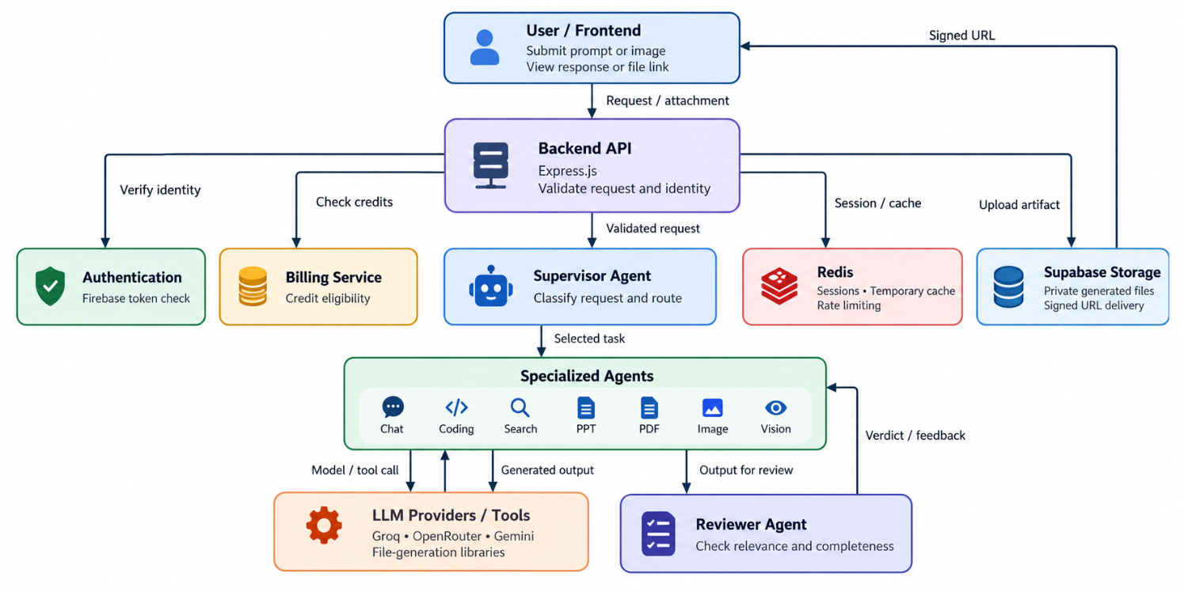
Figure 3 : OrchestrAI Data Flow Diagram
Figure 3 explanation: the user sends a request through the frontend to the express backend. The backend validates the request and checks authentication and credit eligibility. The supervisor agent identifies the task and routes it to a specialized agent. The selected agent may call its configured llm provider or a file generation tools. Its result is passed to the reviewer agent. The feedback returns to the supervisor agent which accepts the result or routes feedback for a bounded retry. Generated files are uploaded to supabase storage and made available through signed urls. Redis supports sessions or temporary conversation caching.

2. Module Interaction Block Diagram
Figure 4 block diagram shows the major functional layers of OrchestrAI and the relationships between the user, backend api, orchestration workflow, specialized agents, review layer, and supporting infrastructure services.
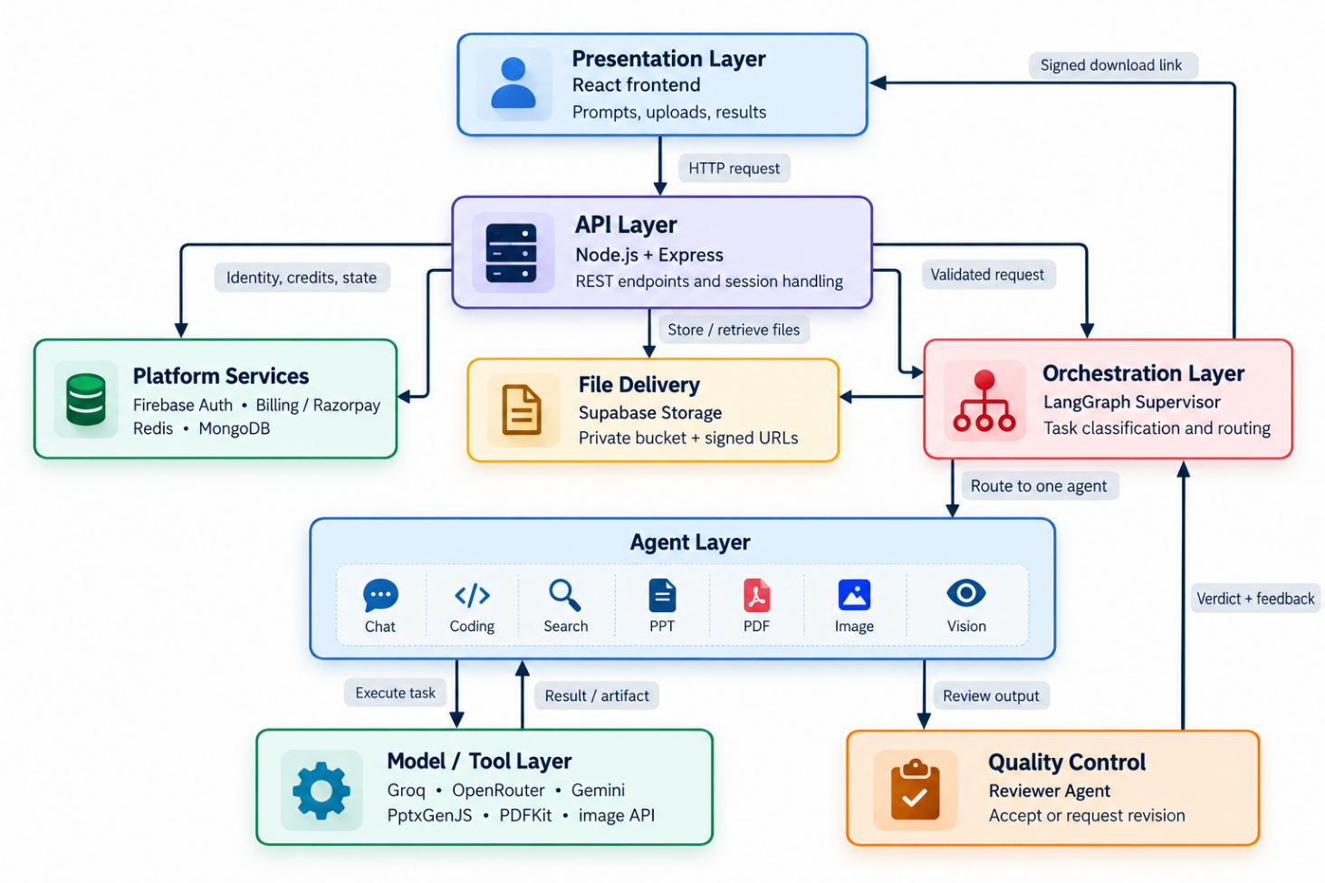
Figure 4 : OrchestrAI System Architecture and Module Interaction

Figure 4 explanation: the frontend submits requests to the express api. Authentication and billing services support access and credit checks while the supervisor agent routes the task to a specialized agent. The specialized agent may use an external llm provider or a file generation library. The reviewer agent checks the generated result.

3. Supervisor Routing and Reviewer Feedback Flowchart
Figure 5 flowchart shows how the supervisor agent selects a specialized agent and the reviewer agent checks the result and decides weather to finalize the response or perform a bounded retry.
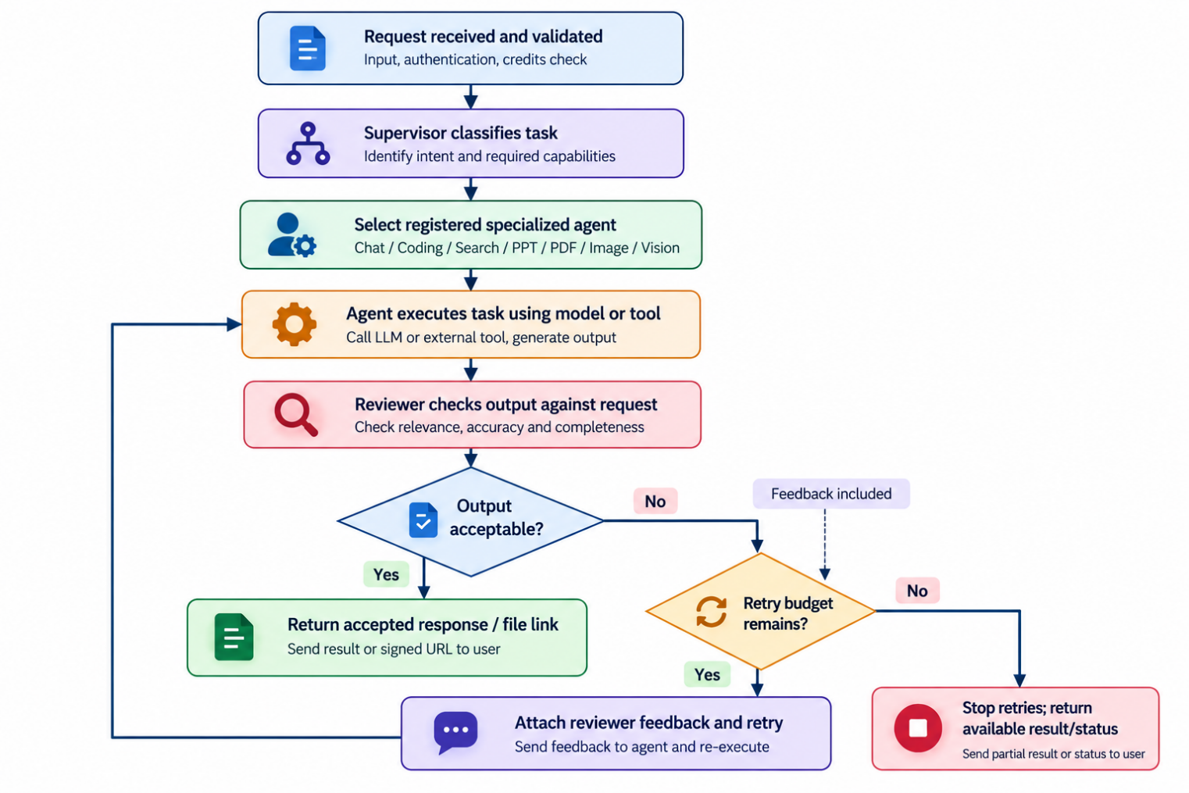
Figure 5 : Supervisor Routing and Reviewer Feedback Loop

Figure 5 explanation: after validation the request is classified and routed to one registered agent. The selected agent produces an output that is evaluated by the reviewer agent. An acceptable output proceeds to finalization. if revision is needed and retries remain feedback is returned to the processing stage otherwise the workflow terminates with the best available result or status. The bounded retry condition prevents an endless loop.

TOOLS AND TECHNOLOGY USED

OrchestraAI uses different tools and technologies to manage user requests and generate results. The tools and technologies used in orchestra ai is discussed below.The frontend provides the user interface while the backend handles the requests and connects the different services.

Langgraph manages the workflow between the supervisor and the specialized agents and l angchain helps connect them with language models and tools. Different model providers are used for tasks such as chatting, coding, searching, and image analysis ppt and pdf generation libraries help create downloadable files.

Authentication and billing services manage user access and credits. Redis is used for temporary data and session management, while supabase storage stores generated files. Docker and docker compose make it easier to run and manage the project services.

Tools and Technologies Summary
Table 4: Tools and Technologies Used in OrchestrAI
Technology | Role in OrchestrAI
React | builds a user interface for entering prompts ,uploading images and seeing the results.
Node.js | runs the backend javascript code and supporting services.
Express.js | handles api requests and connects the frontend with backend services.
LangGraph | controls the workflow between the supervisor,agents and reviewer.
LangChain | connects agents with language models and external tools.
Groq | provides language models for chat and search tasks.
Google Gemini | helps the vision agent understand uploaded images.
OpenRouter | provides models access for coding agent.
Pollinations API | generate images from user prompts.
Firebase Authentication | manages user sign in and identify tokens.
Firebase Admin SDK | verifies user tokens on the backend.
Redis | stores temporary sessions data and conversation cache information.
MongoDB | stores application data, including relevent user and transaction records.
Razorpay | handles payment orders and payment verification.
Supabase Storage | stores generated pdf,pptx and png files and provides signed links.
PDFKit | create pdf documents.
PptxGenJS | create powerpoint presentations
Axios / HTTP APIs | supports communication between backnd services.
Docker | packages application services into containers.
Docker Compose | runs and manages multiple services together.

Implementation & Coding

1. Frontend and Backend API

The fronted is where user interacts with OrchestraAI. Users can enter their prompts upload images when needed and view the results.If an agent generates a file, the frontend also provides a link to access it.

Node.js and Express.js handle requests on the backend. When a request arrives, the API checks the input and verifies the user's identity. The billing service then checks whether the user has enough credits for the requested task. Once these checks are complete, the request is forwarded to the orchestration workflow for processing.

Keeping the API and agent logic separate makes the project easier to maintain.

2. Orchestration with LangGraph and LangChain

LangGraph manages the workflow in OrchestrAI and controls how tasks are move from one step to another. Here the supervisor agent selects the appropriate agent based on the user request. After a task is completed the reviewer agent checks the result and provides feedback when any changes are needed. If the result is not satisfactory it can be sent back for another attempt depending on the retry limit. The workflow keeps track of the request, output, review status, and retry count.

LangChain is used to connect the agent with language models and other tools. It helps to manage prompts without requiring each agent to handle every providers integration separately. The model and tool provider used depend on the applications configuration. This makes it easier to change model settings when required and the results and availability may vary between providers.

3. Specialized Agents and Model Providers

OrchestrAI has different specialized agents for different tasks. The chat agent answers general questions while the coding agent is used for code generation, review, explanation, debugging, optimization, conversion, and documentation. The search agent is used to find information. The ppt agent and pdf agent make presentations and pdf documents. The image agent creates images and the vision agent scans uploaded images based on the user orders.

The supervisor agent takes decision which agent should handle each query. This keeps the tasks individual and allows each agent to use its own prompts, tools, and model settings.

The project integrates groq, openrouter, and google gemini for model related tasks. The tools used depends on the agent and the current instruction. Since these services depends on external requests may sometimes fail because of timeouts, rate limits, or usage restrictions. Such issues should be handled separately.

4. File Generation, Storage, and Delivery

The ppt agent makes content and uses PptxGenJS to generate a powerpoint presentation similarly the pdf agent prepares the document content and converts it into a pdf using PDFKit. The Image Agent sends the users prompt for image generation and processes the generated image when it is available.

When a file is created it is uploaded to supabase storage where it is kept in a private bucket. The backend then generates a signed url that allows the user to access the file for a limited time. This link is returned to the frontend for download unlike a normal text response these tasks require both successful file generation and upload before the file can be delivered to the user.

5. Authentication, Billing, and State Management

Firebase authentication is used for user sign in while the Firebase admin sdk verifies identity tokens on the backend. The billing service works with razorpay to manage payments and user credits. Before allowing a protected task the system checks the users identity and credit balance. Payment status is verified using payment information rather than depending only on the message received from the frontend.

Redis handles temporary data including session information, conversation cache, and request rate counters. It helps the system to reuse recent data and limit repeated requests. Since redis is mainly used for temporary information it does not replace permanent database storage. MongoDB is used to store application records that need to be retained. The amount of data kept in redis depends on the cache expiry and other settings configured for the deployment.

6. Containerization and Inter Service Communication

OrchestrAI is splited into separate services that communicate through HTTP requests. Docker is used to package each service along with the dependencies it needs, while docker compose helps start and manage the services together. It makes easier to run the project in a consistent environment and identify problems by checking individual service logs. However using docker does not automatically make the application highly available or scalable. These features also depend on how the application is deployed and managed.

7. Integrated Request Lifecycle

When a user sends a request it first reaches the express API where the input authentication and credit limits are checked. The supervisor agent then selects the right agent to handle the task. The selected agent processes the request using its configured model or generation tool and the result is sent to the reviewer agent for checking and giving the feedback to the supervisor.

If the result needs improvement the agent can try again using the reviewer feedback within the allowed retry limit. Once the review process ends the backend returns the final text or uploads the generated file to supabase storage and provides a signed url. Redis supports temporary session and cache data during this process.

8. Tooling Limitations and Operational Considerations

OrchestrAI relys on external APIs for model access and file storage so issues with network connectivity, API limits, or incorrect configuration can affect its working. Response time and output quality may also vary between model providers. The Reviewer Agent checks the output generated and suggests changes if needed but its review does not guarantee that every answer is always correct. For file generation the system must also confirm that the file has been created and uploaded successfully.

9. Simplified Tool and Service Interaction
Figure 6 expalins the logical interaction between the application layers.
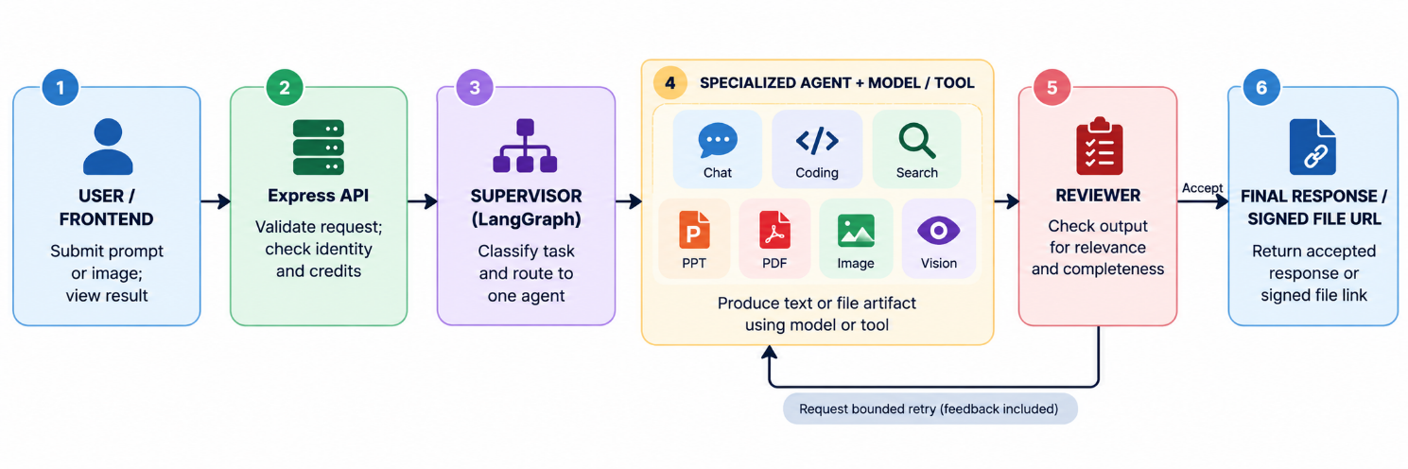
Figure 6 : Simplified Tool and Service Interaction

RESULT DISCUSSION AND ANALYSIS

- Chat Agent

User Prompt : hello , how are you
Generated Response :

Hello! I'm doing great, thanks for asking. How can I help you today?

Figure 7 shows the review report of chat agent

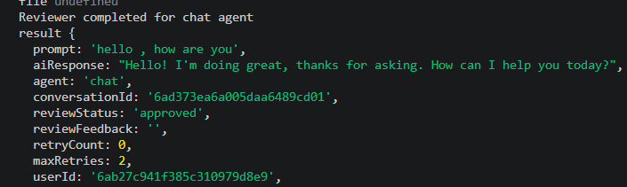
Figure 7 : Review agent report for Chat agent

- Coding Agent :

User Prompt : generate c++ code on reversing array
Generated Response :

#include <iostream>
#include <algorithm>

// Function to reverse an array in place
void reverseArray(int arr[], int size) {
int left = 0;
int right = size - 1;
while (left < right) {
std::swap(arr[left], arr[right]);
++left;
--right;
}
}

int main() {
// Example usage
int arr[] = {1, 2, 3, 4, 5, 6};
int size = sizeof(arr) / sizeof(arr[0]);

std::cout << "Original array: ";
for (int i = 0; i < size; ++i) {
std::cout << arr[i] << ' ';
}
std::cout << '\n';

reverseArray(arr, size);

std::cout << "Reversed array: ";
for (int i = 0; i < size; ++i) {
std::cout << arr[i] << ' ';
}
std::cout << '\n';

return 0;
}

Figure 8 shows the review report of chat agent

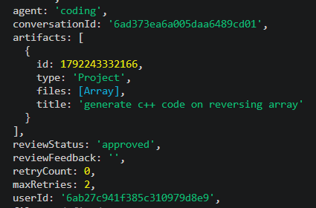
Figure 8 : Review agent report for Coding agent
- Search Agent
User Prompt : What is capital of India
Generated Response :
Figure 9 is the response generated by the search agent


Figure 9 : Output of Search Agent
- PDF Agent

User Prompt : generate pdf on machine learning
Generated Response :
Figure 10 is the response generated by the pdf agent


Figure 10 : Output of Search Agent

CONCLUSION AND FUTURE SCOPE

1. Conclusion

Our project OrchestrAI where we use supervisor agent that acts as a manager and manages the individual specialized agents and the particular specialized agent performs the task according to the user query. The specialized agents such as chat agent is used for general purpose conversation , coding agent generates the code for the coders , pdf agent generates the pdf document , ppt agent generates the ppt document , vision agent generates the image and also analyzes the image that we give to the agent , search agent is used for searching information .

Finally the reviewer will check the result generated by the specialized agent and gives the feedback to the supervisor agent.

2. Future Scope
- More specialized agents: for example data analysis, spreadsheet and email agents.
- Long term memory: persistent user and conversation memory across sessions.
- Agent to agent communication: direct collaboration between agents on complex multi-step tasks, instead of single agent routing [16], [17].
- Improved evaluation: benchmark based and llm as judge evaluation of the reviewer agent and the whole system [21].
- Observability, monitoring and logging: tracing of agent steps, latency and cost.
- Advanced security: rate limiting, prompt-injection defenses, audit logs and finer access control.
- Dynamic agent creation and improved model selection: selecting agents and models at run time according to task and cost.
- Cost optimization and horizontal scaling: caching, model tiering, and running multiple instances of busy services.
- More llm providers and better multimodal capabilities: support for audio and video input.
- Human in the loop workflows: approval or correction by the user at selected stages [23].

REFERENCES

[1] S. Russell and P. Norvig, Artificial Intelligence: A Modern Approach, 4th ed. Hoboken, NJ, USA: Pearson, 2021.
[2] A. Vaswani et al., "Attention is all you need," in Proc. Adv. Neural Inf. Process. Syst. (NeurIPS), vol. 30, 2017, pp. 5998–6008.
[3] T. B. Brown et al., "Language models are few-shot learners," in Proc. Adv. Neural Inf. Process. Syst. (NeurIPS), vol. 33, 2020, pp. 1877–1901.
[4] OpenAI, "GPT-4 technical report," arXiv:2303.08774, 2023.
[5] J. Wei et al., "Chain-of-thought prompting elicits reasoning in large language models," in Proc. Adv. Neural Inf. Process. Syst. (NeurIPS), vol. 35, 2022, pp. 24824–24837.
[6] Z. Ji et al., "Survey of hallucination in natural language generation," ACM Comput. Surv., vol. 55, no. 12, pp. 1–38, 2023.
[7] M. Wooldridge and N. R. Jennings, "Intelligent agents: Theory and practice," Knowl. Eng. Rev., vol. 10, no. 2, pp. 115–152, 1995.
[8] L. Wang et al., "A survey on large language model based autonomous agents," Front. Comput. Sci., vol. 18, no. 6, Art. no. 186345, 2024.
[9] Z. Xi et al., "The rise and potential of large language model based agents: A survey," arXiv:2309.07864, 2023.
[10] T. Guo et al., "Large language model based multi-agents: A survey of progress and challenges," arXiv:2402.01680, 2024.
[11] S. Yao et al., "ReAct: Synergizing reasoning and acting in language models," in Proc. Int. Conf. Learn. Represent. (ICLR), 2023.
[12] T. Schick et al., "Toolformer: Language models can teach themselves to use tools," in Proc. Adv. Neural Inf. Process. Syst. (NeurIPS), vol. 36, 2023.
[13] Y. Shen et al., "HuggingGPT: Solving AI tasks with ChatGPT and its friends in Hugging Face," in Proc. Adv. Neural Inf. Process. Syst. (NeurIPS), vol. 36, 2023.
[14] Gemini Team, Google, "Gemini: A family of highly capable multimodal models," arXiv:2312.11805, 2023.
[15] J. S. Park et al., "Generative agents: Interactive simulacra of human behavior," in Proc. 36th Annu. ACM Symp. User Interface Softw. Technol. (UIST), 2023, Art. no. 2, pp. 1–22.
[16] Q. Wu et al., "AutoGen: Enabling next-gen LLM applications via multi-agent conversation," arXiv:2308.08155, 2023.
[17] S. Hong et al., "MetaGPT: Meta programming for a multi-agent collaborative framework," in Proc. Int. Conf. Learn. Represent. (ICLR), 2024.
[18] P. Lewis et al., "Retrieval-augmented generation for knowledge-intensive NLP tasks," in Proc. Adv. Neural Inf. Process. Syst. (NeurIPS), vol. 33, 2020, pp. 9459–9474.
[19] M. Chen et al., "Evaluating large language models trained on code," arXiv:2107.03374, 2021.
[20] A. Madaan et al., "Self-Refine: Iterative refinement with self-feedback," in Proc. Adv. Neural Inf. Process. Syst. (NeurIPS), vol. 36, 2023.
[21] L. Zheng et al., "Judging LLM-as-a-judge with MT-Bench and Chatbot Arena," in Proc. Adv. Neural Inf. Process. Syst. (NeurIPS) Datasets Benchmarks Track, vol. 36, 2023.
[22] LangChain, "LangChain documentation." [Online]. Available: https://docs.langchain.
[23] LangChain, "LangGraph documentation." [Online]. Available: https://langchain-ai.github.io/langgraph/
[24] N. Dragoni et al., "Microservices: Yesterday, today, and tomorrow," in Present and Ulterior Software Engineering, M. Mazzara and B. Meyer, Eds. Cham, Switzerland: Springer, 2017, pp. 195–216.
[25] D. Merkel, "Docker: Lightweight Linux containers for consistent development and deployment," Linux J., vol. 2014, no. 239, Art. no. 2, 2014.
[26] R. T. Fielding, "Architectural styles and the design of network-based software architectures," Ph.D. dissertation, Dept. Inf. Comput. Sci., Univ. California, Irvine, CA, USA, 2000.
[27] Supabase,"Supabase documentation: Available: https://supabase.com/docs/guides/storage
[28] Redis, "Redis documentation." [Online]. Available: https://redis.io/docs/
[29] Groq, "GroqCloud documentation." [Online]. Available: https://console.groq.com/docs
[30] OpenRouter, "OpenRouter documentation." [Online]. Available: https://openrouter.ai/docs

PLAG REPORT (Through Turnitin)
Similarity Plagiarism Report

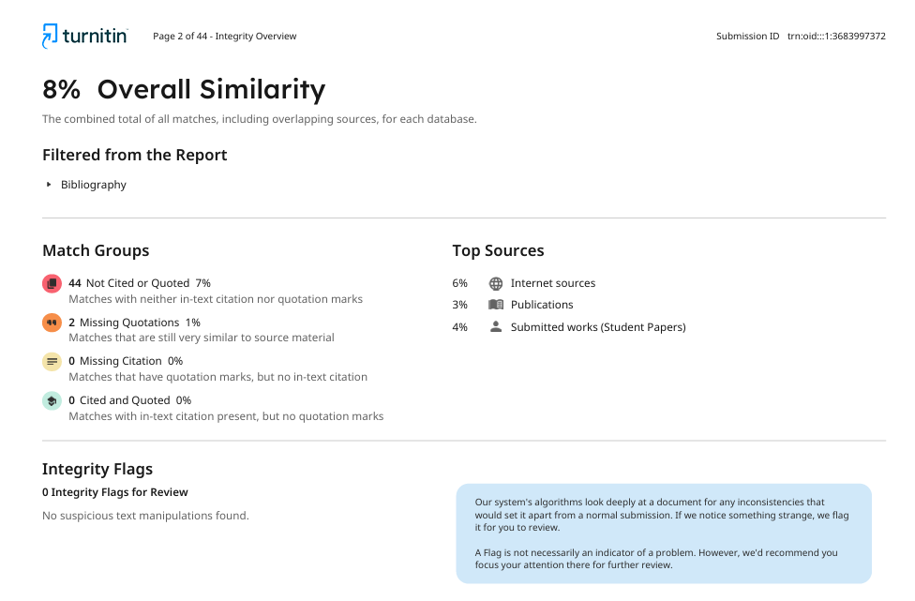

AI Plagiarism Report



