BMW Sales Dashboard
EDA Report
Power BI Project Documentation

1. Project Overview
This report documents the Exploratory Data Analysis (EDA) dashboard created in Microsoft Power BI for BMW sales/customer data. The Power BI report uses the Clean_BMW table and presents interactive customer and sales analysis through KPI cards, slicers and multiple charts.
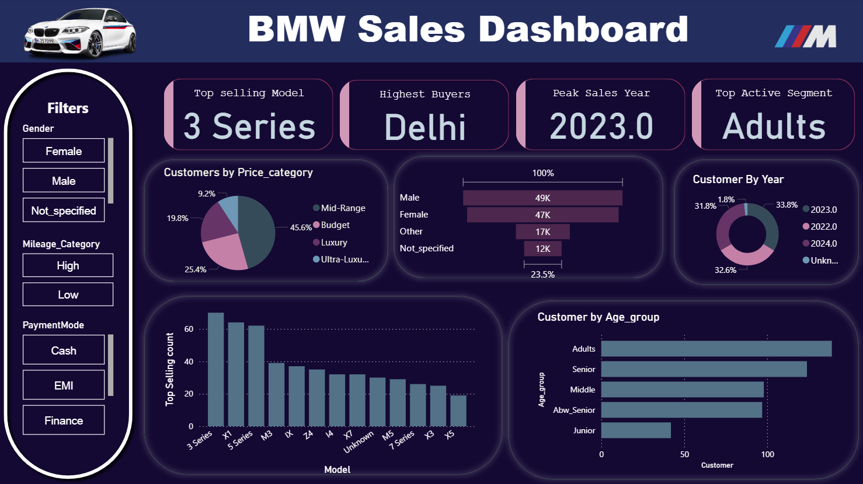

2. Project Objectives
- Explore customer distribution across BMW models.
- Analyze demographic patterns such as gender and age group.
- Study customer distribution by mileage category.
- Analyze payment-mode usage.
- Examine price-category distribution.
- Analyze customer distribution by sale year.
- Use interactive filters to investigate combinations of dimensions.

3. Dataset / Data Model
The Power BI report contains a primary table named Clean_BMW. The dashboard references fields including CustomerID, Model, State, Age_group, Sale_Year, Gender, Mileage_Category, PaymentMode and Price_category.

4. Dashboard Components
KPI Cards: Customer counts segmented by model, state, age group and sale year.
Gender Slicer: Allows the dashboard to be filtered by customer gender.
Mileage Category Slicer: Filters customers according to mileage category.
Payment Mode Slicer: Filters the analysis by payment method.
Price Category Pie Chart: Shows customer distribution across price categories.
BMW Model Column Chart: Compares customer counts across BMW models.
Gender Funnel: Provides a visual comparison of customer distribution by gender.
Age Group Bar Chart: Compares customer counts across age groups.
Customer by Year Donut Chart: Shows customer distribution by sale year.

5. EDA Questions
- Which BMW models have the largest customer representation?
- How is the customer base distributed across age groups?
- How is the customer base distributed by gender?
- How does customer distribution vary across mileage categories?
- Which payment modes are represented in the dataset?
- How are customers distributed across price categories?
- How does customer distribution change across sale years?
- What patterns become visible after combining multiple slicers?

6. Power BI Skills Demonstrated
- Power Query data preparation
- Data modelling
- KPI/card design
- Interactive slicers
- Categorical data visualization
- Dashboard layout and formatting
- Exploratory data analysis
- Business-focused data storytelling

7. How to Run the Project
- Open bmw_dashboard.pbix in Microsoft Power BI Desktop.
- Wait for the report to load.
- Use Gender, Mileage Category and Payment Mode slicers.
- Interact with the charts to investigate customer patterns.
- Use combinations of filters for deeper exploratory analysis.

