ELECTRONICS SALES ANALYSIS
Microsoft Excel Data Analyst Project Documentation
Data cleaning • KPI analysis • Pivot Tables • Dashboard • Business Insights

Prepared as a portfolio-style project report

1. Project Overview
This project analyzes an electronics sales dataset using Microsoft Excel. The workbook is structured into four main sheets: Raw_Data, KPI, Pivot Table, and Dashboard. The analysis focuses on sales value, order volume, quantity sold, customer ratings, delivery performance, product categories, states, payment methods, and order status.

2. Project Objective
- Prepare and validate the sales dataset for analysis.
- Create summary KPIs that give a quick view of overall business performance.
- Use Pivot Tables to analyze sales across products, states, payment modes, order status, and customer gender.
- Build an Excel dashboard to present the analysis visually.
- Identify useful business patterns and data-quality issues from the available records.

3. Dataset Description
The Raw_Data sheet contains 5,017 transaction rows and 14 columns. The main fields describe the order, product, customer, payment, rating, warranty, and order status.
Field Group | Examples | Purpose
Order | Order ID, Order Status | Identify and track transactions
Product | Device Name, Category, Company | Analyze product/category performance
Sales | Price, Quantity | Measure sales value and volume
Customer | State, Gender, Age, Rating | Understand customer patterns
Payment | Payment Mode | Analyze payment preferences
Service | Warranty | Review warranty information

4. Data Cleaning & Quality Checks
The workbook contains a dedicated Raw_Data sheet and uses the cleaned dataset as the source for the KPI and Pivot Table analysis. A validation check of the supplied file identified the following data-quality points:
- 1,270 rating values are blank.
- There are 17 repeated Order ID values among 5,017 rows, while the Order ID field contains 5,000 unique IDs.
- Several categorical fields contain placeholder values such as 'Unknown'.
- Some labels have inconsistent spacing/capitalization, for example category and payment labels with leading/trailing spaces or different case.
- The dataset contains 5,017 data rows, whereas the workbook's Total Orders KPI displays 5,018 because its COUNTA formula includes the header cell.
These checks are important because inconsistent labels or duplicated identifiers can affect Pivot Table totals and business conclusions. For a production analysis, categorical values should be standardized and the definition of an order should be clearly established.

5. Excel Analysis Workflow
- Raw_Data: source transaction-level dataset.
- KPI: formula-based summary metrics.
- Pivot Table: grouped analysis across major business dimensions.
- Dashboard: visual presentation of KPIs and Pivot Table results.
- Filters/slicers are used in the workbook to make the dashboard interactive.

6. Key Performance Indicators
KPI | Workbook Value | Calculation Used
Total Revenue | 95,950,267 | SUM of Raw_Data Price
Total Orders | 5,018 | COUNTA of Raw_Data Order ID
Total Quantity Sold | 8,615 | SUM of Quantity
Average Order Value | 19,125.03 | AVERAGE of Price
Average Rating | 3 | AVERAGE of Rating, rounded to 0
Delivery Rate | 43.6% | Delivered orders / COUNTA of Order Status
Note: The workbook labels the Price average as 'Average Order Value' and the Price sum as 'Total Revenue'. These are documented here exactly as implemented in the workbook rather than redefining the project's measures.

7. Pivot Table Analysis
The Pivot Table sheet summarizes the dataset across several dimensions. Key observations from the supplied workbook include:
- Laptop has the largest summed Price value among the standardized product labels visible in the Pivot Table.
- Camera and TV are also major contributors to the summed Price value.
- Kerala has the highest state-level summed Price value among the states shown in the Pivot Table.
- Credit Card and Cash are the two most frequent payment modes in the supplied records.
- Delivered is the most frequent order-status category, followed by Unknown, Returned, Pending, and Cancelled.
- Male customers form the largest gender group in the current dataset, followed by Female, Other, and Unknown.

8. Dashboard
The Dashboard sheet brings the analysis together into a visual summary. It contains KPI cards and charts designed to provide a quick overview of the sales dataset.
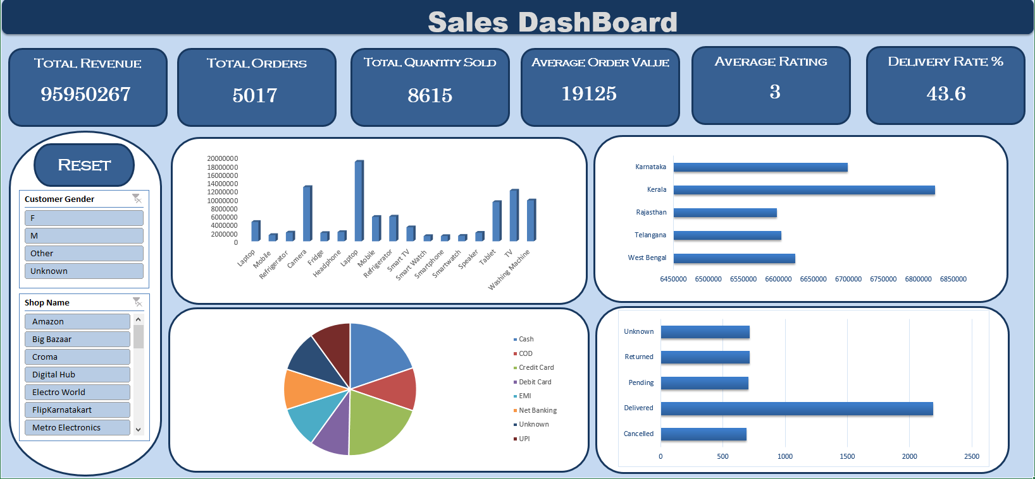
Figure 1. Dashboard preview from the submitted Excel workbook.

9. Excel Formulas Used
Metric | Formula
Total Revenue | =SUM(Raw_Data!E:E)
Total Orders | =COUNTA(Raw_Data!A:A)
Total Quantity Sold | =SUM(Raw_Data!F:F)
Average Order Value | =ROUND(AVERAGE(Raw_Data!E:E),2)
Average Rating | =ROUND(AVERAGE(Raw_Data!L:L),0)
Delivery Rate % | =ROUND(COUNTIF(Raw_Data!N:N,"Delivered")/COUNTA(Raw_Data!N:N)*100,1)

10. Key Business Insights
- The workbook reports a total Price value of 95.95 million across the analyzed records.
- The dataset contains 8,615 units in the Quantity field, indicating that some orders contain more than one unit.
- The delivered status accounts for approximately 43.6% of the records according to the workbook's delivery-rate calculation.
- Laptop is the strongest product category by summed Price in the current Pivot Table, while Camera and TV are also significant contributors.
- Payment behavior is concentrated around Credit Card and Cash, which together represent 1,998 records in the current data.
- The presence of Unknown, blank ratings, repeated Order IDs, and inconsistent labels should be considered before using the analysis for operational decision-making.

11. Conclusion
This Excel project demonstrates a complete beginner-to-intermediate data-analysis workflow: working with transaction data, validating data quality, calculating KPIs, summarizing data with Pivot Tables, and presenting results through an interactive dashboard. The project also highlights why data validation is an important part of the analyst's role: KPI definitions, duplicate identifiers, missing values, and inconsistent category labels can materially affect results.

12. Skills Demonstrated
- Microsoft Excel
- Data cleaning and validation
- Excel formulas and functions
- Pivot Tables
- KPI creation
- Data visualization and dashboard design
- Business-oriented data interpretation
- Data-quality checking

End of Project Documentation

