**Assignment 2 (VBA) , Screen Shots of Multi Year Stock Data (Solved)**

**Year 2106:**

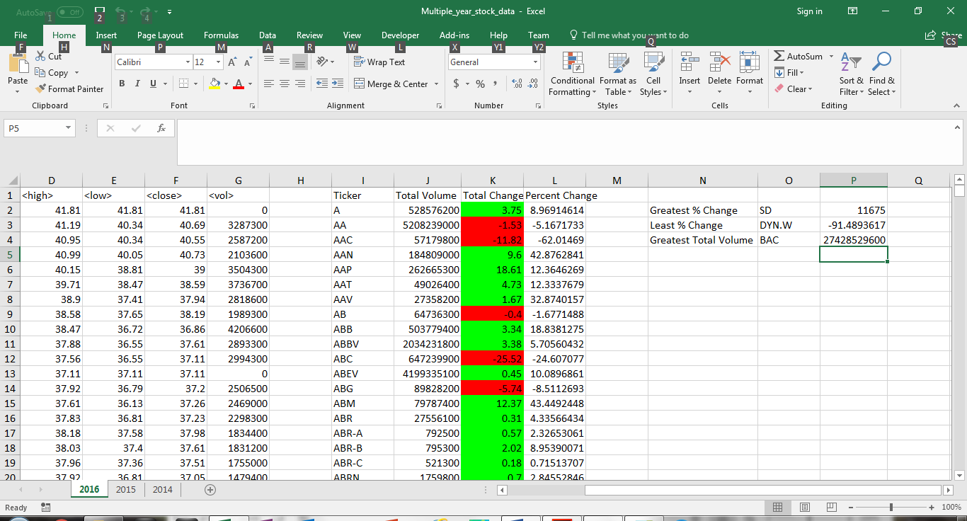

**Year 2015:**

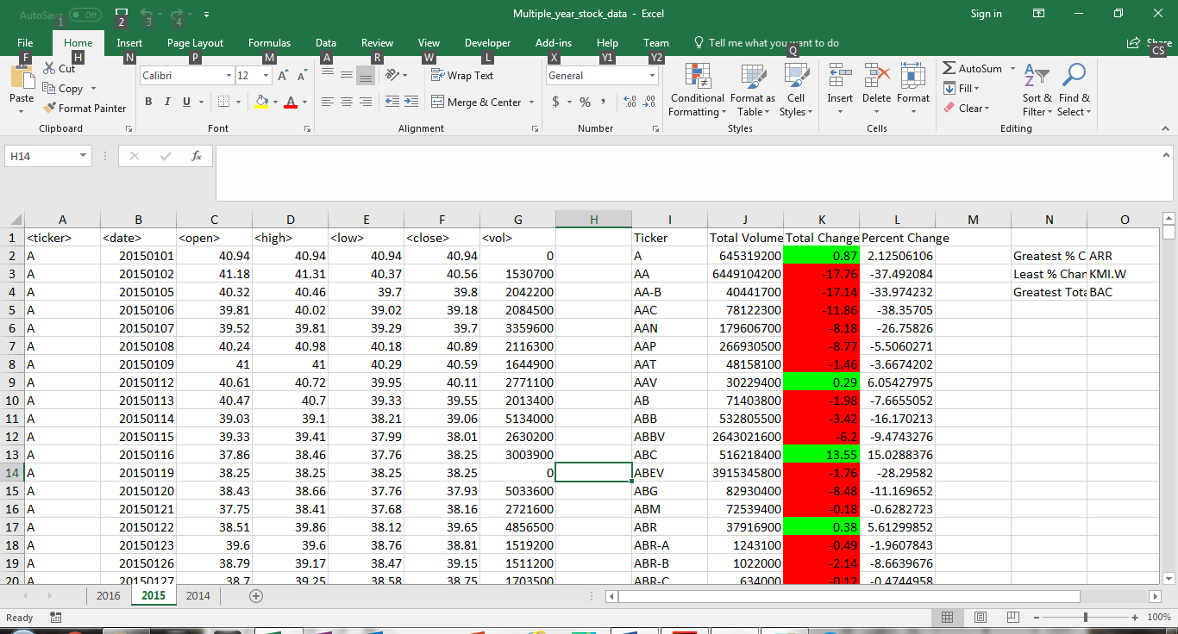

**Year 2014:**

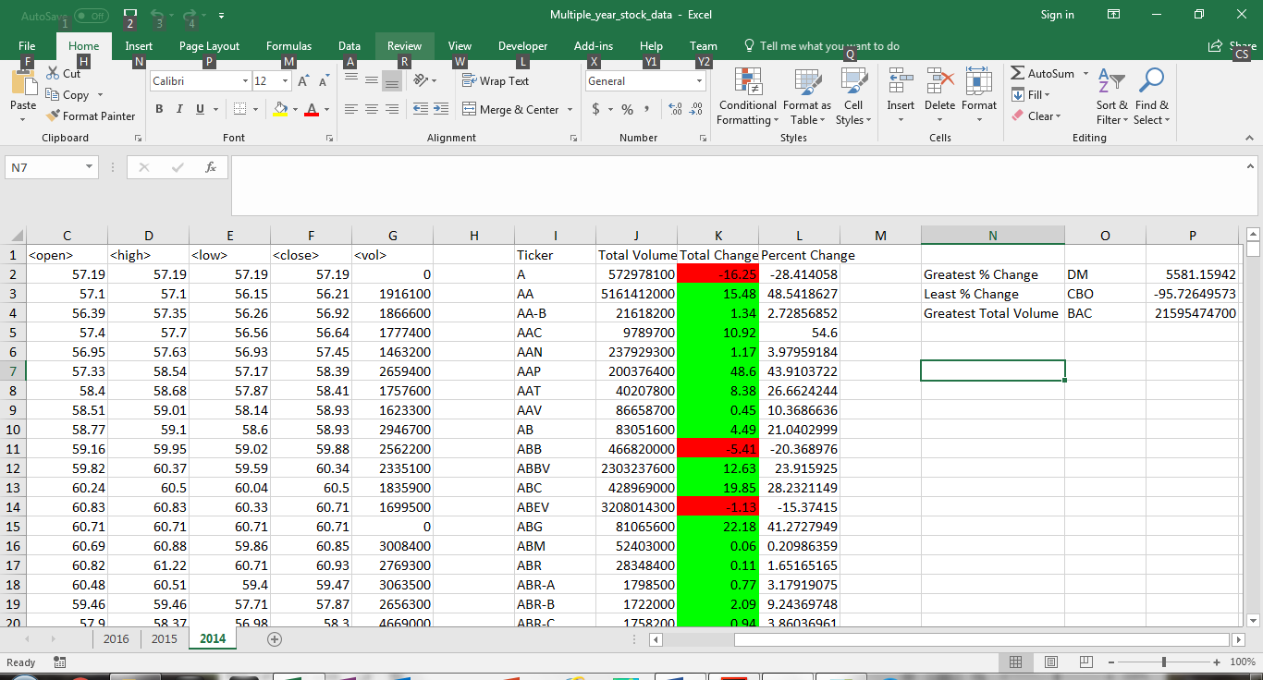

**How I verified My Results.**

**I created a PIVOT table (ticker/sigma for volume) for each of the years to verify in my sums match the pivot table.**

**e.g. 2014:**

