ANALYSIS - PROJECT “PYBER”

The main and expected outcome of the analysis of the Pyber data is that business is concentrated in the Urban areas followed by Suburban and then Rural. The analysis is supported by multiple data plots and different aggregation techniques.

Bubble Plot: The scatter plot shows the gold colored bubbles representing Urban cities as having the highest number of rides. Also the number of drivers in the Urban areas is the highest, represented by the size of the gold bubbles.

Next is the suburban data represented by blue bubbles followed by Rural in coral.

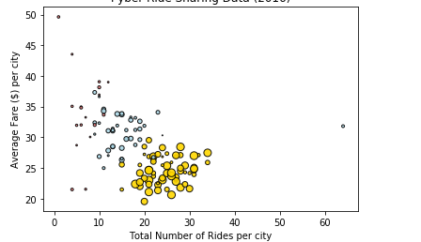

Each of the Pie Charts

* % of Total Rides per City Type
* % of Total Fares per City Type
* % of Total Drivers per City Type

tell the same story.

# Highest numbers are in the Urban, Suburban followed by Rural.

