Docker Notes

Docker is used to build deploy and run containers for software applications

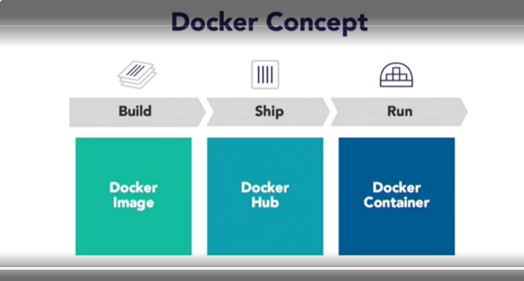

Docker is an application delivery technology. It gives you the ability to build an application using Docker image, ship an application using Docker Hub, or registry is another term for shipping, and then finally, be able to run the application as a Docker container, potentially on multiple hosts so that there is no single point of failure and even multiple instances of a container just to avoid a single point of failure as well.

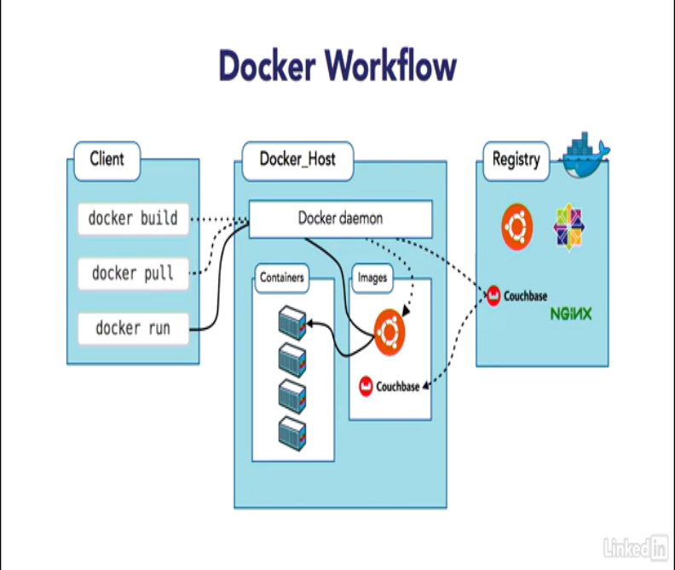

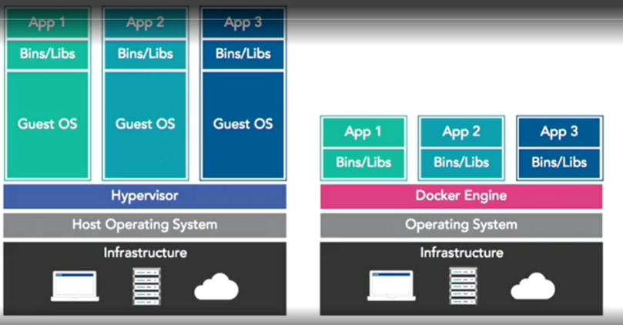

Docker- Package once Deploy Anywhere.

Docker ToolBox:

* Docker Engine
* Docker Machine- Creates VM for us (internal Virtual Box)
* Docker Compose- helps in running multi-container app easily
* Docker Kitematic- Allows to manage VMs
* VirtualBox
* QuickStart Terminal

docker info : gives info about docker

docker version : gives info about docker client and server info

docker –help: gives commands

docker image ls: list images

docker container ls: list containers

Run container (interactive mode): docker container run -it jboss/wildfly

Run container (detached mode): docker container run -d jboss/wildfly

Stop container: docker container stop -it jboss/wildfly

Delete container: docker container rm -it jboss/wildfly

Rename container: docker container –name web jboss/wildfly

----------------------------------------------------------------------------------------------------------------------------

Assigning random default port to the container:

* docker container -d –name web -P jboss/wildfly
* docker container ls
* docker container logs

----------------------------------------------------------------------------------------------------------------------------

Assigning specific port to the container:

* docker container -d –name web -p 8080:8080 jboss/wildfly

----------------------------------------------------------------------------------------------------------------------------

Deploying war file to the server by attaching volume to the container

* docker container run -d –name web -p 8080:8080 -v ‘pwd/webapp.war’:/opt/jboss/wildfly/standalone/deployments/webapp.war jboss/wildfly

----------------------------------------------------------------------------------------------------------------------------

----------------------------------------------------------------------------------------------------------------------------

----------------------------------------------------------------------------------------------------------------------------

----------------------------------------------------------------------------------------------------------------------------

----------------------------------------------------------------------------------------------------------------------------

----------------------------------------------------------------------------------------------------------------------------

----------------------------------------------------------------------------------------------------------------------------

----------------------------------------------------------------------------------------------------------------------------

----------------------------------------------------------------------------------------------------------------------------

----------------------------------------------------------------------------------------------------------------------------

----------------------------------------------------------------------------------------------------------------------------

----------------------------------------------------------------------------------------------------------------------------

----------------------------------------------------------------------------------------------------------------------------

----------------------------------------------------------------------------------------------------------------------------

----------------------------------------------------------------------------------------------------------------------------

----------------------------------------------------------------------------------------------------------------------------

----------------------------------------------------------------------------------------------------------------------------

----------------------------------------------------------------------------------------------------------------------------

----------------------------------------------------------------------------------------------------------------------------

----------------------------------------------------------------------------------------------------------------------------

----------------------------------------------------------------------------------------------------------------------------

----------------------------------------------------------------------------------------------------------------------------

----------------------------------------------------------------------------------------------------------------------------

----------------------------------------------------------------------------------------------------------------------------

----------------------------------------------------------------------------------------------------------------------------