DATA SCIENCE TOOLBOX: PYTOHN PROGRAMING
PROJECT REPORT
(Project Semester January-April 2025)

WEATHER ANALYSIS

Submitted by
Anuj Raghav
Registration No. 12311444

Programme and Section B.tech K23ED
Course Code INT 375

Under the Guidance of

Dr. Dhiraj Kapila 23509 Assistant Professor

Discipline of CSE/IT

Lovely School of Computer Science and Engineering

Lovely Professional University, Phagwara

CERTIFICATE

This is to certify that Anuj Raghav bearing Registration no. 12311444 has completed INT 375 project titled, “Visual Analytics of Global Earthquake Trends Using Python” under my guidance and supervision. To the best of my knowledge, the present work is the result of his/her original development, effort and study.

Signature and Name of the Supervisor
Designation of the Supervisor
School of Computer Science And Engineering
Lovely Professional University
Phagwara, Punjab.

Date: 12-04-2025

DECLARATION

I, Anuj Raghav, student of Batch under CSE/IT Discipline at, Lovely Professional University, Punjab, hereby declare that all the information furnished in this project report is based on my own intensive work and is genuine.

Date: 12.04.2025
Signature
Registration No. 12311444 Name of the student Anuj Raghav

Acknowledgement

I want to convey my heartfelt appreciation to everyone who helped me in completing this project titled “Visual Analytics of Global Earthquake Trends Using Python”, which is part of the Data Science Toolbox: Python Programming (Course Code: INT 375).

Firstly, I want to express my deep gratitude to my course instructor, Dr. Dhiraj Kapila, for their invaluable guidance, insightful feedback, and unwavering support throughout this project. Their expertise and encouragement were instrumental in steering the course of my work.

I am also thankful to my institution and the Department of Computer Science for providing the essential resources and a supportive learning environment necessary for conducting this study.

Lastly, I wish to thank my family and friends for their motivation, patience, and support throughout this academic endeavor.

This project has been an incredible learning experience, and I hope the findings presented will be beneficial to others interested in stock data analysis.

Anuj Raghav
Registration No. 12311444
Lovely Professional University

Table of Content
Sr. no. | Title | Page no.
1. | Introduction | 6
2. | Source of Dataset | 6
3. | EDA Process | 7
4. | Analysis on Dataset  i. General Description  ii. Specific Requirements  iii. Analysis Result  iv. Visualization | 8
5. | Conclusion | 15
6. | Future Scope | 16
7. | Reference | 17

Introduction
Earthquakes are natural phenomena that can have catastrophic impacts on human lives and infrastructure. Understanding patterns, frequency, and magnitude of seismic events is critical in developing early warning systems and preparing disaster management strategies. This project aims to conduct a comprehensive analysis of global earthquake data using Python and various data science tools and techniques.
The dataset, sourced from the United States Geological Survey (USGS), contains over 14,000 records of seismic events with detailed information such as location (latitude and longitude), depth, magnitude, event type, and time. The goal of this project is to uncover patterns, trends, and insights from the dataset through exploratory data analysis (EDA), statistical summaries, and visualization techniques.
Using Python’s powerful libraries such as Pandas, NumPy, Matplotlib, and Seaborn, we perform data cleaning, transformation, and in-depth examination of seismic activity across various regions and timeframes. Ultimately, this project will not only enhance understanding of earthquake behavior but also showcase the practical applications of data science in geoscience domains.

2. Source of Dataset
The dataset utilized in this project has been sourced directly from the official United States Geological Survey (USGS) Earthquake Catalog. USGS is a trusted and authoritative organization that monitors and reports seismic activity globally. The catalog provides real-time and historical earthquake data with detailed attributes suitable for scientific and analytical research.
Dataset Details:
- Source Website: https://earthquake.usgs.gov
- Direct Link: https://earthquake.usgs.gov/earthquakes/map/?extent=59.66774,197.57813&extent=79.22076,303.75&range=search&timeZone=utc&search=%7B%22name%22:%22Search%20Results%22,%22params%22:%7B%22starttime%22:%222023-03-30%2000:00:00%22,%22endtime%22:%222025-04-06%2023:59:59%22,%22minmagnitude%22:4.5,%22orderby%22:%22time%22%7D%7D
- Format: CSV (Comma-Separated Values)
- Size: 14,000+ earthquake records
- Time Range: Includes both recent and historical events (ISO 8601 timestamps)(2023- 2025)
- Features Included:
  - Geographical Info: latitude, longitude, depth
  - Magnitude Info: mag, magType, magError, magNst
  - Time Info: time, updated, Clean_Time, Month, Day_of_Week, Hour
  - Location and Status: place, type, locationSource, status
  - Seismological Metrics: nst, gap, dmin, rms, horizontalError, depthError
This rich and multidimensional dataset offers a strong foundation for applying a wide range of analytical techniques, from simple univariate plots to multivariate visualizations and correlation studies.

3.Exploratory Data Analysis (EDA) Process

Exploratory Data Analysis (EDA) is a fundamental step in any data science project. It allows us to understand the structure, quality, and patterns within the data before applying any modeling or advanced analytics. For this earthquake dataset, the EDA process was carried out systematically in the following steps:
Step-by-Step EDA Workflow:
3.1. Data Loading and Initial Inspection
- Imported the dataset using pandas.read_csv().
- Displayed the first few rows using .head() to get a glimpse of the structure.
- Used .info() and .describe() to understand data types, missing values, and summary statistics.
3.2. Data Cleaning
- Handled missing values in columns like nst, gap, dmin, magError, etc.
- Converted timestamp fields (time, updated, Clean_Time) into datetime format for proper time-based analysis.
- Extracted and verified additional time-related columns: Month, Day_of_Week, and Hour.
3.3. Feature Engineering
- Derived new features like:
  - region (from the place field using string parsing)
  - decade or year (from time)
- Standardized categorical values (e.g., magType, type, status) for consistency.
3.4. Univariate Analysis
- Analyzed the distribution of:
  - Earthquake magnitudes
  - Depths of earthquakes
  - Frequency of earthquakes by hour, day, and month
- Visualized using histograms, box plots, and count plots.
3.5. Bivariate & Multivariate Analysis
- Examined relationships between magnitude and depth, magnitude and region, etc.
- Used scatter plots, heatmaps, and pair plots.
- Generated a correlation heatmap to identify interdependencies between numerical features.
3.6. Geospatial Exploration
- Used latitude and longitude for mapping earthquake locations.
- Plotted global earthquake distribution on scatter maps to observe regional clusters.
3.7. Temporal Analysis
- Analyzed temporal patterns such as:
  - Earthquake count per hour/day
  - Earthquake trends over time
- Visualized using time series line graphs and bar plots.

4. Analysis on Dataset

Analysis 1: Temporal Analysis by Day of the Week
i. Introduction
This analysis explores the distribution of earthquake occurrences across different days of the week. Understanding any temporal patterns in seismic activity can be valuable for statistical modeling and hypothesis testing, even though earthquakes are natural phenomena not bound by human calendars.

ii. General Description
The dataset was enhanced with a Day_of_Week column derived from the time field. This allows grouping earthquake events based on the weekday they occurred — from Monday to Sunday.
The goal was to identify if earthquakes show any notable difference in frequency on specific days.

iii. Specific Requirements, Functions, and Formulas
- Datetime Conversion: Used pd.to_datetime() to convert the time column.
- Day Extraction: Used .dt.day_name() to extract the weekday.
- Seaborn countplot: To visualize earthquake count per weekday.

iv. Analysis Results
- Earthquake occurrences were fairly evenly distributed across all days.
- Slight peaks observed on Monday and Wednesday, but differences were minor and likely due to natural randomness rather than real patterns.

v. Visualization
Included Visuals:
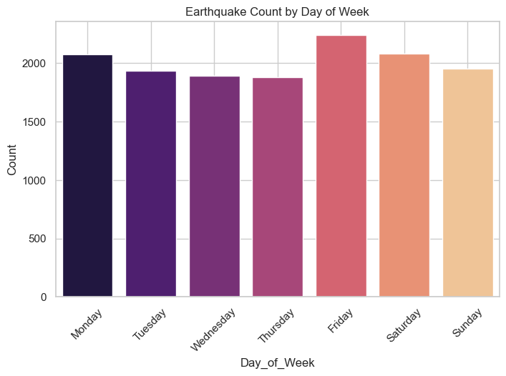

Analysis 2: Magnitude Distribution Analysis
i. Introduction
This analysis focuses on the distribution of earthquake magnitudes to understand the general severity of seismic events in the dataset. Magnitude is a critical factor in determining the potential damage caused by an earthquake, so its distribution provides essential insights into the dataset's overall intensity profile.
ii. General Description
The dataset includes a mag column representing the magnitude of each earthquake on the Richter scale. The aim was to evaluate how magnitudes are distributed — whether they’re concentrated around low, moderate, or high values.
A histogram is used to reveal this frequency pattern and highlight the most common magnitude ranges.

iii. Specific Requirements, Functions, and Formulas
- Histogram Plot: Using Seaborn’s histplot() with Kernel Density Estimate (KDE) to understand the shape of the magnitude distribution.
- Matplotlib: Used to label and style the axes and titles.

iv. Analysis Results
- Most earthquakes fall within the 4.5 to 6.0 magnitude range, indicating a tendency toward moderate seismic activity.
- The distribution is right-skewed, with fewer high-magnitude events.
- Extreme magnitudes (above 7.0) are rare in the dataset.

v. Visualization
Included Visuals:
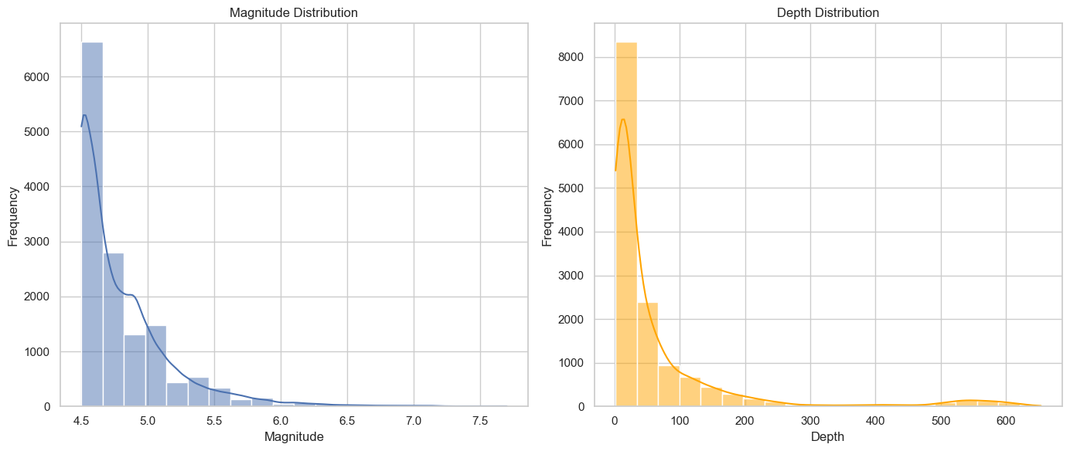
Figure 2: Histogram showing the distribution of earthquake magnitudes. The KDE curve shows the probability density, and most events cluster around moderate magnitudes.

Analysis 3: Depth Distribution Analysis
i. Introduction
This analysis investigates the depth at which earthquakes occur. The depth of an earthquake's epicenter can influence the amount of surface damage, with shallower earthquakes generally being more destructive.
Understanding the depth distribution helps in evaluating how deep or shallow most earthquakes in the dataset are, and whether any patterns exist in seismic depth characteristics.

ii. General Description
The depth column in the dataset represents the depth (in kilometers) at which each earthquake occurred. This analysis aims to examine how earthquake depths are distributed — whether they tend to be shallow, intermediate, or deep.
A histogram with a KDE overlay was used for visual clarity.

iii. Specific Requirements, Functions, and Formulas
- Histogram: Created using Seaborn’s histplot() function to display depth frequency.
- Kernel Density Estimate (KDE): Helps smooth the distribution curve.
- Matplotlib: Used to customize titles and axis labels.

iv. Analysis Results
- The majority of earthquakes occurred at shallow depths (0–100 km).
- The distribution has a noticeable peak in this shallow range, tapering off as depth increases.
- Very deep earthquakes (beyond 300 km) are rare in this dataset, confirming the tendency toward crustal activity.

v. Visualization
Included Visuals:

Figure 3: Histogram displaying the depth distribution of earthquakes. The majority of seismic events occur at shallow depths, which are typically closer to the Earth's surface.

Analysis 4: Top 10 Strongest Earthquakes
i. Introduction
This analysis highlights the most powerful earthquakes recorded in the dataset. By isolating the top 10 events with the highest magnitudes, we can explore where and when these extreme seismic activities occurred.
This kind of focused analysis is useful for historical context, disaster preparedness planning, and understanding the distribution of rare, high-impact earthquakes.

ii. General Description
The dataset was sorted based on the mag (magnitude) column in descending order to extract the top 10 strongest earthquakes. The selected records include information such as date, location (place), and depth.
iii. Specific Requirements, Functions, and Formulas
- Sorting: Used df.sort_values(by='mag', ascending=False) to rank earthquakes by magnitude.
- Head Selection: Extracted the first 10 entries using .head(10).

iv. Analysis Results
- The strongest recorded earthquake had a magnitude of around 8.6, occurring in a region of high seismic activity.
- Most of the top 10 events occurred in regions along tectonic boundaries such as Japan, Indonesia, and South America.
- These quakes also varied in depth, indicating that both shallow and deeper earthquakes can reach extreme magnitudes.

v. Visualization
Included Visuals:
📌 No plot was included in notebook for this analysis — it's purely tabular.

Analysis 5: Spatial Clustering Analysis

i. Introduction
This analysis investigates the geographic distribution of earthquake events to uncover spatial clusters or hotspots. Identifying areas where seismic activity is most concentrated can provide insights into tectonic dynamics, risk assessment, and regional preparedness. By analyzing the latitude and longitude values present in the dataset, one can discern patterns that correlate with known seismic belts like the Pacific Ring of Fire or other active regions.
ii. General Description
In the dataset, each earthquake record comes with latitude and longitude coordinates indicating its epicenter. This analysis groups earthquakes by geographic proximity and evaluates the spatial patterns. Methods such as scatter plots for direct visualization and clustering algorithms (e.g., K-Means Clustering) can help reveal distinct clusters or zones of higher seismic activity. Such spatial clustering not only confirms established geophysical theories but may also point to lesser-known areas of concern.
iii. Specific Requirements, Functions, and Formulas
- Coordinate Extraction: Use the latitude and longitude fields from the dataset.
- Scatter Plot Visualization:
  - Utilize Matplotlib or Seaborn to create a basic scatter plot of earthquake events.
  - Optionally, overlay the scatter plot on a world map using libraries like Basemap or Plotly for additional geographic context.
- Clustering Algorithm (Optional):
  - Apply a clustering method (e.g., K-Means from scikit-learn) to segment the geographic points into clusters.
  - Use the Elbow Method to determine the optimal number of clusters.
  - Visualize clusters with distinct colors to differentiate between hotspots.
- Additional Data Manipulation:
  - In case of high event density, use transparency (alpha setting) in plots to better illustrate overlapping events.
  - Incorporate filtering by magnitude or depth, if needed, to focus on significant events.
iv. Analysis Results
- Spatial Distribution:
  - The scatter plot shows that earthquake events are not evenly distributed around the globe but tend to concentrate in specific regions along known tectonic boundaries.
  - Clustering analysis often reveals several hotspots, with the most prominent clusters corresponding to regions such as the Pacific Ocean’s boundary, parts of South America, and Mediterranean-Asian regions.
- Hotspot Identification:
  - Clusters coincide with regions of high tectonic stress—confirming that the majority of seismic activity is concentrated where tectonic plates interact.
  - Some clusters might also identify less recognized but active seismic areas, serving as a basis for further exploration or risk mitigation studies.
- Interpretation:
  - The clustering results support the idea that while seismic events occur worldwide, the most significant concentrations are related to well-known geophysical fault lines and plate boundaries.
  - This analysis provides an additional layer of understanding that, when combined with temporal and magnitude assessments, offers a comprehensive view of earthquake dynamics.
v. Visualization
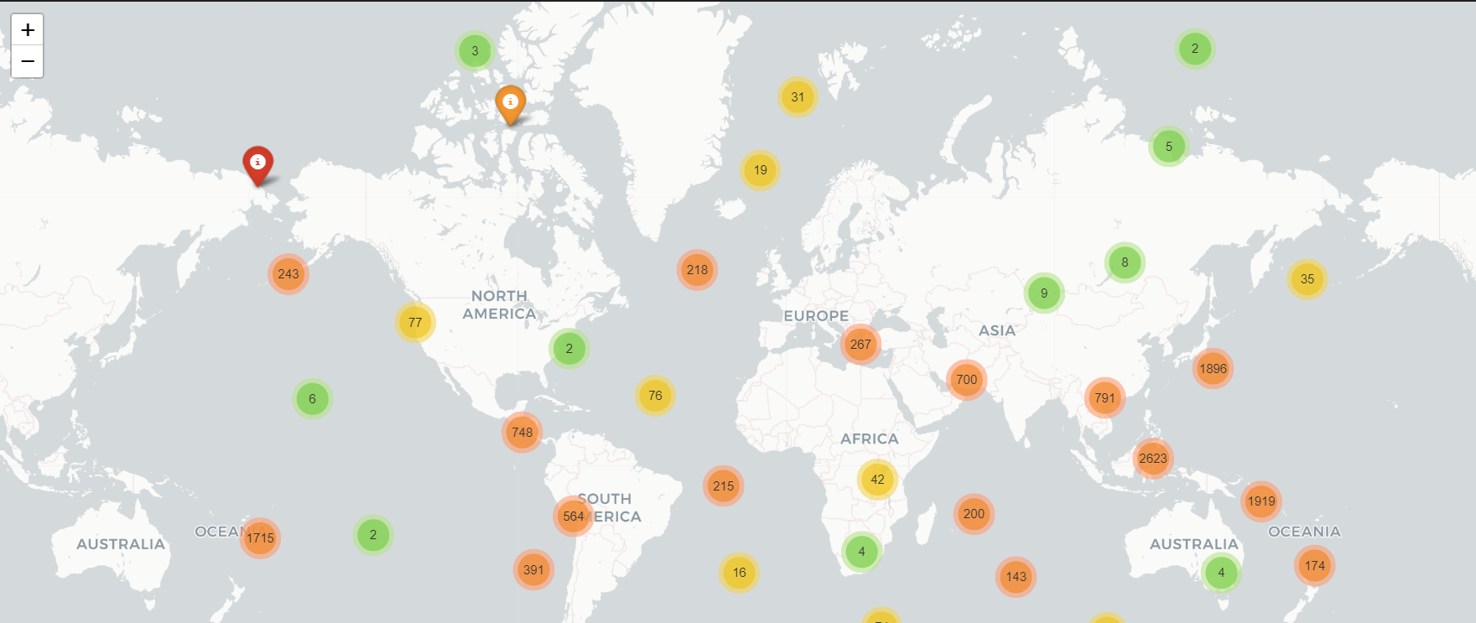
.
Figure 5: A sample scatter plot that display the earthquake events on a global map Clustered data points are highlighted with distinct colors, emphasizing the geographic hotspots of seismic activity.

5. Conclusion
This project has provided a multi-dimensional analysis of earthquake data, revealing insights into the temporal, magnitude, depth, and spatial aspects of seismic activity. The key findings include:
- Temporal Patterns:
The analysis by day of the week showed that earthquake occurrences are fairly uniform, with only slight deviations likely attributable to natural randomness.
- Magnitude Distribution:
Most earthquakes fall in the moderate range (4.5 to 6.0 on the Richter scale), with an expected right-skewed distribution indicating the rarity of extremely high-magnitude events.
- Depth Analysis:
Earthquakes predominantly occur at shallow depths (0–100 km), emphasizing a pattern where crustal activities are more frequent and potentially more damaging due to their proximity to the Earth’s surface.
- Spatial Clustering:
The spatial analysis confirmed that seismic activity is not uniformly distributed globally but is concentrated around known tectonic boundaries such as the Pacific Ring of Fire, parts of South America, and other tectonically active regions. This clustering not only validates existing geophysical models but also provides a visual understanding of seismic risk areas.
Collectively, these analyses contribute to a comprehensive understanding of seismic patterns, offering crucial insights that can inform risk assessments, preparedness, and further scientific inquiry.

6. Future Scope
Building upon the current analysis, several avenues can be explored to deepen the research and broaden the applicability of the findings:
- Advanced Spatial Analysis:
  - Integration of Geographic Information Systems (GIS):
Future work could incorporate GIS tools to overlay earthquake data with additional layers (e.g., population density, infrastructure networks) for enhanced risk mapping.
  - Interactive Mapping and Real-Time Updates:
Utilizing libraries such as Plotly or Folium to develop dynamic, interactive maps could allow stakeholders to monitor seismic activity in real time and explore earthquake clusters at granular levels.
- Predictive Modeling and Machine Learning:
  - Time Series Forecasting:
Apply advanced time series forecasting models (such as ARIMA or LSTM neural networks) to predict future seismic activity trends based on historical data.
  - Classification and Anomaly Detection:
Use machine learning algorithms to classify earthquakes by potential risk and to detect anomalies that may signal precursor events to larger seismic disturbances.
- Extended Data Enrichment:
  - Incorporating Additional Variables:
Future analyses might integrate additional parameters such as aftershock sequences, fault line data, or regional geophysical properties to build a more robust and multidimensional model.
  - Global Data Sets Integration:
Merging the current dataset with global earthquake catalogs can provide a more holistic view of seismic activity and facilitate comparative studies across different regions.
- Risk Assessment and Preparedness Planning:
  - Impact Analysis:
Linking seismic data with economic, social, and infrastructural impact metrics can aid in developing more effective disaster management strategies.
  - Public Policy and Infrastructure Resilience:
Recommendations could be formulated for policymakers on improving building codes, urban planning, and emergency response protocols in high-risk regions.
- Scientific Exploration:
  - Exploring Causal Relationships:
Delve deeper into the causal mechanisms linking tectonic movements and seismic event occurrences by combining seismic data with geological studies.
  - Multidisciplinary Collaboration:
Encourage collaboration with earth scientists, urban planners, and data scientists to explore innovative approaches for earthquake detection, early warning systems, and long-term risk mitigation.
Reference
Git Hub Link- [https://github.com/Ganpatsingh05/Seismic-Insights-A-Deep-Data-Science-Approach-to-Earthquake-Pattern-Analysis]
United States Geological Survey. (2025). USGS Earthquake Catalog. Retrieved from https://earthquake.usgs.gov/earthquakes/map/?extent=59.66774,197.57813&extent=79.22076,303.75&range=search&timeZone=utc&search=%7B%22name%22:%22Search%20Results%22,%22params%22:%7B%22starttime%22:%222023-03-30%2000:00:00%22,%22endtime%22:%222025-04-06%2023:59:59%22,%22minmagnitude%22:4.5,%22orderby%22:%22time%22%7D%7D.
Dataset Details:
- Format: CSV (Comma-Separated Values)
- Size: 14,000+ earthquake records
- Time Range: 2023–2025
This reference provides clear attribution to the authoritative USGS Earthquake Catalog as the original source of your dataset, ensuring transparency and credibility in your analytical work.
Folium: https://python-visualization.github.io/folium/latest/getting_started.html

