VachaVox UI Visual Inventory
Current appearance review for VachaVox 0.3.1.1 | Captured 2026-04-27

This report captures the current VachaVox macOS UI for future redesign planning. The Markdown artifact is the canonical source; this Word version packages the same context with readable screenshots, tables, and rendered flow diagrams.

Visual Inventory
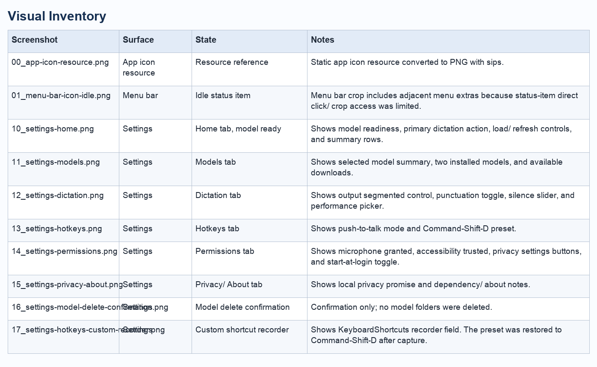
Visual inventory table

Flow Overview

App Launch And Menu Bar Lifecycle
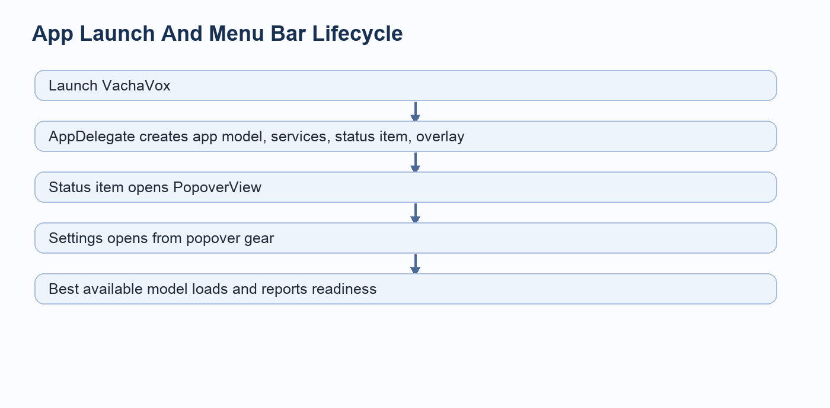
App Launch And Menu Bar Lifecycle

First-Run Permissions And Model Readiness
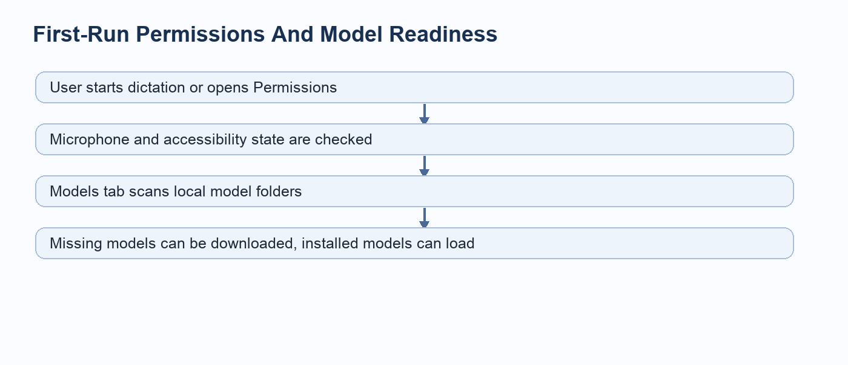
First-Run Permissions And Model Readiness

Dictation Flow
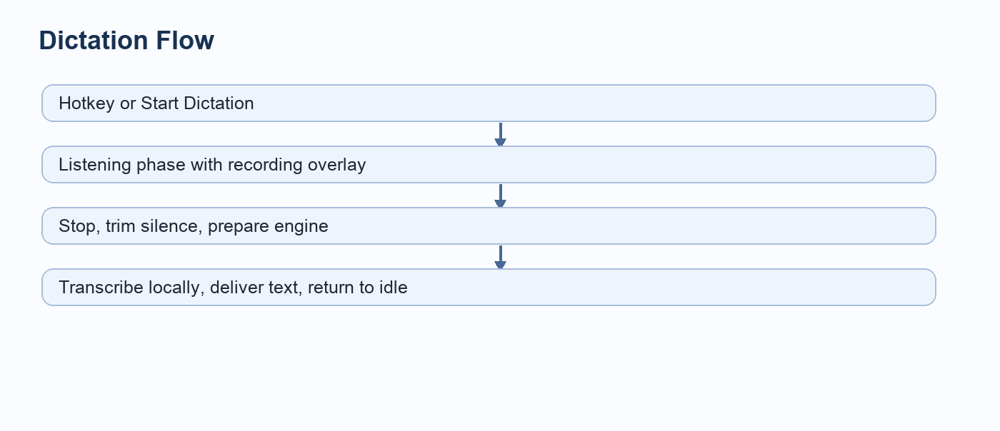
Dictation Flow

Settings Navigation Flow
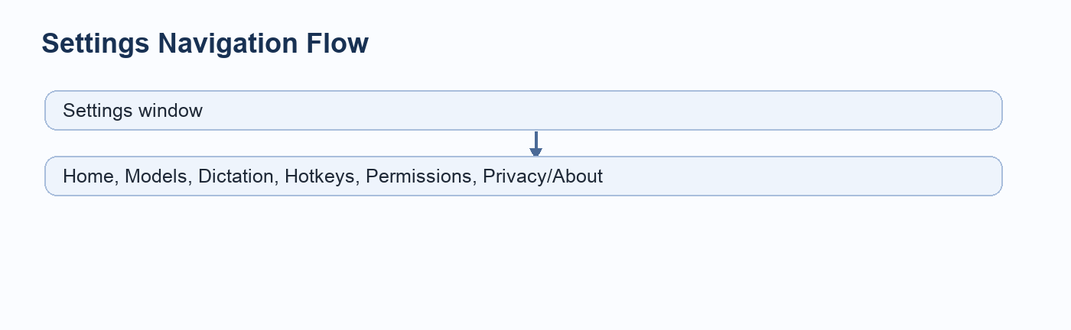
Settings Navigation Flow

Model Management Flow
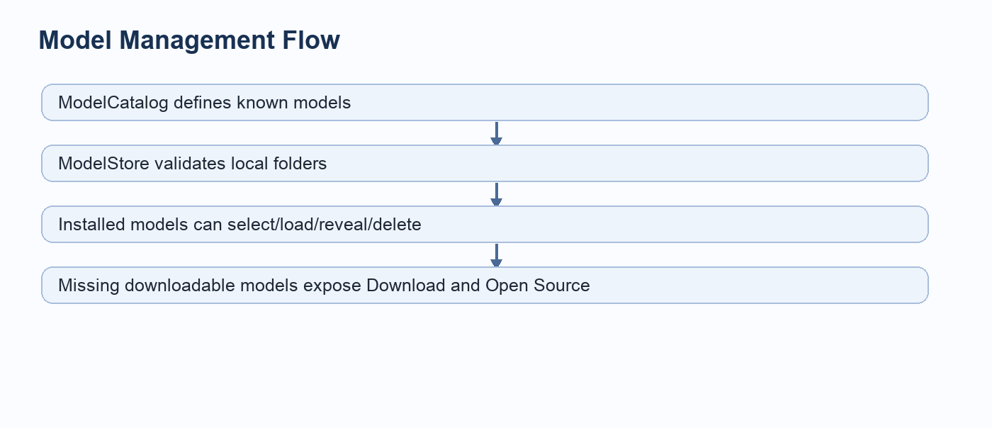
Model Management Flow

Output Delivery Flow
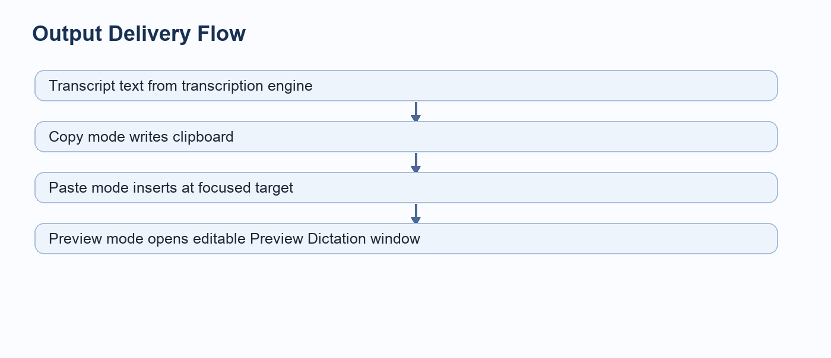
Output Delivery Flow

Per-Screen Inventory

Resource reference
Surface: App icon resource
Entry path: Converted from Sources/ChapadChapad/Resources/VachaVox.icns.
Related code: Sources/ChapadChapad/Resources/VachaVox.icns, build/VachaVox.app/Contents/Info.plist

00_app-icon-resource.png
Static app icon resource converted to PNG with sips.

Idle status item
Surface: Menu bar
Entry path: Captured from the macOS menu bar while VachaVox was running.
Related code: Sources/ChapadChapad/MenuBar/StatusItemController.swift, Sources/ChapadChapad/Resources/MenuBarIcon.png

01_menu-bar-icon-idle.png
Menu bar crop includes adjacent menu extras because status-item direct click/crop access was limited.

Home tab, model ready
Surface: Settings
Entry path: Open VachaVox Settings, select Home.
Related code: Sources/ChapadChapad/UI/SettingsView.swift, Sources/ChapadChapad/App/DictationCoordinator.swift
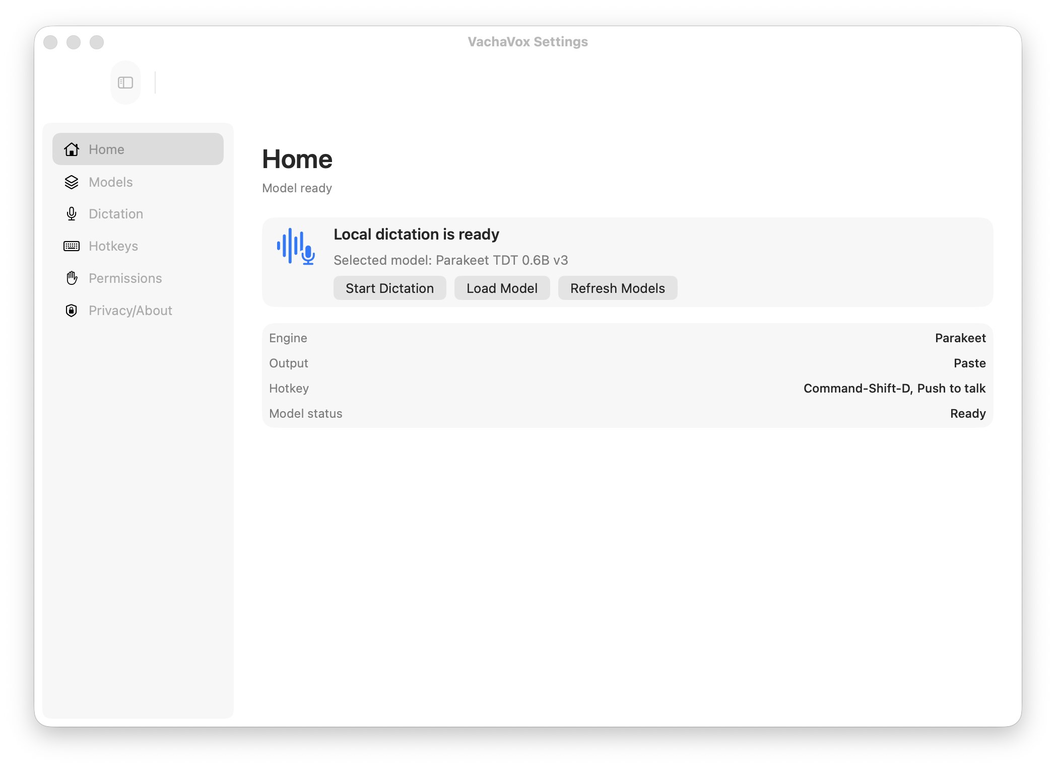
10_settings-home.png
Shows model readiness, primary dictation action, load/refresh controls, and summary rows.

Models tab
Surface: Settings
Entry path: Open VachaVox Settings, select Models.
Related code: Sources/ChapadChapad/UI/SettingsView.swift, Sources/ChapadChapad/Models/ModelCatalog.swift, Sources/ChapadChapad/Models/ModelDownloadService.swift
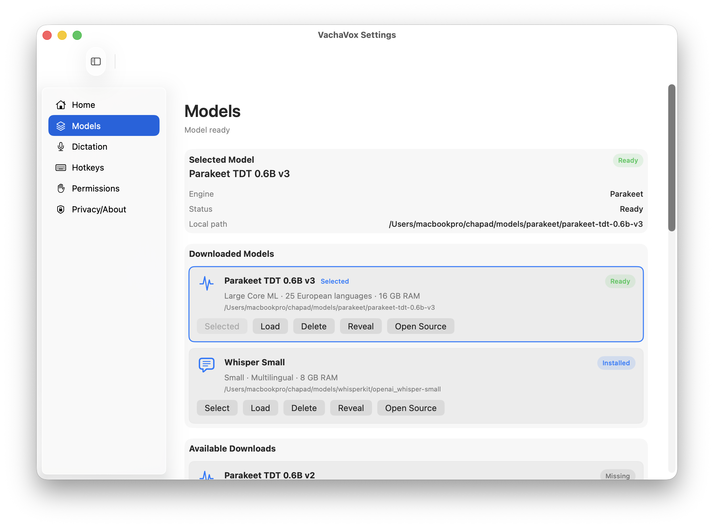
11_settings-models.png
Shows selected model summary, two installed models, and available downloads.

Dictation tab
Surface: Settings
Entry path: Open VachaVox Settings, select Dictation.
Related code: Sources/ChapadChapad/UI/SettingsView.swift, Sources/ChapadChapad/Settings/AppSettings.swift
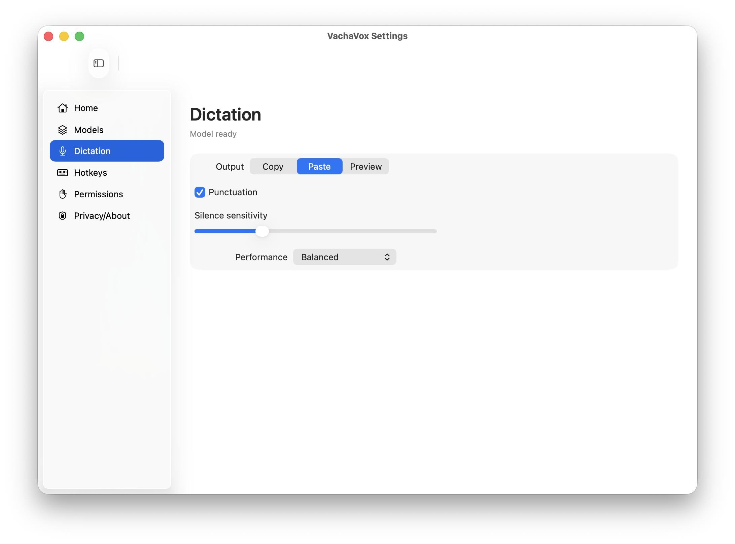
12_settings-dictation.png
Shows output segmented control, punctuation toggle, silence slider, and performance picker.

Hotkeys tab
Surface: Settings
Entry path: Open VachaVox Settings, select Hotkeys.
Related code: Sources/ChapadChapad/UI/SettingsView.swift, Sources/ChapadChapad/MenuBar/HotKeyService.swift, Sources/ChapadChapad/Settings/AppSettings.swift
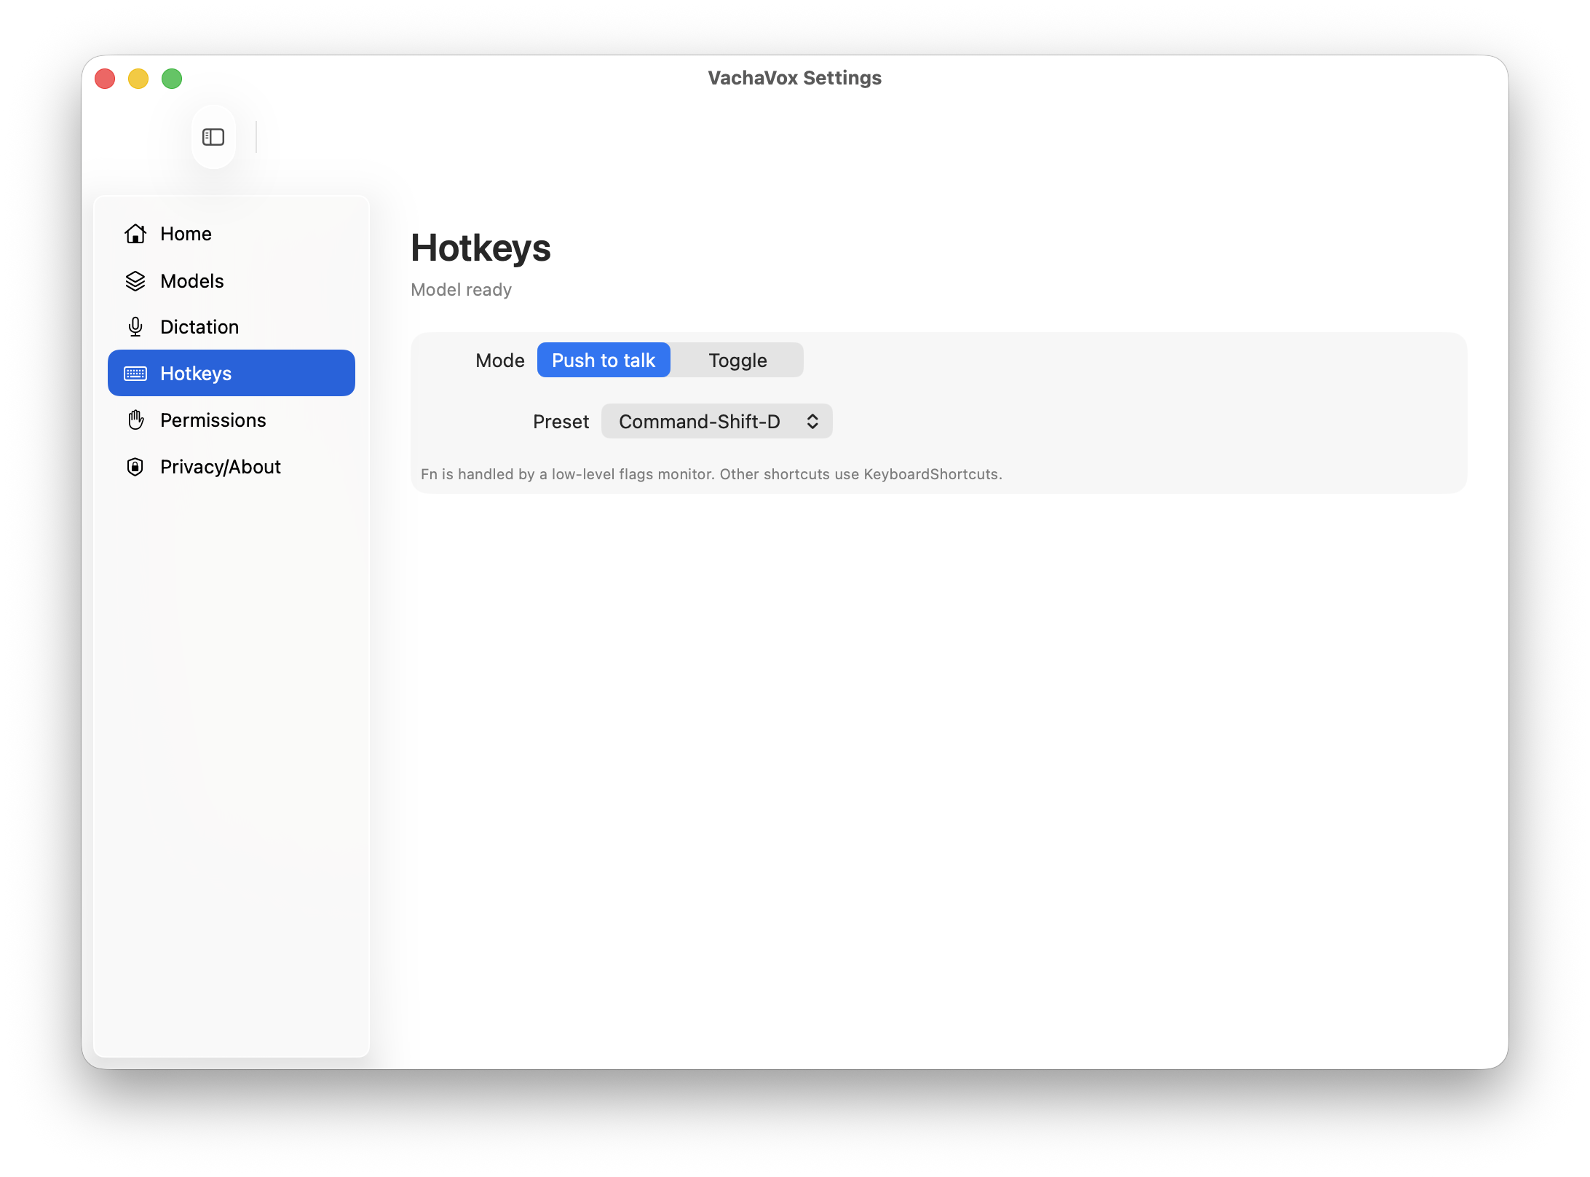
13_settings-hotkeys.png
Shows push-to-talk mode and Command-Shift-D preset.

Permissions tab
Surface: Settings
Entry path: Open VachaVox Settings, select Permissions.
Related code: Sources/ChapadChapad/UI/SettingsView.swift, Sources/ChapadChapad/Permissions/PermissionsService.swift, Sources/ChapadChapad/Utilities/SystemSettingsOpener.swift
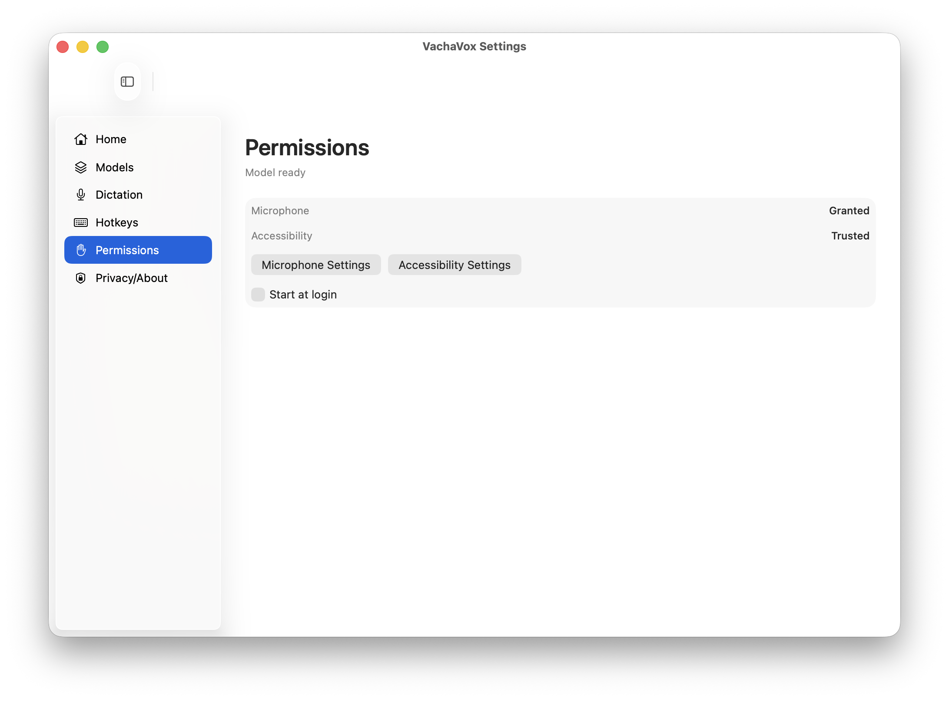
14_settings-permissions.png
Shows microphone granted, accessibility trusted, privacy settings buttons, and start-at-login toggle.

Privacy/About tab
Surface: Settings
Entry path: Open VachaVox Settings, select Privacy/About.
Related code: Sources/ChapadChapad/UI/SettingsView.swift
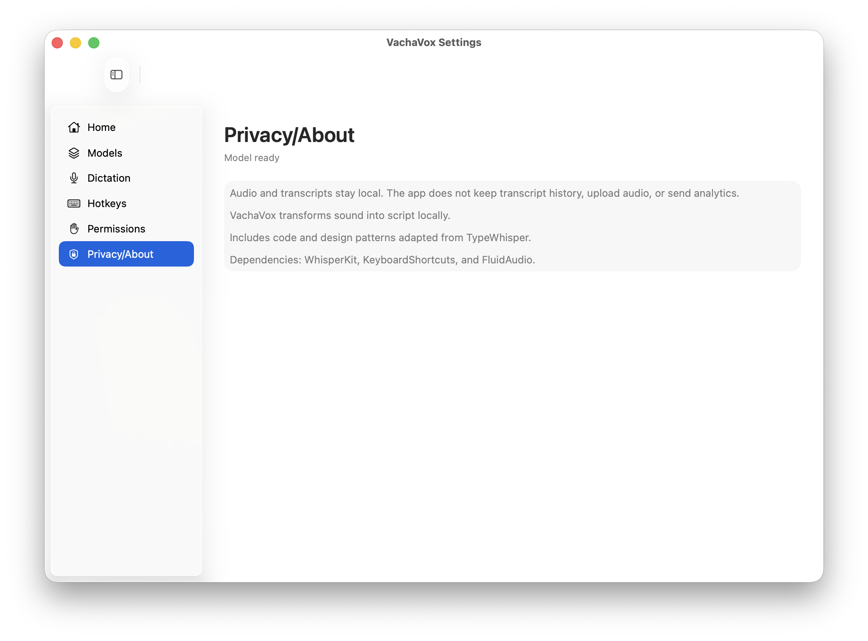
15_settings-privacy-about.png
Shows local privacy promise and dependency/about notes.

Model delete confirmation
Surface: Settings
Entry path: Models tab, click Delete for Whisper Small, then cancel.
Related code: Sources/ChapadChapad/UI/SettingsView.swift, Sources/ChapadChapad/App/DictationCoordinator.swift, Sources/ChapadChapad/Models/ModelCatalog.swift
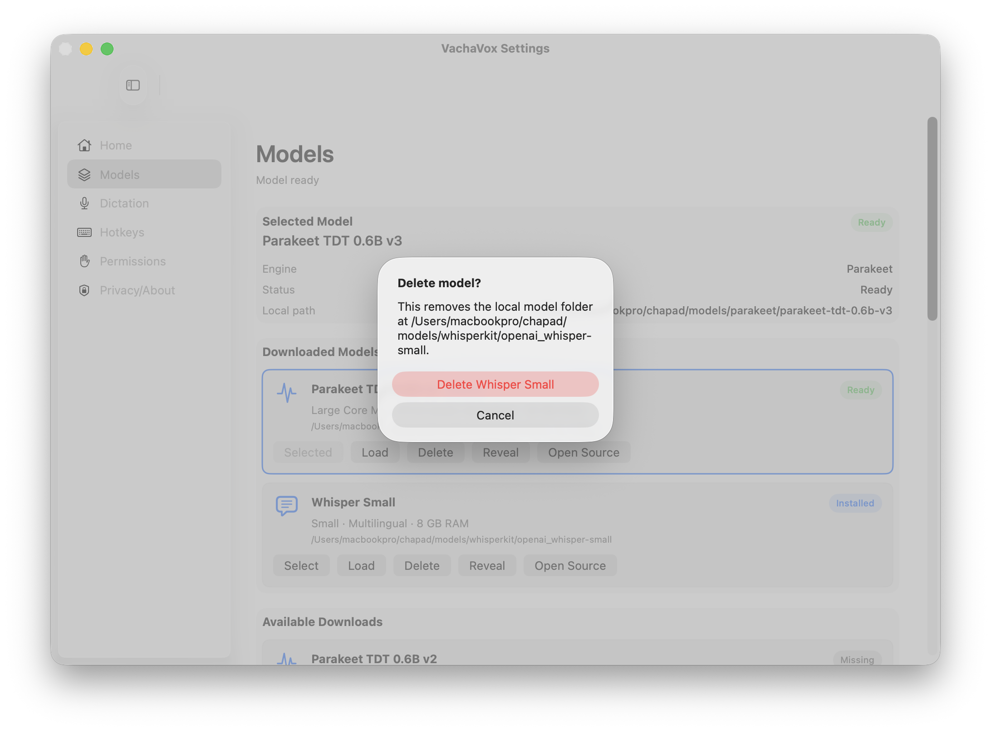
16_settings-model-delete-confirmation.png
Confirmation only; no model folders were deleted.

Custom shortcut recorder
Surface: Settings
Entry path: Hotkeys tab, change Preset to Custom shortcut; setting restored afterward.
Related code: Sources/ChapadChapad/UI/SettingsView.swift, Sources/ChapadChapad/MenuBar/HotKeyService.swift, Sources/ChapadChapad/Settings/AppSettings.swift
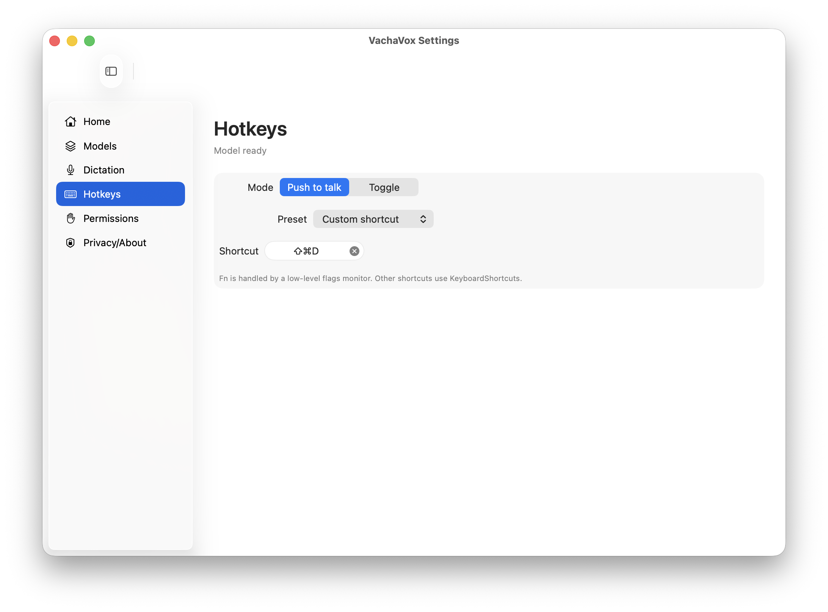
17_settings-hotkeys-custom-recorder.png
Shows KeyboardShortcuts recorder field. The preset was restored to Command-Shift-D after capture.

Skipped Captures
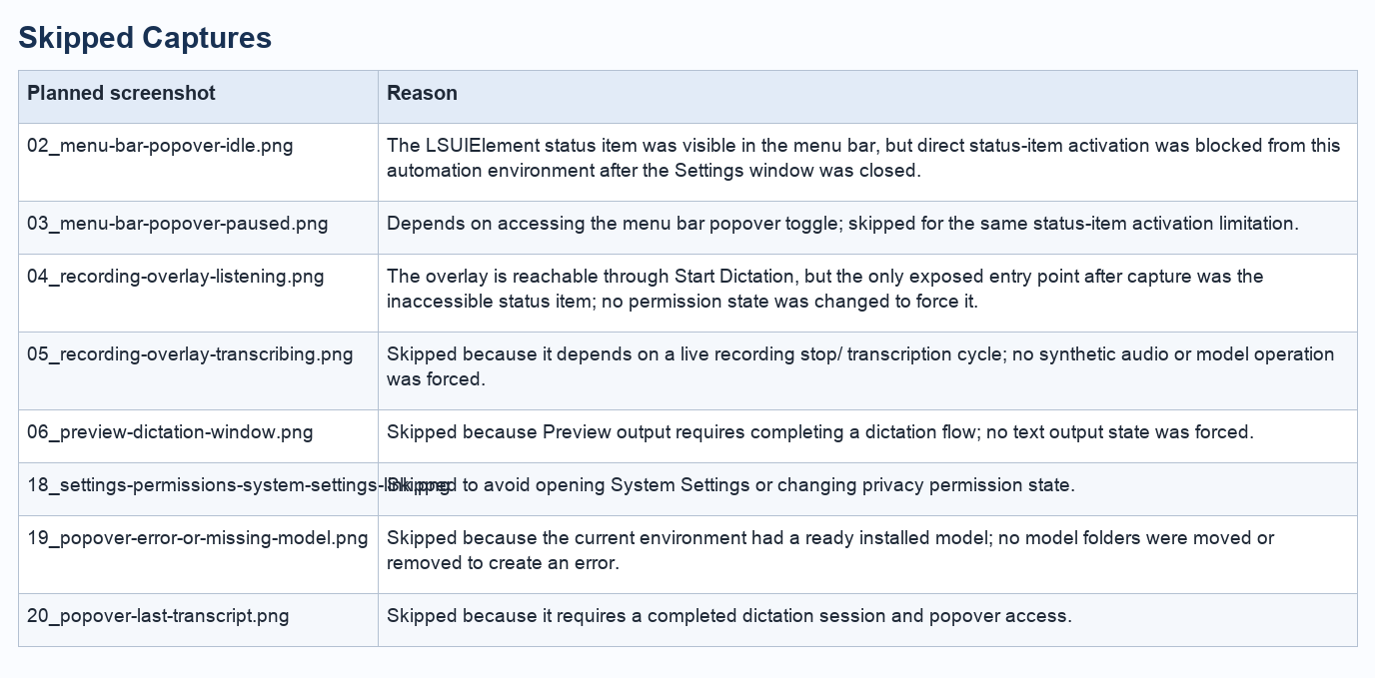
Skipped capture table

Code Mapping Notes
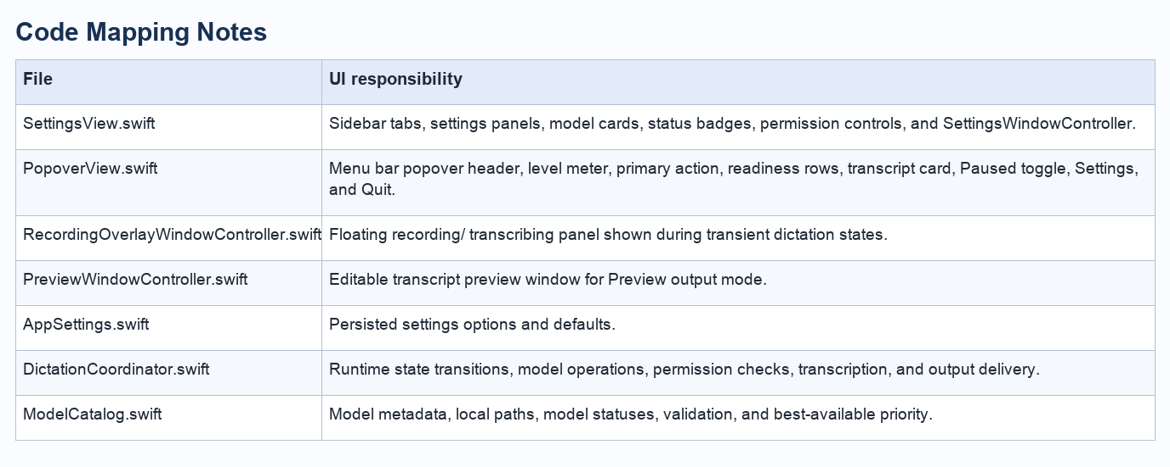
Code mapping table

UI Rework Checklist
- Clarify Settings Home as dashboard, setup checklist, or status summary.
- Normalize status badges and language across Settings and popover.
- Reduce model card density while preserving advanced actions.
- Design explicit empty, error, loading, paused, permission-denied, and missing-model states.
- Audit keyboard navigation, VoiceOver labels, and shortcut recorder behavior.
- Define shared tokens for spacing, typography, radius, iconography, and status colors.

