**Module Creation Steps in Eclipse**



**Madhan & Ramana**

**Step-01:**

Create a **Dynamic web project** with any module name. While creating the project check generate **web.xml** deployment descriptor.

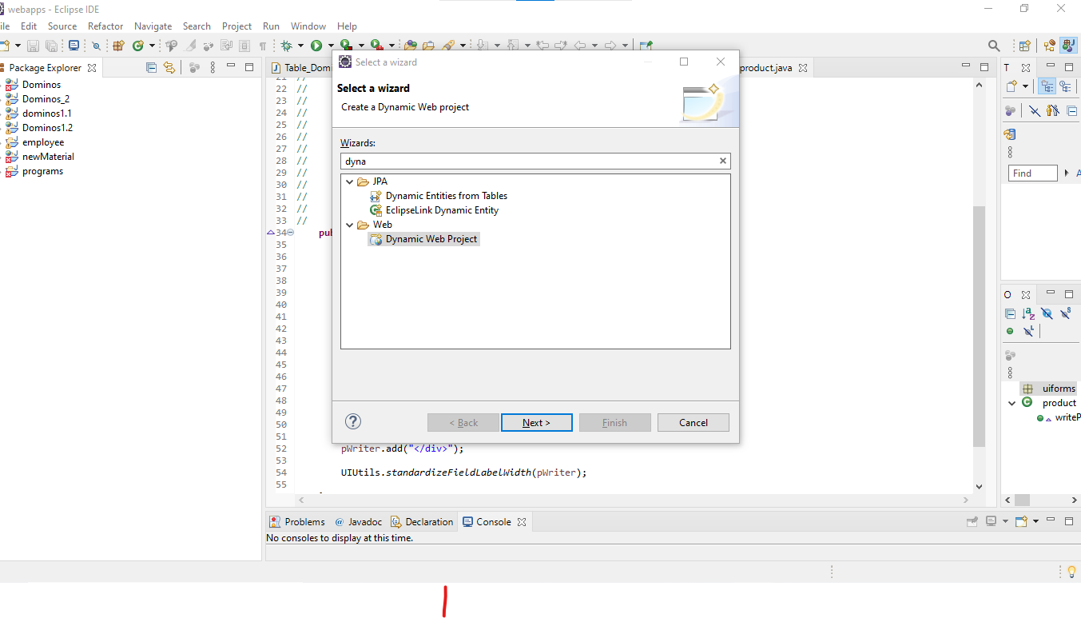

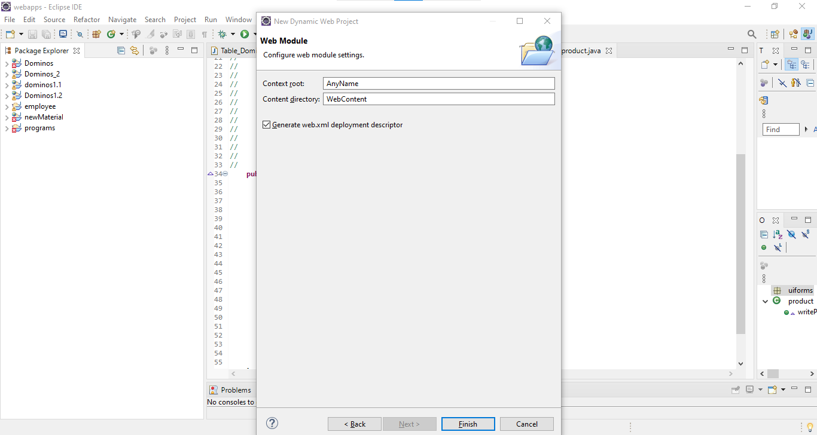

**Step-02:**

Inside **WEB-CONTENT** folder copy **META-INF** AND **WEB-INF** folder past inside the module (outside the web-content folder)

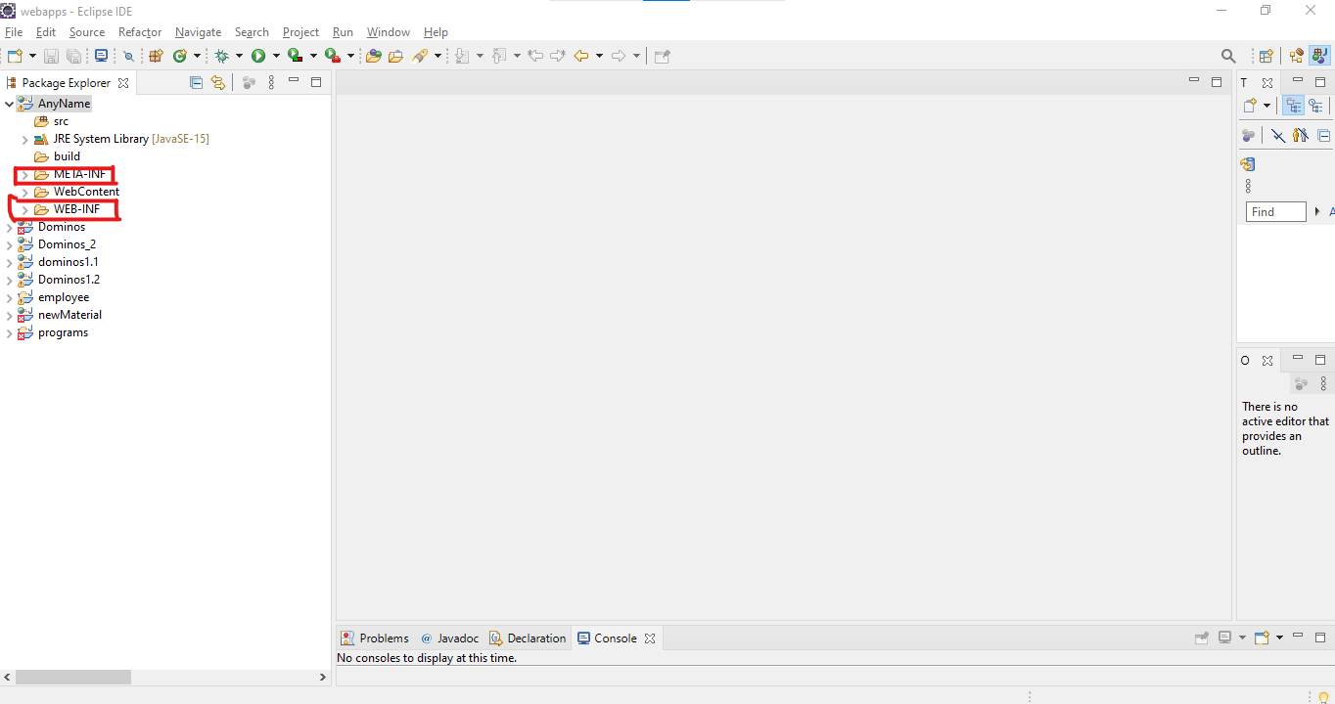

**Step-03:**

Inside **WEB-INF** folder create **ebx** folder. Inside **ebx** folder create **Schemas** folder and **module.xml** file. And inside the **module.xml** and **web.xml** past the appropriate data

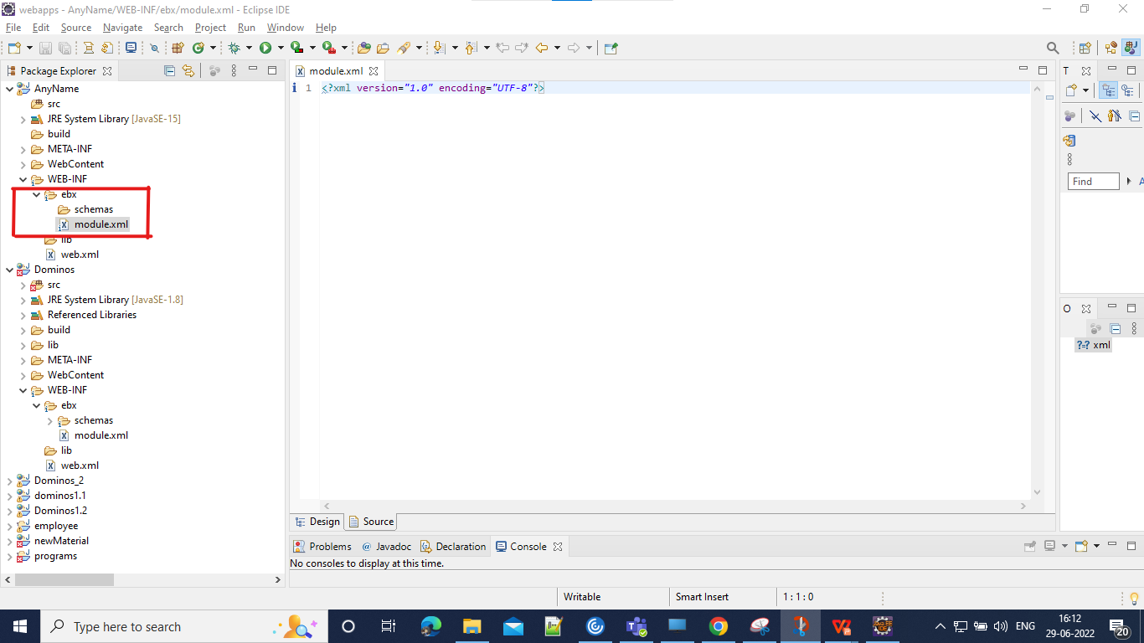

**Step-04:**

Create a **lib** folder inside the module. And place ebx.jar and servlet-api.jar files inside the lib folder.

Add the jar files inside the **module-path** of **java build path(**right click on module

->build path ->configure build path ->libraries -> modulepath ->add jars ->add from the lib folder**)**

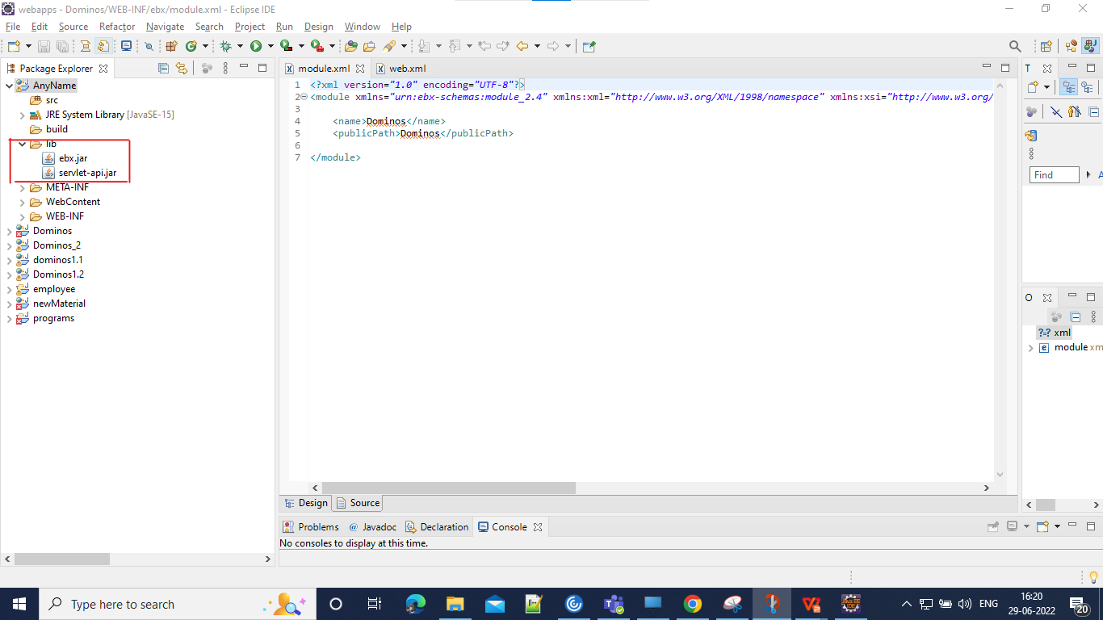

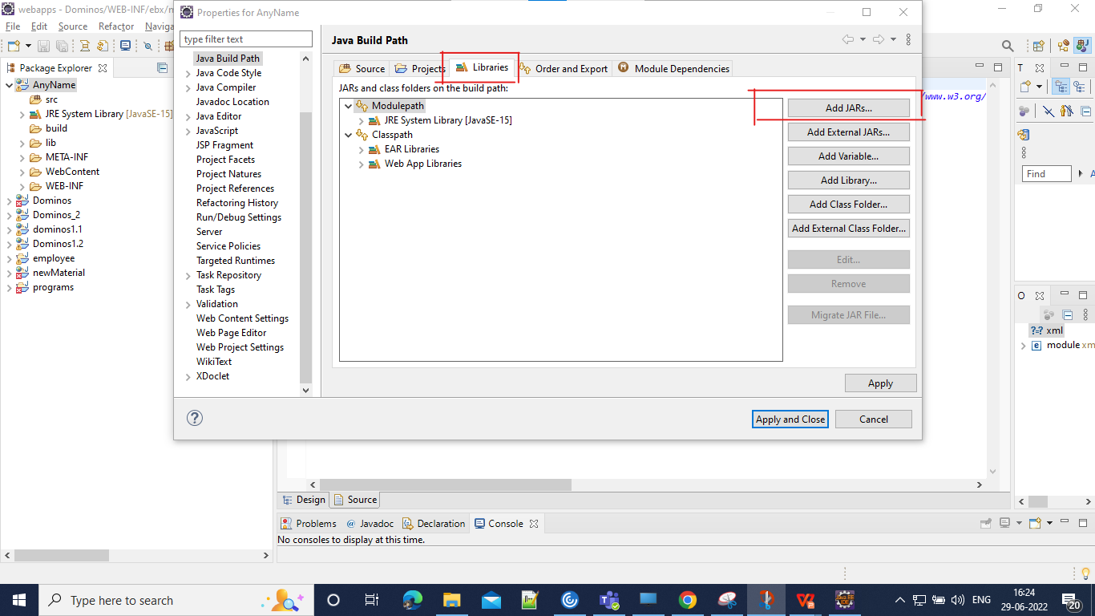

**Step-05:**

Create a package inside the Src folder, inside the package create a class in the name RegistrationServlet.java and place the appropriate data inside the class.

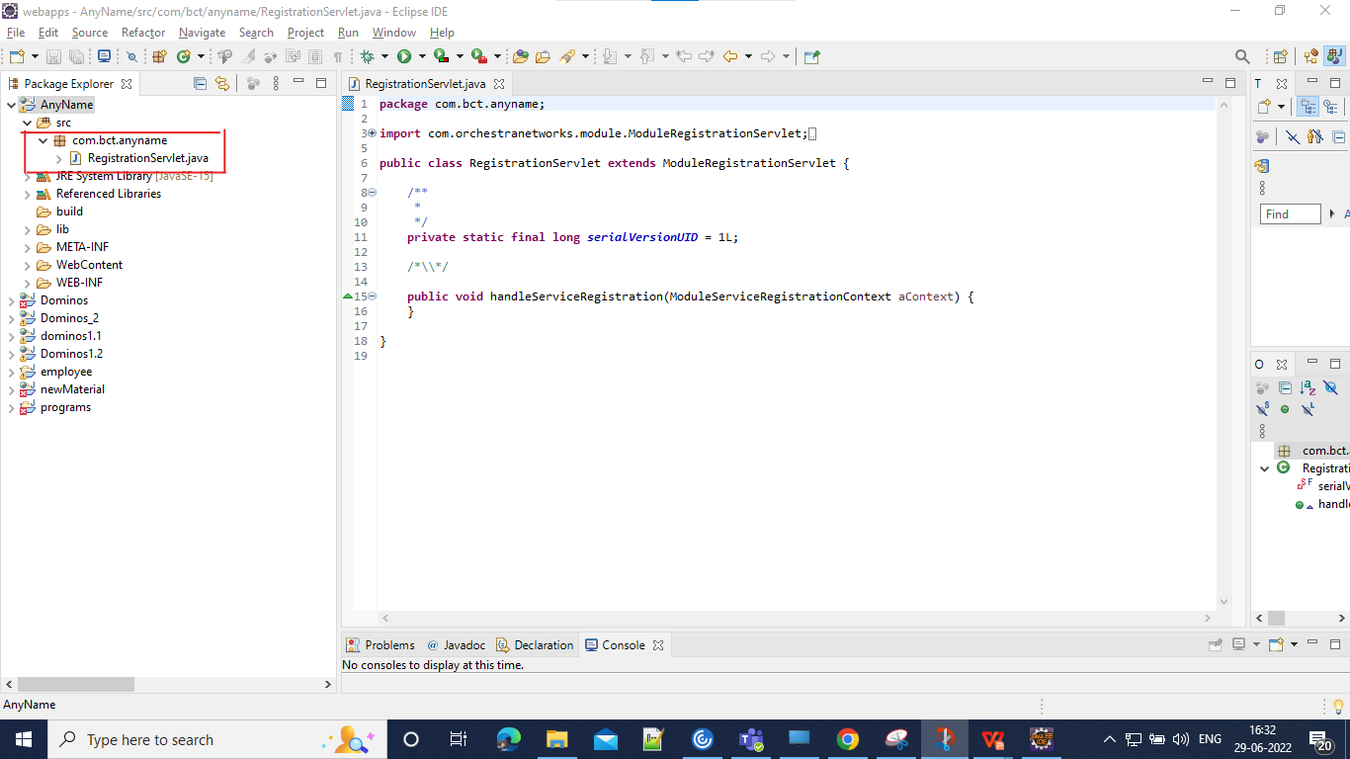

**Step-06:**

Inside the webapps -> module -> WEB-INF -> create a Classes folder Browse this location inside the **source** of **java-build-path**

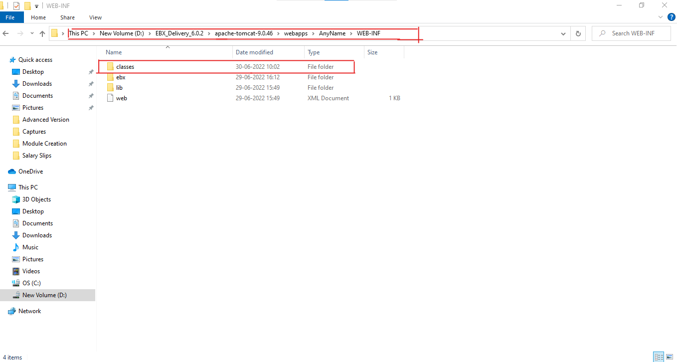

**Step-07:**

Re-run the server and check **modules and datamodules-> other modules** to verify the module creation.

