Process to setup claude code in VSCode

First purchase pro plan.
Go to the terminal and paste
curl -fsSL https://claude.ai/install.sh | bash

Output:

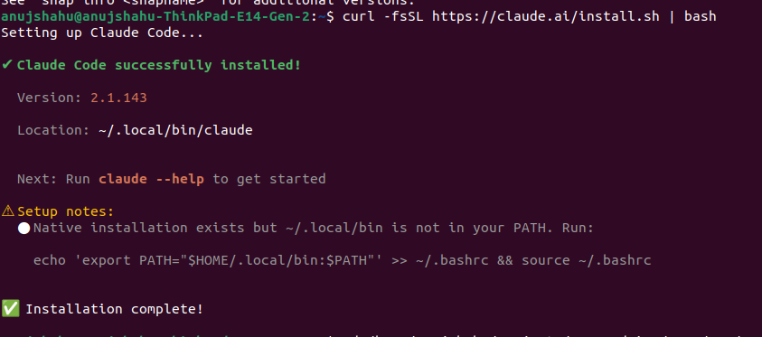
Note: Since this path ~/.local/bin was not my native path for claude installation hence need to run

Run echo 'export PATH="$HOME/.local/bin:$PATH"' >> ~/.bashrc && source ~/.bashrc

Go to your project directory say ~/projects/senecadairy/2026/May/15/bigcommerce-api/

Now run claude

Output:
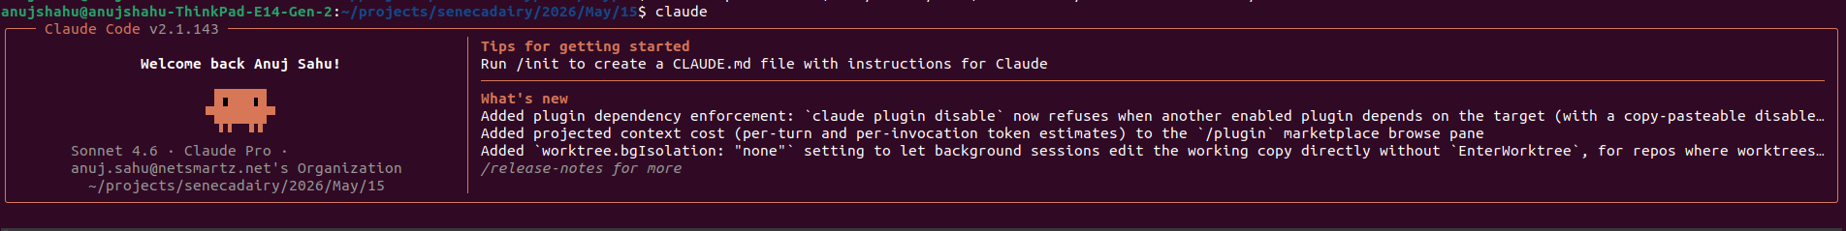

Here is the input field in the terminal itself – now ask your query right here in your code base. This will read the entire directory and help you in many ways.

