EWB AWS INTERNSHIP PROJECT REPORT
Name: ANUJ SAJANKAR
Batch: 1
Project Title: AWS VPC Peering
Region: ap-southeast-2 - Asia Pacific / Sydney
Completion Date: October 26, 2026
————————————————————————————————————————————

Architecture Diagram
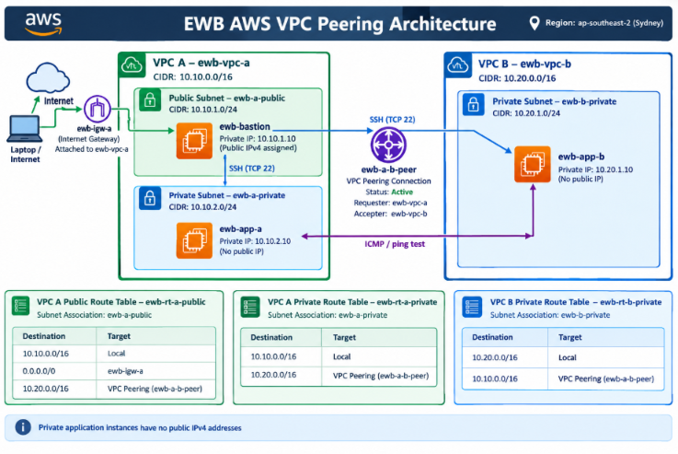

Resource Inventory & Network Parameters:

VPC CIDR Blocks: VPC-A (ewb-vpc-a): 10.10.0.0/16 | VPC-B (ewb-vpc-b): 10.20.0.0/16
Subnet CIDR Ranges: ewb-a-public (10.10.1.0/24), ewb-a-private (10.10.2.0/24), ewb-b-private
(10.20.1.0/24)
Bastion Host (ewb-ec2-bastion): Public IP: 32.236.238.96 | Private IP: 10.10.1.10 | Subnet: ewb-a-public
App-A Server (ewb-ec2-app-a): Private IP: 10.10.2.10 | Subnet: ewb-a-private | Security Group: ewb-sg-
app-a

App-B Server (ewb-ec2-app-b): Private IP: 10.20.1.10 | Subnet: ewb-b-private | Security Group: ewb-
sg-app-b
VPC Peering Connection: pcx-00348da7646c15867 (Requester: ewb-vpc-a, Accepter: ewb-vpc-b, Status: Active)
Internet Gateway: ewb-vpc-a (Attached to ewb-vpc-a)

3. Route Tables & Subnet Associations
Route Table 1: ewb-rt-a-public (Public Route Table)
Associated Subnet: ewb-a-public (10.10.1.0/24)
Routes: 10.10.0.0/16 -> Local | 0.0.0.0/0 -> ewb-igw-a (Internet Gateway)| 10.20.0.0/16-> peering connection
Route Table 2: ewb-rt-a-private (App-A Private Route Table)
Associated Subnet: ewb-a-private (10.10.2.0/24)
Routes: 10.10.0.0/16 -> Local | 10.20.0.0/16 -> pcx-xxxxxx (VPC Peering Connection)
Route Table 3: ewb-rt-b-private (App-B Private Route Table)
Associated Subnet: ewb-b-private (10.20.1.0/24)
Routes: 10.20.0.0/16 -> Local | 10.10.0.0/16 -> pcx-00348da7646c15867 (VPC Peering Connection)

4. Security Groups & Inbound Rules
Bastion Security Group (ewb-sg-bastion)
Rules: Inbound: SSH (Port 22) from Source 122.179.91.0/32 (My IP) for admin terminal access.
App-A Security Group (ewb-sg-app-a)
Rules: Inbound Rule 1: SSH (Port 22) from Source 10.10.1.0/24 (Bastion Subnet).
Inbound Rule 2: All ICMP - IPv4 from Source 10.20.0.0/16 (VPC-B Range).
App-B Security Group (ewb-sg-app-b)
Rules: Inbound Rule 1: SSH (Port 22) from Source 10.10.0.0/16 (VPC-A Range).
Inbound Rule 2: All ICMP - IPv4 from Source 10.10.0.0/16 (VPC-A Range).

5. Forward & Return Explanation
Forward Path Flow
App-A (10.10.2.10) sends an ICMP Echo Request to App-B (10.20.1.10). The route table ewb-rt-a-private routes traffic destined for 10.20.0.0/16 through the VPC peering connection ewb-a-b-peer. The traffic crosses the AWS network into VPC B and follows the route in ewb-rt-b-private. The inbound ICMP rule in App-B's security group, ewb-sg-app-b, allows the request from App-A (10.10.2.10/32).
Return Path Flow
App-B (10.20.1.10) sends an ICMP Echo Reply back to App-A (10.10.2.10). The route table ewb-rt-b-private directs traffic destined for 10.10.0.0/16 through the VPC peering connection ewb-a-b-peer to VPC A. App-A's security group, ewb-sg-app-a, allows the ICMP response from App-B (10.20.1.10/32). Since security groups are stateful, the response to an allowed request is permitted automatically. When both route tables and security group rules are configured correctly, App-A and App-B can communicate privately across the VPC peering connection.
Note: State the result as 0% packet loss only after your ping test confirms it.

6. Test Evidence & Validation Records
Test 1: Baseline Failure Proof (Initial ICMP Block)
Host: ec2-user@10.10.2.10 (App-A)
Test Command: ping 10.20.1.10 — Prior to adding the ICMP inbound rule
Result: 100% packet loss.
Explanation: The baseline test confirmed that even though VPC Peering routes were active, App-B's security group (ewb-sg-app-b) blocked the ICMP Echo Request, demonstrating that network routing alone is insufficient without proper security group authorization.
Test 2: Forward & Reverse Ping Success Proof
Host: ec2-user@10.10.2.10 (App-A)
Test Command: ping 10.20.1.10 — After adding the ICMP inbound rule
Result: 0% packet loss (if confirmed by your actual ping output).
Explanation: Adding the ICMP inbound rule to ewb-sg-app-b allowed communication between App-A (10.10.2.10) and App-B (10.20.1.10) across the VPC peering connection ewb-a-b-peer, confirming forward and return path operation.
Test 3: App-B SSH Proof & Key Management
Host: Windows PowerShell → Bastion (10.10.1.10) → App-B (10.20.1.10)
Test Command: ssh -i "$HOME\Downloads\ewb-lab.pem" -J ec2-user@<BASTION_PUBLIC_IP> ec2-user@10.20.1.10
Result: Successful SSH login (if confirmed by your actual test).
Explanation: The ewb-lab.pem private key is used from the local computer to securely access App-B through the Bastion host, without copying the private key to the Bastion.
Test 4: Controlled ICMP Failure & Recovery Validation
Summary: To validate security group enforcement, the ICMP inbound rule was temporarily removed from ewb-sg-app-b. Re-running ping 10.20.1.10 from App-A (10.10.2.10) should result in packet loss. After restoring the ICMP inbound rule allowing traffic from 10.10.2.10/32, ping traffic should resume, confirming communication between App-A and App-B.

7. Cleanup Evidence

1. Terminated all EC2 instances.

2. Deleted VPC Peering Connection.

3. Detached from ewb-vpc-a. and Deleted Internet Gateway ewb-igw-a .
Deleted custom VPCs ewb-vpc-a and ewb-vpc-b along with associated subnets and route tables to
prevent unauthorized billing.

Summary
Through this hands-on project, I gain knowledge inn multi-VPC architecture design, CIDR block
allocation without overlapping ranges, bastion jump host configuration, SSH key permission security and
bidirectional route table propagation over VPC Peering. Also gained practical experience
troubleshooting network ,security group firewall rules.

