CRIME DATA SET(R OUTPUT)

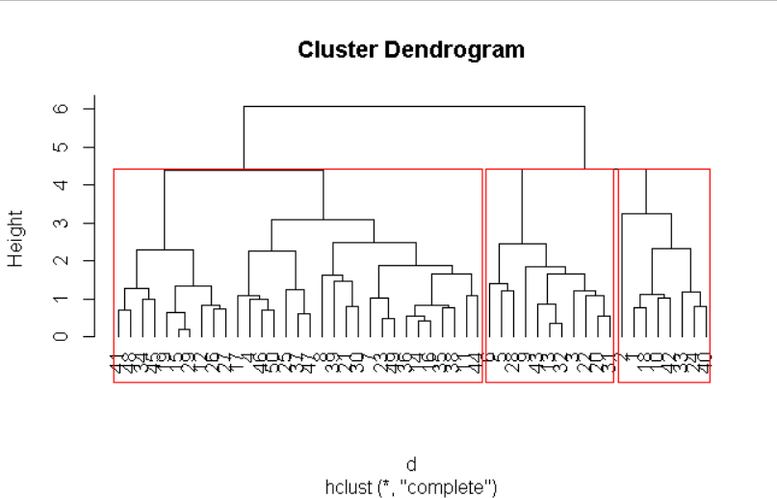

Crime Data Set(Python Output)

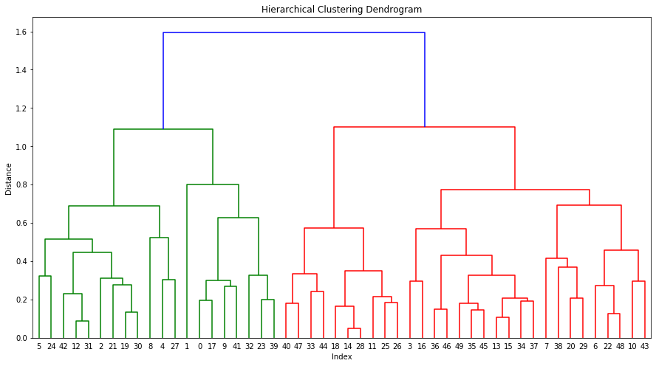

Flight dataset[R OUTPUT]

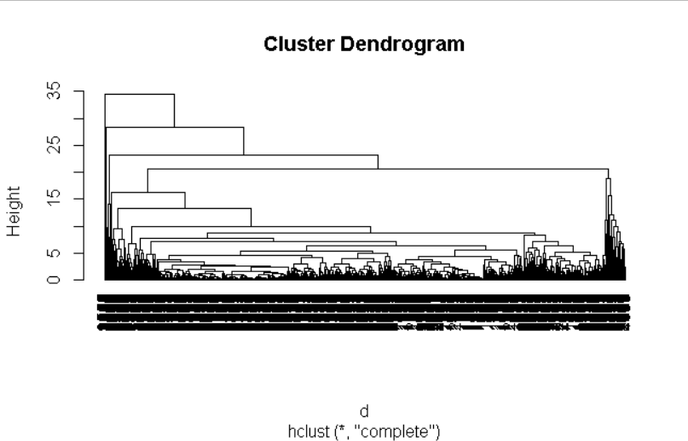

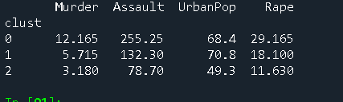

Problems: Assaults is primary reason from where major crime like murder starts.

Objective: Maximise law enforcements

Constraints: minimize crime rate

Category 0 represents Maximum no. of assaults that is which leads to maximum rate of rapes and murder as well as

While no of assaults in category 2 has minimum no. of cases in assaults hence automatically rate of rape and murder is being less.

While in category 1 Assault avg is between cluster 0 and 2

Hence Avg Murder also lies between cluster0 and 2

From all cluster we concluded that Major crime like murder and Rape starts from Assault

So reduction in rate of assault will somehow help to reduction in other major crimes

In order to reduce crimes, law department needs to implement laws in very strict manner which leads reduction in assault.

Flight dataset[pyhton output]

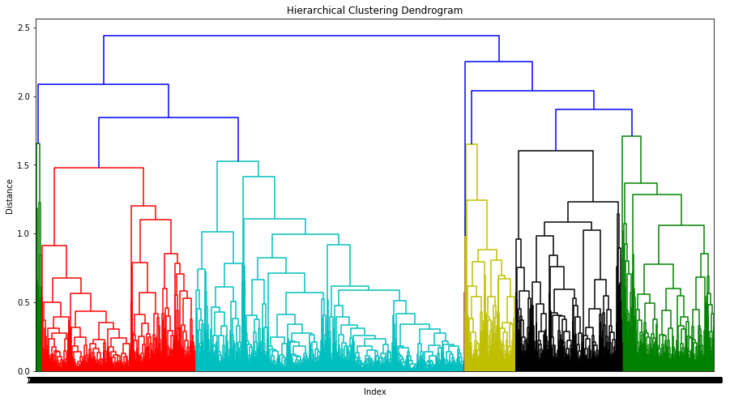

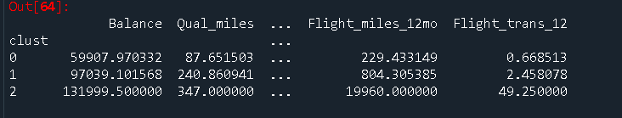

Cluster 1

72.84% of customers fall into this cluster. There is potential business growth

opportunity, if the passengers are turned into regular travellers.

Potential Offers :

1. If frequent flyer credit card is used then the reward points per travel

percentage can increased.

2. If the number of travel checkins are more than 5 in an year, Then extra

bonus points can be awarded to the customer.

Cluster 2

This cluster is second largest with 23.3% of customers.

Potential Offers: If Bonus miles are used with the proportion of 80:20 then the customers can be awarded with 50% off with frequent flyer credit card.

Cluster 3

This is least cluster

Here we can give more special offers to them

From bonus miles can be used for both discount and cashback offers.

If bonus miles are used with proportion of 80:20 then customer will get 50 percent off with reward credit card and also they will get 10 percent cashback whatever amount they paid.