**PROJECT REPORT**

**ON**

**HOSTEL MANAGEMENT**

**SYSTEM**

**Submitted by-**

**Ananya Shrivastava - 171112032**

**Anuj Shrivastav - 171112033**

**Trilok Kumar Ahirwar - 171112018**

**1. Introduction**

1.1 PURPOSE

The purpose of this document is to build a Hostel Management Site to help students book hostel rooms as per their own convenience, file complaints and write reviews about the room.

1.2 INTENDED AUDIENCE AND READING SUGGESTIONS

The project is useful for both students and hostel committee members.

1.3 PROJECT SCOPE

The purpose of this Hostel Management System is to ease hostel management and to create a convenient and easy-to-use application for students . The system is based on a relational database with its room allotment , review and complaint features.

The software will be able to perform the following operations:

1. Allot Rooms: Students will be able to choose hostel rooms according to their convenience and pay for the same.
2. File a complaint: Students will be able to file a complaint regarding any of the facilities and if the complaint could not be resolved within the specified time, it would be sent to the higher authorities.
3. Review the rooms- Seniors who have already stayed in the room will get an option to review a room in which they can upload the room pictures and write about the problems(if they had faced any).

Mess : Students will be able to pay the hostel fees, see their past payments and write reviews about the food and management.

**2. ANALYSIS**

**(a).Specific requirements**

2.1. External Interface Requirements

2.1.1 User Interfaces

The goal is to design the software that will be used for proper management of hostels. The user types are listed below-

1. Students
2. Hostel Committee
3. Mess Committee

Our goal is to develop a software that should be easy to use for all types of users. Thus while designing the software one can assume that each user type has the following characteristics:

1. The user is computer-literate and has little or no difficulty in using the software keeping in mind the software is user friendly.
2. In order to use software a user must be aware of the internal working and expected to know how the things work.
3. All the guidelines about the use of software will be informed to the user once the user signs up on the software or web page.

2.1.2 Hardware interfaces

1) Computer or a smartphone: To open the software and use the software

2) Internet: A good internet connection is required to access the website.

2.1.3 Software interfaces

1) A SQL Database Server will be required to store and retrieve data

2)A web browser will be required to open the website

**(b).ER Model**

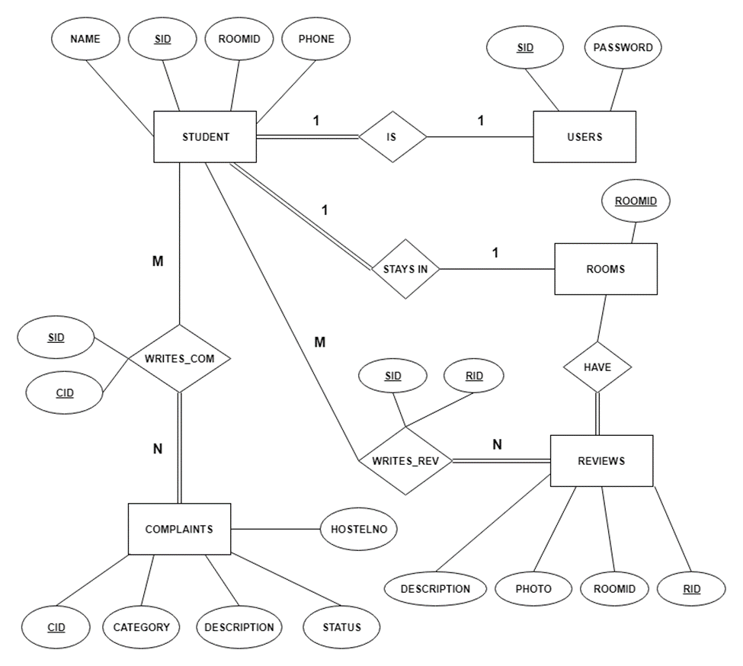

**3.DESIGN**

**(a). RELATIONAL SCHEMA**

1. Users(sid, password)
2. Reviews(rid, roomid, description, photo)
3. Writes_rev(sid, rid)
4. Rooms(rid)
5. Complaints(cid, category, description, status, hostelno)
6. Writes_com(sid, cid)
7. Student(sid, password, name, phone, roomid)

**(b). USER INTERFACE DESIGN**

3.1 GOAL

MAKE INTERFACE

1. Pleasing to the eye.

2. Simple to Use.

3. Minimize the effort it takes for users to accomplish the work.

3.2 PRINCIPLES OF USER INTINTERFACE

1. Layout

2. Content Awareness

3. User experience

4. Consistency

5. Minimize user effort

3.3 VARIOUS USER INTERFACES

1. HOME- It includes the navigation among different pages .Starting with registration and login and address of other pages.

2. REGISTERATION/LOGIN- If you are a new user you have to register and if already a user only login is sufficient. After registration and login user will be redirected to home page.

3. ROOM ALLOTMENT- After logging in it is necessary for the user to to fill room allotment form if the room is already booked user will be redirected to allotment form.

4. DASHBOARD- After booking the room user can see the status in the dashboard including username,scholar no and room booked.

5. REVIEW A ROOM – User can review the room he is alloted only after login. This page is accessible only when the room is alloted. Review includes the description and the photo of the room . After submission page is directed into another page from where user can view his review and even delete .

1. VIEW YOUR REVIEW- It keeps the track of the user’s reviews.
2. REVIEWS OF ROOMS- Before booking the room the user can view the review of various rooms.
3. COMPLAINTS- After room allotment if user requires to file any complaint he can register his complaint.
4. YOUR COMPALINTS- It keeps the record of all the complaints filed by the user.

**(c). FLOWCHART**

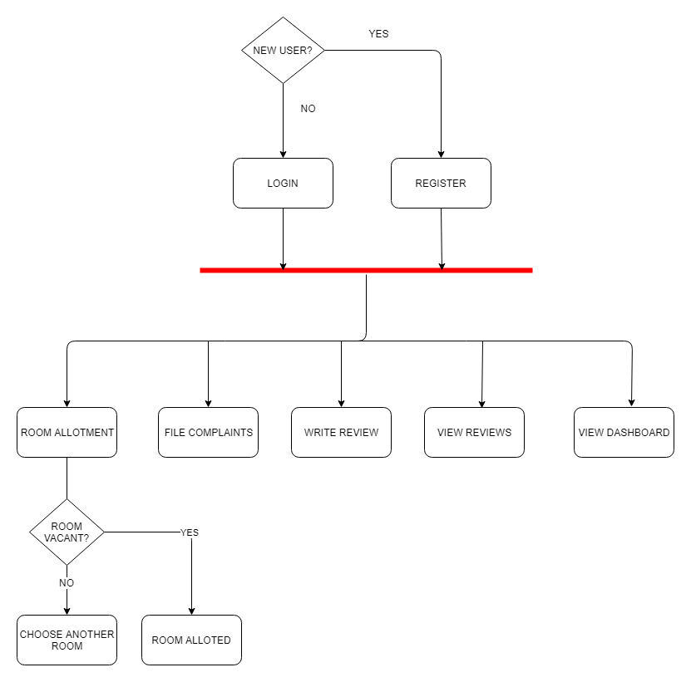

**4 . TESTING**

SYSTEM TESTING

System testing is the stage of implementation, which is aimed at ensuring that the system works accurately and efficiently before live operation commences. Testing is the process of executing the program with the intent of finding errors and missing operations and also a complete verification to determine whether the objectives are met and the user requirements are satisfied. The ultimate aim is quality assurance. Tests are carried out and the results are compared with the expected document. In the case of erroneous results, debugging is done. Using detailed testing strategies, a test plan is carried out on each module. The various tests performed in this project are unit testing, integration testing and user acceptance testing.

Unit Testing

The software units in a system are modules and routines that are assembled and integrated to perform a specific function. Unit testing focuses first on modules, independently of one another, to locate errors. This enables, to detect errors in coding and logic that are contained within each module. Here different units include login/register, room allotment, complaints and room review. Each one of these is tested to work properly independently.

Integration Testing

Data can be lost across any interface, one module can have an adverse effect on another, sub functions when combined, may not produce the desired major functions. Integration testing is a systematic testing to discover errors associated within the interface. The objective is to take unit tested modules and build a program structure. All the modules are combined and tested as a whole. In this project, room allotment and complaints can be filed only after the student has logged in . The room review can only be written once the room is allotted to a student. This testing provides the assurance that the application is well integrated functional unit with smooth transition of data.

User Acceptance Testing

User acceptance of a system is the key factor for the success of any system. The system under consideration is tested for user acceptance by constantly keeping in touch with the system users at time of developing and making changes whenever required.