Lab 1: Data Visualization, Data Preprocessing, and Statistical Analysis Using Python in Jupyter Notebook

Anuj Shrestha
Department of the Computer Science
University of the Cumberlands
Advanced Big Data and Data Mining (MSCS-634-M50)
Dr. Satish Penmatsa

September 20, 2026

Lab 1: Data Visualization, Data Preprocessing, and Statistical Analysis Using Python in Jupyter Notebook

Step 1: Data Collection

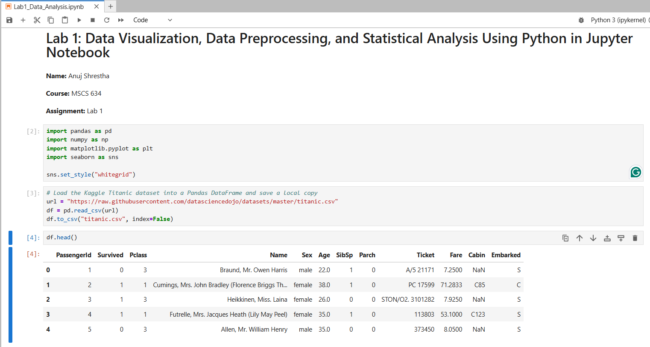
The Kaggle Titanic dataset (891 passengers, 12 columns) was loaded into a Pandas DataFrame with pd.read_csv() and a local copy was saved as titanic.csv. The first five rows from df.head() show each passenger's ID, survival status, class, name, sex, age, family counts, ticket, fare, cabin and port of embarkation.

Step 2: Data Visualization

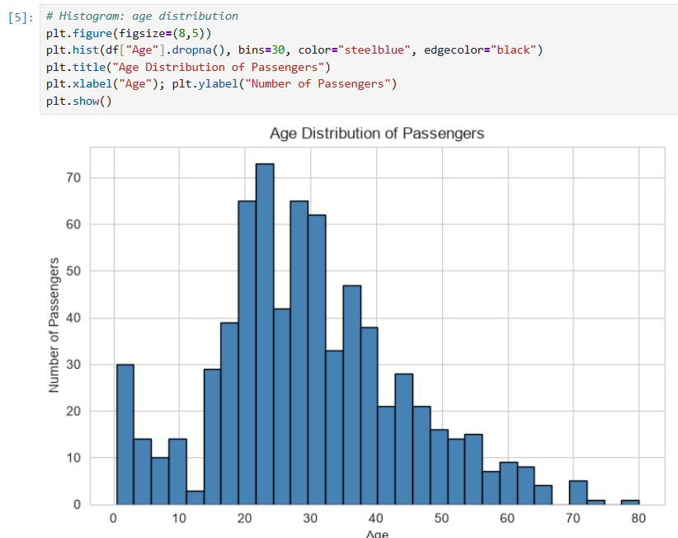
Most passengers were between about 20 and 40 years old, with the peak in the mid-20s and a median age of 28. There is a smaller spike of young children and relatively few passengers over 60.

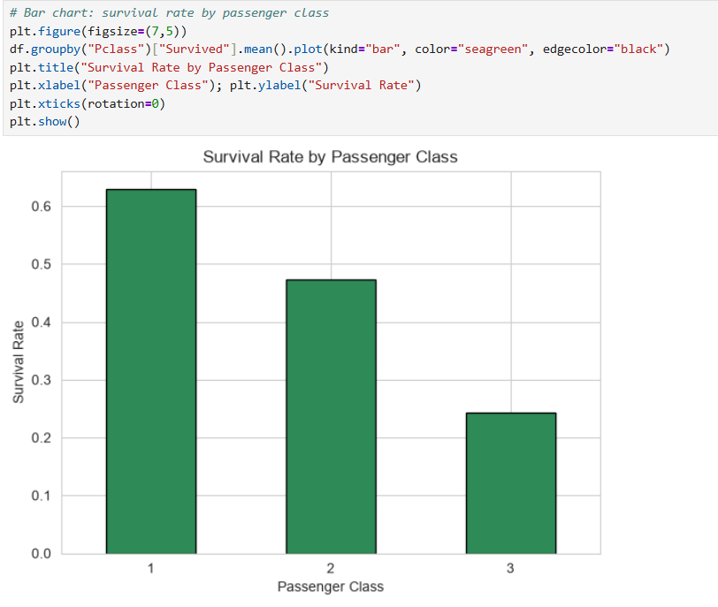
Survival dropped with passenger class: about 63% of 1st-class passengers survived, compared with about 47% in 2nd class and only 24% in 3rd class.

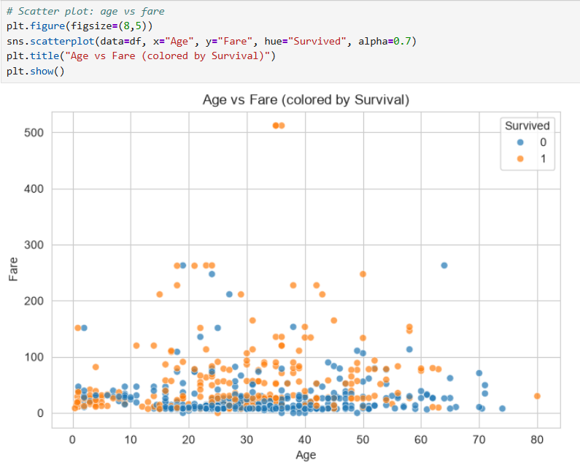
Most fares are below 100, with a few extreme fares near 512. Survivors (orange) appear more often at higher fares, while non-survivors (blue) cluster at the low end. Age shows no clear relationship with fare.

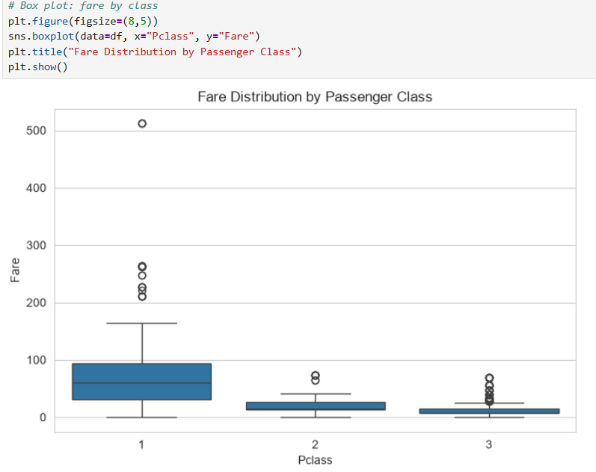

Median fare is about 60 in 1st class, 14 in 2nd class and 8 in 3rd class. 1st class has the widest spread and the most outliers, including fares up to 512.

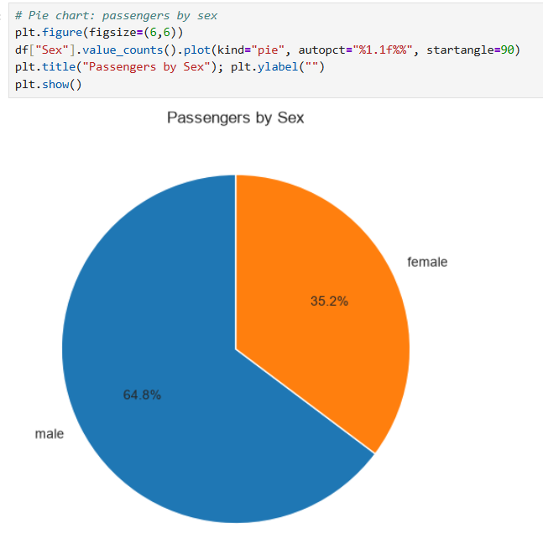
About 65% of the passengers were male and 35% were female, so men made up the majority of those on board.

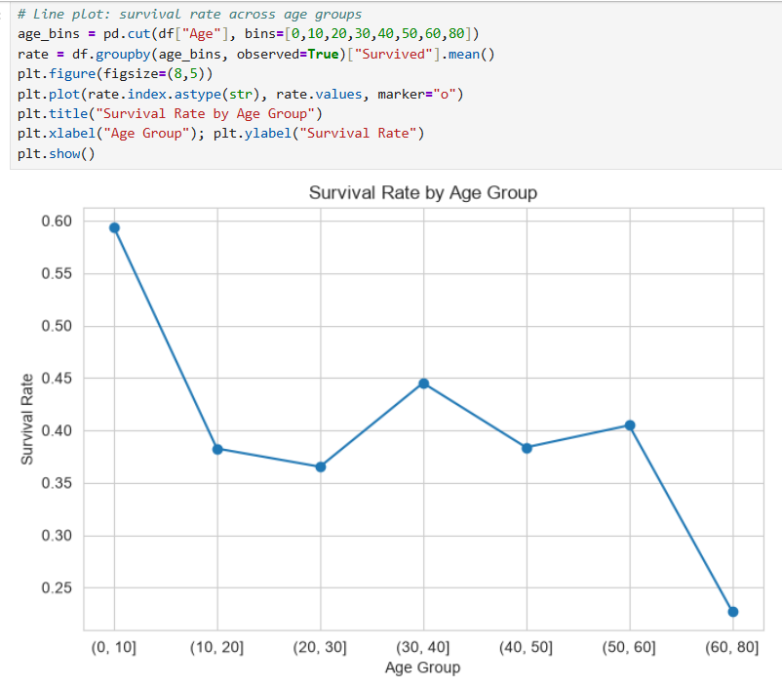

Survival was highest for children aged 10 or under (about 59%) and lowest for passengers over 60 (about 23%). Middle age groups stayed between roughly 37% and 45%.

Step 3: Data Preprocessing

3.1 Handling Missing Values

Before:
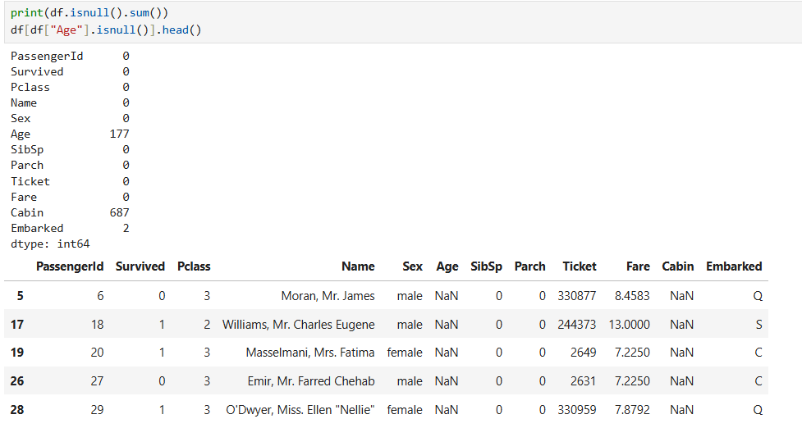
Before cleaning, Age has 177 missing values, Cabin has 687 and Embarked has 2. The five rows shown are missing Age.

After:
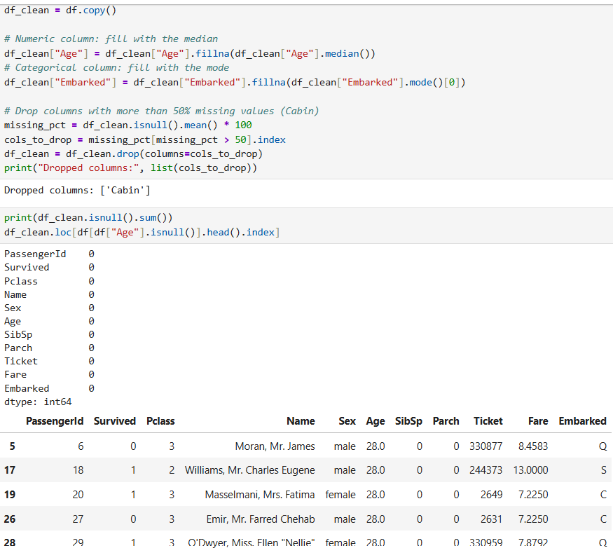
Age was filled with the median (28), Embarked was filled with its mode, and Cabin was dropped because more than 50% of its values were missing (about 77%). No missing values remain and the DataFrame has 11 columns.

3.2 Outlier Detection and Removal (IQR)
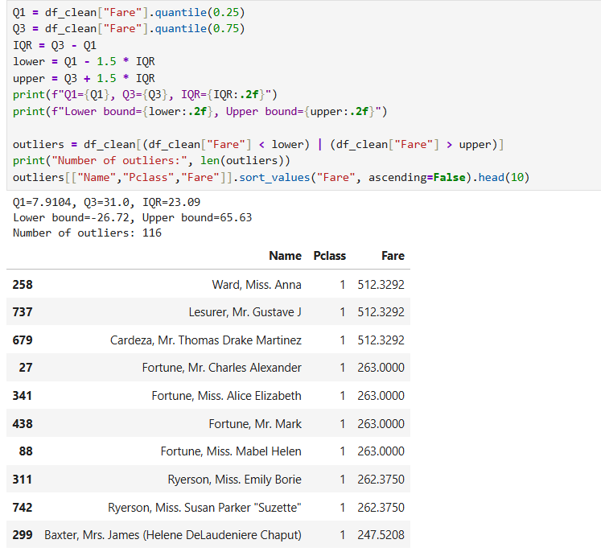

Using the IQR method on Fare: Q1 = 7.91, Q3 = 31.00 and IQR = 23.09, giving a lower bound of -26.72 and an upper bound of 65.63. This flagged 116 outliers, all high fares, such as 512.33 and 263.00 in 1st class.

AFTER:
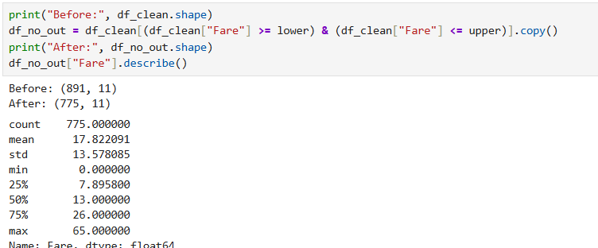
Removing the outliers reduced the data from 891 to 775 rows. The maximum fare is now 65.00 and the median is 13.00.

3.3 Data Reduction

Before:
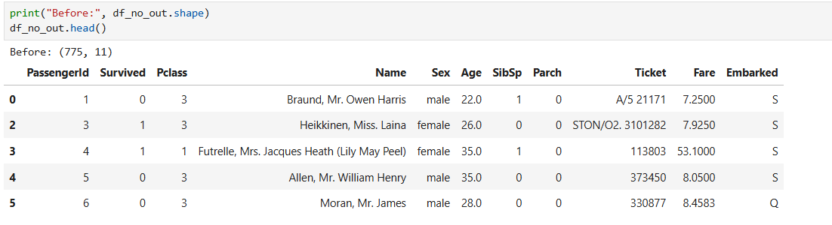

Before reduction, the dataset has 775 rows and 11 columns.

After:
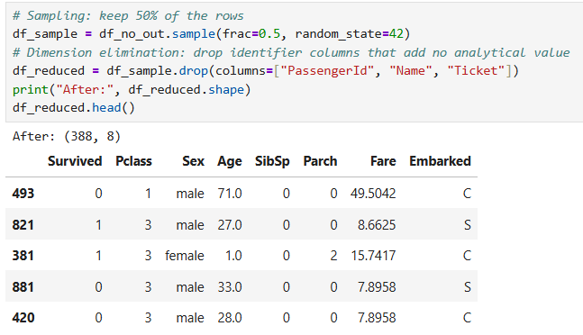
A random 50% sample (random_state=42) reduced the data to 388 rows. Dropping PassengerId, Name and Ticket, which add no analytical value, reduced it to 8 columns.

3.4 Data Scaling and Discretization

Before:
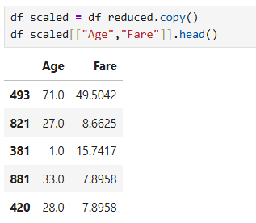
Age and Fare are shown in their original units before scaling.

After:
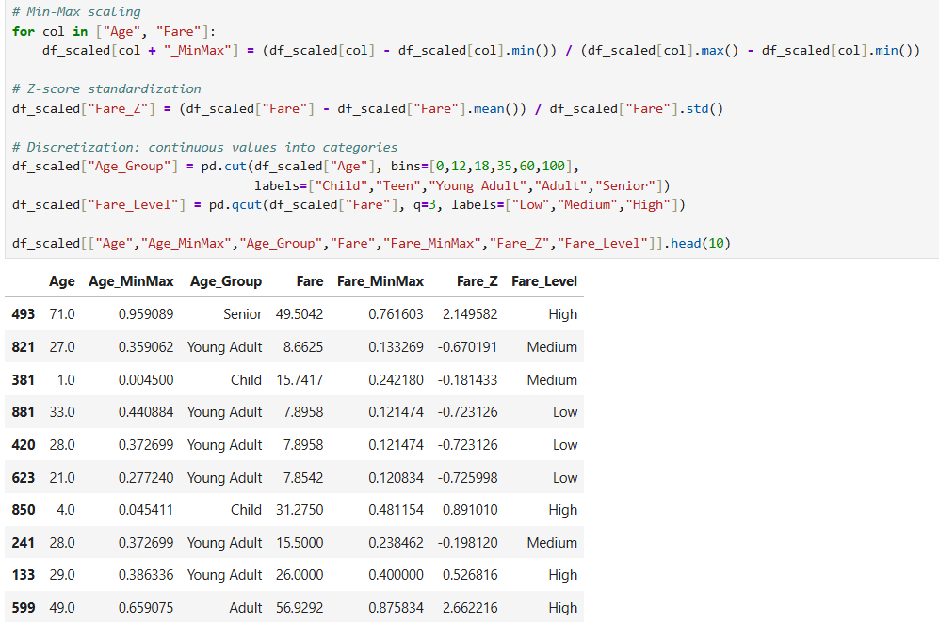
Min-Max scaling rescaled Age and Fare to a 0-1 range, and Z-score standardization was applied to Fare. Age was discretized into Child, Teen, Young Adult, Adult and Senior groups, and Fare was split into Low, Medium and High levels using quantiles.

Step 4: Statistical Analysis

4.1 General Overview of Data
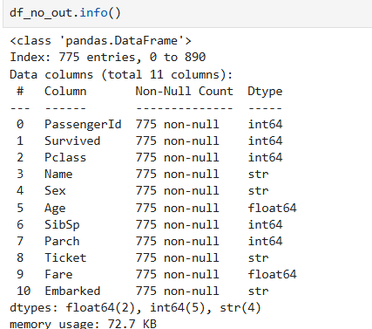

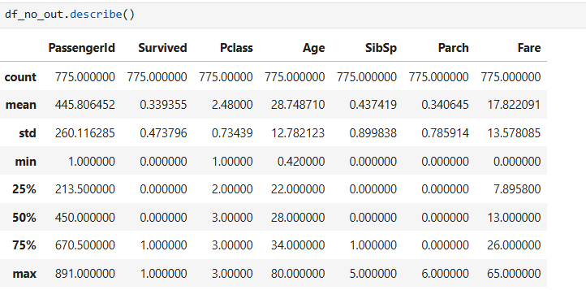
The .info() output confirms 775 rows and 11 columns with no missing values (2 float, 5 integer and 4 text columns). The describe() output shows an average age of about 28.7 and an average fare of 17.82, and about 34% of the remaining passengers survived.

4.2 Central Tendency Measures
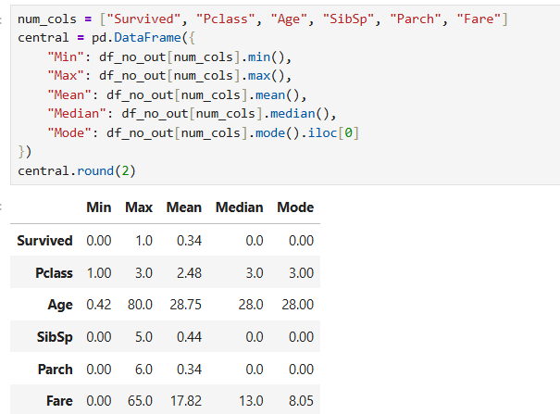
Age has a mean (28.75) close to its median (28), so it is fairly symmetric. Fare has a mean (17.82) above its median (13.00), which shows right skew. The most common class is 3rd (mode 3) and the most common outcome is not surviving (mode 0).

4.3 Dispersion Measures
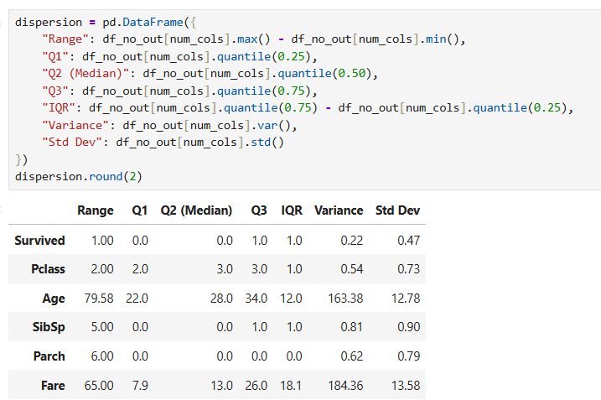
Fare has a range of 65, an IQR of 18.1 and a standard deviation of 13.58. Age has a range of 79.58, an IQR of 12 and a variance of 163.38. The remaining columns have small variances because they take only a few discrete values.

4.4 Correlation Analysis
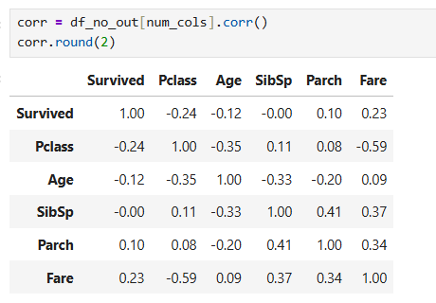

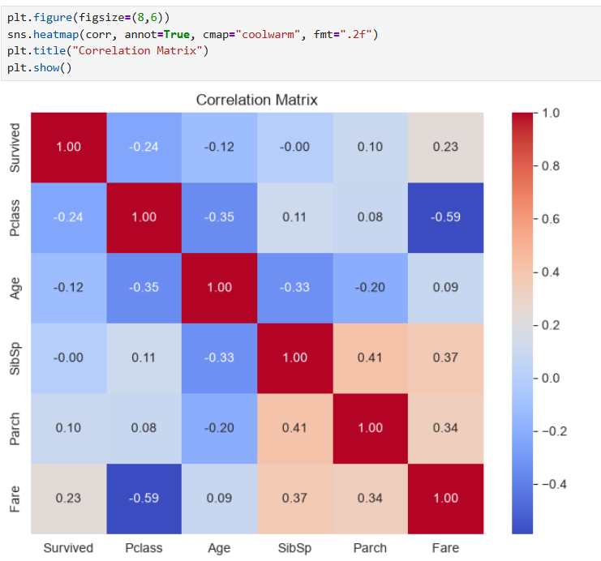

The strongest relationship is between Fare and Pclass (-0.59): higher classes paid more. Survived is negatively correlated with Pclass (-0.24) and positively with Fare (0.23). Family-size columns are moderately related to each other (SibSp and Parch, 0.41) and to Fare (0.37 and 0.34).

Conclusion

Insights: Passenger class turned out to matter a great deal. About 63% of 1st-class passengers survived, compared with only 24% in 3rd class. Age played a part as well, with children under 10 having the best survival rate of any age group. Fare was also revealing: most passengers paid a small amount while a few paid a very large one, and fare was closely tied to class (correlation of -0.59), which makes sense since 1st-class tickets cost more.
Preprocessing decisions: Missing ages were filled with the median so that no passengers were lost. Cabin was missing for about 77% of passengers, so filling it in made little sense and the column was dropped. Extreme fares were removed using the 1.5×IQR rule, which removed 116 rows, so that the statistics reflect what a typical passenger paid. The data was then cut down to a 50% sample, the ID-type columns were dropped, and the remaining values were scaled and grouped.
Challenges: The hardest part was deciding how to handle the missing values and outliers. Those extreme fares are real, so removing them changes the results. The average fare dropped from 32.20 to 17.82, meaning the final statistics reflect the trimmed data rather than everyone on board. The trade-off seemed worthwhile because the trimmed numbers better show what most passengers experienced.

