Lab 2: Classification Using KNN and RNN Algorithms

Anuj Shrestha
Department of the Computer Science
University of the Cumberlands
Advanced Big Data and Data Mining (MSCS-634-M50)
Dr. Satish Penmatsa

September 27, 2026

Lab 2: Classification Using KNN and RNN Algorithms

Step 1: Load and Prepare the Dataset
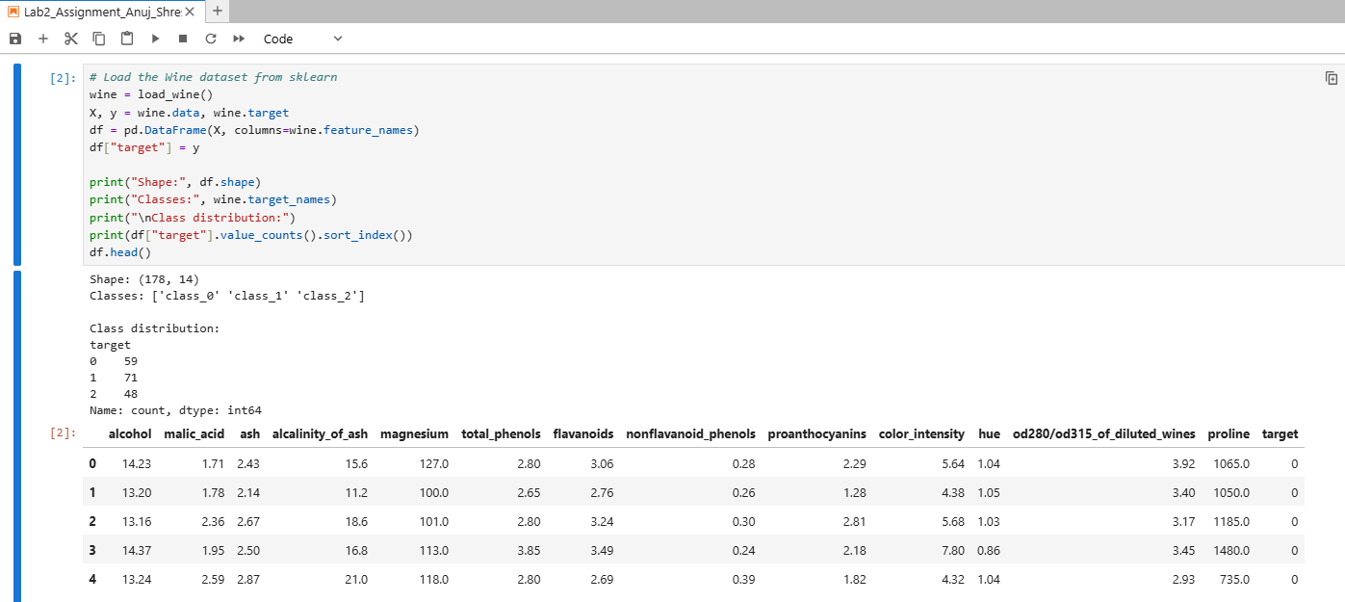
The Wine dataset was loaded from sklearn into a DataFrame with 178 samples and 13 chemical features, plus a target column, giving 14 columns. The three wine classes have 59, 71 and 48 samples, so the classes are reasonably balanced.
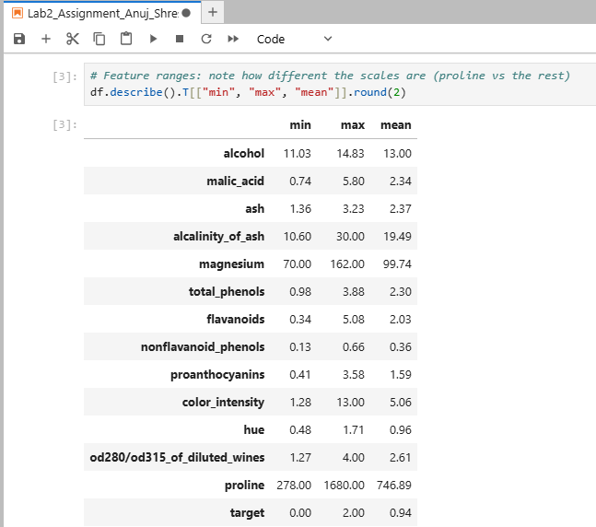
The feature ranges differ widely. Proline runs from 278 to 1680 and magnesium from 70 to 162, while most other features stay below about 15. This matters for KNN and RNN, because distance-based methods are dominated by the features with the largest scale.
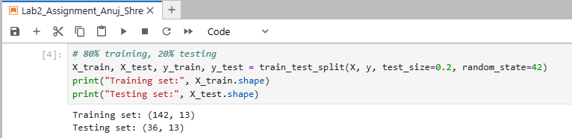
The data was split 80% training and 20% testing with random_state=42, giving 142 training samples and 36 testing samples with 13 features each.

Step 2: Implement K-Nearest Neighbors (KNN)
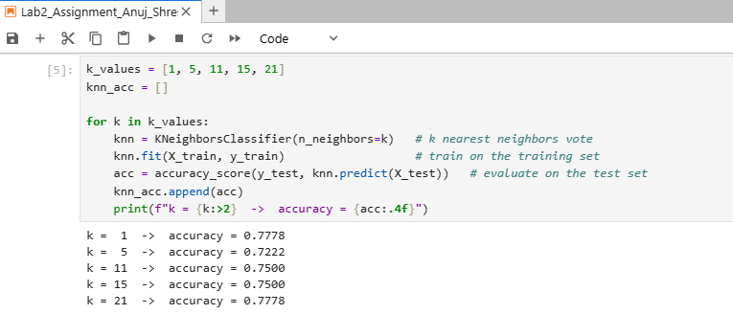
A KNN classifier was trained for each k (1, 5, 11, 15 and 21) and evaluated on the test set. Accuracy was 0.7778 for k = 1, 0.7222 for k = 5, 0.7500 for k = 11 and k = 15, and 0.7778 for k = 21.

Step 3: Implement Radius Neighbors (RNN)
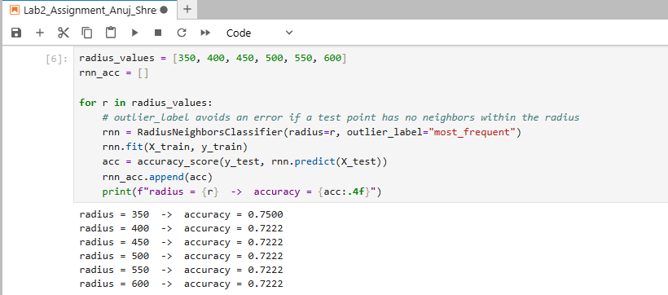
An RNN classifier was trained for each radius from 350 to 600. Accuracy was 0.7500 at radius 350 and 0.7222 for every larger radius. The outlier_label option was set to "most_frequent" so that a test point with no neighbors inside the radius would not cause an error.

Step 4: Visualize and Compare Results
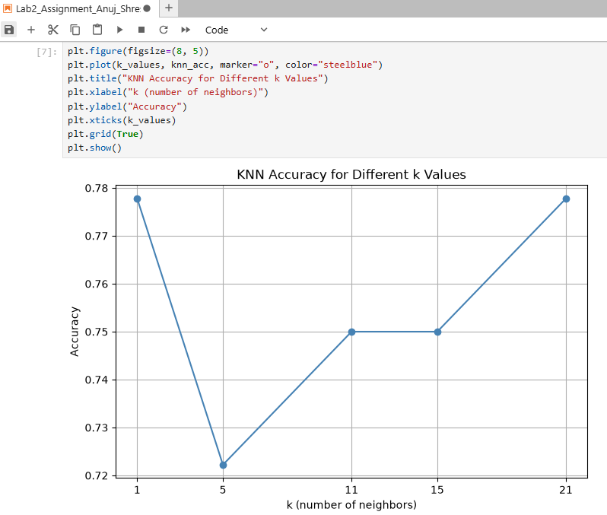
KNN accuracy is highest at k = 1 and k = 21 (about 0.78), lowest at k = 5 (about 0.72), and level at 0.75 for k = 11 and k = 15. There is no steady trend, and the whole range spans only about six percentage points.
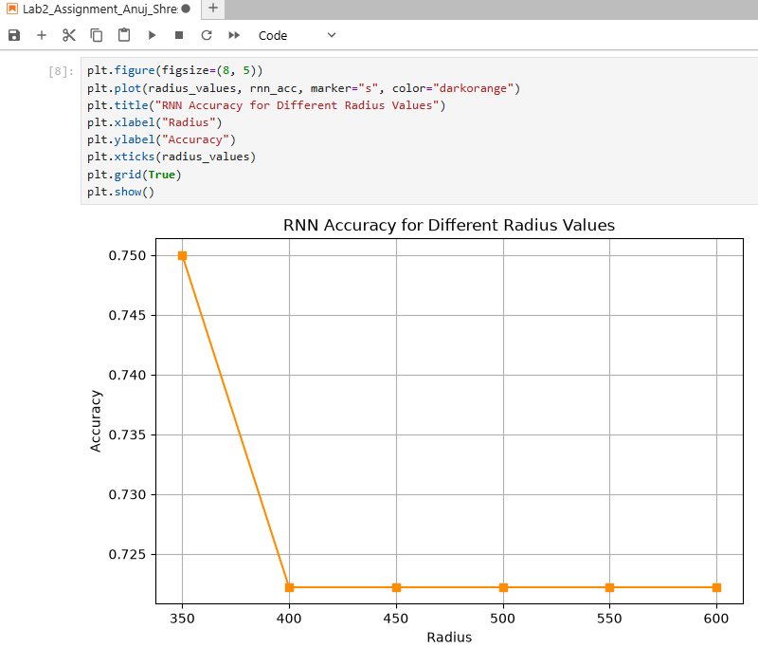
RNN accuracy is 0.75 at radius 350, falls to about 0.72 at radius 400, and then stays flat through radius 600. A larger radius puts more training points into each vote, so the predictions stop changing.
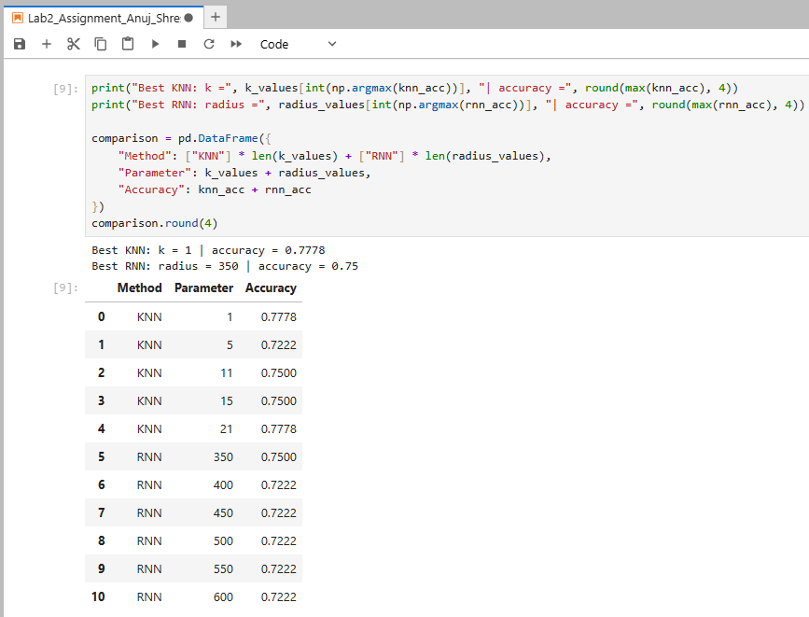
The best KNN result was 0.7778 at k = 1 and the best RNN result was 0.75 at radius 350. KNN is slightly ahead, but with only 36 test samples the gap equals a single sample (28 versus 27 correct), so the two methods perform about the same here.
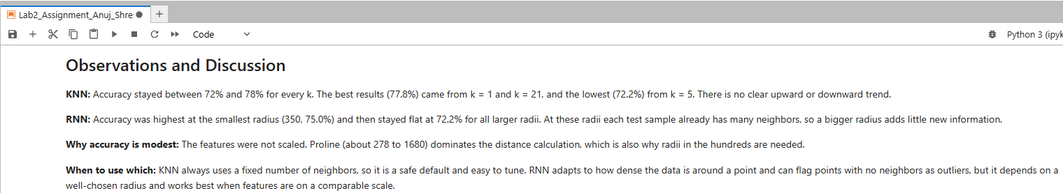
The Markdown cell records the observations for both models and explains when each method is preferable. The full text is repeated in the summary at the end of this document.
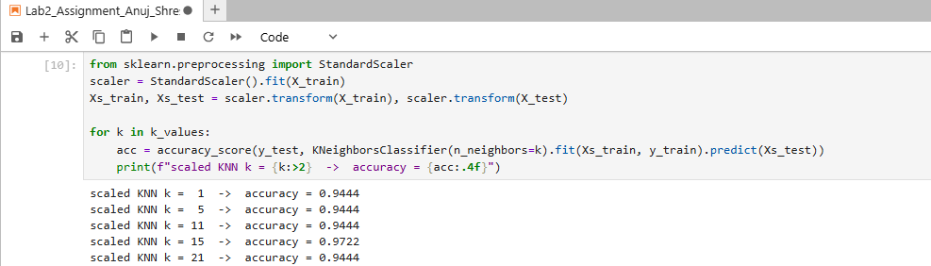
As an extra check, the features were standardized before running KNN. Accuracy rose to 0.9444 for most values of k and 0.9722 at k = 15, roughly 20 percentage points above the unscaled results. Feature scaling matters far more than the choice of k.

Conclusion

KNN results: Accuracy stayed between 72% and 78% for every k. The best results (77.8%) came from k = 1 and k = 21, and the lowest (72.2%) from k = 5. There is no clear upward or downward trend.
RNN results: Accuracy was highest at the smallest radius (350, 75.0%) and then stayed flat at 72.2% for all larger radii. At these radii each test sample already has many neighbors, so a bigger radius adds little new information.
Why accuracy is modest: The features were not scaled. Proline (about 278 to 1680) dominates the distance calculation, which is also why radii in the hundreds are needed. Standardizing the features lifted KNN accuracy to about 94% to 97%.
When to use which: KNN always uses a fixed number of neighbors, so it is a safe default and easy to tune. RNN adapts to how dense the data is around a point and can flag points with no neighbors as outliers, but it depends on a well-chosen radius and works best when features are on a comparable scale.
Challenges and decisions: Choosing the radius was the main difficulty, since a value that is too small leaves a test point with no neighbors. The outlier_label safeguard handled that case. The results also come from a single split with 36 test samples, where one sample changes accuracy by about 2.8 percentage points, so small differences between k values or radii should not be over-interpreted.

