# CHAPTER 1 INTRODUCTION

## Description:

A Web project to help farmers ensure greater profitability through direct farmer to supplier and farmer to farmer communication. This service boosts business communication and brings transparency in the system. Separate login areas with appropriated functionality for farmers, suppliers and authorities. A separate page where only farmers can post complaints and only assigned administrators can read and edit this page.

This innovative site allows for good farmer, retailer and supplier communication. It allows farmers to login and communicate to respective dealers. When dealers publish an advertisement or offer, the respective farmers get notified via SMS message. The farmers may also submit their grievances and complaints to respective dealers or authorities using their farmer login on a separate complaints page and authorities will get access to that page regularly using their login id and passwords.

This web project provides following features:

* + - Separate login areas with appropriated functionality for farmers, administrators and dealers/ retailers.
    - A separate page where only farmers can post complaints and only assigned administrators can read and edit this page.
    - Pages where dealers and retailers may post their ads and notifications.
    - Farmers are notified of these notifications via SMS whenever new ads are published.
    - An effective GUI so that rural people may easily use the service.
    - Can be over for multiple villages to communicate and deal with each other.

## An Overview of Farming Assistant System:

Although most people can see the benefits of using a more precise approach to manage crops with additional information, the tool provided by precision farming and other information technologies have not yet moved into mainstream agricultural management.

The increased complexity of the systems inhibits easy adoption and makes calculations as to the financial benefits uncertain. These issues can be resolved by improving the decision making process though better Management Information Systems, improved data interchange standards and clear management methods. The starting point has been the identification of the current and future data, information and knowledge management needs on the farms, as well as on the way that these needs will evolve in the future and that will influence farm data, farm information and farm knowledge management systems.

At the moment, the utilization of scientific models together with the large amounts of data in different formats produced by modern Farm machinery, sensors located within the farm, remote sensing, etc. is still an open area of research and new methods are developed continuously. The seamless incorporation of new functionality and assisting features into an existing system is of paramount importance.

## Supplier:

* + - * **Register-**The supplier first need to be registered himself to login.
      * **Login-** The supplier need to login in to get access to the system.
      * **Post Advertisement-** Pages where dealers and retailers may post their ads and notifications. The post consists of crop id, crop name, crop image and quantity required. Farmers are notified of these notifications via SMS.
      * **Crop Received-**It is result of post that notified that the crop is accepted or not to the farmers.

## Farmer:

* + - * **Register-**The farmer first need to be registered to login.
      * **Login**-The farmer need to login in to get access to the system.
      * **Complaint Page-**The page where farmers can post their complaints and only assigned administrators can read and edit this page.
      * **View Complaint Status -**In this page farmers can view the complaints details by viewing the status of complaints is read or unread.
      * **Crop Advertisement Details -**This page consist of crop advertisement details post by the

supplier and the status of the sell crop accepted by the supplier or not.

* + - * **Sell Product-**This page is for sailing the crop to the supplier. This includes crop id, Supplier name, crop name, quantity and prices.
      * **Sell product Details-**This page consist of crop details sold by the farmer.

## Admin:

* + - * **View Complaints -**This page contains the complaints of the farmers.
      * **Farming Tips-**The admin gives the farming tips to the farmers.

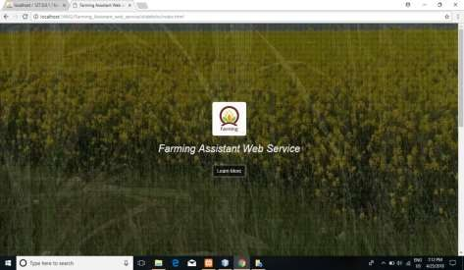

Farming Assistant System Home

## Resource Allocation:

This includes three main research areas. Firstly, it traces the agricultural problems, technology adoption role and issues through extension services particularly in India and in the world in general. Secondly, by finding the factors that are affecting the extension services through proper use of ICTs or determining the factors of transfer of technologies. By doing so, this chapter helps build the fundamental concepts of ICT and decision making at all levels of agricultural decision making process. Lastly, it presents a comprehensive review of various models used by previous researchers in facilitating the information content concerned with farmers in retrieving the information needed in their decision making process.

## Motivation:

Role of middleman in the marketing of agricultural commodities which leads continuous loss to farmers.

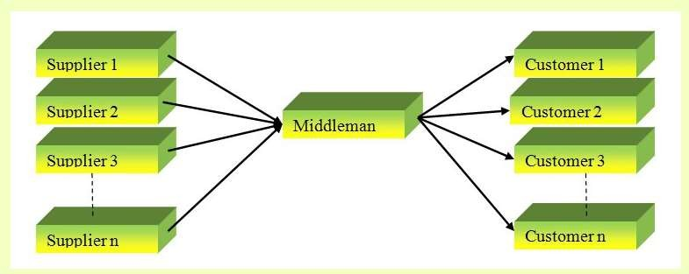

Figure 1.1. Role of middlemen

Usually traders are the middlemen, who link the farmer’s produce with the consumers. Sometimes they also build linkages with the different market far away from the production area. Many times, they are neglected and tried to sell directly in the market. Actually, the profit margins for the farmers are more than 60 per cent but due to low quantity of transaction, farmers are not benefited.

## Problem Statement:

New government mandates and regulations. Stability, development and fluctuations in global financial markets Agricultural marketing continues to be in a bad shape in rural India. In the absence of sound marketing facilities, the farmers must depend upon local traders and middlemen for the disposal of their farm produce which is sold at throw-away price.

Storage facilities in the rural areas are either totally absent or grossly inadequate. Under such conditions the farmers are compelled to sell their produce immediately after the harvest at the prevailing market prices which are bound to be low. Such distress sale deprives the farmers of their legitimate income.

## Scope:

Scope of the project includes:

* + - Through this project farmers ensure greater profitability.
    - This service boosts business communication and brings transparency in the system.
    - Can be over for multiple villages to communicate and deal with each other.
    - Farming tips is given to farmer easily and their compliant can be solved.

# CHAPTER 2 MATERIAL AND METHODS

## Methodology

The objective was to create a Web Application that could perform the following:

* Opening the relevant html pages using **HTTP POST & GET**.
* **Parsing** the farmers, supplier info/corps/problems data logically.

## Implementation and Technology Used:

* HTML
* CSS
* JAVASCRIPT
* ANGULAR 6.X
* JAVA 8
* Spring Boot/Microservices
* Spring Security(JWT)
* Junit 5.x
* MY SQL 5.5
* STS IDE

## Design

Identifying the main entities, their attributes, relationships and constraints, commences the design of a database application. The entities of an agricultural information system represent different information on crops. This include crops and intercrops, production and export, crop and inter-crop diseases, soil suitability, fertilizer, research institutes. These entities are inter-related by crop, product or institute. Characteristics of some of the entities are given in table 2.1. The table and attribute names Used for these entities and their characteristics are given within brackets in italics font Style.

|  |  |
| --- | --- |
| **Entity** | **Characteristics** |
| Crops Specialization (*Crops Specialization*) | Name of the crop (*Crop_Name*) Unique code of the crop (*Crop_No*) |
| Farmers details | Name of the farmer(Farmer_ *Name*)  Unique code of the farmer (farmer_*id*) |
| Suppliers details | Name of the Supplier(Supplier _Name)  Unique code of the Supplier(Supplier_*id*) |
| Post Advertisement | Name of the Crop(Crop_Name)  Unique code of the advertisement (post_*id*) |
| Sell crop details | Name of the Crop(Crop_Name) Unique code of the sold crop (sell_*id*) |
| Farming Tips | Unique code of the Tips (*id*) |
| Complaints of Farmers | Unique code of the farmer (farmer_*id*) Unique code of the Complaint(complt_*id*) |

**Table 2.1:** Selected Entity / Characteristics of a farming assistant web service

## Implementation

The set of tables is created using the relational database for the identified entities at the design stage. The uniqueness of the data fields in these tables are established using primary keys, while the relationships are maintained using foreign keys [ELM94, FER98]. The web pages of this farming assistant web service will guide the use and operation of this system. Figure 1 illustrates the index page for our farming assistant web service Respective modules there and is chosen through a hyperlink of this page. For instance information on research done on rubber by institutes can be viewed through respective the hyperlinks.

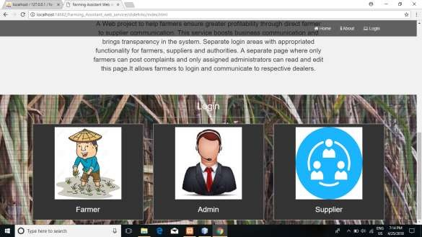

Index page of Farming Assistant System

The system will be having only one User-name and Password section on the front page, as per the user-name and password the system will know whether user is Farmer/Customer/Dealer. We follow the MVC design pattern for developing our system. Model–view–controller (MVC) is a software design pattern for implementing user interfaces on computers. It divides a given software application into three interconnected parts, so as to separate internal representations of information from the ways that information is presented to or accepted from the user.

## 2. 6 Database Implementation:

After getting the requirement of a logical design and structural design of our database, we can move to the implementation stage. In general, implementing our structural design involves defining the various objects and enforcing the constraints on the data relationships. The implementation phase is where you install the DBMS on the required hardware, optimize the database to run best on that hardware and software platform, and create the database and load the data.

### Database of Supplier:

In database, supplier database gather into user table. When supplier create an account then all information of user store into supplier table. In user table store supplier password, email, name, mobile number,address, gender and profile image. If user wants to login website then need that information.

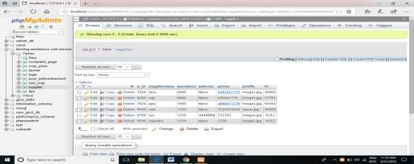

Database of supplier

### Database of Admin:

Admin database store admin login info into admin table. This table store id and password. This table also store access label which type of admin login into admin panel. Our website has two type admin so we use two access label.

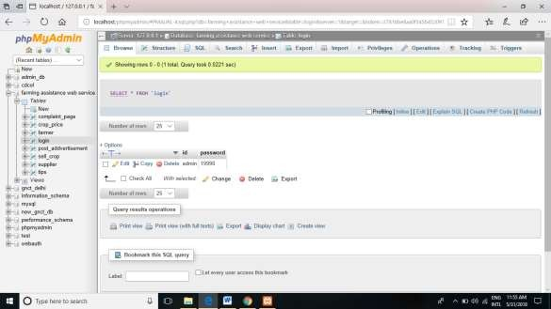

Database of admin

### Database of farmer:

In database, farmer database gather into user table. When farmer create an account then all information of user store into supplier table. In user table store farmer password, email, name, mobile number,address, gender and profile image. If user wants to login website then need that information.

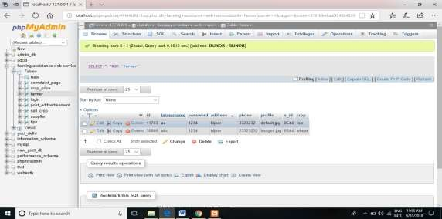

Database of farmer

# CHAPTER 3 LITERATURE SURVEY

This chapter reviews three main research areas. Firstly, it traces the agricultural problems, technology adoption role and issues through extension services particularly in India and in the world in general. Secondly, by finding the factors that are affecting the extension services through proper use of ICTs or determining the factors of transfer of technologies. By doing so, this chapter helps build the fundamental concepts of ICT and decision making at all levels of agricultural decision making process. Lastly, it presents a comprehensive review of various models used by previous researchers in facilitating the information content concerned with farmers in retrieving the information needed in their decision making process.

## Resource Allocation

Much of the project scheduling literature treats task durations as deterministic. In reality, however, task durations are subject to considerable uncertainty and that uncertainty can be influenced by the resources assigned. The purpose of this paper is to provide the means for program managers (who may have responsibility for multiple projects) to optimally allocate resources from common resource pools to individual tasks on several competing projects. Instead of the traditional use of *schedules*, we develop *control policies* in the form of planned resource allocation to tasks that capture the uncertainty associated with task durations and the impact of resource allocation on those durations. We develop a solution procedure for the model and illustrate the ideas in an example.

## Multipurpose Farming Assistant System

The farming web service is multipurpose site which not only provide direct communication between farmer and supplier but also provide communication with admin. The Supplier post the crop advertisement and the farmer will get this add it on his account and sell crop to supplier according to add. The supplier also has the crop received page in his module that updates the status when crop is received by supplier. These will not only provide the farmer to sell their crop but also help them to solve their problems and complaints. The admin also give the farming tips to the farmer help farmers ensure greater profitability

through direct farmer to supplier and farmer to farmer communication. This service boosts business communication and brings transparency in the system.

* + - Through this project farmers ensure greater profitability.
    - This service boosts business communication and brings transparency in the system.
    - Can be over for multiple villages to communicate and deal with each other.
    - Farming tips is given to farmer easily and their compliant can be solved.

## Application:

This system can be used in developing countries to enhance farmer, manufacturer, and retailer communication thus eliminating unnecessary intermediaries.

## Our Product:

* + - The farming assistant web server brings farmer and supplier close.
    - Farmer can sel their product directly to supplier without any middlemen.
    - Farmer can post complaint that wil handle by the administration.
    - The supplier adds the crop as advertisement that is needed by the supplier.

## System Analysis:

The architecture of the whole project is analysed. System analysis is the process of defining the architecture, components, and data of a system to satisfy specified requirements. Design is a method of studying a system by examining its component parts and their interactions. Before implementation began the system was analysed and designed. In this section, use cases, requirement analysis, and other part are described in details.

## Requirement Analysis:

Web service of farmer product required the following requirements. This has mainly four actors. Those are Admin, Farmer and Dealer. This website give service of farmer product to sell holder is known as dealer.

### Data Requirement

During requirement analysis the following data have been identified for a web service of farmer product system: At first each person need to register (without admin) himself/herself as a customer or a farmer or a dealer for accessing the user’s necessary information. Each user requires an unique username or email Id and password to register in the website. Admin/Farmer need to login to the system to operate the system. Admin/Farmer has an individual or unique login user id and password. Through this user id and password admin/farmer can login to the system. A supplier can select a product for buying and post add. Supplier also can pay cash on delivery.

### Process Requirement

The following process requirements are identified for system:

* + - * A valid login is required for all process to be performed. A valid login is required for every registered users and admin. All of them have a valid user id and password. System will authenticate their valid login.
      * After valid login Dealer can check his information, can see personal information and can check product history and buy product.
      * Admin can login to the system. Admin can view complaint and provide Tips too. Admin can also enter new category in the list and insert new product.
      * Farmer can login to the system. Farmer can view, delete, publish and update product info. Farmer can also enter new product in the list and insert new info.

## Features:

* + - Separate login areas with appropriated functionality for farmers, administrators and dealers/ retailers.
    - A separate page where only farmers can post complaints and only assigned administrators can read and edit this page.
    - Pages where dealers and retailers may post their ads and notifications.
    - Farmers are notified of these notifications via SMS whenever new ads are published.
    - An effective GUI so that rural people may easily use the service.
    - Can be over for multiple villages to communicate and deal with each other

# CHAPTER 4

**OVERALL DESCRIPITION OF PROJECT**

## Data flow diagram:

Supplier Login

Accepted

Login

Farmer

Crop advertisement details

Complaint page

Compliant status

Sell product

Login

Admin

View complain

Farming tips

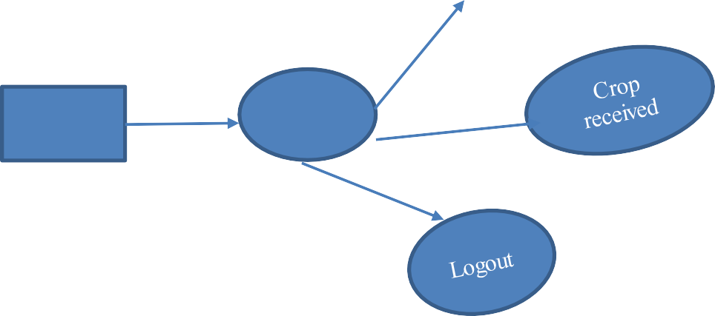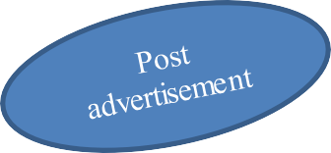

Logout

**Figure 4.1** DFD

## Module Description:

### Supplier:

Supplier module contains:

* + - * Supplier details
      * Post Advertisements
      * Crop Received
      * Edit Supplier Details

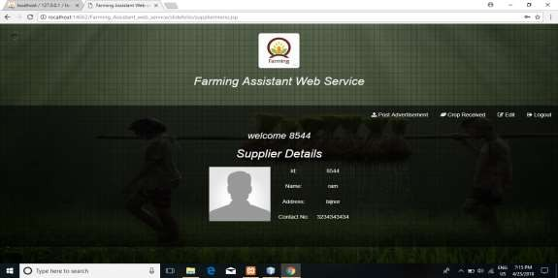

Supplier details

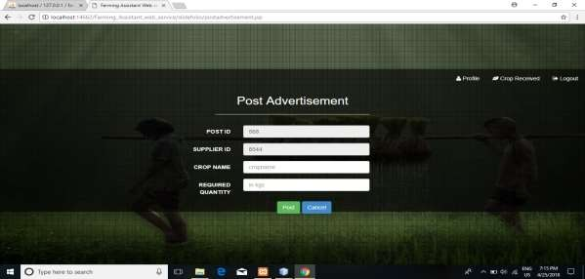

Post advertisement

### Farmer:

Farmer module contains:

* + - * Complaint Page
      * Complaint Status
      * Farming Tips
      * Crop Advertisement Details
      * Sell Crop
      * Sell Crop Details
      * Edit Farmer Details

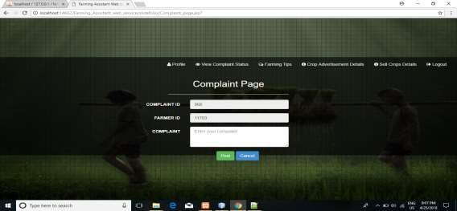

Complaint Page

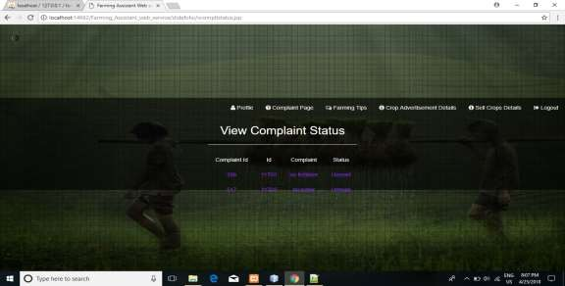

View Complaint Status

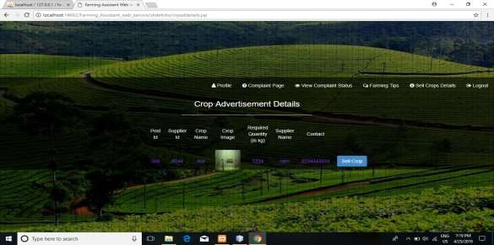

Crop Advertisement Details

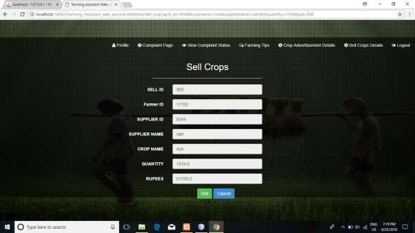

Sell Crop

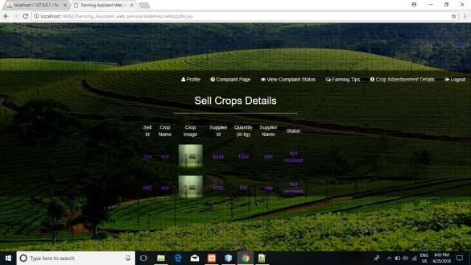

Sell Crop Details

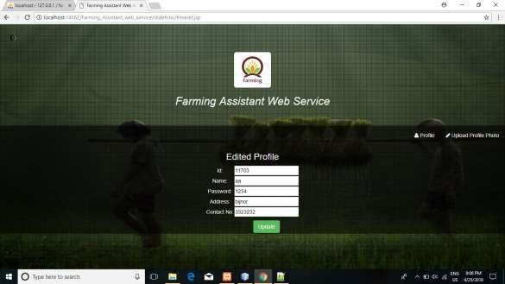

Edit Details

### Admin

Admin module contains:

* + - * View Complaint
      * Farming Tips

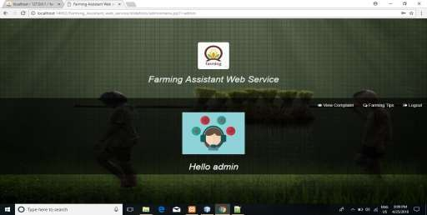

Admin Home

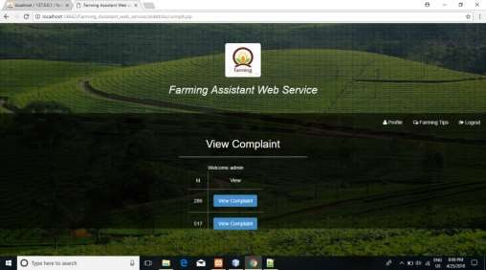

View Complaint

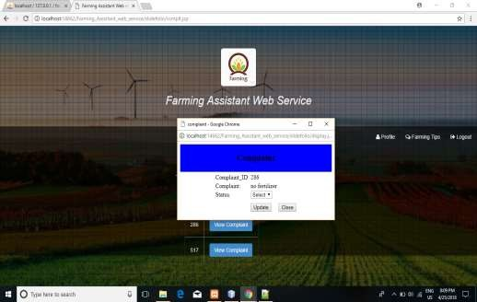

Update status

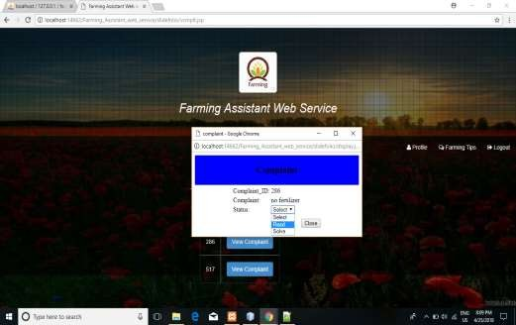

Select Status

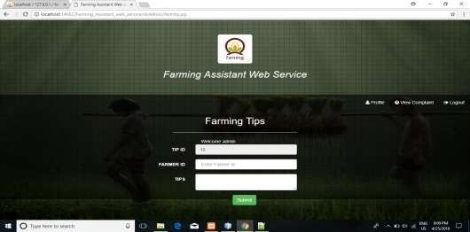

Farming Tips

# CHAPTER 5 CONCLUSION AND FUTURE WORK

## Conclusion

The “Farming Assistant Web Service” is successfuly designed and developed to fulfil the necessary requirements, as identified in the requirements analysis phase, such as the system is very much user friendly, form level validation and field level validation are performing very good. The old manual system was suffering from a series of drawbacks. The present project has been developed to meet the aspirations indicated in the modern age. Through the developed project, anyone can visualize the effectiveness and efficiency in the real life. It is very helpful for computerization or doing automation of a personal information management system. This program helps reduce the manual method and stress which is done by a person and that is time consuming and lengthy process. With this application user’s information are stored very efficiently in a secured database. Trend of information improvement in the generation has improved the quality and services of human operation just as the case of this application for job services has reduce the mobility rate of human and improve their standard of database storage.

## Future Work

The future plan of this project is to improved design; implementation and documentation in such a way that anyone can use this project for better perform. I will develop the site more dynamically. In future I will add the few modules for better improvement of the project such as, real-time chat bot option for user and farmer, so that user can directly enquiry theirs problem on any time through the chat bot. Video conversation option for supplier and farmer and admin and barcode generation for membership card and using online buy and sell product. Online account verification and notification for user for specific job category they searching for jobs. In future I will also add mobile version app of this website.