**User instructions**

**Context of experiment**

The OSi wants to links their authoritative linked data dataset with DBpedia to be included in the Linked Open Data diagram; a set of Linked Open Datasets that are interlinked and meeting certain quality criteria. In this experiment, you take on the role as someone from the OSi responsible for curating these links, and therefore are responsible for their quality. You are taking up this role along with two other users. You and your colleagues can discuss and present your arguments with the help of mapping framework. Conclusion could be make whether the links can be accepted or not, based on the mutual consent. If there is a disagreement, you and your colleagues could vote and conclude based on the majority.

**Follow the below steps for linking OSI dataset with DBpedia**

**Step 1:** Follow the following URL to access the mapping governance platform: <http://theme-e.adaptcentre.ie/portal1/> . The link will lead you to the login page of the platform.

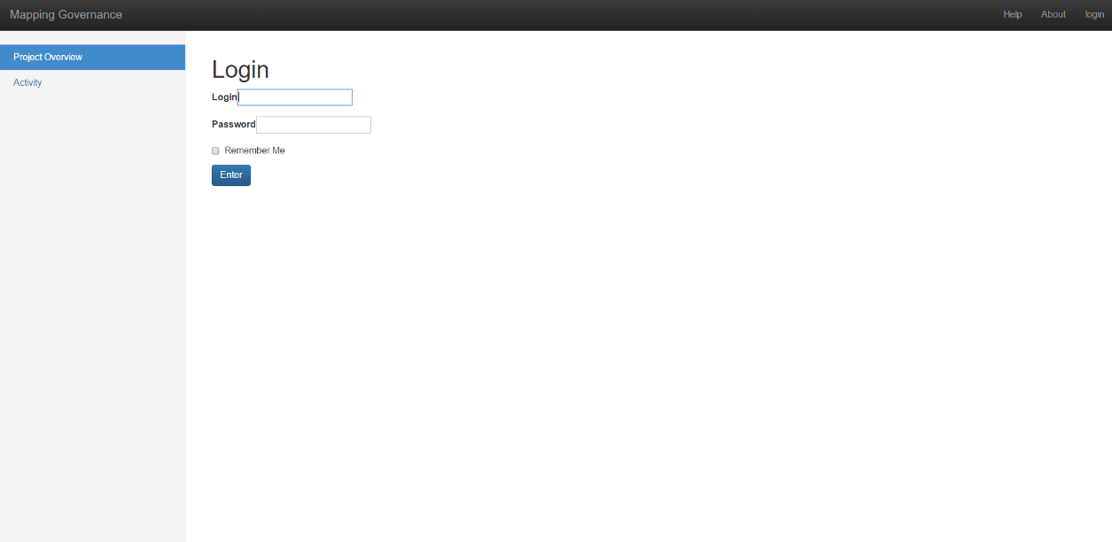

**Step 2:** Please provide the below credentials:

*Username and password will be provided at the time of experiment*.

**Step 3:** Once you cleared the login step, you will find the following web page on the browser. The following webpage present the ontology mapping projects currently in progress. The table on the page present the “title” of the project, creator (username of the stakeholder who created this project) and created (timestamp when this project has been created).

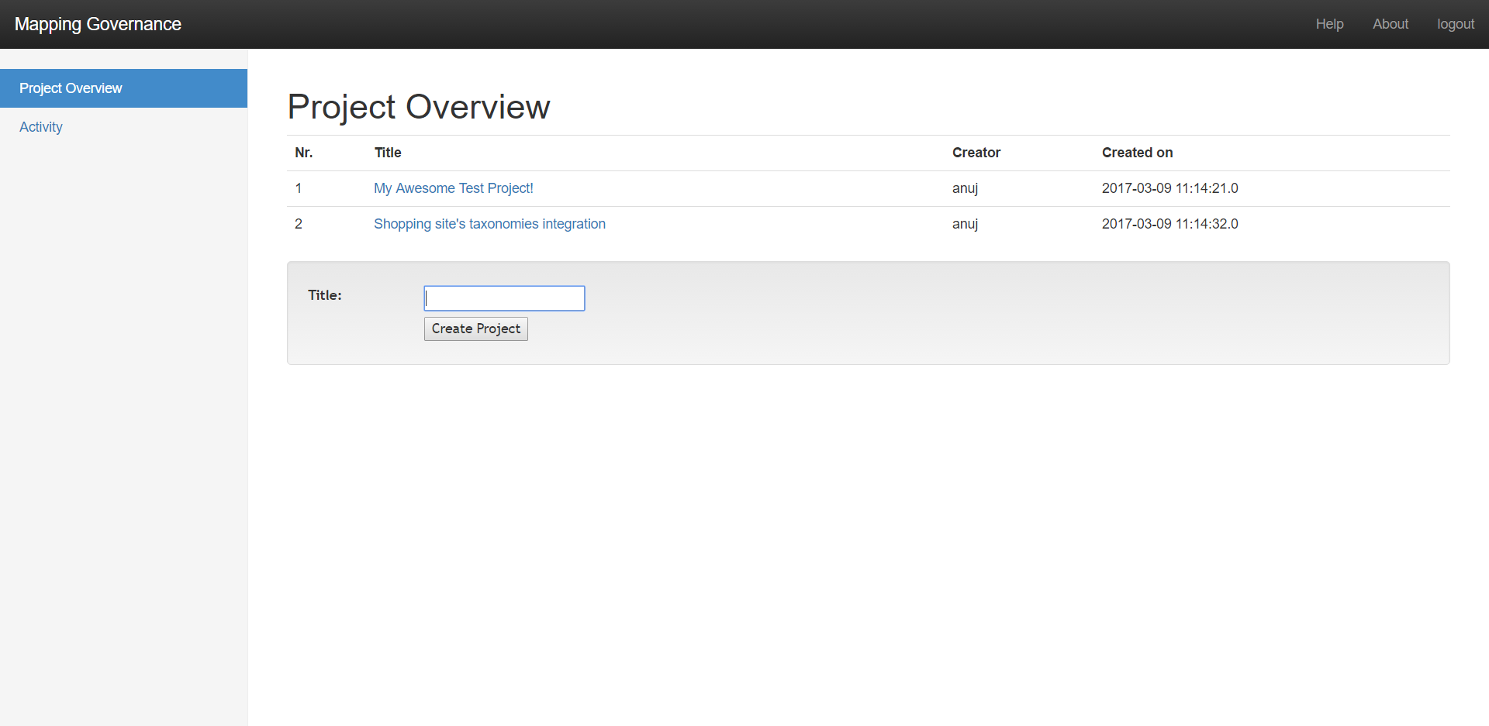

**Step 4:** Click on the link circled with red in the above webpage. This link will redirect you to the project overview page as shown in following figure. The following webpage present the details of the selected project. The Discussion table on the page present all the activities done on the project while the project was progressing. This table present the “title (type of activity)”, “creator (stakeholder who initiated this activity)”, “created (timestamp at which the activity has been initiated)” and “status (the current state of the activity)”. Status table present the current phase and the phases which project has already cleared, this table also present the starting and ending timestamp of the respective phase.

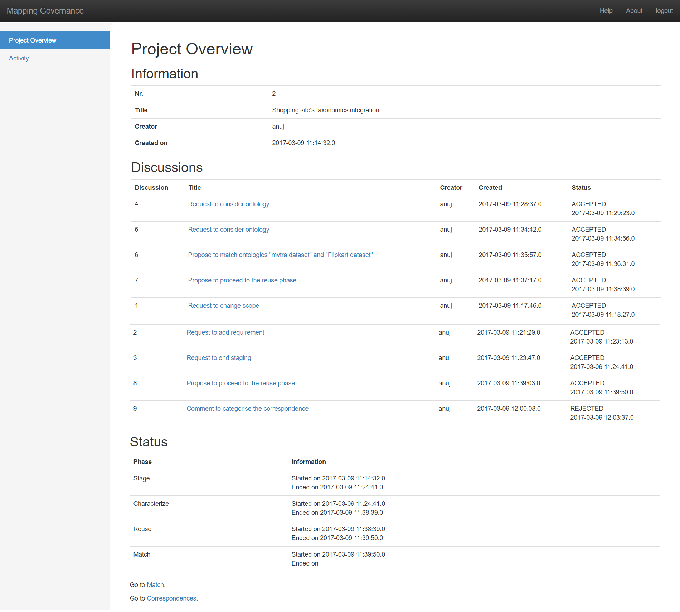

**Step 5:** Click on the correspondences link circled with red in the above webpage. This link will redirect you to the page where you will be able to locate all the correspondences. The redirected page will look like as the following page. The table on the following webpage present all the correspondences identified between the two different ontologies. These correspondences are the result of matching of two ontologies (researcher has done the matching with the Alignment API). This table present the correspondenceid( unique identifier attached to each correspondence), object1(entity of ontology 1), object2(entity of ontology 2), relation (type of relationship exist between object1 and object2), strength(the confidence value for the relation) and decision(status of the correspondence). You need to click the link 1 for the information of object1 and link 2 for the information of object2. These link will redirect you to the pages, where you can find the detail information about these entities. This information will help you in the next steps to be carried out, which is to decide whether this correspondence is acceptable or not. Figure 1 and Figure 2 depicts the webpages which are associated with the link 1 and link 2 respectively.

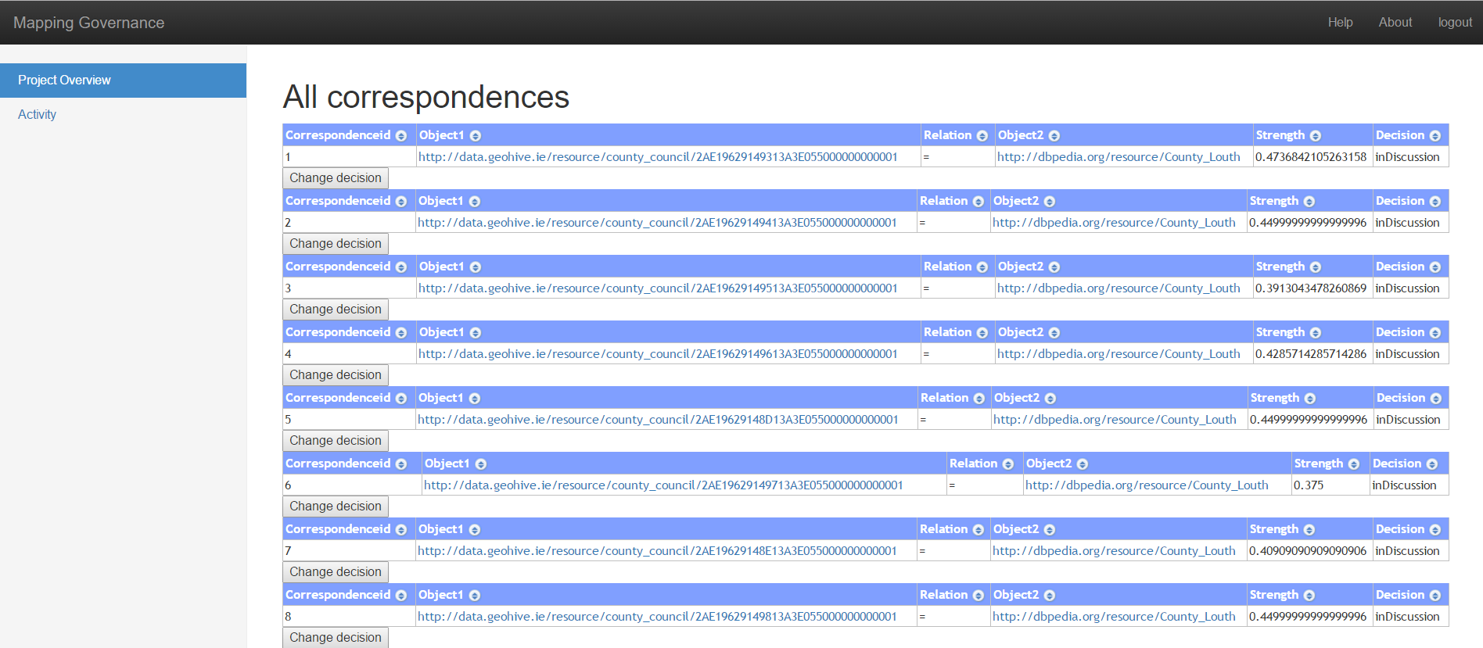

Link 1

Link 2

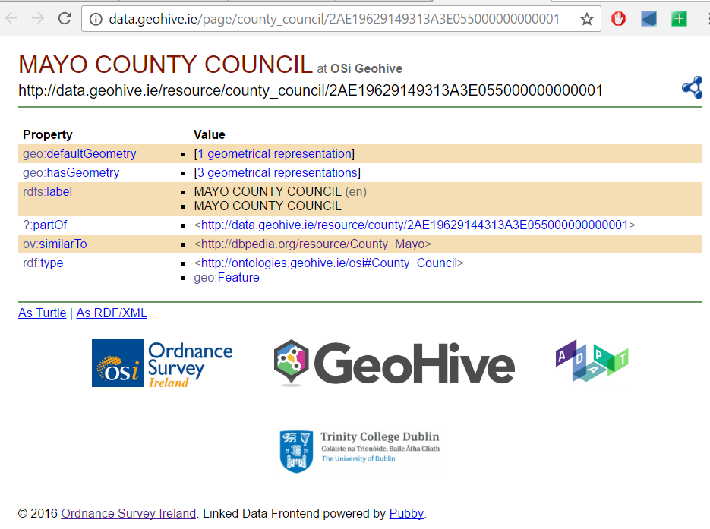

**Figure 1: Link 1 webpage**

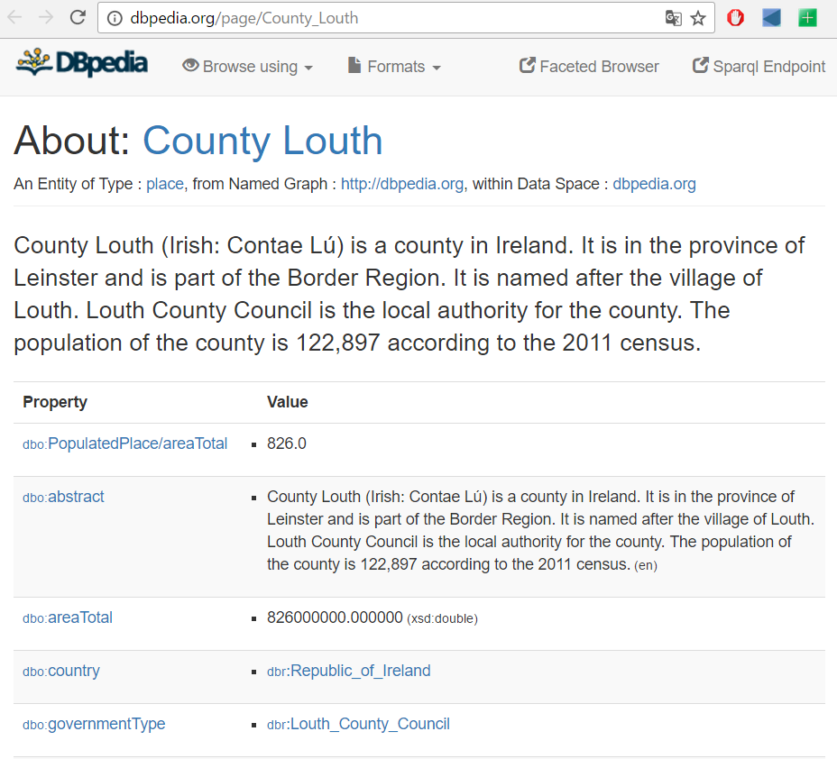

**Figure 2: Link 2 web page**

**Step 6:** To discuss (please find the guidelines for a good discussion at the end of this document) a correspondence, you need to click the “Change decision” button (marked with the red circle in the above image). This will redirect you to the following page, where you can add your comments in the “reply” box. You need to select the appropriate “reply type” for your comment before adding your reply, reply could be of type “example (evidence for supporting or objecting a statement), “motivation (reason for supporting or objecting a statement)”, “justification (action of showing your statement to be supporting or objecting)” “Add reply” button need to be used for adding your comment.

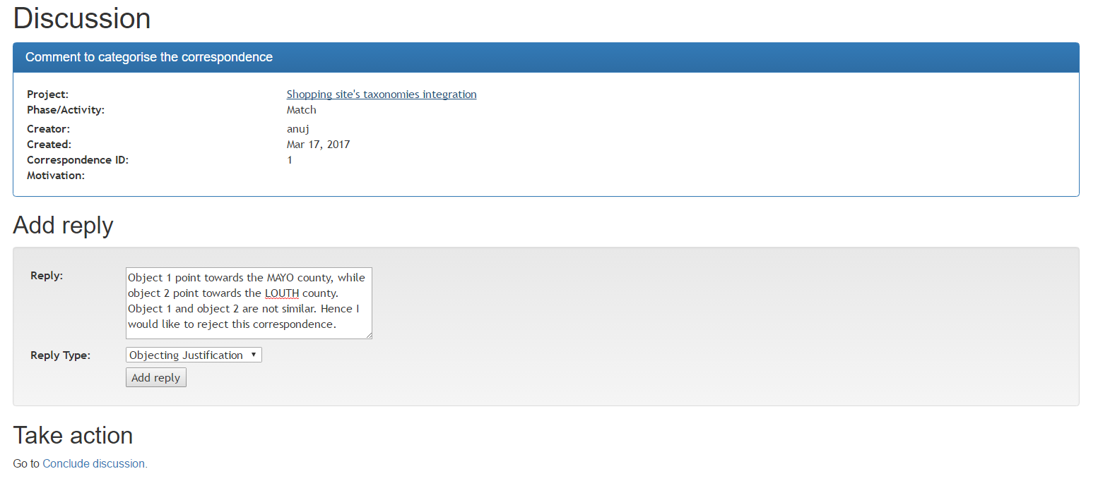

Add comments

Add reply

Add reply type

**Step 7:** You can continue to discuss as explained in step 6, once all participants reaches to a conclusion, you or any of your colleagues can conclude the discussion by clicking the “Conclude discussion” button, which will redirect you to the following page, where you can add the conclusion with the select outcome, whether the correspondence is being “Accepted” or “Rejected” by you and your colleagues. Once done with adding comment and outcome, press “Take action” button, so that your decision will be saved.

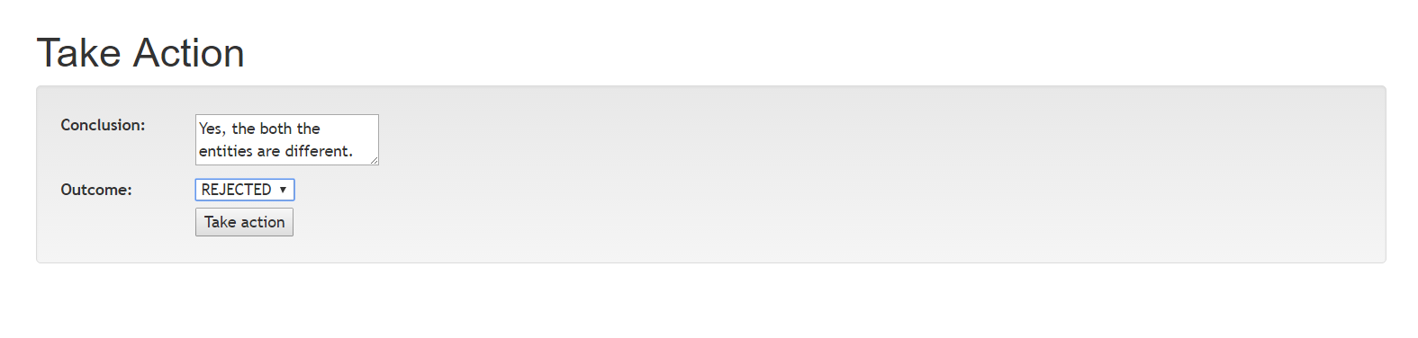

Save decision

Add outcome of the discussion

Add conclusion

**Step 8:** Your decision will be reflected on the page, which displays all the correspondences. You can locate your decision in the “decision” column of the table, as shown in the following figure.

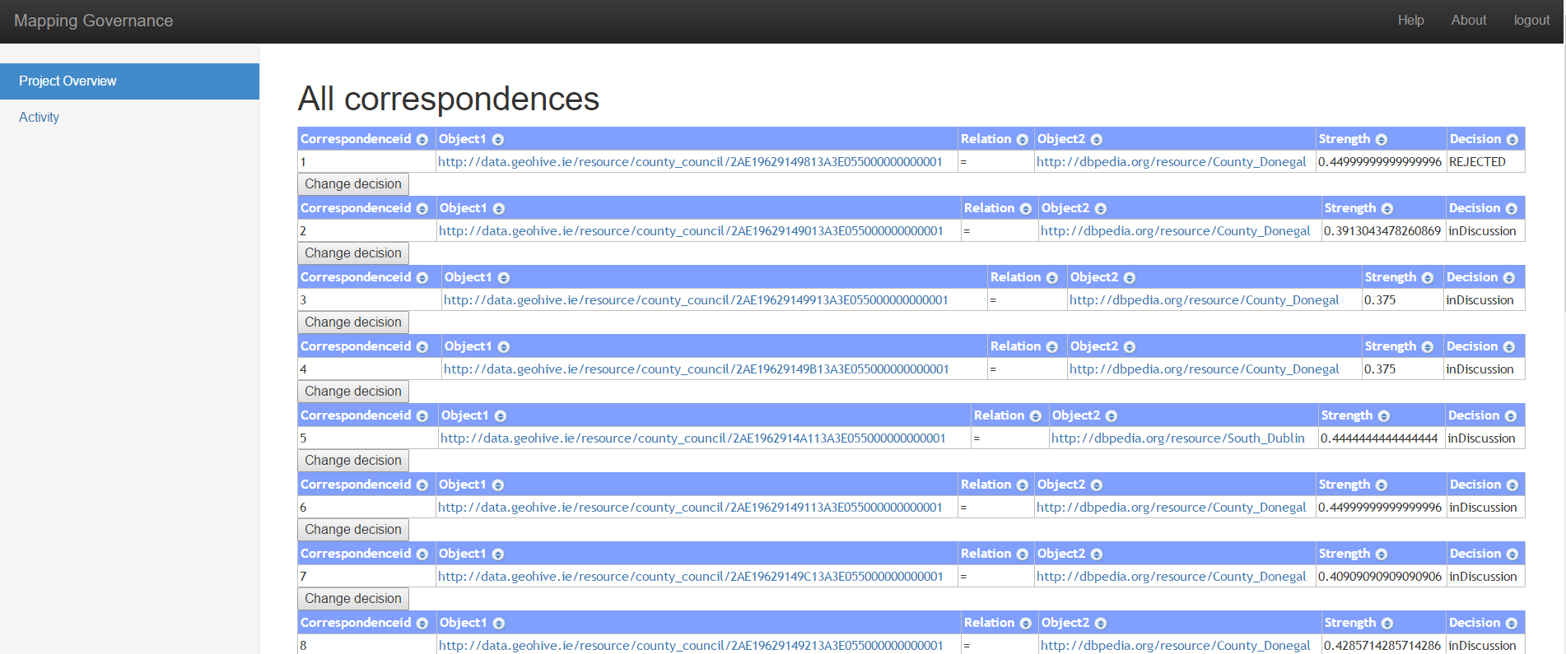

**Guidelines for a good discussion [1]:**

**Participate:** This is a shared environment for discussion. It is not enough to login and read the discussion thread of others. For the maximum benefit to all, everyone must contribute.

**Report Glitches:** This framework is electronic. If for any reason you have trouble participating, please inform researcher about the issue. Chances are others are having the same problem.

**Be Patient:** Read everything in the discussion thread before replying. This will help you avoid repeating something someone else has already contributed. Acknowledge the points made with which you agree and suggest for those with which you don’t.

**Be Brief:** You want to be clear—and to articulate your point—without being preachy or pompous. Be direct. Stay on point. Aim for clear, direct sentences so your colleagues can follow your comments.

**Use Proper Writing Style:** This is a must. Write as if you were writing a term paper. Correct spelling, grammatical construction and sentence structure are expected.

**Cite Your Sources:** Another big must! If your contribution to the discussion includes the intellectual property (authored material) of others, e.g., books, newspaper, magazine, or journal articles—online or in print—they must be given proper attribution.

**Emoticons and Texting:** Social networking and text messaging has spawned a body of linguistic shortcuts that are not part of the discussion in this framework. Please refrain from :-) faces.

**Respect Diversity:** It’s an ethnically rich and diverse, multi-cultural world in which we live. Use no language that is—or that could be construed to be—offensive toward others. Racists, sexist, and heterosexist comments and jokes are unacceptable, as are derogatory and/or sarcastic comments and jokes directed at religious beliefs, disabilities, and age.

**No YELLING!:**Step carefully. Beware the electronic footprint you leave behind. Using bold upper-case letters is bad form, like stomping around and yelling at somebody (NOT TO MENTION BEING HARD ON THE EYE).

**No Flaming!:** Criticism must be constructive, well-meaning, and well-articulated. Please, no tantrums. Rants directed at any other contributor are simply unacceptable and will not be tolerated. The same goes for profanity. The academic environment expects higher-order language.

1. http://teaching.colostate.edu/tips/tip.cfm?tipid=128