Statistics for Data Analytics
Part | Topic
Session 1 | Introduction to Statistics (Descriptive vs Inferential)
Session 2 | Types of Data & Measurement Scales
Session 3 | Measures of Central Tendency (Mean, Median, Mode)
Session 4 | Measures of Dispersion (Range, Variance, Std Dev)
Session 5 | Percentiles, Quartiles & Boxplots
Session 6 | Probability Basics
Session 7 | Conditional Probability & Bayes' Theorem
Session 8 | Probability Distributions (Discrete)
Session 9 | Probability Distributions (Continuous)
Session 10 | Sampling Techniques
Session 11 | Central Limit Theorem
Session 12 | Hypothesis Testing Concepts
Session 13 | t-tests (One-sample & Two-sample)
Session 14 | Chi-Square Test
Session 15 | ANOVA (Analysis of Variance)
Session 16 | Correlation Analysis
Session 17 | Introduction to Regression (Simple Linear Regression)
Case Study 1 | E-Commerce Sales Analysis (Excel Edition)
Case Study 2 | Customer Churn Analysis (Excel Edition)

CONTENTS

Session 1: Introduction to Statistics (Descriptive vs Inferential)

Task 1: Create the data
Create a column 'Order Amount' with 20 random numbers between 100 and 1000 (Zomato order values for a day).
In Excel or Google Sheets type Order Amount in cell A1 and the 20 values in A2:A21. You can type your own, or generate them with =RANDBETWEEN(100,1000) and then copy and Paste Special > Values so they stop changing. The values below are the ones used in this solution.
# | Order Amount (₹) | # | Order Amount (₹)
1 | 250 | 11 | 280
2 | 480 | 12 | 820
3 | 320 | 13 | 370
4 | 750 | 14 | 520
5 | 560 | 15 | 190
6 | 320 | 16 | 690
7 | 910 | 17 | 450
8 | 150 | 18 | 600
9 | 640 | 19 | 340
10 | 430 | 20 | 980

Tip: MODE returns #N/A if no value repeats. Make sure at least one value appears twice (here 320 appears twice).

Task 2: Mean, median and mode
Calculate the mean, median and mode with AVERAGE, MEDIAN and MODE and write the results below the data.
Measure | Excel formula | Result
Mean | =AVERAGE(A2:A21) | ₹502.50
Median | =MEDIAN(A2:A21) | ₹465
Mode | =MODE(A2:A21) | ₹320

How the median is found: sort the 20 values. The 10th value is 450 and the 11th is 480, so the median is (450 + 480) / 2 = 465. The mean is 10,050 / 20 = 502.50. The mode is 320 because it is the only value that appears twice.

Task 3: Sample mean vs population mean
Take the first 5 values as a sample, calculate the sample mean and compare it with the population mean.
Sample (A2:A6): 250, 480, 320, 750, 560. In Excel use =AVERAGE(A2:A6).
Quantity | Symbol | Value
Population mean (all 20 orders) | μ | ₹502.50
Sample mean (first 5 orders) | x̄ | ₹472.00
Difference | μ − x̄ | ₹30.50 (sample is about 6.1% lower)

The sample mean is close to, but not equal to, the population mean. A different sample of 5 orders would give a different answer. This gap is called sampling error, and it generally shrinks as the sample gets larger. Note that the first 5 rows are a convenient sample, not a random one; a random sample is better practice.

Task 4: Population vs sample paragraph
Explain the difference between 'population' and 'sample' using your Zomato data, and say which is more practical for a food delivery company.
A population is the complete set of items we want to study, while a sample is a smaller part of it. In my Zomato example, the 20 order values form the population, and its average (the parameter) is ₹502.50. When I took only the first 5 orders as a sample, the average (the statistic) was ₹472, which is close to the true value but not identical. In reality, Zomato handles lakhs of orders every day, so analysing every order each time a decision is needed would be slow and expensive. Using a sample is far more practical: the company can estimate average order value or delivery time from a well-chosen random sample and use inferential statistics to draw conclusions about all orders, accepting a small, measurable margin of error.
Quick reference: a parameter describes a population (μ, σ); a statistic describes a sample (x̄, s). Descriptive statistics summarise the data you have; inferential statistics use a sample to draw conclusions about a larger population.

Session 2: Types of Data & Measurement Scales

Task 1: Classify the Zomato columns
Classify each column as Numerical (Continuous or Discrete) or Categorical (Nominal or Ordinal).
Column | Type | Sub-type | Scale | Reasoning
Restaurant Name | Categorical | Nominal | Nominal | Names are labels with no natural order.
Cuisine Type | Categorical | Nominal | Nominal | North Indian, Chinese, Italian etc. have no ranking.
Average Cost for Two | Numerical | Continuous | Ratio | A measured amount of money with a true zero. It is recorded in whole rupees, but money can take fractional values, so it is treated as continuous.
User Rating | Numerical | Continuous | Interval (in practice) | An averaged rating such as 4.2 can take any value in a range. If it were one user's 1 to 5 star choice, it would be Categorical (Ordinal).
City | Categorical | Nominal | Nominal | Place names with no order.
Open/Closed Status | Categorical | Nominal | Nominal | Two categories (a binary variable) with no order.

Note on User Rating: this is the only debatable column, so state your assumption in your answer. Averaged ratings are normally treated as numerical in analysis.

Task 2: Eight real-life examples
Eight examples (not from class) from apps like Instagram, Flipkart or IRCTC, with the measurement scale and a short reason.
# | App | Data | Scale | Explanation
1 | Instagram | Number of Likes | Ratio | True zero (no likes), and 200 likes is twice 100 likes.
2 | Flipkart | Order Status (Placed, Shipped, Out for Delivery, Delivered) | Ordinal | Follows a natural sequence, but the gaps between stages cannot be measured.
3 | IRCTC | Train Departure Time (e.g. 18:30) | Interval | Differences are meaningful (2 hours later), but 00:00 is not "no time", so ratios make no sense.
4 | Flipkart | Payment Method (UPI, Card, COD) | Nominal | Categories with no order.
5 | IRCTC | Travel Class (SL, 3A, 2A, 1A) | Ordinal | Ranked by comfort and price, but the distance between classes is not uniform.
6 | Instagram | Account Type (Personal, Creator, Business) | Nominal | Labels only, with no ranking.
7 | Flipkart | Product Weight (grams) | Ratio | Zero means no weight, and 500 g is twice 250 g.
8 | Instagram | Story Posted Time (clock hour) | Interval | Differences are meaningful, but there is no true zero.

Common trap: a number does not automatically make data numerical. PNR numbers, pin codes and phone numbers are Nominal, because arithmetic on them has no meaning.

Task 3: Spotify listening history
Identify which columns are time-series, categorical or numerical, and explain.
Column | Classification | Reasoning
Date | Time-series index | It orders the observations in time, recorded at regular (daily) intervals.
Song Name | Categorical (Nominal) | Labels with no order or arithmetic meaning.
Play Count per Day | Numerical (Discrete, Ratio) | A count of whole plays with a true zero (0 plays).

The dataset is a time series because Play Count is tracked over Date. Date is the time axis, Play Count is the variable followed over time, and Song Name is a category that can split the data into one series per song. A time series lets you look for trends (is listening growing?), seasonality (more plays on weekends?) and spikes (a new album release).

Task 4: Scale detection function
Write a function or pseudocode that guesses whether a column is Nominal, Ordinal, Interval or Ratio, and describe the logic for each type.
Scale | Rule used
Nominal | Text values with no known order, or ID-like columns (order id, pincode, phone number) identified by the column name.
Ordinal | Text values that match a known ordered list (e.g. Placed, Shipped, Delivered), or whole numbers in a small range with few unique values (e.g. star ratings 1 to 5).
Interval | Numeric values that are dates/times, or that contain negative numbers, which suggests an arbitrary zero (e.g. temperature in °C).
Ratio | Non-negative numbers where zero means "none" (price, quantity, weight). This is the default for numeric columns that match no other rule.

Python code
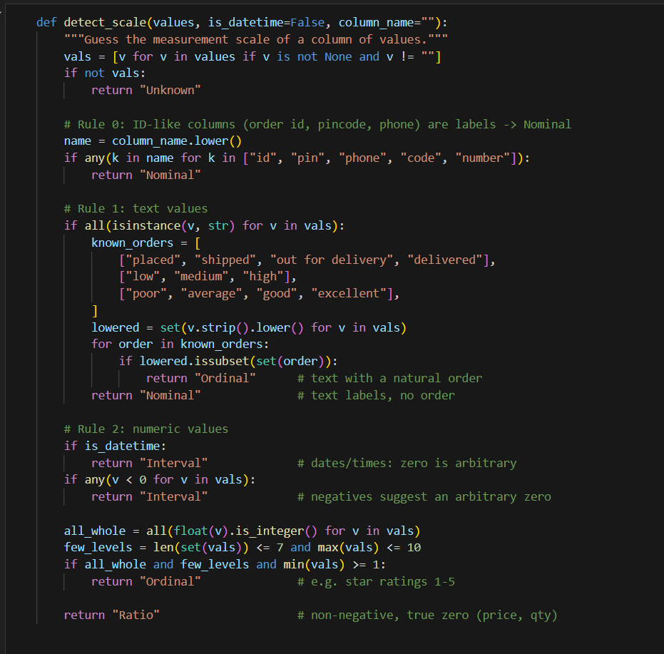
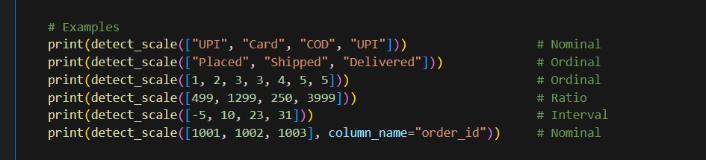
Output
Nominal
Ordinal
Ordinal
Ratio
Interval
Nominal

Limitations: a rule-based guess cannot know context. Star ratings and small counts both look like small integers, and interval data is hard to detect from values alone, which is why the function uses a datetime flag and negative values. A real system would also need human confirmation for edge cases.

Session 3: Measures of Central Tendency

Task 1: Mean of 7 daily step counts
Create an array of 7 daily step counts and write code to calculate the mean.
Sample data (replace with your own phone's figures): 8200, 6500, 9100, 7300, 10200, 5400, 7800.
Python code
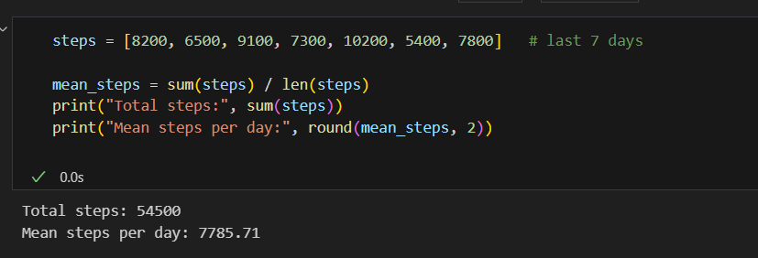
Output
Total steps: 54500
Mean steps per day: 7785.71

Mean = 54,500 / 7 = 7,785.71 steps per day.

Task 2: Median delivery time
Given the delivery times of 9 orders [32, 28, 29, 45, 30, 31, 60, 30, 29], write a function to find the median.
The list has 9 values (an odd number), so the median is the 5th value after sorting. The function also handles an even count by averaging the two middle values.
Python code
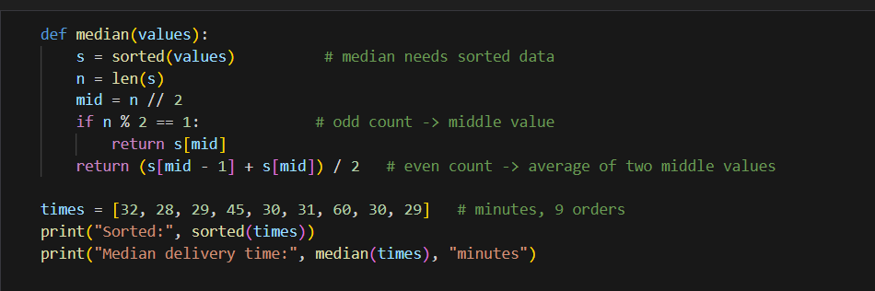

Output
Sorted: [28, 29, 29, 30, 30, 31, 32, 45, 60]
Median delivery time: 30 minutes

The median delivery time is 30 minutes. The two slow orders (45 and 60 minutes) hardly affect it, whereas the mean would be 314 / 9 = 34.89 minutes.

Task 3: Mode of YouTube genres
Write code to find the mode (most watched genre) of the 12 videos.
Python code
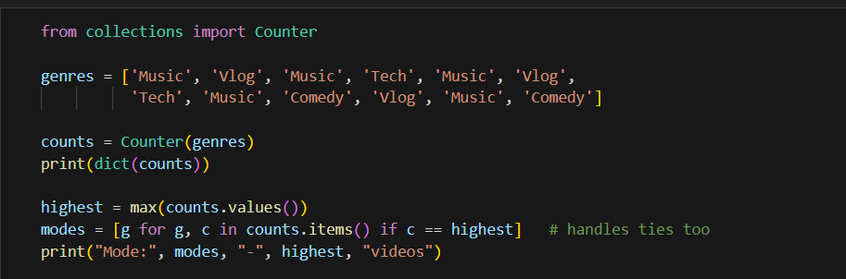
Output
{'Music': 5, 'Vlog': 3, 'Tech': 2, 'Comedy': 2}
Mode: ['Music'] - 5 videos

The mode is Music, watched 5 times out of 12. The code collects all genres with the highest count, so it also reports ties correctly.

Task 4: Mean vs median of UPI transactions
Calculate the mean and median of [100, 120, 105, 110, 5000, 115, 108] and explain which is a better measure of a 'typical' transaction.
Python code
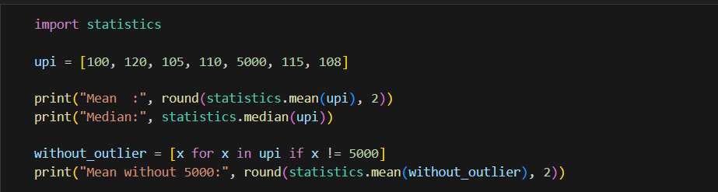

Output
Mean : 808.29
Median: 110
Mean without 5000: 109.67

Session 4: Measures of Dispersion

Task 1: Range of daily steps
Calculate the range of [6500, 7200, 8000, 6000, 9000, 7500, 8200] and explain the activity pattern.
Python code
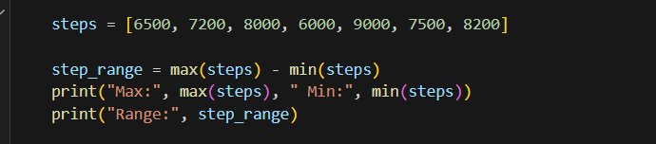
Output
Max: 9000 Min: 6000
Range: 3000

Range = 9000 − 6000 = 3,000 steps. The mean is 52,400 / 7 = 7,485.71 steps, so the gap between the best and worst day is about 40% of the average day. The user's activity is therefore moderately variable. Remember that the range uses only the two extreme days, so it says nothing about the days in between.

Task 2: Variance and standard deviation of order amounts
For the orders [250, 400, 350, 300, 500], write code to compute the variance and standard deviation.
Mean = 1,800 / 5 = 360. Deviations from the mean: −110, 40, −10, −60, 140. Squared: 12,100, 1,600, 100, 3,600, 19,600. Sum of squares = 37,000.
 | Population (÷ n) | Sample (÷ n − 1)
Variance | 37,000 / 5 = 7,400 | 37,000 / 4 = 9,250
Standard deviation | √7,400 = ₹86.02 | √9,250 = ₹96.18

Python code
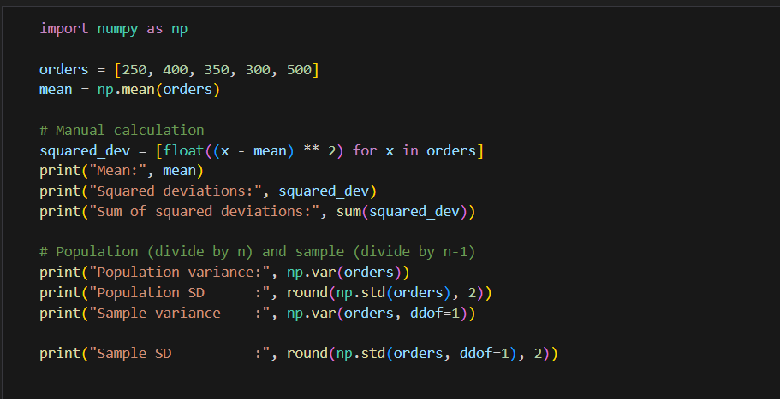
Output
Mean: 360.0
Squared deviations: [12100.0, 1600.0, 100.0, 3600.0, 19600.0]
Sum of squared deviations: 37000.0
Population variance: 7400.0
Population SD : 86.02
Sample variance : 9250.0
Sample SD : 96.18

Which to report? These 5 orders are a sample of all Zomato orders, so the sample values are the right ones: variance 9,250 and standard deviation about ₹96.18. If the 5 orders were the whole population, you would use 7,400 and ₹86.02.

Task 3: Coefficient of variation of data usage
Monthly data usage [3.2, 2.8, 3.5, 3.0, 2.9, 3.1] GB. Calculate the CV and interpret it.
Python code
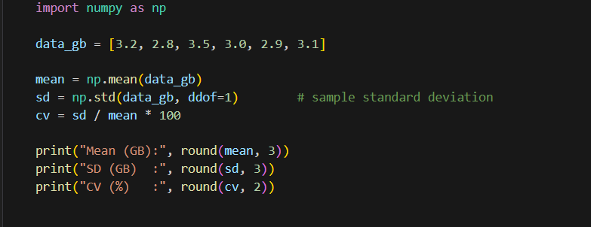
Output
Mean (GB): 3.083
SD (GB) : 0.248
CV (%) : 8.05

CV = (0.248 / 3.083) × 100 = 8.05%. A CV below roughly 10% is usually read as low variability, so this user's monthly data usage is consistent: the typical month differs from the average by only about a quarter of a GB. (The 10% and 30% cut-offs are common rules of thumb, not strict laws.)

Task 4: Consistency of Instagram likes
For likes [120, 150, 130, 110, 170, 140, 135, 160, 125, 155], compute the standard deviation and compare it with the mean.
Python code
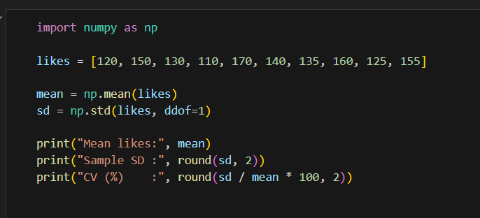
Output
Mean likes: 139.5
Sample SD : 19.07
CV (%) : 13.67

The mean is 139.5 likes and the sample standard deviation is 19.07, so the CV is 13.67%. The standard deviation is only about 14% of the mean, and 8 of the 10 posts fall between 120 and 160 likes. Engagement is fairly consistent, with moderate variation, and no post is wildly different from the rest.

Task 5: Variance and SD of generated UPI data
Use an AI tool to generate at least 8 daily UPI transaction amounts for a week, then calculate the variance and standard deviation and interpret the result.
Prompt used: "Generate 8 realistic daily UPI spending totals in rupees for one week for a college student." AI-generated data: 450, 120, 800, 260, 90, 1500, 340, 610.
Python code
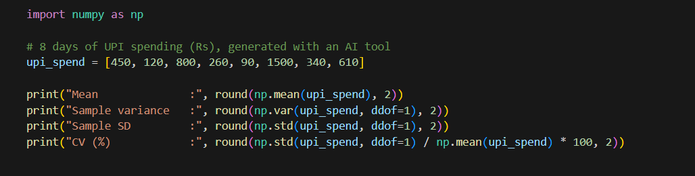
Output
Mean : 521.25
Sample variance : 213812.5
Sample SD : 462.4
CV (%) : 88.71

Interpretation: the average day is ₹521.25, but the standard deviation (₹462.40) is almost as large as the mean, giving a CV of 88.71%. Spending is very unstable: ordinary days are around ₹100 to ₹600, while one day of ₹1,500 pushes the variance up sharply. For budgeting, this user should plan for occasional large spends rather than rely on the daily average.

Session 5: Percentiles, Quartiles & Boxplots

Task 1: Percentiles of 20 delivery times
Calculate the 25th, 50th and 75th percentiles using numpy.percentile.
Sample data (minutes): 25, 32, 28, 45, 30, 35, 27, 40, 38, 29, 33, 50, 31, 26, 36, 42, 34, 30, 28, 55.
Python code
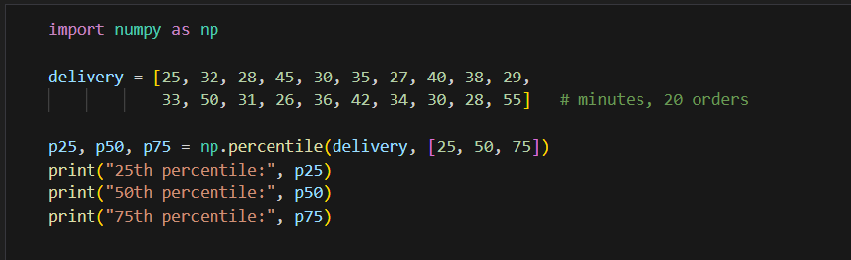
Output
25th percentile: 28.75
50th percentile: 32.5
75th percentile: 38.5

25% of orders arrive within 28.75 minutes, half arrive within 32.5 minutes, and 75% arrive within 38.5 minutes. (numpy uses linear interpolation by default, the same method as Excel's PERCENTILE.INC.)

Task 2: Quartiles of IPL scores
Write a script that divides an array of IPL player scores into quartiles using numpy.quantile and prints Q1, Q2 and Q3.
Python code
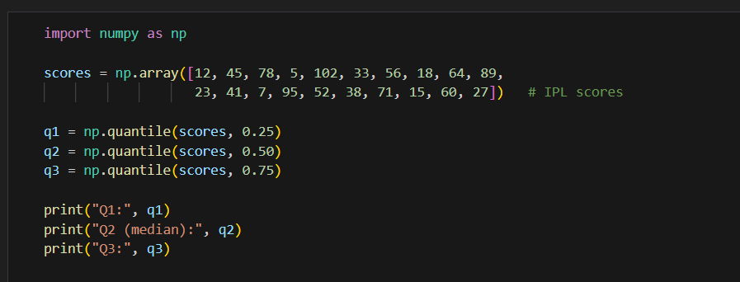

Output
Q1: 21.75
Q2 (median): 43.0
Q3: 65.75

A quarter of the scores are at or below 21.75, the median is 43, and three-quarters are at or below 65.75. numpy.quantile takes fractions (0.25) where numpy.percentile takes percentages (25); both give the same results.

Task 3: IQR of a month of step counts
Calculate the interquartile range of a month of daily step counts and explain what it says about consistency.
Python code
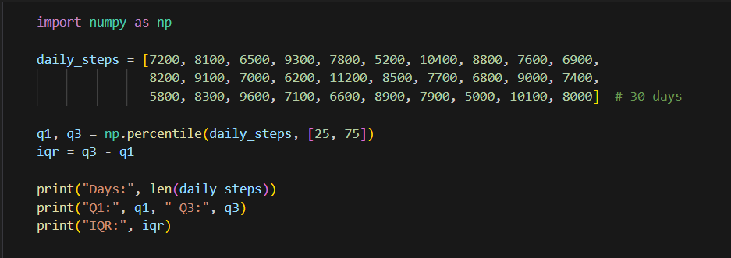
Output
Days: 30
Q1: 6925.0 Q3: 8875.0
IQR: 1950.0

IQR = 8,875 − 6,925 = 1,950 steps. The middle 50% of days fall inside a band only 1,950 steps wide, so day-to-day activity is reasonably consistent. A smaller IQR means more consistency, and the IQR is not distorted by a few extremely active or lazy days.

Task 4: Detecting outliers in Swiggy order amounts
Write a function to detect outliers with the IQR method (below Q1 − 1.5×IQR or above Q3 + 1.5×IQR) and print them.
Python code
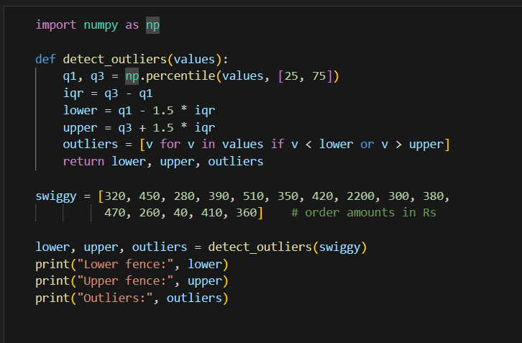
Output
Lower fence: 122.5
Upper fence: 622.5
Outliers: [2200, 40]

The fences are ₹122.50 and ₹622.50. The outliers are ₹2,200 (an unusually large order) and ₹40 (an unusually small order, perhaps an add-on or a refund).

Task 5: Boxplot of weekly screen time
Create a boxplot of 8 weeks of screen time with labelled axes and highlight any outliers.
Sample data (hours per week): 32, 34, 31, 35, 33, 30, 52, 34.
Python code
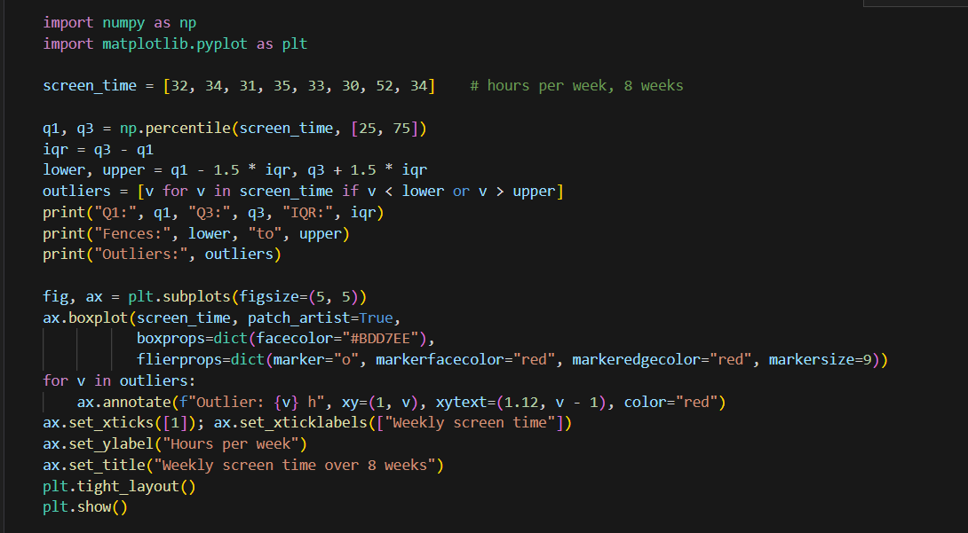
Output
Q1: 31.75 Q3: 34.25 IQR: 2.5
Fences: 28.0 to 38.0
Outliers: [52]

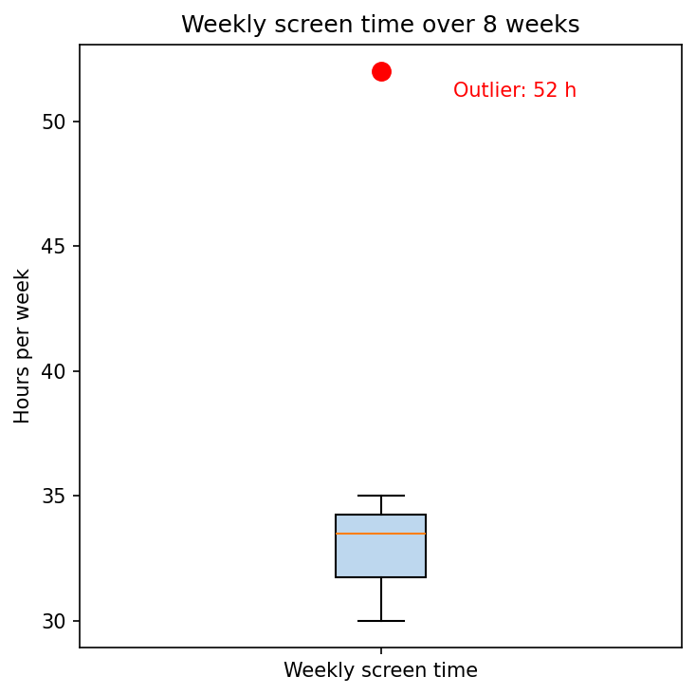
Boxplot of weekly screen time with the outlier highlighted in red
The box spans Q1 (31.75) to Q3 (34.25), the orange line is the median, and the whiskers stop at the last points inside the fences (28 and 38). The 52-hour week lies far above the upper fence, so it is flagged as an outlier.

Session 6: Probability Basics

Task 1: Sample space of a die and a coin
List all possible outcomes of rolling a six-sided die and flipping a coin together, as ordered pairs.
Each outcome is (die, coin). There are 6 × 2 = 12 equally likely outcomes:
S = {(1,H), (1,T), (2,H), (2,T), (3,H), (3,T), (4,H), (4,T), (5,H), (5,T), (6,H), (6,T)}
Python code
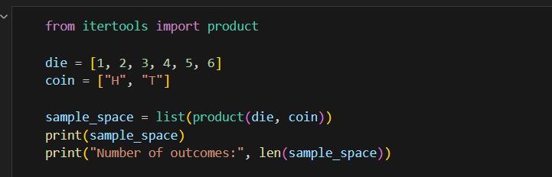
Output
[(1, 'H'), (1, 'T'), (2, 'H'), (2, 'T'), (3, 'H'), (3, 'T'), (4, 'H'), (4, 'T'), (5, 'H'), (5, 'T'), (6, 'H'), (6, 'T')]
Number of outcomes: 12

Task 2: Probability of an even card
A deck has 10 cards numbered 1 to 10. Find the probability of drawing an even number.
- Sample space: 10 cards, so the total number of outcomes is 10.
- Favourable outcomes: 2, 4, 6, 8, 10, so there are 5.
- P(even) = favourable / total = 5 / 10 = 1/2 = 0.5.

Task 3: Probability the song is NOT by Arijit Singh
A playlist has 8 songs and 3 are by Arijit Singh. What is the probability that a random song is not by him?
P(Arijit) = 3/8. Using the complement rule: P(not Arijit) = 1 − 3/8 = 5/8 = 0.625. Check: 5 of the 8 songs are by other artists, and 5/8 = 0.625.

Task 4: Addition rule for Pizza or Burger
P(Pizza) = 0.3, P(Burger) = 0.4, P(both) = 0.1. Find P(Pizza or Burger).
P(A or B) = P(A) + P(B) − P(A and B) = 0.3 + 0.4 − 0.1 = 0.6. We subtract 0.1 because users who order both would otherwise be counted twice.
Python check for Tasks 2, 3 and 4
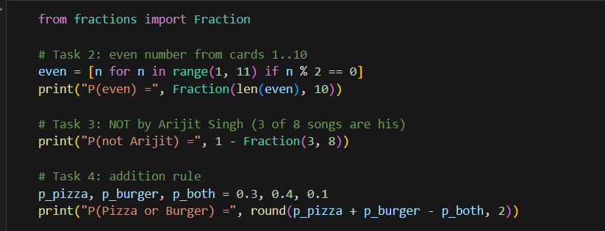
Output
P(even) = 1/2
P(not Arijit) = 5/8
P(Pizza or Burger) = 0.6

Task 5: Meaning of the conditional probability
P(add phone to cart) = 0.2, but 0.5 if the user is interested in mobiles. Explain what this conditional probability means.
Without knowing anything else, only 2 in 10 users browsing electronics add a phone to their cart: P(Phone) = 0.2. A conditional probability narrows this to a group we have extra information about. Among users who are specifically interested in mobiles, 5 in 10 add a phone: P(Phone | Mobiles) = 0.5. Knowing the user's interest more than doubles the chance of a phone purchase, so Flipkart should show phone offers to mobile-interested users first.

Session 7: Conditional Probability & Bayes' Theorem

Task 1: P(Phone | Accessories)
Of 500 users, 120 bought accessories, 80 bought a phone and 50 bought both. Find P(Phone | Accessories).
P(Phone and Accessories) = 50/500 = 0.10 and P(Accessories) = 120/500 = 0.24. So P(Phone | Accessories) = 0.10 / 0.24 = 50/120 = 0.4167 (about 41.7%). The 80 phone buyers figure is not needed for this particular calculation.
Python code
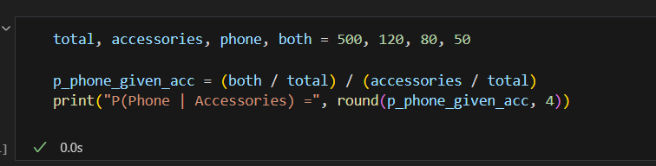
Output
P(Phone | Accessories) = 0.4167

Task 2: Smartphone given headphones
30% of users buy headphones, and among those 40% later buy a smartphone. Find P(smartphone | headphones).
Let B = bought headphones, A = buys a smartphone. P(B) = 0.30 and P(A and B) = 0.40 × 0.30 = 0.12. Then P(A | B) = P(A and B) / P(B) = 0.12 / 0.30 = 0.40. The question already states this value (40% of headphone buyers go on to buy a smartphone); the working confirms it.
Python code
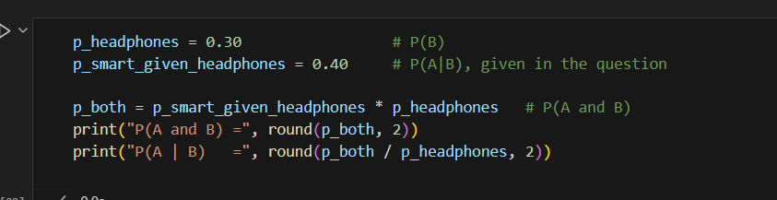
Output
P(A and B) = 0.12
P(A | B) = 0.4

Task 3: Bayes' function for churn
Write bayes_churn_probability(prior_churn, prob_email_given_churn, prob_email) and test it with 0.15, 0.6, 0.25.
Python code
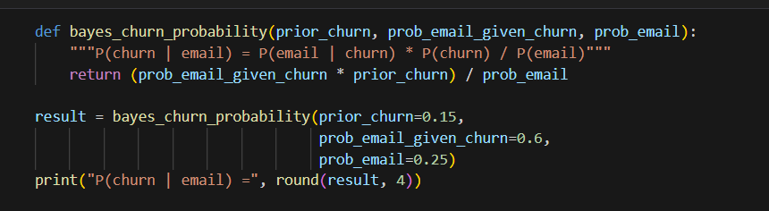
Output
P(churn | email) = 0.36

P(churn | email) = (0.6 × 0.15) / 0.25 = 0.09 / 0.25 = 0.36. Users who received a 'we miss you' email are more likely to be churners (36%) than the overall base rate (15%), because the company sends that email mostly to users who are leaving.

Task 4: Fraud alert
2% of transactions are fraud. The alert flags 90% of fraud and falsely flags 5% of normal transactions. Find P(fraud | alert).
- P(F) = 0.02, P(A | F) = 0.90, P(A | not F) = 0.05.
- P(A) = 0.90 × 0.02 + 0.05 × 0.98 = 0.018 + 0.049 = 0.067.
- P(F | A) = (0.90 × 0.02) / 0.067 = 0.018 / 0.067 = 0.2687 (about 26.9%).
Python code
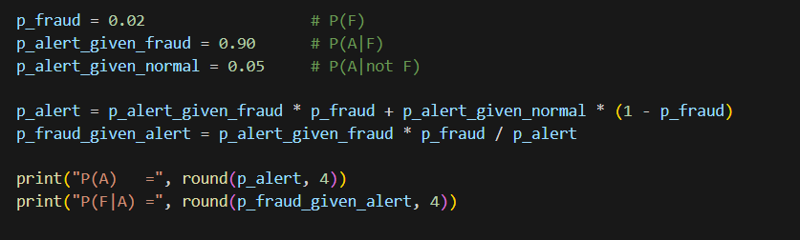
Output
P(A) = 0.067
P(F|A) = 0.2687

Even though the alert catches 90% of fraud, only about 27% of flagged transactions are actually fraudulent. Fraud is rare (2%), so false alarms from the large number of genuine transactions outnumber true alerts (0.049 against 0.018).

Task 5: Conditional probability in a food delivery app
Generate a scenario where conditional probability is used in Zomato or Swiggy, explain how Bayes' Theorem could improve recommendations, paste the AI output and add one sentence of your own analysis.
Prompt used: "Give a real-world scenario of conditional probability in a food delivery app and explain how Bayes' Theorem could improve its recommendation system."
AI output (generated by Claude):
Scenario: Swiggy wants to decide whether to suggest a dessert to a user who has just added a biryani to the cart. Suppose 15% of all orders include a dessert, 40% of dessert orders also contain a biryani, and 25% of all orders contain a biryani. Then P(Dessert | Biryani) = P(Biryani | Dessert) × P(Dessert) / P(Biryani) = 0.40 × 0.15 / 0.25 = 0.24. A biryani in the cart raises the chance of a dessert order from 15% to 24%, so the app should show the dessert suggestion to this user rather than to everyone. Bayes' Theorem lets the system keep updating these probabilities as new orders arrive, turning past behaviour into better, personalised recommendations.
My analysis: the jump from 15% to 24% shows that a recommendation based on what is already in the cart is far more effective than a generic one, so it is worth the effort of computing conditional probabilities for popular item pairs.

Session 8: Probability Distributions (Discrete)

Task 1: Bernoulli simulation of logins
Simulate a Bernoulli trial for a Zomato login (success = 1, failure = 0, p = 0.85) 20 times and print the results.
Python code
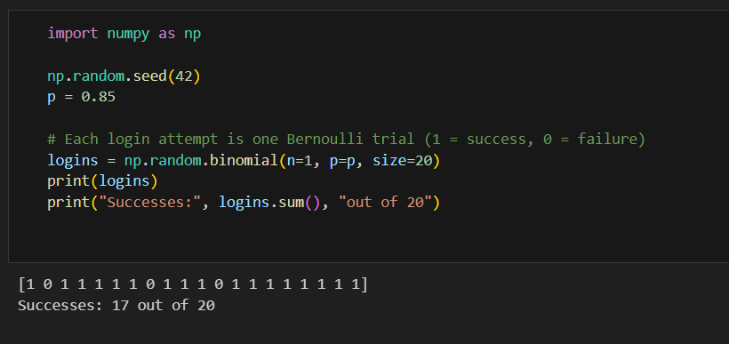
Output
[1 0 1 1 1 1 1 0 1 1 1 0 1 1 1 1 1 1 1 1]
Successes: 17 out of 20

Each login is one Bernoulli trial, here generated as a binomial with n = 1. In this run 17 of 20 attempts succeeded, which is 85% and matches p. Another seed would give a slightly different count.

Task 2: Exactly 3 successful UPI payments out of 5
Use the binomial distribution to find the probability of exactly 3 successes in 5 attempts when p = 0.9.
Python code
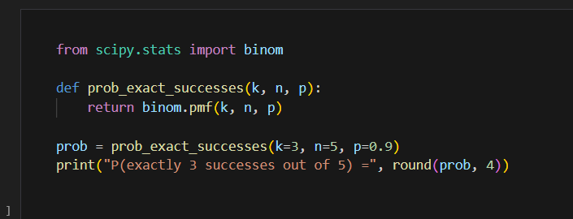
Output
P(exactly 3 successes out of 5) = 0.0729

By hand: P(X = 3) = C(5,3) × 0.9³ × 0.1² = 10 × 0.729 × 0.01 = 0.0729 (about 7.3%). Getting exactly 3 out of 5 is unlikely because the success rate is so high; most runs will have 4 or 5 successes.

Task 3: Poisson probability of 6 playlists
The average is 4 new playlists per minute. Find the probability that exactly 6 are created in a minute.
Python code
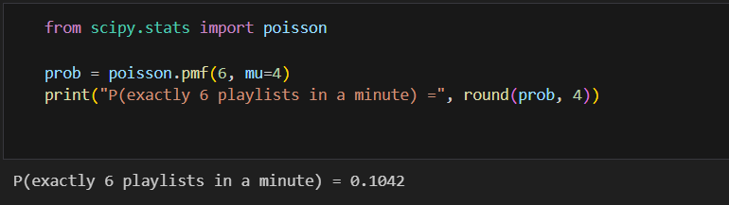
Output
P(exactly 6 playlists in a minute) = 0.1042

By hand: P(X = 6) = e⁻⁴ × 4⁶ / 6! = 0.018316 × 4096 / 720 = 0.1042 (about 10.4%).

Task 4: Simulating Flipkart reviews per hour
Simulate and plot the number of reviews in 12 random hours with an average of 10 per hour using the Poisson distribution.
Python code
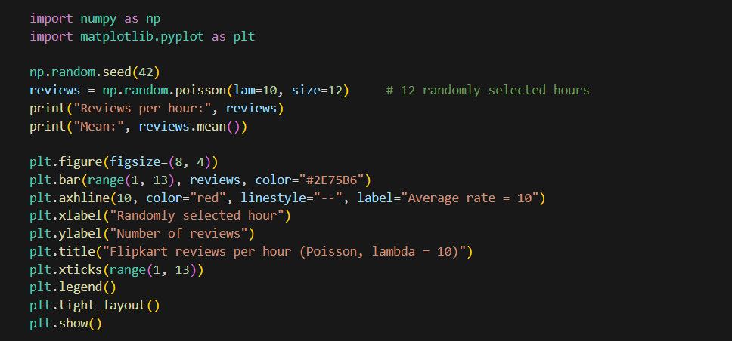
Output
Reviews per hour: [12 6 11 14 7 8 9 11 8 10 7 11]
Mean: 9.5

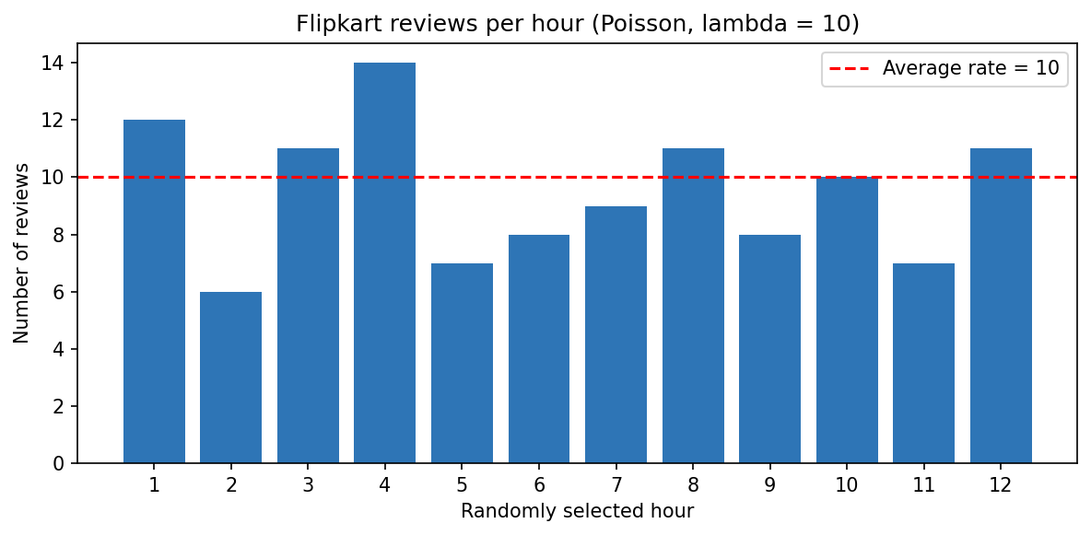
Simulated reviews per hour (Poisson, average 10)
The hourly counts fluctuate around the average of 10 (this sample of 12 hours averages 9.5). Some hours have 6 or 7 reviews and some 12 to 14, which is the natural randomness of a Poisson process.

Task 5: Real-world use-case
Pick one distribution, ask an AI for an Indian app use-case, paste it, and explain in 2 to 3 lines why the distribution fits.
Prompt used: "Give a real-world analytics use-case of the Poisson distribution from an Indian app like IRCTC."
AI output (generated by Claude): IRCTC's analytics team wants to know how many payment failures occur per minute during the 10 AM Tatkal booking window. If the average is 3 failures per minute, the Poisson distribution gives the probability of seeing, say, 8 or more failures in a single minute. Operations can set an alert threshold at that probability and add server capacity when it is crossed.
Why Poisson fits: it counts how many times an event happens in a fixed interval (one minute), the failures occur independently of one another at a roughly constant average rate, and there is no fixed upper limit on the count, which are exactly the conditions for a Poisson model.

Session 9: Probability Distributions (Continuous)

Task 1: 1000 normal random numbers
Generate 1000 random numbers from a normal distribution with mean 500 and SD 100, and plot them.
Python code
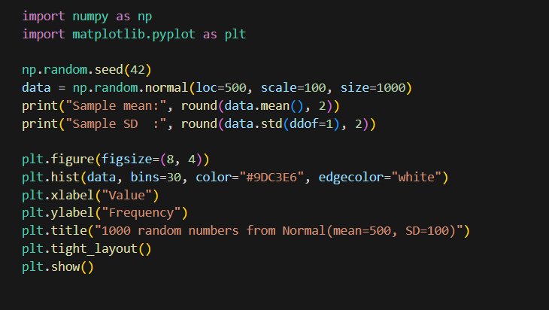
Output
Sample mean: 501.93
Sample SD : 97.92

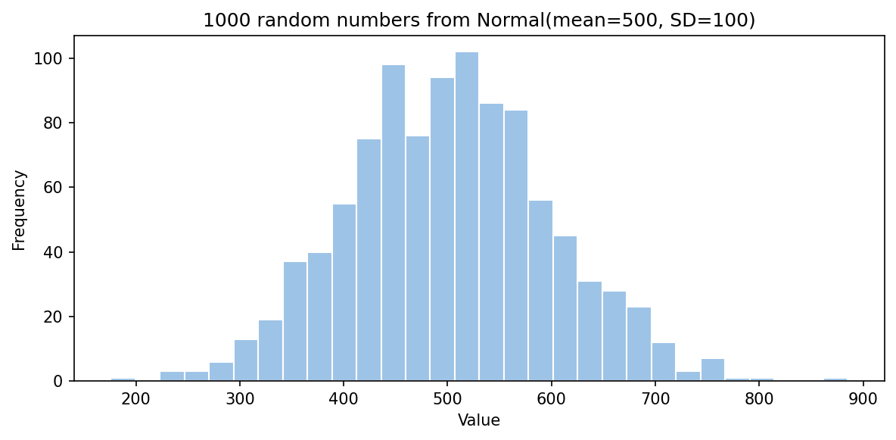
Histogram of 1000 values from Normal(500, 100)
The sample mean (501.93) and standard deviation (97.92) are very close to the true values 500 and 100, and the histogram has the typical bell shape centred near 500.

Task 2: Z-score of 9500 steps
Mean = 8000, SD = 1200. Find the Z-score for 9500 steps.
Python code
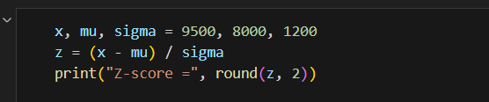
Output
Z-score = 1.25

Z = (9500 − 8000) / 1200 = 1,500 / 1,200 = 1.25. The user walked 1.25 standard deviations above their average. Roughly 89% of days (the normal-curve area below Z = 1.25 is 0.8944) would be below this level, so it is a clearly better-than-usual day.

Task 3: Standard normal curve with shaded area
Plot the standard normal curve and shade the area between Z = −1 and Z = 1.
Python code
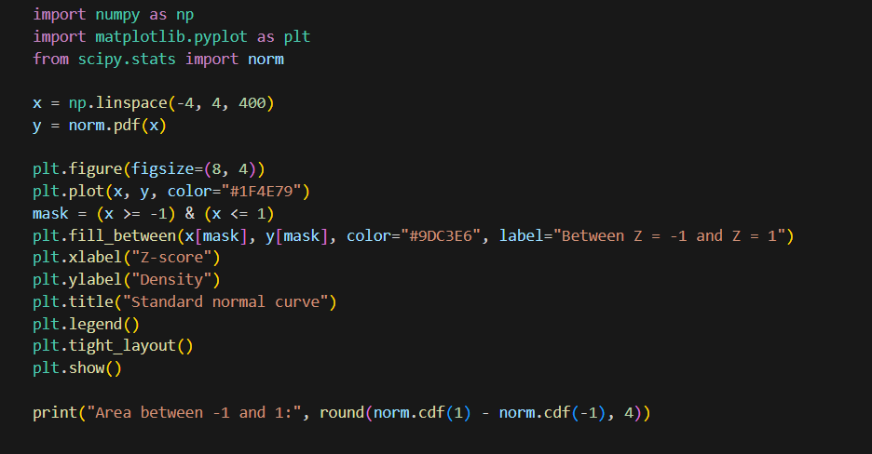
Output
Area between -1 and 1: 0.6827

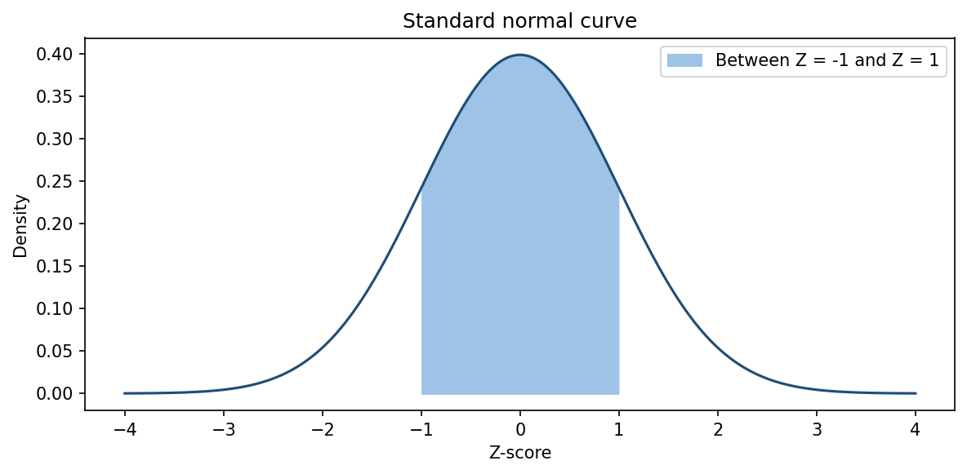
Standard normal curve, area between Z = -1 and Z = 1 shaded
The shaded area is 0.6827, so about 68.27% of values lie within one standard deviation of the mean. This is the first part of the 68–95–99.7 rule.

Task 4: Probability that delivery takes under 25 minutes
Delivery times are Normal(mean 30, SD 5). Find P(time < 25).
Python code
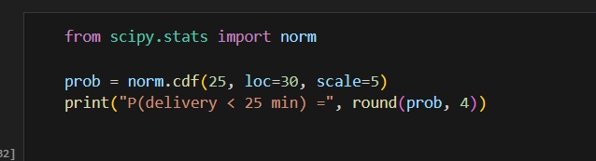
Output
P(delivery < 25 min) = 0.1587

Z = (25 − 30) / 5 = −1, so P(Z < −1) = 0.1587. About 15.9% of deliveries take less than 25 minutes.

Task 5: Why the normal distribution matters
Ask ChatGPT (or another AI) why the normal distribution is important for app data, and paste your prompt and the AI's answer.
Prompt used: "Explain in simple words why the normal distribution is important for analysing real-world app data like sales, delivery times or user ratings."
AI answer (generated by Claude):
Many quantities in apps, such as delivery times, daily sales or the average of many ratings, tend to cluster around a typical value with fewer and fewer cases far away on either side. The normal distribution describes this bell-shaped pattern with just two numbers, the mean and the standard deviation. Once data is roughly normal, you can use Z-scores to say how unusual a value is, calculate the chance of a delivery being late, set sensible thresholds for alerts, and apply many standard statistical tests. It is also important because, by the Central Limit Theorem, averages of many observations become approximately normal even when the raw data is not, which is what makes statistical inference possible.

Session 10: Sampling Techniques

Task 1: Simple random sample of 20 users
Generate a random sample of 20 users from 200 user IDs.
Python code
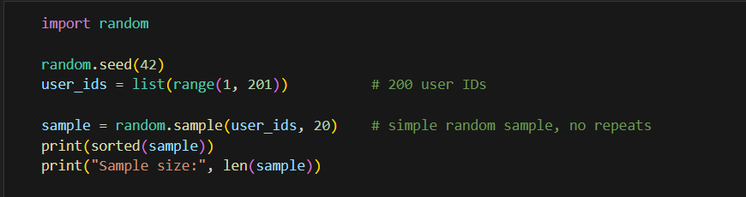
Output
[7, 8, 9, 23, 24, 27, 29, 36, 56, 58, 60, 63, 71, 109, 140, 152, 164, 174, 189, 190]
Sample size: 20

random.sample picks 20 different IDs, each with an equal chance of selection, which is a simple random sample without replacement.

Task 2: Stratified sample of 60 Flipkart orders by city
Given 1000 orders labelled by city, generate a stratified sample of 60 with each city proportionally represented.
Assumed population: Ahmedabad 400, Surat 300, Vadodara 200, Rajkot 100 orders. Each city should supply (its share) × 60 orders: 40% → 24, 30% → 18, 20% → 12, 10% → 6.
Python code
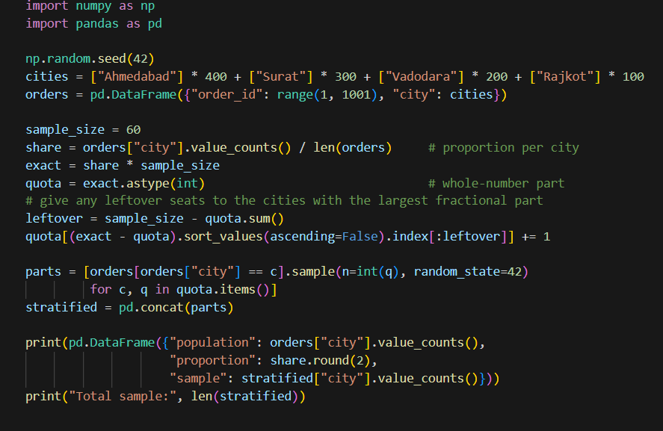

Output
population proportion sample
city
Ahmedabad 400 0.4 24
Surat 300 0.3 18
Vadodara 200 0.2 12
Rajkot 100 0.1 6
Total sample: 60

The sample has exactly the same city proportions as the population, and a random selection is made inside each city. The code also gives leftover seats to the cities with the largest fractional part, so the total is always exactly 60 even when proportions do not divide evenly.

Task 3: Systematic sampling of every 10th review
Write a function that performs systematic sampling on 500 reviews, selecting every 10th review.
Python code
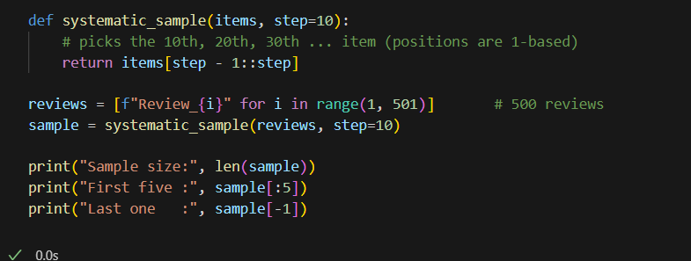
Output
Sample size: 50
First five : ['Review_10', 'Review_20', 'Review_30', 'Review_40', 'Review_50']
Last one : Review_500

Starting at the 10th review and taking every 10th after it gives 500 / 10 = 50 reviews. (A common variation is to pick a random start between 1 and 10 and then take every 10th review from there.)

Task 4: Effect of sample size on accuracy
Explain with calculations how the sample size affects the accuracy of an estimate of the average Swiggy delivery time from 10,000 records when you sample 50, 200 or 500.
The task does not give the spread of delivery times, so I assume a standard deviation σ = 10 minutes. The accuracy of a sample mean is measured by its standard error SE = σ / √n, with a finite population correction √((N − n)/(N − 1)) because we sample from only 10,000 records. The 95% margin of error is 1.96 × SE.
Python code
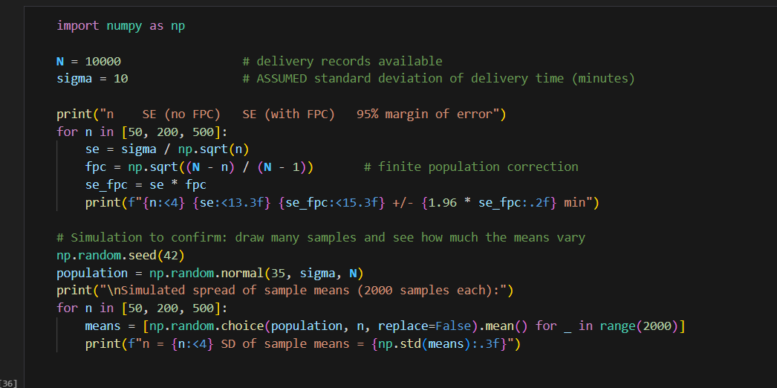
Output
n SE (no FPC) SE (with FPC) 95% margin of error
50 1.414 1.411 +/- 2.77 min
200 0.707 0.700 +/- 1.37 min
500 0.447 0.436 +/- 0.85 min

Simulated spread of sample means (2000 samples each):
n = 50 SD of sample means = 1.435
n = 200 SD of sample means = 0.709
n = 500 SD of sample means = 0.443

Sample size n | SE = σ/√n | SE with correction | 95% margin of error
50 | 1.414 | 1.411 | ± 2.77 min
200 | 0.707 | 0.700 | ± 1.37 min
500 | 0.447 | 0.436 | ± 0.85 min

Conclusion: accuracy improves with sample size, but with diminishing returns. Going from 50 to 200 records (4 times larger) halves the error, and going from 50 to 500 (10 times larger) cuts it by about √10, roughly 3 times. The simulation, which repeatedly draws samples from a made-up population of 10,000 records, confirms the formula: the spread of the sample means (1.435, 0.709, 0.443) matches the calculated standard errors. If the real standard deviation is different, all the errors scale in proportion.

Task 5: Stratified sample of IPL fans
Use IPL fans grouped by favourite team and generate a stratified sample of 40 fans, proportionally represented, with your own logic.
Assumed population of 500 fans: CSK 140, MI 120, RCB 100, KKR 60, DC 40, Others 40. This version groups the fans into a dictionary, converts each team's share into seats, and then picks fans at random within each group.
Python code
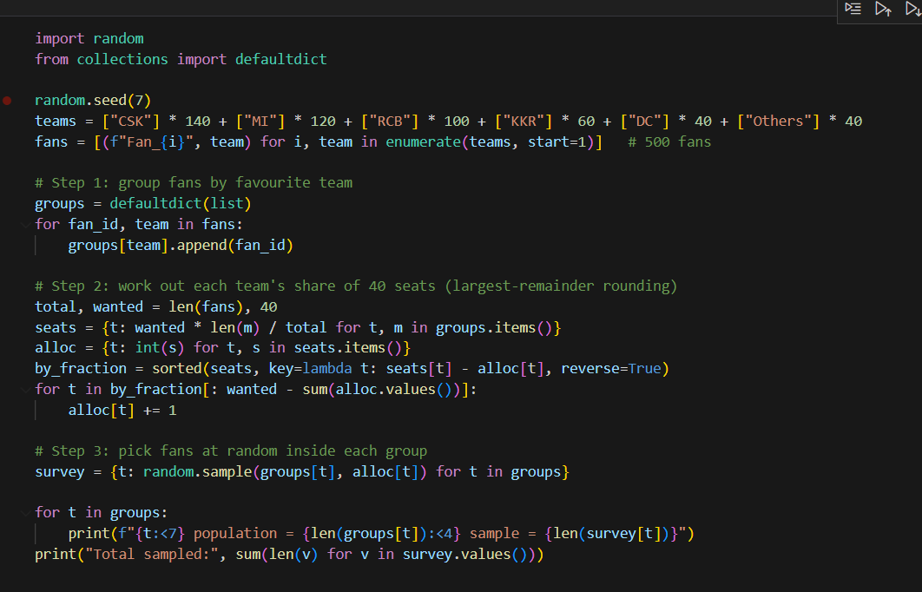
Output
CSK population = 140 sample = 11
MI population = 120 sample = 10
RCB population = 100 sample = 8
KKR population = 60 sample = 5
DC population = 40 sample = 3
Others population = 40 sample = 3
Total sampled: 40

Each team's share of the sample matches its share of the population (for example CSK is 28% of fans and gets 11 of the 40 seats, which is 27.5%), and every team is represented.

Session 11: Central Limit Theorem

Task 1: Simulating the CLT
Take 1000 random samples of size 30 from a skewed dataset (Instagram likes), calculate each sample mean and plot their histogram.
Python code
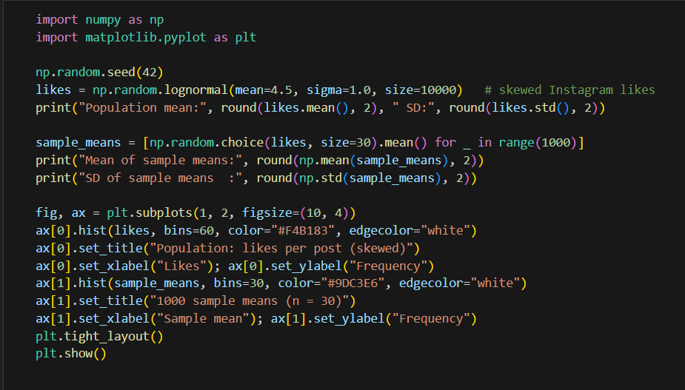
Output
Population mean: 148.79 SD: 197.29
Mean of sample means: 148.7
SD of sample means : 34.48

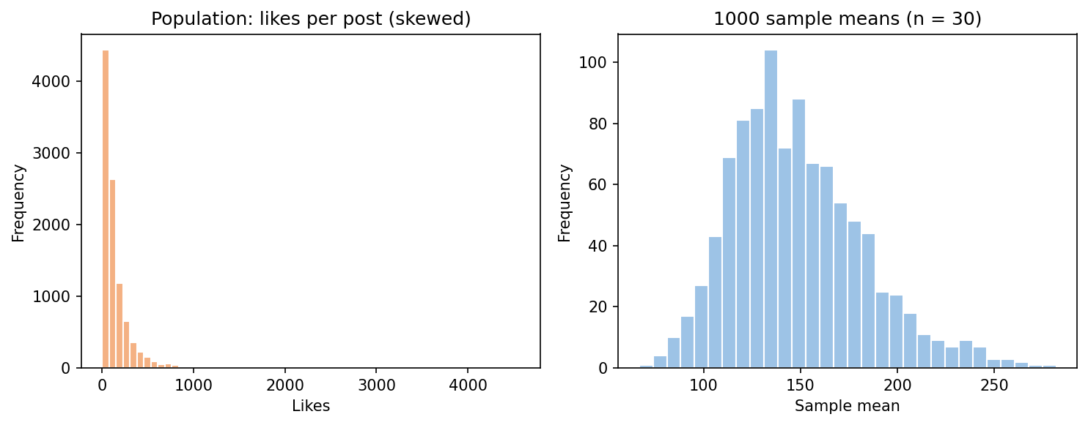
Left: skewed population. Right: distribution of 1000 sample means (n = 30)
The population of likes is strongly right-skewed (mean 148.79, SD 197.29), but the sample means form an almost bell-shaped histogram centred on the population mean (148.70). Their spread (34.48) is close to the theoretical σ/√n = 197.29/√30 = 36.02.

Task 2: Why the sampling distribution becomes normal
Explain in your own words why the sampling distribution of the mean becomes approximately normal even if the original data is not.
Take Zomato order amounts: most orders are small (₹200 to ₹400), but a few big party orders create a long right tail, so the data is not normal. If I pick 30 orders at random and average them, that average will usually contain mostly typical orders and perhaps one big one, so it lands near the middle. A very large average needs several big orders in the same sample, which is rare. Repeating this many times, the averages pile up around the true mean with few at the extremes, and that pile is bell-shaped. In short, averaging cancels out extreme values, and the more values we average, the more normal the result looks.

Task 3: A real-world use of the CLT
Pick a scenario from Flipkart, Swiggy or IRCTC where the CLT helps analytics or decisions and write a short paragraph.
IRCTC wants to know whether the average waiting time on its booking page has gone above 4 seconds after a software update. Individual waiting times are skewed (most are fast, a few are very slow), so they are not normal. But the average of, say, 100 randomly chosen page loads is approximately normal by the CLT. This lets the team build a confidence interval or run a t-test around that average, and decide with a known level of confidence whether the update slowed the site, without having to measure millions of page loads.

Task 4: Sample size n = 5 vs n = 30
Run the simulation with n = 5 and compare the histogram of sample means to the one with n = 30.
Python code
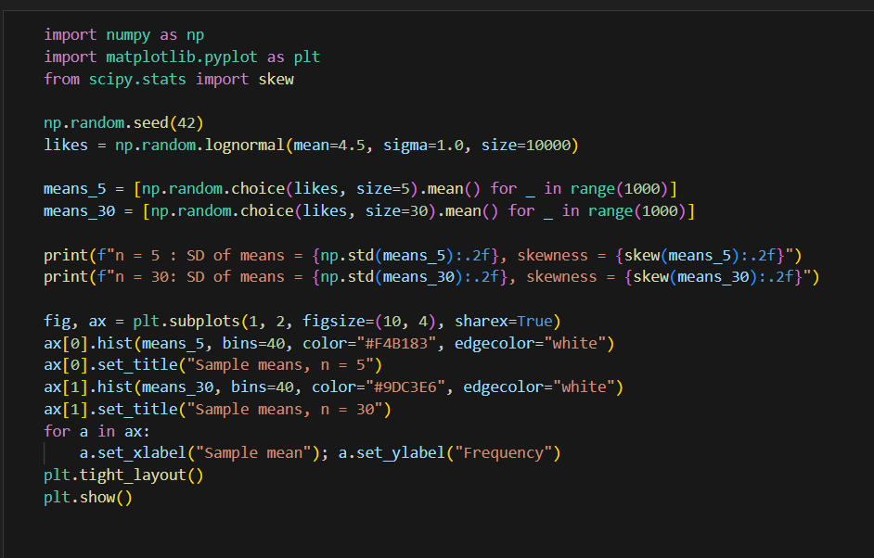
Output
n = 5 : SD of means = 85.92, skewness = 2.38
n = 30: SD of means = 36.44, skewness = 0.96

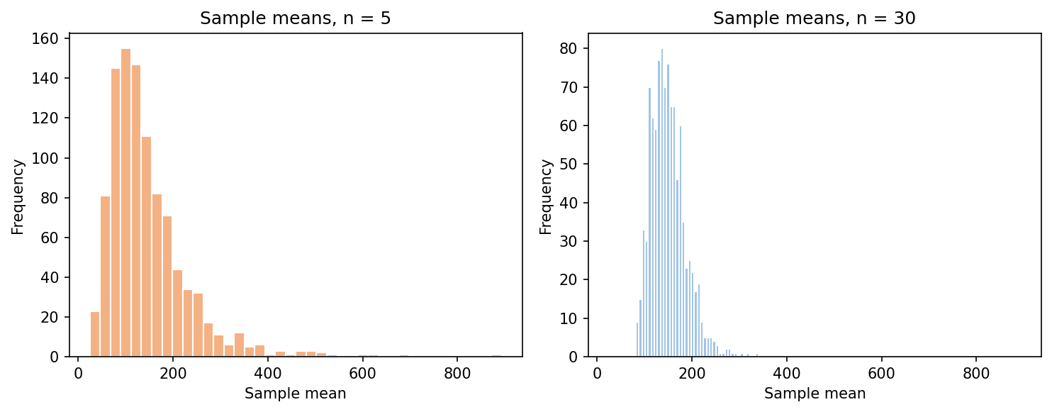
Sample means for n = 5 (left) and n = 30 (right), same horizontal scale
 | n = 5 | n = 30
SD of sample means | 85.92 | 36.44
Skewness | 2.38 (strongly skewed) | 0.96 (much closer to symmetric)
Shape | Wide, long right tail | Narrower, roughly bell-shaped

Observation: with n = 5 the sample means are widely spread and still strongly right-skewed, so the CLT has not yet taken effect. With n = 30 the distribution is much narrower (the spread falls by a factor of about 2.4, close to √(30/5) = 2.45) and far more symmetric. A larger sample gives both a more normal shape and a more precise estimate of the mean.

Task 5: CLT with an exponential distribution
Use an AI tool to generate Python code that demonstrates the CLT with a non-normal distribution (e.g. exponential), run it, paste the output plot and describe what you observe.
Prompt used: "Write Python code that demonstrates the Central Limit Theorem using random samples from an exponential distribution, with plots." The code below is the AI-generated version, run as is.
Python code
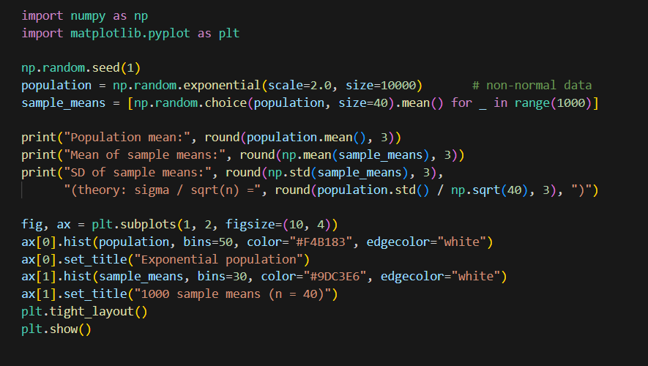f
Output
Population mean: 1.977
Mean of sample means: 1.993
SD of sample means: 0.314 (theory: sigma / sqrt(n) = 0.31 )

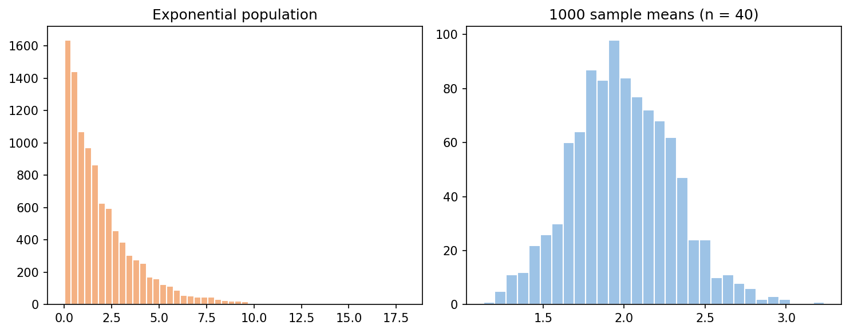
Left: exponential population. Right: 1000 sample means (n = 40)
What I observe: the exponential population is extremely skewed, with most values near zero and a long tail. The sample means, however, form a symmetric bell curve centred on the population mean (1.977 against 1.993 for the mean of sample means), and their standard deviation (0.314) matches the theoretical σ/√n (0.31). This is the Central Limit Theorem in action.

Session 12: Hypothesis Testing Concepts

Task 1: Hypotheses for the cashback offer
State the null and alternative hypotheses for testing whether a cashback offer increased the average number of daily orders.
Let μ_before be the average daily orders before the offer and μ_after the average after the offer.
Hypothesis | Statement | In words
H₀ (null) | μ_after ≤ μ_before | The cashback offer did not increase daily orders.
H₁ (alternative) | μ_after > μ_before | The cashback offer increased daily orders.

This is a one-tailed (right-tailed) test because we only care about an increase. Many textbooks write the null simply as μ_after = μ_before; the conclusion is the same.

Task 2: Type I or Type II error?
The app claims its algorithm raises listening time from 40 to 45 minutes. Which error occurs if you wrongly conclude it works when it does not?
This is a Type I error (a false positive). We rejected the null hypothesis ("the algorithm does not increase listening time") even though it was true, so we falsely concluded that the algorithm works.

Task 3: p-value of 0.03 at a 95% confidence level
An A/B test of a discount banner gives p = 0.03. At a 95% confidence level, do you reject or fail to reject the null hypothesis, and what does it mean?
A 95% confidence level means a significance level α = 0.05. Since p = 0.03 is less than 0.05, we reject the null hypothesis. In the app's context this means the data provides statistically significant evidence that the new discount banner increases purchases. Precisely, if the banner had no effect, we would see a result this strong only about 3% of the time by chance. It does not prove the effect is large or guarantee it will always work, so the business should still consider the size of the increase.

Task 4: Meaning of a 99% confidence level
You want to be 99% confident that match alerts increase engagement. Explain what this means and how it affects your decision.
A 99% confidence level means α = 0.01: we accept only a 1% risk of a Type I error, that is, of launching the feature when it has no real effect. In practice we should recommend the alert feature only if the test gives p < 0.01. A result such as p = 0.03 would be good enough at 95% but not at 99%, so we would not yet accept the feature. The price of this stricter standard is a higher chance of a Type II error (missing a real benefit), which can be reduced by collecting more data or running the test longer.

Session 13: t-tests (One-sample & Two-sample)

Task 1: One-sample t-test of delivery time
Test whether the average Zomato delivery time differs from 30 minutes using [28, 32, 27, 35, 29, 31, 30, 33, 26, 34].
H₀: μ = 30 H₁: μ ≠ 30 (two-tailed, α = 0.05, df = 9)
Python code
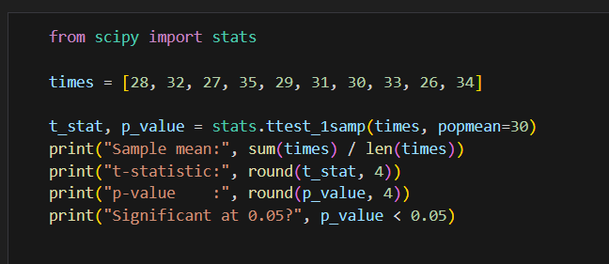
Output
Sample mean: 30.5
t-statistic: 0.5222
p-value : 0.6141
Significant at 0.05? False

Conclusion: p = 0.6141 is much greater than 0.05, so we fail to reject H₀. The sample mean of 30.5 minutes is not significantly different from 30 minutes.

Task 2: Independent t-test of daily steps
Simulate two independent groups (before and after installing a fitness app) and test whether steps per day increased.
H₀: μ_after ≤ μ_before H₁: μ_after > μ_before (one-tailed). Data are simulated with true means of 6,000 and 7,000 steps, using different users in each group.
Python code
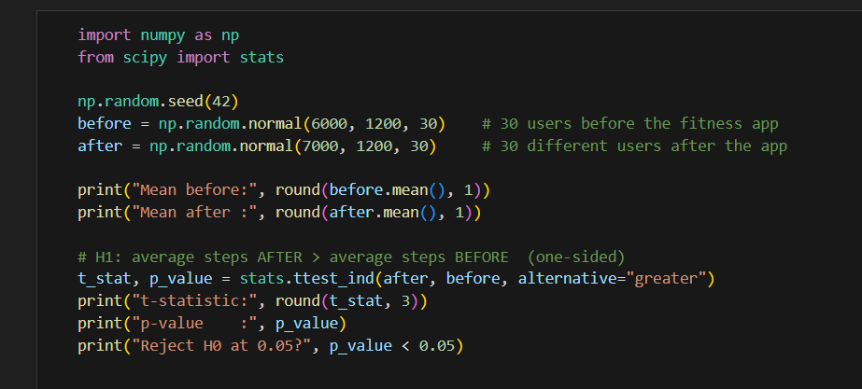
Output
Mean before: 5774.2
Mean after : 6854.6
t-statistic: 3.808
p-value : 0.0001701995561740197
Reject H0 at 0.05? True

Conclusion: p = 0.00017 < 0.05, so we reject H₀. Average daily steps are significantly higher after installing the app (about 6,855 against 5,774 in this simulation). Because the groups are different users, this shows association rather than proof that the app caused the increase.

Task 3: Paired t-test of Focus Mode
Simulate screen time for 10 users before and after 'Focus Mode' and test whether it significantly reduced screen time.
The same 10 users are measured twice, so a paired test is appropriate. H₀: mean reduction = 0, H₁: screen time before > screen time after.
Python code
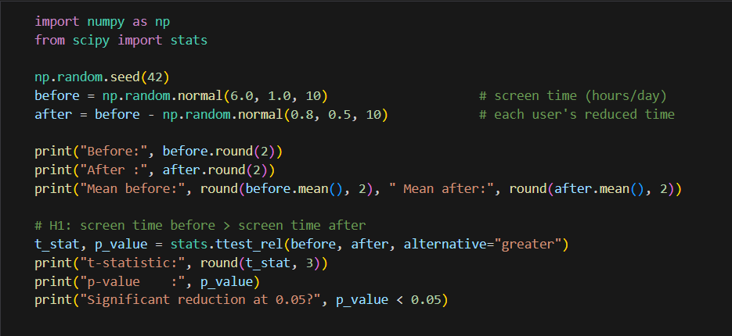
Output
Before: [6.5 5.86 6.65 7.52 5.77 5.77 7.58 6.77 5.53 6.54]
After : [5.93 5.29 5.73 7.68 5.83 5.25 7.29 5.81 5.18 6.45]
Mean before: 6.45 Mean after: 6.04
t-statistic: 3.388
p-value : 0.004009533702384422
Significant reduction at 0.05? True

Conclusion: p = 0.0040 < 0.05, so we reject H₀. Focus Mode significantly reduced screen time, by an average of about 0.41 hours (6.45 to 6.04 hours per day) in this simulated sample.

Task 4: Zomato vs Swiggy ratings
Compare the average ratings of two apps using 15 random user ratings each, perform the appropriate t-test and explain the choice.
Sample ratings (1 to 5 scale) are used for each app.
Python code
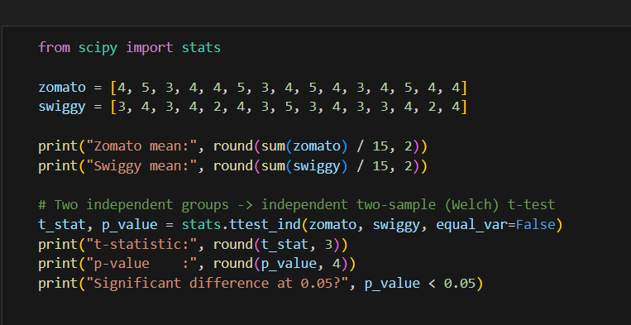
Output
Zomato mean: 4.07
Swiggy mean: 3.4
t-statistic: 2.376
p-value : 0.0248
Significant difference at 0.05? True

Why this test: the two sets of ratings come from different, unrelated users, so the groups are independent and we compare two means with an independent two-sample t-test. I used the Welch version (equal_var=False) because it does not assume the two groups have equal variances. At α = 0.05, p = 0.0248 means the difference (4.07 against 3.40) is statistically significant. (Because ratings are whole numbers from 1 to 5, a Mann-Whitney U test is a useful non-parametric cross-check.)

Task 5: One-sample t-test on PhonePe data
Use an AI tool to write code for a one-sample t-test on a dataset of your choice, run it and paste both the code and the output.
Prompt used: "Write Python code that performs a one-sample t-test on average daily UPI transactions per user on PhonePe." Claim tested: the average is 5 transactions per user per day.
Python code
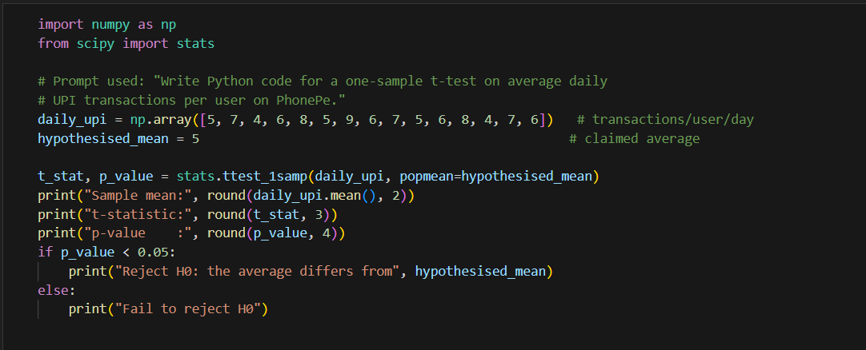
Output
Sample mean: 6.2
t-statistic: 3.154
p-value : 0.007
Reject H0: the average differs from 5

Conclusion: p = 0.007 < 0.05, so we reject H₀: in this sample, users make significantly more than 5 UPI transactions a day (mean 6.2). The data are illustrative.

Session 14: Chi-Square Test

Task 1: Contingency table of app vs payment method
Create a contingency table showing the relationship between users' favourite food delivery app and preferred payment method, with at least 20 responses.
I used a survey of 80 responses. A larger sample keeps every expected count above 5, which the chi-square test needs. In Excel, put the raw data in two columns (Delivery App in A, Payment Method in B), then either use Insert > PivotTable (Rows = Delivery App, Columns = Payment Method, Values = Count) or the formula below in each cell of the table.
Excel formula (cell F2 copied across and down)
=COUNTIFS($A$2:$A$81, $E2, $B$2:$B$81, F$1)

Delivery App | Paytm | PhonePe | Credit Card | Row total
Zomato | 12 | 14 | 8 | 34
Swiggy | 8 | 10 | 10 | 28
Uber Eats | 6 | 6 | 6 | 18
Column total | 26 | 30 | 24 | 80

Task 2: Expected counts for music app preference
Observed counts: Spotify (M 12, F 18), Gaana (M 8, F 7), YouTube Music (M 10, F 15). Calculate the expected counts assuming independence.
App | Males | Females | Row total
Spotify | 12 | 18 | 30
Gaana | 8 | 7 | 15
YouTube Music | 10 | 15 | 25
Column total | 30 | 40 | 70

Expected count = (row total × column total) / grand total, with grand total = 70.
App | Expected males | Expected females
Spotify | 30 × 30 / 70 = 12.857 | 30 × 40 / 70 = 17.143
Gaana | 15 × 30 / 70 = 6.429 | 15 × 40 / 70 = 8.571
YouTube Music | 25 × 30 / 70 = 10.714 | 25 × 40 / 70 = 14.286

Python check
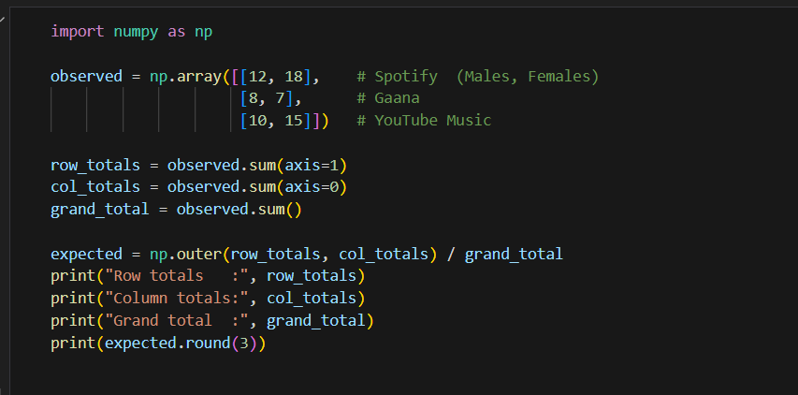
Output
Row totals : [30 15 25]
Column totals: [30 40]
Grand total : 70
[[12.857 17.143]
[ 6.429 8.571]
[10.714 14.286]]

Task 3: Chi-square test of independence
Perform a chi-square test of independence on the contingency table from Task 1 and state your conclusion.
- Hypotheses. H₀: app choice and payment method are independent. H₁: they are associated. α = 0.05.
- Expected counts = (row total × column total) / 80.
Expected | Paytm | PhonePe | Credit Card
Zomato | 11.05 | 12.75 | 10.20
Swiggy | 9.10 | 10.50 | 8.40
Uber Eats | 5.85 | 6.75 | 5.40

- Contribution of each cell = (O − E)² / E.
(O − E)² / E | Paytm | PhonePe | Credit Card
Zomato | 0.082 | 0.123 | 0.475
Swiggy | 0.133 | 0.024 | 0.305
Uber Eats | 0.004 | 0.083 | 0.067
Sum = χ² |  |  | 1.2941

- Degrees of freedom = (3 − 1)(3 − 1) = 4. The critical value at α = 0.05 is 9.488.
Python code
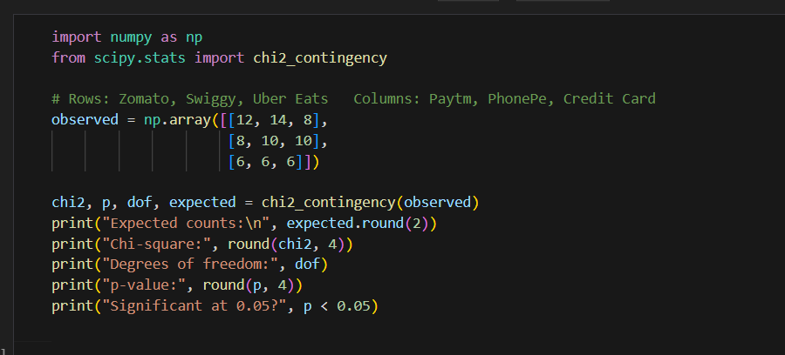
Output
Expected counts:
[[11.05 12.75 10.2 ]
[ 9.1 10.5 8.4 ]
[ 5.85 6.75 5.4 ]]
Chi-square: 1.2941
Degrees of freedom: 4
p-value: 0.8624
Significant at 0.05? False

Conclusion: χ² = 1.294 is far below the critical value 9.488 (p = 0.8624 > 0.05), so we fail to reject H₀. There is no significant association between the delivery app a user prefers and the payment method they prefer in this sample.

Task 4: Goodness of fit for the Flipkart claim
Of 30 surveyed users, 18 prefer the new product and 12 do not. The company claims 70% will prefer it. Perform a chi-square goodness of fit test.
Category | Observed (O) | Expected (E) | (O − E)² / E
Prefer new product | 18 | 30 × 0.70 = 21 | (18 − 21)² / 21 = 0.4286
Do not prefer | 12 | 30 × 0.30 = 9 | (12 − 9)² / 9 = 1.0000
Total | 30 | 30 | χ² = 1.4286

H₀: the true proportions are 70% / 30%. df = 2 − 1 = 1; the critical value at α = 0.05 is 3.841.
Python code
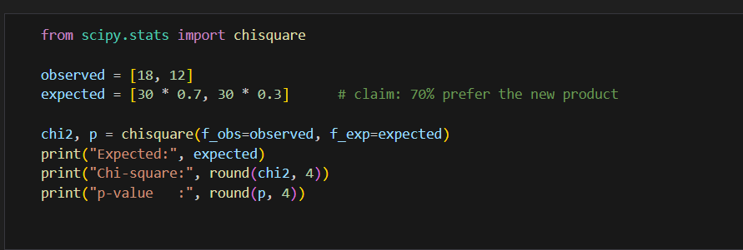
Output
Expected: [21.0, 9.0]
Chi-square: 1.4286
p-value : 0.232

Conclusion: χ² = 1.4286 < 3.841 (p = 0.232 > 0.05), so we fail to reject H₀. The observed 60% preference is consistent with the company's 70% claim; the difference could easily be due to chance with only 30 users.

Session 15: ANOVA (Analysis of Variance)

Task 1: The CSV file
Create purchase_data.csv with columns customer_id, age_group and purchase_value, with at least 15 records and 5 customers per age group.
The file is created by the first lines of the script in Task 2, and it is also supplied separately as purchase_data.csv. Contents:
customer_id | age_group | purchase_value
1 | 18-25 | 450
2 | 18-25 | 520
3 | 18-25 | 480
4 | 18-25 | 610
5 | 18-25 | 540
6 | 26-35 | 820
7 | 26-35 | 760
8 | 26-35 | 900
9 | 26-35 | 850
10 | 26-35 | 790
11 | 36-50 | 980
12 | 36-50 | 1050
13 | 36-50 | 910
14 | 36-50 | 1120
15 | 36-50 | 1000

Task 2: One-way ANOVA in Python
Read purchase_data.csv with pandas and run a one-way ANOVA using scipy.stats; print the F-statistic and p-value.
Python code
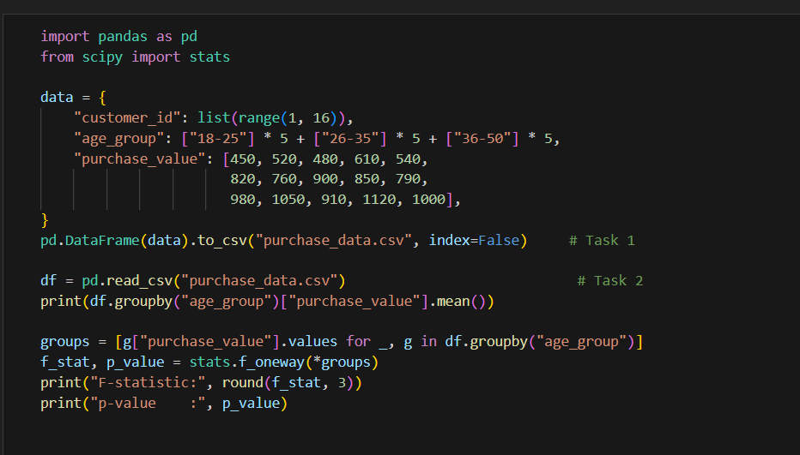
Output
age_group
18-25 520.0
26-35 824.0
36-50 1012.0
Name: purchase_value, dtype: float64
F-statistic: 71.95
p-value : 2.079717190044007e-07

Task 3: Interpretation
Interpret whether there is a statistically significant difference in average purchase value between the age groups (2 to 3 lines).
H₀: all three age groups have the same mean purchase value. The F-statistic is 71.95 with p ≈ 0.0000002, far below 0.05, so we reject H₀. There is a statistically significant difference in average purchase value between the age groups (₹520 for 18–25, ₹824 for 26–35 and ₹1,012 for 36–50). ANOVA only tells us that at least one group differs; a post-hoc test such as Tukey's HSD would show which pairs differ.

Task 4: Between-group and within-group variance
Calculate and print the between-group and within-group variance and explain what each represents.
Python code
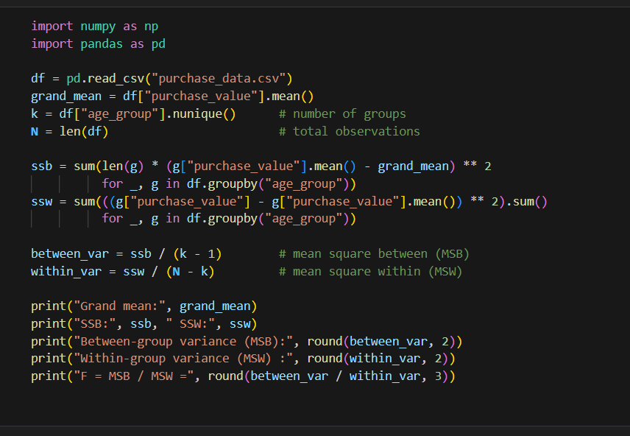
Output
Grand mean: 785.3333333333334
SSB: 616373.3333333334 SSW: 51400.0
Between-group variance (MSB): 308186.67
Within-group variance (MSW) : 4283.33
F = MSB / MSW = 71.95

Quantity | Formula | Value
Grand mean | average of all 15 values | 785.33
Sum of squares between (SSB) | Σ nᵢ (group mean − grand mean)² | 616,373.33
Sum of squares within (SSW) | Σ (value − its group mean)² | 51,400
Between-group variance (MSB) | SSB / (k − 1) = SSB / 2 | 308,186.67
Within-group variance (MSW) | SSW / (N − k) = SSW / 12 | 4,283.33
F-statistic | MSB / MSW | 71.95

Between-group variance (308,186.67) measures how far the three age-group averages are from the overall average, that is, the differences caused by age. Within-group variance (4,283.33) measures how much customers inside the same age group differ from their own group's average, that is, random variation. The between-group variance is about 72 times the within-group variance, which is exactly the F-statistic and explains why the result is so significant.

Task 5: ANOVA on Zomato customer segments
Use an AI tool to generate code for a one-way ANOVA on average monthly order amounts of Students, Working Professionals and Retirees, paste it and run it with dummy data.
Prompt used: "Write Python code that performs a one-way ANOVA on average monthly Zomato order amounts for three customer segments: Students, Working Professionals and Retirees."
Python code
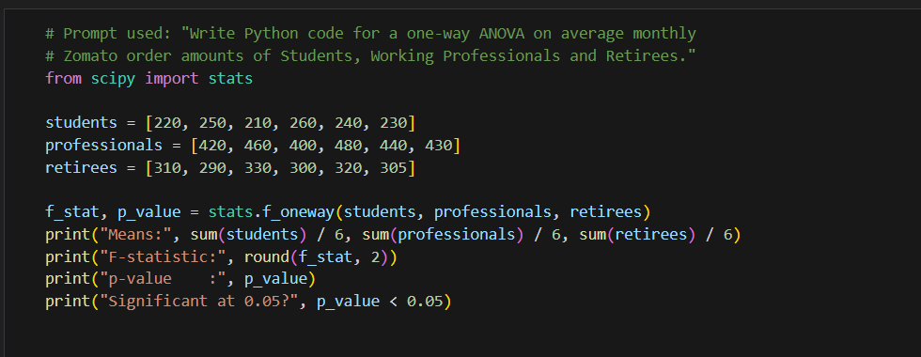
Output
Means: 235.0 438.3333333333333 309.1666666666667
F-statistic: 139.03
p-value : 2.0820999316602064e-10
Significant at 0.05? True

Conclusion: F = 139.03 and p ≈ 2 × 10⁻¹⁰ < 0.05, so the average order amount differs significantly among the three segments (dummy data: students ₹235, working professionals ₹438, retirees ₹309).

Session 16: Correlation Analysis

Task 1: Pearson correlation for songs
Create a small dataset of 10 to 15 songs with danceability, energy and popularity, and calculate the Pearson correlation between danceability and popularity.
Song | Danceability | Energy | Popularity
1 | 0.82 | 0.70 | 78
2 | 0.65 | 0.60 | 85
3 | 0.71 | 0.80 | 62
4 | 0.55 | 0.50 | 70
5 | 0.90 | 0.85 | 91
6 | 0.60 | 0.55 | 58
7 | 0.75 | 0.65 | 84
8 | 0.48 | 0.45 | 60
9 | 0.68 | 0.75 | 66
10 | 0.85 | 0.78 | 75
11 | 0.58 | 0.62 | 72
12 | 0.73 | 0.68 | 68

Python code
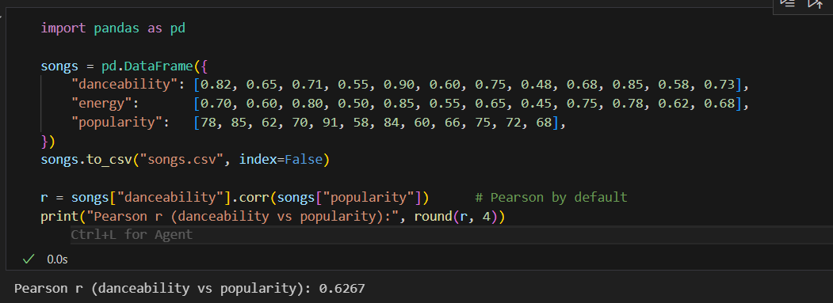
Output
Pearson r (danceability vs popularity): 0.6267

r = 0.6267: a moderately strong positive linear relationship. More danceable songs tend to be more popular in this sample, but the relationship is far from perfect (r² ≈ 0.39, so danceability explains about 39% of the variation in popularity).

Task 2: Spearman correlation of runs and followers
Use scipy.stats.spearmanr to calculate the Spearman correlation between IPL players' runs and Instagram followers, and interpret it.
Data for 10 players: total runs 8000, 7500, 6000, 5200, 4500, 3800, 3200, 2500, 2000, 1500; followers (millions) 250, 120, 40, 30, 60, 15, 20, 10, 25, 8.
Python code
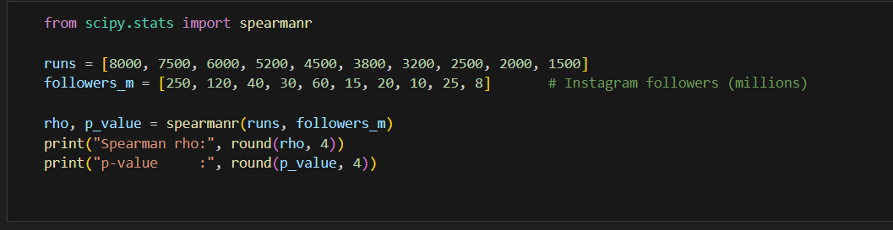
Output
Spearman rho: 0.8788
p-value : 0.0008

ρ = 0.8788 (p = 0.0008): a strong positive rank correlation. Players with more runs generally have more followers, although the order is not identical (for example the player with 4,500 runs has more followers than the one with 5,200). Spearman is a good choice here because follower counts are very skewed. This shows association, not that scoring runs alone causes popularity.

Task 3: Correlation matrix for Flipkart products
Create a correlation matrix for price, user rating and number of reviews using pandas' corr() and display it.
Data for 12 products: price (₹) 15000, 22000, 8000, 35000, 12000, 45000, 6000, 28000, 18000, 9500, 52000, 14000; rating 4.2, 4.4, 4.0, 4.5, 4.1, 4.3, 3.9, 4.4, 4.2, 4.0, 4.6, 4.1; reviews 5200, 3100, 8900, 1800, 6400, 1200, 9800, 2400, 4300, 7600, 900, 5800.
Python code
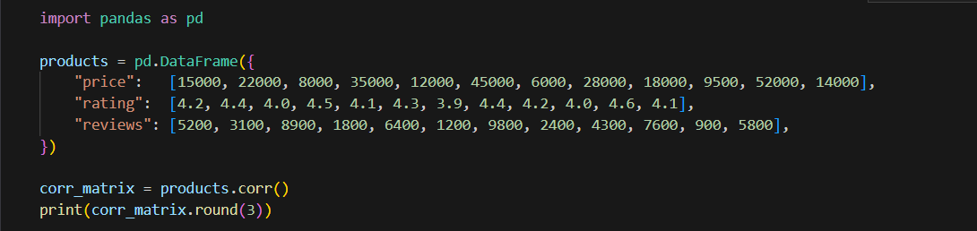
Output
price rating reviews
price 1.000 0.871 -0.909
rating 0.871 1.000 -0.940
reviews -0.909 -0.940 1.000

Price and rating are strongly positively correlated (0.871): pricier products tend to be rated higher. Price and reviews are strongly negatively correlated (−0.909): cheaper products collect many more reviews, because more people buy them. Rating and reviews are also negatively correlated (−0.940).

Task 4: Heatmap of the correlation matrix
Visualise the correlation matrix as a seaborn heatmap with annotations and a colour bar.
Python code
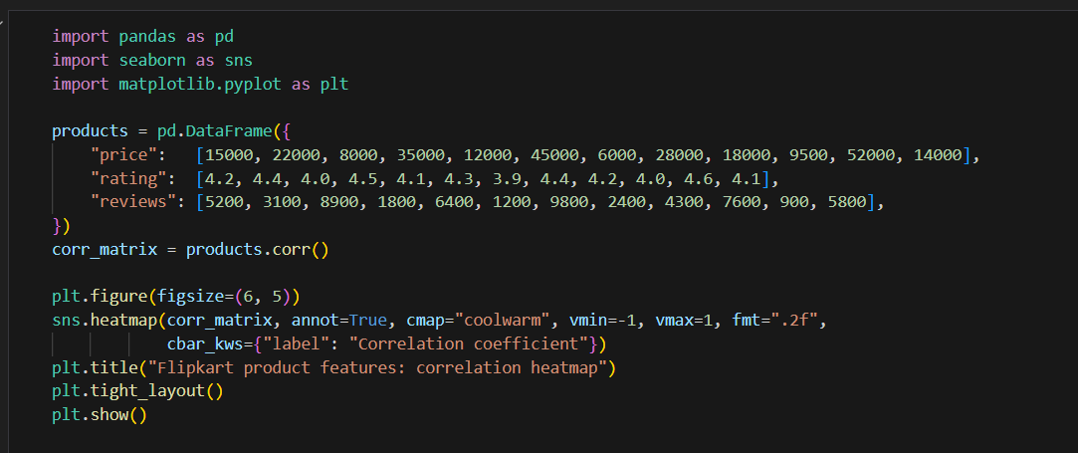
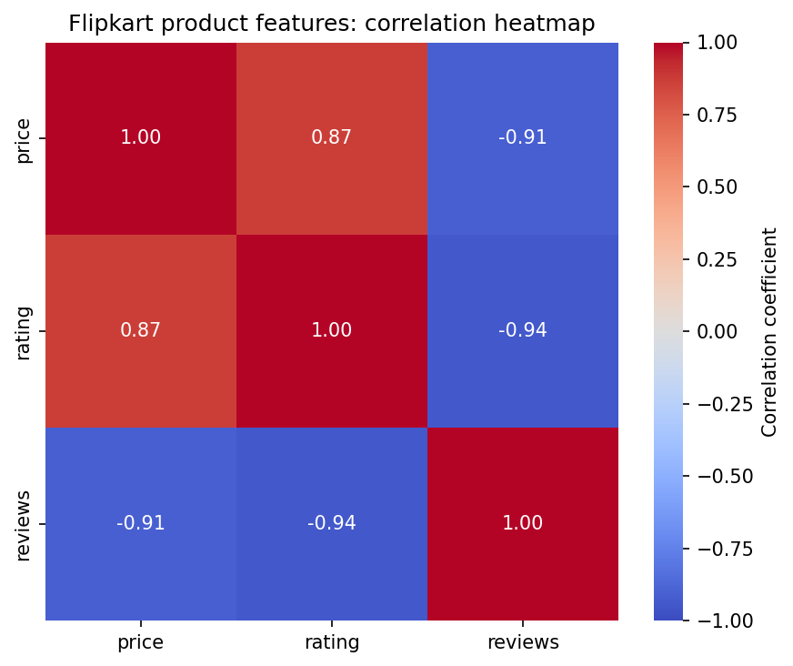
Correlation heatmap of price, rating and reviews
Red cells show positive correlation and blue cells show negative correlation. The diagonal is always 1 because every variable is perfectly correlated with itself.

Task 5: Two pitfalls when interpreting correlation
List two potential pitfalls with a short example for each.
- Correlation is not causation (hidden third variable). On Zomato, ice-cream orders and cold-drink orders rise and fall together, giving a high positive correlation. Ordering ice cream does not cause people to order cold drinks; hot weather drives both. Acting on the correlation alone (for example promoting cold drinks to lift ice-cream sales) would fail.
- Pearson correlation only measures straight-line relationships and is sensitive to outliers. On YouTube, the relationship between video length and the percentage of the video people watch typically rises and then falls (very short and very long videos are watched less fully). The correlation coefficient could be close to 0 even though the relationship is strong. Likewise, a single viral video with huge views and likes can make r look high for a channel whose other videos show no relationship at all. Always plot the data and consider Spearman when the data is skewed.
A related caution from Task 3: rating and number of reviews are strongly negatively correlated in our sample, but that does not mean having fewer reviews makes a product rated better; price is a likely common factor.

Session 17: Introduction to Regression (Simple Linear Regression)

Task 1: Dependent and independent variables
For YouTube influencers with followers and average monthly brand deals, identify the dependent and independent variable and explain.
Independent variable (X): number of followers. Dependent variable (Y): average monthly brand deals. We expect brands to approach influencers with larger audiences, so the number of deals depends on the audience size, not the other way round. Followers are the input we use to predict the outcome, and brand deals are the outcome we want to explain or predict.

Task 2: Scatter plot with line of best fit
Plot a scatter plot of Myntra ad spend (lakhs) against app downloads for 10 data points and draw the line of best fit.
# | Ad spend (₹ lakhs) | Downloads (thousands)
1 | 2 | 15
2 | 3 | 22
3 | 4 | 30
4 | 5 | 34
5 | 6 | 41
6 | 7 | 48
7 | 8 | 52
8 | 9 | 60
9 | 10 | 66
10 | 12 | 79

Python code
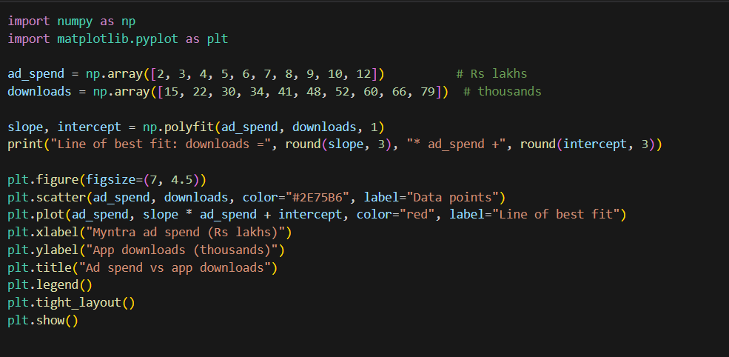
Output
Line of best fit: downloads = 6.297 * ad_spend + 3.143

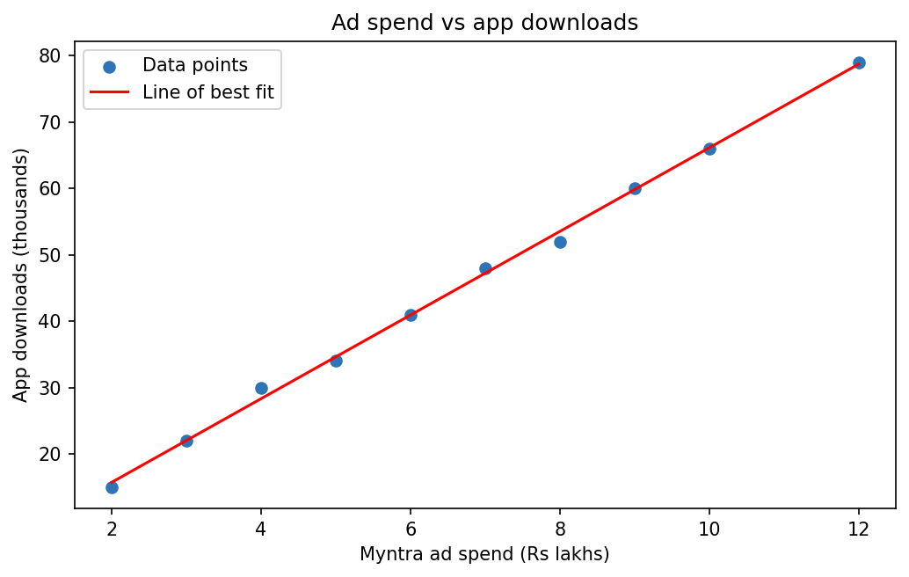
Scatter plot of ad spend against downloads with the least-squares line
The points follow a clear upward straight-line pattern. The fitted line is downloads = 6.297 × ad spend + 3.143: each extra lakh of advertising is associated with about 6,300 more downloads.

Task 3: Simple linear regression with scikit-learn
Fit a simple linear regression to predict average daily Swiggy orders from daily advertising spend; print the slope and intercept and explain them.
Sample data: ad spend 1 to 8 lakhs; daily orders 1200, 1500, 1750, 2100, 2300, 2650, 2900, 3250.
Python code
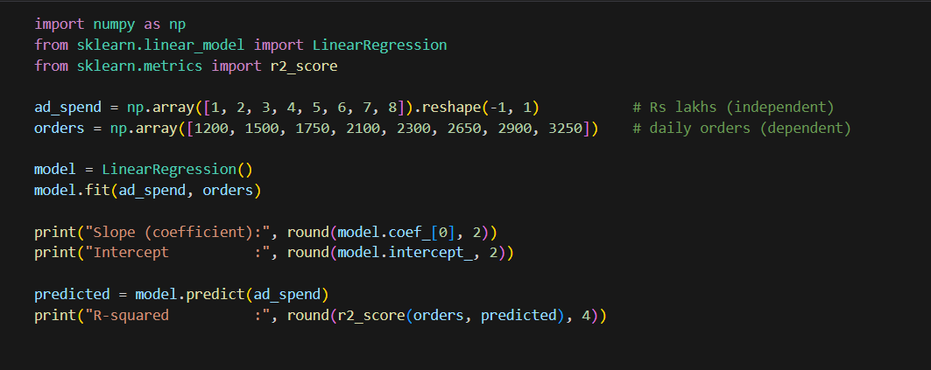
Output
Slope (coefficient): 288.69
Intercept : 907.14
R-squared : 0.9981

Slope = 288.69: for every extra lakh spent on ads, average daily orders increase by about 289 orders. Intercept = 907.14: this is the predicted number of daily orders when ad spend is zero, which we can read as the baseline of roughly 907 orders a day that come from existing customers without advertising. (Be careful: our data only covers 1 to 8 lakhs, so the intercept is an extrapolation.)

Task 4: R-squared
Calculate the R-squared of the model and interpret what it says about the relationship between ad spend and daily orders.
The R-squared printed in the output above is 0.9981. It is extremely close to 1, which means that about 99.8% of the variation in daily orders is explained by ad spend in this data, so the model fits the points almost perfectly. Two cautions: the dataset is small and illustrative, and real-world data would show a lower R² because of seasonality, offers and weather. A high R² also shows association, not proof that advertising alone causes the extra orders.

Case Study 1: E-Commerce Sales Analysis (Excel Edition)
Data: Kaggle Online Retail dataset, file OnlineRetail.csv. Columns: InvoiceNo (A), StockCode (B), Description (C), Quantity (D), InvoiceDate (E), UnitPrice (F), CustomerID (G), Country (H).
Important: I cannot open the Kaggle file here, so this section gives the exact Excel method for each task and tells you what to write down. I have not invented numbers. Your results will come from your own copy of the file.

Before you begin: open and prepare the data
- Open Excel > Data > From Text/CSV, choose OnlineRetail.csv, set File Origin to *1252: Western European* (the file is not UTF-8, so this avoids garbled characters), and click Load.
- Click inside the data and press Ctrl + T to turn it into a Table (or at least apply Data > Filter).
- In cell I1 type Sales and fill the column with =D2*F2 (Quantity × UnitPrice).
- Cancellations have InvoiceNo starting with "C" and negative Quantity. For sales analysis, filter these out (for example Quantity > 0) so they do not reduce totals. Note that many rows have a blank CustomerID.

Task 1: UK transactions and unique customers
Filter to show only 'United Kingdom' transactions and count the unique CustomerIDs.
- Click the filter arrow on Country (column H), untick Select All, tick United Kingdom.
- Count unique CustomerIDs with one of these methods (use your own last row number instead of 541910):
Excel 365 / 2021 (dynamic arrays)
=COUNTA(UNIQUE(FILTER(G2:G541910, (H2:H541910="United Kingdom")*(G2:G541910<>""))))

Older Excel: copy the visible CustomerID cells of the filtered data into a new sheet, use Data > Remove Duplicates, then count the remaining non-blank cells with =COUNT(A:A).
Write down: the number of unique UK CustomerIDs. Blank IDs must not be counted.

Task 2: PivotTable of total sales by country
Create a PivotTable of total sales (Quantity × UnitPrice) by Country and identify the top 3 countries.
- Click inside the data > Insert > PivotTable > new worksheet.
- Drag Country to Rows and Sales (the helper column) to Values, set to Sum.
- Click any value > right-click > Sort > Sort Largest to Smallest.
- Read the first three rows. The United Kingdom normally dominates by a wide margin, so check the other two against your pivot.
- Type the three names in a cell below the table, for example ="Top 3: "&A5&", "&A6&", "&A7" (adjust to your pivot cell addresses).

Task 3: Average order value and highlighting large invoices
Calculate the average order value (total sales per InvoiceNo) and highlight any InvoiceNo where the order value is above 10,000.
- Create a new PivotTable with InvoiceNo in Rows and Sum of Sales in Values (this is the order value of each invoice). Using a pivot is much faster than SUMIFS on more than 500,000 rows.
- Copy the pivot (Paste Special > Values) to a new sheet with headers InvoiceNo and Order Value.
- Average order value: =AVERAGE(B2:B25901) (use your own last row). Write the result in a cell.
- Select the Order Value column > Home > Conditional Formatting > Highlight Cells Rules > Greater Than... > enter 10000 > choose a fill colour.
Note on units: the dataset records prices in pounds (£), so apply the 10,000 threshold to the dataset's own values unless your instructor asks you to convert currency. Remember to exclude cancellation invoices (starting with C).

Task 4: t-test, France vs Germany
Compare the average order value of customers from France and Germany with a two-sample t-test assuming unequal variances at the 0.05 level.
- Build a pivot with Country and InvoiceNo in Rows (Tabular layout, Repeat All Item Labels) and Sum of Sales in Values. Filter the Country field to France.
- Copy France's order values into column A of a new sheet and Germany's into column B (under headings France and Germany).
- Turn on File > Options > Add-ins > Analysis ToolPak. Then Data > Data Analysis > t-Test: Two-Sample Assuming Unequal Variances.
- Variable 1 Range = France column, Variable 2 Range = Germany column, Hypothesized Mean Difference = 0, Alpha = 0.05, choose an output cell.
- Decision rule: look at P(T<=t) two-tail. If it is less than 0.05, the difference between the average order values is statistically significant; otherwise it is not significant. State the two means and your conclusion in one sentence.

Task 5: AI summary on an 'Insights' sheet
Use ChatGPT or Copilot to summarise the key customer purchasing patterns from your analysis and paste it into a new sheet named 'Insights'.
Right-click a sheet tab > Insert a new sheet named Insights. Give the AI your real results from Tasks 1 to 4 using this prompt (fill in the blanks from your workbook), then paste its answer into the sheet:
I analysed the Online Retail dataset in Excel. Results:
- Unique UK customers: [__]
- Top 3 countries by total sales: [__, __, __]
- Average order value across all invoices: [__]
- Number of invoices above 10,000: [__]
- France vs Germany t-test: mean France [__], mean Germany [__], p-value [__]
Write a short summary of the key customer purchasing patterns (high-value countries,
average order size, seasonal trends) for a business manager.

For the seasonal trend, add a pivot with InvoiceDate in Rows (right-click > Group > Months and Years) and Sum of Sales in Values, and mention the peak months in your prompt.

Case Study 2: Customer Churn Analysis (Excel Edition)
Data: Kaggle Telco Customer Churn dataset, file Telco-Customer-Churn.csv. The standard file has 21 columns. In it, tenure is column F, InternetService is I, Contract is P, MonthlyCharges is S and Churn is U. Check your letters against the headers and adjust the formulas if your file is arranged differently.
Reference values: for the standard Kaggle version of this file (7,043 customers) the results are listed in each task so you can check your own work. If your numbers differ, check your filter and ranges before trusting either.

Task 1: Count churned and non-churned customers
Use the Filter feature to count customers with Churn = 'Yes' and Churn = 'No'.
- Select the header row > Data > Filter. On the Churn column filter by Yes; the status bar at the bottom of Excel shows "x of 7043 records found". Repeat for No.
- Or confirm with formulas:
Excel formulas
=COUNTIF(U2:U7044, "Yes")
=COUNTIF(U2:U7044, "No")

Churn | Customers | Share of 7,043
Yes | 1,869 | 26.5%
No | 5,174 | 73.5%

Task 2: Churn by contract type
Use a PivotTable to show the count of churned customers for each Contract type.
- Insert > PivotTable. Drag Contract to Rows, Churn to Columns, and customerID to Values (Count).
- Read the Yes column (or filter the Churn field to Yes to show only churned customers).
Contract | Churned (reference) | Reading
Month-to-month | 1,655 | By far the most churn
One year | 166 | Low
Two year | 48 | Lowest

Insight: customers on month-to-month contracts account for about 88% of all churners (1,655 of 1,869). Encouraging longer contracts is an obvious retention strategy.

Task 3: Average MonthlyCharges with AVERAGEIF
Calculate the average MonthlyCharges for customers who churned versus those who did not, using AVERAGEIF.
Excel formulas
=AVERAGEIF(U2:U7044, "Yes", S2:S7044)
=AVERAGEIF(U2:U7044, "No", S2:S7044)

Group | Average MonthlyCharges (reference)
Churned (Yes) | 74.44
Not churned (No) | 61.27

Insight: customers who left were paying about 13 units more per month on average, which suggests that higher bills are linked to churn.

Task 4: Bar chart of churn by InternetService
Create a bar chart comparing churned and non-churned customers for each InternetService type (DSL, Fiber optic, No).
- Create a PivotTable with InternetService in Rows, Churn in Columns and Count of customerID in Values.
- Click inside the pivot > PivotTable Analyze > PivotChart > Clustered Column (or Insert > Column or Bar Chart).
- Add a chart title, axis titles (InternetService, Number of customers) and a legend (No / Yes).
InternetService | No (stayed) | Yes (churned) | Total
DSL | 1,962 | 459 | 2,421
Fiber optic | 1,799 | 1,297 | 3,096
No | 1,413 | 113 | 1,526

Insight (reference values): fiber optic customers churn the most, both in number and as a share of their group (about 42%), while customers with no internet service churn the least.

Task 5: CORREL between Tenure and Churn
Convert Churn to 1/0 in a new column and use CORREL to check for correlation with Tenure, then interpret it.
- In the first empty column (V1) type Churn_Num. In V2 enter =IF(U2="Yes",1,0) and fill down to row 7044.
- Compute the correlation:
Excel formula
=CORREL(F2:F7044, V2:V7044)

Reference result: about −0.35. The negative sign means that as tenure increases, the likelihood of churn decreases: customers who have stayed longer are less likely to leave. A value of −0.35 is a moderate relationship, not a strong one, and since Churn is a 0/1 variable this is a point-biserial correlation. It shows association, not cause, so it supports focusing retention efforts on new customers in their first months.

Final tip: keep every answer in its own worksheet tab (for example Task1 to Task5), write each result in a labelled cell, and add one line of interpretation under each result.

